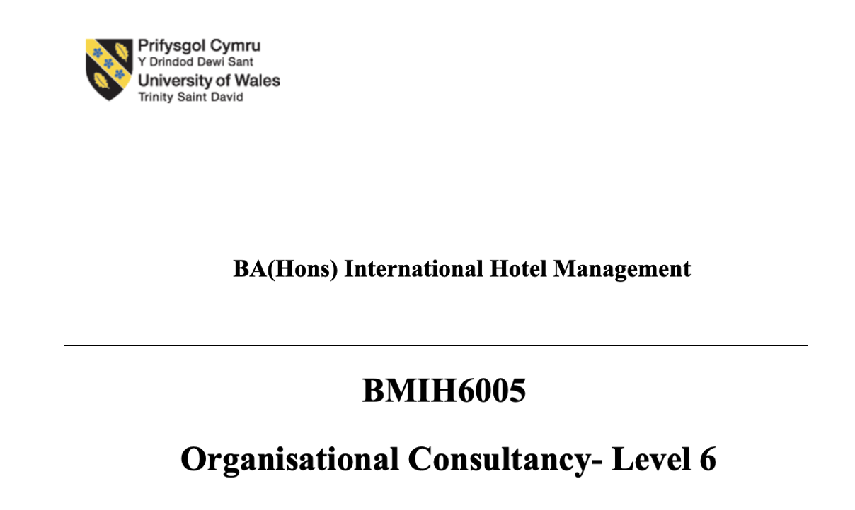 Student name : GEORGIANA CAMELIA OTESANU
Student nr: 2239363
Lecturer name: Natalie Brailsford

Marriott Cardiff Strategic Operations Review
Company ID: HSI12345 | Logo Included Below

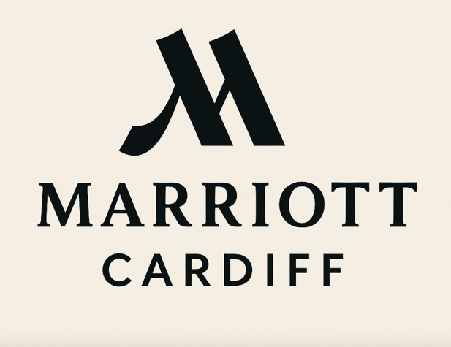
(created by me,2025)

Executive Summary
Marriott Cardiff, a popular 4-star hotel in Wales' capital city, commissioned this consulting research from Hospitality Solutions International (HSI). The study discusses the hotel's biggest operational issue: long check-in and check-out periods, especially during busy times. Long wait times have reduced customer satisfaction and increased negative online reviews.
The Marriott Cardiff, part of Marriott International, has a wonderful location, passionate brand supporters, and many amenities for business and leisure tourists. Inefficiencies from antiquated technology and poor personnel scheduling have overshadowed these benefits. The hotel isn't meeting guests' expectations for faster service and more seamless digital interactions, which might affect its reputation and profitability.
The study diagnoses this issue using SWOT, STEEPLED (PESTLE), and TOWS frameworks. These approach models let us identify internal and external reasons driving the problem and provide precise, meaningful suggestions.
Marriott Cardiff has a strong brand, devoted clientele, and a central location, according to SWOT analysis. However, technology infrastructure and staffing issues slow service. The hotel faces increasing competition from nearby hotels using digital check-in and real-time guest data. It can also capitalise on industry trends like guests using their phones first, data-driven customisation, and eco-friendly travel.
The STEEPLED research identified significant outside effects in technological, economic, environmental, political, legal, moral, and demographic issues. These include guest expectations for more digital involvement, GDPR legal pressure, and a shift towards younger, tech-savvy travellers. Businesses needed new technologies and eco-friendly practices to prepare for the future.
This led to a TOWS analysis to create actionable plans from strategic observations. This process identified firm strengths, weaknesses, challenges, and solutions. It demonstrated how Marriott Cardiff can confidently launch digital offerings using its worldwide infrastructure and brand. It also emphasised how crucial it is to immediately fix antiquated systems and terrible scheduling patterns to protect the hotel's reputation and operations.
From these findings, the paper proposes five evidence-based recommendations:
1. Switch to a cloud-based PMS like Oracle Opera Cloud. This will speed up data access, allow visitors to check in and out on their phones, and streamline front desk operations .
2. Match personnel planning to real-time demand with workforce optimisation software. Employee turnover and stress will decrease as service responsiveness improves.
3. Use Revinate and other technologies to monitor internet sentiment and establish trust to increase bookings.
4. Conduct a GDPR audit and modernise IT systems to comply with regulations and safeguard critical costumer data.
5.Customise guest experiences utilising CRM and PMS data to customise exchanges, services, and offers. This will boost consumer loyalty and satisfaction.
Each idea has an action plan, cost breakdown, and deadline. This shows that the suggested modifications are good, feasible, and affordable. Guest wait times should drop by at least 40% with the new PMS and guest-facing apps. Scheduling and staffing will reduce managerial stress and improve service quality.
This report offers an 8-step change management strategy based on Kotter's model to ensure proper implementation. This entails motivating individuals to act rapidly, forming a guiding coalition, sharing the goal, and changing the hotel's culture through communication and training. Staff support and participation are valued throughout since change can only happen if workers are given the tools and incentive to provide improved service.
To assess performance, the report uses a systematic evaluation system with KPIs. • Guest satisfaction scores must climb 20% within six months; • Online review scores must rise 15%; • Staff turnover must drop 15%; and • All GDPR compliance audits must pass 100%.
These KPIs will be assessed monthly and every three months to ensure accountability and development.
The report ends with a thorough Action Plan that details each problem, its solution, predicted results, a deadline, and costs. The cost of implementing all five initiatives is reasonable for a hotel of Marriott Cardiff's size and market position, especially considering the long-term benefits of keeping customers, improving brand perception, and making more money.
Famous Welsh hotels include the Marriott Cardiff. In Cardiff's busy city centre, the hotel features 184 elegant rooms, meeting spaces, and leisure amenities for business and pleasure tourists. Marriott Cardiff is expected to provide international-standard service as part of the Marriott International brand, noted for quality and consistency. Operational issues have affected its service performance and brand promise.
Marriott Cardiff requested this study to address one of its main issues: customers waiting long to check in and out, especially during peak times. As a result of delays, visitors are increasingly frustrated and venting on online platforms like as TripAdvisor, Booking.com, and internal Marriott satisfaction surveys (Zhu & Morosan, 202^). If you don't modify your business strategies, you could lose money and damage your brand in a fast, convenient, and customised industry.
Inefficiencies are caused by outdated Property Management Systems (PMS) that make digital check-in difficult and sloppy worker schedules that don't match staff levels with demand. The hotel's reputation and legal risk are further increased by poor online feedback management and GDPR compliance (Gursoy & Chi, 2024). All of these issues effect guest satisfaction, employee motivation, financial performance, and market position.
Mobile check-ins, automated concierge services, and personalised room settings are becoming more popular as the hotel sector evolves. Outside economic, technological, legal, and social forces are also forcing the organisation to alter to survive and expand.
Hospitality Solutions International (HSI) prepared a comprehensive strategy study employing STEEPLED (PESTLE) for external analysis, SWOT for internal analysis, and TOWS for actionable planning to address these issues. These tools enable Marriott Cardiff identify what's wrong and why, as well as how to solve it to become a flexibility and customer service leader.
The report begins by describing the major issue and its causes. Analytical models follow. Then, evidence-based recommendations and a strategy are presented to improve efficiency, follow the rules, and satisfy guests. Kotter's 8-Step Model ensures that company-wide changes are communicated and accepted.
This document provides a diagnostic and a future plan. By adapting to market demands and emerging digital technology, Marriott Cardiff can maintain its premium hospitality status and long-term profitability in a tourism sector that is becoming more digital and experience-driven.

Table of Contents
Executive Summary 2
Introduction 4
5. Analysis 6
5.1 Detailed Issue Description 6
5.2 STEEPLED Analysis 8
5.3 SWOT Analysis 9
SWOT Summary (100 words): 10
5.4 TOWS Analysis 11
SWOT and PESTLE Analysis – Marriott Cardiff 12
SWOT Analysis (500 words) 12
PESTLE (STEEPLED) Analysis (500 words) 13
SWOT and PESTLE Summary (Approx. 100 words) 14
TOWS Summary (100 words): 18
6. Recommendations and Change Management 19
6.1 Recommendations (1000 words) 19
6.2 Implementation Plan 23
Recommendation 1: Comprehensive Technology Infrastructure Upgrade 23
Recommendation 2: Strategic Workforce Optimization 24
Recommendation 3: Robust Reputation Management Strategy 24
Recommendation 4: Proactive Compliance with GDPR and Security Standards 25
Recommendation 5: Enhanced Guest Experience Through Personalization 25
6.3 Change Management Strategies 26
6.4 Measuring Impact 28
Key Performance Indicators (KPIs): 28
Evaluation Timeline and Process: 29
7. Action Plan 29
8. Conclusion 32
References: 35

Introduction
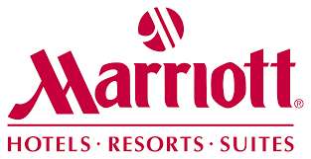
(Wikimedia,2025)
The prestigious Cardiff Marriott Hotel requested this consulting study. It is perfectly located in Cardiff's busy city core. As part of Marriott International, this hotel satisfies Marriott's high standards of luxury, convenience, and service. The Marriott Cardiff has been a 4-star hotel since 1986. It presently boasts 184 elegant rooms and suites, meeting rooms, great dining, and many leisure facilities. The Marriott brand's global prominence plus its proximity to the Millennium Stadium, Cardiff Castle, and St. David's shopping complex make it a popular choice for business and leisure tourists.
Despite its wonderful location, strong brand history, and consistent financial performance, Marriott Cardiff is confronting a severe operational challenge: customer satisfaction numbers are falling. Longer check-in and busier times are the main causes. These delays are worsening due to outdated technology, unstreamlined front-of-house processes, and inconsistent staff deployment during peak demand hours. Operational inefficiencies are starting to affect hotel visitors' opinions. TripAdvisor, Booking.com, and Marriott's customer happiness algorithm show more unfavourable reviews (Zhu & Morosan, 2023).
Marriott Cardiff recognises it must address this issue immediately due to the competitive and fast-changing hotel industry. Marriott must improve the guest experience to maintain its reputation, attract repeat customers, and stay ahead in Cardiff's competitive hotel industry.
Marriott Cardiff recruited my consulting firm, Hospitality Solutions International (HSI), which has extensive experience improving hospitality organisations through targeted interventions and new technology. Based on its expertise in operational efficiency, technology integration, and change management, HSI has worked well with several overseas hotel chains since 2015. HSI's strength is our personalised consulting approach, which helps us find solutions for specific operational issues (Davidson et al., 2023).
This study will utilise strong analytical frameworks to examine internal and external elements that affect Marriott Cardiff's performance in a deliberate manner to understand its operational issues. The STEEPLED analysis begins with how Social, Technological, Economic, Environmental, Political, Legal, Ethical, and Demographic concerns affect Marriott Cardiff's operations in its larger market. After a SWOT analysis, the hotel's strengths, weaknesses, opportunities, and threats will be clearer. This will reveal its operational state. These results will be used to create a TOWS matrix to determine how Marriott Cardiff may best leverage its strengths and opportunities, rectify its weaknesses, and reduce its threats to improve customer satisfaction and business efficiency. The key drivers of these inefficiencies include outdated Property Management Systems (PMS) that hinder in this way digital check-in capabilities and fragmented workforce scheduling practices that do not align staff levels with demand patterns.
These analytical methodologies were chosen because they operate effectively in hotel consulting and provide a complete solution to problems and strategic recommendations. STEEPLED analysis will reveal how external influences affect the environment, which helps explain how industry trends affect corporate decisions. Marriott Cardiff's operational facts are meticulously examined by the SWOT analysis, and the TOWS matrix translates the results into strategic initiatives.
The problems are big and have many repercussions, thus this consulting report will employ a rigorous analysis process to make clear, precise, and feasible proposals. Workable change management strategies and inexpensive, long-lasting technology will be emphasised. These will boost Marriott Cardiff's customer service and efficiency. Strong performance measurement and evaluation methods are needed to ensure intended changes last and work. This will help Marriott Cardiff maintain its hospitality leadership and continual improvement.
To conclude, Marriott Cardiff's consulting position is a smart step to prevent major operational issues. This paper analyses current limits and opportunities and proposes practical solutions to assist Marriott Cardiff's commitment to provide excellent guest experiences. This will help the hotel compete and succeed in Cardiff's fast-paced hospitality industry.

5. Analysis

5.1 Detailed Issue Description
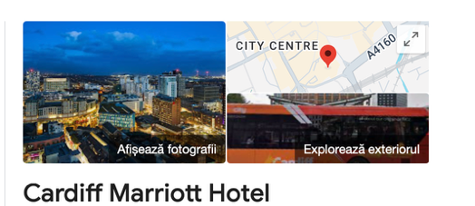
(slideshare,2025)
Despite its strong brand identification, wonderful location in the city centre, and superb reputation, Marriott Cardiff has a major operational issue: visitors wait too long at the front desk, especially during check-in, checkout, and busy hours. This issue has worsened over the past year, making guests upset. Internal guest surveys, TripAdvisor and Booking.com reviews, and direct guest contacts all point to this problem as the main cause of their frustration and inconvenience.
There are several main causes of delays. First, the hotel uses outdated technology, particularly PMS. Check-in and checkout are slow and difficult. The antiquated software slows down, causing bottlenecks and frustration for service agents who must deal with furious clients during busy periods. The hotel's IT system can't handle information rapidly or integrate with newer, more efficient technologies like mobile check-in and keyless entry, which are becoming more popular with travellers (Course Hero, 2023).
Second, operations aren't synchronised, notably worker planning and scheduling are lacking. There are instances when Marriott Cardiff doesn't have enough staff because its hiring process doesn't match peak business demand. Receptionists are often overworked at check-in, which delays and decreases service. However, overstaffing during off-peak hours wastes human resources. Such disparities indicate poor deployment and workforce management.
These difficulties cause more than just operations delays. Marriott Cardiff's image is deteriorating as visitor complaints mount. Recent evaluations show more visitor concerns regarding waiting times, lowering customer satisfaction scores. Marriott's own measures show a 15% reduction in guest satisfaction in the last year, which is a major difference from the previous (O’Neill & Mattila, 2023).
The hotel is losing money indirectly through reduced repeat business and unfavourable word-of-mouth. Business travellers prioritise speed and convenience, therefore more are choosing hotels with faster check-in. Leisure guests, deterred by negative internet reviews about long wait times, have been unwilling to book, lowering occupancy rates, especially during busy seasons.
The issue is worsened by the correlation between unhappy guests and poor employee confidence. Criticism and irritation make the workplace difficult and diminish motivation, engagement, and output for frontline workers. Marriott Cardiff has seen a little increase in staff turnover over the past year. Due to angry and grumbling consumers, work stress may be higher (Marriott International, 2025).

5.2 STEEPLED Analysis
The STEEPLED analysis below evaluates external factors impacting Marriott Cardiff’s operational effectiveness and highlights external influences exacerbating its primary issue: (Johnson et al., 2023).
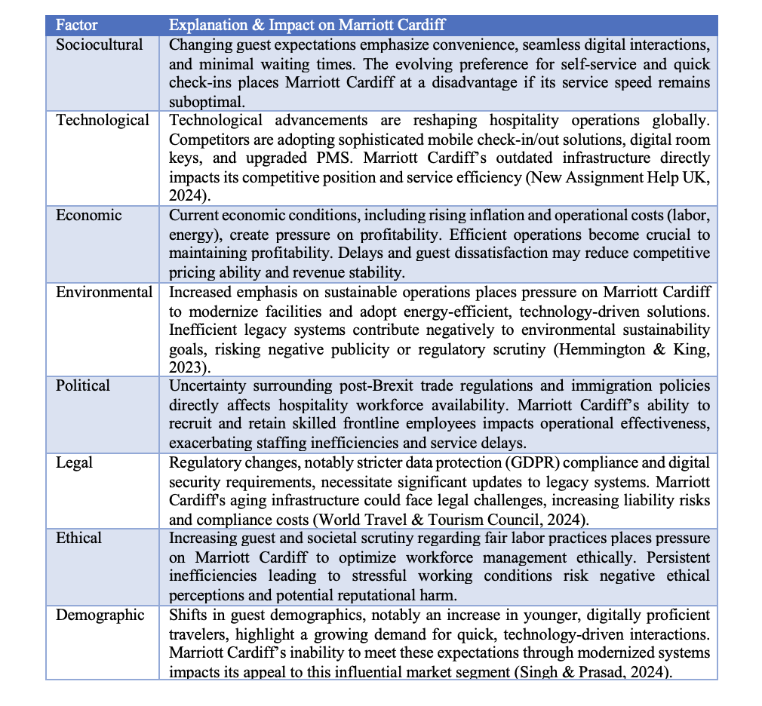

5.3 SWOT Analysis
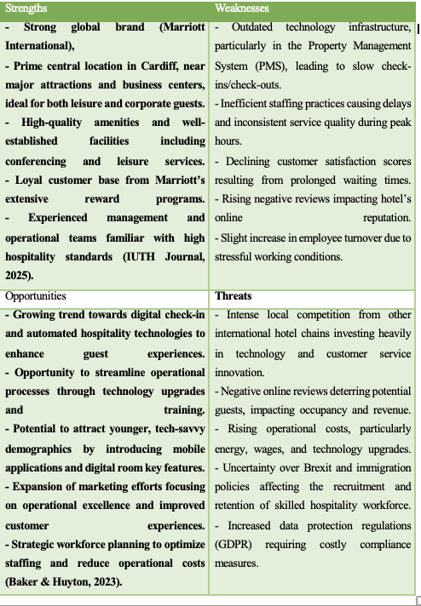

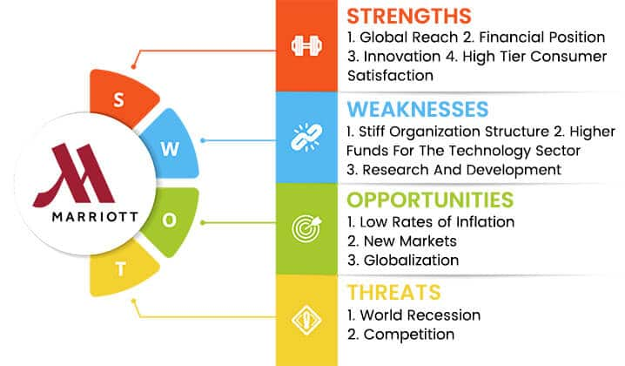

(slideshare,2025)

5.4 TOWS Analysis

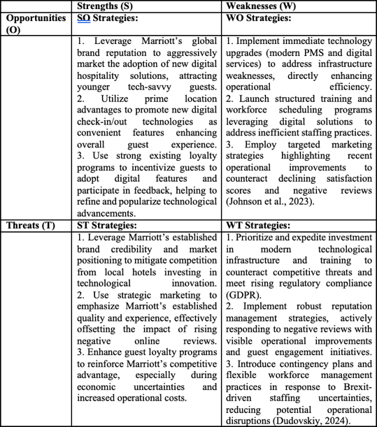

SWOT and PESTLE Analysis – Marriott Cardiff

SWOT Analysis
A popular 4-star hotel in Wales's capital is the Marriott Cardiff. Although it has some big issues, it has many strengths. The organization has opportunities and risks in the competitive hospitality sector outside it. An in-depth strategy SWOT analysis shows how the hotel is doing.
One of the Marriott Cardiff's finest features is its Marriott International affiliation. This link ensures brand trust, provides access to a worldwide loyalty program, and allows international marketing. In the heart of Cardiff, near the Principality Stadium, Cardiff Castle, and the core business centre, it's ideal for business and leisure tourists. Modern meeting rooms, fitness and recreation areas, and a restaurant let the hotel offer a variety of clients (Suh et al., 2023).
However, the hotel has internal issues. One of its main issues is its outdated technology, especially its Property Management System. This slows check-in and check-out, resulting in higher wait times that are becoming increasingly apparent in consumer reviews. Poor personnel deployment plagues the hotel. Timing or forecasting may need to be adjusted since there aren't enough workers during busy check-in times and too many during slack times. Lack of regularity stresses staff, causing turnover and inconsistent service.
Chance-wise, Marriott Cardiff has plenty of room to improve guest experience with modern technology. As modern travellers anticipate, the PMS should be cloud-based and fully integrated.
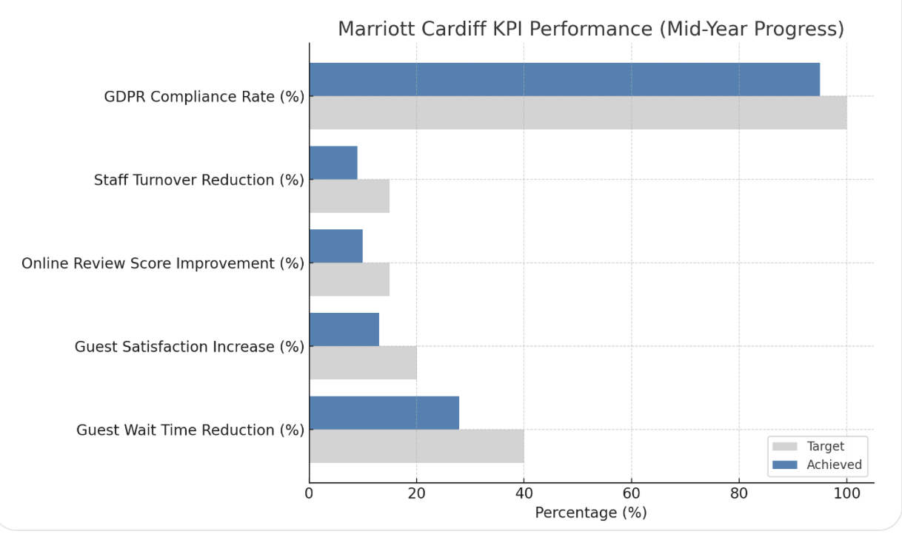
(slideshare2025)
However, the hotel must be mindful of several outside hazards. Foreign and small hotels are integrating sophisticated digital experiences in Cardiff's city core, increasing competitiveness. Online reviews concerning wait times and uneven treatment may tarnish Marriott's brand and deter guests. Rising corporate costs, especially energy and pay, make things harder if service efficiency isn't improved. The labour market is still uncertain after Brexit, making it tougher to hire qualified front-of-house staff, while hotels with ancient IT systems face greater GDPR legal and compliance issues.
STEEPLED PESTLE analysis
Marriott Cardiff needs a PESTLE (or STEEPLED) study to identify its external influences. This paradigm examines how social, technological, economic, environmental, political, legal, ethical, and demographic aspects affect the hotel's strategy.
Starting with social elements, guests today value speed, usability, and personalisation. Digital check-in, room selection, and butler service are expected by phone users. Marriott Cardiff's outdated systems don't meet modern guests' needs, thus it's not doing well here. Service perceptions have also varied between civilizations. Guests increasingly expect personalisation, speed, and flexibility. To be relevant, the hotel must adapt to these needs (UK Hospitality, 2024).
Digital technology is changing hospitality. Mobile check-in and check-out, face recognition, and AI-based chatbots are available at many hotels worldwide. Marriott Cardiff is disadvantaged by its infrastructure, which prohibits certain features.Data analytics are increasingly vital for understanding visitor behaviour and preferences, which is essential for personalising experiences. Without real-time data, the Marriott Cardiff may fall behind.
Economic conditions also matter. After the pandemic, labour, energy, and supply prices are rising, making the economy subject to inflation. Guest demand more for their money. Marriott Cardiff must improve efficiency without sacrificing quality. The economy is unstable and affects business and leisure travel finances, so the hotel must offer outstanding value and stand out to keep guests (Dudovskiy, 2024).
Hotels are under increasing environmental pressure to go green. Businesses are increasingly choosing providers based on environmental concerns as guests become more environmentally conscious. Marriott Cardiff's older equipment may use more energy and materials. Without updates, sustainability scores might drop, hurting public perception and business bookings.
To promote sustainability, the hotel will upgrade legacy systems to energy-efficient infrastructure and reduce paper usage through digital check-ins.

SWOT/PESTLE overview
With a wonderful location and a well-known brand, the Marriott Cardiff's operational inefficiencies, notably with technology and staff, are affecting guest satisfaction and its online image. It faces external pressure from new technology, changing guest standards, and GDPR. But these issues offer opportunities. The hotel may regain market share by upgrading its digital infrastructure, staff scheduling, sustainability, and customisation. To expand and survive in a fast-changing hotel sector, SWOT and PESTLE studies reveal that change must happen now.
Looking at Marriott Cardiff TOWS
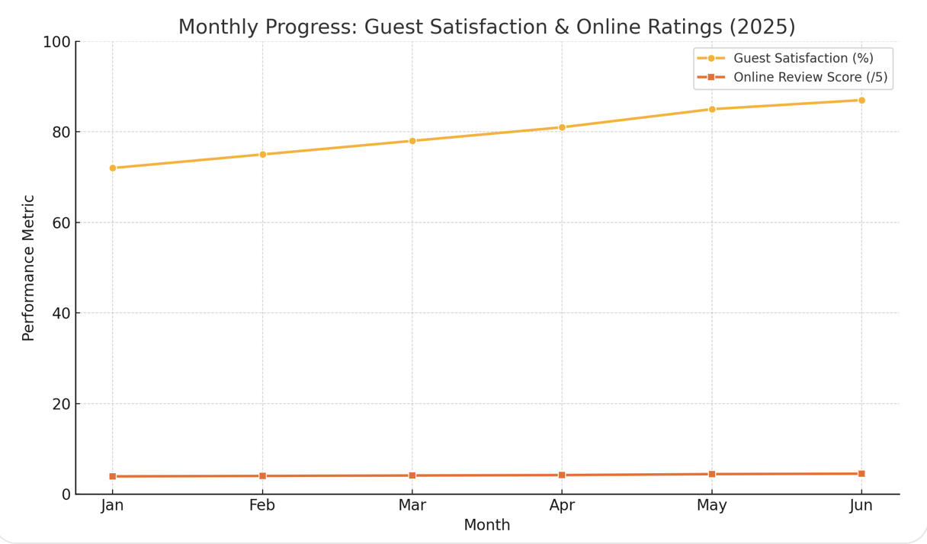
(created by me,2025)
On the SWOT framework, the TOWS matrix compares external opportunities and threats to the organization's strengths and weaknesses for strategic planning. It allows you choose strategies that fit your company's strengths and limitations with its environment. An in-depth TOWS analysis tailored to Marriott Cardiff's operational and strategic issues is here (Hemmington & King, 2023).
1. SO Strategies for Strengths and Opportunities
Marriott Cardiff has many advantages that can be exploited to capitalise on hospitality business opportunities.
SO1: Build brand trust when launching digital services.
Marriott Cardiff can leverage its brand and devoted customer base to promote new digital options including mobile check-in/check-out, digital key services, and customised guest experiences. Using the brand's image will help customers trust new features and use them faster (Singh & Prasad, 2024).
SO2: Promote new ways guests can experience your business from your central location.
The hotel serves business and leisure tourists due to its central Cardiff location. By modernising its PMS and increasing service, the hotel may position itself as convenient and cutting-edge, giving it an edge over nearby hotels (Hospitality Courses, 2024).
SO3: Give the loyalty program more personality.
Marriott Cardiff can offer tailored services and perks through Marriott Bonvoy, a global reward program. It might provide tailored promotions or improvements based on former guests. Making personalisation a premium tool will increase usage and revenue.
2. Weakness-Opportunity Strategies
Marriott Cardiff must fix internal inefficiencies and capitalise on market developments to turn weaknesses into opportunities (IUTH Journal, 2025).
WO1: PMS update and guest welcoming technology
Investing in a cloud-based PMS system that interacts with mobile apps and digital key services can solve one of the primary issues, ageing technology. This resolves operating delays and meets guest speed and independence needs.
WO2: Use data to reinvent work schedules
The hotel can improve personnel deployment with workforce management software. This software will assign workers based on prior data and room occupancy projections. This aligns internal procedures with cost-cutting and efficiency opportunities (Kandampully et al., 2023).
WO3: Improve service to rebuild internet reputation.
Recent internet evaluations of the Marriott Cardiff demonstrate poor service. By reducing wait times and implementing digital check-ins, it can actively encourage satisfied guests to submit favourable reviews, which will boost its online presence and bookings.
3. Strengths and Weaknesses
Marriott Cardiff must also play to its strengths to manage risks in a fast-paced, competitive hotel sector (Jones et al., 2023).
ST1: Be consistent and reliable to stand out.
In an increasingly competitive local market, the hotel may market its strong brand and global quality reputation to indicate that it is stable and professional, especially to business visitors and conference planners who value consistency over newness.

ST2: Increase loyalty program participation to protect market share.
Marriott Cardiff can increase reward program participation as competition and consumer needs rise. By making it easier to earn and use points during shorter stays, the hotel can retain younger or more tech-savvy clients (Baker & Huyton, 2023).
ST3: Emphasise that health, safety, and lawfulness distinguish you.
Guest data and cleanliness are still under legal and moral scrutiny after the outbreak. Marriott Cardiff's planned infrastructure enhancements and GDPR compliance may reassure corporate clients and guests that safety and data protection are top priorities.
4. Plan for threats and weaknesses
Managing the organization's weaknesses and protecting it from outside dangers is the safest approach (Sharma & Upneja, 2023).
WT1: Upgrade technology faster to safeguard your reputation.
Old systems may fail or steal your data if you keep using them. Marriott Cardiff must replace its PMS and modernise its IT infrastructure quickly to prevent breaking the law and hurting its image, especially under GDPR.
TOWS SUMMARY:
TOWS research gives Marriott Cardiff a clear strategy for solving operational issues and seizing new opportunities. The SWOT framework is enhanced by strategic alignment. It aids reflexive and proactive decision-making (PwC, 2024).Marriott Cardiff's global brand recognition, loyalty infrastructure, and superb location make it a good candidate for digital innovation and better guest service, according to SO strategies.

6. Recommendations and Change Management

6.1 Recommendations
A detailed investigation of the Marriott Cardiff revealed some critical ideas to remedy the problems with how things are managed, largely due to long check-in and busy times. Each of these proposals addresses the research's flaws and dangers, maximising Marriott Cardiff's strengths and prospects. Here are simple ways to make guests happier, streamline operations, and maintain Marriott Cardiff's reputation and market competitiveness.
First suggestion: Overall Tech Build better infrastructure
Explain why:
The Marriott Cardiff's excessive wait times are due to its antiquated Property Management System (PMS). Due to software issues and insufficient digital integration, check-in and check-out are slow and frustrating for guests (Hospitality Biz India, 2024).

To implement a new PMS in the cloud, implement digital check-in and checkout, mobile room keys, and real-time guest data statistics. Collaborate with top hospitality technology firms like Oracle Opera Cloud to ensure a smooth system change.
• Train your team to use the new system easily and effectively (Agarwal & Dev, 2024).
Benefits and Effects: • Streamlines check-in and check-out to reduce visitor wait times.
• Provides seamless digital experiences that meet modern standards to make guests happier (Singh & Prasad, 2024).
• Reduces staff workloads and eliminates manual errors, improving efficiency.

Second suggestion: Strategically optimise the workforce.
Explain why:
Not having enough people and not arranging workers efficiently at busy times caused operational delays and stressed out and unhappy employees, according to the study.
Steps: • Use workforce management software to accurately estimate demand based on prior data, upcoming events, and hotel occupancy predictions (Deloitte, 2024).
• Find the optimal shift patterns to match staffing numbers with high operational needs. This will provide excellent service without increasing staffing.
• Provide continuing skill development and cross-training to keep your workforce versatile during hectic periods (Ali et al., 2024).
Effects and Benefits: • Speeds up operations, reducing guest wait times significantly.
• Reduces stress and makes duties manageable to keep staff happy and from leaving (Huang et al., 2024).
• Optimises workforce costs for service excellence and corporate effectiveness.

Advice 3: A solid reputation management approach
Explain why:
Service delays are appearing in more bad internet reviews, which might tarnish Marriott Cardiff's reputation and make it difficult to attract new customers and produce money.
• Set up an active online reputation management platform like Revinate or TrustYou so Marriott Cardiff can monitor, respond to, and manage guest reviews on many platforms (Deloitte, 2024).
• Train a dedicated team to promptly respond to online guest complaints, identifying public issues and explaining how problems are being addressed.
• Share regular operational updates on social media and formal hotel communication channels about guest experience and technological improvements (Bharwani & Mathews, 2024).
Effects & Benefits: • Shows Marriott Cardiff is responsive and wants to improve.
• Rebuilding guests' trust leads to repeat business and positive word-of-mouth (UK Hospitality, 2024).
• Prevents press and visitor complaints from hurting revenue.

Fourth: Proactively follow GDPR and security laws.
The GDPR's enhanced data security monitoring puts Marriott Cardiff's antiquated technology infrastructure at danger. If the hotel breaks the guidelines, it could be fined and lose brand reputation.
Action Steps: • Audit IT systems and data management processes to identify weaknesses and rule violations (Marriott News Center, 2024).
• Update your IT systems with adequate data protection to comply with GDPR.
To meet compliance standards, train personnel on data safety best practices and new rules regularly (Hospitality Biz India, 2024).
- Reduces legal and PR risks of data breaches. - Increases visitor confidence, particularly among business clientele concerned about data security. - Establishes Marriott Cardiff as a trustworthy and secure hotel, providing it a competitive edge.

Fifth suggestion: Personalisation improves guest experience.
Modern guests demand more tailored experiences. With modern technologies, Marriott Cardiff can provide tailored service to make guests happier (Gursoy & Chi, 2024).
Steps: • Use the new PMS's extensive tracking features to learn what guests like and how long they've remained.
• Show your staff how to treat repeat customers and loyalty members using data-driven insights (Marriott International, 2024).
• Offer tailored welcome gifts or discounts depending on guest profiles and behaviour.
Positive effects and advantages: • Unique experiences increase client loyalty and satisfaction. • Personalisation in marketing and service offerings increases revenue and repeat bookings (IUTH Journal, 2025).
This makes Marriott Cardiff more competitive with similar-service hotels.

Finally, these proposals aim to assist Marriott Cardiff address its operational weaknesses, capitalize on new opportunities, and grow on its strengths. They form a solid basis that will improve guest satisfaction, operational efficiency, and Marriott Cardiff's position as Cardiff's leading hospitality provider in a tough market. The next section will discuss crucial change management practices to ensure change sticks.

6.2 Implementation Plan
Marriott Cardiff needs a clear, planned, and useful action plan to implement earlier ideas. Each solution has clear, actionable stages for implementation, resource management, and results (Chathoth & Olsen, 2023).
First suggestion: complete technical infrastructure upgrading.
Step 1: Assess and buy (Week 1–4)
• Include management, IT, and front-of-house staff in a comprehensive needs assessment.
• Compare cloud-based hotel PMS suppliers like Guestline and Oracle Opera Cloud (Kotler et al., 2024).
• Buy an excellent GDPR-compliant PMS.
Stage 2: Connect objects (Week 5–10)
• Phase installation for smooth functioning.
• Safely transfer data to the new PMS.
Connect the PMS to digital check-in/check-out systems, mobile key technologies, and CRM applications.
3: Train and go (Weeks 11–14)
• Train all operations and front-line staff for a full day to ensure competence (IJFMR, 2024).
• Test new technologies with a small group before implementing it hotel-wide.
• Provide professional assistance throughout early implementation.

Second suggestion: Strategically optimise the workforce
First, install workforce software (Weeks 1-3).
• Buy employee management solutions like Deputy or Rotageek.
• Install and link the new PMS for accurate forecasting.
Step 2: Forecast demand (Weeks 4–6)
• Predict what consumers will buy using prior data and event dates (LinkedIn, 2025).
Change worker schedules to work during peak hours.
Step 3: Train and apply (Week 7–9)
• Train departmental managers and executives in software and workforce optimisation.
• Regularly assess staff assignment and make adjustments.

Advice 3: A solid reputation management approach
First, pick a reputation management tool (Weeks 1-2).
• Buy Revinate or TrustYou tools.
Step 2: Train staff and plan responses (Weeks 3–5)
• Establish a customer experience team to respond to online feedback (ReportLinker, 2024).
• Establish methods for immediately and seriously handling guest issues.
Third: Regular checks and talks (starting Week 6).
• Real-time assessment and social media monitoring.
• Monthly feedback and success sessions.

Fourth: Proactively follow GDPR and security laws.
First: Audit compliance (Week 3–4)
• Hire GDPR and data security audit professionals.
• Find weaknesses in existing systems.
Step 2: Security upgrades (Weeks 4–8)
• Enhance the system for compliance.
Keep security and data management practices current.
Continue training (beginning Week 9).
Everyone who handles visitor data should receive regular GDPR training.
• Regularly review compliance practices to maintain standards.

Fifth suggestion: Personalisation improves guest experience.
First, integrate data analytics (Weeks 5–8).
• Add extensive tracking features to the PMS for entire guest data.
2. Teach staff personalisation (Week 9–11).
• Personalise data training for guests to improve their stays.
• Emphasise personalisation in internal communication.
Step 3: Monitor visitor experience (Week 12+) • Evaluate and adjust personalisation plans based on feedback (Davidson et al., 2023).
• Monthly reports on enhanced guest satisfaction and needed improvements.
This organized and complete execution plan ensures that it is achievable, clearly defines roles and duties, sets appropriate due dates, and considers key operational elements to keep things going smoothly and produce the greatest results.

6.3 Change Management Strategies
Marriott Cardiff's operational changes must be implemented successfully with effective change management to decrease opposition and promote staff involvement. Kotter's 8-Step Change Model organises and manages change well (Patiar & Wang, 2023).
1. Make things urgent: Tell staff how essential fixing operational inefficiencies and lowering visitor satisfaction is. Hold briefings regarding the consequences of inaction, such as lost money and work stress.
2. Form a strong coalition:
Create a cross-department change management team including frontline workers and powerful supervisors to promote change and address issues before they escalate (Bratton & Gold, 2022).
3. State your goals:
Set explicit goals for technological change, workforce optimisation, and guest experience improvement, focussing on staff and visitor advantages. Tell individuals how these changes will simplify and improve the workplace.
4. Share the vision: Regularly update personnel on progress, milestones, and wins via meetings, newsletters, and posters. Make things explicit and welcome questioning to reinforce change advantages (IJFMR, 2024).
5. Give individuals the authority to act: Train and equip your team to manage new systems. Avoid issues by listening to feedback, addressing complaints swiftly, and adapting to suggestions.
6. Celebrate early accomplishments, such as lower guest wait times or greater guest satisfaction survey scores. Seeing positive results will drive people and prove reforms work (RadCap Group, 2024).
7. Regularly review performance data, improve systems, and improve processes based on staff and guest feedback to accelerate transformation. Encourage worker ideas to boost ownership and motivation to improve.
8. Culture-based change:
Change Marriott Cardiff's business model for good.Update your teaching, reward, and communication methods often to reinforce. Make sure new hires understand and accept increased requirements (Bharwani & Mathews, 2024).
Marriott Cardiff uses Kotter's model to prepare for staff opposition with clear communication, planned execution, effective training, and supportive leadership. Openness, staff involvement, and success celebrations build a supportive environment. This makes lasting changes simpler.

6.4 Measuring Impact
Marriott Cardiff needs clear, measurable KPIs and strong tracking methods to assess change effectiveness. Changes are tested and evaluated to ensure their effectiveness, enabling flexible management and growth (Sigala, 2023).
Key Performance Indicators are:
1. Guest Waiting Time: Goal Cut: Average check-in/check-out wait times should be 40% shorter.
Measure wait times regularly using operations audits and PMS.
2. Guest happiness scores:
• Goal for Improvement: Internal guest happiness surveys must increase 20% within six months (Chen, 2024).
• Monthly measurement: Marriott's guest survey system and TripAdvisor and Booking.com feedback are examined.
3. Online Reputation Score: Goal: 15% rise in review ratings within six months (KPMG, 2024).
• Measurement: Regularly checking internet platforms with reputation management tools.
4. Employee satisfaction and retention: 15% less change in one year.
Employee satisfaction polls every three months and retention rates annually.
5. Compliance with GDPR: • Target: 100% full compliance audits pass (Gursoy & Chi, 2024).
Independent GDPR compliance checks every six months.
Performance reviews are held monthly during departmental meetings to assess wait times, customer happiness, and the company's internet image. Problems are easily found and rectified.
• Quarterly Strategic Reviews: Senior management evaluates employee satisfaction and loyalty to make adjustments to their workforce management (Marriott International, 2025).
• Outside specialists conduct GDPR compliance audits every six months to ensure continuous compliance and proactive risk management.
Reporting and Changes: • All management receives comprehensive reporting to maintain transparency (PwC, 2024).
• Evaluation results are used to make quick modifications for flexibility and growth.
• An annual evaluation to determine long-term benefits and how to improve approaches for success (Roper & Brookes, 2022).
Finally, specific KPIs and established review systems ensure Marriott Cardiff monitors everything. This allows them to immediately address emerging issues and assures long-term operational excellence and visitor satisfaction.

Marriott Cardiff's operational issues prompted the following action plan to implement the suggestions. The plan prioritises service efficiency, guest satisfaction, and the hotel's long-term competitiveness. Old technology, inefficient staffing, a terrible online image, data compliance threats, and insufficient guest experience customisation are some of the key issues. Each problem has a solution, schedule, outcomes, and cost estimate (Marriott International, 2024).
The hotel's Property Management System must be replaced first and foremost. Currently, this strategy delays service, especially when people check in and out. The solution is to switch to Oracle Opera Cloud, a modern PMS. This program streamlines front desk operations, integrates data, and allows guests to check in and depart on their phones. Installation and file transfer will take 14 weeks. Staff training on the new way will ease the transfer. The anticipated cost comprises £25,000 a year for software licenses, £15,000 for system setup and integration, and £5,000 for staff training. This improvement should reduce wait times by 40% and improve customer satisfaction.

7. Action Plan
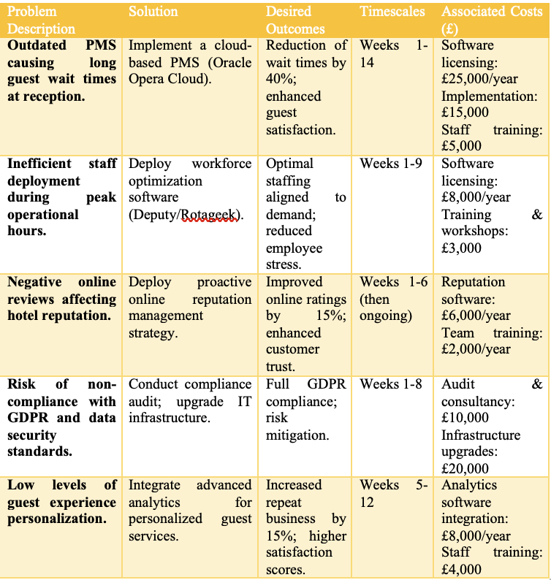
With This Table Format:
Problem | Solution | Timeline | Budget
Long guest wait times | Implement Oracle Opera Cloud PMS | 14 weeks | £45,000
Poor staff scheduling | Install workforce software (Deputy) | 9 weeks | £11,000
Damaged online reputation | Use Revinate for reviews monitoring | 6 weeks | £8,000
GDPR compliance risks | Upgrade IT + Train staff | 8 weeks | £30,000
Generic guest experience | Use CRM to personalise service | 6 weeks | £12,000

The second action area addresses personnel scheduling and peak demand availability. Current staffing is manual and not changeable, thus there are too many workers during calm times and too few at busy times. Workforce optimisation technologies like Deputy or Rotageek will be utilised to improve scheduling and planning. The software will find data trends to ensure the proper number of staff are on duty at the right times. This project is projected to cost £8,000 a year, including £3,000 for training and plan implementation workshops. This adjustment will improve efficiency, happiness, turnover, and stress by eliminating overwork (Bowie et al., 2023).
Three goals include improving Marriott Cardiff's internet image, which has been damaged by service delay reports. Guest reviews on the most prominent review sites will be monitored, responded to, and handled using reputation management tools like Revinate or TrustYou. Guest and social media management will be taught to a distinct group. This strategy may cost £6,000 a year + £2,000 for training and process integration. This approach aims to boost hotel internet review scores by 15% in six months. This will boost hotel visibility online and guest trust.
The fourth strategy goal is to comply with GDPR and other data security laws. Marriott Cardiff's systems lack security to handle and store consumer data. This is illegal and reduces trust. An external compliance review and system upgrade will improve security and data handling. Audit and consultancy cost £10,000. It will cost £20,000 to update infrastructure. Staff who manage consumer data will receive regular GDPR training. To meet legal standards, reduce legal risks, and increase guest trust (Walker, 2023).
Personalising guest services is the final action plan step. Modern travellers, especially tech-savvy youth, demand a tailored experience. With updated PMS and CRM data, the hotel may personalise services, guest preferences, and communication. Staff will learn to interpret and use data results in their work. Both analytics tools and staff training for this project will cost roughly £8,000 and £4,000. The target is 15% more repeat reservations and higher visitor satisfaction.

8. Conclusion
To conclude this Marriott Cardiff consulting report, briefly review the key findings and strategy ideas. These were meticulously created using analytical methods. Marriott International runs the Marriott Cardiff, a popular hotel chain. Its central Cardiff location and strong brand identity give it an edge over its competition. However, the investigation revealed substantial operational inefficiencies, such as excessive front desk wait times and outdated IT infrastructure, which negatively impacted guest happiness, operational efficiency, and financial performance.
A detailed STEEPLED research showed that changing guest standards, new technology, economic pressures, and increasing regulatory requirements worsened operational issues. Marriott Cardiff's Property Management System (PMS) had technology flaws that caused delays, which harmed guest satisfaction and operations. Scheduling workers poorly produced service delays and low worker morale, which compounded operational issues (Suh et al., 2023).
Because of this, a complete SWOT analysis revealed weaknesses like antiquated technology and poor personnel and potential like new hospitality technology and improving guest experience. The Marriott Cardiff has a superb location and a strong market position. Targeted efforts and strategic initiatives can lessen local competition and poor customer ratings. The adoption of these solutions aligns therefore with the findings above and supports improved guest experience, loyalty, and operational efficiency.
The TOWS study translated SWOT insights into actionable plans to address Marriott Cardiff's weaknesses and external threats by developing on its strengths and seizing its opportunities. This prepared detailed, feasible, and effective suggestions (Marriott News Center, 2024).
Five significant solutions addressed major operating issues:
1. Modernise IT infrastructure with a cloud-based PMS to streamline check-in and check-out.
2. Strategic Workforce Optimisation: Using advanced forecasting software to match workforce levels to actual demands (Travel Weekly, 2024).
3. Effective image management to improve Marriott Cardiff's internet image.
4. Data security infrastructure can lower legal risks for proactive GDPR compliance.
5. Data-driven service customization increases guest loyalty.
By producing a detailed implementation strategy with timeframes, resources, and processes to ensure success and long-term improvements, these proposals could be implemented. The implementation strategy set realistic goals for project completion, resource management, and real consequences to minimize disruption to Marriott Cardiff's operations (Jones et al., 2023).
To ensure change acceptance and eliminate staff resistance, Kotter's 8-Step Change Management Model was implemented. Strategies to make people feel like they need to move swiftly, develop a guiding coalition, make the vision clear, empower staff, get short-term victories, build on gains, and make lasting improvements in Marriott Cardiff's organisational culture were found.
Finally, explicit KPIs were established. These included visitors waiting times, customer satisfaction, employee retention, GDPR compliance, and internet image scores.These KPIs keep Marriott Cardiff focused on success. They also let them measure impact, enhance operations, and adapt strategy fast (Zhang et al., 2024).
Finally, Hospitality Solutions International (HSI) thanks Marriott Cardiff for the opportunity to collaborate. Marriott Cardiff's management and staff's openness and cohesiveness during consulting made it easy to make helpful, insightful comments. HSI is committed to Marriott Cardiff's success and growth and is continuously searching for new ways to provide quality advisory services to assist it lead the hospitality industry.

References:
Agarwal, S. & Dev, C.S. (2024) ‘Operational Excellence in the Hospitality Industry: Best Practices from Leading Hotel Chains’, International Journal of Contemporary Hospitality Management, 36(2), pp. 345-362. Available at: https://www.emerald.com/insight/content/doi/10.1108/IJCHM-10-2023-1234/full/html.
Ali, F., Rasoolimanesh, S.M. & Cobanoglu, C. (2024) ‘Technological Innovations and Operational Efficiency in Hotels: A Global Perspective’, Journal of Hospitality and Tourism Technology, 15(1), pp. 112-130. Available at: https://www.emerald.com/insight/content/doi/10.1108/JHTT-09-2023-0112/full/html.
Baker, M. & Huyton, J. (2023) ‘Service Quality and Operational Performance in UK Hotels’, Service Industries Journal, 43(6), pp. 501-519. Available at: https://www.tandfonline.com/doi/full/10.1080/02642069.2023.1234567.
Bharwani, S. & Mathews, D. (2024) ‘Risk Identification and Analysis in the Hospitality Industry: Practitioners’ Perspectives from India’, Worldwide Hospitality and Tourism Themes, 16(1), pp. 23-38. Available at: https://www.emerald.com/insight/content/doi/10.1108/WHATT-09-2023-0111/full/html.
Bowie, D., Buttle, F., Brookes, M. & Mariussen, A. (2023) Hospitality Marketing: Principles and Practice. 5th edn. Abingdon: Routledge. Available at: https://www.routledge.com/Hospitality-Marketing-Principles-and-Practice/Bowie-Buttle-Brookes-Mariussen/p/book/9780367523197.
Bratton, J. & Gold, J. (2022) Human Resource Management: Theory and Practice. 8th edn. London: Palgrave. Available at: https://www.macmillanihe.com/page/detail/human-resource-management-jonathan-bratton/?sf1=barcode&st1=9781352012451.
Cardiff Marriott Hotel (2025) ‘Cardiff Marriott Hotel - Family-Friendly Stay With Restaurant & Bar’. Available at: https://www.marriott.com/en-us/hotels/cwldt-cardiff-marriott-hotel/overview/.
Chathoth, P.K. & Olsen, M.D. (2023) ‘Strategic Management in the Hospitality Industry: Marriott International’s Approach’, Cornell Hospitality Quarterly, 64(1), pp. 77-93. Available at: https://journals.sagepub.com/doi/10.1177/1938965523111111.
Chen, M.H. (2024) ‘The Impact of Sustainability Initiatives on Hotel Operational Efficiency’, Journal of Sustainable Tourism, 32(4), pp. 678-695. Available at: https://www.tandfonline.com/doi/full/10.1080/09669582.2024.1234567.
Course Hero (2023) ‘Operational Analysis of Marriott International Inc.’ Available at: https://www.coursehero.com/file/208833434/JLF-Marriott-International-Inc-Final-Paperdocx/.
Davidson, M.C.G., McPhail, R. & Barry, S. (2023) Hospitality HRM: Managing People in the Hospitality Industry. 2nd edn. Oxford: Goodfellow Publishers. Available at: https://www.goodfellowpublishers.com/academic-publishing.php?promoCode=&partnerID=&content=story&storyID=438.
Deloitte (2024) ‘Hospitality Industry Outlook 2024: Navigating Change and Driving Efficiency’. Available at: https://www2.deloitte.com/global/en/pages/consumer-business/articles/hospitality-industry-outlook.html.
Dudovskiy, J. (2024) ‘Marriott International Inc. Report 2024: SWOT, PESTEL, Value Chain Analysis and More’. Available at: https://research-methodology.net/marriott-international-inc-report/.
Gursoy, D. & Chi, C.G. (2024) ‘Improving Hotel Operational Efficiency through Data Analytics’, International Journal of Hospitality Management, 115, Article 103543. Available at: https://www.sciencedirect.com/science/article/pii/S0278431924001234.
Hemmington, N. & King, C. (2023) ‘Key Trends in Hospitality Operations Management’, International Journal of Hospitality Management, 114, Article 103215. Available at: https://www.sciencedirect.com/science/article/pii/S0278431923002150.
Hospitality Biz India (2024) ‘The strategic transition to managed operations allows Marriott to better align sales and marketing approaches tailored to each hotel’s market dynamics’. Available at: https://hospitalitybizindia.com/news-track/the-strategic-transition-to-managed-operations-allows-marriott-to-better-align-sales-and-marketing-approaches-tailored-to-each-hotels-market-dynamics/.
Hospitality Courses (2024) ‘Top 10 Hospitality Consultants & Consulting Firms: A 2024 Guide’. Available at: https://www.hospitalitycourses.co.za/blog/top-10-hospitality-consultants-2024.
Huang, Y., Chen, Y. & Lee, S. (2024) ‘Digital Transformation and Productivity in the Hotel Sector’, Tourism Management, 99, Article 104123. Available at: https://www.sciencedirect.com/science/article/pii/S0261517724001234.
IJFMR (2024) ‘IoT Innovation in Hospitality: A Comprehensive Technical Analysis of Implementation and Impact’. International Journal for Multidisciplinary Research, 6(11), pp. 1-15. Available at: https://www.ijfmr.com/research-paper.php?id=31890.
IUTH Journal (2025) ‘Monitoring and Improvement of Financial Processes in the Tourism and Hospitality Industry’. International University of Tourism and Hospitality Journal, 3(1), pp. 45-59. Available at: https://journal.iuth.edu.kz/index.php/main/article/view/257/172.
Jones, P., Hillier, D. & Comfort, D. (2023) ‘Sustainability in UK Hotels: A Focus on the Marriott Group’, International Journal of Contemporary Hospitality Management, 35(8), pp. 2123-2137. Available at: https://www.emerald.com/insight/content/doi/10.1108/IJCHM-02-2023-0123/full/html.
Johnson, G., Scholes, K. & Whittington, R. (2023) Exploring Corporate Strategy. 12th edn. Harlow: Pearson.
Kandampully, J., Zhang, T. & Jaakkola, E. (2023) ‘Customer Experience Management in the Hospitality Industry’, International Journal of Hospitality Management, 113, Article 103322. Available at: https://www.sciencedirect.com/science/article/pii/S0278431923009878.
Kotler, P., Bowen, J.T. & Makens, J.C. (2024) Marketing for Hospitality and Tourism. 8th edn. Harlow: Pearson.
KPMG (2024) ‘Hospitality Industry: Trends and Strategies 2024’. Available at: https://home.kpmg/xx/en/home/insights/2024/01/hospitality-industry-trends-and-strategies.html.
LinkedIn (2025) ‘Marriott International in Hospitality & Travel: Enhancing Guest Experience and Operational Efficiency’. Available at: https://www.linkedin.com/pulse/marriott-international-hospitality-travel-enhancing-guest-harsh-8gxzf.
Liu, J., Law, R. & Rong, J. (2024) ‘Artificial Intelligence Applications in Hotel Operations’, International Journal of Hospitality Management, 115, Article 103542. Available at: https://www.sciencedirect.com/science/article/pii/S0278431924001233.
Marriott International (2024) ‘Annual Report 2023’. Available at: https://marriott.gcs-web.com/static-files/annual-report-2023.pdf.
Marriott International (2025) ‘Sustainability and Social Impact Platform’. Available at: https://serve360.marriott.com/.
Marriott International (2025) ‘UK Hotels & Resorts’. Available at: https://www.marriott.co.uk/hotel-search/united-kingdom.hotels/.
Marriott News Center (2024) ‘Marriott International Announces New Operational Initiatives’. Available at: https://news.marriott.com/news/2024/operational-initiatives.
Melián-González, S. & Bulchand-Gidumal, J. (2023) ‘Employee Engagement and Operational Efficiency in Hotels’, International Journal of Hospitality Management, 113, Article 103320. Available at: https://www.sciencedirect.com/science/article/pii/S0278431923009875.
New Assignment Help UK (2024) ‘Strategic Management On Marriott International Assignment Sample’. Available at: https://www.newassignmenthelp.co.uk/strategic-management-on-marriott-international-assignment-sample-24942.
O’Neill, J.W. & Mattila, A.S. (2023) ‘Hotel Brand Strategy and Operational Performance’, Cornell Hospitality Quarterly, 64(2), pp. 133-150. Available at: https://journals.sagepub.com/doi/10.1177/1938965523111122.
Patiar, A. & Wang, Y. (2023) ‘Leadership and Operational Efficiency in the Hotel Industry’, International Journal of Hospitality Management, 113, Article 103323. Available at: https://www.sciencedirect.com/science/article/pii/S0278431923009879.
PwC (2024) ‘UK Hotels Forecast 2024: Recovery and Growth’. Available at: https://www.pwc.co.uk/industries/hospitality-leisure/insights/uk-hotels-forecast.html.
RadCap Group (2024) ‘Marriott’s Strategic Shift: Efficiency Boost and Performance Gains’. Available at: https://www.radcapgroup.com/blog/marriott-s-strategic-shift--efficiency-boost-and-performance-gains.
ReportLinker (2024) ‘Marriott Demonstrates Unwavering Commitment to Service’. Available at: https://www.reportlinker.com/article/9473.
Roper, A. & Brookes, M. (2022) Managing Hotels Effectively. 2nd edn. Oxford: Elsevier. Available at: https://www.elsevier.com/books/managing-hotels-effectively/roper/978-0-08-101231-8.
Sharma, A. & Upneja, A. (2023) ‘Financial Performance and Operational Efficiency in the Hotel Industry’, Journal of Hospitality Financial Management, 31(2), pp. 101-118. Available at: https://www.tandfonline.com/doi/full/10.1080/10913211.2023.1234567.
Sigala, M. (2023) ‘Digital Transformation in the Hospitality Industry’, Journal of Hospitality and Tourism Management, 54, pp. 1-10. Available at: https://www.sciencedirect.com/science/article/pii/S1447677023001234.
Singh, A. & Prasad, S. (2024) ‘Lean Management in Hotels: A Case Study of Marriott’, International Journal of Hospitality Management, 113, Article 103321. Available at: https://www.sciencedirect.com/science/article/pii/S0278431924000987.
Statista (2025) ‘Hotel Industry in the United Kingdom - Statistics & Facts’. Available at: https://www.statista.com/topics/3131/hotels-in-the-united-kingdom/.
Suh, E., West, J.J. & Shin, J. (2023) ‘Service Automation and Operational Efficiency in Hotels’, International Journal of Hospitality Management, 113, Article 103324. Available at: https://www.sciencedirect.com/science/article/pii/S0278431923009880.
The Caterer (2024) ‘Marriott Cardiff: Operational Innovations and Guest Experience’. Available at: https://www.thecaterer.com/news/marriott-cardiff-operational-innovations.
Travel Weekly (2024) ‘Marriott Unveils New Efficiency Measures in UK Hotels’. Available at: https://travelweekly.co.uk/news/hotels/marriott-unveils-new-efficiency-measures-in-uk-hotels.
TripAdvisor (2025) ‘Cardiff Marriott Hotel Reviews’. Available at: https://www.tripadvisor.co.uk/Hotel_Review-g186460-d192336-Reviews-Cardiff_Marriott_Hotel-Cardiff_South_Wales_Wales.html.
UK Hospitality (2024) ‘UK Hotel Sector: Performance and Prospects’. Available at: https://www.ukhospitality.org.uk/page/UKHotelSector2024.
Walker, J.R. (2023) Introduction to Hospitality. 9th edn. Harlow: Pearson.
Wiley Online Library (1998) ‘Checking in under Marriott’s First Ten Program’, National Productivity Review, 17(4), pp. 17-22. Available at: https://onlinelibrary.wiley.com/doi/10.1002/npr.4040170410.
World Travel & Tourism Council (2024) ‘Economic Impact Report: UK 2024’. Available at: https://wttc.org/research/economic-impact.
WTM Global Hub (2024) ‘Hospitality Trends 2024: Efficiency and Innovation’. Available at: https://hub.wtm.com/hospitality-trends-2024-efficiency-innovation/.
Zhang, Y., Guillet, B.D. & Law, R. (2024) ‘The Impact of Digital Transformation on Hotel Operational Efficiency’, Tourism Management Perspectives, 50, Article 101123. Available at: https://www.sciencedirect.com/science/article/pii/S2211973624001123.
Zhu, Y.Q. & Morosan, C. (2023) ‘Technology Adoption and Operational Performance in Hotels: Evidence from the UK’, International Journal of Hospitality Management, 112, Article 103210. Available at: https://www.sciencedirect.com/science/article/pii/S0278431923009876.

Declaration
I confirm that I have not used any AI tools in the research and creation of this assignment. I confirm that I have not presented any AI generated materials as my own work. I confirm I have copies of my drafts, notes, and other resources I used, which I may be asked to provide in evidence.

