DS 1 Template

My Screenshots/Photos
- Please add 4–6 screenshots or photos of your digital life.
- You can use your phone or laptop.
- For each screenshot, write one or two sentences explaining what it shows.

Screenshot/Photo 1
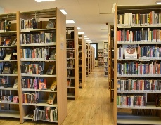
I use the library to study, read books, and do my homework in a quiet place. The library helps me find information and focus on learning.

Screenshot/Photo 2

I use books to learning new things, improve my knowledge, and practice reading. Books also help me relax and enjoy interesting stories.

Screenshot/Photo 3

I use my laptop and phone to study, search for information, and communicate with other people. They also help me with schoolwork and everyday tasks.

Screenshot/Photo 4
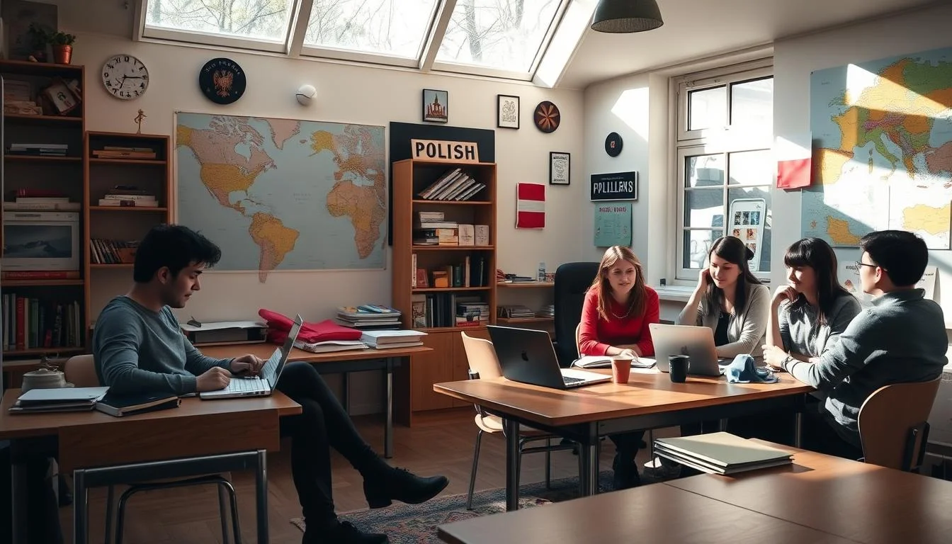
I work in a group to share ideas, help others, and complete tasks together. Group work helps me improve my communication and teamwork skills.

Screenshot/Photo 5

I use my laptop to think, plan, and solve different problems. It helps me organize my ideas and focus on my work.

Screenshot/Photo 6

I use books to gain knowledge and learn new information. Reading books also helps me improve my vocabulary and understanding.

My Short Reflection
- Write 5–8 simple sentences about your digital life.
- You can use the sentence starters below if helpful.
This project helped me realize how different things support my learning every day. The library gives me a quit place to study and focus, while books help me improve my knowledge and English skills. I also use my laptop and phone to search for information, do assignments, and stay organized.
Working in a group taught me how important teamwork and sharing ideas can be. This project made me think more about my learning habits and the tools I use in everyday life.

Sentence starters
- I use digital tools to … study, communicate, and find information.
- I feel confident when I …use technology for learning and solving problems.
- I want to improve …my digital and communication skills.
- I often use these tools: …laptop, phone, tablet, and online resources.
- I sometimes feel nervous about …about technical problems and online safety.
- I hope this module will help me … improve my digital knowledge and skills.
- Digital skills are important for me because …they help me learn and prepare for the future
You can write more if you want.

Submission Checklist
Before you submit, please check:
​​​ ☐ I added 4–6 screenshots
☐ I wrote short sentences for each screenshot
☐ I wrote my short reflection
☐ My work is my own
☐ My file opens correctly
​​☐ My file opens correctly

