Marketing Essentials of Marriott

Name: Andrei Florian Popa
Student ID number: 2127688
The Module Title: Marketing Essentials (BMIH4005 RESIT)
Lecturer’s name: Chris Wilkin

Table of Contents
1.1 Introduction 2
1.2 Marketing Mix 2
1.3 The Marketing Environment SWOT 250 3
1.4 The Marketing Environment PESTEL 4
1.5 Customer Value and Engagement 7
1.6 Effective Use of Digital Marketing 7
1.7 Conclusion 7
2 References 8

Introduction
Marketing is a vital tool in advanced business companies as it includes comprehending the market, understanding customer demands, creating good relations, and delivering quality among the clients. At the same time, hospitality marketing defines how part of the hospitality industry, for instance, hotels and restaurants, use their marketing tools to encourage their services and products (Suh and Chow, 2021). Therefore, the selected Hotel for the report is Marriott Hotel. The report will briefly explain the leading roles of the marketing function within a Marriott Hotel. It will further compare the methods by which the company applies the marketing mix to the marketing planning procedures to obtain business goals.

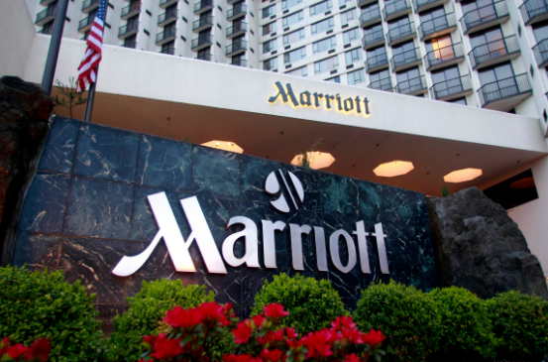

Marketing Mix
Product
Marriott offers a bequest of premium service and is dedicated to offering experiences and atmospheres that ultimately encourage customers to flourish in meaningful connections. The Marriott provides accommodation, fitness center facilities, dining, meeting rooms, spa, and hosts venue for events (Marriott Hotel, 2022). Its target customer will be a luxury tourists from the 21 to 30 age group.

Place
Marriott has developed itself in more than 100 countries worldwide, and they are located near the central market, airport, and highways. For the development of its hotels, Marriott has also accepted a mixed channel strategy comprising both third-party and direct channels. Customers can also use their websites and other accounts on social media for booking and other details (Girgen, 2021).
Price
Marriott will use a premium pricing strategy to offer value-based services to its luxurious tourists. It delivers the best possible service and hence changes premium prices accordingly. After the pandemic, Marriott will deliver competitive advantages in pricing choices, rising effectiveness, and enhancing profits of property-level for hotels (Marriott a. 2022). Such as, the price of a hotel room will be 258.66 pounds after the pandemic. For regular customers, Marriott will provide discounts on some services, such as free spa service or fitness training.
Promotion
The promotion strategy is attentive to digital promotions. However, this indicates the emphasis on advertising their hotels through social media and websites. Such as, they will make a promo code to provide their guests by sharing on their website's "promotion" page or other social media platforms, such as Instagram, Facebook, Twitter, and YouTube.

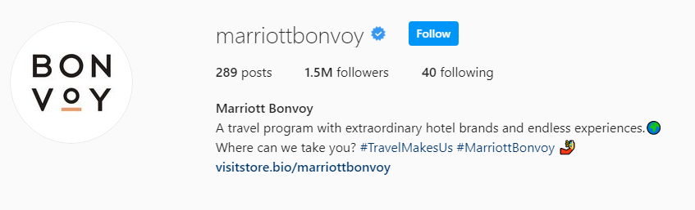
Figure: Instagram Page of Marriott
(Source: Instagram, 2022)

The Marketing Environment SWOT

Strength
Marriott Hotel is situated in 127 countries and areas worldwide. Marriott is a large international hotel chain with over 81 hotels, 30 brands, and $25.1 billion in resources under its inspiring portfolio and 6,500 properties, contributing over 1.2 million rooms worldwide. Moreover, the operational philosophy of Marriott concentrates on innovation, and most of its systems and processes are intended to implement commitment and innovation to assure complete satisfaction (Marriott, 2021).

Weakness
Worldwide development and a high number of Marriott hotels may cause dilution of the brand. However, the rules and regulations of Marriott are so strict that they are suffocating its workers and reducing productivity and job satisfaction. Another weakness of Marriott is that it constantly had challenging relationships with the law, and it caused adverse marketing for the company (Pratiwi and Sudiarta, 2019).
Opportunities
As more Gen-Z and millennials come into the customer market, the firm has the opportunity to create its customer base by aligning as a casual, youthful product. Request for high-end services in emerging countries is rising quickly, presenting profitable opportunities for Marriott. Marriott can distinguish itself from rivals by delivering customized services that meet its clients' precise requirements.

Threats
The recession impacted the hospitality industry adversely. Due to covid-19, Marriott has already lost 92% of its revenue. Thus, effectiveness will endure to suffer if the virus becomes an everlasting certainty. The hospitality industry is exceptionally competitive, and various popular hotels can reduce the market share of Marriott (Hashim et al. 2016).

The Marketing Environment PESTEL
Political
When the Hotel implements and formulates the policies, the political arena significantly influences the business regulation. Government has to inspire foreign and local stakeholders to invest their money to grow and liberate taxes and tourism products. The government also controls the taxation system. The tax strategy has been accepted by the Hotel’s director and implemented in all entities in the UK (George, 2021).
Economic
Financial crises affect the Hotel sector negatively. While local financial prudence significantly and directly take advantage of the hospitality sector when international and domestic tourists spend money in hotels, entertainment spots, restaurants, and transport (Arif and Hossin, 2016).
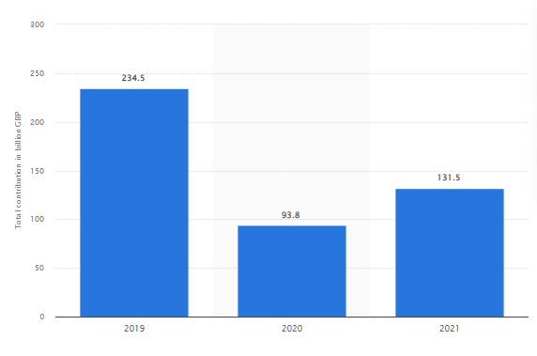
Figure 1: Total contribution of travel and tourism to GDP in the United Kingdom (UK) from 2019 to 2021
(Source: Statista a, 2022)
The graph shows that the overall contribution of tourism and travel to the UK's GDP raised roughly 40% in 2021 in the previous year.
Social
The current generation worldwide has demonstrated a strong trend towards traveling. The social media platform has fueled it further where people are capable of exchanging their experiences and thus generate peer pressure to travel. Numerous hotels also offer discounts, and others propose to ensure that people can afford extended, more comfortable stays (Xiang et al., 2015).
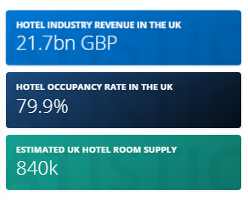
Figure 2: Hotel industry in the United Kingdom
(Source: Statista b. 2022)
The graph highlights that the UK hotel market is one of the contrasts, varying from renowned luxury hotels to leading national budget brands. Further, the higher and luxury sections are most prominent in London, where great economic wealth and traveler traffic give a more significant market for luxurious and superb hotels.

Technology
In recent times, hotels have become more technology-friendly. They are intended to deliver strong security and other features that make their guest more comfortable. Variously, hotels are using information technology to serve their clients best, and technology is helping them for the growth. Security and data management are authentic tech issues for the industry (Chithradevi and Nadda, 2022). The below graph shows the reason for using technologies in the hotels. The main reason is to enhance the customer experience.

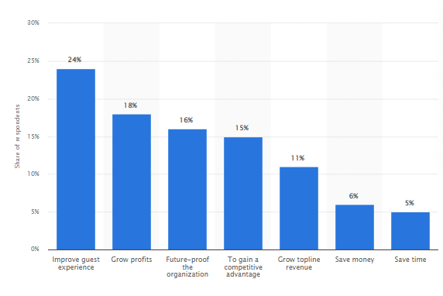
Figure 3: Main reasons for hoteliers to use technology worldwide
(Source: Statista c. 2022)
Environment
It is noted that the environment has a significant influence on hotels. Hotels put augmented pressure on the atmosphere as they have enormous fuel, water, lightning, and other needs. The industry uses a considerable number of disposable items, which can be the cause of critical concerns for the environment.
Legal
The UK has strict laws for food safety in the world. However, hoteliers should comply with the Gas Safety in the UK to defend the welfare of their customers. Hotels in the UK are also becoming firmer in recognition before permitting a customer to use their services. Thus, this is known as advanced, keeping in mind the increase of terrorism and crime worldwide (Shen et al., 2021).

Customer Value and Engagement
The score of customer service is relied on the two metrics of YouGov brands: Satisfaction and Recommend. Thus, Marriott pastors a personalized and seamless experience. Marriott provides these involvements all over its website, in person, in-app, or through a mixture of touchpoints. Further, for Marriott to endure carrying premium hotel experiences, it required better comprehending how consumers were involved. This indicates altering the method data was measured and understood. Hence, carrying in the correct expertise to make it occur. The company targets its offerings at consumers of changing economic backgrounds through hotel brands that provide different service levels and price points. Marriott offers numerous benefits to their customers, such as free Wi-Fi, hotel discounts, vision insurance, long-term disability insurance, and financial benefits. Moreover, the company will engage visitors by using reliable messaging to enhance guests' engagement, collaborate and create relationships with guests, and use social media to attract visitors (Adobe, 2022).

Effective Use of Digital Marketing
Digital marketing of hotels means maintaining and creating the hotel's presence online. This involves social media platforms such as Instagram, Facebook, Twitter, and YouTube. However, social media has delivered Marriott with the advanced strategy of promoting the services and products it provides to its customers (Brioso and Borbon, 2022).
Moreover, they will use a promo code to attract new customers after the pandemic. This will enhance foot traffic and booking orders, which can cause more significant profit and sales. It also creates client loyalty, increases brand awareness, and delivers a rapid infusion of cash for Hotel. This method is helpful because it benefits both businesses and customers. As the business produces the best revenue and customers obtain the product, they need it for a lower price. The company will start this campaign to reach new customers by using single promo code and coupons, personalize that coupon, use gamification techniques, get involve with customers and also influencers. This coupon campaign will spark reliable users’ interest by delivering what all customer need. The best thing about the promotion code is that they operate nicely with fresh and returning clients (Azpeitia, 2021).

Conclusion
The report has demonstrated the essential marketing plan for Marriott. The marketing mix for Marriott hotels has been evaluated and highlights various strategies for price, product, place, and promotion. The SWOT of Marriot has analyzed the strength, weaknesses, opportunities, and threats. However, covid-19 has impacted the hotel industry and decreased the revenue of Marriott. Further, Marriott's first priority is customer satisfaction, and they provide a range of benefits for their employees, such as discounts. Also, Marriott uses various digital promoting strategies to attract new customers, such as promo codes on social media that will create brand awareness.

References
Adobe, 2022. Available at Customer Success Stories: Case Study Of Marriott https://business.adobe.com/customer-success-stories/marriott-case-study.html. Assessed on 22 June 2022
Arif, T.M.H. and Hossin, M.Z., 2016. A comparative analysis of internal and external environments between Hotel Hyatt, UK and Hotel The Cox Today, Cox’s Bazar, Bangladesh. IOSR Journal of Humanities and Social Science, 21(6), pp.13-22.
Azpeitia, J., 2021. Social media marketing and its effects on TikTok users.
Brioso, J. and Borbon, N.M. 2022. Digital marketing among DOT accredited hotels in Camarines Sur: Basis for marketing plan. International Journal of Research, 10(2), pp.63-77.
Brioso, J. and Borbon, N.M., 2022. Digital marketing among DOT accredited hotels in Camarines Sur: Basis for marketing plan. International Journal of Research, 10(2), pp.63-77.
Chithradevi, S.N. and Nadda, V., 2022. Impact of Mobile Technology to Enhance the Customer Service Experience in SME Hotels. In Disruptive Innovation and Emerging Technologies for Business Excellence in the Service Sector (pp. 1-22). IGI Global.
GERGEN, M.Ü., 2021. IMPORTANCE OF MARKETING STRATEGIES FOR TOURISM COMPANIES. Research and Reviews in Social, Human and Administrative Sciences-I.
George, R. 2021. Tourism and Hospitality Marketing Planning. In Marketing Tourism and Hospitality (pp. 149-182). Palgrave Macmillan, Cham.
Hashim, I. Hashim, S. Xie, Y.B., Ahmad, M. and Mobin, M., 2016. Empirical Analysis of Pakistan Hotel industry based on SWOT Model. Journal of Tourism, Hospitality and Sports. 19, 17, 24.
Instagram, 2022. Marriottbonvoy. Available at: https://www.instagram.com/marriottbonvoy/. Assessed at 22 June 2022
Marriott 2021. Annual Report Available at https://marriott.gcs-web.com/static-files/33ba0a19-8a68-4f3f-9f73-fef2c458c22e. Assessed at 22 June 2022
Marriott a. 2022. Annual Report. Available at https://marriott.gcs-web.com/static-files/33ba0a19-8a68-4f3f-9f73-fef2c458c22e. assessed at 22 June 2022
Marriott Hotel, 2022. Annual Report. Available at https://marriott-hotels.marriott.com/experience/. Assessed at 22 June 2022
Pratiwi, N.P.L. and Sudiarta, M. 2019. Alternative marketing strategies for low season period at courtyard by Marriott Bali Seminyak resort. Journal of Applied Sciences in Travel and Hospitality, 2(2), pp.109-119.
Shen, C., Wei, M. and Sheng, Y., 2021. A bibliometric analysis of food safety governance research from 1999 to 2019. Food Science & Nutrition, 9(4), pp.2316-2334.
Suh, T. and Chow, T.E. 2021. Developing a digital marketing tool for ethnic ventures' mixed business model and market-shaping: A design scientific approach of web demographics. Industrial Marketing Management, 93, pp.10-21.
Statista b. 2022. Hotel industry in the United Kingdom. Available at https://www.statista.com/topics/3146/hotel-industry-in-the-united-kingdom-uk/#topicHeader__wrapper. Assessed at 22 June 2022
Statista c. 2022. Main reasons for hoteliers to use technology worldwide as of February 2021. Available at https://www.statista.com/statistics/1250334/key-reasons-hotels-use-technology-worldwide/. Assessed at 22 June 2022
Statista, 2022. Total contribution of travel and tourism to GDP in the United Kingdom (UK) from 2019 to 2021. Available at https://www.statista.com/statistics/598093/travel-and-tourism-gdp-total-contribution-united-kingdom-uk/. Assessed at 22 June 2022
Xiang, Z., Magnini, V.P. and Fesenmaier, D.R., 2015. Information technology and consumer behavior in travel and tourism: Insights from travel planning using the internet. Journal of retailing and consumer services, 22, pp.244-249.



