Task 1: Locating Sources
Identify and locate three different sources (a report, a journal article, and a website) related to the question.
“What employability skills do business graduates need to succeed in the modern workplace?”
Show how you used keywords, search terms, and Boolean operators to find them, and explain how you know which type of source each one is and why it is appropriate for the research question.

Source Type & Why It Is Appropriate | URL/DOI | What search engine did you use? Google/Online Library/Library AI Assistant | Keywords/Boolean Operators Used
This is an article and it contains all the keywords and key information for the question in the abstract | https://librarysearch.uwtsd.ac.uk/permalink/44WHELF_UWTSD/1bmis16/cdi_doaj_primary_oai_doaj_org_article_2fcd3a7b3b3b4b3dae8350f58af054b4 | I used the UWTSD Library | AND OR
This is an article about employability in graduates. | https://librarysearch.uwtsd.ac.uk/permalink/44WHELF_UWTSD/1bmis16/cdi_crossref_primary_10_35564_jmbe_2021_0008 | I used the UWTSD library | AND OR
This is an article and it is about employability and education. | https://librarysearch.uwtsd.ac.uk/permalink/44WHELF_UWTSD/1bmis16/cdi_hal_primary_oai_HAL_hal_04838999v1 | I used the UWTSD library

Task 2: Evaluating Information (CRAAP Test)
Your colleague has forwarded you a source from a peer reviewed journal, and they are not sure whether it is appropriate to use and has asked for your help. Your task is to evaluate the source by using the CRAAP Test to assess its appropriateness.
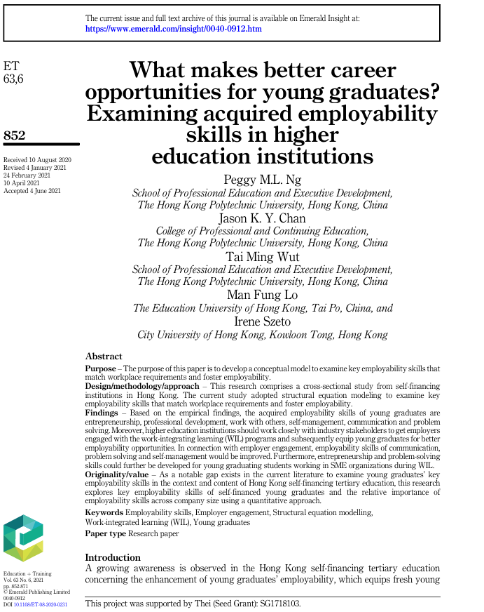

CRAAP Test
Currency | This piece, received in 2020 and revised in 2021, makes it roughly 5-6 years old as a result some of the information may be outdated when looking at certain industries. This paper is a research paper.
Relevance | “Examine key employability skills that match workplace requirements” – the purpose tells you everything in terms of currency.
Authority | Emerald publishing limited  And also supported “thei, (seed grant), an official publisher is a good sign that it is recognised by an authority and holds fact checked information, there are also several names mentioned at the start of the paper that belong to well-known educational institutions.
Accuracy | This paper contains a lot of accurate information and has been proofread; there is the slight issue of being released about half a decade ago some of the information could be outdated.
Purpose | The purpose of this paper is to examine education and the possible career opportunities for future graduates.

Task 3: Source Analysis
Your manager has provided you with a short extract from a source and has asked you to analyse the source by Identifying one strength, one weakness, and providing a brief explanation of the strength and weakness identified.
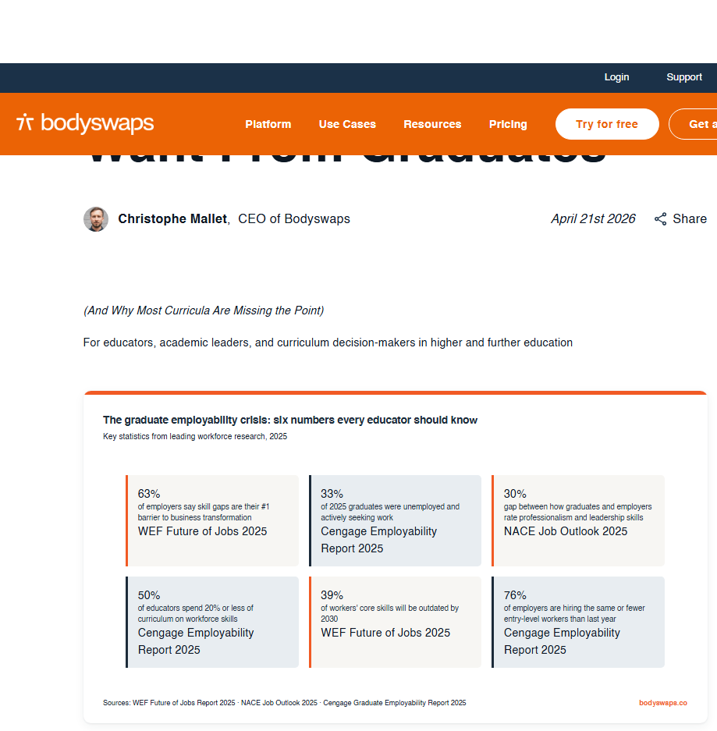
.

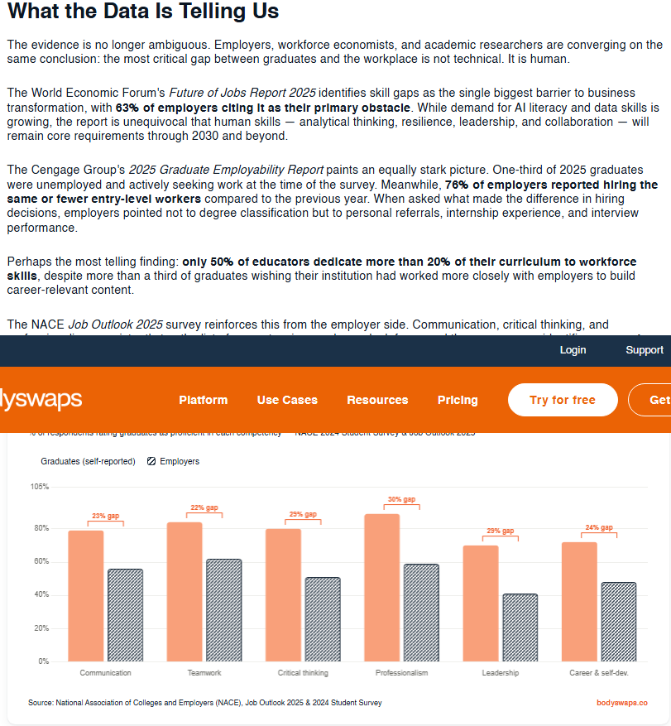

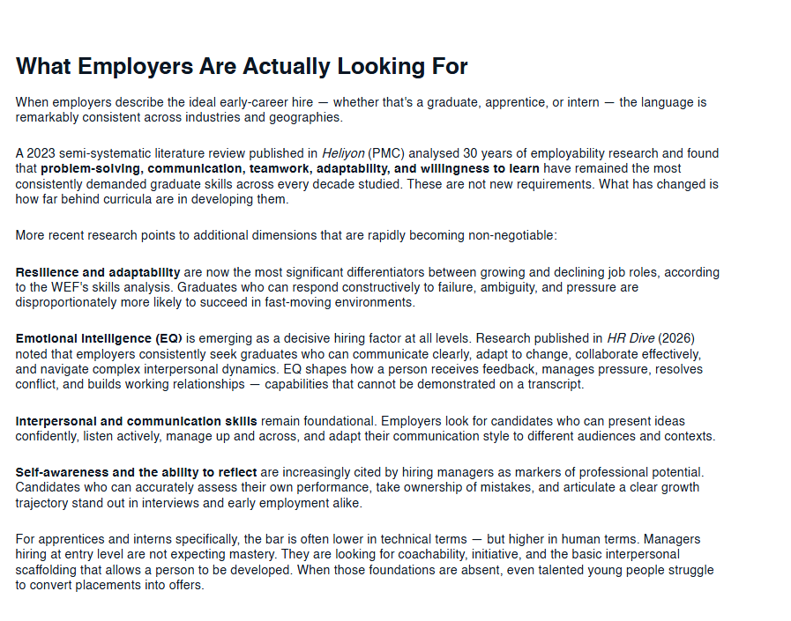

Please click the link if you wish to read the article online.
What Employers Actually Want from Graduates

Strength of the Source:
The source contains a lot of useful data, graphs and relevant questions and statements that could be very useful when writing on its subject matter, there is also the positive of it being clear and concise with-it delivery of its information and data.

Weakness of the Source:
Although it contains a lot of useful information it does also cover other subjects that may not be relevant to the work you are doing and could contain some outdated information.

