INDIVIDUAL REPORT ON KNOWLEDGE AND INFORMATION MANAGEMENT OF AMAZON.COM

Module Name: KIM
Instructor: Md Kalam
Student: Mohammed Arif Khan
Student ID: 1818579

Table of Contents
1. Introduction 3
2. Company Overview 3
3. Management Theories 4
4. Information Integration Importance for Management Development Practice 6
5. Information Systems for Amazon 7
6. Input, Processing and Output of Information System 8
7. Information Management Culture of Amazon 10
8. Amazon’s Management Challenges 12
9. Recommendations to Strengthen Management Practices 13
10. Conclusion 14
11. References 16

Introduction
According to Jennex (2015), the knowledge and information system are the type of IT systems which retrieves and stores data and information in order to enhance collaboration, understanding, and procedure alignment. Furthermore, it has been said that knowledge management is the procedure of creating, sharing, utilising, and managing the information and knowledge of a firm that attain multidisciplinary approach for attaining the organisational aims by making the correct and best use of knowledge and information (Girard and Girard, 2015). The knowledge and information and management is important in any company or organisation because it will boost the effectiveness and proficiency of the company in decision making ability. Furthermore, it will ensure that every employee get the access to the overall expertise held with the firm and an enhanced and smarter workforce is built who would be more able to make faster, an informed decision that will foster the growth of the company. Therefore, the correct information and knowledge management strategies are necessary for any organisation to enhance the management development practices within organisation which will improve the scalability and effectiveness of the firm in the long term basis (Nowacki and Bachnik, 2016).
The study will provide an in-depth analysis of the knowledge management and information system of Amazon which is the world’s largest e-commerce platform recognised in every country due to high quality and cheap rates and high customer satisfaction and advanced customer relationship. The purpose of this report is to analyse the information and knowledge management system of Amazon and how amazon effectively boost sales in the period of covid pandemic lockdown. The report will demonstrate the knowledge management theories along with the efficiency of information and knowledge system culture within the Amazon organisation in terms of creating knowledge assets and maintaining effective customer relationship management. Furthermore, the report will discuss the challenges of amazon in knowledge management practices and provide recommendation to sort out identified issues and challenges.

Company Overview
Amazon is the world’s largest e-commerce platform that started in 1995 under the ownership of Jeff Bezos who is the current CEO of Amazon. It is well known for its quality standards and cheaper prices on its products and great expertise in fulfilling customer’s expectations and needs. The customer relationship is one of the major reasons for the growth of Amazon in past years. The researchers predicted that Amazon implements the rules and principles which at the first glance are primitive, but it is clear that their hard work along with strong strategies and effective teamwork stands behind their success today (Cho, 2019). The company always kept their prices at a minimum level so that the customers can use them on holidays and have the products sent to their friends and families that live in other countries. Amazon is a company that showed to the world that customer satisfaction is the major reason for the business especially e-commerce business growth and when the product is founded to have defected the company does not cost anything to have customers sent back to them. Amazon returns a new product with a warranty (Cutter, 2019). Amazon displays products with great advertising content and competent customers invest in products to make money and follow great policies of amazon that take very low rates. Even though during a pandemic, Amazon effortlessly connected zillions of people with gigabytes of product information and the company did not face any sales down an issue or any issue which most of the business sectors faced during the covid-19 pandemic. There is no doubt that Amazon utilises advanced knowledge management (KM) techniques for this purpose which helps their customer to shop easily from the amazon platform without facing any delay in the order. Amazon uses different information system and knowledge management strategies in the light of knowledge management theories and due to this, the company is recognised as the world’s leading ecommerce platform (Bacon, 2020).

Management Theories
Knowledge management is the procedure of retaining, structuring, defining, and sharing the experience and knowledge of employees with a firm. The real objective of knowledge management is to enhance the firm’s efficiency and productivity and save knowledge with the firm. The aim is to enable organisational learning and make a learning culture, where knowledge sharing is empowered and encouraged, and people who want to learn so that they can improve their skills in easy manner (Omotayo, 2015). The main areas of knowledge management are an accumulation of knowledge actual features or areas of this management are the accumulation of knowledge, knowledge storing, and knowledge sharing. The centralised knowledge management theories in the context of efficiency and growth of Amazon are featured as ecological, organisational, and techno-centric. The organisational knowledge management theory basically focuses on the organisational structures and how a firm is designed hiracrchirically and culturally to manage knowledge and knowledge procedures. The ecological knowledge management primarily focuses on learning communities, people and relationships which include interaction among firm and individuals and the internal and external factors which draw people together to share their knowledge. The techno-centric theory is based on the technology and the procedure of designing technology that enables assist facilitates the flow of knowledge and information storage. The impacts of process, people, and technology in knowledge management in sharing and storing knowledge (Santoro et al., 2018). When it comes to the organisational management of knowledge which has based approach for the supporting activities. The knowledge management system could be known as the information technology based system which is made for the identified support of knowledge associated tasks and activities.
The encompasses included the IT systems as the decision making and decision support system, video conferencing data warehouses, intranets, computer supported collaborative work, and competence system as well. The effective sharing of knowledge needs the foundation based on trust among all involved parties and effective knowledge sharing will need the clarity of roles of individuals and team members (Grant, 2015). Furthermore, it has been stated that effective knowledge sharing will also demand strong knowledge sharing culture as it is the influential factor for organisational learning. While effective knowledge sharing will also need the existence of the same or common language among workers which will enhance the mental model among them to understand the firm will receive certain information which is not possible without involving everyone to speak the same language. The process approach of KM attempt to codify the firm knowledge with the help of processes formalised controls and technologies where the firm adopts the process approach to implement the explicit policies which given how the knowledge will be gathered, stored, and shared. On the other side, the practice approach to KM will be the big deal for the firm knowledge is tacit in nature, and that the formal processes, controls, and technologies will not be suitable for transmitting this type of approach., The focus is giving on building the social environment of individuals with the same professional; interest who will perform together informally (Gao, Chai and Liu, 2018). However, the KM is a diversified field that consists of different activities and the major activities include the drivers and objectives of KM which are based on knowledge creation, knowledge storing and knowledge sharing, and knowledge seeking. The theoretical concept of knowledge management are effectively implemented in various organisations specially Amazon and which is noted as the reason of scalability and efficiency and high customer relationship of the company (Omotayo, 2015).

Information Integration Importance for Management Development Practice
The proficient storing, creating, sharing, and integration and application of knowledge, data and information is mandatory for the basic requirements of effective knowledge management practices. The effective management of knowledge is the analytical ingredient for firms seeking to make sure that sustainable strategic competitive advantage. Because the development and creation of knowledge play a significant role and are known as the intrinsic feature of knowledge management. The data is largely and individually owned and became difficult to hold the charge of and control over data and the knowledge exploited more effectively firms need to store and codify the individual's knowledge which includes creating tacit knowledge divide and transpose knowledge into firms knowledge which will be possible with the use of ICTs. Knowledge accumulation, storing, and sharing are the major areas of Knowledge management as stated which increases the efficiency and scalability of the company. Explicit knowledge and tactic knowledge are the two types of knowledge covered in the study of knowledge management (Omotayo, 2015). The improved knowledge management will successfully enhance the organisation in different ways such as ensure that the specialised knowledge of employees does not leave with them or go utilised by other workers who would benefit from that identified or stored knowledge. This also allows for better situational awareness and opens and makes doors for learning about the best practices, lessons learned, and entire firm improvement. This is important because it promotes the efficiency of a firm’s decision making ability and ensures that every employee has the access to the entire company held within the firm, a smarter workforce is created which will be more able to make fast and informed decisions that benefit the company in long term basis (Omotayo, 2015).
The innovation becomes easy to foster within the firm and customers could benefit from the enhanced access to best practices and worker turnover will get minimised. Most of the companies use this management in order to merger could spur the requirement of codifying knowledge and encourage team members to share their expertise and skills. The imminent retirement of good employees would get demonstrate the requirement to capture their knowledge and the upcoming recruitment drive highlight the wisdom in utilising knowledge management to help in the training of new employees for the company. The creation, storing, and sharing of knowledge will increase the efficient workplace, and make decision-making better and faster. This will promote increased and enhanced collaboration among team members and build organisational knowledge. Furthermore, the employee on boarding and training procedure will be optimised and increase employee retention and happiness with the help of valuing knowledge, training, and innovation (Newcombe et al., 2015). This is known as the mandatory tool in any firm which needs to enhance their bottom line and market shares such as Amazon who already increased their huge market share with the help of information system and advance knowledge management tools, techniques, and strategies. The purpose of knowledge management which is to enhance the organisational efficiency and create, save and share knowledge will be fully served with advanced knowledge management which promotes business scalability and efficiency, and companies with advanced knowledge management can grow even in the strict lockdown and pandemic situation as well (Amazon, 2015).

Information Systems for Amazon
The implementation of the advanced information system is one of the biggest success and growth factors for Amazon. The integration of information systems into business procedure analysis has played a significant role in the decentralisation of decision making procedures and enhances the efficiency of the main business procedures. Amazon mainly operates two piece information management software that is based on the simple storage service which is connected to the integrated database and also the amazon web service which enhances access to the e-commerce platform of amazon (Smith and Linden, 2017). The web service of amazon enables customers to the creation of user accounts and personalise their profiles for enhancing efficiency in transaction processing. The Amazon web service is consists of effective communication among sellers, buyers, and staff of amazon. The robust web service combines distinct features which include scalability, reliability, efficiency, and security to create it highly efficient in providing business processes through a CRM customer Relation Management system. The integrated smart analysis search system operates in order to give optimal security for user data and information and to enhance personalised customer services as per the customer profile as well (Bermudez et al., 2013). Furthermore, the system is built an SOA which is service Oriented Architecture to further promote service decentralisation for enhancing the scalability of the entire system. Moreover, the transaction processing system of amazing is the main feature of the business information system that enable customers of Amazon to make purchase efficiently and securely. The distinct features including one click purchase, encrypted, and secured (Amazon, 2015).
The information management system of amazon are also integrated along with different unique functionalities including the recommendation system of intelligence which examine the old search queries of a customer in order to make recommendation from them for similar products through a process which is called data mining which allow the process to extremely interactive and in return enhance customer satisfaction (Yao et al., 2010). The dada of customer order is processed under the supply chain management system which is highly integrated into the web service and payment system. The entire information gathered through the web service is forwarded to the Enterprise Resource Management system which operates on the oracle database management system which automates the ordering processing with high accuracy levels in scheduling and delivery tracking of orders. The CRM system is another analytical feature of the information system of amazon which supported the growth of the company over the past years significantly (Shao et al., 2012). This gathers customer data including the transaction history, credit card information, and order records which are used to specialised sorting algorithms which save and store the customer data and information in the customer profile which encrypts the sensitive data related to the credit card information and redirects the customer order information to the delivery system for the purpose of shipment. The CRM system gathers information as well related to the customer queries feedback and reviews of the product in order to enhance efficiency and scalability. The information system of amazon promotes competitive advantage and opportunities for the company in order to implement the decentralising of decision making procedure which is the key to the success of Amazon (Smith and Linden, 2017). The information system of amazon is highly integrated and designed in such a way that promotes efficiency in every stage of order purchasing to order delivery and increases the scalability of the brand as well.

Input, Processing and Output of Information System
The output of amazon matters more than the input. Amazon refers to the output as the result which they achieve and the input refers to how hard they work to achieve their results. The input and output processing section of the AWS step functions developer guide provides a detailed explanation. The output of the state could be a copy of its input data or the result at its products and a combination of its input and result (Swedha and Dubey, 2018). The input initiates the systems of creating information or knowledge and processing the thinking part of the information system which considers the input and decides now what should be done with the input. The output is the information system's response to the being activated. The input, processing, and output are the three major activities of Amazon’s information system which produces the information which the company needs (Varia and Mathew, 2014). The input captures and collects the raw data and knowledge from within the company or any other external source. Then the processing converts the raw knowledge or raw input into a meaningful state. At last, output transfers the processed information to the people who utilise it or activities for the company to assist them in correcting and evaluating the input step (Mathew and Varia, 2014).
Amazon uses Amazon Web Service (AWS) and Simple Storage Service (SS) which are the main information management system of amazon. The resulting path is used to include the content from the result with the input before the passing to the output, while when the resulting path is not specific; the default is set to replace the overall input in the amazon web service. Furthermore, Amazon's simple storage service is offered by the company which provides objective storage through a web service interface (Narendula, 2012). Amazon uses the same scalable storage infrastructure which the company uses to run its worldwide e-commerce platform and e-commerce network. Amazon S3 is an objective storage service that offers industry leading scalability, security performance, and data availability which means that customers of every industry and size could use it to protect and store any sort of data for a range of usage cases that includes websites data lakes, bile applications, restore, backup, archive, IoT devices, enterprise applications ad big data analytics (Newcombe et al., 2015). The service provides easy to use management features so that individuals could organisation their data and configure the finely tuned access in order to meet the specific organisational, business and compliance needs and demands (Mathew and Varia, 2014).

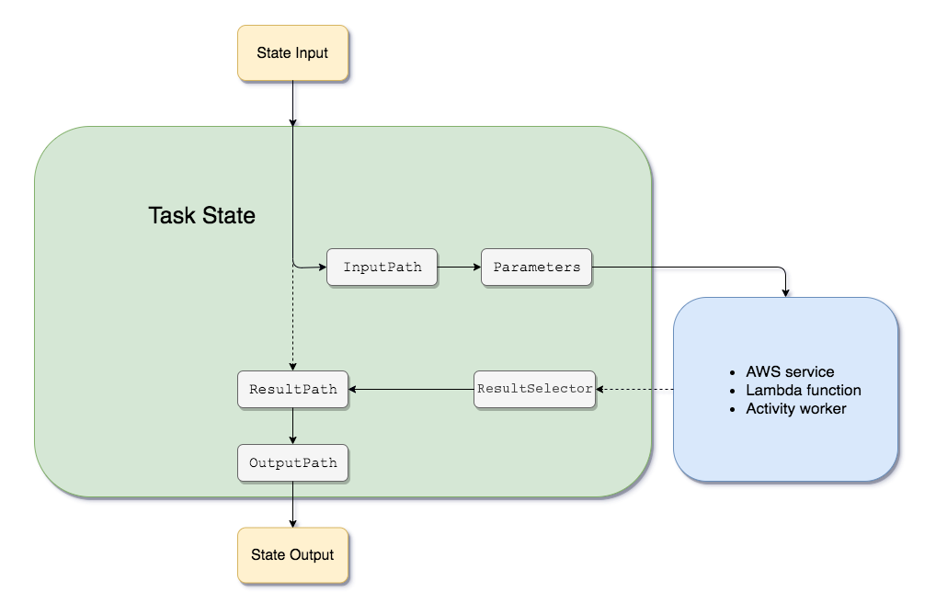
Source: Mathew and Varia, 2014

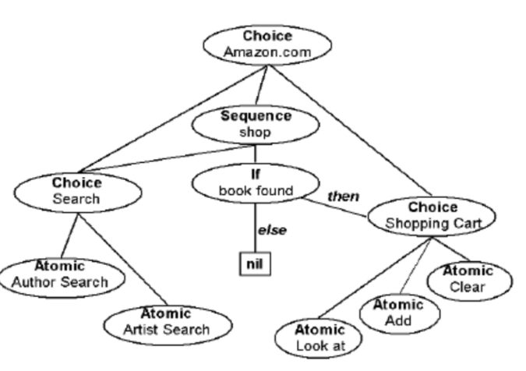
Source: Narendula, 2012

Information Management Culture of Amazon
The information management or knowledge management system helps associations and their cadres to engage in a more ruthless and resolute approach to fostering collaboration between people and information structures. Knowledge Management (KM) helps associations find the best choices at key and hierarchical levels (De Brito et al., 2016). Amazon's example is a strong alignment of information innovation with the overall vital needs of society. Amazon's approach to Internet business has been adapted by providing site administrators free of charge, in particular from its query structures. Amazon uses a high-level knowledge management (KM) framework as a powerful component to make management rehearsals run more smoothly while ensuring that buyers receive varying amounts of KM contributions (Lima and da Silva Müller, 2017). In a global climate, knowledge management has acquired a major role in the development of an organization. Amazon has the advantage of launching an "all under one roof" procedure. Customers are wrong when faced with so many other options. They become data-rich, with multiple decisions, no matter how poorly they understand, without thinking about which buying decision would be right for them. To cope with this, Amazon is building and modifying its recommendation system using the big data they get from shoppers when they search (Taylor, 2018). The more information Amazon has about you, the more it will want to predict what you need to buy. Plus, if the store understands what you need, it will work to convince you to buy it - for example, by choosing different brands rather than expecting you to go through the entire list.
Amazon's recommendation calculation is based on general browsing, which makes sure it figures out what you want by creating your profile, and then suggests things that people with comparative profiles have bought. Every time a customer visits Amazon, the organization collects information from them. Despite the Covid pandemic, the association keeps track of what you watch, your house number, and what ratings or comments you leave, no matter what you buy. The moment customers browse the Internet, Amazon collects information such as the amount of time spent on each page. External databases, such as registration results, are often used by the retailer to collect segment information. Amazon, which began as a global Internet-based American business organization, has evolved into a major online store and distributed computing administration service provider (Calabrese and Rollins, 2019). Consolidating customer relationship management and information into Amazon's overall marketplace system are two advances that have led to the organization's prosperity. Amazon's IT infrastructure is planned in such a way that it can support not only many operations, but also most of the requests and problems from sellers. Linux has been the main driving force behind Amazon's innovation. Merging the knowledge management framework and evolving big data with other electronic programming is the most compelling part of implementing intelligent virtual agents for Amazon amid the ongoing pandemic (Calabrese and Rollins, 2019). With the emergence of social systems management in both virtual and non-virtual modes, Amazon wants to expand its market by consolidating KM into a second life (the virtual phase of social systems management), creating a lasting effect of enthusiasm. with the personalities of Amazon buyers.

Amazon’s Management Challenges
Many organisations are also fascinated by Amazon's ability to transform supply chain technology and close colossal deals. However, organizations should be aware that Amazon has its supply chain issues, especially during the Prime Day deal when shoppers grumbled that items published as available were sold out while they were looking at them. Amazon's development fuelled by the pandemic is unlikely to slow anytime soon, especially with preparations for Prime Day in October and the upcoming holidays. Amazon's supply chain management tool is simple despite its size. It all starts when a customer submits a request (Smith and Linden, 2017). The warehouse is then alerted with a red light to show the items that have been transported, so the distribution centre staff can change the barcode as requested. The lined goods are then stacked on a conveyor belt in a box before being transported to a shipping station to determine the barcode sequence. The containers are moved to a specific area where orders contrast with product barcodes and are quickly placed in gutters before being put into the box. From this point on, barcodes are used to recognize the request before the containers are evaluated and taped. The packages are then shipped via UPS or USPS for the last mile, with customers receiving their packages within one to seven days. Amazon's distribution centres are divided into five error-free storage regions: Case Flow Prime, Library, Pallet Prime, Reserve, and Random. Buyers are often frustrated by misconceptions about the market (Warrier et al., 2021). Amazon is consistently addressing market and availability issues by stockpiling in anticipation of high-volume requests on Prime Day and the holiday season. They are data-driven and make recommendations based on the data being verified and late buyers well in advance of an event or holiday. Although Amazon is a clear advantage and pioneer of e-commerce, it has supply chain management challenges (Shrestha and Nasoz, 2019). Organisations participating in or planning to open their online stores will benefit from learning how Amazon operates at scale to address challenges and continually evolve to overcome new obstacles. Amazon representatives, on the other hand, are happy with their opinion because ERP packages have exactly what any end customer involved in presenting, distributing, and managing organizational technologies expects (Shrestha and Nasoz, 2019). Thanks to Amazon, the capacity of mechanised warehouses is excellent, comparable to the user interface through which employees communicate with customers. In addition, innovation challenges are the most limiting elements in supporting new applications. For example, Amazon is pursuing phishing ploys that challenge shoppers to the intricacies of current Amazon customer accounts. This must be combated with the powerful enemy of phishing attacks that grab the attention of buyers.

Recommendations to Strengthen Management Practices
The organization's progress is determined by KPIs and Key Areas of Operation. Subsequently, Amazon's special plans will be better tailored to customer requirements. Using data from clients who have a site with a specific collection can help solidify this methodology by providing newsletters that are tailored to the needs of these groups. Amazon's recommendations exclude recommendations on how best to improve a structure or stage, but instead, offer ideas on how to best think and use existing data. Securing the market is not the right solution for Amazon. More emphasis should be placed on human asset management and business monitoring due to the use of CRM approaches through enterprise asset management procedures to work with buyers in the current pandemic (Shrestha and Nasoz, 2019).
Moreover, automation is now an important part of most transport chains. Automated association tasks will be faster and more reliable thanks to faster, trouble-free transport. To keep up with interest, Amazon will need to invest resources in cutting-edge hardware and automation innovation. Of course, greater satisfaction and faster handoffs will require more careful inventory management and monitoring (Calabrese and Rollins, 2019). For the accelerated supply chain to continue to function properly, Amazon wholesalers must employ qualified personnel who also use state-of-the-art coordination equipment. Most organisations have used the method of rethinking coordination and acceptance of shares in the past. This involves using their in-house products while relying on third-party minions to distribute them throughout the supply chain. Amazon can sell many products that other stores have, but they have their own extremely solid distribution base to deliver those products to their customers to overcome the financial barriers caused by the Covid-19 pandemic.
Amazon should improve the combination created by combining data from advertising, distribution, and after-sales offices (Kordrostami and Rahmani, 2020). The association's information management fund must continually provide buyers with points of contact. Amazon will integrate the entire organic system with the social administration stages, leveraging the customer relationship stage to sell and acquire additional customers. Most buyers live in a social space, as evidenced by eBay's knowledge management framework and the knowledge management framework of future e-commerce organizations. Coordinating a customer's shopping experience across the management profile of his or her social system will help promote Amazon products and administration to nearby end-customer networks. Leveraging large corporate resources to manage to program in social administration will help Amazon trade customer reviews and testimonials, building customer trust (Kordrostami and Rahmani, 2020).
Amazon should improve its customer service by introducing procedures and improving its distribution activities accordingly. This requires the organization of additional human resources as if you were entering previously unexplored business sectors. Amazon should analyse the following objective socioeconomic opportunity using data on customer buying habits. Another idea that Amazon will benefit from in the long run is the use of artificial thinking as a means of increasing consumer interest. Later, intelligent virtual agents will prepare for Amazon and its information boxes (Kordrostami and Rahmani, 2020). Further improvements are needed in the way information blocks communicate to people. Amazon should make change management a standard practice, and Approach E should be flexible enough to accommodate changing customer expectations and needs. Intelligent mechanical aids will be used for supply chain management, customer relationship management, coordination management, and human asset management. The use of intelligent virtual agents allows the organisation to focus less on customer service and receive great staffing deals.

Conclusion
This has been concluded that the knowledge management and information system of Amazon is the best approach that any other company can develop to boost the growth, productivity, scalability, and efficiency of the company. The theoretical aspects of knowledge management which have been discussed such as organisational, economical, and techno-centric are the core factors of the information system of Amazon. However, the challenges identified for the company which could limit the growth of the company need to be addressed as per the situation and scenario of the company. The study also provided recommendations for Amazon which can enhance and strengthen the knowledge management practices from the knowledge acquisition retention transfer perspective. It has been analysed that Amazon is determined to be a user experience based which provides the ability to its customers to figure out what they want quickly and easily which is the key to the success of Amazon. Moreover, the company can further enhance its knowledge management practices with the implementation of the identified recommendations which will help the company to grow in the future with high intensity than before. Furthermore, the study analysed the information system of amazon which are Amazon web service and amazon simple storage service which are the most prominent and effective storage and information sharing services provided by the company.

References
Amazon, E.C., 2015. Amazon web services. Available in: http://aws. amazon. com/es/ec2/(November 2012).
Bacon, D., 2020, September. Courage in the Time of Covid-19: Amazon Warehouse, May Day 2020. In New Labor Forum (Vol. 29, No. 3, pp. 38-41). Sage CA: Los Angeles, CA: SAGE Publications.
Bermudez, I., Traverso, S., Mellia, M. and Munafo, M., 2013, April. Exploring the cloud from passive measurements: The Amazon AWS case. In 2013 Proceedings IEEE INFOCOM (pp. 230-234). IEEE.
Cho, J., 2019. Amazon. com, Inc.
Cutter, C., 2019. Amazon to retrain a third of its US workforce. Wall Street Journal.
Gao, T., Chai, Y. and Liu, Y., 2018. A review of knowledge management about theoretical conception and designing approaches. International Journal of Crowd Science.
Girard, J. and Girard, J., 2015. Defining knowledge management: Toward an applied compendium. Online Journal of Applied Knowledge Management, 3(1), pp.1-20.
Grant, K., 2015. Knowledge management: An enduring but confusing fashion. Leading issues in knowledge management, 2, pp.1-26.
Jennex, M.E., 2015. Knowledge management. Wiley Encyclopedia of Management, pp.1-6.
Mathew, S. and Varia, J., 2014. Overview of amazon web services. Amazon Whitepapers.
Narendula, R., 2012. Amazon Web Services-a Case Study (No. REP_WORK).
Newcombe, C., Rath, T., Zhang, F., Munteanu, B., Brooker, M. and Deardeuff, M., 2015. How Amazon web services uses formal methods. Communications of the ACM, 58(4), pp.66-73.
Nowacki, R. and Bachnik, K., 2016. Innovations within knowledge management. Journal of Business Research, 69(5), pp.1577-1581.
Omotayo, F.O., 2015. Knowledge Management as an important tool in Organisational Management: A Review of Literature. Library Philosophy and Practice, 1(2015), pp.1-23.
Santoro, G., Vrontis, D., Thrassou, A. and Dezi, L., 2018. The Internet of Things: Building a knowledge management system for open innovation and knowledge management capacity. Technological forecasting and social change, 136, pp.347-354.
Shao, Y., Di, L., Bai, Y., Guo, B. and Gong, J., 2012, August. Geoprocessing on the Amazon cloud computing platform—AWS. In 2012 first international conference on agro-geoinformatics (agro-geoinformatics) (pp. 1-6). IEEE.
Smith, B. and Linden, G., 2017. Two decades of recommender systems at Amazon. com. Ieee internet computing, 21(3), pp.12-18.
Swedha, K. and Dubey, T., 2018, July. Analysis of web authentication methods using Amazon web services. In 2018 9th International Conference on Computing, Communication and Networking Technologies (ICCCNT) (pp. 1-6). IEEE.
Varia, J. and Mathew, S., 2014. Overview of amazon web services. Amazon Web Services, 105.
Yao, J., Chen, S., Nepal, S., Levy, D. and Zic, J., 2010, May. Truststore: Making amazon s3 trustworthy with services composition. In 2010 10th IEEE/ACM International Conference on Cluster, Cloud and Grid Computing (pp. 600-605). IEEE.
Calabrese, A., Rollins, T., 2019. Amazon.com. In: Global Media Giants.
De Brito, E.M., Ziviani, F., De Oliveira, J.L.R., Christino, J.M.M., 2016. Knowledge management in the context amazon: A study in cooperative credit. Rev. Bras. Gest. e Desenvolv. Reg.
Kordrostami, E., Rahmani, V., 2020. Investigating conflicting online review information:evidence from Amazon.com. J. Retail. Consum. Serv.
Lima, V.A., da Silva Müller, C.A., 2017. Why do small businesses innovate? Relevant factors of innovation in businesses participating in the Local Innovation Agents program in Rondônia (Amazon, Brazil). RAI Rev. Adm. e Inovação.
Shrestha, N., Nasoz, F., 2019. Deep learning sentiment analysis of Amazon.com reviews and ratings. arXiv.
Smith, B., Linden, G., 2017. Two Decades of Recommender Systems at Amazon.com. IEEE Internet Comput.
Taylor, S., 2018. Organisational Behaviour, Leadership and Change. Journals Pub.
Warrier, U., Singh, P., Jien, C.W., Kee, D.M.H., Yi, G.Z., Jiann, T.W., Liang, T.Y., SB, G., Nair, S., Nair, R.K., Lokhande, S.D., Ganatra, V., 2021. Factors that Lead Amazon.com to A Successful Online Shopping Platform. Int. J. Tour. Hosp. Asia Pasific.

