
BMIH5003
Cultural Awareness
Intercultural Competence
Assignment No: 2

Student Name: Lorella Mihut
Student ID:2214491
Lecturer:Lisa Bassler

Executive Summary
Diversity Hotel & Spa's development in France calls for an in-depth familiarity with French culture. Using data collected as part of the GLOBE Project, this paper examines every facet of French society. It stresses the importance of cultural understanding in the hospitality sector, and how it may affect both visitor pleasure and workplace relations. Culture lessons, clear lines of communication, working with natives, flexible policies, and following the law are all things that come up as possible solutions. These methods are crucial for the hotel's continued performance in the competitive French market.

Table of Contents
Executive Summary 2
Introduction 4
Brief outline the French culture and customs 5
Chosen Country analysis using Globe Project’s 5
Critically discuss why cultural intelligence and sensitivity is essential 8
Conclusion 9
Recommendations to the General Manager 10
References 11

Introduction
A comprehensive analysis of intercultural competence and leadership is required in light of Diversity Hotel & Spa's planned expansion from London to France. Learning the local norms and practises is crucial to making the change over smoothly. This article uses the findings of the GLOBE Project's studies of leadership and culture to perform a comprehensive analysis of French culture and practices. In addition, it will highlight the value of cultural awareness and understanding in the hospitality sector, highlighting the critical role they play in creating positive experiences for customers. At the procedure's conclusion, the General Manager will be supplied with a set of suggestions designed to prepare the company for culturally sensitive entry into the French market.

Briefly outlining the French culture and customs
French cuisine is famous globally. Careful preparation, high-quality ingredients, and flavour define French cuisine (Aycan et al., 2017). This involves providing great hotel food, potentially with local delicacies and wines. "Art de Vivre," or living art, is important to French culture. It values beauty, grace, and refinement (Christiansen, Branch & Karmowska, 2020). Hotels should prioritise interior design, furniture, and ambience to convey refinement and comfort. French society values politeness. Hotel personnel should be educated to welcome customers warmly and professionally and meet their requirements with elegance and respect.
English is often used at hotels, although even a few French greetings are welcomed. It respects the local language and culture. History, art, and literature abound in France. Information on surrounding cultural sites, museums, and events may enrich tourists' experience and deepen their connection to the place. French workers value work-life balance (House et al., 2016). Fair working hours and relaxation help hotel workers stay motivated, which improves client happiness.

Chosen Country analysis using Globe Project’s
The GLOBE Project's culture and leadership study identifies six global leader behaviour dimensions and nine cultural dimensions (GLOBE Project, 2023). For the purpose of this report, we'll focus on the cultural dimensions that are most relevant to the scenario of Diversity Hotel & Spa expanding into France.
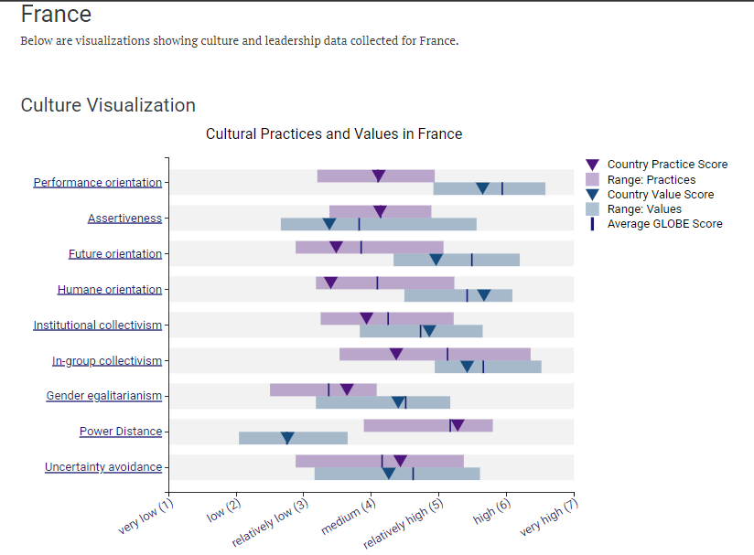
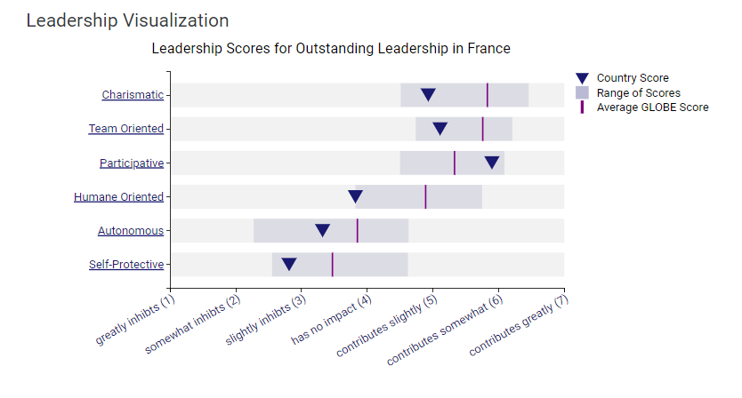
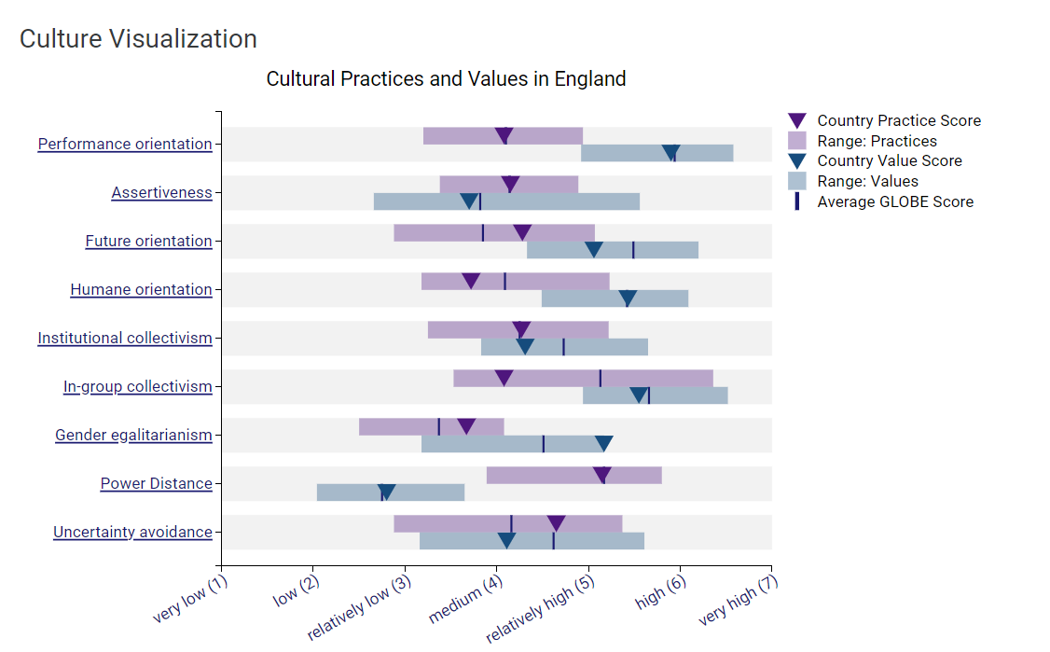
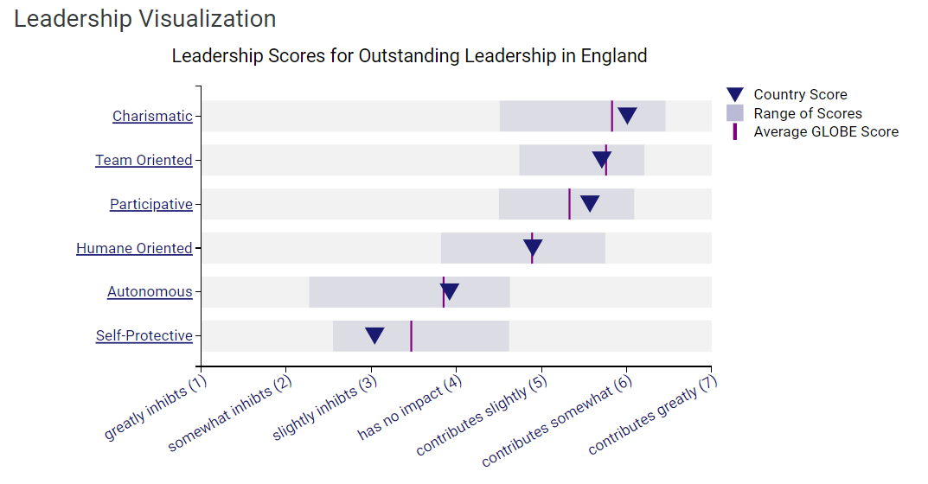

Figure 1: Culture and leadership data collected for France (GLOBE Project, 2023).
Figure 2:Culture and leadership data collected for England (GLOBE Project,2023)
Power distance in France is low (2.76) compared to other nations, reflecting a preference for more equitable superior-subordinate relations. This indicates collaborative, consultative hotel leadership. Supervisors should encourage open communication and employee involvement. France scores average on avoiding uncertainty (4.26). They value order and conventions but also flexibility and innovation. Thus, the hotel's management must establish clear guidelines and allow for creative problem-solving. France favours individualism over collectivism. Teamwork and collaboration are required in a hotel, especially to make visitors happy. Staff should be encouraged to collaborate while retaining their freedom.
In-group collectivism in France is modest, 4.37 out of 7. Thus, community and friendship are weaker than in other communities. Hotels should foster collaboration without cliques. France scores middle-ground in assertiveness (4.13). A balance between aggressiveness and accommodation is needed. The finest hotel managers are resolute yet listen to staff. French thinkers are more futuristic. This suggests hotels should emphasise inventiveness, trend tracking, and visitor happiness. A modest 4.11 for Performance Orientation in France. This shows accomplishment and job excellence are valued. Hotels should encourage service excellence. France prioritises Humane Orientation. Altruism, compassion, and caring are shown. The hotel's staff treats clients with care and compassion (GLOBE Project, 2023).
The success of Diversity Hotel & Spa's planned expansion into France depends on the hotel's ability to successfully traverse the country's cultural terrain. The ability to communicate effectively across cultural boundaries is crucial for a successful hospitality business.

Critically discussing why cultural intelligence and sensitivity are essential
Cultural intelligence and sensitivity are crucial for hotel personnel within the business context for several compelling reasons:
Improved Guest Satisfaction: An awareness and admiration of French culture and customs might assist the hotel personnel to more successfully respond to the needs of both French and non-French guests. This leads to happier tourists who are more likely to provide glowing reviews (Jokinen, 2019).
Stronger Customer Relations: If the hotel staff shows cultural awareness, it might help customers feel more at home there. Customers are more likely to remain loyal to a company with whom they have established a trusting, mutually beneficial connection.
Inclusive Work Environment: When the hotel's personnel includes people from a variety of cultural backgrounds, guests and employees alike are more likely to feel at ease and part of a larger group (Kirkman, Lowe & Gibson, 2017). It encourages a culture where workers are open to hearing new ideas and are keen to learn from their own experiences.
Long-term Success: Successfully navigating cultural differences is crucial to the long-term success of Diversity Hotel & Spa in the French market. It helps the hotel gain a reputation for welcoming guests from all walks of life and all walks of culture.

Conclusion
In conclusion, adopting cultural knowledge and sensitivity is important for Diversity Hotel & Spa's development in France. The hotel's long-term success in today's diversified and globalised market depends on its staff's ability to understand and accommodate guests from a wide range of cultural backgrounds.

Recommendations to the General Manager
French hotel staff may have different expectations regarding leadership and management styles compared to those at the home location. Understanding and adapting to these differences will be crucial to maintaining effective communication and motivation (Maheshkar & Sharma, 2018). The General Manager should proactively promote cultural sensitivity and provide training to bridge potential gaps. Recommendations for the General Manager:
- Conduct Cultural Sensitivity Training: All employees should be given in-depth training that places a premium on cultural awareness and understanding in the workplace (Minkov & Hofstede, 2016).
- Establish Open Communication Channels: Encourage an open dialogue in which workers may ask questions or voice concerns about cultural misunderstandings. Maintain a steady schedule of feedback meetings.
- Collaborate with Local Experts: Consult with consultants or professionals in the area who are conversant with French business customs and culture (Saluy et al., 2022). Their insights may be important in handling possible issues.
- Regularly Review and Update Policies: The hotel's worldwide standards and the demands of the French market must be constantly assessed, and business rules must be modified as necessary.

References
Aycan, Z., Kanungo, R. N., & Mendonca, M. (2017). Organizations and management in a cross‐cultural context. In Oxford research encyclopedia of business and management.
Christiansen, B., Branch, J.D. and Karmowska, J. (2020) Cultural Factors and Performance in 21st Century Businesses. Hershey: IGI Global.
GLOBE Project (2023) Results - France globe project, GLOBE Project. Available at: https://globeproject.com/results/countries/FRA?menu=list - country .
GLOBE Project (2023) Results- England globe project, GLOBER Project Available at: https://globeproject.com/results/countries/GBR?menu=list - country .
House, R. J., Hanges, P. J., Javidan, M., Dorfman, P. W., & Gupta, V. (2016). Leadership, culture, and organizations: The GLOBE study of 62 societies. SAGE Publications.
Jokinen, T. (2019). Leadership and national culture. In Advances in Global Leadership (Vol. 12, pp. 27-50). Emerald Publishing Limited.
Kirkman, B. L., Lowe, K. B., & Gibson, C. B. (2017). A quarter century of Culture's Consequences: A Review of Empirical Research Incorporating Hofstede's Cultural Values framework. Journal of International Business Studies, 48(1), 30-47.
Maheshkar, C. and Sharma, V. (2018) Handbook of Research on Cross-Cultural Business Education. Hershey: IGI Global.
Minkov, M., & Hofstede, G. (2016). A replication of Hofstede’s uncertainty avoidance dimension across nationally representative samples from Europe. International Journal of Cross-Cultural Management, 16(2), 173-186.
Saluy, A.B. et al. (2022) ‘Motivation moderating the influence of organizational culture and leadership on employment performance’, WSEAS Transactions on Environment and Development, 18, pp. 662–670. doi:10.37394/232015.2022.18.63.
Wisetsri, W. (2020) ‘The influence of leadership, work motivation and organizational culture on job performance’, International Journal of Psychosocial Rehabilitation, 24(5), pp. 7336–7350. doi:10.37200/ijpr/v24i5/pr2020768.

