How to activate element deletion

When an material point has been fully damaged the element at that point can be removed. Removal of element is a convenient way of avoiding mesh distortion that can crash the solve and provides a result that appears visually useful. However, element deletion removes that element’s ability to transmit any subsequent stresses to its neighbours.
MESH module
- First, Select the Part you want to change the element properties: Here I have selected the Bullet part.

- Select ASSIGN ELEMENT TYPE:
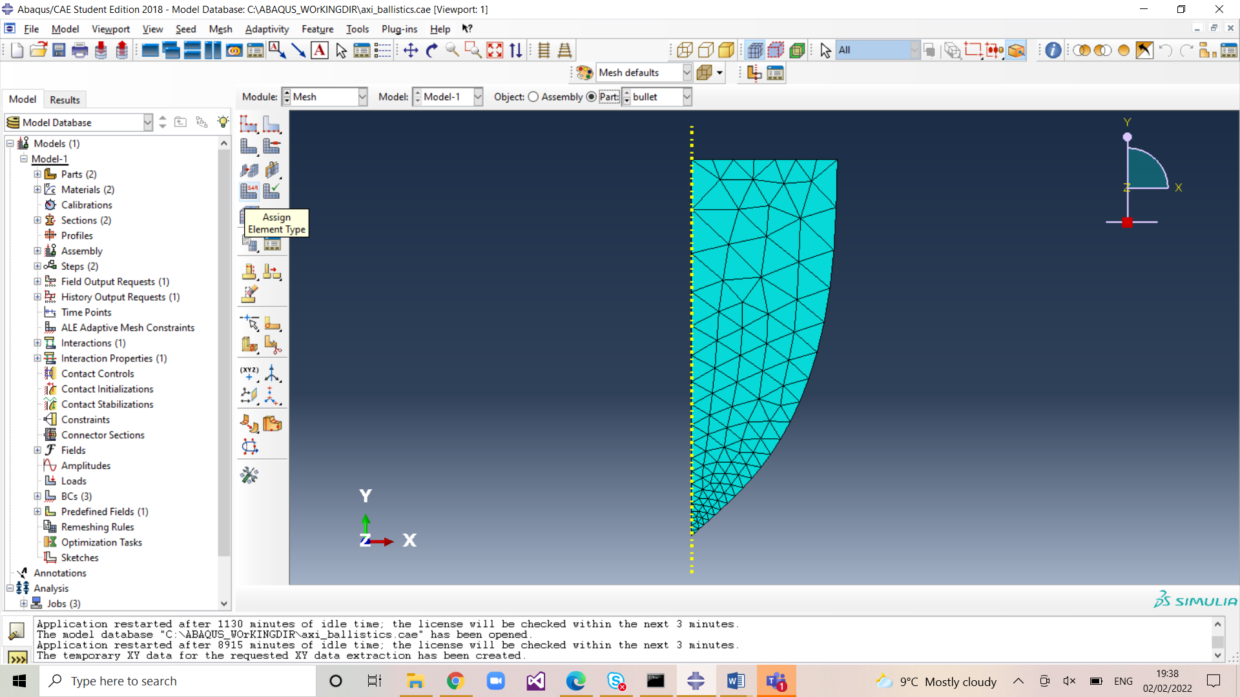

- Select the region and then DONE:
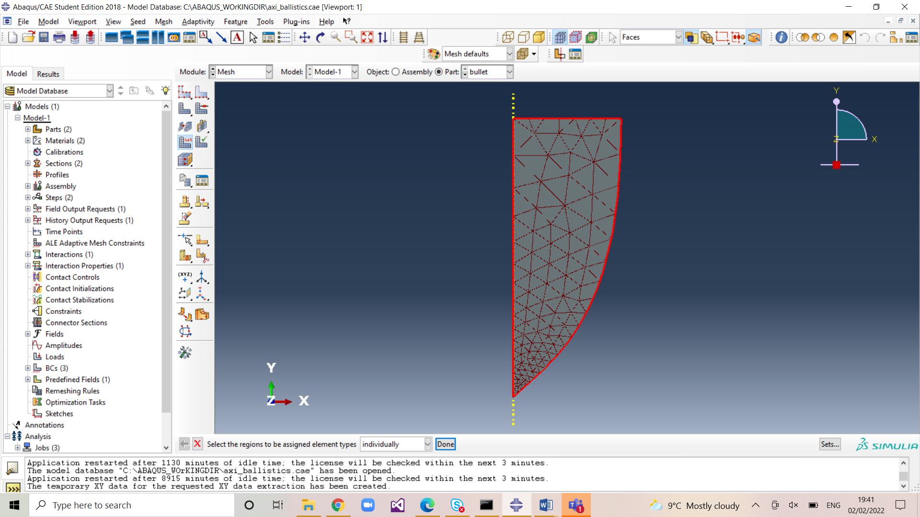

Now you can select the element delete option in the dialog box that appears:


