REBECCA – Green ones are not complete, just some notes for me to get started. Yellow ones are complete.

Scenario: ParcelCare is a long- established national parcel and package delivery service. ParcelCare is now finding it difficult to attract, recruit and retain staff throughout the organisation.
You have just started in your new role of People Manager and you have been asked to report to senior leaders on how these issues can be addressed.
In preparation, you write answers to 10 questions in the assessment brief.

(AC 1.1) New entrants to the parcel delivery market and other labour market competitors have adversely affected ParcelCare’s ability to compete in labour markets.
Explain how ParcelCare can strategically position themselves in competitive labour markets.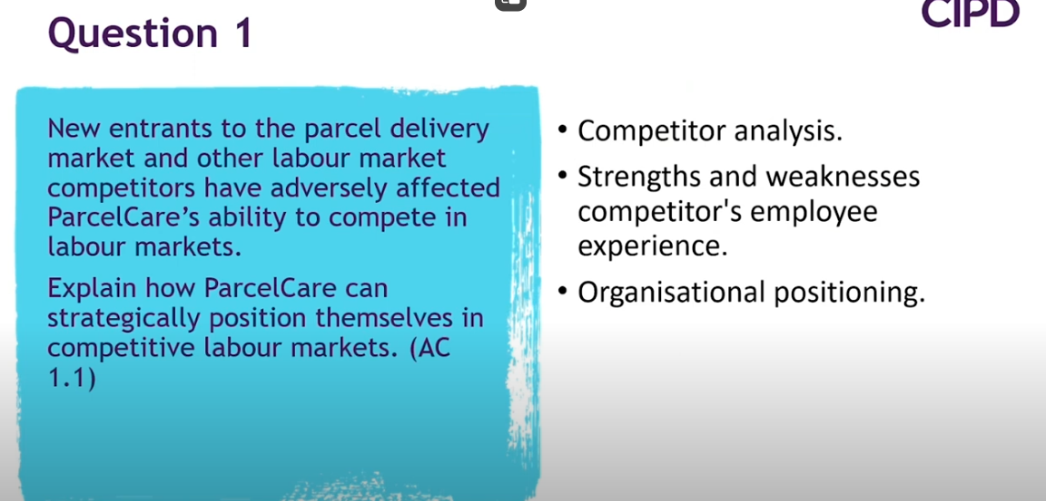
(AC1.2) Explain the impact of changing labour market condition on resourcing decisions at ParcelCare.
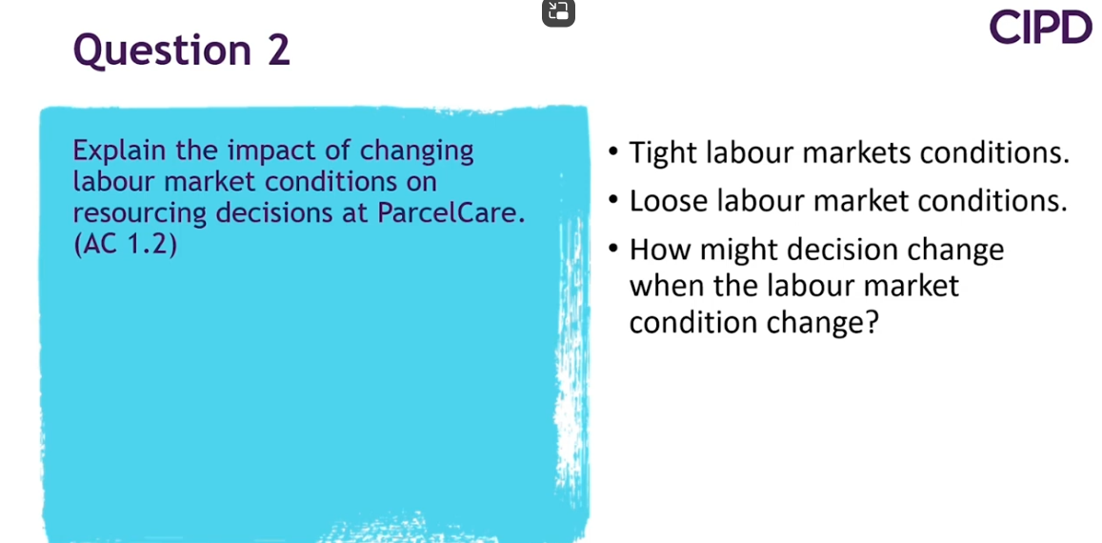

(AC 2.1) You are aware that workforce planning has not been carried out in the past and decide to persuade the senior leadership team that this activity is worth doing.
Analyse the impact of effective workforce planning, making clear how ParcelCare could benefit from this activity. 316 words
Workforce planning is the process of analysing and aligning the workforce with the organisation’s future need, thus increasing the ability to achieve its objectives. There is a need to ensure that the supply of labour is appropriate and in the right place at the right time to ensure that the work required is completed effectively. The process is ongoing and should be consistently reviewed and monitored to ensure that the desired results are achieved and to allow for continuous improvement, as such, data is vital to allow outcomes to be assessed and measured (Hayden, 2024). The diagram below shows the workforce planning cycle.

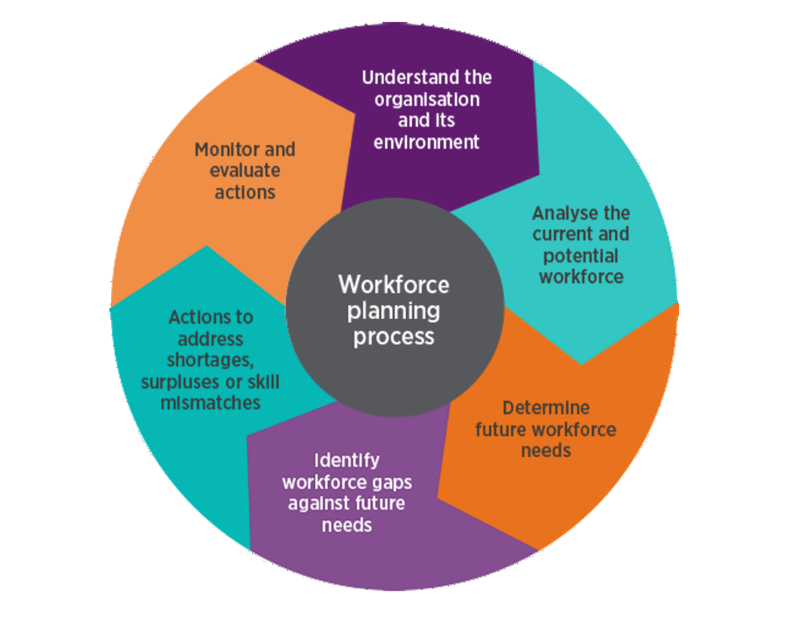
Hayden, 2024
Workforce planning is a key connection between HR and the People Strategy and the wider organisational operations and strategic objectives. The process links to various other HR tasks such as talent management and there is a requirement to consider both short term and long term requirements of the business. (People Management, 2010)
Effective workforce planning can contribute to an organisation’s long terms success and achievement of objectives. There are several benefits including cost efficiency, as labour is inline with requirements so cases of too much labour is minimised, there are links to increased awareness of organisational objectives and appropriate resource allocation which can be linked to increased productivity (CIPD, undated). Increased awareness of objectives and assessment of future needs can assist with risk management processes which can also assist an organisation to meet its objectives.
ParcelCare has not previously undertaken the workforce planning process. I feel that it would be beneficial to undertake this process; particularly with the current difficulties in recruitment to help to ensure that future needs are assessed, and appropriate actions are taken to ensure that they are met and in turn, objectives are met. The organisation could benefit from the numerous cited benefits which could increase productivity, morale and reputation making the organisation a more attractive place to work which could assist with recruitment issues.

AC 2.2 To strengthen your argument to introduce workforce planning, evaluate techniques that can be used to support the process of workforce planning.
Link to Q3 – ensure to appraise, not just list - value (or not) validity, reliability and applicability.

AC 2.3 Currently, vacancies are advertised on ParcelCare’s website. Line managers then interview shortlisted applicants. You feel that these are suitable recruitment and selection methods to use but want to broaden the methods used. Evaluate the strengths and weaknesses of two different recruitment methods and two different selection methods. (617 words)
‘Recruitment and resourcing involves attracting individuals to, and then selecting individuals for, a job role’ (McCartney, 2023). ParcelCare is currently advertising through their website which could limit their reach as it requires potential candidates to be aware of the organisation and actively check the site for vacancies. Wider advertising on sites such as LinkedIn or Indeed could help attract more applicants from a more diverse pool. There is a likelihood of candidates seeing the role or being informed of the role without having to search and monitor the website. It is key for the organisation to promote what it can offer. Sites such as this can allow organisations to assess their offering to other similar roles to assess how attractive their vacancy is and, if required, make amendments.
However, trends have shown that online recruitment can be problematic with candidates applying for multiple jobs that they have no connection with or to the organisation which has led to ‘ghosting’ (Indeed, 2024a).
The organisation could also consider internal advertisement to allow staff to progress into other roles which could help the organisation to retain good staff, saving money and time as current staff would have a good level of knowledge and may require less training. The organisation would be aware of the staff members abilities and performance in their current role (Gamba Quilliam, 2024).
This approach could limit diversity and new ideas by retaining the same people with the same ideas. It can also contribute to resentment or reduced morale in unsuccessful candidates. By moving staff into other roles, gaps are created in other teams (Indeed, 2024) This approach may not be suitable for all roles but could be considered for middle management type roles.
Selection is the shortlisting and assessment of candidates within a recruitment cycle. There are multiple methods that can be used to undertake selection including interviews, assessment centres, psychometric testing or work-based skills testing. Each method has strengths and weaknesses and may be more suited to particular roles.
Psychometric testing involves the assessment of used to measure an individual’s personality, cognitive ability and behaviours. Within recruitment, this is used to assess suitability for the role and is seen as an objective and fair approach (practical aptitude tests). It has been suggested that such testing can be a good predictors of job performance and is more commonly used for more senior roles due to the time required to undertake.
Whilst the approach can be useful, there are some potential limitations including the need for an appropriately trained person to undertake the test and analyse results and the requirement feedback to all candidates. Some candidates may not be familiar with this approach so some assistance may be required. This approach shouldn’t be used in isolation so needs to be part of a wider recruitment process.
Skills based testing can take multiple forms but should ‘assess skills and abilities relevant to the role the candidate is applying for’ (McCartney, 2023a) This approach allows employers to assess the candidate’s actual ability to undertake the role, rather than rely upon the candidates word within an interview. For example, should data analytics be a key component of a role, a recruiting organisation may ask a candidate to analyse data and present results. It has been found that skills-based testing allows for more accurate predictions on job performance than traditional recruitment approaches (McCartney, 2023a).
This approach lends itself to some roles more than others, it may be more suitable to roles such as analysts or call handlers within ParcelCare but may be less appropriate for delivery drivers. The approach can be time consuming and must accurately resemble work-based tasks to be relevant, otherwise the value is drastically reduced (CIPD, 2022).

AC 3.1 On examining employee turnover rates, you feel the rate is higher than it should be, and higher than internal targets. To try and understand this further, discuss the differences between avoidable and unavoidable turnover and the differences between push and pull factors. (232 words)
All organisations have an element of turnover which is natural and healthy for an organisation. Staff often move on due to the end of fixed term contracts, retirement, life changes or dismissal. This is unavoidable for an organisation and benefits can be had through backfilling those roles such as increased diversity and new ideas.
There are some circumstances where turnover is avoidable. This is where employees would have stayed and been beneficial to the organisation ‘but for’ an action or non-action from the organisation. Avoidable turnover can be categorised in to push and pull factors. Push factors are where the organisation pushes employees to leave through actions such as poor company culture and/ or management, not offering appropriate growth or development opportunities, uncompetitive salary or benefits or general employee dissatisfaction factors which are not resolved. Pull factors are those outside of the business such as better benefits, enhanced working conditions within other competitors which entice the employee to leave. Generally, both are at play as happy and satisfied employees would be less tempted by the pull factors (Thomas, 2019).
ParcelCare needs to be monitoring the reasons for leaving and internal and external factors to ensure that it remains competitive and that staff satisfaction levels are monitored and changes made where issues are identified. Otherwise, there is a risk that employees will leave and will be difficult to replace due to reputational and market factors (Peters, 2024).

AC 3.2 Retention of warehouse staff is an issue, as there are many labour market competitors. Compare the following retention approaches: realistic job previews; induction; job enrichment and reward. (469 words)
It has been noted that ParcelCare have struggled to retain warehouse staff, therefore, the organisation should look to enhance its retention framework. There are multiple approaches which could be considered.
Realistic job previews (RJP) are where organisations are transparent with employees during the recruitment process as to the day-to-day tasks of the role and the expectations on the employee should they be successful. This approach is linked to retention of employees as well as enhanced job satisfaction as the employee was aware of the role and expectations prior to starting to reduce the risk of disappointment and allowing them to assess suitability (Indeed, 2024b). RJP’s are common in repetitive, targets-based roles so may be useful when recruiting for warehouse staff. The approach would have limited ongoing cost or resource requirements as documents could be produced and used for all recruitment. The approach works to prevent people from starting who wont stay which saves training and onboarding, however, there is a risk that should the role be undesirable, the approach would deter potential candidates.
Induction is a process, which often starts before the commencement date to integrate the employee into the organisation and to help them understand their role, objectives, values and culture of the organisation. An effective induction programme is a key retention factor as it promotes a positive link to the organisation and promotes engagement (McCartney, 2023b). This can be time intensive for the organisation, however many organisations offer hybrid or online inductions which can help to minimise this.
Job enrichment is the concept of designing roles to make them more motivational. This process can increase motivation and retention. It looks at the responsibility of the role as well as how the job is undertaken and the support in place. The following elements are generally considered – health and safety, capability, speed and quality of work, sustainability, quality of working life, productivity and the business purpose (Young, 2024) Job design or enrichment links to the concept of ‘good work’ (CIPD, 2024). There are multiple benefits of this process for both organisations and employees. There may need to be an element of training to allow ParcelCare to implement this process, but this could be offset by the increased productivity and retention of staff.
Reward is often considered as wage rate; however, it is important to consider the whole employee experience and the total reward package which could include elements such as opportunities for training and development, flexible working, engagement and involvement in decision making, health care and support and other enhanced benefits (Cotton, 2024). Feeling involved, recognised and engaged in an organisation, coupled with fair pay and enhanced benefits promote employee retention, as well as productivity. This approach can be financially costly; however, this cost can be offset against the cost of turnover and subsequent recruitment and the enhanced productivity which could be effective in promoting the achievement of objectives.

AC 3.3 To influence the senior leadership team to accept that employee turnover should be addressed, explain the impact of dysfunctional employee turnover. (213 words)
Dysfunctional turnover is the loss of high performing staff who are valuable to the organisation, often with skills which are difficult to replace. The impact of this can be catastrophic to an organisation with risks to the ability to achieve objectives as well as decrease in morale of other staff and stakeholders (CruncHR, 2024).
There are several reasons why senior management should be concerned about dysfunctional turnover, not least as it can have a significant impact on the organisations ability to achieve its objectives. Financially, there is a cost to recruiting new staff members and often in cases of high demand roles, the wage cost is higher for a new employee but there is often a need to utilise recruitment agents which come at a significant cost (Peters, 2024). Training of new staff would also be required which would mean increased downtime which could lead to objectives not being able to be met.
Poor culture can push people to leave, however, it is often the higher performing members of staff who do. This could lead to worsening culture. There is a need to listen to exit meeting feedback and understand why people are leaving. Poor culture can lead to disengagement and poor morale which can affect productivity within the remaining staff (Cholteeva, 2022).

AC 4.1 ParcelCare employs the majority of employees on permanent, full-time contracts. You feel that these contracts have their place, but it is time to consider whether other types of contractual arrangements could be beneficial to the organisation, especially when delivery services increases and decreases.
Assess the suitability of permanent, full-time contracts for delivery drivers as well as two other types of contracts. (422 words)
ParcelCare could utilise several different contractual arrangements to support its service delivery. The current arrangement of full time, permanent contracts have many benefits including continuity for both parties, ability to budget based on set wage and clear expectations. However, these may not be attractive for all employees or to support the achievement of organisational objectives. ParcelCare could utilise several different contractual arrangements to support its service delivery.
The organisation could consider the use of contracts type. Using the limited information provided within the scenario, I would assume that there are peak times such as Christmas where ParcelCare is especially busy. This could lend itself to a fixed term contract to cover November and December with the contract ending in January when the Christmas period ends. The contractual period could be extended with agreement from both parties, but ParcelCare should be aware that continuous employment for over four years would be treated as a permanent employee with the same rights. Fixed term contracts could be defined by a fixed length of time, completion of a particular task or project or to end when a defined event occurs (Lewis Silkin 2023). This approach could be beneficial to the organisation to allow for fluctuating workload whilst promoting consistency for the employee.
Another option could be zero hours contracts. The CIPD define this contract type as “an agreement between two parties that one may be asked to perform work for another but there is no minimum set contracted hours” (Beatson, 2024). These contracts are commonly used for delivery and warehouse work. Under zero hours contracts, there is no minimum hours an employee has to be offered, and the employee does not have to take the hours offered. An employee on this contract type has all the same rights as any other contract such as the right to rest breaks, holiday and national minimum wage and the same rights should continuous employment exceed two years. The major benefit of this contract type for both parties, is flexibility. Employees could work for multiple organisations in this manner (ACAS, 2024). There is a risk however, that when work is available, employees won’t take it which could leave ParcelCare short of staff, a common mitigation of this risk is to have multiple employees in place to offer the work to.
Overall, the organisation should assess the types of work and decide on the best approach for each. There are likely some roles best matched to particular contract types or a combination of contract types. The contracts in place should be supporting the organisation in delivering its objectives.

AC 4.3 At present, an ad hoc approach is taken to onboarding and typically involves the line manager ensuring new starter forms are completed and health and safety training provided. You identify that onboarding can be improved but first need to convince others that investment in this area is worthwhile.
Explain the benefits of effective onboarding.
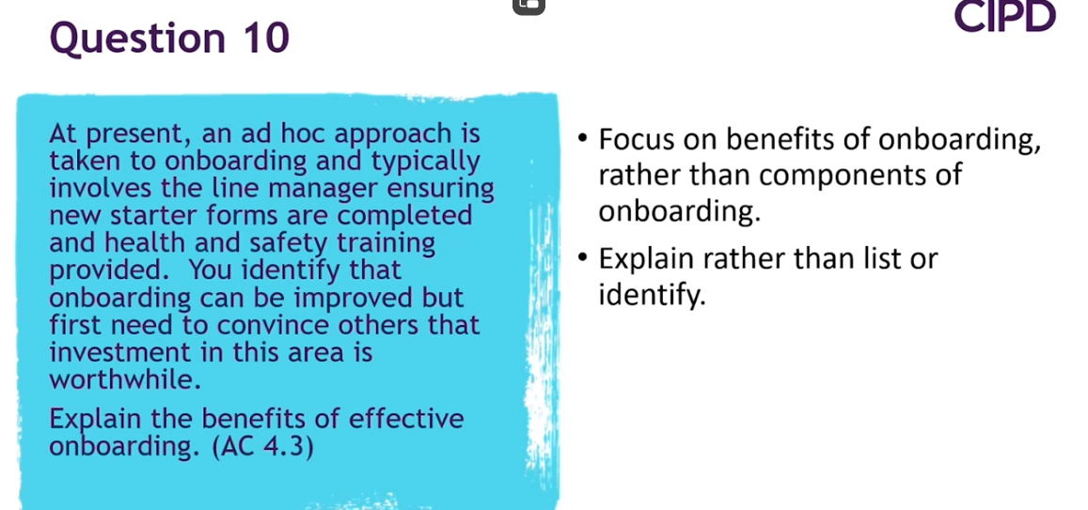
Induction | Factsheets | CIPD
https://www.forbes.com/consent/ketch/?toURL=https://www.forbes.com/councils/forbeshumanresourcescouncil/2020/12/02/why-effective-onboarding-is-more-important-than-ever/

BIBLIOGRAPHY
WEBSITES
ACAS (2024) Zero Hour Contracts available at Zero-hours contracts - Acas accessed 11 November 2024
Beatson, M (2024) Zero Hour Contracts available at https://www.cipd.org/uk/knowledge/factsheets/zero-hours-factsheet/?_gl=1*dxgseq*_ga*MTQ0NTM4Nzc3LjE2ODY2NjY2OTc.*_ga_D9HN5GYHYY*MTcyNzg5ODExMi4xMjQuMS4xNzI3ODk5MDI3LjU2LjAuMA..#zero-hours accessed 11 November 2024
Cholteeva, Y (2022), High employee turnover damaging company culture, research suggests
Available at https://www.peoplemanagement.co.uk/article/1795419/high-employee-turnover-damaging-company-culture-research-suggests#:~:text=Increased%20employee%20turnover%20is%20leading%20to%20the%20deterioration accessed 11 November 2024
CIPD, undated, Productivity and People Management – CIPD ViewPoint, available at Productivity and people management | CIPD Viewpoint | CIPD accessed 29 October 2024.
CIPD (2022), Inclusive recruitment: Guide for people professionals available at https://www.cipd.org/uk/knowledge/guides/inclusive-employers/#selection-process- accessed 2 November 2024
CIPD (2024)CIPD Good Work Index available at Good Work Index | Survey reports | CIPD accessed 11 November 2024
Cotton, C (2024) Reward: An Introduction available at https://www.cipd.org/uk/knowledge/factsheets/reward-factsheet/#totalreward accesses 10 November 2024
CruncHR, 2024, Understanding Dysfunctional Turnover: Impact, Prevention, and Strategies, available at https://www.crunchr.com/resources/blog/understanding-dysfunctional-turnover-impact-prevention-and-strategies/ accessed 2 November 2024
Gamba Quilliam, G (2024) Talent Management Factsheet available at https://www.cipd.org/uk/knowledge/factsheets/talent-factsheet/#Benefitstalentmanagement accessed 2 November 2024
Hayden, D, Workforce Planning available at https://www.cipd.org/uk/knowledge/factsheets/workforce-planning-factsheet/ accessed on 29 October 2024
Indeed, 2024, 6 Advantages and 5 Disadvantages of Internal Recruitment, available at https://www.indeed.com/career-advice/career-development/disadvantages-internal-recruitment#:~:text=5%20cons%20of%20internal%20recruitment%201%201.%20Creating,culture%20...%205%205.%20Encouraging%20unfair%20promotions%20 accessed on 2 November 2024
Indeed (2024a) Recruiter Ghosting: Why It Happens and How To Handle It available at Recruiter Ghosting: Why It Happens and How To Handle It | Indeed.com accessed 10 November 2024
Indeed (2024b) What Is a Realistic Job Preview? (Plus Why It's Important) available at https://www.indeed.com/career-advice/career-development/realistic-job-preview#:~:text=A%20realistic%20job%20preview%20is%20a%20tool%20that%20employers%20use accessed 10 November 2024
Lewis Silkin (2023) Fixed Term Contracts Guide available at https://www.cipd.org/uk/knowledge/guides/fixed-term-contracts-guide/#summary-of-legal-rights-and-protections accessed 11 November 2024
McCartney, C (2023), CIPD Recruitment Factsheet available at Recruitment process overview | Factsheets | CIPD accessed on 29 October 2024
McCartney, C (2023a) CIPD Selection Methods factsheet available at https://www.cipd.org/uk/knowledge/factsheets/selection-factsheet/#Selectionprocess accessed on 2 November 2024
McCartney, C (2023b) Induction available at Induction | Factsheets | CIPD accessed 10 November 2024
People Management (2010) Workforce Planning: A force for good available at https://www.peoplemanagement.co.uk/article/1741070/workforce-planning-force-for-good accessed on 29 October 2024
Peters, R (2024) Employee Turnover and Retention available at https://www.cipd.org/uk/knowledge/factsheets/turnover-retention-factsheet/ accessed 10 November 2024
Practical aptitude tests (undated), What is a Psychometric Test? Available at https://www.practiceaptitudetests.com/what-is-a-psychometric-test/#:~:text=A%20psychometric%20test%20is%20an%20assessment%20used%20to,candidate%20to%20perform%20well%20in%20a%20job%20role accessed on 2 November 2024
Thomas, J (2019) Retaining talent with leadership that cares available at https://www.hrmagazine.co.uk/content/features/retaining-talent-with-leadership-that-cares#:~:text=Retention%20strategies%20could%20cover%20identifying%20potential accessed 10 November 2024
Young (2024) Job Design factsheet available at Job Design | Factsheets | CIPD accessed 11 November 2024

