ASSIGNMENT1
Research, Build, and deploy a virtualized Enterprise Network

Module: Network Operating System Services

Module Code: ACCA5023

Student Name: Beda Clement NDEPO

Student No: 2411399

Lecturer: MD Sadeque Imam Shaikh



UNIVERSITY OF WALES TRINITY ST DAVID

Table of Contents
INTRODUCTION 2
TASK 1 3
1- Research on Hypervisor 3
1.1 Hypervisor type 1 and type 2 3
1.2 Advantages & Disadvantages 4
1.3 Features of Type 1 and 2 4
1.4 Research on IP Addressing 4
1.4.1 What is IP address 4
1.4.2 IP Address Contributions 5
1.4.3 IP Address function 5
1.4.4 Difference between IPV4 and IPV6 5
Practical Example 6
1.4.5 How it works 6
1.5 Research on Routing 6
1.5.1 Difference between Static and Dynamic Routing 6
1.6 Research on Network Services 7
1.6.1 Virtual Private Networks (VPNs) 7
VPNs provide secure remote access by encrypting data traffic, protecting confidentiality across public networks. [9] 7
1.6.2 Dynamic Host Configuration Protocol (DHCP) 8
1.6.3 Active Directory Domain Services (AD DS) 8
1.6.4 Certificate Authorities (CAs) & PKI 8
TASK 2 9
2.1 Evidence of Download and installation 9
2.1.1 Creation of Virtual machine Windows1 and 2 9
2.1.2 Creation of Virtual machine Linux Debian1 and 2 9
2.1.3 Installation of Windows and Linux OS 10
as you can see on the virtual box the 4 operations systems windows and Linux are installed and are running well 10
2.2 Network Deployment 10
2.2.1 Creation of Network with NAT Network 1 for windows 11
2.2,2 Creation of Network with NAT Network 2 for Linux 11
2.3 IP addressing 12
2.3.1 Windows Server and Windows Client 12
2.3.2 Debian Server & Client 12
2.3.3 Successful connectivity within Windows network. (Ping 192.168.1.1 and Ping 192.168.1.10) 13
13
2.3.4 Successful connectivity within Linux network. (Ping 192.168.2.1 and Ping 192.168.2.10) 13
2.3.5 Unsuccessful connectivity between Linux and windows network 14
TASK 3 14
3- Technical Reflection covering network deployment and testing 14
3.1 Personal reflection 15
CONCLUSION 15
References 16

INTRODUCTION

Network operations systems and services comprise the tools, processes, and architectures used to monitor, manage, and maintain network infrastructures for optimal performance. They play a vital role in tracking network behaviour, regulating traffic, ensuring quality of service, and detecting anomalies, functions that are crucial for effective network management and informed decision‑making. Through this study, we will define the appropriate hypervisor type, how IP addressing is important, and some research on routing and Network services.

TASK 1

Research on Hypervisor

1.1 Hypervisor type 1 and type 2
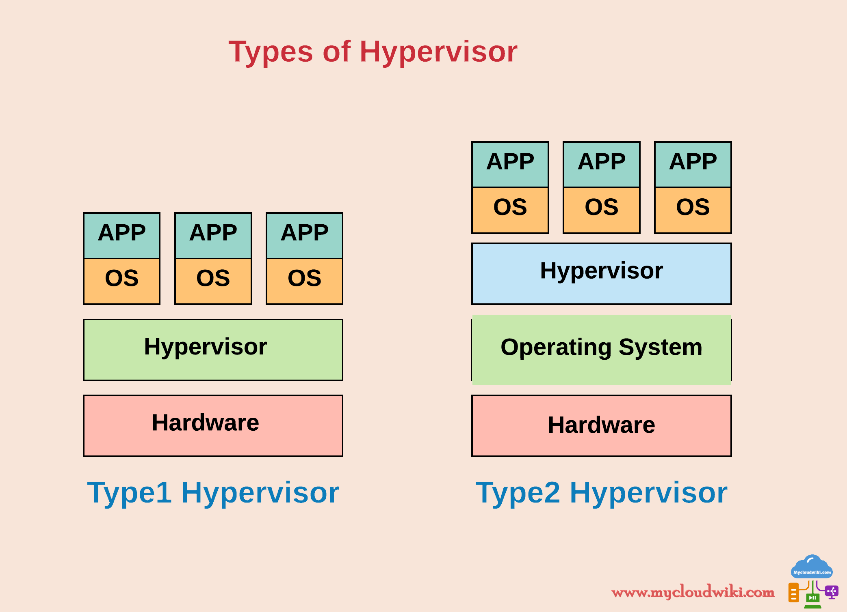
A hypervisor is software that enables multiple operating systems to run at once on a single physical machine by controlling hardware resources. [1]

Type 1 Hypervisors (Bare-Metal):
Run directly on hardware, no host OS. Provide strong isolation, security, and performance. Common in servers, less desktop support.
Type 2 Hypervisors (Hosted):
Operates on a host OS, easy to deploy, best for testing/dev, less isolation. Examples: VMware Player, Parallels Desktop, Windows Virtual PC.

1.2 Advantages & Disadvantages
Hypervisors are a fundamental element of virtualization technology, serving as an abstraction layer that allows Multiple virtual machines can run at the same time on a single physical system. By decoupling VMs from the underlying hardware, hypervisors enhance resource efficiency and enable diverse operating systems to coexist on the same platform. This separation also strengthens security by isolating each VM, thereby minimizing the risk of direct hardware-based attacks. [2]

1.3 Features of Type 1 and 2
Type 1 (Bare-metal Hypervisors)
Runs directly on hardware without a host operating system.
Performance & Stability: Offers better resource utilization and lower overhead.
Features: Live migration, high availability, snapshots, clustering, enterprise-grade scalability.
Type 2 (Hosted Hypervisors)
Runs on top of a host OS (e.g., Windows or Linux).
Ease of Use: Simple to install and manage, good for labs or small setups.
Features: Snapshots, portability, but less efficient than Type 1.
Considering the environment (SWANSEA ACCA) the most suitable hypervisor for this topology is the type2 because:
Oracle VirtualBox is free, cross-platform, supports Windows and Debian.
VMware Workstation is a robust desktop virtualization, good for testing

1.4 Research on IP Addressing

1.4.1 What is IP address
An IP address is the core system that directs data across the internet, like a digital postal service. Routers act as mail carriers, moving packets between devices until they reach their destination. Unique addresses and routing protocols ensure data arrives at the right place efficiently. [3]
IP addresses are the backbone of digital communication, making networks functional, effective, and capable of supporting everything from personal devices to global enterprises.
Data is split into packets, routed through networks, and reassembled at the destination, with IP addresses guiding each packet to ensure reliable communication. Switches link devices within a local network, while routers guide data between networks across the internet.

An IP address contributes by uniquely identifies devices, enabling efficient routing for reliable, scalable, and secure communication

1.4.2 IP Address Contributions

Contributions | Descriptions
Unique Identification | Each device is assigned a distinct IP address, preventing confusion and ensuring accurate delivery of data packets.
Location Addressing | IP addresses act like digital coordinates, guiding routers to deliver information to the correct destination.
Efficient Data Transmission | By combining identification and location, IP addresses enable seamless communication among billions of devices.
Routing and Delivery | Routers use IP addresses to choose the best path for data, ensuring speed, reliability, and scalability.
Scalability and Growth | IPv4 and IPv6 systems allow networks to expand; IPv6 supports nearly limitless unique addresses.
Security and Tracking | IP addresses enforce security policies, detect suspicious activity, and aid troubleshooting.

1.4.3 IP Address function
An IP address is a vital identifier that enables device communication across networks. As cloud computing and the Internet of Things expand, the surge in connected devices demands careful IP management to prevent conflicts and maintain efficient network operations [4]

1.4.4 Difference between IPV4 and IPV6
The key difference between IPv4 and IPv6 is address space. IPv4’s 32-bit system supports about 4.3 billion addresses, which ran out around 2010 due to rapid internet growth. IPv6, with its 128-bit design, offers 2^128 possible addresses, ensuring ample capacity for future expansion [5]
Feature | IPv4 | IPv6
Address Size | 32-bit (≈4.3 billion addresses) | 128-bit (≈340 undecillion addresses)
Header Complexity | Larger, more complex
Address Format | Decimal, dotted (e.g., 192.168.0.1) | Hexadecimal, colon-separated (e.g., 2001:0db8:85a3::8a2e:0370:7334)
Configuration | Manual or DHCP | Auto-configuration supported
Security | No built-in security (requires IPSec as add-on) | IPSec is mandatory, providing stronger security
Efficiency | Less efficient | More efficient, reduces routing table size
Quality of Service | Limited support | Better traffic prioritization for voice/video

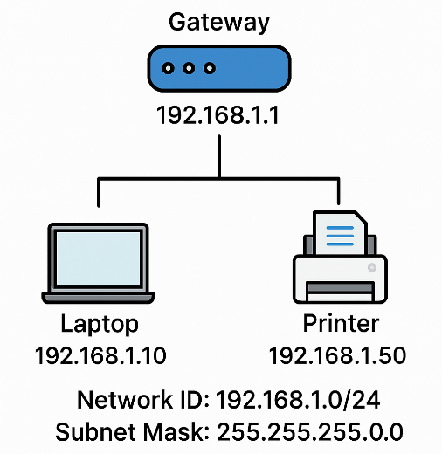
Practical Example
Imagine you’re setting up a small office:
Network ID: 192.168.1.10/24
Subnet Mask: 225.225.225.0
Gateway: 192.168.1.1 (router)
Devices:
• Laptop: 192.168.1.10
• Printer: 192.168.1.50

1.4.5 How it works
When the laptop (192.168.1.10) wants to print, it sends data directly to the printer (192.168.1.50) because they’re on the same subnet.
When the laptop wants to browse the web, it sends traffic to the gateway (192.168.1.1), which forwards it to the internet.

1.5 Research on Routing
Routing protocols are systems that define how data travels from a source node to its destination within a network. They are vital for directing data packets efficiently and reliably across different types of networks. By continuously managing routes, these protocols overcome challenges such as shifting network topologies, restricted bandwidth, energy limitations, and significant propagation delays. Their importance is particularly evident in specialized environments, including underwater wireless sensor networks (UWSNs) and opportunistic networks, where conditions are highly dynamic and resource constrained. [6]
Routing protocols play a crucial role in guiding data across networks by identifying the most efficient paths for transmission. They function by allowing routers to share network information, evaluate possible routes, and dynamically adjust to changes in the network to maintain smooth and reliable communication.

1.5.1 Difference between Static and Dynamic Routing
A Static Routing is: Manually configured routes by an administrator.
- Operation: Fixed paths in the routing table; no automatic updates.
- Advantages: Simple for small networks; predictable and secure.
- Disadvantages: Not scalable; requires manual changes if topology shifts.
Example: Small office router with preset route to the internet.

Dynamic Routing: Routes learned and updated automatically via routing protocols.
- Operation: Routers exchange information and adjust paths as the network changes.
- Advantages: Scalable, adaptive, and resilient to failures.
- Disadvantages: More complex; consumes bandwidth and processing resources.
- Example: Enterprise network using OSPF to reroute traffic when a link goes down.

If you have a single router connecting the Debian relay and the Windows server: Use static routes. Keep the route from client subnets to the Windows server and back clear and tested. DHCP relay will work if the relay can reach the Windows server’s DHCP service and return traffic is routed correctly. [7]
If you have multiple routers or redundant links between client subnets and the Windows server: Use a dynamic IGP like OSPF so the relay and clients maintain reachability during failures without manual intervention.
According to the topology setup with one route, the best routing approach will be the static Routing

1.6 Research on Network Services
VPNs are commonly deployed to securely link remote offices, research sites, and mobile users, serving as a cost-effective alternative or supplement to dedicated network lines. By encrypting data traffic, they enable safe remote access and ensure that information remains confidential even when transmitted across public networks. [8]
VPNs safeguard remote connections, DHCP streamlines IP address allocation, AD DS centralizes identity and policy management, and certificate authorities (CAs) establish trust through digital certificates. Effective use of these technologies relies on strong security, precise configuration, and scalable practices.

1.6.1 Virtual Private Networks (VPNs)

VPNs provide secure remote access by encrypting data traffic, protecting confidentiality across public networks. [9]

Features: Confidential data exchange, remote access, IPSec/SSL/TLS
Best Practices: Strong encryption, MFA, regular patching, log monitoring

1.6.2 Dynamic Host Configuration Protocol (DHCP)
DHCP automates IP configuration by dynamically assigning addresses and network settings, reducing errors and simplifying administration.
Features: Dynamic IP assignment, subnet/gateway/DNS configuration, lease management
Best Practices: Reservations for critical devices, VLAN segmentation, failover setup, log auditing

1.6.3 Active Directory Domain Services (AD DS)
AD DS consolidates identity, access control, and policy administration for enterprise environments. [10]
Features: Centralized user/group management, Kerberos authentication, Group Policy enforcement, domain trust relationships
Best Practices: Apply least privilege, structure OUs logically, clean up stale accounts, enable auditing

1.6.4 Certificate Authorities (CAs) & PKI
Certificate authorities establish digital trust by issuing and managing secure cryptographic certificates. [11]
Features: Certificate issuance for authentication, encryption, and signatures; supports SSL/TLS, S/MIME, code signing; integrates with AD CS
Best Practices: Secure root CA, protect keys with HSMs, renew/revoke certificates regularly, enforce strong cryptography, document PKI policies

TASK 2

Evidence of Download and installation
A Type 2 hypervisor is best when you need a simple, flexible way to run multiple operating systems on a personal computer. It allows easy software testing and exploration of new environments without rebooting or investing in extra hardware.
Would you like me to make this even more concise like a one‑line tagline you could use in slides or notes?

2.1.1 Creation of Virtual machine Windows1 and 2
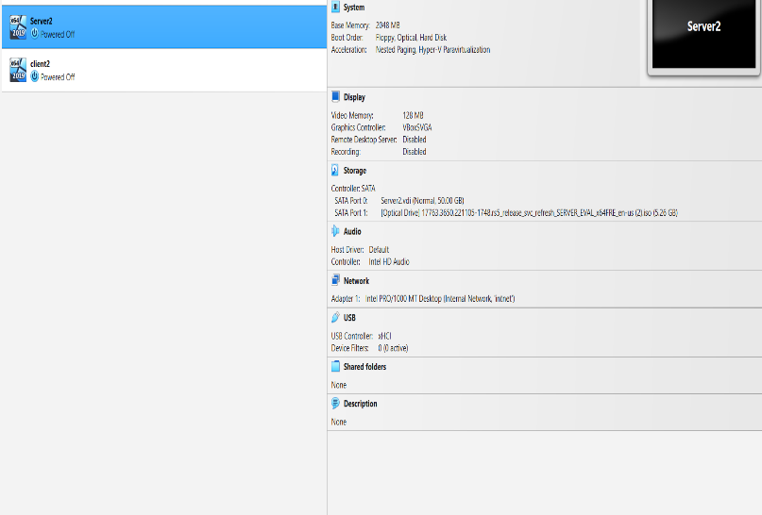
1. Download and Install VirtualBox
- Go to the Oracle VirtualBox official site.
- Download the latest Windows installer.
- Run the setup file and follow the wizard.
2. Install Extension Pack (Optional but Recommended)
- Download the VirtualBox Extension Pack from the same site.
- Double-click the file to install it.
3. Create a New Virtual Machine
- Launch VirtualBox Manager.
- Click New, then enter a name (Windows 11).
- Choose the appropriate operating system type and version (Windows).

2.1.2 Creation of Virtual machine Linux Debian1 and 2

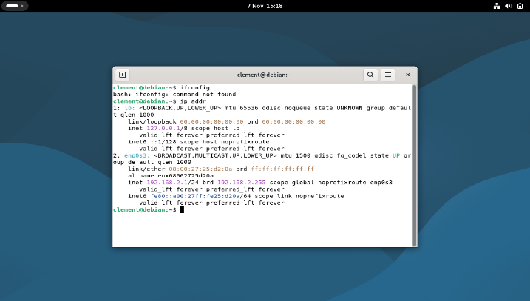
1 Install VirtualBox
• Download VirtualBox from Oracle’s official site.
• Install it on your system (Linux Debian server and Client).
Create a New Virtual Machine
- Open VirtualBox and click New.
- Enter the following details:
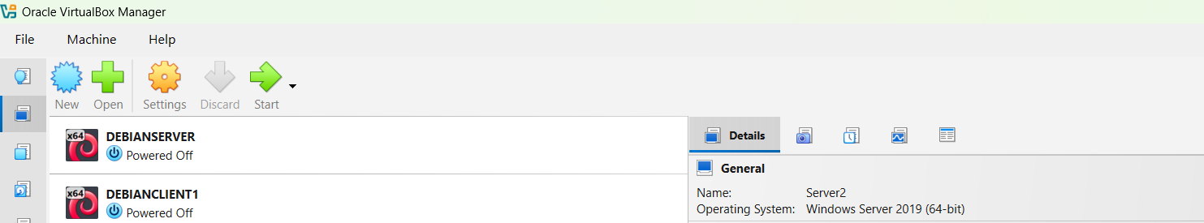
- Name: Debian Server or Debian Client
- Type: Linux

2.1.3 Installation of Windows and Linux OS

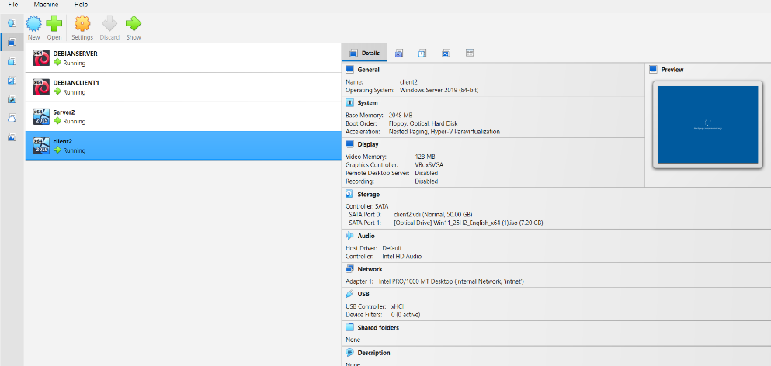
as you can see on the virtual box the 4 operations systems windows and Linux are installed and are running well

Network Deployment

2.2.1 Creation of Network with NAT Network 1 for windows

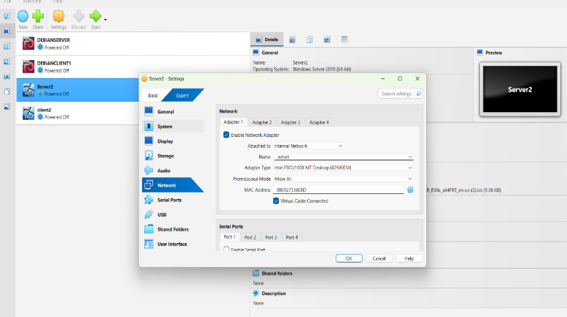
Go to setting and click on Network enable Network Adapter choose Name: intnet promiscuous mode Allow all

2.2,2 Creation of Network with NAT Network 2 for Linux

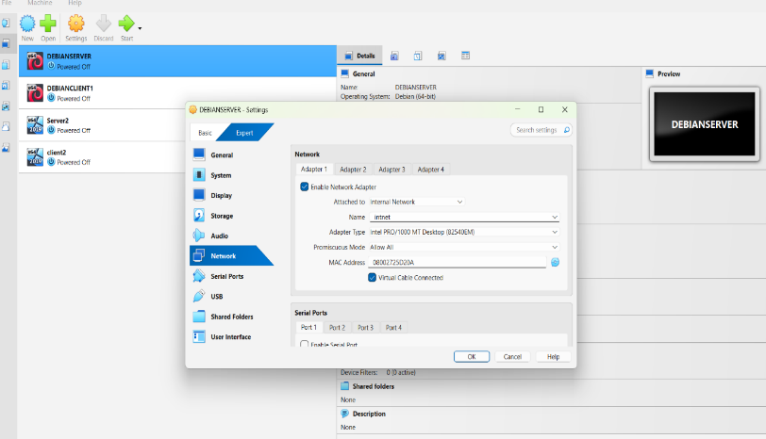
Setting-Network- enable Network Adapter-Name intnet-promiscuous mode allow all

IP addressing

2.3.1 Windows Server and Windows Client
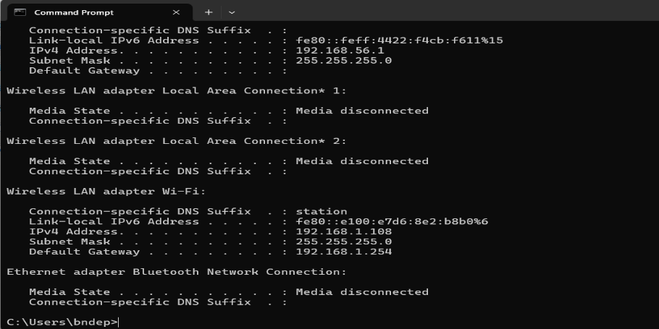

Windows Server IP address 192.168.1.1
Write in command prompt ipconfig then enter

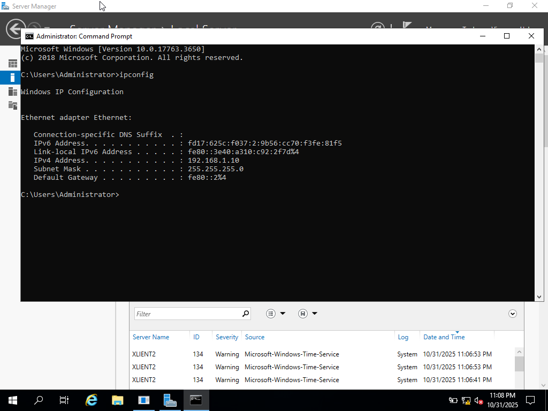
Windows Client IP address 192.168.1.1.10
Write Ipconfig in command prompt then enter

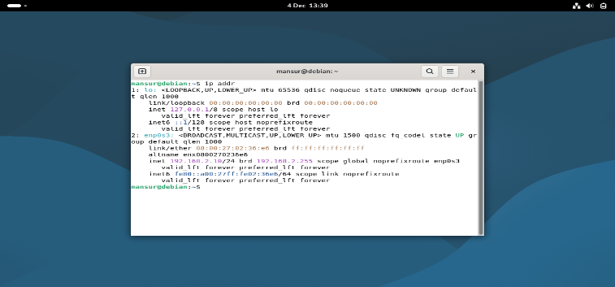
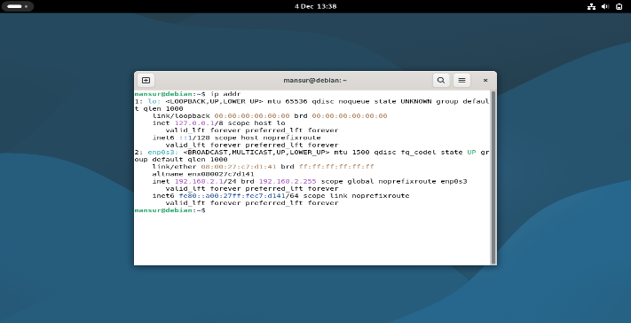
2.3.2 Debian Server & Client
Debian Server 192.168.2.1
Debian Client 192.168.2,10

To find the IP address of Debian you should type Ip addr in command prompt

2.3.3 Successful connectivity within Windows network. (Ping 192.168.1.1 and Ping 192.168.1.10)
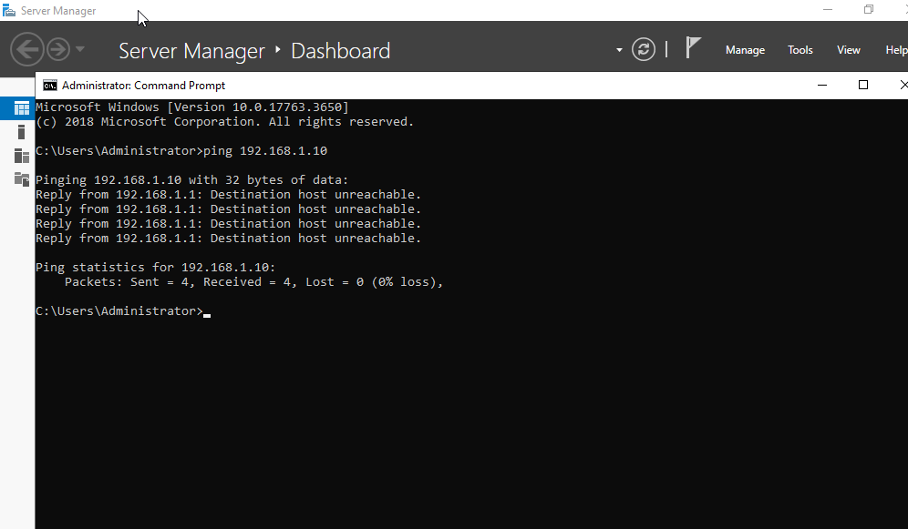
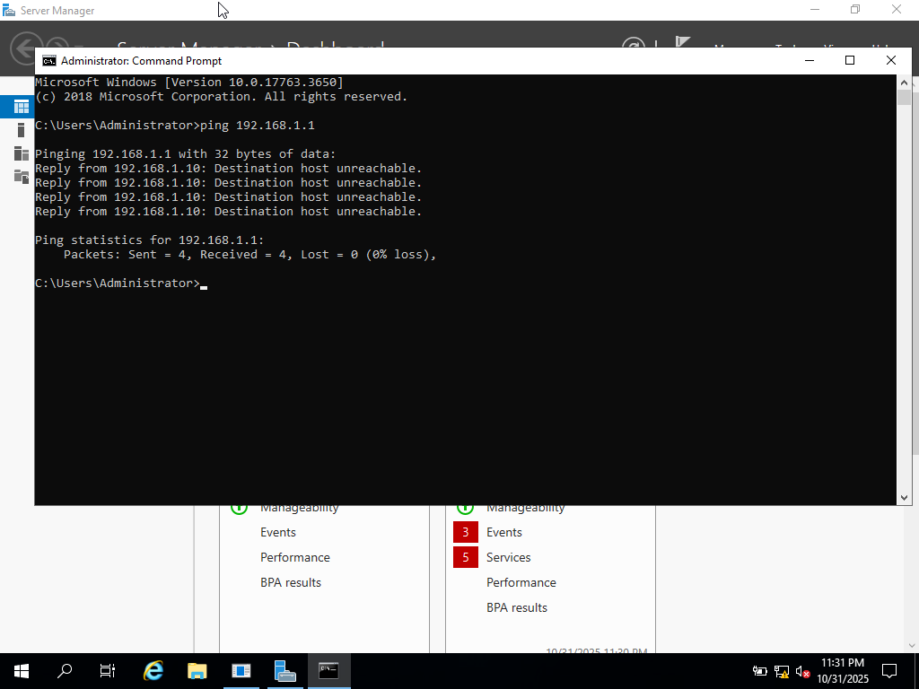
Ping Windows Client 192.168.1.10 to windows Server
Ping Windows sever 192.168.1,1 to Windows Client

Windows networks achieve seamless connectivity because all systems rely on common protocols, default firewall rules, unified authentication methods, and built-in discovery features, making communication nearly effortless.

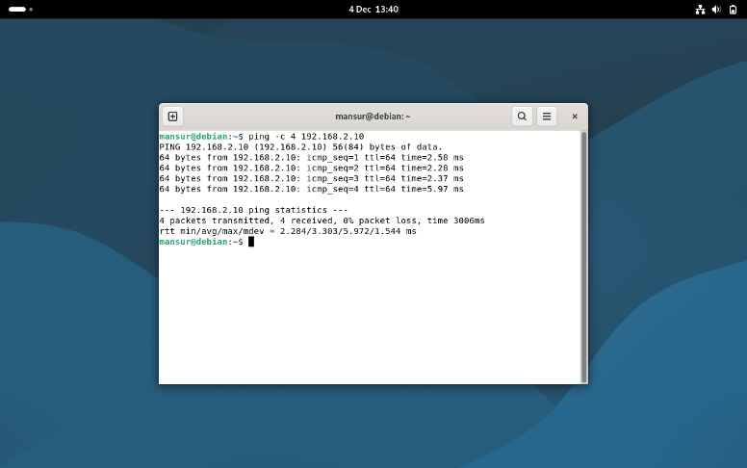
2.3.4 Successful connectivity within Linux network. (Ping 192.168.2.1 and Ping 192.168.2.10)
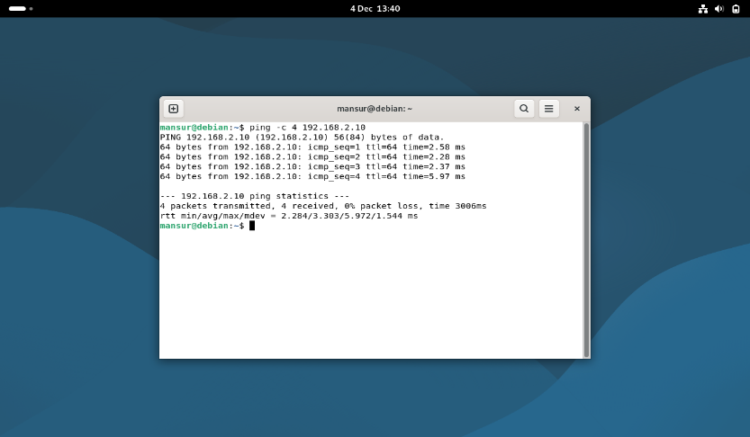

Linux systems connect successfully because they rely on open protocols, standardized tools, flexible configurations, and a unified kernel networking stack, ensuring reliable and predictable communication.

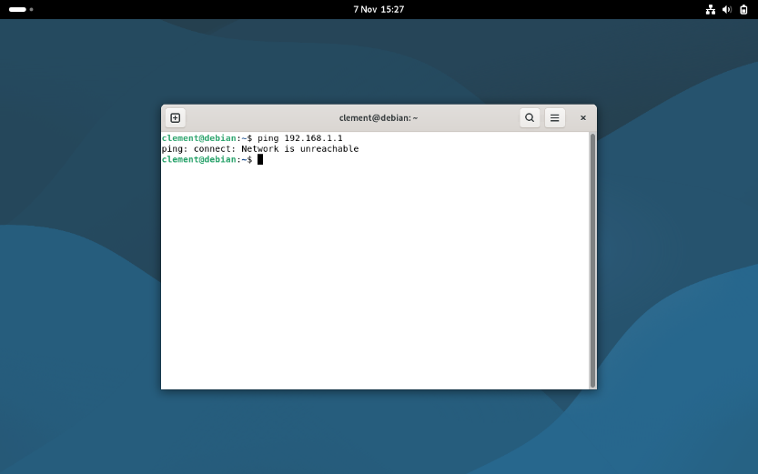
2.3.5 Unsuccessful connectivity between Linux and windows network

Connectivity issues between Linux and Windows often arise from firewall restrictions, protocol or service incompatibilities, incorrect IP or subnet configurations, authentication errors, or problems with virtualization and network adapters.

TASK 3

Technical Reflection covering network deployment and testing
Network deployment and testing often expose hidden complexities. IP conflicts highlight the need for structured address management, DNS issues emphasize the importance of reliable name resolution, and firewall misconfigurations remind us that security must balance accessibility. The reflection here underscores that resilient networks are built not only on strong design but also on careful validation, documentation, and continuous monitoring.
1 IP Address Conflicts
Issue: Duplicate IPs from poor static management or DHCP misconfiguration.
Impact: Connectivity loss, unstable ARP tables, time-consuming troubleshooting.
Resolution: Use DHCP scopes/reservations, maintain IPAM, and monitor conflicts proactively.
2 DNS Resolution Problems
Issue: Misconfigured servers, stale records, or delays in propagation.
Impact: Service access failures, broken dependencies (e.g., email, authentication).
Resolution: Validate DNS hierarchy, refresh caches, monitor with tools, and apply split-horizon DNS.
3 Firewall Configuration Challenges
Issue: Rules too restrictive block traffic; too permissive expose vulnerabilities.
Impact: Application communication failures weakened security posture.
Resolution: Apply least-privilege principles, document/test rules, monitor traffic, and automate deployments.

The deployment and testing phases must prioritize DNS resolution optimization, automated firewall configuration, and validation of stateful network functions to proactively address common issues that could undermine network performance and security. [12]

3.1 Personal reflection
Networking is a system of interdependencies where hypervisors enable virtualization, routing manages traffic, services provide functionality, connections ensure communication, deployment supports scalability, and IP addressing unifies it all. My experience across these areas highlighted the need for precision, planning, and adaptability to build reliable networks.

CONCLUSION
In conclusion, this assignment allowed us to explore and address questions related to hypervisors, routing, network services and connections, IP addressing, and deployment. However, certain practical challenges remain unresolved, such as establishing reliable connectivity between Debian and Windows systems

References

[1] | b. Jon, “bare-metal desktop hyprvisor: A primer,” Southborough Foundry, london, 2010.
[2] | P. M and Z. S. H. R. ichael, “Virtualisation: Issues, Security Threats and solution,” ACM computing Surveys, vol. 45, pp. 1-39, 2013.
[3] | M. K. Tiwari, R. Pal, R. Singh, A. K. Singh, V. Kumar, S. Sharma and N. Zaib, “The Comprehensive Review: Internet Protocol (IP) Address a Primer for Digital Connectivity,” Asian Journal of Research in Computer Science, vol. 17, no. 8, pp. .34-45, 2024.
[4] | N. Sahana and U. R. K R, “Design of Intelligent IP Address Management System for Communication Networks,” in 11th International Conference on Computing, Communication and Networking Technologies (ICCCNT), london, 2020.
[5] | M. Jothilakshmi, M. K. Pavithra and S. Yuvabarathi, “Performance Comparison between IPV4 AND IPV6,” International Journal of Science, Engineering and Computer Technology., vol. 4, no. 12, pp. 384-384, 2014.
[6] | A. S. Ismail, X. Wang, A. Hawbani, S. Alsamhi and S. Abdel Aziz, “Routing protocols classification for underwater wireless sensor networks based on localization and mobility,” Wireless networks, vol. 28, no. 2, pp. 797-826, 2022.
[7] | Debian, “Debian Manpage”.
[8] | A. Maulidi, M. Abdullah and D. Handani, “Virtual private network (VPN) model for AIS real time monitoring,” IOP conference series. Earth and environmental science, vol. 1081, no. 1, p. 12028, 2022.
[9] | V. A. B. Scott and S. A. Giancarlo, “Designing the VPN with Top-Down to Improve Information Security,” Science and Information (SAI) Organization Limited; International journal of advanced computer science & applications, vol. 15, no. 6, 2024.
[10] | N. Weinberg, “DHCP defined and how it works,” Network World, 2022.
[11] | P. A. Kadam, S. Bhushan, V. Rishiwal, M. Yadav, P. Yadav and U. Agarwal, “ValidCertify: an effective blockchain-based domain certificate authentication and verification scheme,” Peer-to-peer networking and applications, vol. 18, no. 4, p. 177, 2025.
[12] | D. Ranathunga, M. Roughan, H. Nguyen, P. Kernick and N. Falkner, “Case Studies of SCADA Firewall Configurations and the Implications for Best Practices,” IEEE; IEEE eTransactions on network and service management, vol. 13, no. 4, pp. 871-884, 2016.

