Data Handling & Business Intelligence | BA Business Management LCBB5000_BIRM Abdallah Naser  Georgi Dimitrov Student number 2230344

Section 1

You are working as a data analyst intern with a well-known research centre. This research institute is focused on analysing the daily coffee consumption habits of a selected group of individuals. The research study, titled " student performance ", has collected a comprehensive dataset over a considerable period, ensuring the data is as detailed and accurate as possible. This dataset, handed over to you for detailed analysis, features information regarding daily coffee intake in cups, categorised by each individual participant, alongside a corresponding health index and diagnostic results.
The centre possesses a licensed copy of Microsoft Excel. They have been using this software for their basic data processing and analysis needs. However, for a more detailed, statistically significant study they recently acquired SPSS data mining statistical software. As a data analysis expert, your role is to explore the dataset using the both MS Excel and newly-acquired SPSS software. By fostering a strong collaborative relationship and working closely with the team, your combined efforts will pave the way to new insights about the impacts of coffee consumption on human health, potentially informing future dietary recommendations. Conduct the following tasks and produce a report for your team.

Using the Excel or SPSS statistical software, you need to discuss and analyse the student performance dataset (provided) to evaluate the following:

What is the mean value for reading score?

The arithmetic mean is the most commonly used average, and Excel's AVERAGE function can be used to find it. To create a figure that illustrates a typical value from a range, distribution, or list of values, utilize the Excel AVERAGE function.
AVERAGE calculates the statistical mean from a list of numbers. It ignores text and empties, but includes zeros. (Buckley 2024)

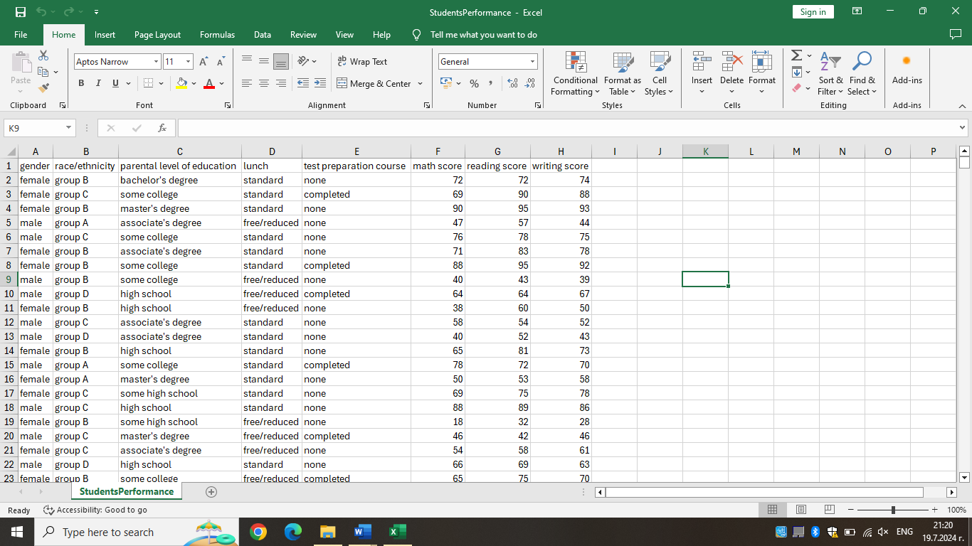
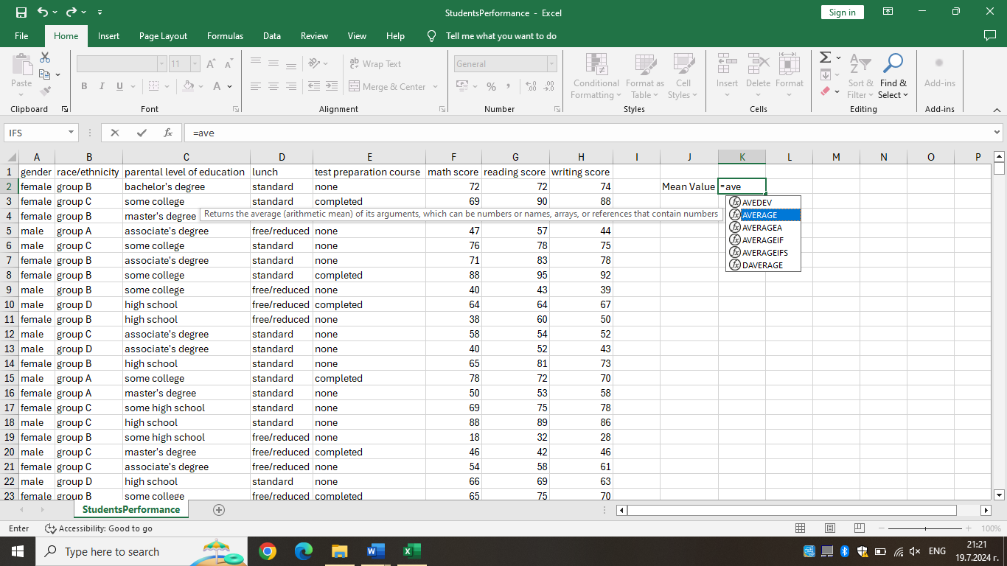

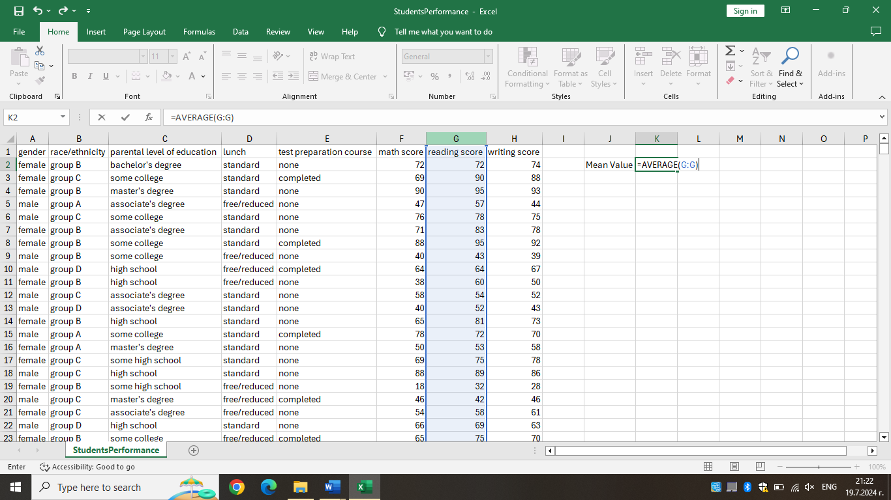

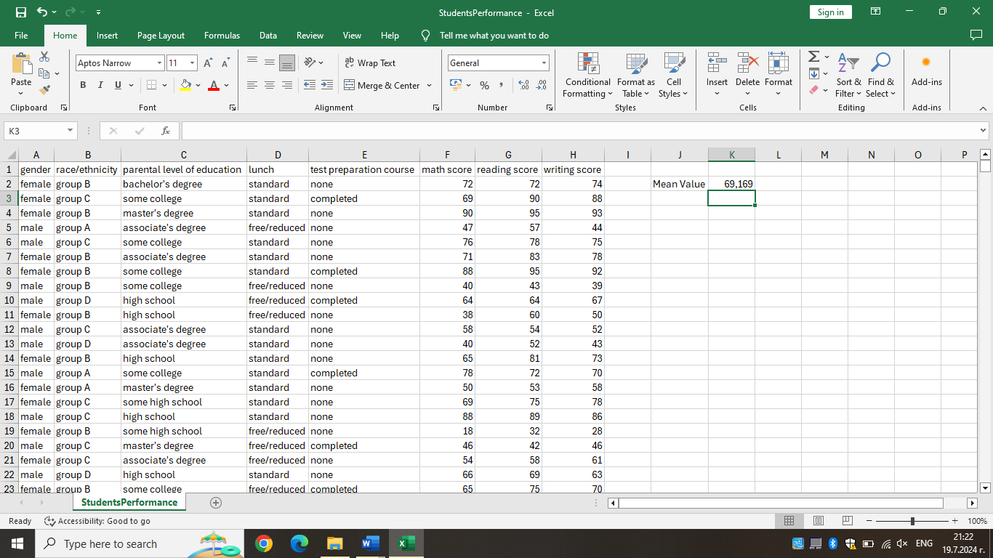

What is the median value for reading score?

Although the arithmetic mean is the approach that is most frequently used to calculate averages, it is by no means the only one. Using the arithmetic mean has the drawback of allowing extremely high or extremely low numbers to drastically change the findings.
Consider the subsequent numerical sequence: 22, 1, 14, 21, 15, 16, 18, 100, 19, 19, 22, 25, 18. The result of calculating the arithmetic mean would be 23.8.
MEDIAN determines the numerical order of the list of values and uses the one in the middle as the average. Manual sorting is not necessary. (Buckley 2024)

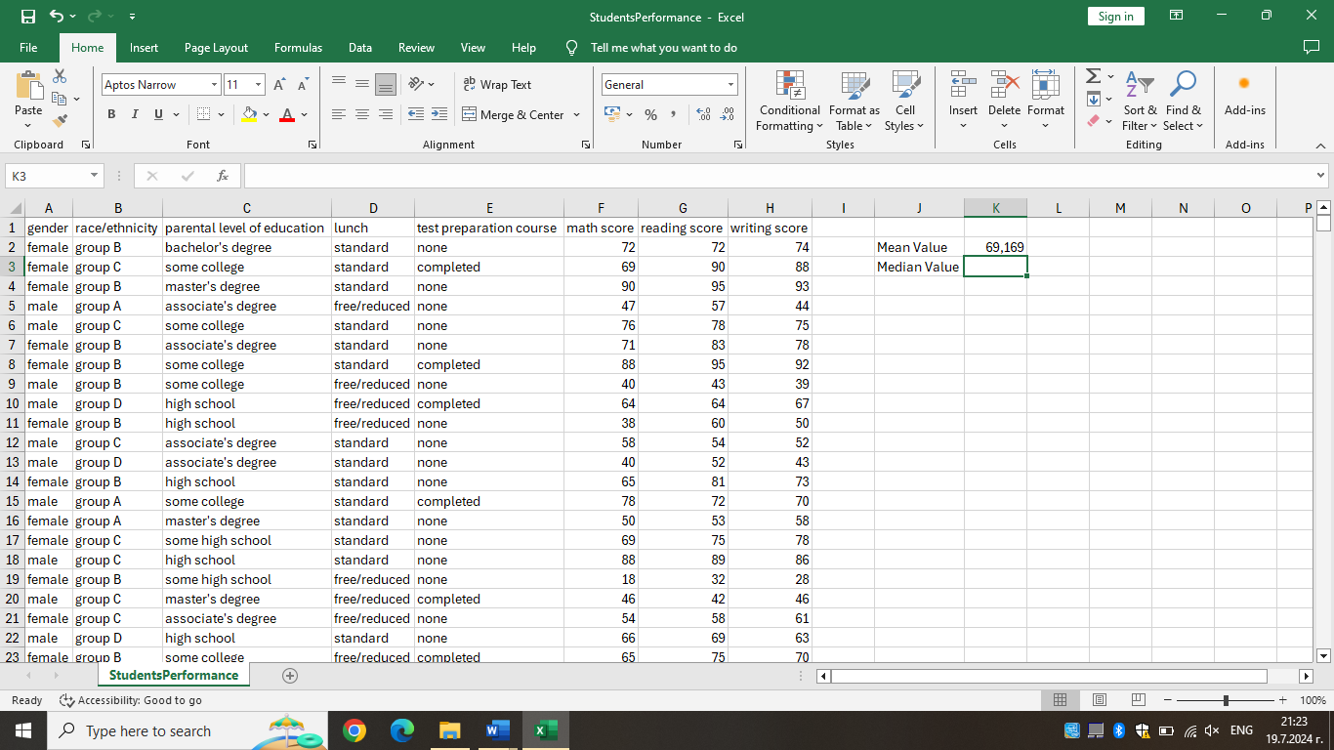

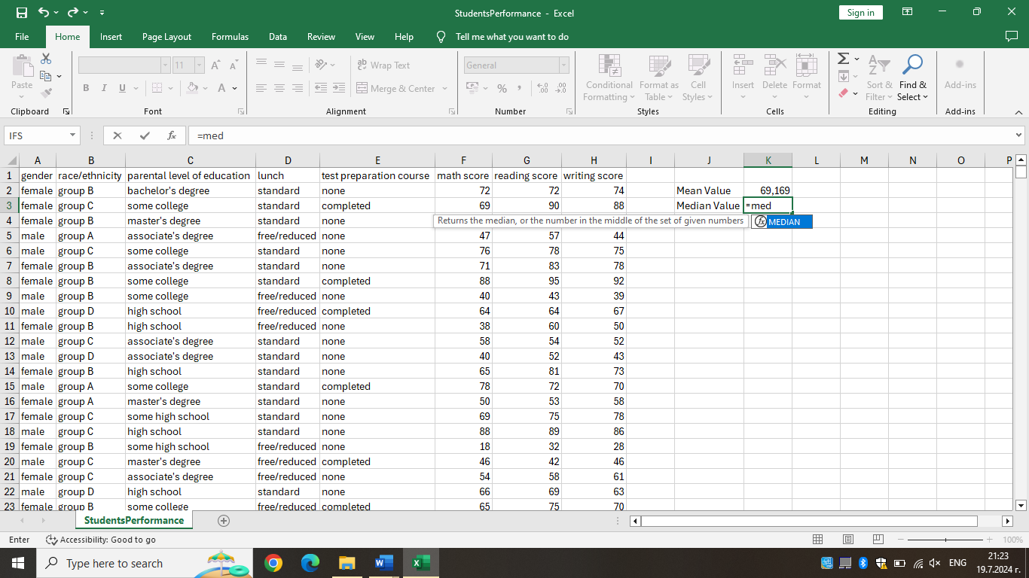

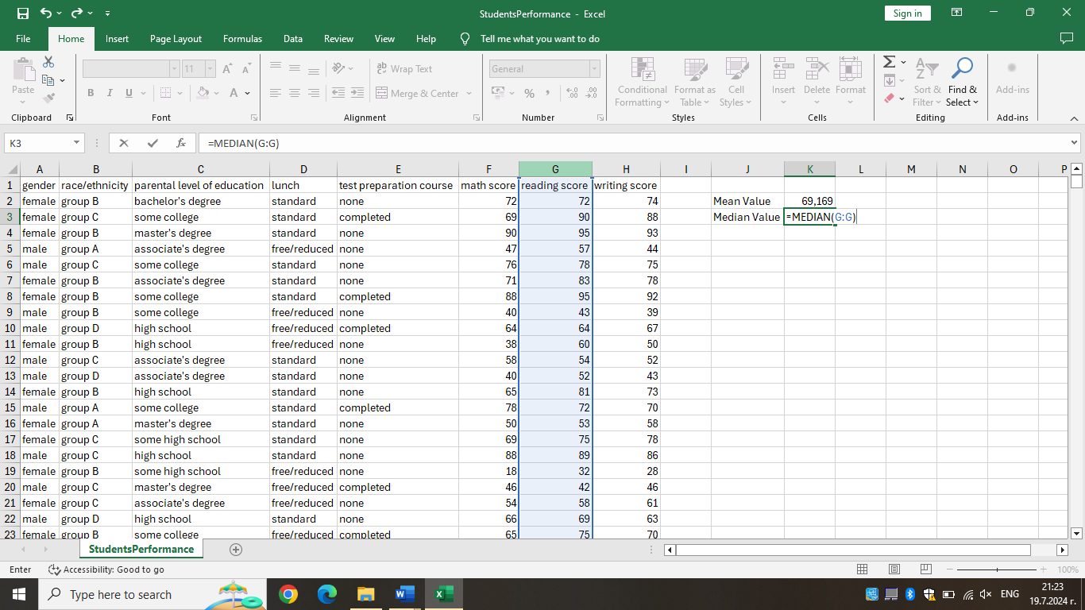

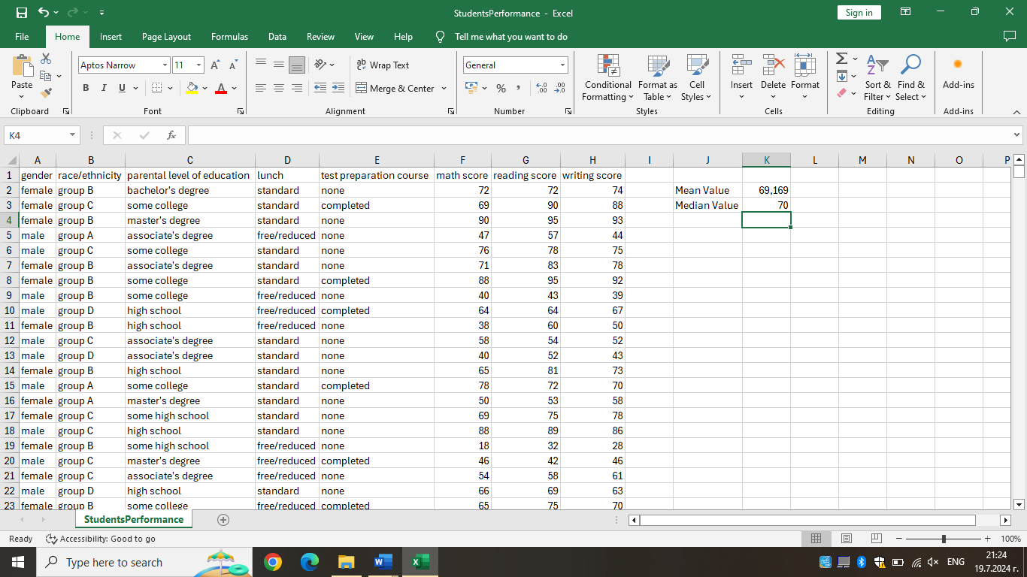

What is the mode of the reading score?

Finding the mode, or the number that is repeated the most, is a third way to calculate the average of a of a group of integers. At the moment, Excel has three "mode" functions. With this function, Excel assesses the values in the list or range and determines the average value of the group by looking at the number that appears the most frequently. The mode calculates the group average using the number that appears the most frequently.

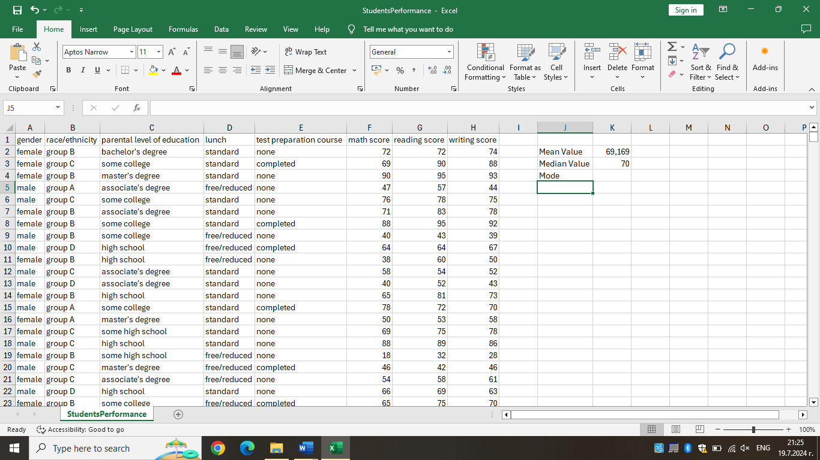

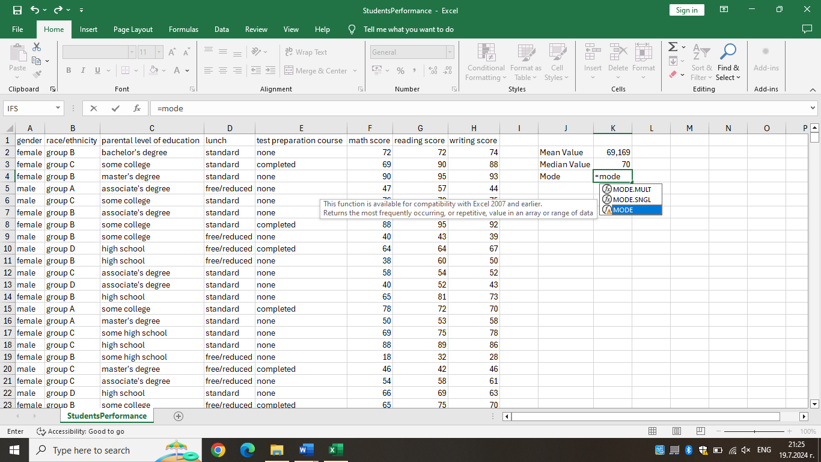

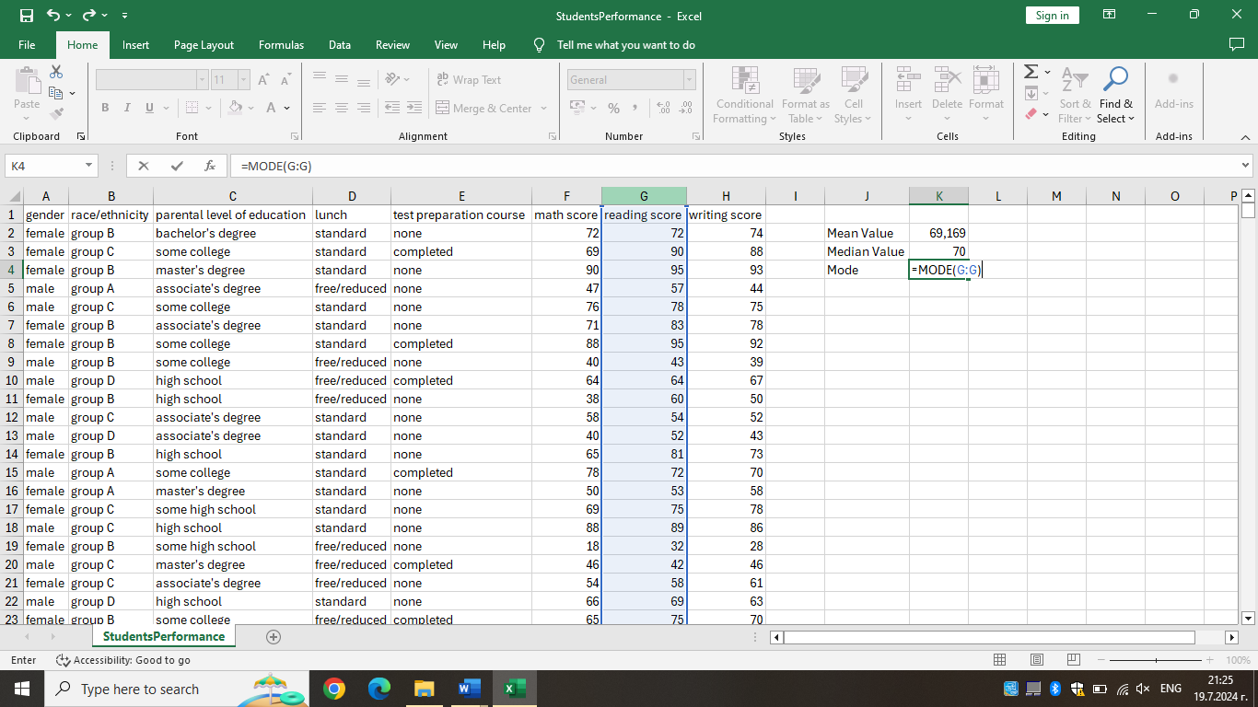

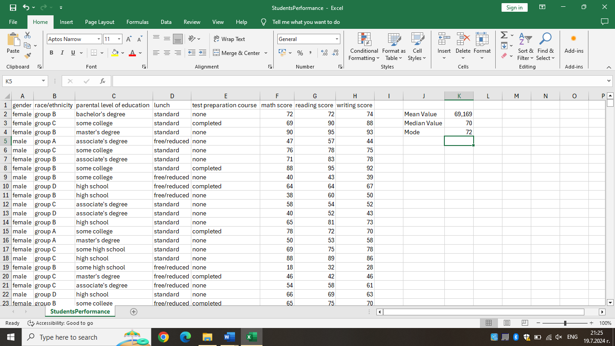

What is the standard deviation for writing score?

A dataset's variation is measured using the standard deviation. This statistic can be quite helpful in determining how similar or different your data is from one another. Standard deviation can be quickly calculated in Microsoft Excel with the right formulae and commands.

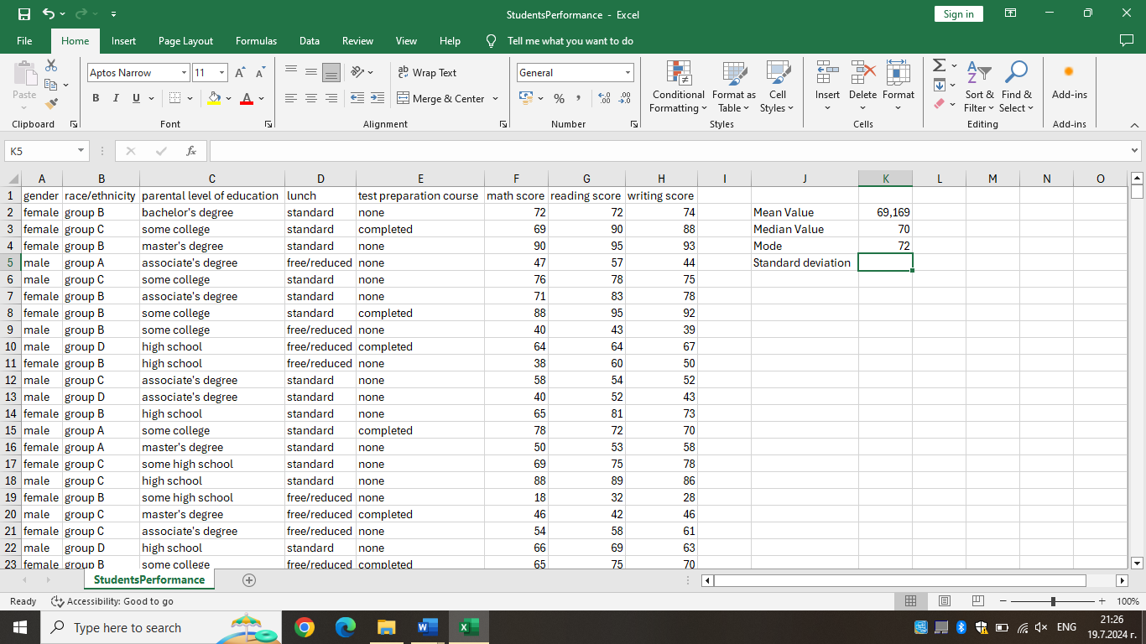

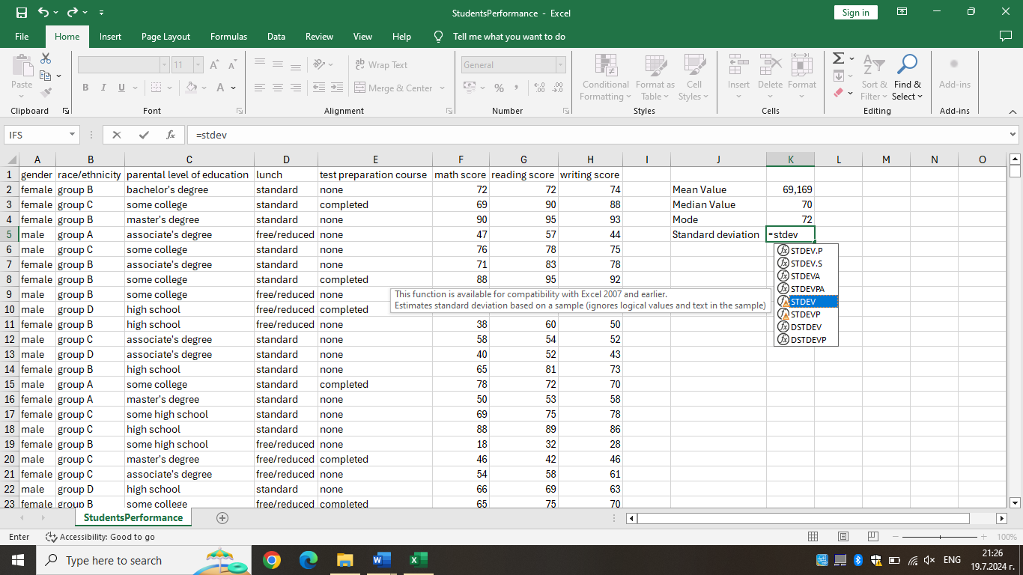

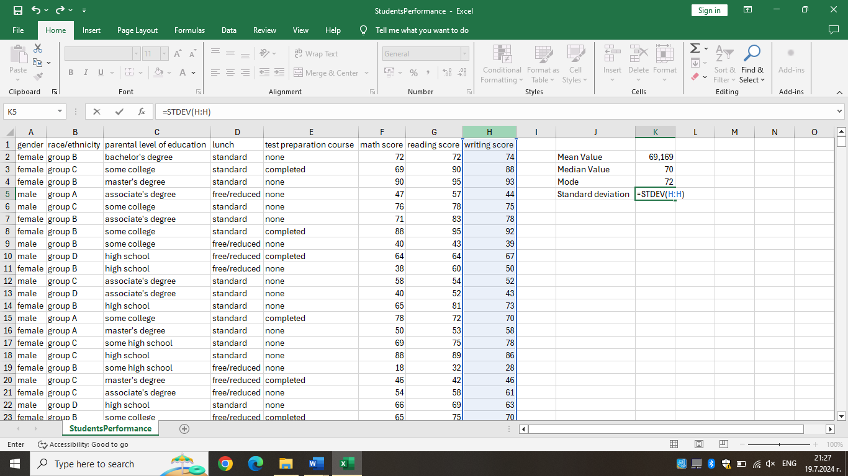

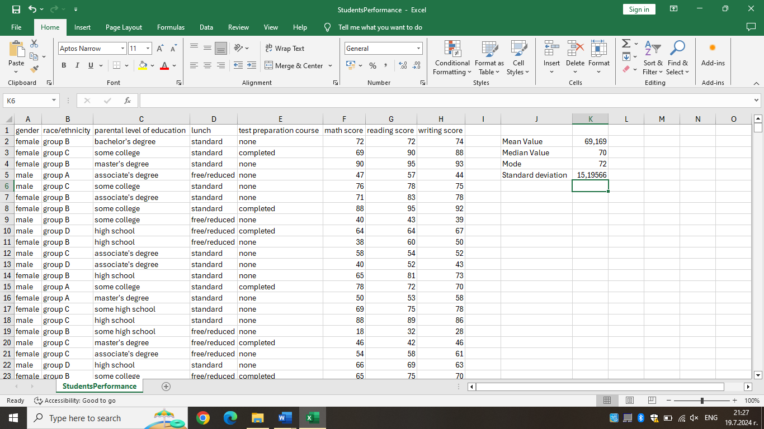

Which one of the variables has a larger variance?

Variance is a measure of how dispersed a set of values is around the data's mean (average) in statistics and probability theory. When something is said to have a "higher variance," it indicates that there is a greater range of values since the data points are further dispersed from the mean.

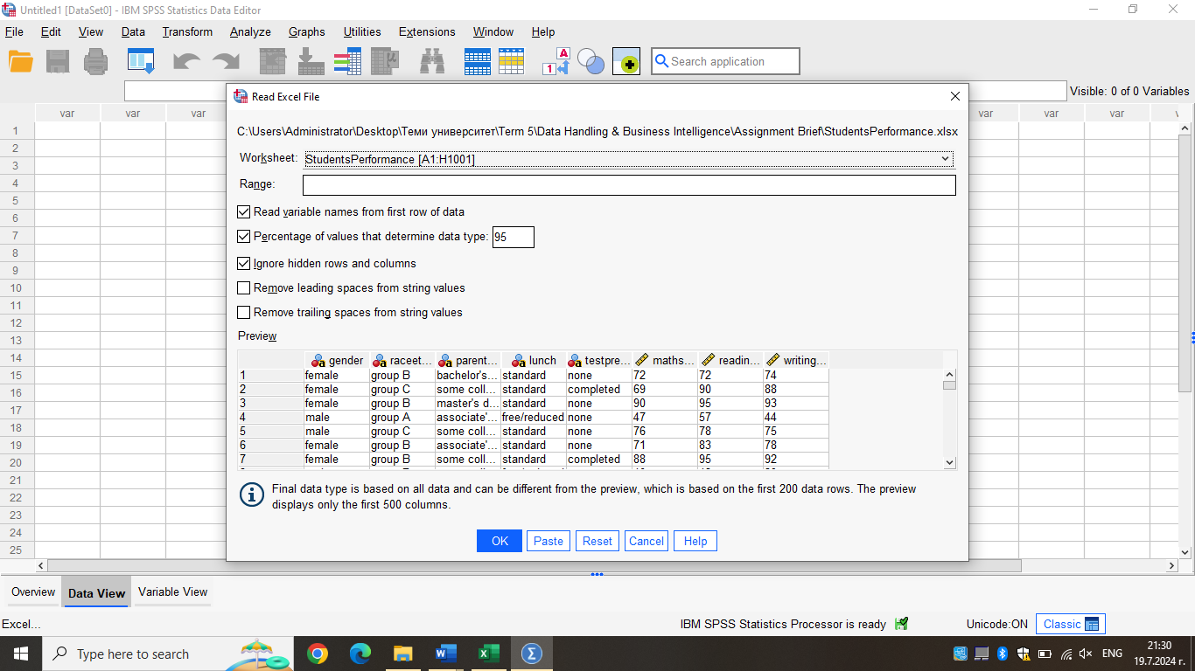

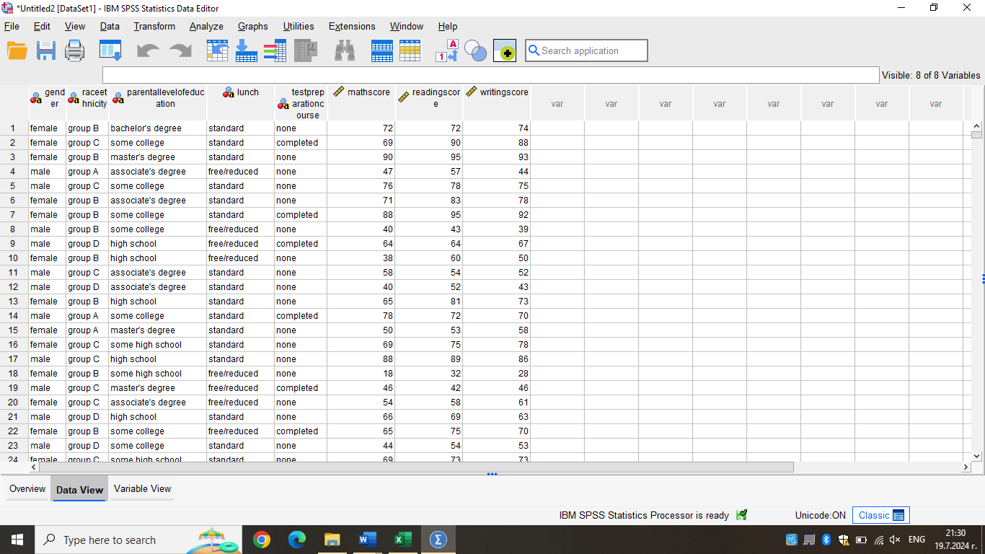

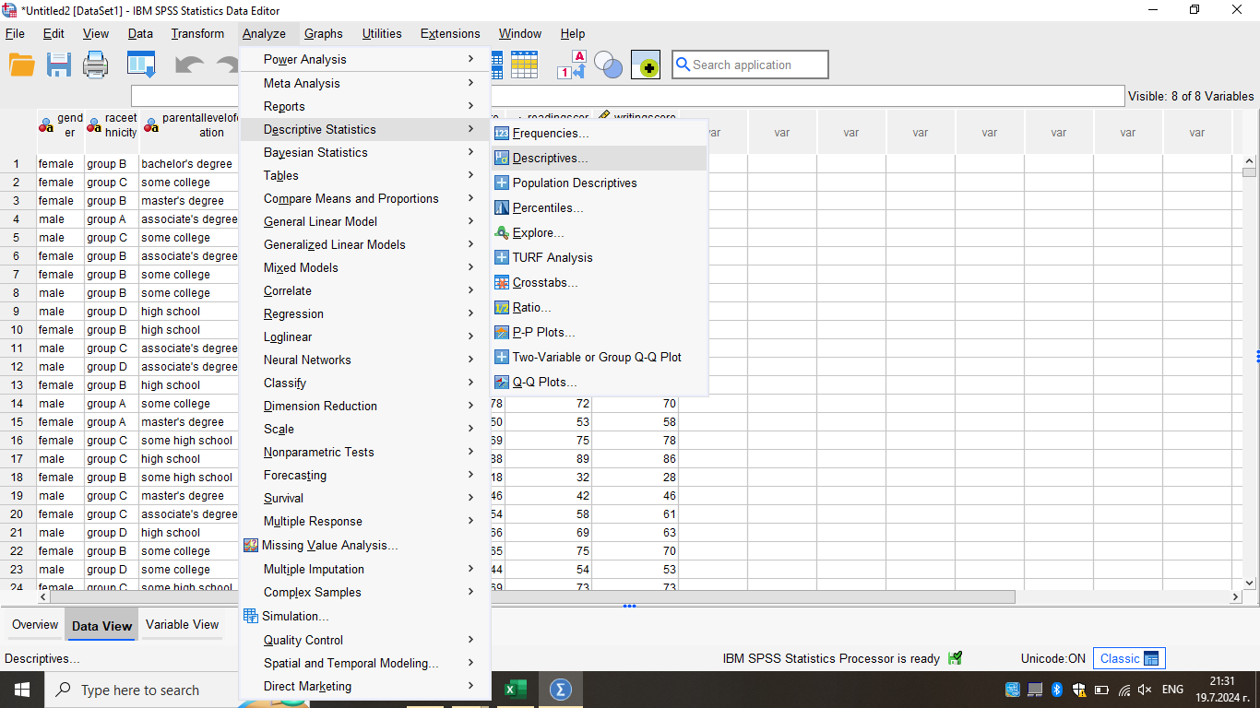

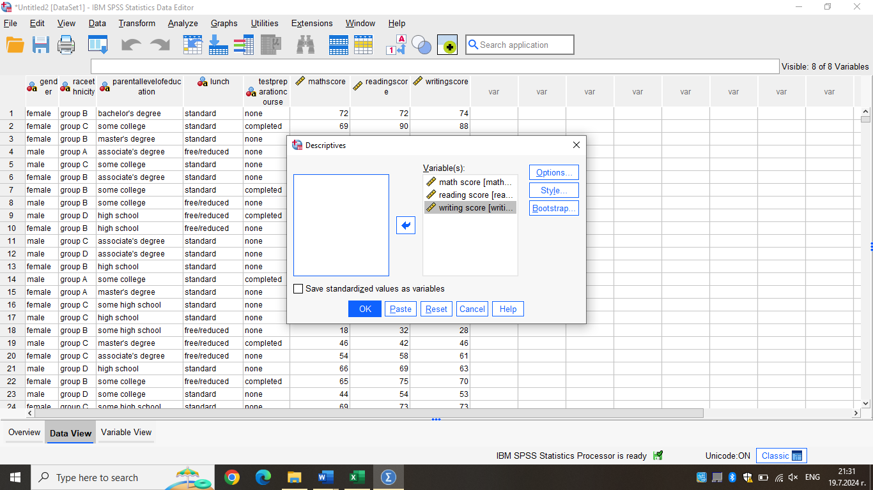

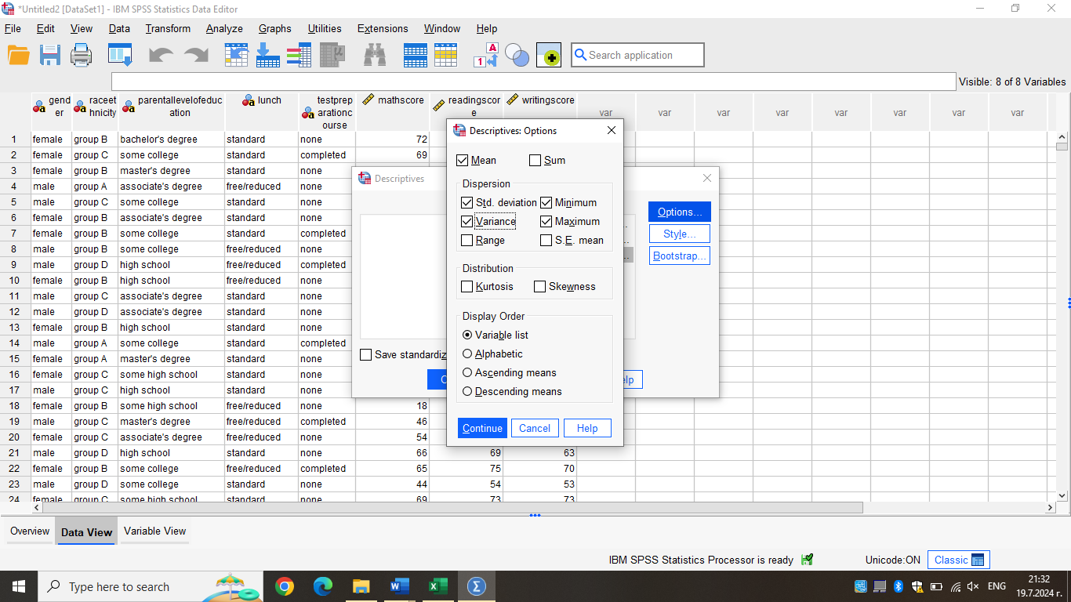

Which one of the variables has a larger standard deviation?

Though it is a unit of measurement on the normal distribution, the standard deviation serves other purposes as well. In general, it is a spread measure. A location measure is the mean
The coefficient of variation is the ratio of the standard deviation to the mean. When two data sets are provided in different units, this might be useful in differentiating them. For instance, the economic statistics may be quoted in various currencies if we are comparing data from two distinct nations. When the mean and standard deviation cannot be directly compared, a direct comparison can still be made since the coefficient of variation has no units.
The index of dispersion, which is calculated by dividing the square of the standard deviation by the mean, is a ratio that is comparable. For instance, in biology, we might examine where the trees are located inside a wood. A dispersion that is uniformly at random, or consistent with a Poisson process, would be indicated by an index of dispersion equal to 1. A number of more than one would suggest more variability than a Poisson process would be anticipated to have; a value of less than one would suggest less variance.

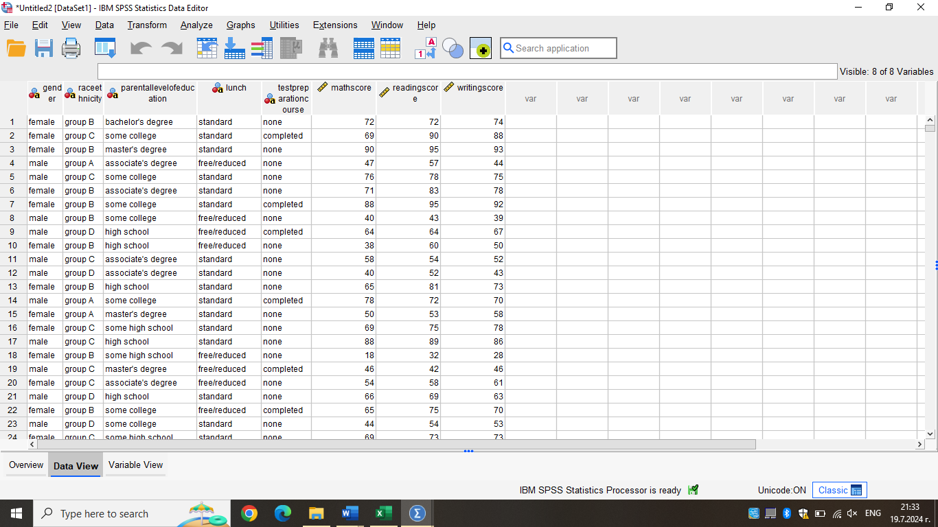

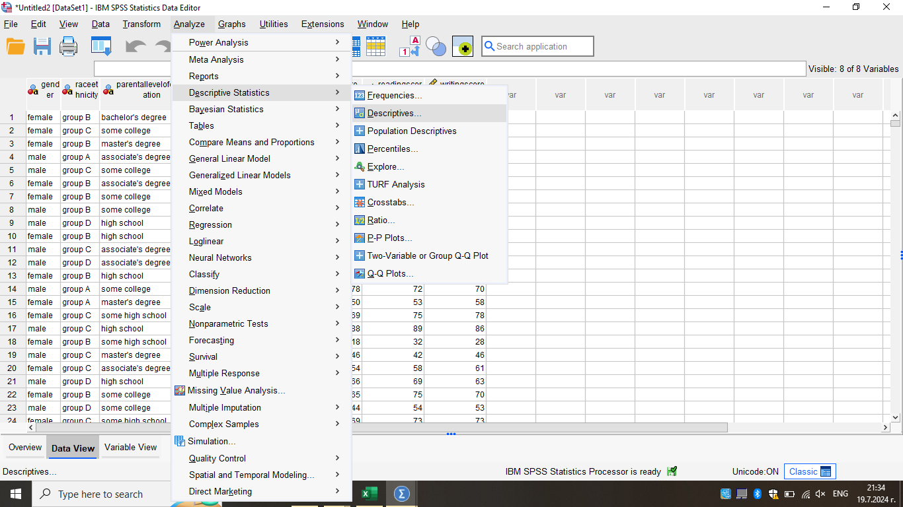

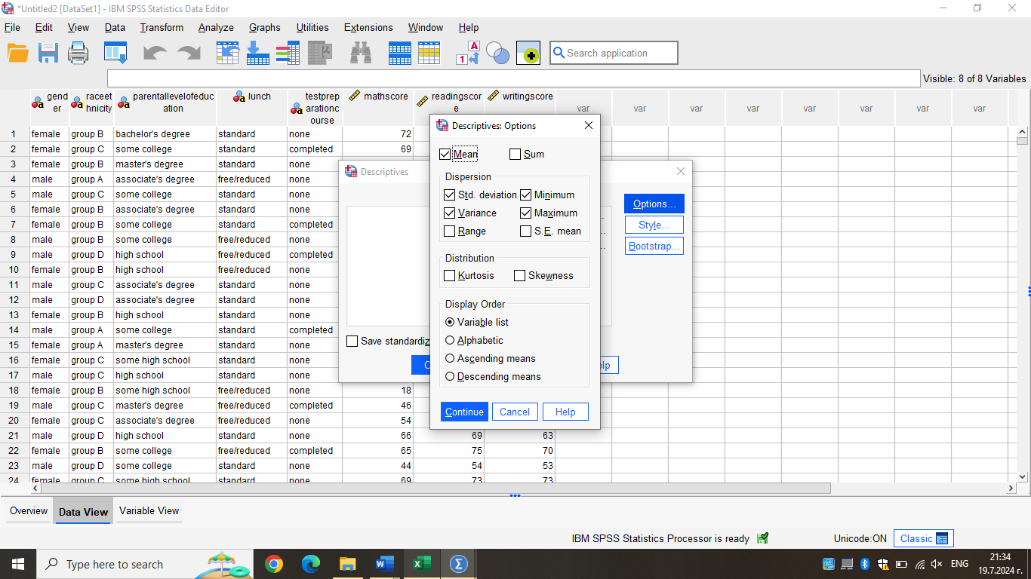

Can you interpret the last three outcomes?
In statistics, the two key metrics are variance and standard deviation. Standard deviation is a measure of the distribution of statistical data, while variance is a measure of how data points differ from the mean. The variance is expressed in squared units, whereas the standard deviation is expressed in the same units as the data mean. This is the primary distinction between the two.
Variance
In plain English, the variance is a measurement of the degree to which a set of data deviates from its mean or average value. The symbol for it is "σ2."
Properties of Variance
- Since the variance sum squares each term, the result is either positive or zero, hence it is always non-negative.
- The units of variance are always squared. For instance, kg squared will be used to represent the variance of a collection of weights assessed in kilograms. We are unable to directly compare the population variance with the mean or the actual data because it is squared.
Standard Deviation
The standard deviation quantifies the distribution of statistical data. Data divergence from the mean or average location is measured by distribution. The technique for determining the deviation of data points is used to compute the degree of dispersion. 'π' is the symbol used to represent it.
Properties of Standard Deviation
- It is also known as the root-mean-square deviation and represents the square root of the mean of the squares of all values in a data set.
- Since the standard deviation cannot be negative, its smallest value is 0.
- The standard deviation will be very low, or almost nonexistent, when the data values in the group are similar. However, the standard variation is large or far from zero when the data values vary from one another.
Variance and Standard deviation Relationship
Standard deviation is the square root of the number, while variance is the average squared deviations from the mean. Furthermore, the variance's square root equals the standard deviation. Although the units of both measures differ—the variance is expressed in squared units, while the standard deviation is expressed in the same units as the original values—they both show variety in distribution.

Using MS Excel, you need to demonstrate how you can present the data in your report with the use of any one of Excel functions such as: IF, PIVOT TABLES, CHARTS AND GRAPHS. (Show your workings with full screenshots).

One of Microsoft Excel's most potent and terrifying features is the pivot table. Large data sets can be compiled and made sense of with the use of pivot tables. They also have a reputation for being difficult, though. One of Microsoft Excel's most potent and terrifying features is the pivot table. Large data sets can be compiled and made sense of with the use of pivot tables. They also have a reputation for being difficult, though.

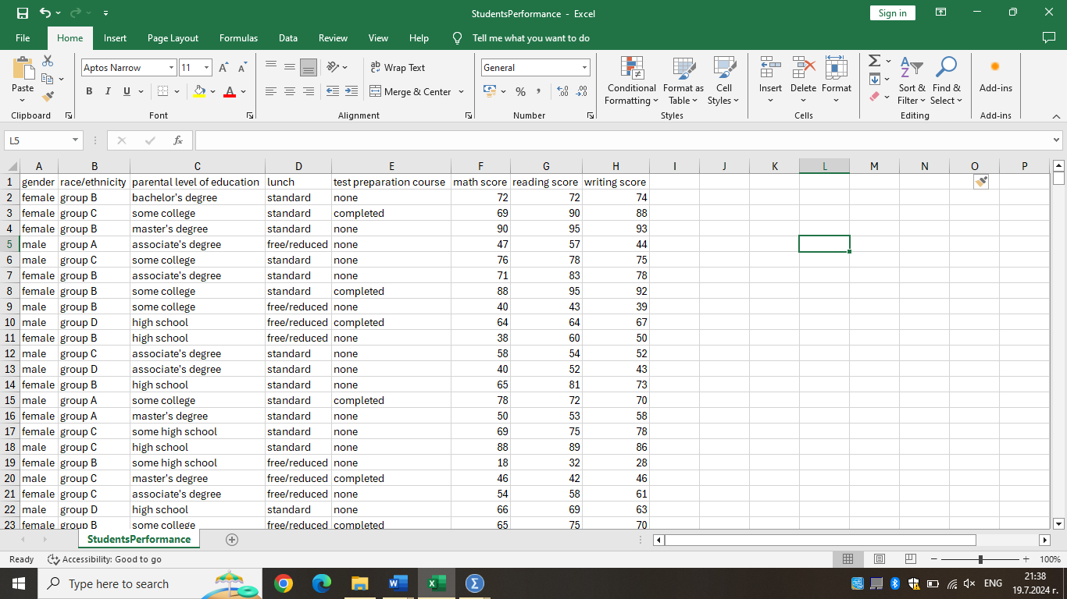

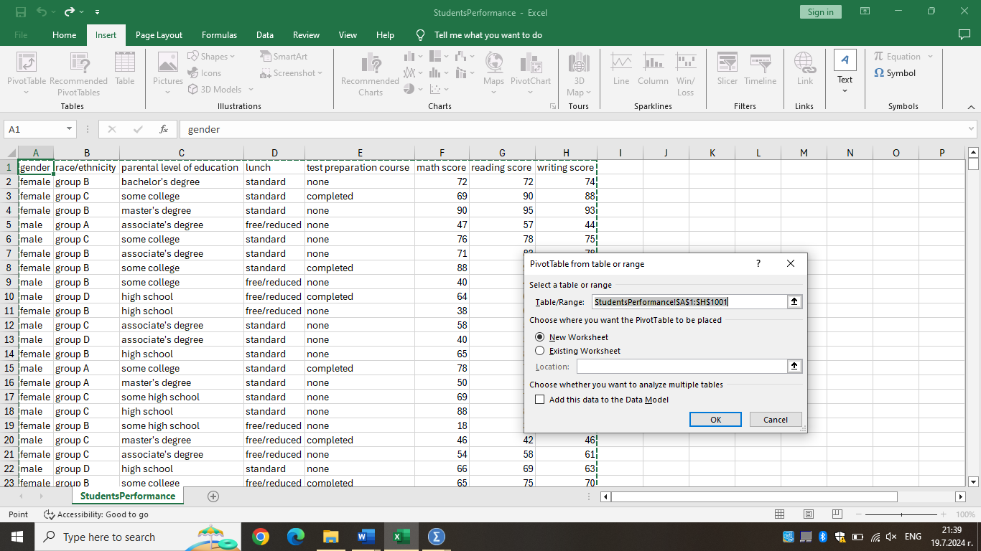

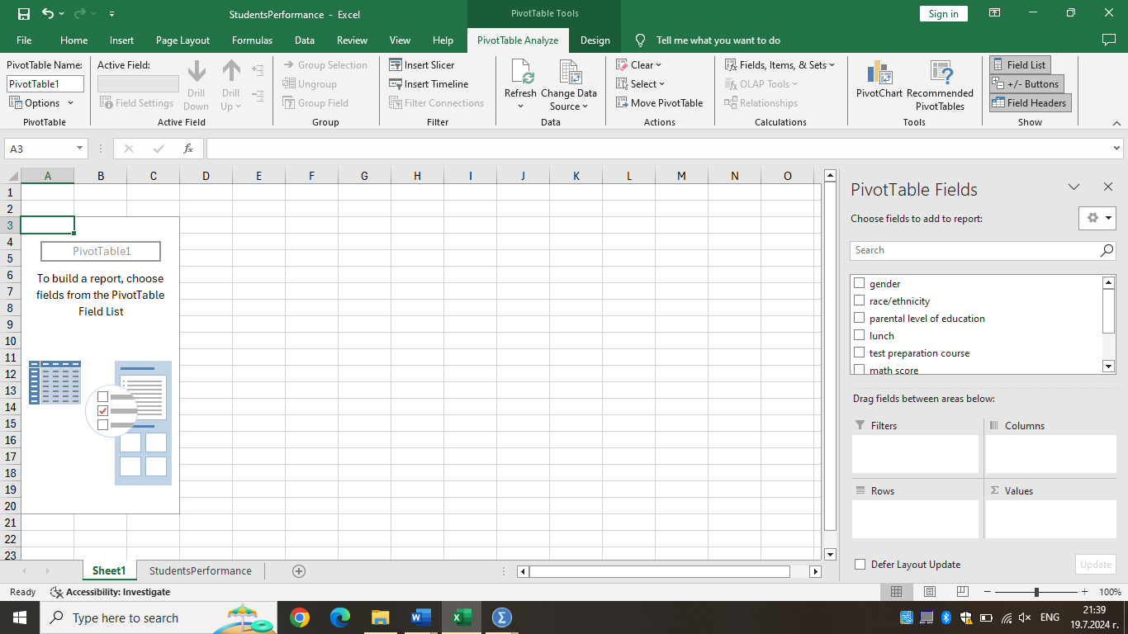

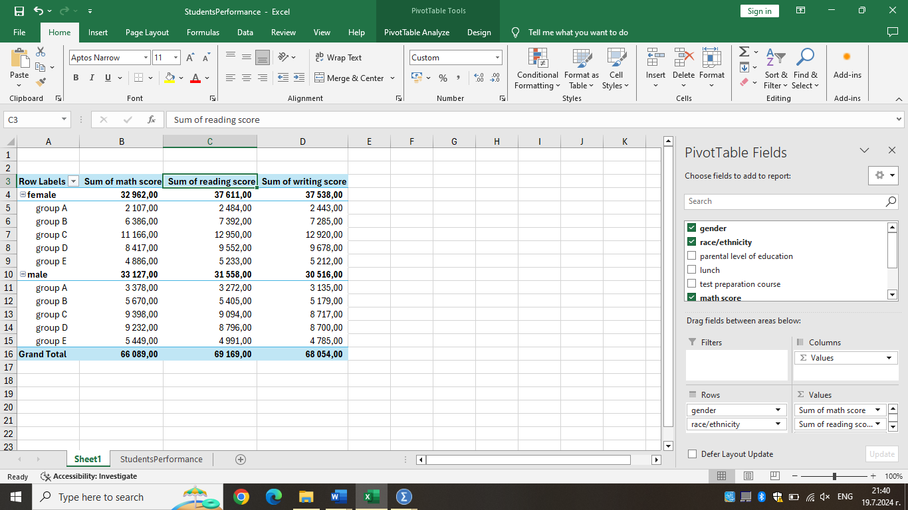

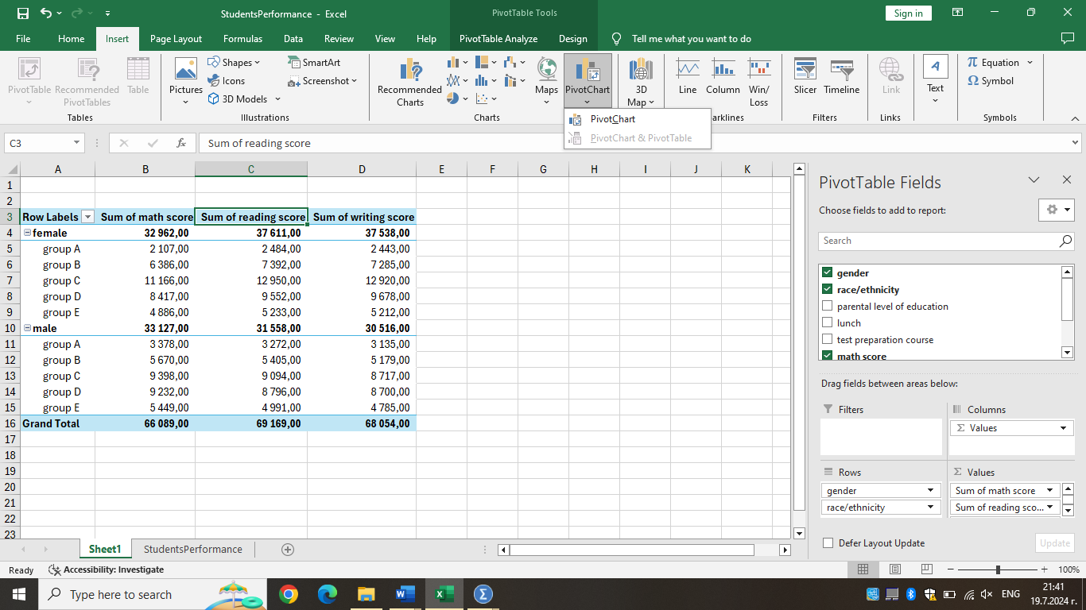

Because of the complexity and volume of the data, it can occasionally be challenging to comprehend Excel data. Thus, charts provide a visual representation of the data that is easy to understand. Data are represented visually in charts.
Charts are available in Excel so you can benefit from graphical depiction. Data saved in an Excel table is not as comprehensible as data displayed through charts. This speeds up the data analysis process. Excel users are able to analyze data quickly. Charts are a useful tool for graphical data display, which facilitates understanding complex data analysis. Excel contains a wide range of charts, each with unique features and styles of depiction. Excel's available charts Numerous charts, including Pie, Bar, Line, Stock, Surface, Radar, and many more, are available in Excel to display the data in various ways. Using them is up to you and your data and analysis.

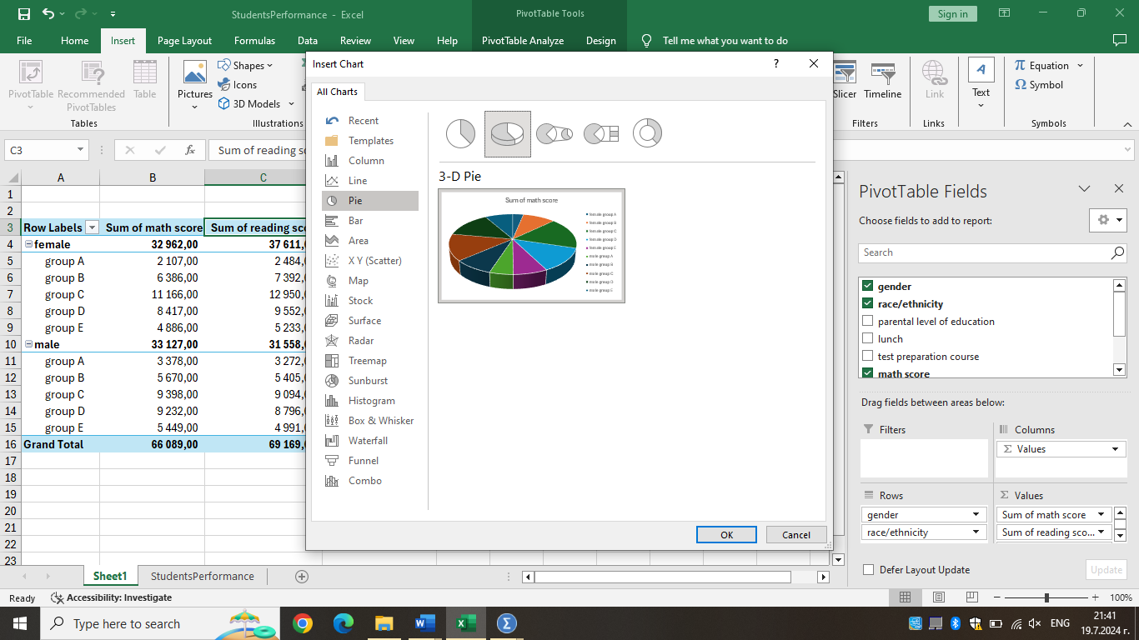

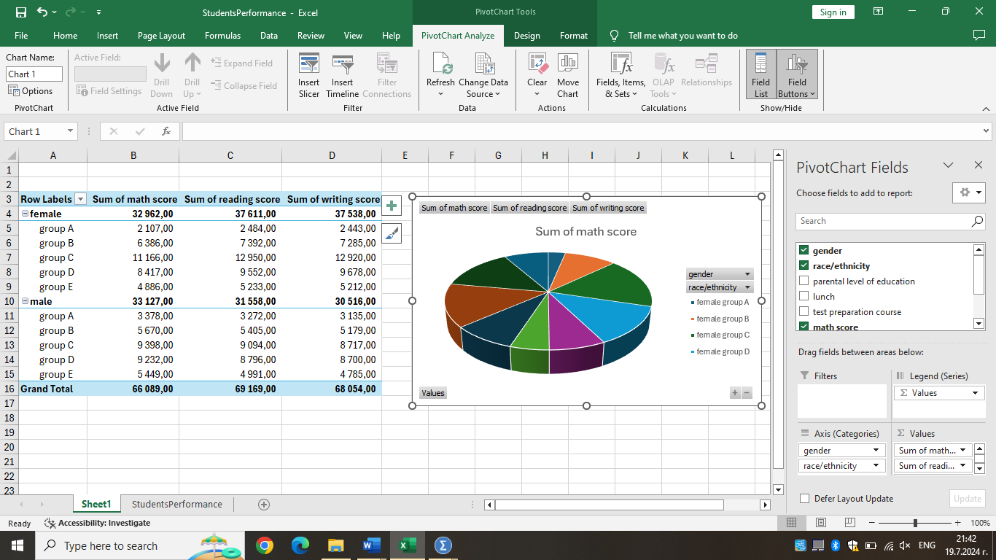

Using SPSS –

Find out what is the correlation between writing score and reading score? (Show your workings with full screenshots).

A measure of the relationship between two variables is correlation. It is widely used in statistics and business. What action would you take in this situation if two variables required simultaneous study? How would you use SPSS to simultaneously find the relationship, association, link, or bonding between two variables? Correlation analysis is the study of the relationship between two variables. The degree and direction of the linear link between two variables are described via correlation analysis.

- The positive and negative symbols denote, respectively, positive and negative correlation. A positive correlation means that as one variable rises, the other also rises, whereas a negative correlation means that as one variable rises, the other falls. But the value itself tells you something about how strong the relationship is.
- A correlation of one or minus one indicates complete correlation. When two variables have perfect correlation, one variable's value can be entirely determined by the other.
- If the correlation coefficient is zero, it indicates that the two variables do not have any relationship. As a result, one variable offers no assistance in forecasting the other.

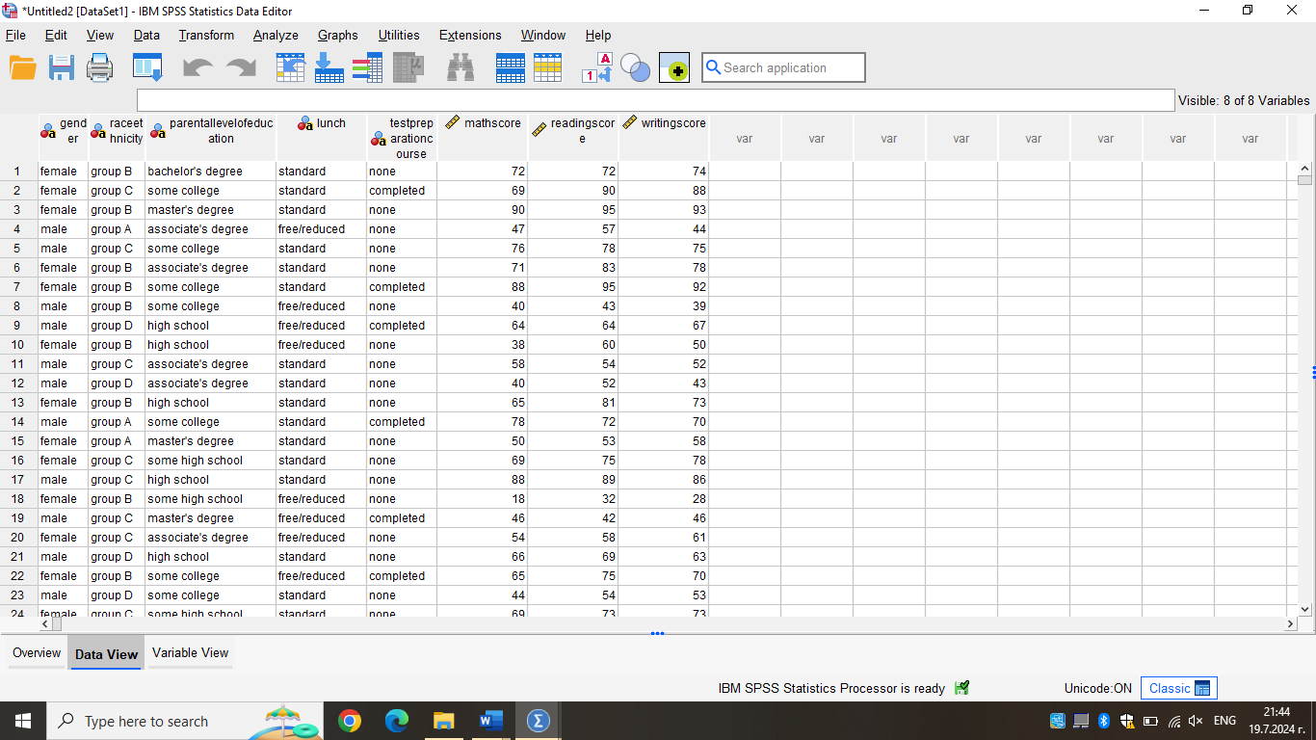

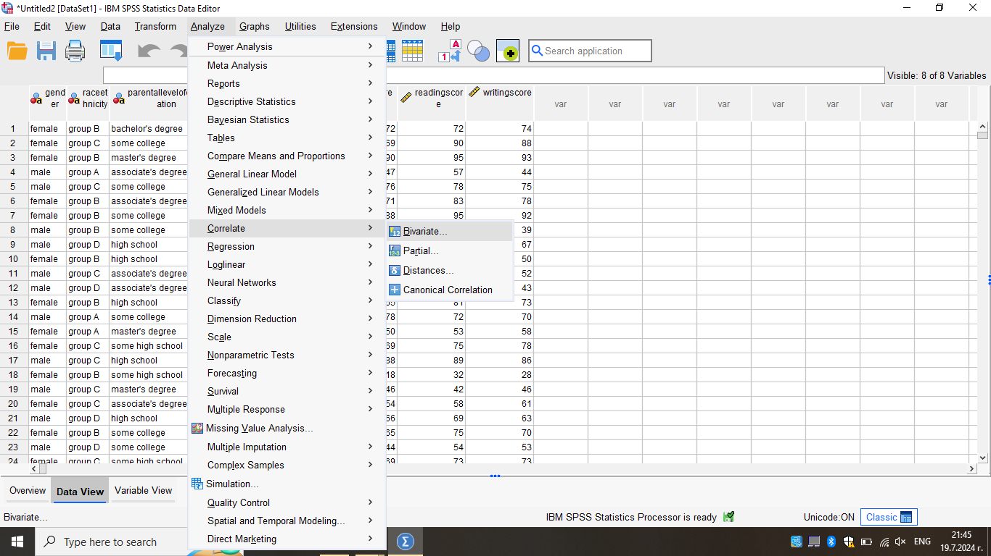

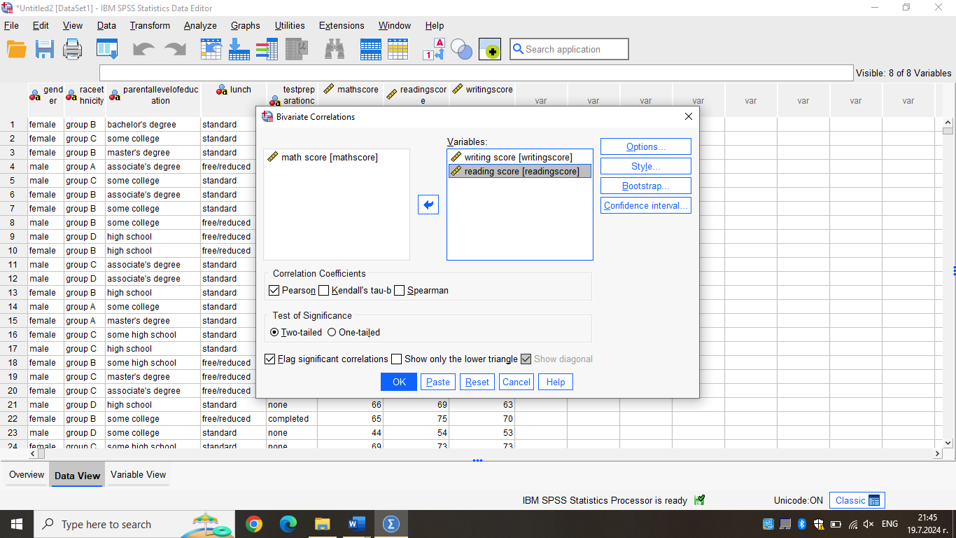

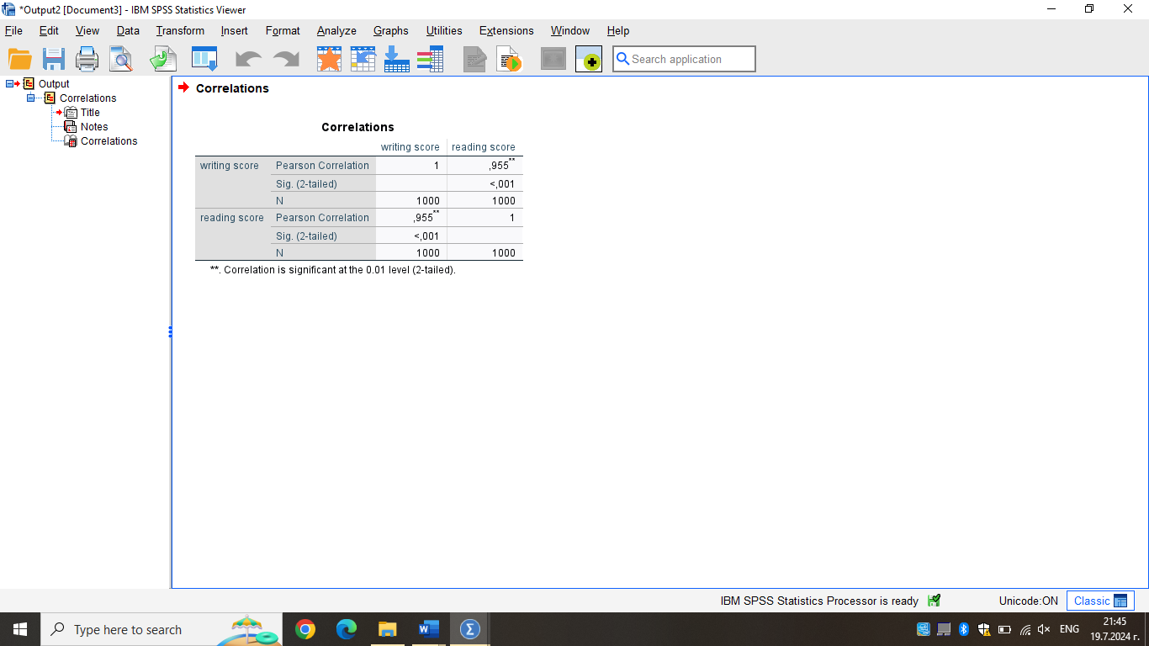

Produce a scatterplot of the two variables. Use writing score on the horizontal axis and reading score on the vertical axis and comment on the graph. (Show your workings with full screenshots).

A scatterplot shows the correlation between two data sets. Another name for a scatterplot is a scattergram, or scatter diagram. One data point is represented by a dot in a scatterplot. A visual representation of the data distribution is obtained by graphing multiple data points. There might be a definite trend in the data that you can see based on how closely the dots cluster together.
The greater or higher the correlation between the two variables, the closer the data points are to making a straight line when plotted. The variables are considered to have a positive correlation if the data points form a straight line that extends from close to the origin to high y-values. The variables have a negative correlation if the data points begin at high y-values on the y-axis and move downward to low values.

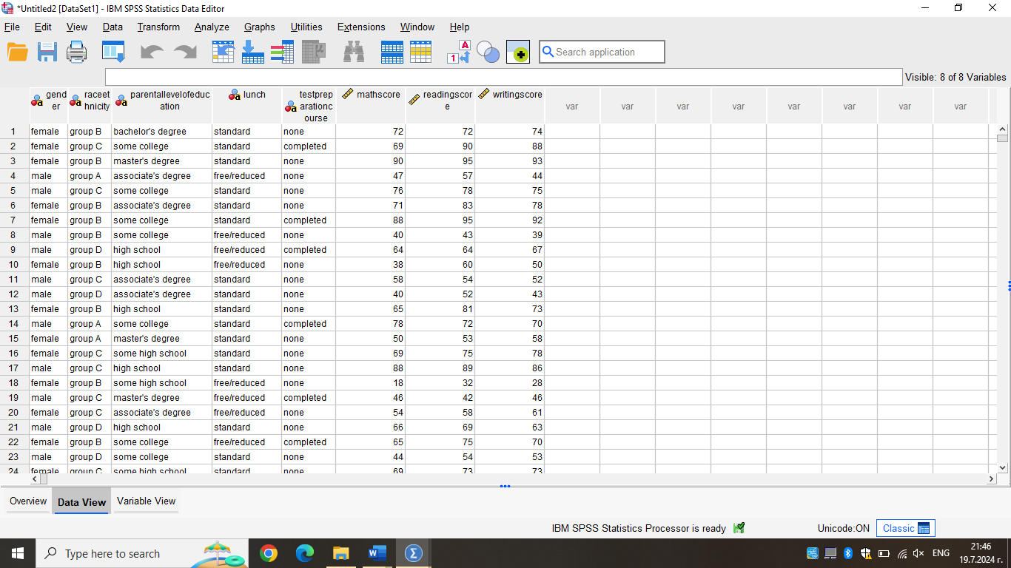

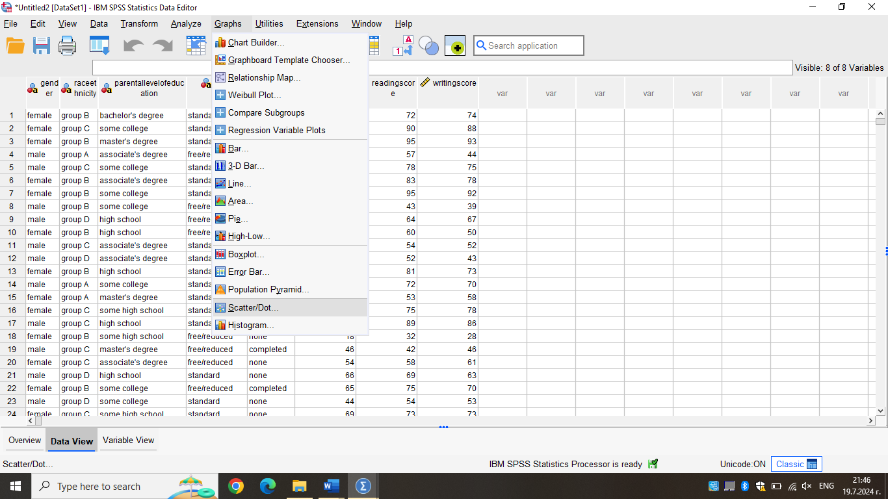

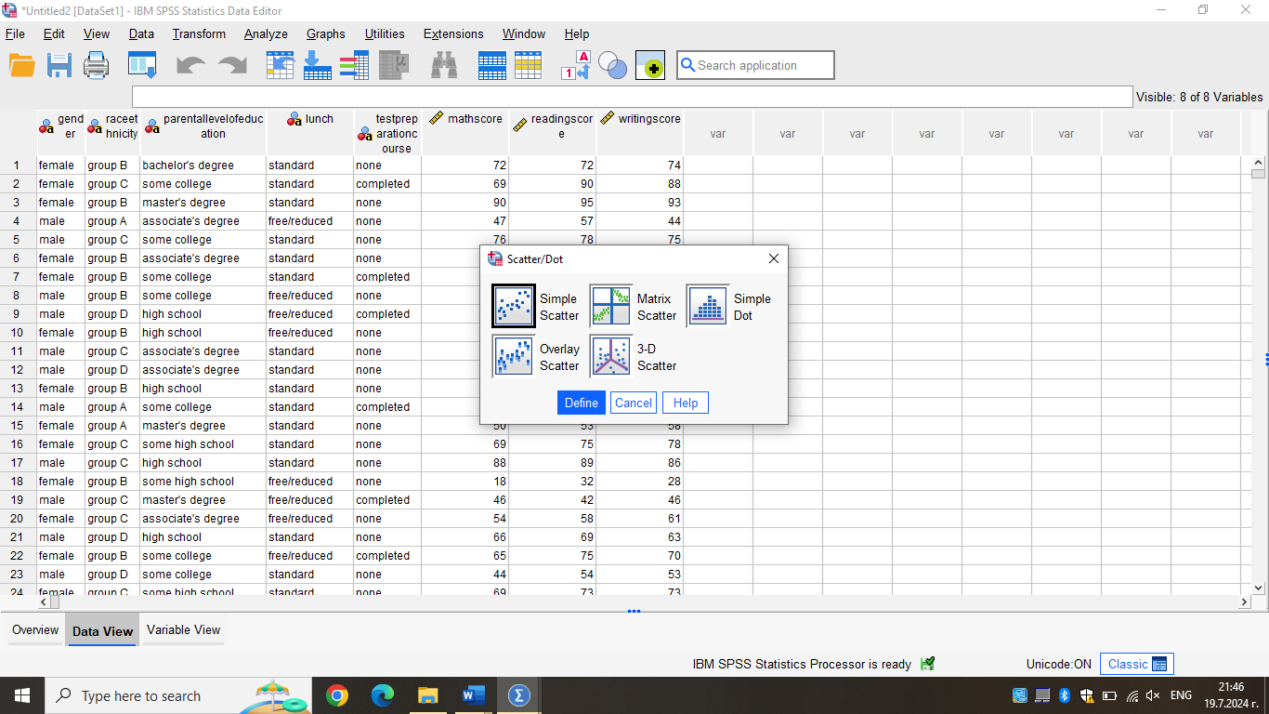

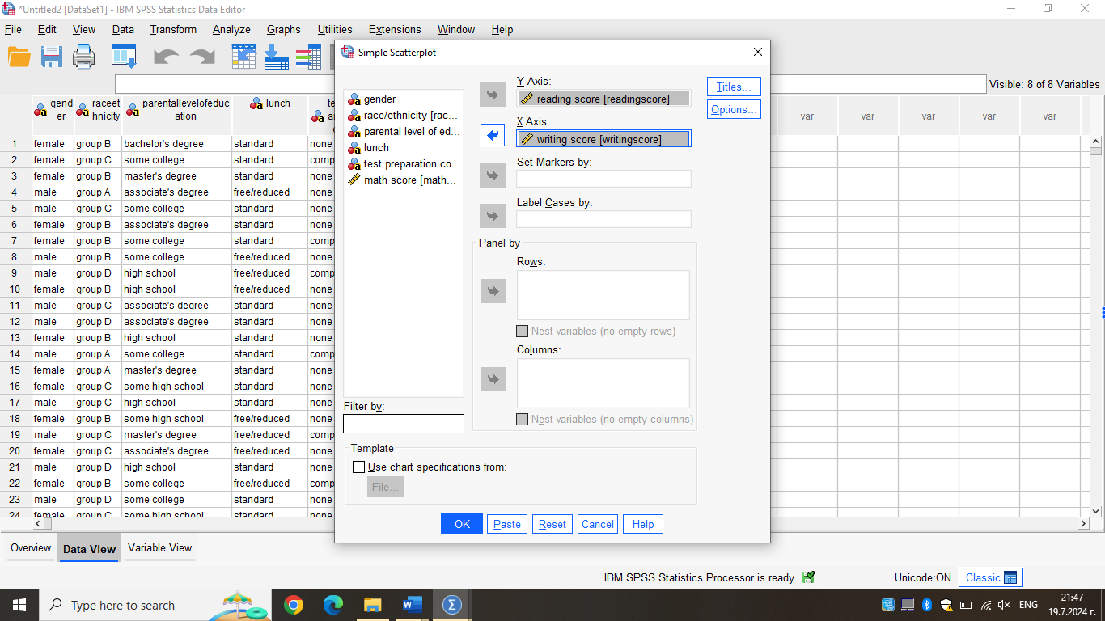

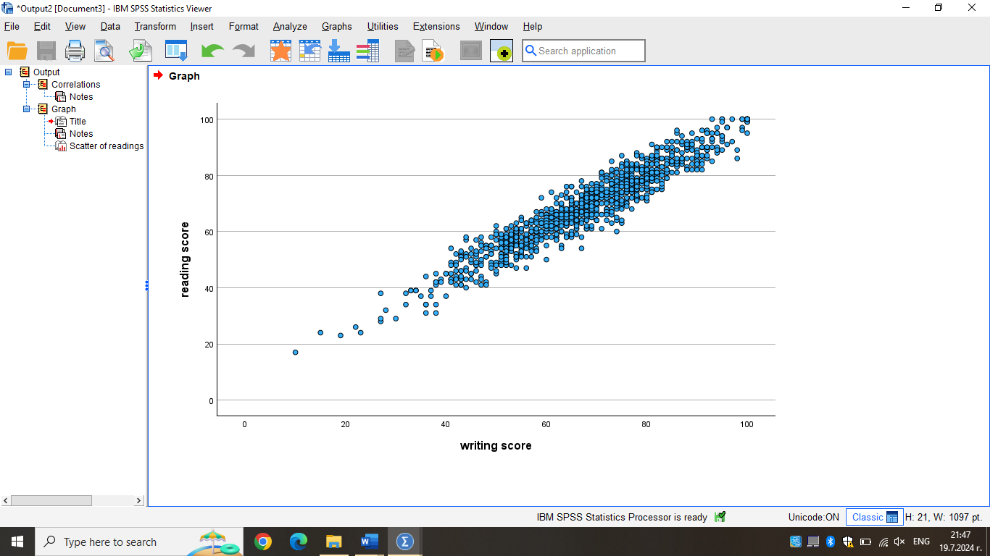

Section 2
Discuss the advantages and disadvantages of using SPSS or Excel or Tableau using relevant practical examples.

Advantages and Disadvantages of Using SPSS, Excel, and Tableau

SPSS (Statistical Package for the Social Sciences)

SPSS is a powerful tool designed specifically for statistical analysis, making it ideal for users who require advanced statistical tests. It comprises numerous functions, such as regression analysis, analysis of variance, and factor analysis. For instance, a researcher analyzing a detailed survey can run through other statistical tests within the shortest time possible and get insights from that analysis with the help of SPSS. Because the software's interface is menu-based, even a person with little to no background in programming or coding can easily use the software's features (George & Mallery,2019). To the end user, SPSS is easy to use and benefits social scientists with little or no programming knowledge but would still want to maneuver around SPSS to carry out data analysis easily. Also, SPSS offers efficient data management capabilities of organizing, cleaning, transforming, and massaging data. For instance, a healthcare analyst can qualify patient data by cleansing it in preparation for data analysis.However, it is worth noting that there are limitations associated with using SPSS. The software is, however, commercial, and its licensing is quite expensive, meaning it will not be easily affordable for small users or organizations. An illustration is that a small nonprofit organization might not be able to afford the cost of acquiring SPSS compared to the other cheaper options. Thirdly, although SPSS has a relatively friendly interface, it is challenging to master the most efficient use of the options, particularly the advanced ones. New users need to be more abreast of how best to use the available statistical tests and may find it challenging initially. Moreover, while SPSS offers the feature of data visualization, it is weaker than programs for data visualization, such as Tableau. A marketing analyst may need help developing interactive data dashboards in SPSS for use in data presentations, which is problematic.

Excel

Excel is a versatile and widely available tool that most professionals are familiar with, making it a convenient choice for data analysis. Excel is easy to use and familiar to business analysts; hence, they can quickly analyze data. It enables users to accomplish all activities, from entering initial data to generating analytical and graphical results (Islam,2020). For instance, an accountant can use Excel to develop financial models, forecast budgets, and make charts and graphs. Users can quickly and easily get to grips with Excel due to its graphical usability and copious notes and guides. A project manager can easily monitor the timelines and costs within a project with the help of templates and calculation tools in Excel. However, Excel has limitations when it comes to statistical analysis. Although it can do fundamental statistical analysis, it may need to do better than other specialized statistical software like SPSS. A researcher who needs to perform highly specialized analyses might need to use Excel more. Further, when working with large denominations of data or values, it often gets slow and could be more efficient with its computation time. An analyst working with millions of rows of data may find them moving slowly, and the application might lock up. Excel also entails data manipulation that is usually done manually, which consumes much time and is very sensitive to errors. An analyst may have to invest much time correcting data using tools that require manual operation, such as Excel.

Tableau

Tableau is renowned for its advanced data visualization capabilities, allowing users to create interactive and dynamic dashboards. Tableau applied by a sales manager may include using the tool to develop dynamic and up-to-date sales performance visualizations. The tool mainly uses drag-and-drop functionality so that marketing specialists can make visualizations based on the campaign response rates without advanced technical skills (Skender &Manevska,2022). Tableau understands relational databases, cloud applications, and spreadsheets, among other data sources. For instance, a data scientist can apply Tableau to an SQL database to analyze big data sets. Thus, although it is highly functional, Tableau is a paid tool with expensive licenses, which could be a drawback. Tableau licenses can, however, be costly, and a young startup might need help to cover the costs (Viljanen,2020). Moreover, there can be a problem in familiarizing with the enhanced functions of Tableau since, despite its tremendous and unproblematic graphical user interface, it may take considerable time and effort to master. A new user might need to spend some effort learning how the program operates and what needs to be done to obtain the maximum benefit of the software. Moreover, Tableau offers essential chart tools and is unsuitable for more complex statistical analysis than any given software such as SPSS. There may be a situation where an academic researcher will need to use another tool parallel to the Table for statistical analysis.

Explain the meaning and importance of Data Mining Cycle with examples.

The Data Mining Cycle

The data mining cycle refers to the iterative process of discovering patterns and knowledge from large datasets, which is crucial in transforming raw data into valuable insights for decision-making. The process often comprises at least the following stages: data collection is the first step. Data is collected from databases, sensors, and web data. For instance, a retail firm obtains sales information from its sales terminals as well as from clients (Romero & Ventura,2020). After data collection, data cleaning is carried out, including preprocessing of data to eliminate noise, missing values, and inconsistent data for analysis. For example, an analyst purges the set of customers by eliminating double data entries and completing lost values. Data integration is the subsequent activity in which data obtained from various sources are aggregated to offer a more coherent view. A healthcare provider might consolidate records from one hospital into another into a single database. Next is the data transformation step, which includes data normalization, data aggregation, and feature selection — the process of preparing data for analysis. An example of an intermediate information consumer includes the following: A financial analyst uses several individual transactions to get a total of the month-end spending. The data mining step analyzes data by applying specific algorithms to identify patterns, trends, or relations. Many companies use clustering algorithms in customer classification; for example, a telecom company divides customers according to frequency of use.
Pattern evaluation vindicates the found patterns in an endeavor to ascertain their adequacy. A fraud detection system analyzes and assesses patterns to identify legitimate or fake transactions. If the discovery process is understood correctly, then knowledge representation is an efficient way to represent the knowledge in reports, charts, and dashboards to derive decisions. An example of dashboarding in understanding and implementing business intelligence is having a business intelligence team devise a sales and customer behavior dashboard. Lastly, deployment involves applying the knowledge gained to make the right business decisions and enhance business processes. In advertising, a marketing team could use analysis derived from data mining to promote specific products to specific customer segments.
Organizations must acquaint themselves with the data mining cycle to promote and maximize the use of data mining to derive insights from data. For instance, the cycle enables users to make decisions based on corresponding analyses and conclusions. For instance, a bank applies data mining in a way that aims at its clients: the best candidates for credit are those most likely to pay their loans back. Companies implementing data mining can reap big by discovering new markets and improving operations. An e-commerce company may apply data mining to suggest the relevant products to be sold to different customers, thus improving its sales and customer satisfaction; besides, by using data mining, an organization master how to conduct searches that will identify problems that require improvement as well as how to cut costs. A manufacturing firm, for instance, applies data mining to determine the tendencies of equipment to fail, thus preserving time and maintenance costs. Therefore, all three used tools, SPSS, Excel, and Tableau, have advantages and disadvantages depending on the task and resources of the user. Also, there is a need to grasp and fulfill the data mining cycle as a process for discovering meaningful and valuable information from the data that helps organizations to make the right decisions and to outdo competitors.

References
- George, D. and Mallery, P., 2019. IBM SPSS statistics 26 step by step: A simple guide and reference. Routledge.
- Islam, M., 2020. Data analysis: types, process, methods, techniques and tools. International Journal on Data Science and Technology, 6(1), pp.10-15.
- Skender, F. and Manevska, V., 2022. Data Visualization Tools-Preview and Comparison. Journal of Emerging Computer Technologies, 2(1), pp.30-35.
- Viljanen, I., 2020. Improving solutions for analytics services in a mid-sized insurance company.
- Romero, C. and Ventura, S., 2020. Educational data mining and learning analytics: An updated survey. Wiley interdisciplinary reviews: Data mining and knowledge discovery, 10(3), p.e1355.
- https://researchwithfawad.com/index.php/lp-courses/data-analysis-using-spss/pearson-correlation-analysis-using-spss/
- https://www.indeed.com/career-advice/career-development/how-to-use-excel-to-calculate-standard-deviation, July 31, 2023 Indeed Editoral Team
- https://www.goskills.com/Excel/Resources/How-to-calculate-average-in-Excel, Claudia Buckley 2024

