Student Name: Edwige Taty - Bitemo
Student Number: 2511480

Module Code: LCHS4003
Module Title: Introduction to Health and Social Care

Lecturer’s name: Daniel Haruna

Assignment title: Written Assignment
TABLE OF CONTENTS
Introduction 3
1. The importance of effective communication within the context of Mr Ahmed’s care 3
2. The importance of good administrative skills within professional practice within the context of Mr Ahmed’s care 4
3. The importance of working collaboratively with other professionals involved in Mr Ahmed’s care 5
Conclusion 7
Reference List 8

Written Assignment

Introduction
This section will critically evaluate the underlying principles that govern professional practice in communication in health and social care, with Mr Ahmed’s care following a stroke as the contextual basis. It will discuss how issues of equality, dignity, and reasonable adjustments will be maintained in line with the Equality Act 2010, specifically in relation to language issues and disability. The section will also critically discuss person-centred and culturally competent strategies that need to be adopted to meet the needs of a 68-year-old service user who is receiving three daily care visits. The use of an established framework for communication will be critically evaluated to demonstrate how communication barriers can be overcome in a complex care setting. Finally, in an effort to promote autonomy, safety, and legality, this section will provide a critical review of the ways in which shared decision-making and informed consent will be facilitated.

1. The importance of effective communication within the context of Mr Ahmed’s care
Upholding Equality, Dignity and Reasonable Adjustments
With equality in the care of Mr Ahmed, the Equality Act 2010 will have to be enforced, especially in the areas of race and disability (Ahmed, 2025). The UK has a stroke incidence of more than 100,000 individuals every year, with a high number of victims developing aphasia, thereby requiring communication modifications. The sensible adjustments that will be made are the employment of professional Bengali interpreters, medication plans that will be translated, and an extension of the consultation time by 20-30 minutes (Hieke et al., 2025). This will improve respect and reduce errors in prescribing medication. One of the strengths is improved autonomy, but weaknesses such as the availability of interpreters and financial issues may work as barriers to decision-making and communication.
Person-Centred and Culturally Competent Communication
The focus of person-centred communication will be on the preferences and cultural identity of Mr Ahmed, and his rehabilitation objectives. The older generations of Bengali speakers might turn to the involvement of family members greatly, but instead of replacing the voice of the spouse, the professional should not use his/her voice instead. Visual swallowing charts, simplified written instruction and 10-15 minutes of speech therapy reinforcement will help understand the material (D’Angelo, 2023). The positive side is that there was better adherence to antihypertensive medication and dietary recommendations. Some drawbacks include cultural presumptions among the personnel and time issues among the three daily care visits, which may diminish the extent of interaction.
Application of the Shannon and Weaver Communication Model
Based on the Shannon and Weaver model, the professionals will determine noises like aphasia, hearing fatigue, and terminologies that are not known to them. A message, which is encoded using short sentences with fewer than 10 words and with pictorial aid, will minimise distortion (Hong et al., 2022). Understanding will be checked with feedback loops, i.e., teach-back after explaining the medications. Systematic identification of the communication barriers is a strength; nevertheless, the linear structure of the model can simplify the role of emotional and relational aspects in conversations about stroke recovery. It might not be able to reflect culture or power in communication within a family.
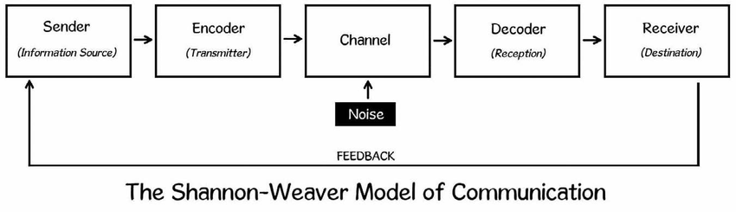
Figure 1: Shannon-Weaver Model of Communication
(Source: Researchgate.net, 2024)
Promoting Shared Decision-Making and Informed Consent
Shared decision-making will also imply direct evaluation of the mental capacity of Mr Ahmed according to the Mental Capacity Act 2005, as well as offering information in the Bengali language whenever necessary (Taslima, 2023). The idea of blood pressure monitoring twice a week and taking medication three times a day has to be properly explained to be clear before consent. One of the strengths is the empowerment of strengths and lessened safeguarding threat. Limitations, however, come in the case when fatigue affects the understanding or elsewhere where the members of the family accidentally become overbearing in the discussions, which may limit independent expression and informed participation by Mr Ahmed.

2. The importance of good administrative skills within professional practice within the context of Mr Ahmed’s care
Legal and Regulatory Frameworks
The record-keeping of the case concerning Mr Ahmed will work in Mr Ahmed's Data Protection Act of 2018, Data Protection Regulation 17 of UK GDPR and Regulations of 2014 on the Regulated Activities of the Health and Social Care Act of 2008, Rel. 17 (Rehman, 2024). Health data, which is under the category of special category data, needs increased protection. The missed medication after one unattended visit proves to be a risk under the regulations since the providers are required to show accurate time-stamped records of the three visits per day. One of the strengths of this framework is the presence of accountability because of an audit trail, but restrictions are administrative overload and the incompatibility of systems within agencies available on a digital basis.
Applying Data Protection Principles
The use of the principles of data protection will necessitate legal processing, data minimisation, precision, and the safeguarding of data. The blood pressure measurements of Mr Ahmed should be made twice a week concurrently, the MAR chart and speech therapy records should be made, and only be available only to the authorised personnel. The risk of a breach will be minimised by having encryption and password Systems (Omotunde and Ahmed, 2023). One strength is increased confidentiality and trust, but shortcomings are human error, slow uploading of the electronic files, and the staff not having the knowledge of GDPR compliance, which may have an influence on the accuracy of the records.
Documentation for Clinical Safety and Continuity
Correct recording will be used to make it continuous across the GP, district nurse, speech therapist, and domiciliary carers. As an illustration, the systolic measurements exceeding 160 mmHg and difficulties in swallowing noticed in a single session should result in a cordial move. Visit and medication delays will be mitigated by electronic care monitoring systems that have the ability to provide real-time alerts (Elhadad et al., 2022). One of the strengths is better protection and less risk of hospital readmission. But interoperability might be restricted by the fractured digitisation of four professionals and slow down access to essential updates.
Transparency, Rights and Professional Accountability
Mr Ahmed will be within his rights under the Data Protection Act 2018 to seek access to his records within a calendar month. The nature of the incident reportage on the missed visit should be reported objectively, that is, by date, time, and who (Lesko et al., 2022). Open documentation enhances organisational learning and secures the professionals in the research when found in an inquiry. Improved public trust and defensible practise is a strength, but there are limitations arising when defensive documentation takes what can be described as an interest in liability protection over reflexive improvement and engagement with the service-user.

3. The importance of working collaboratively with other professionals involved in Mr Ahmed’s care
Role Clarity and Integrated Care Planning
The role clarity will make the GP handle the work with antihypertensive prescribing, the district nurse take the blood pressure twice a week, the domiciliary carers give the medication 3 times a day, and the speech therapist provide the structured rehabilitation sessions. Duplication and omission will be minimised with the help of a shared care plan that will specify 4-6 measurable objectives, like safe swallowing and improvement of mobility (Cairney, 2025). One strength could be accountability that is well co-ordinated but weaknesses occur when accountability is overlapped or when there is no clear escalation route, which results in delays in responding to urgent cases, e.g. systolic readings exceeding 160 mmHg and no action is taken.
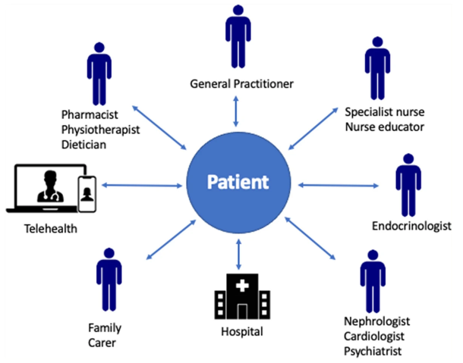
Figure 2: Integrated Care Planning
(Source: Carrigan et al., 2023)
Structured Communication and Information Sharing
The use of structured instruments, like SBAR, will create uniformity in the handover between four professionals and make sure that important information, including the dose that was missed, the wound condition, or the language loss have to be reported in a concise manner (Patrich, 2026). Traceability will be enhanced by having electronic care logs with time-stamping of each visit. As an illustration, recording a delayed visit of 30 minutes will lead to an escalation. An advantage is enhanced patient safety with the help of clarity, but deficiencies in this aspect are the lack of consistency in digital platforms and timeliness in updates, which can render the individual's real-time decision-making weak.
Addressing Challenges in Multi-Agency Practice
Working within multiple agencies will be problematic, and some of the issues will involve workload pressures, fragmented IT systems and professional hierarchy. As an example, three daily carers might notice the swallowing changes prior to the weekly visitation of the speech therapist, but are unwilling to escalate the issues. The risk will be reduced by holding regular monthly multidisciplinary meetings and establishing clear escalation limits (Xiong et al., 2025). Problem-solving and decreased hospital readmission are regarded as its strengths, yet scheduling issues, staff shortage, and resource limitations are its weaknesses, influencing the utilisation of collaborative engagement on time.

Conclusion
It will become clear in the scenario of Mr Ahmed that the delivery of safe and quality care in the UK health and social care system requires communication that is legally aware, good recording, and multi-agency working. The promotion of equality and the idea of reasonable adjustments will ensure the preservation of dignity and autonomy, while structured recording in accordance with the Data Protection Act 2018 will ensure clinical safety. Multi-agency working with four professionals will reduce the risk of adverse events such as missed doses of medication and uncontrolled hypertension.

Reference List
Ahmed, Md.S. (2025) ‘Right to Equality and Non-Discrimination against the Persons with Disabilities: A Case Study on Public Transport in Bangladesh’, International Social Research Nexus (ISRN), 1(3), pp. 1–15. Available at: https://doi.org/10.63539/isrn.2025023.
Cairney, P. (2025) ‘Policymaking integration, policy coherence, and whole-of-government approaches: a qualitative systematic review of advice for policymakers’, Open Research Europe, 5, p. 75. Available at: https://doi.org/10.12688/openreseurope.19864.1.
Carrigan, A., Roberts, N., Clay-Williams, R., Hibbert, P., Austin, E., Pulido, D.F., Meulenbroeks, I., Nguyen, H.M., Sarkies, M., Hatem, S., Maka, K., Loy, G. and Braithwaite, J. (2023) ‘What do consumer and providers view as important for integrated care? A qualitative study’, BMC Health Services Research, 23(1). Available at: https://doi.org/10.1186/s12913-022-08997-x.
D’Angelo, E.C. (2023) ‘Clinical Feeding and Swallowing Evaluation for the School-Based Speech-Language Pathologist’, Language Speech and Hearing Services in Schools, pp. 1–14. Available at: https://doi.org/10.1044/2023_lshss-23-00019.
Elhadad, A., Alanazi, F., Taloba, A.I. and Abozeid, A. (2022) ‘Fog Computing Service in the Healthcare Monitoring System for Managing the Real-Time Notification’, Journal of Healthcare Engineering, 2022, p. e5337733. Available at: https://doi.org/10.1155/2022/5337733.
Hieke, G., Black, G.B., Yargawa, J., Vindrola-Padros, C., Gill, P., Islam, L., Williams, E.D., Braun, S. and Whitaker, K.L. (2025) ‘South Asian patient experiences of professional interpreting service provision in general practice in England: a qualitative interview study’, International Journal for Equity in Health, 24(1). Available at: https://doi.org/10.1186/s12939-025-02477-4.
Hong, T., Kim, D., Ji, M., Hwang, W., Nam, D. and Park, S. (2022) ‘BROS: A Pre-trained Language Model Focusing on Text and Layout for Better Key Information Extraction from Documents’, Proceedings of the AAAI Conference on Artificial Intelligence, 36(10), pp. 10767–10775. Available at: https://doi.org/10.1609/aaai.v36i10.21322.
Lesko, C.R., Fox, M.P. and Edwards, J.K. (2022) ‘A framework for descriptive epidemiology’, American Journal of Epidemiology, 191(12). Available at: https://doi.org/10.1093/aje/kwac115.
Omotunde, H. and Ahmed, M. (2023) ‘A comprehensive review of security measures in database systems: Assessing authentication, access control, and beyond’, Mesopotamian Journal of CyberSecurity, 2023(2), pp. 115–133. Available at: https://doi.org/10.58496/MJCSC/2023/016.
Patrich, M. (2026) ‘Streamlining Clinical Endorsement: Electronic Sbar-Integrated Clinical Handover Management Framework’, Journal of Medical and Health Studies, 7(1), pp. 20–28. Available at: https://doi.org/10.32996/jmhs.2026.7.1.4.
Rehman, A. (2024) ‘Supply Chain Challenges and Opportunities in Pakistan’s Textile Sector: A Case Study of Gul Ahmed’, Bahria.edu.pk [Preprint]. Available at: http://hdl.handle.net/123456789/19284.
Researchgate.net (2024) Figure 2.1 Shannon-Weaver Model of Communication., ResearchGate. Available at: https://www.researchgate.net/figure/Shannon-Weaver-Model-of-Communication_fig1_368593942.
Taslima, Y. (2023) ‘Reconciling “best interests of the child” with the traditional Muslim law rules on child custody: Trends in the judicial decisions of Bangladesh’, Brunel.ac.uk [Preprint]. Available at: http://bura.brunel.ac.uk/handle/2438/29242.
Xiong, B., Stirling, C., Bailey, D.X., Prudon, P. and Martin-Khan, M. (2025) ‘Implementation strategies of a national standard for comprehensive care in acute care hospitals: An interview study’, International Journal of Nursing Sciences [Preprint]. Available at: https://doi.org/10.1016/j.ijnss.2025.06.002.

