What Makes a Great Leader?
Elon Musk

Cezar Sulugiuc
1710295
University of Wales Trinity Saint David
BA Skills for the Workplace: Leadership and Management
Tutor: Brynach Heffernan

Contents

Introduction 3
Reason for Choosing the Leader Based on Achievements and Impact Created 3
Evaluation of Elon Musk’s Positive and Negative Styles and Traits to Link with Leadership Models and Theories 5
Analysis of Leadership Strategies of Elon Musk Changing People’s Life 7
Compare and Contrast of the Positives and Negatives of Three Leadership Styles 10
Evaluation of Personal Ability for Fulfilling Leadership Responsibilities at Changing Workplace 12
Conclusion 14
Reference List 15

Introduction
In this essay, Elon Musk, who is one of the most outstanding leaders of the world in contemporary times, has been chosen. He is an over-achiever from his childhood and earning $500 at twelve by making a video game is its proof. He shows the traits of transformational leadership while leading his team members to over-achieve like him. Moreover, he follows the theory of charismatic, democratic and authentic leadership. However, at some point, such leadership harms the life of subordinates, creating public controversy. Apart from that, the factors associated with autocratic, democratic and bureaucratic leadership styles are analysed to find out the negative and positive factors by comparing and contrasting them. The traits which the researcher has and can help in leading a team and bringing change in an organisation are explained in this formal essay.

Reason for Choosing the Leader Based on Achievements and Impact Created
Among the many leaders and innovators, who have brought revolutions in the world, Elon Musk has been chosen here due to his multiple innovations and achievements. He is able to reach such a position and become worth $150 billion due to the effective leadership styles he has maintained until the present (Pisarchik, Maksimenko and Hramov, 2019). Musk has few achievements even before he started as an entrepreneur and a businessperson. Even when he was just a child of nine years, he had finished reading the Encyclopedia Britannica. Just after that, when he was just ten years, he started having an interest in technology and programming and finished learning the BASIC programing language in only three days (Kudas, 2019). He used this technical knowledge to make his own video game, Blaster, at age twelve and earn $500 by selling it to a magazine. Even before his achievements in the business world, he took some bold steps, such as calling executives of different companies to meet for lunch. It helped him get his first internship in the Bank of Nova Scotia. Unlike other university students of his age, he did not take an education loan for paying college fees. Instead, he took the innovative way of renting a frat house consisting of ten rooms and then made it a club, through which he used to earn a whole month’s rent in just one night. Moreover, he graduated with a double major in Physics and Business from Wharton School.
After leaving college, he started his own company named Zip2 by collaborating with his brother Kimbal, which was his first try at making a mark in the industry of the internet. After this, the start-up of Musk was taken up by Compaq for $307 million. When he was just 27 years old, he got $22 million for the transaction. He is considered one of the greatest inventors of the twenty-first century, as his inventions are breakthroughs, which has helped him in achieving success at a very young age. His electric car company Tesla is able to meet the requirements of the customers, whose stock has increased almost seven folds in two and a half years (Rimmer, 2018). Musk’s company SpaceX has landed a contract with NASA to build a spacecraft that can take crew members from earth to ISS and back. Musk was also the co-founder of the company X.com, which was created in 1999 that offered email payments and other financial services, which later merged with Confinity and named it PayPal. When PayPal was sold to eBay in 2002, Musk got $165 million. Though the Hyperloop transportation system is at its formative stage, it is still considered one of his most ambitious projects (Monarrez, 2020). The SolarCity of Elon Musk has generated $102.8 million in a quarter of the year 2015 that provides installation of solar power systems in 14 states other than Columbia.
Using his innovation and leadership skills, he came up with the Musk Foundation in 2002 with his brother, which was privately owned, and he has donated $300 million so far. It is currently focused on using technology such as AI to make innovations sustainable and help in disaster relief. Elon Musk, as a leader, believes that a CEO of a company needs to lead by example and do all the tasks which have been assigned to the subordinates to inspire them. Musk is such a leader who has a fixed vision, and it gives him a purpose to move forward until the destination is reached (Yauney, 2018). He believes that in order to lead, a leader must have creativity, which cannot be learned from only formal education and fixed process in a company. Musk is also a leader who believes in teamwork as the path to success, where he leads by doing and not saying, and also feels proud when his team succeeds. Musk encourages innovation through failure, which is one of the leadership traits that allow people working with him to put forward any new ideas. Elon Musk is highly decisive, and at first, he decides what he wants and then commits to it entirely in the present to reach the desired destination in the future. He has adapted to all the changes in the business world and in all the industries in which he is working, becoming the leader which he is in the present (Kulshreshth, Anand and Lakanpal, 2019). Due to that, while hiring individuals, he carefully selects them for the first time itself so that they can help the company grow. Musk believes that the standard of performance and aim should be set high by a leader, where only talented individuals are taken as employees and given the right role in the company.

Evaluation of Elon Musk’s Positive and Negative Styles and Traits to Link with Leadership Models and Theories
The Transformational and Transactional leadership styles are mostly used by leaders. Apart from that, other leadership styles are also followed by many leaders, which include Democratic, Autocratic, Bureaucratic, Charismatic, Laissez Faire and Task-Oriented. Based on the traits of the chosen leader Elon Musk, his style of leadership is linked with its models and theories. Among the above-mentioned styles of leadership, the transformational leadership traits are mostly noticed in Elon Musk (Mahmood, Uddin and Fan, 2019). The explanation of the transformational leadership style will be helpful in linking those traits with style.
In this kind of leadership, throughout the process, the leader helps the followers and they, in turn, help him, and this collaboration and collective work help them to reach a higher level of motivation and morale (Buil, Martínez and Matute, 2019). Elon Musk believes that talent is essential for a company or in any other profession, which can be multiplied if each individual in a team is collaborative. Using the talented individuals in his companies, Musk employs those strategies which help them to work in collaboration for the company to help it succeed. Due to that, he focuses on building a team that is cohesive and works to make his vision successful in a team-oriented fashion.
This style of leadership brings a change in the leaders, as well as the followers, as the perception, aspiration, expectations and values of both the parties are realigned to meet the goals of the organisation (Eliyana and Ma’arif, 2019). The companies founded or co-founded by Musk have compelling goals to achieve, and he aims to revolutionise all the three industries in which he is working. Transformational leaders are less focused on gaining power and monetary benefits and motivated by serving the world and working for the greater good. Elon Musk himself said that he entered the spacecraft-making industry to make a make in the world so that humankind can reach greater heights, and people remember him for that. The followers follow the footsteps of the leader, and due to that, the personality, character, and vision of the leaders matter the most. Along with that, the changes overcome by the leader and the example set through different achievements are the traits that make the person a transformational leader (Zuraik and Kelly, 2019). Elon Musk might be the CEO and co-founder of many companies. However, he believes that in order to set an example, the leader himself needs to do every kind of work, even if it is disliked by oneself. It is for the greater good, which is the success of the company. Elon Musk believes in putting in extra effort than the subordinates, which enables him to finish the job at hand earlier than what could have been expected if only the employees have worked.
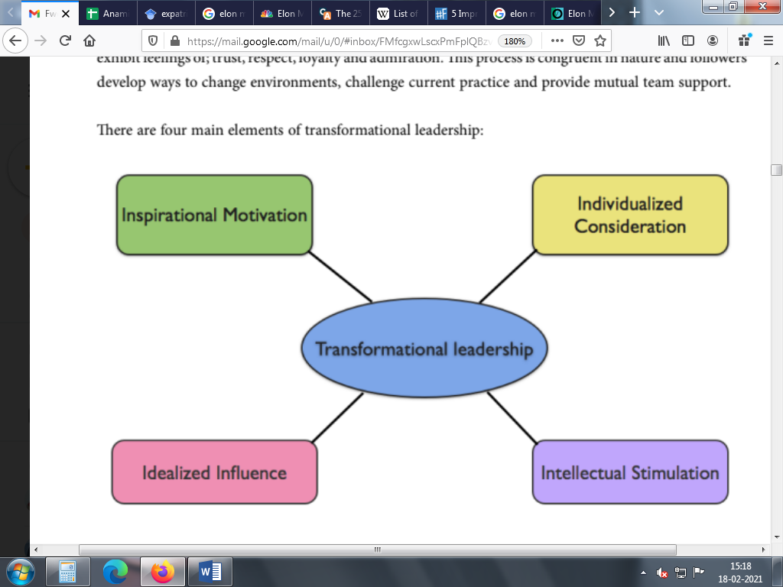
Figure 1: Elements of Transformational Leadership
(Source: Simpson, 2012)
One of the elements of transformational leadership styles is “individual consideration,” where the leader is concerned about the desires and needs of individuals so that through self-motivation and self-development, they can contribute to organisational goals. Elon Musk believes in hiring those individuals who are motivated to work towards the goals. Based on that, the perfect role is given to the person, making the whole process of goal-achieving faster and smoother. “Intellectual Stimulation” is another trait of this style where innovativeness and creativity among the employees are encouraged by the leaders (Simpson, 2012). Musk believes that, without fostering creativity, innovation is impossible, which makes the progress of an individual or a company stagnant. “Inspirational Motivation” is another factor where communication is the key, through which the vision and mission of the company are dispersed to all, which motivates them to work harder to the best of their abilities. Musk continuously keeps inspiring his team members by making the standard of achievement high. Moreover, “idealised influence” is another element of such a leader, who is charismatic, with a sense of principle, values and firm conviction (Van Eeden, Cilliers and Van Deventer, 2008). Musk is highly ethical, and along with taking every possible way to meet his goals, he is not afraid to work harder than others to achieve it. However, such kind of leadership of Musk had some setbacks, which is considered fierce. For the Tesla Model S, two sets of employees were assigned, each of whom had to work for 24 hours straight to finish the work faster. He is the founder of many companies, and while managing it, his worst side came out when he did not acknowledge the support which one of his executives had given him and instead fired her.

Analysis of Leadership Strategies of Elon Musk Changing People’s Life
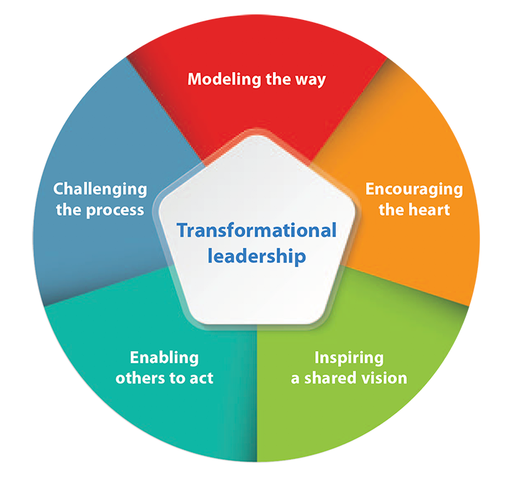
Figure 2: Transformational Leadership Qualities
(Source: Meslec et al., 2020)
Apart from the transformational leadership style, the traits of a few other leadership styles can be noticed in Elon Musk, who is the chosen leader for this paper. However, it needs to be mentioned here that there is a strong link between transformational leadership and charismatic style. Charismatic leaders inspire the staff through motivation while instilling a sense of commitment and excitement in them (Meslec et al., 2020). A sense of “invincibility” can be noticed in this kind of leader, which makes the subordinates overly dependent on the person, which can bring positive results and, in some cases, create negative impact leading to failure. Elon Musk micromanages many of the work in his companies, which can be helpful in a few cases, making the outcome perfect and as expected. However, due to this, the employees in his company are unable to become confident about their decision, which might get rejected by Musk if needed.
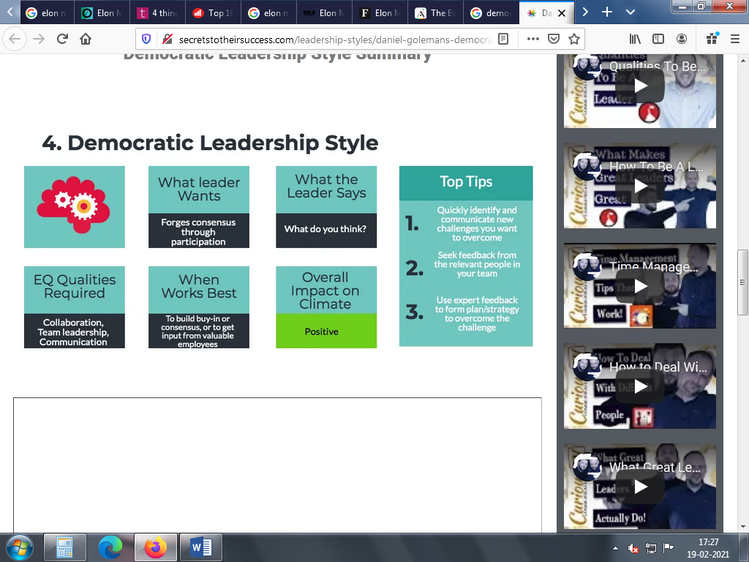
Figure 3: Democratic Leadership Qualities
(Source: Woods, 2020)
The traits of the Democratic Leadership style can also be noticed in Musk. A democratic leader is open-minded, who takes into account the opinion of others, irrespective of their position, before taking the final decision himself. It ensures that the skills and talents of each of the individuals are utilised in the best possible manner (Wilson, 2020). In order to make that possible, Elon Musk starts right from the hiring process, where only the person with mental agility and appropriate behavioural drive is chosen for doing the right kind of role. The natural skills of the selected individuals get utilised at their full potential as they are happy and energetic to do the task, helping his companies to survive the competition and succeed. The team is highly involved in all the tasks increasing productivity, making the staff feel highly empowered. Democratic leadership is suited where quality is given greater importance than just productivity level (Woods, 2020). Elon Musk has the trait where he strives for making the products or services and even the processes better consistently. Due to that, he welcomes the feedback from his team members and even looks for solutions to problems on Facebook, which has helped in improving the overall organisational performance.
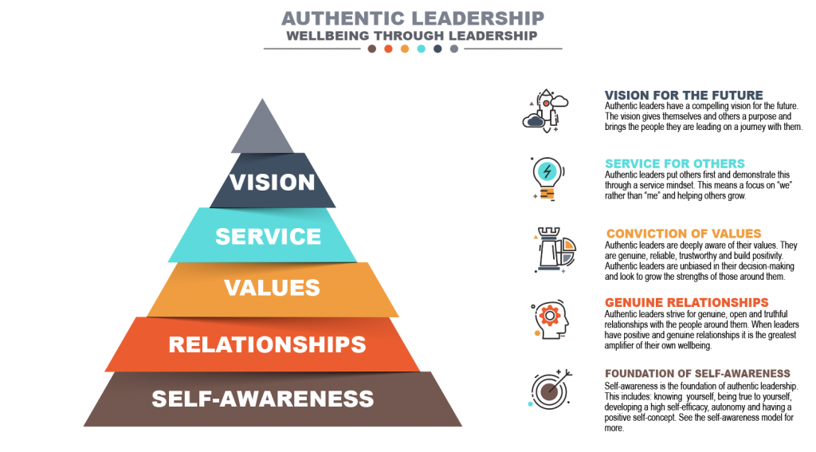
Figure 4: Authentic Leadership Qualities
(Source: Hoch et al., 2018)
The Authentic Leadership philosophy denotes that a leader who is authentic stays true to oneself and the ways in which work is done (Hoch et al., 2018). Elon Musk has always been true to himself and never tried to be like any other person just to make the company successful. His brother has mentioned that he says and writes those things in which he believes, without thinking about the consequences, at times. Moreover, this kind of leader is self-motivated by a bigger purpose. Musk is motivated by his dream of making a mark in the world, in whatever way possible, by contributing to the growth of humankind. Due to this, he is never afraid of failure and learns from each of those mistakes until he gets what he has aimed for respectively. This self-motivation helps him to tackle all the obstacles which he faces throughout the process of a project. Authentic leaders focus on sustainability in the long term and make each of the decisions based on their own value system, ignoring what would be liked by others (Duncan et al., 2017). Founding Tesla for manufacturing electric cars which would reduce carbon emission, taking the project of Hyperloop and Electric Jet in hand, and aiming to make space transportation more manageable and cheaper are his decisions for future sustainability. Musk values communication, which is why he has created the feedback loop, through which each of the subordinates in his company is able to directly communicate with him instead of going through a chain of command (Covelli and Mason, 2017). In order to fulfil his extraordinary dream, he works closely with the team members and constantly inspires and motivates them to do so. His attitude of taking failure as a way of learning and taking obstacles head-on motivates employees to follow the same path.

Compare and Contrast of the Positives and Negatives of Three Leadership Styles
The three leadership styles chosen here are autocratic, democratic, and bureaucratic. The positive factors, as well as the negative sides of each of the leadership styles, are compared and contrasted. In the case of autocratic leaders, it is their belief that they have the authority of the whole organisation. Moreover, they have the power to control the subordinates and the tasks they perform (Simpson, 2012). On the other hand, the Bureaucratic leaders follow the rules and instructions which the position offers them, while the democratic leaders take into account the opinion of each of the team members before making the decision. However, the final decision is taken by these democratic leaders, based on the ideas of each of the members. The focus of the autocratic leaders is on the completion of goals set for the team or the organisation, where the growth or other factors related to the employees are not taken into consideration. Similar to that, bureaucratic leaders can be seen more as an enforcer than a leader, who makes the subordinates do what the higher authorities had directed or ordered (Bark and Bell, 2019). In contrast, the leaders following the democratic style focus primarily on the opinions of the employees before taking the final decision, due to which they are liked by the subordinates more than other kinds of leaders.
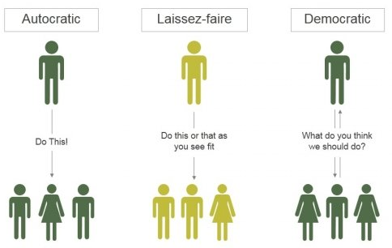
Figure 5: Comparison of Autocratic, Democratic and Laissez-Faire or Bureaucratic Leadership
(Source: SlideGeeks, 2021)
While a task is allocated to the team members, the autocratic kind of leader takes the dictatorial approach. Leaders following the mentioned style just convey the message or order given by the higher authorities. The autocratic leaders are the sole decision-maker for the whole team according to themselves (Harms et al., 2018). In no situation, the autocratic leaders have any concern about what the team members think and due to that, their opinions are ignored, even if they are beneficial for the performance of the team and the company. It leads to mediocre decisions, which might not be best for the team or the company. Similar to the autocratic leader, the bureaucratic leader too follows all the procedures and rules which are given to them as instruction, and they never deviate from it, even by a word (Adha et al., 2020). Due to that, the fact that the team members might have individual opinions or ideas is ignored. In situations where the bureaucratic leaders are unable to make a decision, they defer the command to the person who is “up the chain”. In contrast to that, democratic leaders are more open-minded and vary their decision after considering the views of other members of their team, which makes the members feel comparatively more empowered and work more for the company’s goal (İnce, 2018). The high involvement of the team members in the decision-making process has a positive result, which is the high productivity of the individual and the organisation.
There are specific benefits and setbacks of each type of leader. As the authority of decision-making is solely in the hand of autocratic or bureaucratic leaders, the time taken to reach a decision is much lower. Contrarily, the democratic leaders take the opinion of each team member, which makes the decision-making process much lengthier and time-consuming. As a result, the work done under an autocratic or bureaucratic leader is more effective compared to democratic ones (Dyczkowska and Dyczkowski, 2018). However, the quality of the result under democratic leaders is much higher as quantity is not their prime focus, due to which it is used in those industries which require more flexibility and expect the staff to be innovative and creative. Autocratic leadership is mostly used in the industries of construction, manufacturing and in the military. On the other hand, bureaucratic leadership is required in situations where safety or security is the prime concern, and the same tasks are performed repeatedly, which involve height, machinery, and toxicity (Eshbaugh-Soha, 2017). The reason behind this kind of leader getting promoted is their strict rule-following, where the talent, expertise, or qualification of the employees do not matter. Adversely, under democratic leadership, the environment encourages free information sharing, where conformity has no place (Hilton, Arkorful and Martins, 2021). Due to that, the talent, as well as the skills of each of the members of the team and the leader, is utilised to the full extent.

Evaluation of Personal Ability for Fulfilling Leadership Responsibilities at Changing Workplace
Globalisation has brought a drastic change in the market, which has affected the level of complexity, which exists within an organisation. Due to that, it has become essential to adjust to the changing environment at the workplace by fulfilling the leadership roles and responsibilities based on the appropriate leadership style. According to Agarwal and Toshniwal (2020), there are mainly three kinds of leadership, which are transformational, transactional and laissez-faire. In order to understand which leadership styles are ideal for a person, there is a need to determine the personal ability and personality traits that match the style and will help in fulfilling the roles at a complex workplace setting. A leader of an organisation has few responsibilities to fulfil, which include meeting the goal set for the organisation, with the vision of reaching an improved situation. Moreover, the leaders are also responsible for taking into account different factors to determine the path, which is the most effective to reach the desired result (Frieder, Wang and Oh, 2018). Along with that, the leaders must have the trait of self-motivation and inspire others through it to achieve personal and organisational goals. In the cases where the employees are successful, the leader must be attentive enough to celebrate their success formally, through promotion or hike in salary, or informally by throwing a party.
The person aiming to be a successful leader also has the primary aim to meet the organisational goals set by himself or the higher authorities before fulfilling the other responsibilities. However, he wants to make sure to bring down the dissatisfaction, which exists among the employees, which is possible with the use of the democratic leadership style (Aydogmus et al., 2018). The personality trait of giving importance to the ideas and opinions of all the team members before taking the final decision is the trait that can be seen in a democratic leader. He believes that each person has a specific quality and talent, which helps the person to gain expertise in specific tasks. While guiding such employees in the organisation, he will try to find out the specific talent. Based on that, the right task will be delegated, which will enable boosting the performance of each employee and the company as a whole.
One of the critical traits of transformational leaders is that they focus on forming a team, which works together to meet the team goal. Additionally, he would focus on forming a team where each member helps the others to meet the individual goals at the workplace (Gnambs, 2019). As a transformational leader, he would not always follow the hierarchy of power and position existing at the workplace, as he believes that these traits or qualities of leadership are organically formed, and when such situations are faced, it comes out. The high focus on people will help him to gain the trust of the followers and inspire the same trust within each other, which fuels innovation among them and helps in their personal development along with the organisation. In the changing environment within the organisation, he will manage the change by providing assistance to the subordinates and team members by making the process smoother (Ibrahim and Daniel, 2019). In order to make it possible, the proactive, risk-taking behaviour will come into use, which will enable him to make an appropriate plan that involves innovative problem-solving characteristics that generate opportunities.

Conclusion

This formal essay focuses mainly on a global leader, whose characteristics and personality traits are analyzed to determine the type of leadership he follows. The chosen leader is Elon Musk, who has made some revolutionary innovations that have changed the lives of people or have the potential to do so in the future. The analysis of different leadership styles has led to the conclusion that Musk mainly follows the transformational style of leadership. In addition to that, he follows the charismatic, authentic and democratic leadership theory, due to which he gives high importance to communication, innovation and motivates the employees to work harder by setting an example of himself. The positive and negative sides of the autocratic, bureaucratic and democratic leadership styles are compared and contrasted. Finally, the personal ability of the person aiming to be a successful leader to fulfil the responsibilities of a leader for bringing change in complex situations at the workplace is described.

Reference List
Adha, S., Sintawati, F., Julyanto, O., Wulandari, R.A. and Purwanto, A., (2020). Leadership Style for Indonesian Public Health Center: Charismatic, Bureaucratic, Transactional, Transformational, Autocratic or Democratic? European Journal of Molecular & Clinical Medicine, 7(7), pp.115-124. https://ejmcm.com/article_1713.html
Agarwal, A. and Toshniwal, D., (2020). Identifying leadership characteristics from social media data during natural hazards using personality traits. Scientific reports, 10(1), pp.1-15. https://www.nature.com/articles/s41598-020-59086-0
Aydogmus, C., Camgoz, S.M., Ergeneli, A. and Ekmekci, O.T., (2018). Perceptions of transformational leadership and job satisfaction: The roles of personality traits and psychological empowerment. Journal of Management and Organization, 24(1), pp.81-107. http://repository.bilkent.edu.tr/handle/11693/38145
Bark, T. and Bell, E., (2019). Issue prioritisation by bureaucratic leaders: The influence of institutional structure. Administration & Society, 51(6), pp.915-950. https://journals.sagepub.com/doi/abs/10.1177/0095399718810194
Buil, I., Martínez, E. and Matute, J., (2019). Transformational leadership and employee performance: The role of identification, engagement and proactive personality. International Journal of Hospitality Management, 77, pp.64-75. https://www.sciencedirect.com/science/article/pii/S0278431917308472
Covelli, B.J. and Mason, I., (2017). Linking theory to practice: Authentic leadership. Academy of Strategic Management Journal, 16(3), pp.1-10. https://search.proquest.com/openview/a69a4feb2ff9219cce2892aacbdf82c6/1?pq-origsite=gscholar&cbl=38745
Duncan, P., Green, M., Gergen, E. and Ecung, W., (2017). Authentic leadership—is it more than emotional intelligence? Administrative Issues Journal, 7(2), p.3. https://dc.swosu.edu/aij/vol7/iss2/3/
Dyczkowska, J. and Dyczkowski, T., (2018). Democratic or autocratic leadership style? Participative management and its links to rewarding strategies and job satisfaction in SMEs. Athens Journal of Business & Economics, 4(2), pp.193-218. https://pdfs.semanticscholar.org/578a/c17d226420b6ca6040dba5b35904e919975d.pdf
Eliyana, A. and Ma’arif, S., (2019). Job satisfaction and organisational commitment effect in the transformational leadership towards employee performance. European Research on Management and Business Economics, 25(3), pp.144-150. https://www.sciencedirect.com/science/article/pii/S2444883418300196
Eshbaugh-Soha, M., (2017). Presidential rhetoric, agency turnover, and the importance of salience to bureaucratic leadership. The Social Science Journal, 54(2), pp.206-215. https://www.sciencedirect.com/science/article/pii/S0362331917300083
Frieder, R.E., Wang, G. and Oh, I.S., (2018). Linking job-relevant personality traits, transformational leadership, and job performance via perceived meaningfulness at work: A moderated mediation model. Journal of Applied Psychology, 103(3), p.324. https://psycnet.apa.org/record/2017-45569-001
Gnambs, T., (2019). Opinion leadership types or continuous opinion leadership traits? International Journal of Psychology, 54(1), pp.88-92. https://onlinelibrary.wiley.com/doi/abs/10.1002/ijop.12442
Harms, P.D., Wood, D., Landay, K., Lester, P.B. and Lester, G.V., (2018). Autocratic leaders and authoritarian followers revisited: A review and agenda for the future. The Leadership Quarterly, 29(1), pp.105-122. https://www.sciencedirect.com/science/article/pii/S1048984317300814
Hilton, S.K., Arkorful, H. and Martins, A., (2021). Democratic leadership and organisational performance: the moderating effect of contingent reward. Management Research Review. https://www.emerald.com/insight/content/doi/10.1108/MRR-04-2020-0237/full/html
Hoch, J.E., Bommer, W.H., Dulebohn, J.H. and Wu, D., (2018). Do ethical, authentic, and servant leadership explain variance above and beyond transformational leadership? A meta-analysis. Journal of Management, 44(2), pp.501-529. https://journals.sagepub.com/doi/abs/10.1177/0149206316665461
Ibrahim, A.U. and Daniel, C.O., 2019. Impact of leadership on organisational performance. International Journal of Business Management and Social Research, 6(2), pp.367-374. https://www.academia.edu/download/62084490/Impact_of_leadership_on_organisational_performance20200213-112320-1ylryu7.pdf
İnce, F., (2018). The effect of democratic leadership on organisational cynicism: A study on public employees. İşletme Araştırmaları Dergisi, 10(2), pp.245-253. https://www.ceeol.com/search/article-detail?id=687786
Kudas, M., (2019). The brand new world in science and engineering–Elon Musk. In Наукові розробки молоді на сучасному етапі. Київський національний університет технологій та дизайну. https://er.knutd.edu.ua/bitstream/123456789/14379/1/NRMSE2019_V3_P605-606.pdf
Kulshreshth, A., Anand, A. and Lakanpal, A., (2019, October). Neuralink-an Elon Musk start-up achieve symbiosis with artificial intelligence. In 2019 International Conference on Computing, Communication, and Intelligent Systems (ICCCIS) (pp. 105-109). IEEE. https://ieeexplore.ieee.org/abstract/document/8974470/
Mahmood, M., Uddin, M.A. and Fan, L., (2019). The influence of transformational leadership on employees’ creative process engagement. Management Decision. https://www.emerald.com/insight/content/doi/10.1108/MD-07-2017-0707/full/html
Meslec, N., Curseu, P.L., Fodor, O.C. and Kenda, R., (2020). Effects of charismatic leadership and rewards on individual performance. The Leadership Quarterly, 31(6), p.101423. https://www.sciencedirect.com/science/article/pii/S1048984320300503
Monarrez, A., (2020). Autonomous Vehicle Manufacturers: Applying a Common Carrier Liability Scheme to Autonomous Vehicle Manufacturers—and Why Elon Musk Will Be Haunted by His Words. https://digitalcommons.law.seattleu.edu/cgi/viewcontent.cgi?article=1007&context=sulr_supra
Pisarchik, A.N., Maksimenko, V.A. and Hramov, A.E., (2019). From novel technology to novel applications: Comment on “An integrated brain-machine interface platform with thousands of channels” by Elon Musk and Neuralink. Journal of medical Internet research, 21(10), p.e16356. https://www.jmir.org/2019/10/e16356
Rimmer, M., (2018). Elon Musk’s open innovation: Tesla, intellectual property, and climate change. In Intellectual Property and Clean Energy (pp. 515-551). Springer, Singapore. https://link.springer.com/chapter/10.1007/978-981-13-2155-9_19
Simpson, S., (2012). The Styles, Models & Philosophy of Leadership. Denmark: Ventus Publishing Aps. http://consus.boku.ac.at/files/projects/268/en/handouts/the-styles-models-philosophy-of-leadership.pdf
SlideGeeks, (2021). Leadership Styles Based On Authority. SlideGeeks. [Online] Available at: https://www.slidegeeks.com/business/product/leadership-styles-based-on-authority-tamplate-2-ppt-powerpoint-presentation-templates [Accessed on: 19th February, 2021]
Van Eeden, R., Cilliers, F. and Van Deventer, V., (2008). Leadership styles and associated personality traits: Support for the conceptualisation of transactional and transformational leadership. South African Journal of Psychology, 38(2), pp.253-267. https://journals.sagepub.com/doi/abs/10.1177/008124630803800201
Wilson, D.E., (2020). Moving toward democratic-transformational leadership in academic libraries. Library Management. https://www.emerald.com/insight/content/doi/10.1108/LM-03-2020-0044/full/html
Woods, P.A., (2020). Democratic leadership. In Oxford Research Encyclopedia of Education. https://oxfordre.com/education/view/10.1093/acrefore/9780190264093.001.0001/acrefore-9780190264093-e-609
Yauney, R.H., (2018). Leadership Development: A Study of Elon Musk. Marriott Student Review, 2(2), p.4. https://scholarsarchive.byu.edu/marriottstudentreview/vol2/iss2/4/
Zuraik, A. and Kelly, L., (2019). The role of CEO transformational leadership and innovation climate in exploration and exploitation. European Journal of Innovation Management. https://www.emerald.com/insight/content/doi/10.1108/EJIM-10-2017-0142/full/html

