Digital Skills and Research Method

- Student name: Petronela Gabriela Uruioc
- Student number:1914742
- Module code: BMSW4003
- Lecture name: Suneth Fernando

Topic: The impact of Virtual Learning Environment (VLE) – Moodle on students’ learning experience at the University of Wales Trinity Saint David London Campus
Executive summary
The research report aims to provide an evaluation of the positive affect of virtual learning experiences on the students of the University of Wales followed by a conduction of a small-scale research. The report has the purpose to conduct a literature review relevant to this topic to identify the positive impact and the issues related to the virtual learning experience. In addition, the research conducted both primary and secondary data analysis by designing an academic questionnaire sent to the students of the university to find their response over the topic and reviewing relevant journals and articles to make an effective conclusion.

Table of Contents
Introduction 4
Research title 4
Research rationale 4
Research objectives 4
Literature review 5
Introduction 5
Positive impacts of Virtual learning environment 5
Issues regarding Virtual learning environment 5
Summary 6
Literature gap 6
Methodology 6
Research philosophy 6
Research approach 6
Research design 7
Data collection method 7
Sampling size 7
Ethical consideration 7
Time Scale 7
Gantt chart 8
Primary data analysis 9
Secondary data analysis 15
Conclusion 15
Reference list 16
Appendix 18

Introduction
Virtual learning environment is introduced to promote active learning and skills of thinking critically that are required for transferring classroom-based knowledge to the practical process (Ryan and Poole, 2019). The research report aims to discuss the affect of VLE on the learning experiences of students by conducting a small-scale research followed by a primary and secondary data analysis. Moreover, there is a review of the impact of VLE by analysing different literatures related to the positive affect of using VLE.

Research title
“The impact of Virtual Learning Environment (VLE) – Moodle on students’ learning experience at the University of Wales Trinity Saint David London Campus”

Research rationale
The research is conducted to provide an insight on the significant role of Virtual learning to enhance students' satisfaction and engagement towards the learning sessions. The research will be helpful to identify the efficiency of the tool for learning and teaching (Mosquera, 2017). The research will be beneficial to comprehend the significance of virtual learning to increase students' motivation and it includes the issues related to this on the students' learning process.

Research objectives
The objectives of the research are listed below:
- To find the positive impacts of VLE on students' learning
- To find the significance of VLE to motivate the students to learn
- To identify the issues regarding virtual learning

Literature review

Introduction
Virtual learning is used widely in education and learning systems to deliver effective materials and foster communication between learners and teachers. The following literature review has been conducted through analysing different perspectives of renowned writers from journals and articles. The review will discuss the positive impacts of VLE and issues related to this.

Positive impacts of Virtual learning environment
VLE has been used since 2000 as blackboard software in different educational institutes in the UK. Moodle is one of the popular VLE introduced in 2001 to foster online courses by focusing on collaborative materials in learning (moodle, 2020).
The positive impacts of using VLE can be identified as it is used as a collaborative tool, which helps students and teachers to interact online effectively and improve their analytical ability. As opined by Kiat et al. (2016), it helps to enhance independent thought of students and encourage them to have multiple understanding and perspectives over a particular topic. VLE helps to encourage progressive thinking of the students and enables them to think independently and rationally over the study material. According to McKenna et al. (2017), it has been found that introverted students become able to express their views and they are likely to get involved in online discussion more frequently compared to the traditional classroom session. It provides the opportunity to reinforce the missed materials and facilitates open discussion. However, there are some limitations of using VLE compared to the usage of traditional classroom sessions that do not highlight the structure or culture of an organisation.

Issues regarding Virtual learning environment
It is a quiet imperative to maintain virtual experiences and its relevance to the learners' future opportunities in career and every day working life. Odryekhivsk et al. (2019) say virtual learning sometimes can create unrealistic and difficult situations that are irrelevant to the learners while handling a realistic problem. VLE limits the learners' engagement, as they are not able to ask their teachers instant queries for better understanding of the module. It fosters limited understanding the materials covered in the virtual learning process. According to Atayeroet al. (2017), as VLE is a software based system, learners often face technical issues related to network problems, security problems, bandwidth glitches and others. It hampers the motivation of the students while learning in a virtual environment.

Summary
In summary, it can be said that virtual learning is a significant tool to improve students' engagement and attention towards the learning sessions and it facilitates learning by encouraging rational and analytical thinking. However, there are some issues faced by the learners while learning in such an environment such as limited engagement, technical issues and others.

Literature gap
The review is limited to the analysis of a few journals and an article covering the topic as the researcher was unable to read a vast range of literature to determine the affect of VLE on the students' learning perception. The analysis can be further improved by covering other details from different journals and articles covering the topic.

Methodology

Research philosophy
It is important to conduct the research within a particular pattern by collecting the relevant and significant information effectively. Research philosophy enables to complete the research in an effective way by collecting important data from different sources (Kennedy, 2017). In this mentioned research, the positivism philosophy has been used as it has the purpose to collect the data based on a scientific structure.

Research approach
Research approaches can be defined as an effective plan to enhance the data collection process and analyse them in an efficient way. Two research approaches include deductive and inductive; in this case, the deductive approach will be used to collect primary and secondary data as it helps to evaluate the data with the help of the current theoretical review.

Research design
Research design is a framework for all the necessary data and information related to the topic by conducting a market research (Alase, 2017). In this following research, the descriptive research design is chosen to use to provide an integration of qualitative and quantitative data collection.

Data collection method
Data collection methods are used to conduct market research and analyse all the relevant information (Paradis et al., 2016). The above research has been completed through primary and secondary data collection methods. Here, academic questionnaires have been designed and sent to the students of University of Wales to find their response and the secondary data analysis has been conducted with the help of different literatures relevant to the topic.

Sampling size
In this study, the researcher has chosen a sample of 20 students from the University of Wales for the primary data collection and secondary information has collected by studying journals and articles to comprehend the facts related to the above topic.

Ethical consideration
All the participants are chosen irrespective of kind of discrimination and they have given all the freedom to answer the questions sent to them. The research has been done for academic purpose and the primary information of the respondents will be not enclosed with the acknowledgement of the data protection act in the UK (gov.uk 2011).

Time Scale
Activities | Start date | Duration | End date
Identification of the research topic | 6/19/2020 | 2 | 6/21/2020
Research objectives | 6/21/2020 | 3 | 6/24/2020
Literature review | 6/24/2020 | 14 | 7/8/2020
Research methodology | 7/8/2020 | 7 | 7/15/2020
Primary data collection | 7/15/2020 | 10 | 7/25/2020
Secondary data collection | 7/25/2020 | 10 | 8/4/2020
Recommendation | 8/4/2020 | 4 | 8/8/2020
Conclusion | 8/8/2020 | 5 | 8/13/2020
Table 1: Time scale
(Source: developed by the learner)

Gantt chart
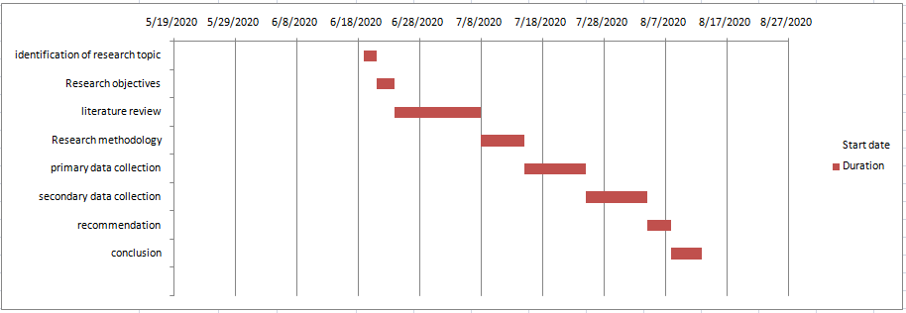
Figure 1: Gantt chart
(Source: developed by the learner)

Primary data analysis
The primary data collection has been conducted through a participation of 20 students of University of Wales to identify their perspective of the positive affect of VLE on their learning perception.
Qs 1: What is your age?

Age group | Number of respondents | Percentage of respondents | Total respondents
18-21 | 7 | 35% | 20
22-25 | 8 | 40% | 20
25-30 | 5 | 25% | 20
Table 2: Age of the participants
(Source: Developed by the learner)
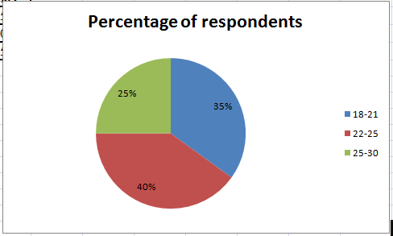
Figure 2: Age of the participants
(Source: Developed by the learner)
The above table indicates that the researcher has focused on the students belonging to the age group of 22 to 25 as they are the maximum number of students in the university. Around 35% of the students belong to the group of 18 to 21 years age and the rest are from the group of 25 to 30.
Qs 2: Do you agree that the use of moodle enhances the quality of your learning?

Options | Number of respondents | Percentage of respondents | Total respondents
Strongly Agree | 7 | 35% | 20
Agree | 6 | 30% | 20
Neutral | 5 | 25% | 20
Disagree | 2 | 10% | 20
Table 3: Response to the statement that the use of moodle enhances the quality of your learning
(Source: Developed by the learner)
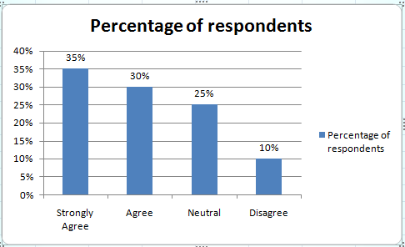
Figure 3: Response to the statement that the use of moodle enhances the quality of your learning
(Source: Developed by the learner)
The above table indicates that 35% of the students have strongly agreed to the question that the use of moodle, the virtual learning experience enhances the quality of their learning. Around 30% of the participants agreed to the statement, 25% answered neutrally and 10% disagreed to the statement. It can be said that virtual learning can enhance the quality of learning and it is better than the conventional learning method.
Qs 3: Do you agree that VLE encourages independent learning?

Options | Number of respondents | Percentage of respondents | Total respondents
Strongly Agree | 6 | 30% | 20
Agree | 6 | 30% | 20
Neutral | 5 | 25% | 20
Disagree | 3 | 15% | 20
Table 4: Response to the statement that VLE encourages independent learning
(Source: Developed by the learner)
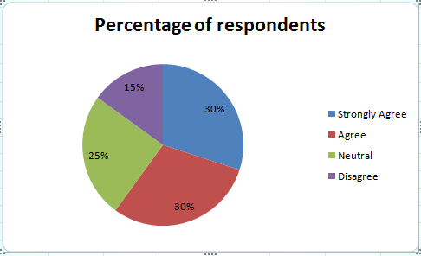
Figure 4: Response to the statement that VLE encourages independent learning
(Source: Developed by the learner)
The above figure indicates that around 60% of the students feel that virtual learning has encouraged them to think independently and rationally and it has fostered independent learning. However, 25% of the students give neutral answers and 15% disagree with this.
Qs 4: Do you agree that VLE helps to increase motivation of the students to learn?

Options | Number of respondents | Percentage of respondents | Total respondents
Strongly Agree | 8 | 40% | 20
Agree | 6 | 30% | 20
Neutral | 4 | 20% | 20
Disagree | 2 | 10% | 20
Table 5: Response to the statement that VLE helps to increase motivation of the students to learn
(Source: Developed by the learner)
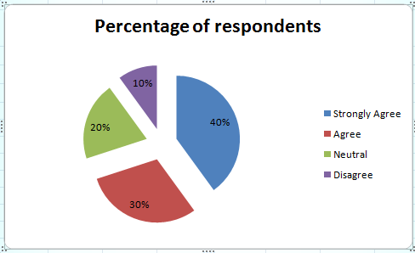
Figure 5: Response to the statement that VLE helps to increase motivation of the students to learn
(Source: Developed by the learner)
From the above figure, it can be identified that around 40% of the respondents strongly agree that virtual learning is helpful to enhance motivation in the students to learn. Around 30% of them agree to that, 20% give answers neutrally and the rest disagree with this. It can be concluded that virtual learning is beneficial to provide the opportunity of increasing motivation towards learning and it gives satisfaction to the students.
Qs 5. What is the issue you faced while learning in a virtual platform?
Options | Number of respondents | Percentage of respondents | Total respondents
Inexperienced partner | 5 | 25% | 20
Distraction | 6 | 30% | 20
Technical issues | 7 | 35% | 20
Motivation | 2 | 10% | 20
Table 6: Issues faced while learning in a virtual platform
(Source: Developed by the learner)
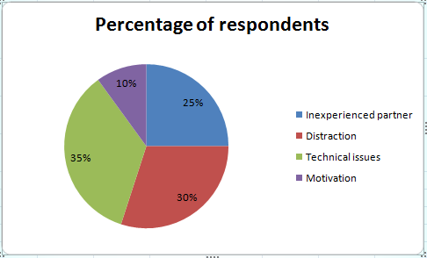
Figure 6: Issues faced while learning in a virtual platform
(Source: Developed by the learner)
The above figure shows that around 35% of the students participated in the survey faced technical issues during a virtual learning experience from their home, as not all the students have the appropriate facility and equipment for learning in a virtual platform. Around 30% thought that they got distracted while learning online and 10% faced motivational issues while 25% complained for having an inexperienced collaborate that hamper their study as well.

Secondary data analysis
Positive impact of VLE
As opined by Kiat et al. (2016), as a VLE, Moodle has a user base to provide a learning platform and different course managements that helps the students to learn effectively from any devices online. It provides a better collaboration between the teachers and students and helps them to develop their analytical skill and understanding ability. It helps to maximize the reflection of the students and encourages them to think positively and independently (McKenna et al., 2017). It improves the quality of learning and fosters a positive difference in the comprehension approach of the students. It accommodates the demands of the students and increases their confidence.
Issues regarding VLE
The web-based materials and instruction do not allow emotional and social communication that limits the interaction between teachers and the students. The journal identifies that technical, networking issues can limit the application of virtual learning, and it hampers the motivation of the students (Atayeroet al., 2017).

Conclusion
The research report concludes that virtual learning can be beneficial to promote Independence learning and critical thinking abilities of the students and it enables to increase the motivation and the quality of learning of the students in the University of Wales. In addition, the research can be recommended to use an inductive research approach that can allow flexibility in the context of collecting the data and analyse them.

Reference list
Alase, A., 2017. The Interpretative Phenomenological Analysis (IPA): A Guide to a Good Qualitative Research Approach. International Journal of Education and Literacy Studies, 5(2), pp.9-19.
Atayero, A.A., Ilori, O.A. and Adedokun, M.O., 2017. Cloud security and the Internet of Things: Impact on the virtual learning environment. Covenant university.
Government Digital Service. 2011. Data protection. [online] GOV.UK. Available at: <https://www.gov.uk/data-protection#:~:text=The%20Data%20Protection%20Act%202018%20is%20the%20UK’s%20implementation%20of,used%20fairly%2C%20lawfully%20and%20transparently> [Accessed 1 Aug. 2020].
Kennedy, A.M., 2017. Macro-social marketing research: Philosophy, methodology and methods. Journal of Macromarketing, 37(4), pp.347-355.
Kiat, L.B., Ali, M.B., AbdHalim, N.D. and Ibrahim, H.B., 2016, October. Augmented reality, virtual learning environment and mobile learning in education: a comparison. In 2016 IEEE Conference on e-Learning, e-Management and e-Services (IC3e) (pp. 23-28). IEEE.
McKenna, G., Baxter, G. and Hainey, T., 2017.Adopting a virtual learning environment towards enhancing students’ self-efficacy. Journal of Applied Research in Higher Education.
Moodle, Moodle App - Mobile Learning on iOS, Android & PC 2020. Moodle. [online] Moodle. Available at: <https://moodle.com/app/> [Accessed 1 Aug. 2020].
Mosquera, L.H., 2017. Impact of implementing a virtual learning environment (vle) in the efl classroom. Íkala: Revista de Lenguaje y Cultura, 22(3).
Odrekhivskyy, M., Pasichnyk, V., Rzheuskyi, A., Andrunyk, V., Nazaruk, M., Kunanets, O. and Tabachyshyn, D., 2019.Problems of the Intelligent Virtual Learning Environment Development.In MoMLeT (pp. 359-369).
Paradis, E., O'Brien, B., Nimmon, L., Bandiera, G. and Martimianakis, M.A., 2016. Design: selection of data collection methods. Journal of graduate medical education, 8(2), pp.263-264.
Ryan, E. and Poole, C., 2019. Impact of Virtual Learning Environment on Students’ Satisfaction, Engagement, Recall, and Retention. Journal of medical imaging and radiation sciences, 50(3), pp.408-415.

Appendix

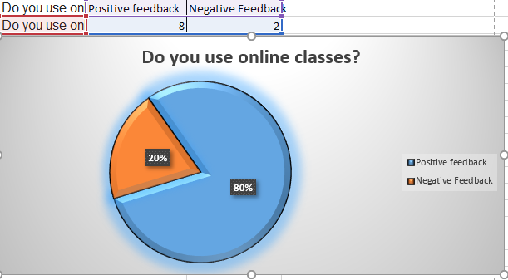

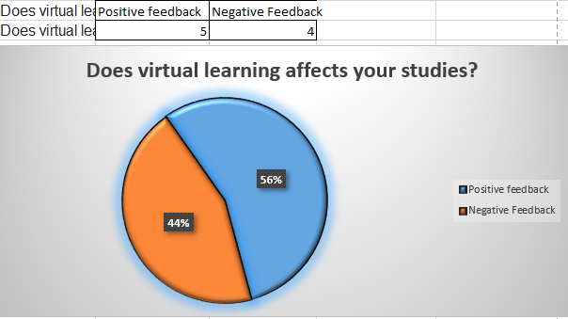
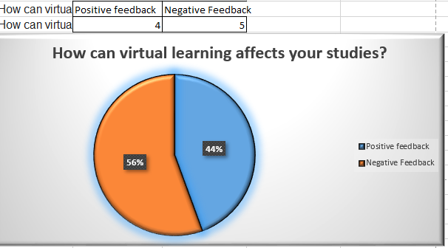

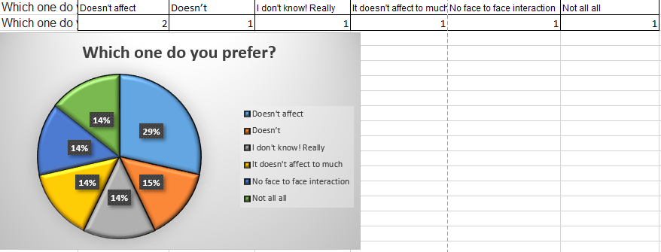
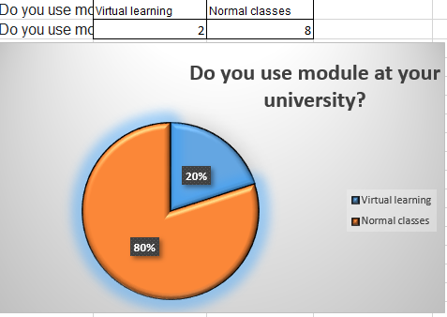
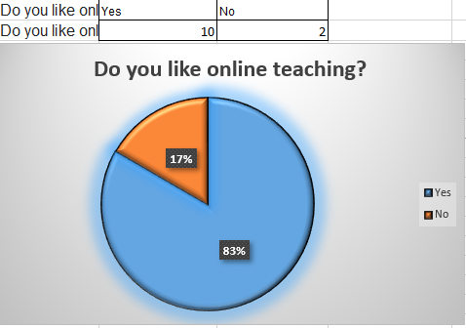

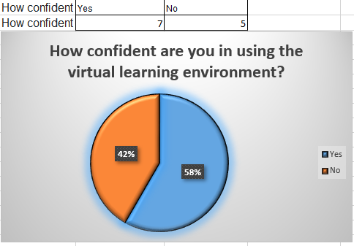

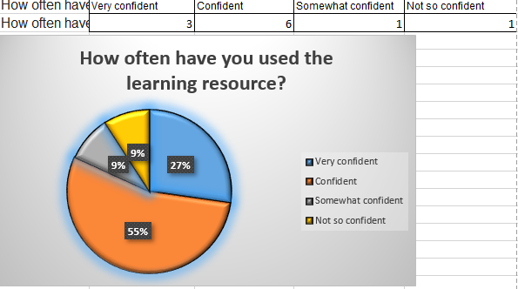

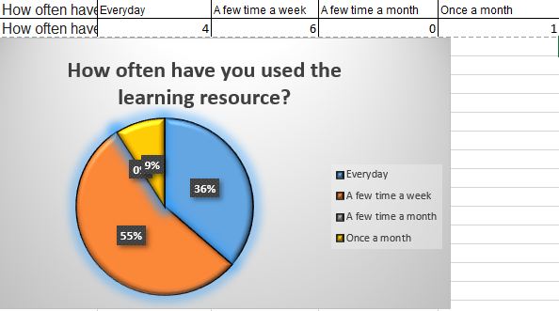
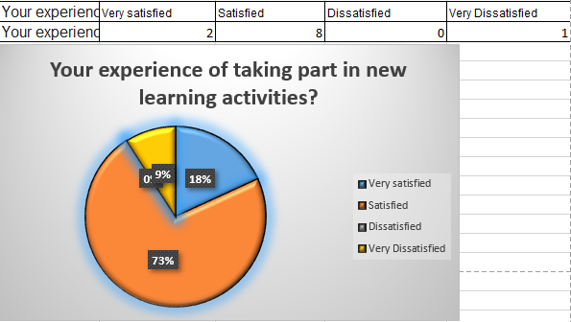

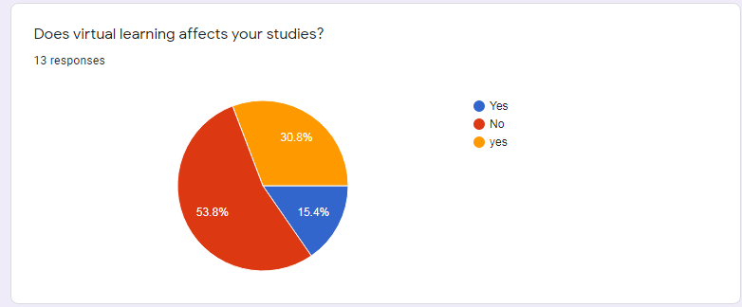

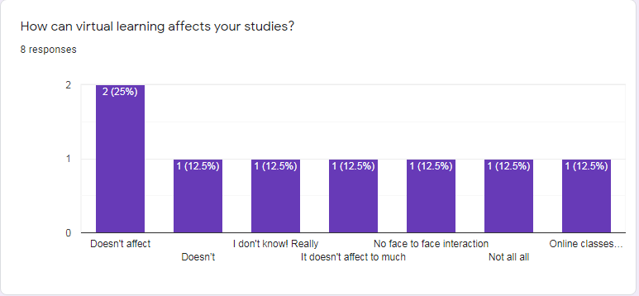

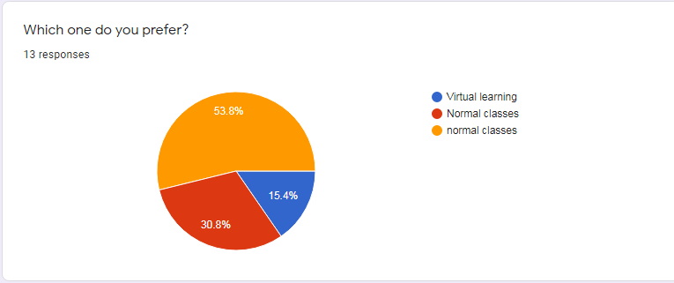

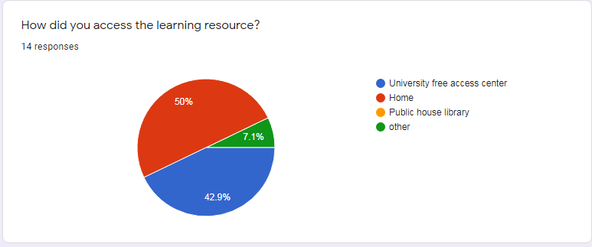

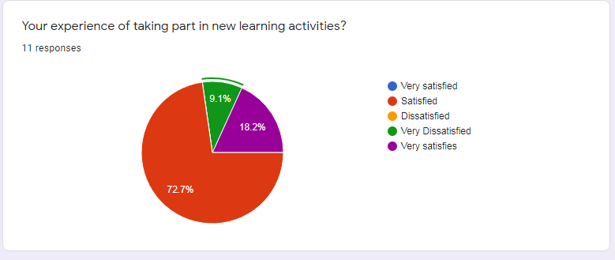

https://docs.google.com/forms/d/e/1FAIpQLSe7LTXEXURX7P9NjmMc4Ga3LJ4PNN0V70mD6O03qsyvLgBuGQ/viewform?usp=sf_link

