

  - LCBB5000
  - Data Handling and Business Intelligence

  - Component 2

Student Name: Elena Dineva
Student Number: 2226629
Lecturer: Molly Jack
Table of Contents
Part 1. 3
Introduction 3
Task 1. Finding the sales trend over the months 3
Task 2. Finding the most frequently purchased products 5
Task 3. Finding the number of products, the customer purchase in each transaction 6
Task 4. Finding the most profitable segment customers 7
Task 5. Based on above findings, strategy to recommend to the business to gain more profit 9
Conclusion 11
Part 2. 11
Task 1. Finding number of male and female students 12
Task 2. Finding number of students qualifies or does not for reduced or free lunch 13
Task 3. Finding the mean and median of the students qualifies or does not for reduced or free lunch for pretest and posttest 14
Task 4. K-Means Clustering 14
Task 5. SPSS and Excel – advantages, disadvantages & discussion 17
References 20

Part 1.

Introduction
In today's world, the use of e-commerce systems has become one of the most important methods through which businesses are boosting their performance and sales. This is also helping the consumers in improving their opportunity of enjoying the shopping in their convenient way and 24/7. However, in order to run the e-commerce business, it is extremely important to ensure that the use of data management is being conducted successfully in order to understand the market print and apply the strategies in the business for enhancing the performance of the company.
In this report the discussion about data handling and data management has been conducted by analysing result transaction data of an e-commerce business organisation over the last one year. On the basis of the findings of the data analysis, suitable strategies have been recommended as well to the company for improving the opportunity of earning profit. This report has been specially prepared to find out about the sales trend witnessed by the company over the months in last year; to find out about the most frequently purchased products; the number of products generally ordered by a customer in each transaction; the most profitable segment of the business; et cetera. Strategies for improvement of performance have been recommended on the basis of the findings.

Task 1. Finding the sales trend over the months
Month | Total revenue
January | 172592.36
February | 179868.59
April | 79020.71
May | 288295.47
June | 190335.34
July | 263611.26
August | 215952.78
September | 604502.11
November | 2739679.19

Graph 1: Sales trend over the months [Source: Self-created by author]

From the found information about the sales transaction of the company throughout the months, in the last year it has been found that the overall performance of the company has increased significantly especially in the month of November. Over the period of time it has been found that the overall growth of the company was visible. However, little fluctuation in the sales trend of the company was visible in the last 12 months of time. It is important to note that in a few of the months there were no sales recorded in the business transaction from the data set given. Therefore, it can be said that the overall stability of the e-commerce business organisation in the last one year is not satisfactory. It has been found that in the months of March, October and December, no sales were recorded in the business. On the other hand, the continuous growth of the company through the sales is visible as the sales of the business in both September and November is significantly higher than the original sales amount of the company in January and the other previous months. The sudden growth of the business performance in November can be taken into consideration by the company to identify the changes that have been made by the business management to maintain the stability in business performance and growth opportunity available for the business.

Task 2. Finding the most frequently purchased products

Graph 2: Frequently purchased products from the e-commerce business [Source: Self-created by author]

From the above graph it is visible that the distribution of products is showing the 'rabbit night light' is the most frequently purchased product in the e-commerce platform. Among the few of the names that have been found in the list among the most frequently purchased products in the platform, the highest frequency of purchasing was found for the rabbit night light. According to the finding it is also understood that other than these products which have been bought by 369 times, the ‘paper chain kit 50's christmas’ is also the second most popular item which has been bought by 328 times. The third popular item in the ecommerce platform is the ‘hot water bottle keep calm’, which has been brought by 243 times. Other than the same, there were 241 items which have been found in the list, each of which was brought only one time, in the last one year from the e-commerce platform.
For the purpose of analysing sales data to find out the most frequently purchased product in the ecommerce platform a pivot table has been used in excel. The use of this data analysis will benefit the company in understanding the market trend and the preferences of the customers. In order to prepare the future strategies for operation in the business, the outcome of this data analysis can be used by the company.

Task 3. Finding the number of products, the customer purchase in each transaction

Graph 3: Products bought by a customer in each transaction [Source: Self-created by author]

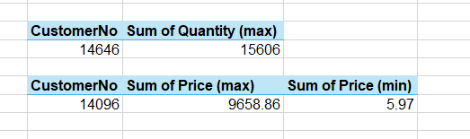
Figure 1: More details found about customer transaction and spending [Source: Self-created by author]

From the above graph it is visible that the sum of price and sum of quantity has been represented in the chart for different customers. According to the finding it is understandable but the highest amount of purchase by quantity has been conducted by the customer number 14646. The amount of quantity that has been purchased by the customer is 15606. According to the finding also it has been found that there are different types of customer which has been found who even though the sum of quantity is not the highest has been paid the highest amount of rice to the ecommerce platform. For example, according to the consideration of the sum of price paid by the customer, the highest purchase from the individual customer 14096 was found. The amount of purchase that has been done by this customer is 9658.86. From the findings it is also understood who has been purchased for very little quantity which can also include purchase of one product or the returning of the product. As well as rather than purchase the return of the product has been recorded as well in the ecommerce platform. On the other hand, the lowest price paid by the customer has also been found which has been recorded as 5.97.

Task 4. Finding the most profitable segment customers
The most profitable customer segment is the segment where the customer has been able to spend the highest amount of price in the purchase. Rather than the quantity, it is important to find the total amount of spending conducted by the customer in order to identify the most profitable segment of the customers in the report. From the data, the analysis has been conducted by using the pivot table.
According to the findings, Customer no. 14096 is the most profitable segment customer as he shops for $9658.86 at one segment. The data is shown below-
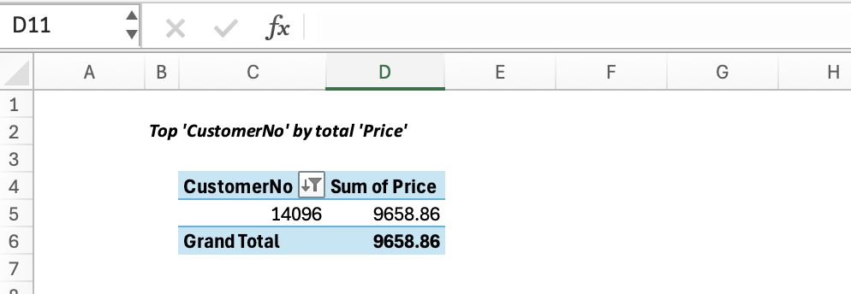
Figure 2: Most profitable segment customers [Source: Self-created by author]

From the table above, it is understandable that the customer number 14096 has been able to spend a total amount of 9658.86 in the ecommerce platform making the customer most profitable for the business. However, it is important to note that the price paid by the customer to the e-commerce business is not the definition for the company to analyse about the profitability. The purchase price that is being paid by the customers is the revenue for the business. However, due to the lack of data about the cost of the products, the profit from each of the products cannot be calculated. Thus, the total amount paid by the customers is considered as the profitable customer segment in this situation, considering the highest revenue for the business from the customer will result in highest profitability.

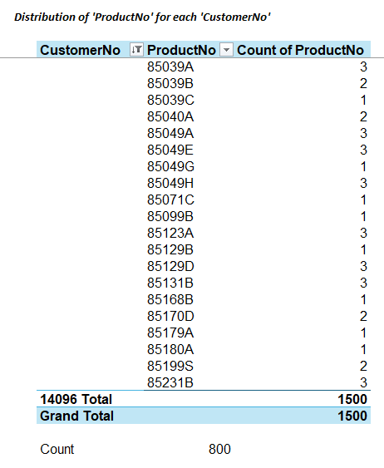
Figure 3: Distribution of purchase for customer 14096 [Source: Self-created by author]

From the above figure it is understandable that the total purchase of the customer mentioned is around 800 different products. Considering the customer has brought multiple units of a single product it is visible that a total 1500 units of product was purchased by the customer. As a result, this customer has been chosen as the most profitable customer for the company.

Task 5. Based on above findings, strategy to recommend to the business to gain more profit
In order to earn a better amount of profit, the company needs to focus on improving their strategic planning and implementation process by using different methods and techniques. Some of the best possible combination has been provided below-
- Maintaining sales stability- Maintaining stability in the overall sales of the business is one of the most important responsibilities of the company which will help the businesses in improving their ability to maintain margin of profit. Fluctuation in the sales unit of the company will directly affect the performance of the business in the market and will reduce the opportunity for achieving success in the long run (Hunger, 2020). The stable sales in the ecommerce platform will also help ecommerce platforms to maintain their reputation in the competitive e-commerce industry which will help the business organisation in the long run as well.
- Inclusion of data analysis for effective decision making, strategic planning and implementation- Data analysis is one of the most important factors in today's world which can help in ensuring that the business organisation has a stable decision making and decision support system (Hunger, 2020). With the help of data analysis soft wares, the company would be able to improve their chances of performance significantly in the market by not only improving their decision making ability in the strategy planning but also through having a better understanding about the changes in the market trend and business environment. Therefore, inclusion of data analysis in the business function is important for the company to improve their performance in future (Afuah, 2020).
- Recruiting people with skills in data handling, management and analysis- Recruiting people with skill for data handling, management and analysis will help the company in improving the ability of data analysis and decision making (Marr, 2017). This will help the company in effective big data collection as well as analysis of the same which can be included in the decision making of the business directly to enhance the strategic planning and implementation ability (Marr, 2017).
- Investing in a stable and reliable data analysis software- Investing in a stable and reliable data analysis software is another important method that should be mentioned which can help the ecommerce business organisation in ensuring the stability of data analysis and quality of outcome found from the same (Afuah, 2020).
- Market research and understanding of consumer preference- Focusing on market research and understanding about the consumer preference will help the business organisation in understanding about the area of profitable segment in the business as well as the target market and the promotional activities which are working (Choi et al., 2018). It will provide competitive advantage to the company by monitoring the need and preference of the consumer on a continuous basis as well as adjusting the strategy of operation for the company in response to the changes in the market and consumer preference (Marr, 2017). Thus, the competitive advantage of the business will increase in the market.
- Cost control- Controlling the cost of the corporation of the business is another important strategy that can benefit the company in controlling the overall cost. By identifying the unnecessary activities, the cost can control techniques can help the business to improve the profit margin effectively (Choi et al., 2018).
The above mentioned strategies can be beneficial for the ecommerce platform to maintain their operation and efficiency and strategic planning which will help the company in improving their opportunity for earning better profitability.

Conclusion
In conclusion, in the era of e-commerce and digital business, having the understanding of big data and using data analysis is extremely important for all of the companies in order to have a better understanding about the market and improve their overall performance in order to achieve a better revenue and profitability. Using different types of data analytics soft wares and skilled professionals in this regard the company will be able to enhance the efficiency of operation and improve the cost control ability. This in return will help the company in improving the sales turnover and profitability.

Part 2

Task 1. Finding number of male and female students


Task 2. Finding number of students qualifies or does not for reduced or free lunch



Task 3. Finding the mean and median of the students qualifies or does not for reduced or free lunch for pretest and posttest


Task 4. K-Means Clustering
From the above tables of K-Means clustering, an overall clustering result of about 2133 school students has been highlighted regarding their gender, qualification for free or reduced lunch based on their pre-test and post-test course. K-Means clustering mainly helps in K cluster partitioning of the data based on feature spaced similarities (Apriani et al., 2024). Several data points as initially the average values have been identified in the cluster centre regarding the variables forming two different clusters.
Considering: Zscore(V8): Gender, where, (1=Male, 2=Female), Zscore(V9): Lunch , where, (0 = Does not qualify for free/reduced lunch, 1= Qualify for free/reduced lunch ), Zscore(V10): Pre-test score and Zscore(V11): Post Test score
SPSS workings with screenshots have been presented:
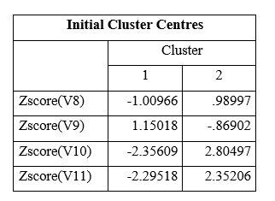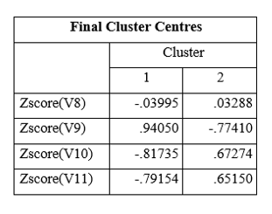
Cluster 1 indicates the lower gender value, skewed slightly towards the males with higher scores of free lunch qualification. While cluster 2 indicates higher skewed gender valuation towards the female with lower scores of free or reduced lunch qualification.
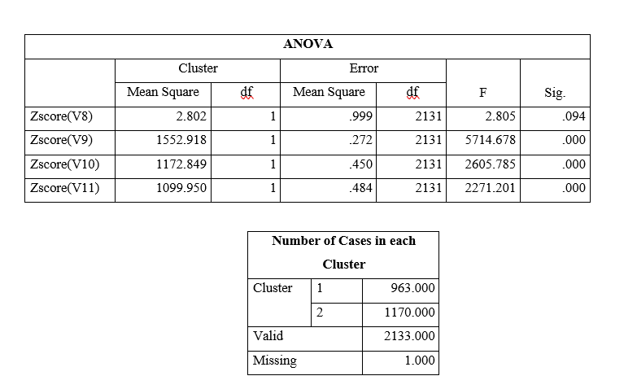
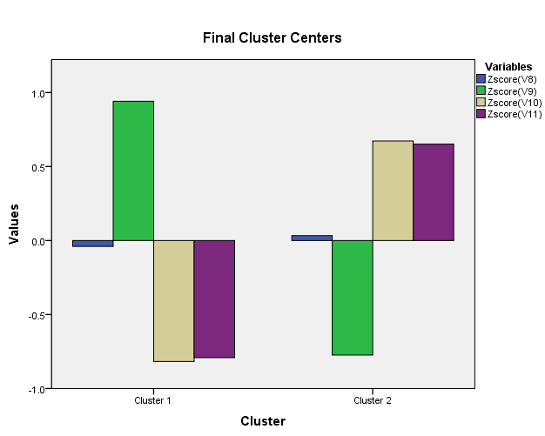
Figure: K-Means Clustering of the groups
(Source: Self Developed)

After the overall final clustering by the K-means algorithm, the optimisation of the clustered separation has been identified, highlighting cluster 1 with a balanced gender distribution with significant lower scores of lunch regarding qualification while comparing with cluster 2. While final centred cluster 2 has also maintained higher scores regarding all the pre-tests and post-test balancing the qualification towards free or reduced lunch. The significant difference identfied regarding the two different clusters has been further confirmed by the ANOVA result highlighting diversified student profiles as per their characteristics.

Task 5. SPSS and Excel – advantages, disadvantages & discussion
Point of view | SPSS |  | Microsoft Excel
Point of view | Advantages | Disadvantages | Advantages | Disadvantages
User-friendly interface | This software has a user-friendly interface for the purpose of conducting statistical analysis. | Despite having the user friendly interface it is important to have the knowledge and training about the use of software especially for those who are not familiar with the statistics (McCormick and Salcedo, 2017). | Microsoft excel is one of the most commonly used and family interfaces which can be used by people with little or no knowledge (Remenyi et al., 2022). | Complex functions cannot be managed under Microsoft excel.
Functionality | To complete the complex and advanced statistical test and analysis these software is extremely beneficial for the researcher and students (McCormick and Salcedo, 2017). | Other than statistical application this software does not have any other functionality. | Different types of data manipulation and visualisation techniques can be found which can be used for different purposes. | The statistical analysis tool is limited which also requires high expertise knowledge and skills (Remenyi et al., 2022).
Data management | The ability of SPSS for handling a huge amount of data in the large data set is extremely efficient with the built-in deter management system. | Without specialised knowledge, it is not possible to handle the large scale data set under SPSS due to complex operation procedure (McCormick and Salcedo, 2017). | Microsoft excel is more suitable for the purpose of telling with a small scale data set which uses a flexible cell based system (Remenyi et al., 2022). | In case of a very large database the rational functionality of Microsoft excel can vary.
Statistical analysis | Sophisticated statistical analysis is possible to be conducted which can help in providing better understanding and explanation of the situation from the numerical data (McCormick and Salcedo, 2017). | Without having understanding about the concept and the procedures it is not possible to apply and interpret the result found. | A statistics function can be applied even by people with comparatively low knowledge of statistics and related concepts. | Complex statistical procedure and function is not suitable to be applied in Microsoft excel which can also increase the complexity and requirement of expertise knowledge (Remenyi et al., 2022).
Cost | The cost of acquiring the software is affordable for the institutions which allow all of the students and professionals to use the same. | For the individual or the small businesses, the affordability of the software is comparatively difficult due to high cost. | A very little cost is needed for using Microsoft excel as it is already inbuilt as a part of Microsoft office (Remenyi et al., 2022). | In order to ensure that the advanced level application is being possible it is important to use additional purchases for additional add-ins or advanced software applications.

References
Afuah, A., (2020). Innovation management-strategies, implementation, and profits.
Apriani, A. and Heikal, J., (2024). Segmentation Analysis Using K-Means Clustering Model with SPSS Case Study of Backpacker Jakarta Community Members. Jurnal Indonesia Sosial Sains, 5(03), pp.441-460.
Choi, T.M., Wallace, S.W. and Wang, Y., (2018). Big data analytics in operations management. Production and operations management, 27(10), pp.1868-1883.
Hunger, J.D., (2020). Essentials of strategic management.
Marr, B., (2017). Data strategy: How to profit from a world of big data, analytics and the internet of things. Kogan Page Publishers.
McCormick, K. and Salcedo, J., (2017). SPSS statistics for data analysis and visualization. John Wiley & Sons.
Remenyi, D., Onofrei, G. and English, J., (2022). An introduction to statistics using Microsoft Excel. UJ Press.

