

Methods and Search Strategy Academic Poster

Student name: Mahmoona Sadaqat
Student ID: 2321821

Module name: Independent project
Element 2 Poster
Impact of dementia on older adults, quality of life [QoL], family difficulties and health care experience when managing care
01 Introduction and Research Aim  Dementia is a significant public health issue for the older population, their families, and health and social care services in the United Kingdom (Hazzan et al, 2022). It is a disease that may have serious consequences on the mental abilities, independence, involvement in social activities and quality of life among patients and this is placing additional burdens on the lives of their families.  Aim  The project aims to undertake critical analysis of impacts of dementia among aged people. Factors such as- quality of life, family issues and healthcare challenges will be considered for assessing an in-depth influence on health outcomes of aged people. | 02 Search Strategy  A structured literature search was developed from the research aim, objectives and questions. This includes-  Dementia AND Quality of Life  Dementia AND Older Adults  Dementia AND Family Caregivers  Caregiver burden AND Dementia  Dementia AND Healthcare Services  Dementia AND United Kingdom  Furthermore, Boolean operators such as- “AND” & “OR” were used for combining and broadening search terms.
03 Searching for Information  Literature was identified using databases such as PubMed, Google Scholar, UWTSD Library Search and BioMed Central. Other sources used for literature were renowned organizations such as NHS, NICE, Alzheimer’s Society, WHO and ONS. Literature published within the period 2016 and 2025 was approached. The literature sought was English, peer-reviewed, about older people with dementia, family carers, and health professionals. | 04 Picture/Graph/Visual Aid/Statistics  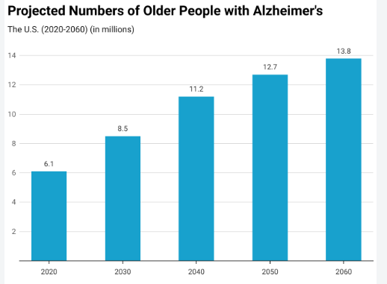  Figure 1- Source- (Statista, 2025)  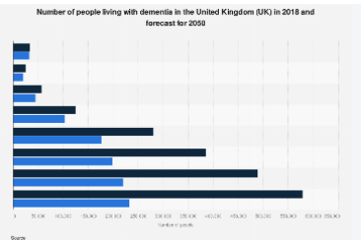  Figure 2- Source- (Statista, 2025)
05 Research Validation and Analysis
The retrieved literature was screened initially through abstract, titles and conclusions. Afterwards, evidence was assessed while using CRAAP framework-

Currency-Depicted about contemporary relevance
Relevance- Alignment with research objectives
Authority- Author and publication credibility
Accuracy-Methodology, consistency and evidence quality.
Purpose- Potential bias and conflict of interest

Secondary research analysis refers to the process of examining and interpreting reports, data existing studies for developing findings (Alnes et al, 2022). Further, a thematic analysis approach was considered for identifying repeated concepts and patterns across the selected literature.

06 Inclusion Criteria  - Peer-reviewed journal articles  - Published from 2016–2025  - English language  - Older adults living with dementia  - Quality of life, caregiver burden or healthcare experience  - UK evidence and relevant international evidence  - Recognised government and organisational publications | 07 Exclusion Criteria  - Articles published before 2016  - Non-English publications  - Conference abstracts without full papers  - Opinion pieces, blogs and newspapers  - Studies focused solely on biomedical treatment  - Studies involving children or younger adults
08 Ethical Considerations

The dissertation has considered secondary research which was based on existing publicly available evidence. Therefore, formal participants based ethical approval was not needed in the study. Additionally, academic integrity was maintained through appropriate acknowledgement of the sources. Further, appropriate (Lee et al, 2022). Harvard references were used, plagiarism was avoided and transparent reporting of the search was undertaken. Thus, significant focus has been integrated on performing ethics as these are considered as crucial for the study.

References

Alnes, R.E., Malmedal, W., Nordtug, B., Steinsheim, G. and Blindheim, K. (2022) Improving everyday life of people with dementia living at home: Health care professionals' experiences. Journal of nursing management, 30(7), pp.3628-3636.
Hazzan, A.A., Dauenhauer, J., Follansbee, P., Hazzan, J.O., Allen, K. and Omobepade, I. (2022) Family caregiver quality of life and the care provided to older people living with dementia: qualitative analyses of caregiver interviews. BMC geriatrics, 22(1), p.86.
Lee, K., Chung, J., Meyer, K.N. and Dionne-Odom, J.N. (2022) Unmet needs and health-related quality of life of dementia family caregivers transitioning from home to long-term care: A scoping review. Geriatric Nursing, 43, pp.254-264.
Statista, (2025) Online. Available through https://cdn.statcdn.com/Statistic/1285000/1289608-blank-355.png

