Module: Digital Skill and Research Methods

Module code: BMSW 4003

Assignment Title: Report- Research report

Lecturer: Yohan Mendis
Student name: Khademudin Allahyar
Student ID Number: 2117720

Contents
Abstract 2
Introduction. 3
Research Design 3
Method 3
DIKW 5
Data 7
Information 8
Knowledge 8
Wisdom 9
Conclusion 9
REFERENCES 9

Abstract
In this report I have researched about the structure of data collection, how it analyses, how the examination and progress happen, and the digital tools most used for collaboration at UWTSD, and also how we use technology to collaborate at UWTSD. So, in my presentation, our group focused on the three digital tools that were most commonly used to collaborate, such as Microsoft teams, so I wrote about Microsoft teams and the beneficial points of it that students can collaborate. Next, we mentioned with our team was Outlook, again I researched about the good points and usefulness that students can collaborate with Outlook. The third tool that students of UWTSD can use to collaborate is WhatsApp. It is easy and useful for Students to keep up communication through WhatsApp.

Introduction.
In this report I research about how we use technology to collaborate at UWTSD and which digital tool is most used for collaboration at UWTSD, and I explain about collecting data.
This report evaluates the use of digital tools such as Microsoft team, WhatsApp, and outlook. The report further explains the data collection and data research of these tools followed by examples. The report then briefly explains the benefits of these tools as well as their use and positive outcomes from using these tools within various settings. This report also discusses how using these tools can improve the chances and prompt work, education, and enhancement of job opportunities.

Research Design
In this section, I am going to explain about how technology use to collaborate at UWTSD and which digital tool is most used for collaboration at UWTSD.
In this report it has been explained how qualified students learned in an online plan track - teaching is the exchange of information over significant distances by electronic. The study shows many ways for learners to use technology and have ability to communicate in small groups. The student used many webs tools to collaborate. Using technology solve the issues and the students can know each other (Murphy, and Cifuentes, 2001).

Method
In this section I am going to explain the three tools which is mostly or commonly used for collaboration around students in UWTSD

WhatsApp: Is one of the apps in social media, it is useful for students to help each other in university or college work. The report surveys tell us about how important and useful WhatsApp is for students.
The article is a discussion run with students in UAE who were in use of WhatsApp during their coursework. The outcome of the report was that students are taking part in using WhatsApp for their assignments and use it as a group chat or vocal communications service, making them more motivated to communicate and active in the lecture's topic - therefore according to this article, WhatsApp is helpful & useful, and a successful application. (Volume: 49 issue: 2, page(s): 239-249)
WhatsApp can be used for free collaboration. We can use WhatsApp easily with most common mobile models as well as through computers. WhatsApp is particularly good in voice calls; students can send voice calls and audio messages as well. Students can send documents about 100 mb to anyone. Calling each other is quite easy on WhatsApp. The good thing about WhatsApp is that we can delete any messages any time we want, this also can be beneficial for student confidentiality. We can add as many friends as we want on WhatsApp, and we know who we are communicating with which is what makes it a safe platform. The student can share their location, videos, and pictures. Whenever a student collaborates, they should have an internet connection (Riyaz , 2021).
Microsoft teams: With teams, students can manage their time and they can give better attention to their work while being connected. The students do not need to go to an inbox and waste their time; they can get all messages from everyone and everything in the context. They only get the things which are necessary, or they need the specific report linked to the topic. So, they do not need to spend time cleaning mailboxes - it saves their time, and they can focus and pay attention to their work.
A problem for everyone who uses teams is to make sure that they keep everyone in the chain and make them feel that they know what is going on. It is not hard to make this easier in team. You do not need to worry about who to put in cc or email or in team meetings. with teams you can put messages and send to people, and you can notify them easily.
The Team users gain a lot of profit, interest, and satisfaction in moving to a digital workplace. While also being cloud based which really helps with accessing from multiple devices. To get details or data from everywhere or any computer is a big profit for the Teams users. If your first language is not English you can automatically switch to your native language and if you miss any meeting, you can catch up by hearing the recorded one.
A lot of users of team get confused about the order or arrangement of files the way they store (HEINZ TSCHABITSCHER, 2020).
Microsoft outlook: Depends on the person using it, the person using it should see all its features and working method, then can decide whether it is suitable or not.
It is easy to organise Outlook in many options such as, finding emails, having access to emails in multiple ways.
Outlook is safe for emailing; students can have their own level of restrictions. All the unsafe emails can be found in the Junk folder.
While having outlook, we do not need to use MS Word for editing emails, we can manage emails as we want to. Working in outlook is easy for having so many options in the toolbar and they are customisable to the way we want. Ability to see Files and HTMLs without any other Apps (Heinz Tschabitscher , 2020).

DIKW
In this section I am going to explain about DIKW and show some examples as of collecting data.
When we see ‘Data’, it seems complex to us but once we collect it and process it, it all becomes processable primary information for what we want. After that we can start analysing it. Raw date is the primary requirement for receiving an important outcome in the end. Everything from logging, tracking etc consider date. As it's all assembled in size it considers both whether it is useful and not useful. It is all raw data; it is not giving remarkable results. Further data on its own does not respond to your inquiry or achieve any outcome. To know how data changes into useful outcomes using the DIKW pyramid model you can see examples.(Brahmachary, 2019)
Next is the ‘Information’ in DIKW - which comes from analysing and cleaning raw data, and it becomes pieces of information. Information could be called as data as it is describing a related link or relation. Once the analysis is complete it can give the answer to all questions like who, what, when, and where.(Brahmachry, 2019).
The third level of the pyramid is ‘knowledge’. The explanation for knowledge is to collect helpful information. When we think about information that's why it is important then Straight Away it comes in our mind that it is a collection of knowledge. Every piece of knowledge is useful. That step is always given to you the answers for ‘how’ questions.(Brahmachary 2019).
The fourth and final level of DIKW pyramid is ‘Wisdom’. The last result that we can get through processes of knowledge is wisdom. The amount from all other levels of DIKW and processes them through special types of programming. We can say that the wisdom phase is the knowledge found in the past stage and now can be applied to our daily life. Wisdom always answers the questions about ‘why’. (Brahmachary, 2019)
In this section I will explain about collecting data from forms and I will share some pictures from the survey of collecting data. When I started this module, I had to collect primary data. I made a Microsoft forms survey to collect data from my university friends. The survey included five questions. Which is shown below in pictures:
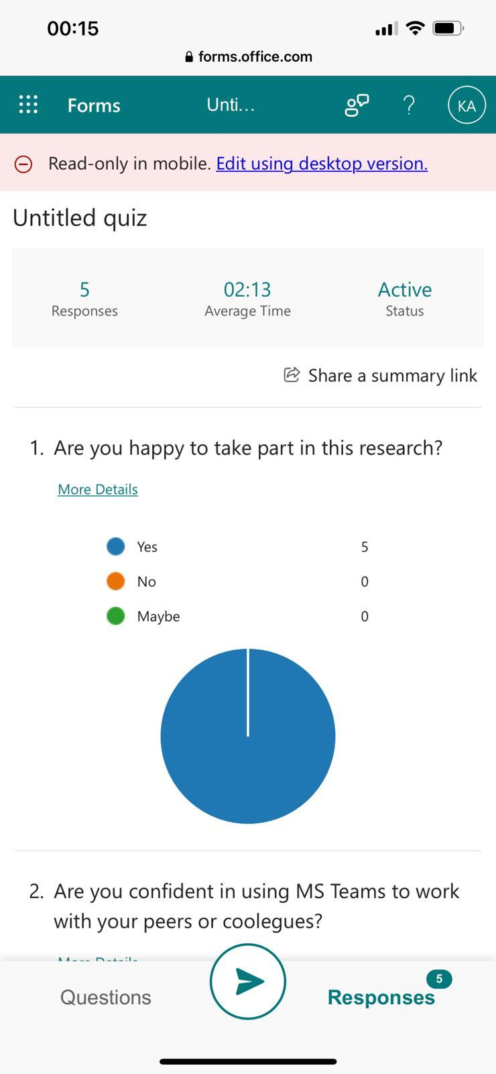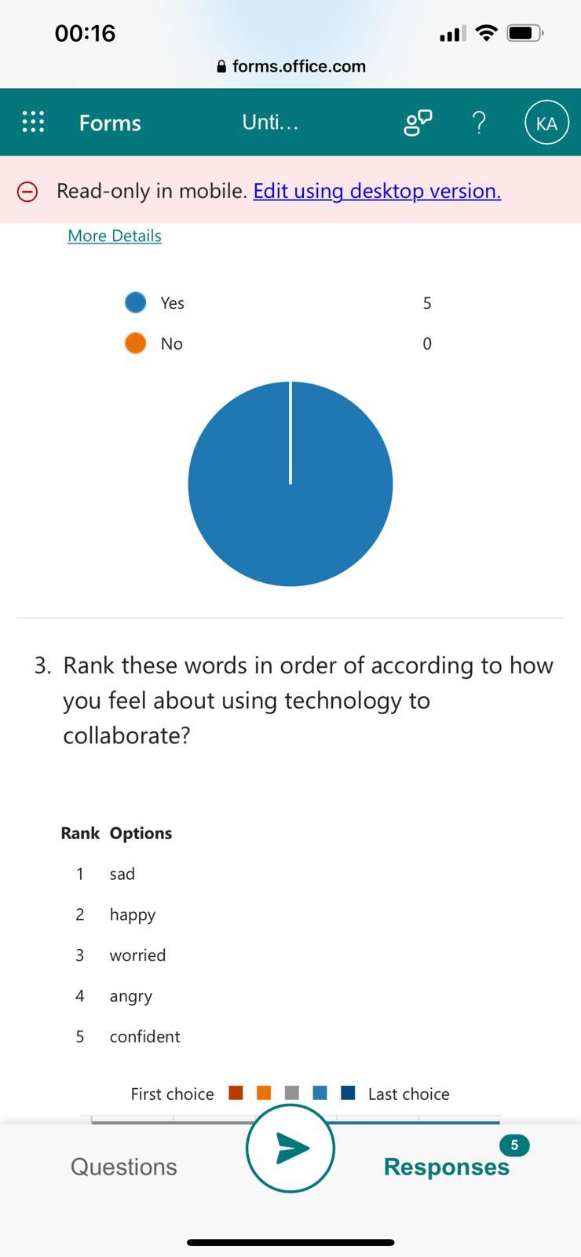
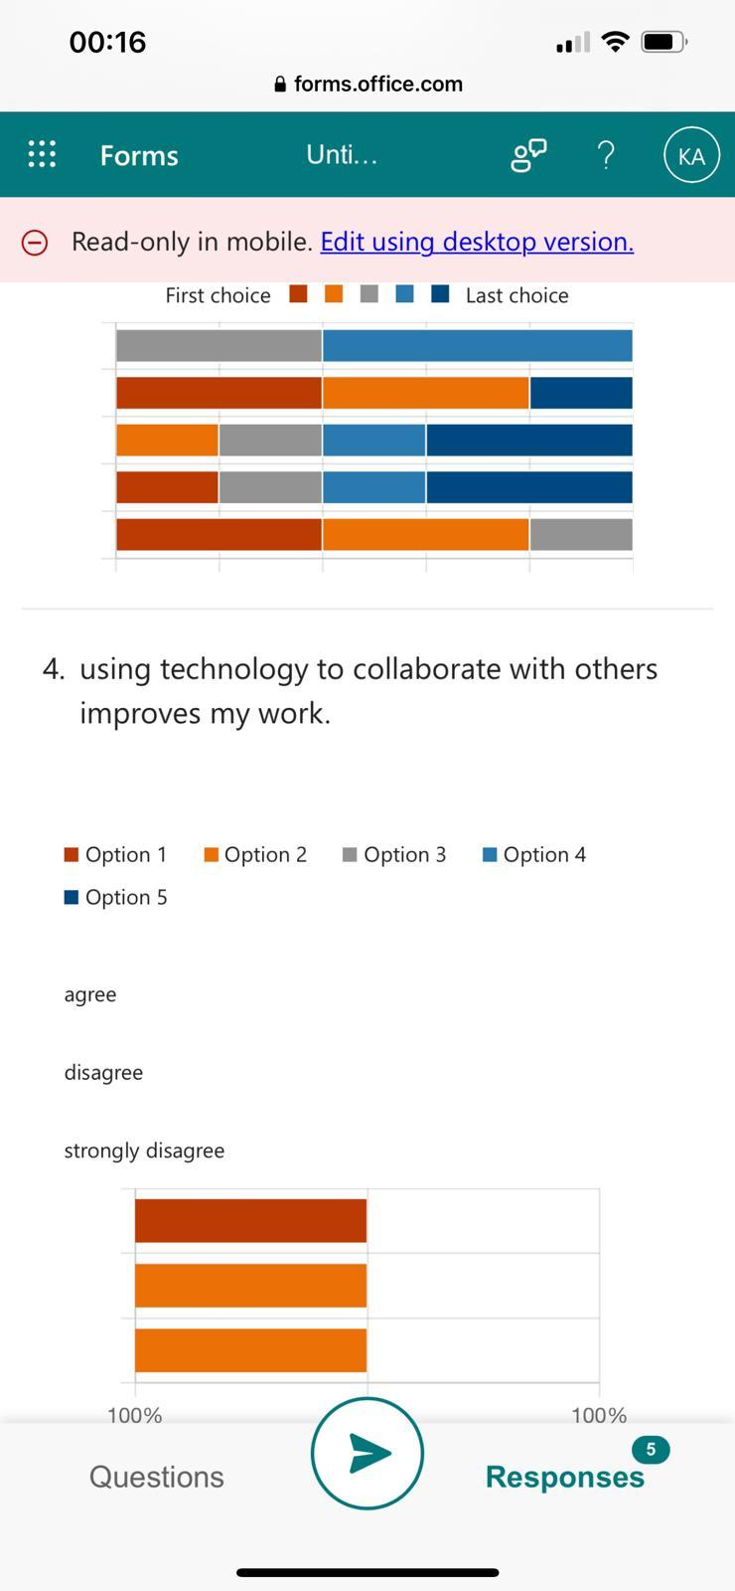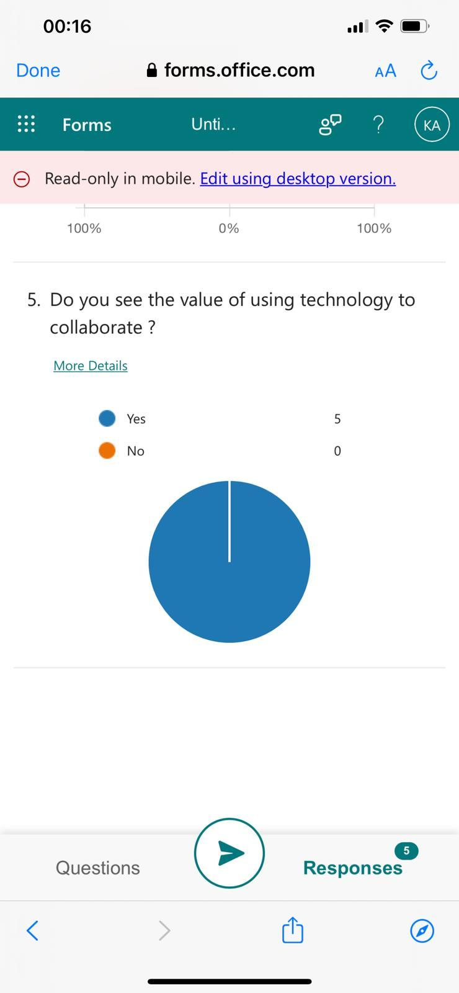

Data
The serious bit to anonymise the data. If we use someone else's data, they need to be informed why their data has been used. (Data protection act 2018) after sending the survey out with a few questions to my university friends, I received answers from them. At the beginning the process is to clean data. It should be checked that the surveys that have been sent out are filled correctly or not, or even sometimes it is not filled at all, or sometimes the survey can be submitted more than one time. So, it is better we check the responses and process it carefully. The data that has been collected by me was five questions. When I process data next it moves to information, knowledge, and wisdom. We should look at the size of data collection to collect real and true responses to make a successful report from it. (kabir, 2016)

Information
The second level of the pyramid is information. For this everyone should process their data. They should come across to have the responses for who, what and where questions. (Brahmachry, 2019)
Information data turned out into a detailed explanation. This can happen by calculating data first. Information is always meaningful as per data. Data do not have any meaning unless it's not processed to become information. (Baskarada and koronios, 2013)
The pyramid gives you an idea of what data is then you can go forward to Analyse further.
If we collect the average grit for each level and then count how many people got each level. For academic level it will work out the average grit.
We can use two methods to find out the results: pie chart and line chart. If we put data on a pie chart it is clearer and more visible than what data is showing.
In the line chart, it will show Duckworth grit score. We can find the information. This is how we can get information from data. The next level is knowledge.

Knowledge
According to Figueroa (2019), if we put data and information together, we can get knowledge. I want to say my idea that I understand or what I have completed. I became confident on how to analyse data and information to create an important piece of research and share it with others, but with knowledge you can say your idea with evidence of information and data that you have collected.
Knowledge compares primary data and secondary data (Stechies 2019) with primary data we can get information the way it is we do not use other work it can be many forms for example bar charts etc.
Secondary data is getting information from other work, or you compare your work with others. Like newspapers, the internet, or articles etc.

Wisdom
The fourth one is wisdom. According (Liew, 2013), wisdom is the last level on the model. Wisdom is more than knowledge. Wisdom is a shape of acknowledgement, a model or set of concepts .It is the final destination and body of reference. We can reach wisdom after a lot of experience. Wisdom means being mature. Getting lots of experience you can have a good and deep knowledge so you can get the correct article. It can make you motivate others and assist them with wisdom. Wisdom makes you more self-confident and assists you with expanding even more. In my experience if we compare pie charts and line chart secondary data with primary data, we can achieve wisdom at last!

Conclusion
I want to mention the summary and key points of the research that I have written are about digital tools that are most used for collaboration at UWTSD and how we use technology to collaborate at UWTSD. Next, I talked about data collection and analysis and the use of tools which students mostly use, that is Microsoft teams which are being used for online classes etc. Outlook is a useful tool for students that can receive their emails from the university easily, and use of WhatsApp is also common between students which I mention in my report.

REFERENCES
- Baskarada, S and Koronios, A. (2013) ‘Data, Information, Knowledge, Wisdom (DIKW): A Semiotic Theoretical and Empirical Exploration of the Hierarchy and its Quality Dimension’ vol.18, No. 1,2013.
Available at: https://papers.ssrn.com/sol3/papers.cfm?abstract_id=2304010
(Accessed 02 April 2022).
- Brahmachary, A. (2019) DIKW Model: Explaining the DIKW Pyramid or DIKW Hierarchy. Available at: https://www.certguidance.com/explaining-dikw-hierarchy
(Accessed 11 April 2022).

- Figureoa, A. (2019) Data Demystified-DIKW model.
Available at: https://towardsdatascience.com/rootstrap-dikw-model
(Accessed 10 April 2022).
- (HEINZ TSCHABITSCHER UPDATED,2020)
Available at https://www.lifewire.com/microsoft-office-outlook-2010-email-1166876
(Accessed 12 April 2022)
- Kabir, S. (2016) ‘Methods of data collection’, pp.201-275.
Available at:
https://www.researchgate.net/publication/325846997_METHODS_OF_DATA_COLLECTION
(Accessed 01 April 2022)

- Murphy, K.L. and Cifuentes, L., (2001). Using Web tools, collaborating, and learning online. Distance Education, 22(2), pp.285-305.
- (Riyaz, 2021)
- (Volume: 49 issue: 2, page(s): 239-249)

