How do practising astrologers understand the epistemic nature of astrology and what impact does this have on their practice?

Lisa Stockley
2307752

Dissertation submitted in partial fulfilment of a Master of Arts in Cultural Astronomy and Astrology
University of Wales Trinity Saint David 2026

Contents

Introduction 7

Literature review 14
Astrology and the objective 16
Astrology and the subjective 19
From the objective to the subjective 22

Methodology 26
Reflexivity – the insider perspective 28

Findings and Discussion 30
Astrology and the objective 33
Astrology and the subjective 36
Objective to subjective and back again 37
The sources of astrological knowledge 39
The astrological dialogue 41
Articulating the hidden 44

Conclusion 51

Bibliography 54

Appendix 1 – Survey Questions 58

Appendix 2 - Interview structure and questions 70

List of Figures

Figure 1: Astrological tradition of knowledge 30

Figure 2: Testing of astrology 32

Figure 3: New forms of science 32

Figure 4: Vindication of astrology by critics 33

Figure 5: Scientific / statistical studies 34

Figure 6: Impact of scientific studies on practice 34

Figure 7: Astrological knowledge as intuitive understanding 35

Figure 8: Astrological knowledge about more than following rules 35

Figure 9: Source of astrological knowledge – beyond the human 38

Figure 10: Source of astrological knowledge – created by people 38

Figure 11: Dialogue with the chart owner 39

Figure 12: Dialogue with the more than human 39

Figure 13: Something known but not articulated 46

Figure 14: Something previously unknown 46

Acknowledgements

Many thanks to my supervisor Garry Phillipson for all the support, for helping me to clarify my thinking, signposting useful references and attention to detail.

Thanks also to all my tutors on the MA for all the fascinating rabbit holes it has sent me down.

Thanks to everyone who responded to the questionnaire and especially to my interviewees for their insights.

Finally, many thanks to my family, for support and space to think, and for all the lunches brought to my desk.

Abstract

This dissertation examines astrologers’ perceptions of the nature of astrological knowledge, considering the epistemological paradigm of astrology and the potential impact of that paradigm on astrological practitioners. It investigates how Western horoscopic astrologers understand and work with the epistemological issues of astrology. Astrology’s status as “rejected knowledge” is explored along with the impact of that status on astrological practitioners. The study argues that both objective and subjective forms of knowledge are necessary for the creation of meaningful astrological knowledge, which is seen as accurate if it is considered helpful by astrological clients. The role of the astrological tradition of knowledge is explored as a basis for the creation of subjective or intuitive knowledge with a focus on the process of dialogue taking place during astrological consultations. The study argues not only that both the rational and the irrational are necessary for the creation of meaningful astrological knowledge, but that it is the connection between different knowledge frameworks which defines astrology. The research builds on previous studies of astrological knowledge and is situated within broader questions around the nature of astrology and its role in contemporary culture.

Introduction

This dissertation explores astrologers’ perceptions of the nature of astrological knowledge, building on existing scholarship to consider the epistemological paradigm of astrology and the potential impact of that paradigm on astrological practitioners. The objective is to investigate how Western horoscopic astrologers understand and work with the epistemological issues of astrology, comparing experiences and perceptions with previous scholarship on astrological knowledge and the nature of astrological truth. The different ways that astrological knowledge is created and used will be considered, especially astrological consultations. The research is situated within broader questions around the nature of astrology and its role in contemporary culture.

The background for this research can be seen in Wouter Hanegraaff’s conception of esoteric knowledge, including astrology, as being outside the normative paradigm for knowledge that prevails in the modern western world. Hanegraaff notes the ‘post-Enlightenment reputation’ of astrology ‘as the epitome of a false “occult science” grounded in superstition. It is therefore seen as what Hanegraaff refers to as ‘rejected knowledge,’ perceived as being incompatible with European Enlightenment ‘normative concepts of religion, rationality, and science. These have become ‘hidden normativities’ which are ‘taken for granted as self-evident,’ so that knowledge such as astrology which does not conform with them is rejected. This rejection results in an epistemological problem for astrologers. If they accept astrology as rejected knowledge, the experience of working with it undermines the contemporary normative paradigm in which they have been raised. On the other hand, they may consider this rejection as a mistake, so that they need to consider how astrology can conform with the current paradigm. This research considers the impact of this dilemma and astrologers’ responses to it.

Nicholas Campion has defined astrology as ‘the practical implementation of cosmological ideas in order to understand the past, manage the present, and forecast the future,’ a definition which itself implies the complex nature of astrological knowledge. Astrological knowledge can be seen as containing both broadly applicable concepts and practical applications of those concepts. For instance, Venus is often associated with concepts such as love and beauty, as Joanna Watters notes. As Campion and Liz Greene have also stated, astrology can be seen as paradoxical in that it contains ‘a relatively stable tradition of cosmological and astral representations and ideas combined with an immensely creative fluidity and adaptability.’ Therefore as Konrad Klawikowski notes, astrological knowledge combines elements which can be seen as objective, constructing charts through astronomy and mathematics, and the subjective, defined by Klawikowski as ‘the individual astrologer’s intuitive and creative leaps.’ The objective contributes to the ‘stable tradition’ cited by Campion, at least the astronomical and mathematical parts of that tradition, and the subjective, the ‘creative fluidity’. This research aims to explore the ways astrologers understand these two elements along with their impact on astrologers’ practice and understanding of astrology.

The research considers astrology as an ‘epistemic culture’, defined by Karin Knorr Cetina as ‘those sets of practices, arrangements and mechanisms… which make up how we know what we know.’ For example, Klawikowski considers how astrological knowledge is transmitted through texts, teaching and other methods. He also considers the creation of astrological knowledge, for example through interactions between astrologers and astrological consultations as well as through astrological texts and formal study. This meets Cetina’s criteria of ‘epistemic cultures as cultures of creating and warranting knowledge.’ Omri Elisha, in his study of astrology and historical knowledge, also considers astrology to be a ‘veritable epistemic culture’ with a ‘network of practitioners, publications and platforms.’

The research is triggered in part by personal observations made in the course of working with and teaching astrology, so working within this epistemic culture. For example, class discussions around how to communicate knowledge found in the astrological chart which may be challenging for the chart owner imply that the astrological chart contains a kind of objective knowledge, which exists independently of the astrologer and which it is then the responsibility of the astrologer to share. A new student recently commented that there was a strong tradition of fortune telling in his home country, going on to say, ‘but of course astrology is a science.’ Comments such as these may be seen as the rejection of the non-normative status of astrology noted above and therefore an attempt to situate astrology more clearly as ‘normative knowledge,’ unlike fortune telling which in this case is seen as counter-normative. The research is therefore based on emic perceptions of how astrologers understand the epistemic nature of astrology.

The tradition of ‘cosmological and astral representations’ in terms of astrological knowledge can be traced back at least to Claudius Ptolemy in the 2nd century CE. There is continuity within this tradition, so that the planetary symbolism explored by Ptolemy is still recognisable in contemporary astrological sources. For example, Ptolemy refers to the planet Mercury as symbolising ‘reason and the mind. In 1647 William Lilly referred to Mercury as representing ‘a man of subtill and politick brain, intellect and cogitation.’ The astrologer Robert Hand, in a book published in 1981, describes Mercury as ‘connected to the mind, especially the logical and reasoning capabilities.’ The astrological tradition can therefore be seen as relatively consistent through time. This tradition is seen as providing objective knowledge, with astrologer Michael Harding suggesting for example that ‘these meanings are quite independent of us’. However he also notes that whilst the astrological experience is often perceived as ‘an objective truth – it isn’t,’ affirming that the knowledge provided by astrology goes beyond the objective. This is a broader definition of objective than that cited by Klawikowski above and this research aims to explore whether astrologers see the ‘stable tradition’ of astrological knowledge as being objective, in terms of having the independent meanings to which Harding refers.

Ptolemy’s codification of astrology is, as Patrick Curry describes, as ‘a kind of natural philosophy: not only systematic but fully rational.’ This is affirmed by Joanna Komorowska, who observes that Ptolemy was aiming to ‘to establish astrology as a science in its own right… with reference to the Aristotelian paradigm of demonstrative – and true – sciences.’ This conception of astrology as science implies a modern, normative definition of science as knowledge which can be proved, rooted in the work of Aristotle as Komorowska notes. In this case, scientific knowledge is seen as being based on statements which ‘on account of their regularity and reproducibility, are in principle inter-subjectively testable’ as Karl Popper describes, and this is a definition of science which is sufficient for the present research. An astrology offering regular, reproducible and inter-subjectively testable results would challenge critics who dismiss astrology as not being true or providing true knowledge.

This project considers whether a concept of astrology as science is shared by contemporary astrologers, as suggested by the anecdotal evidence noted above, and whether they consider that astrology carries the possibility of being proved in a way that would satisfy the definition of science cited here. A positivist epistemic approach to astrology has been assumed for example by researchers such as Geoffrey Dean, who reviewed and carried out experiments aiming to test astrology. However a contrasting approach focuses on astrology as divination, based on a process of interpretation of a specific astrological chart, rooted in the astrological knowledge tradition but bringing in a more subjective epistemological approach and the ‘creative fluidity’ noted by Campion and Greene. As Patrick Curry has explained, ‘divination… proceeds by way of the openly metaphoric… development of symbolic images, often proceeding by indirection and intuitively.’ In exploring astrology as providing divinatory knowledge, Curry suggests that the ‘paradigmatic divinatory question’ which can be applied to astrology is ‘What should I do?’ affirming the ‘what’ of the question as meaning that ‘cognitive knowledge… is sought.’ This research aims to explore that nature of that cognitive knowledge and the implications of that nature on the rest of the question, which as Curry continues implies both the participation of the seeker – ‘I’ – and also specific action – ‘do.’ This suggests the ‘practical implementation of cosmological ideas’ described by Campion.

As can be seen, these varying definitions and concepts of the nature of astrology suggest contrasting epistemological approaches. The nature of knowledge in the broader field of esoteric studies has been explored by Dimitry Okropiridze, who suggests in the context of esoteric knowledge that some knowledge is onto-epistemological, in that it has an external reality which allows it to be objectively known. On the other hand, knowledge may be epistemo-ontological, a discourse which itself generates reality. In allowing for the conclusions of both of these approaches to be valid, he affirms the existence of different models of knowledge. The first may be generalised as material-based science whilst the second is based on concepts such as religion, society and so on. In the context of astrology, the first of these can be seen as the astrological tradition and the second as the application of the tradition to the ‘creative fluidity’ of the interpretation of individual astrological charts. The first may be seen as objective, in the sense suggested by Harding as having an external reality and the second as subjective. This has an impact on how astrologers perceive and work with astrological knowledge. Klawikowski notes that astrologers ‘have the problem of synthesising subjective knowing with objective knowledge.’ This research will consider this process of synthesis and astrologer’s perceptions of this ‘problem.’ The research therefore builds on existing scholarship in considering the nature and impact of this epistemological divide more explicitly.

Garry Phillipson takes the definition of knowledge as “justified true belief,” or ‘true opinion accompanied by reason’ as Plato describes it. Phillipson explores theories of truth and how they apply to astrology. Whilst this dissertation uses this definition of knowledge and aims to build on this work, the focus in this project is less on whether astrology is true and more on the nature of astrological knowledge, the kind of knowledge astrology can provide and the role that that knowledge may play in the lives of those working with it. This implies of course that it has a level of truth for them, but this is seen as less relevant for the present study, which explores the perception of astrological knowledge and how it affects the practice and experience of astrological practitioners and their clients.

This research also considers astrological knowledge in a wider social context. The idea that cosmic events such as the movement of the planets should provide knowledge which can be used by humans has been criticised for almost as long as it has existed. For example, Marcus Tullius Cicero, in On Divination in the 1st century BCE, refers to the possibility that a ‘celestial force’ influences ‘minds, manners, disposition, physical condition, career in life and destinies’ as ‘inconceivable madness!’ and ‘utterly devoid of reason.’ As introduced above, changing definitions of science have also impacted the epistemological acceptance or otherwise of astrology, especially in recent centuries. Hanegraaff has observed that ‘the story of modern science narrates its triumph over “occult pseudo-scientific superstitions” such as astrology or alchemy.’ The apparent marginalisation of astrology was therefore a part of ‘an important reordering of established knowledge,’ as Rienk Vermij and Hiro Hirai have described it, in the historical context. Since the intellectual developments described by Vermij and Hirai, the definition of science offered by Popper above has come to be seen as definitive and not to allow for any other concepts of reality, so that as Klawikowski states, ‘astrologers [are] placed by academics in an epistemological framework formed by the natural and social sciences, in which astrology is conceived of as a failed or pseudo-science.’ Criticism or dismissal of astrology is therefore acceptable and even expected in the context of normative knowledge, with Richard Dawkins, Chair of Public Understanding of Science at Oxford University, writing for example in 1995 that ‘there is not a smidgen of validity in any of the things that astrologers so profitably do.’ This research will therefore also consider this perspective on astrological knowledge as being rejected and the impact of that rejection on astrological practitioners, asking as Michael York has put it ‘what are the dynamics of cognitive dissonance in relation to the discipline of astrology?’ For example, personal anecdotal evidence suggests that students new to studying astrology encounter resistance and negative comments from friends and family, seeking reassurance as suggested above by considering astrology normative knowledge by choosing to see it as a science. On the other hand, Susannah Crockford’s work exploring the role of astrological knowledge in spiritual communities in Arizona suggests that the use of astrological language grants social capital which brings a sense of belonging in a society which often rejected more normative ways of thinking. As Crockford notes, ‘this complicates interpretations of astrology as rejected knowledge, bringing into focus relationships of power and constructions of epistemic capital.’ As this example shows, responses by astrologers to astrology as rejected knowledge may take different forms.

Literature review

As noted above, In recent years a number of scholars have considered the nature of astrological knowledge. Phillipson explores the nature of astrological truth in the context of the main theories of truth found in the western epistemological tradition, delineating between astrology as science and astrology as divination, exploring the conception of truth for each approach and how it relates to astrology. He concludes that whilst astrology may not sufficiently cohere with a scientific epistemological paradigm to be considered “true”, it can be said to cohere with a divinatory paradigm and in this sense, ‘it is philosophically defensible for an individual to assert that, in their experience, astrology works; and on this basis, to consider that astrology is true.’ Phillipson’s thesis brings together much of the discussion and theory explored by scholars considering the ontology and by extension the epistemology of astrology making it a key resource for the present study. Konrad Klawikowski, by contrast, sets out to explore ‘how practitioners conceive of the content of astrological knowledge’, providing another key foundation for the present research, albeit from a more practical and less theoretical standpoint than Phillipson. Whilst acknowledging the scientific approach to understanding astrological knowledge, Klawikowski takes as his starting point astrology as a divinatory system, noting that astrologers work in a ‘field of non-institutional religiosity.’ He explores the nature of astrological knowledge as a process of learning as well as in the context for example of astrological consultations.

Alison Bird also considers the process of learning astrology in her anthropological study of astrology education, defining astrology ‘as a ‘magico-religious’ practice’ and exploring the nature of astrology as belief rather than knowledge, given astrology’s ‘predominantly non-empirically justifiable nature which seemingly defies its being readily acceptable in terms of knowledge.’ Whilst acknowledging astrology’s ‘liminal status vis à vis both science and religion,’ Bird states that ‘science is known; religion, on the other hand, is believed’ and therefore that astrology is founded on belief rather than knowledge. This implies a definition of knowledge which is objectively true. The subjective element is acknowledged for example by reference to the work of Hans Vaihinger and his ‘the philosophy of As If’ which suggests that ‘all knowledge, including the scientific type, is based on originating hypotheses or fictions.’ Here the epistemological nature of astrology is seen as being more akin to a religion than a science.

Campion has also considered the nature of astrology as astrologers themselves see it, a parallel approach to the present study. He discovered that there is ‘resistance to the definition of astrology as a science’ but also ‘profound hostility to… astrology as a religion.’ However he also notes that astrology can be described as a hidden or invisible religion, which may be ‘one of many popular responses to… disenchantment.’ Astrology can be regarded as a meaning system or symbolic universe which ‘flourish at a popular level’ but are not officially recognised or accepted. Astrology is therefore seen neither as science or as religion, and therefore does not fully fit in with the epistemological paradigm implied by either of those.

Scholars of astrology have also considered the tradition of astrological knowledge, with A.P. Ashwin Kumar noting for example that it has ‘a surprising level of internal coherence and systematicity.’ As well as being well established, the astrological knowledge tradition is seen as evolving over time. For example, Klawikowski sees it as ‘dynamic and iterative, with astrologers taking authorities and building on their work rather than replacing it wholesale.’ This development happens in various different ways, with Elisha observing that ‘astrologers cite multiple sources of information, everything from ancient mythological symbolism to modern scientific data… as well as insights from private consultations and chart readings.’ This can be seen for example in Rod Chang’s recently published book Comets in Astrology, which includes chapters on the astronomy of comets, how comets were interpreted by ancient astrologers, mythology relating to comets, modern developments of the symbolism and a range of natal charts which show pertinent comet symbolism. The astrological tradition can also be seen as limited, with James Brockbank for example arguing that ‘different parts of the tradition will always be open to interpretation so they cannot provide a clear absolute authority.’ Whilst there is a level of objectivity about the information provided by the astrological knowledge tradition, the process of interpretation means that the objective knowledge does not give the full story.

As noted in the introduction, the practical nature of astrological knowledge is also seen as intrinsic to its nature. Several scholars have concluded for example that astrology does provide knowledge but that rather than empirical, repeatable knowledge, the knowledge provided is ‘practical wisdom’ as Brockbank has described it. For Brockbank, drawing on the work of Stephen Toulmin, the ‘sort of knowledge [astrology] provides is phronesis’ which he defines as ‘practical knowledge about what to do in certain situations.’ Klawikowski develops and broadens this possibility, suggesting forms of knowledge which are about for instance understanding the self. He gives the example of a client for whom an astrological reading helped her to form a narrative which ‘allowed her to navigate her life in new ways.’ The nature of astrological knowledge is therefore seen in terms of the potential impact it has in providing self understanding as well as practical guidance.

Astrology and the objective

Turning to studies of astrology as a science, the work of Geoffrey Dean and his colleagues since the 1970s has been most prominent, as noted above. Dean, along with Arthur Mather and Rudolf Smit have carried out empirical studies of astrology and reviewed such studies from a wide range of sources. As they comment in their interview with Phillipson in Astrology in the Year Zero, they ‘controlled for artifacts and other sources of error’ but were ‘dismayed to find that artifact and errors seemed to explain everything.’ They therefore took heed of the ‘mounting evidence and cease[ed] actual practice’ despite having been active as astrologers prior to that. Dean and his colleagues delineate clearly between the objective and the subjective, explaining that ‘To be accepted, subjective astrology does not need to be true’ whilst ‘to be accepted, objective astrology needs to be true.’ The need to remove the influence of the astrologer in order to obtain a truly objective understanding of astrological knowledge was also seen as important, with Dean and his fellow researchers stating that ‘to adequately test astrology the participation of the astrologer must be eliminated.’ Astrological knowledge is therefore divided into either subjective or objective, rather than a combination of the two.

Explorations of astrology which rely on a normative epistemological perspective can also be found among those explicitly critical of astrology, with criticism often based on a perceived lack of accuracy in the knowledge astrology provides. This may be based on a perception referred to by Campion of astrology as ‘an anachronistic survival from the past’ which therefore contradicts contemporary normative knowledge. For example, Ze Hong and Joseph Henrich use divination, including astrology, as an example of the ‘cultural evolution of epistemic practices’, seeing divination as an outdated form of knowledge which does not ‘seem to be effective based on our understanding of the causal nature of reality.’ Hong and Henrich state that users of divinatory techniques are seeking to obtain ‘factually accurate information about their world.’ This affirms Phillipson’s assertion that many critics of astrology assume it to be ‘an information service – something that delivers facts on demand with significant reliability.’ However as Alison Bird has noted, the process of interpreting a chart may be more important to astrologers (if not to their clients) than the knowledge it provides, and this is ‘not something which astrology’s critics seem ever to consider when they focus upon its inaccurate prognostications.’ The focus of Hong and Henrich’s study on an ‘understanding of the causal nature of reality’ could be seen as a normative understanding of reality, rooted in Popper’s definition of science. Hanegraaff, for example, notes that the ‘instrumental causality’ referred to here has been ‘internalised’ as a ‘foundational narrative’ of normative epistemology, which includes the possibility of it being given ‘a privileged status compared with other narratives.’ Quantitative studies of astrology often assume this normative epistemic paradigm and its superiority, positioning astrological knowledge as rejected or simply inaccurate. Consequently, such studies may not fully explore the nature of astrological knowledge as perceived by astrologers.

Other definitions of science have also appeared in recent decades, which astrologers have hoped might bring scientific validity to astrology. For example, Dennis Elwell writes that ‘it is undeniable that the impact of the new physics… must create a climate more favourable to an enlightened astrology.’ This is because the new science offers an understanding of ‘the underlying interrelatedness of all things.’ In considering the interconnected nature of astrology in the context of chaos theory, Bernadette Brady sees astrology as bringing together the order of the cosmos and the notion of ‘sumpatheia’ or correspondences, ‘a web of connectivity which binds all to everything.’ Brady’s concepts of cosmos and chaosmos may be seen as broadly mapping onto the objective and subjective sides of astrology, offering a paradigm in which both ways of knowing are necessary to obtain the full story. These new concepts of science have been explored by Phillipson, who concludes that whilst they ‘do not prove astrology,’ they can offer ‘a framework of understanding’ for individuals to consider ‘astrology’s validity.’

Studies of astrology carried out from a mainstream scientific epistemological perspective therefore open up a philosophical debate on the nature of astrology and astrological knowledge. For example, Geoffrey Cornelius argues that such studies may ‘come to be seen as having played a significant and even positive role’ in overcoming what he refers to as an ‘epistemological void, a collective failure to identify our knowledge-base.’ Studies of astrology which take a scientific or quantitative approach are seen as insufficient to fully explain the epistemological nature of astrology.

Astrology and the subjective

Studies of astrological knowledge have sought to fill this ‘epistemological void’ by exploring contrasting approaches to a normative epistemological perspective. James Brockbank’s ontological study of astrology specifically rejects astrology as a science, asserting that astrology is ‘too complex to make empirical, repeatable tests relevant, as there are simply too many disparate factors to take into account.’ Instead he explores a model of astrology in which:
a non-human agency brings together astrological chart and context in a way which allows the astrologer, using the rules and traditions of astrology, to provide pertinent guidance on the matter being considered.

Cornelius also explores an explicitly divinatory approach, in which ‘psychic gifts or intuition’ are seen as ‘allied with, or functionally related to, rational interpretation.’ Whilst these are more explicitly subjective approaches to the creation of astrological knowledge, the objective knowledge tradition is still seen as part of the process. Lindsay Radermacher also approaches astrology from a specifically divinatory and dialogic perspective, considering astrological consultations as a space in which ‘dialogue occurs, centred on a living symbolic presence that is the birthchart itself.’ In exploring astrology as providing a connection to the divine, Radermacher acknowledges that ‘astrology is an internally rational and ordered body of knowledge which nevertheless contains… symbols, which are capable of disorderly and unpredictable activity.’ There is a link between the established knowledge tradition and the ‘creative fluidity’ with which it can be expressed, so that astrological knowledge brings together the objective and the subjective.

The nature of astrology as a symbolic language, as affirmed by Campion, is also relevant here. As Radermacher explains:
if the process of seeking guidance is, in itself, part of the journey, and one is prepared to spend some time engaging with this… this is the territory of the symbol.

Radermacher sees symbols as offering more complex and personal knowledge, since ‘images stimulate the non-discursive (imaginative) areas of the mind.’ In invoking the imagination, Radermacher brings the focus of astrological knowledge back to ‘creative fluidity’ and indeed she goes on to explore symbols as ‘participating’ in the reality, or knowledge, that they create. The dynamic of participation is seen as taking place through the astrological consultation, which brings together astrologer, astrological chart and client. This is also explored elsewhere in the literature, with Klawikowski for example noting that consulting astrologers often see statements of astrological meaning as ‘uncertain or fluid by nature,’ relying on dialogue with the client to become more certain or to be deemed accurate. Cornelius has also noted the importance of dialogue in creating meaning, stating that ‘the best and truest interpretation is what the client needs to hear now.’ The knowledge created is therefore ‘fluid by nature’ in that it is also decided at least in part by the needs or expectations of the client, suggesting a participatory process. As Cornelius notes, this also releases astrology from ‘the shadowy bondage of having to know everything.’ This in turn suggests that astrological knowledge can be unique to the chart reading as well as, or even instead of being based on what Brockbank refers to as ‘timeless principles,’ which:
do not exist because no one astrological configuration - relating the position of the planets at a particular time to a particular situation - will ever be the same as another.

Going on to suggest that ‘astrology is concerned with the contingent - in relating a unique astrological chart to a unique set of circumstances’ he affirms that astrological knowledge is therefore unique to each astrology chart or reading. This suggests a fully subjective approach to astrological knowledge.

Darrelyn Gunzburg has also explored the nature of the consultation space, and by extension the knowledge it can provide. The professional astrologers she interviewed spoke of the dialogue between astrologer and client as providing moments of recognition, generating a kind of participatory knowledge. However in contrast to Radermacher and Brockbank who see this participation as including something beyond the human, Gunzburg’s interviewees were clear that this was a human connection; ‘the point where life and symbols met, the inner landscape of the life of the client met the symbolic landscape of the horoscope and created a change in understanding.’ As one of Gunzburg’s respondents notes, referring to astrology specifically as divine knowledge ‘disavows’ the role of the astrologer. These approaches share a conviction that the presence of the astrologer as a mediator of the astrological chart to the client plays a role in the creation of astrological knowledge. There is therefore shared understanding in the literature of astrological dialogue as a way of creating astrological knowledge but different perceptions of the participants in that astrological dialogue.

From the objective to the subjective

The creation of astrological knowledge is therefore seen as a process, which relies on the astrologer, the astrological chart, the client and the potential for something beyond the human. Phillipson’s conception of this process as ‘concatenated knowledge’ is important here. He suggests that there may be:
a relationship between two forms of knowledge… This would be a relationship between the specific information derived from a horoscope… and a different, primarily affective, form of knowledge.

Klawikowski also refers to this concept, noting that whilst
there is balance between the rational and intuitive mind, the astrologer does not use each facet equally… the technical know-how acts as a base for the intuitive mind to put the information together.

The two epistemological paradigms are both seen as necessary for the creation of astrological knowledge. This suggests the possibility, as Okropiridze has suggested, that ‘it is only when interpretation takes place that we have access to whatever is interpreted’ so that ‘the pre-interpreted state [is] a super-position of signifier and signified as a state of pure potential.’ This in turn suggests Michael Polyani’s concept of ‘tacit knowledge’ in which ‘we can know more than we can tell’ and ‘most of this knowledge cannot be put into words.’ In this case, knowledge of one thing (for example a proposition in the astrological chart) can lead to knowledge of what is ‘tacit’ (for example a way of perceiving the self) so that ‘we are aware of that from which we are attending to another thing’ which in turn allows us to understand the meaning of the second thing. As Stephan Heilan has noted in his exploration of tacit knowledge and astrology, astrologers may have a ‘vast pool of tacit knowing… out of which only one or two factors will be drawn into conscious association.’ The creation of astrological knowledge can therefore be seen as a process of bringing together their tacit, or unconscious, knowledge of the astrological tradition, with the chart and client in front of them.

In combining the objective with the subjective, the nature of astrological knowledge as being born of dialogue suggests a participatory dynamic, as noted above. Hanegraaff contrasts participation with the ‘instrumental causality’ referred to above, defining participation as ‘an affective rather than a rational stratum in human thought and action,’ which is a ‘spontaneous tendency of the human mind.’ He asserts that if instrumentality causality is seen as the dominant social narrative, ‘participation becomes something highly problematic’ since it challenges causality as a foundational narrative. Like the magic he refers to in making this argument, astrology may also be seen as an example of the ‘continuing presence of the feeling of participation’ in a world which has been disenchanted by the normative causal paradigm.

The potentially mystical element in this process has been explored by Radermacher in terms of Rudolf Otto’s “mysterium tremendum,” which she states can have a ‘full numinous impact’ for the astrologer. Phillipson describes this experience of the mysterium as ‘a form of knowledge’. The connection with the mysterium may not give factual information or knowledge which can be evaluated by an external authority. Instead it brings ‘direct affective knowledge’ which as Phillipson has noted, can be seen as having an emotional impact, which Phillipson relates to William James’ concept of intimacy, so that the ‘experience of intimacy would then be a type of knowledge (knowledge of acquaintance).’

William James is one of a number of philosophers of knowledge and belief whose work illuminates the nature of astrological knowledge. As noted above, Phillipson delineates between James’ concepts of ‘knowledge-about’ and knowledge-of-acquaintance. These delineations of knowledge can be seen as relating to the subjective and the objective, since as Phillipson states ‘[knowledge-of-acquaintance] is direct and experiential, whereas [knowledge-about] is conceptual. James also explores knowledge arising from mystical experiences, including in his delineation of such experiences a ‘noetic quality’ which is a ‘state of knowledge… insight into depths of truth unplumbed by the discursive intellect.’ James therefore advocates a ‘pragmatic epistemology which avoids rigid distinctions between science and spiritualism,’ as Matthew Crippen notes in his exploration of James’s epistemology in the context of indigenous epistemologies. Similarly, Alfred North Whitehead also seeks to move away from what he refers to as a ‘division of territory between science and philosophy’ in a way that can be seen as relevant to astrology. He explores knowledge as a ‘method of imaginative rationalization’ explaining that:
The true method of discovery is like the flight of an aeroplane… from the ground of particular observation; it makes a flight in the thin air of imaginative generalization; and it again lands for renewed observation rendered acute by rational interpretation.’

This suggests a movement from the rational to the irrational and perhaps back again. Finally, the work of Michael Polanyi on personal and tacit knowledge can also be seen as relevant, since as Brockbank has noted Polanyi ‘was one of the first to say… that scientific knowledge was derived in a more complex manner than often thought.’ Explorations of knowledge in wider philosophical literature can therefore offer useful concepts for understanding the epistemological paradigm of astrology.

Turning to astrology as rejected knowledge, Klawikowski focuses on the ways that this relates to the ‘dominant epistemological approach’ and in the context of contrasting epistemic cultures. He suggests that astrologers adopt ‘elements from the dominant scientific epistemology’ for example in the process of testing a new astrological technique, noting however that ‘they rarely do this in a structured manner… in a way that would be recognised as sufficiently rigorous by a scientifically-trained person.’ He continues by noting that the ‘othering process’ of astrological knowledge is still ongoing, so that astrologers try to integrate the dual nature of their practice into a coherent whole. The work of Susannah Crockford also references this ‘othering’ process, contrasting the ‘pervasive’ nature of astrological discourse in Sedona with astrology’s epistemological status more generally in America, where it is seen as a form of rejected knowledge. Crockford also focuses on astrology ‘as a form of divination’, focusing on the social role of astrological knowledge rather than its validity or truth, noting that in Sedona ‘there was… little interest in… whether astrology was true.’ She argues that astrology “works” as ‘a special form of knowledge… that defines its truth in dynamic contrast with the wider epistemic claims of American culture.’ Astrology in this case is seen as part of what Egil Asprem refers to in the context of the broader field of esoteric studies as the inflated version of the marginalised knowledge narrative, noting that ‘embracing esoteric rejected knowledge may lead to a sense of empowerment.’ Crockford affirms this, stating that the inhabitants of Sedona see spirituality, including astrology, as ‘a counter-hegemonic field, rejected by and… rejecting the elite discourses.’ In this case, astrological knowledge grants social capital which brings a sense of belonging in a society which often rejected more mainstream ways of thinking. Astrology’s status as rejected knowledge may therefore have different impacts in different social contexts.

Many explorations of astrological knowledge focus on the personal or individual, as in the examples given by of Klawikowski. In contrast, Omri Elisha has explored the nature of astrological knowledge in a broader historical and cultural context. Elisha’s focus is on ‘anticipatory knowledge… broad temporal frames’ so that astrology is seen as providing potentially useful or practical knowledge, but from a less personal perspective. He notes the ‘potential influences of alternative epistemic and temporal orientations in shaping future political and social imaginaries’, operating from an awareness of astrology as a potentially rejected knowledge and questioning how far astrological knowledge reproduces or challenges the status quo, referring also to critiques from astrologers that it does the former.. Rather than questioning the validity of astrological knowledge, he focuses on its potential impact, conceding that whilst ‘it is hard to say with absolute confidence what practical influence astrology… has… on everyday political and social ethics,’ astrological discourse has a cultural impact which makes it worthy of study. The literature on astrological knowledge therefore explores a range of approaches, which share a concept of astrology as drawing on both objective and subjective forms of knowledge.

Methodology

This dissertation takes a qualitative, phenomenological approach based on astrologers’ lived experience of learning and working with astrological knowledge. This allows the research ‘to exemplify the variety of perspectives in existence amongst astrologers,’ as Phillipson explains his own research. In order to gain both breadth and depth of understanding of these perspectives, a mixed methods approach is taken including an online questionnaire and semi-structured interviews. The interview process especially can also be seen as echoing the dialogic process of astrological knowledge creation discussed in the Literature Review, in that as Alan Bryman has noted, ‘the interviewer and the interviewee jointly create this knowledge.’

An online survey was created and shared on social media and by email. The survey was shared with my own contacts through the Faculty of Astrological Studies, and also through the Astrological Association, a UK based organisation. The survey was shared in two Facebook groups, one Faculty of Astrological Studies group and the other the Astrological Association group, as well as by email to current Faculty of Astrological Studies students. The aim was to collect around fifty responses and a total of fifty-eight were received. Following the survey, semi-structured interviews were carried out to build on and deepen responses to the questionnaire. The interviews built on specific responses, to that some questions were asked to all interviewees and others arose specifically from their responses to the survey. Interviewees were chosen based on questionnaire responses, taken from those who had included an email address to indicate that they were willing to take part in an interview. Apart from the option to include an email address for this reason, the survey was fully anonymous. The aim was to conduct between six and eight interviews, and a total of seven interviews were carried out.

A potential issue in carrying out the research was that my main source of contacts in the astrological community is through the astrology school for which I teach. This potentially limits the respondents to those who follow a particular astrological approach and therefore may have similar experiences of and ideas about astrological knowledge. Aiming to mitigate this risk, the survey link was also shared to online astrology groups and passed to respondents in the wider community. Another possible implication of this is a focus on modern psychological astrology, which is the type of astrology taught at the Faculty of Astrological Studies. Sharing the research in wider circles aims to mitigate this and bring in practitioners of a wider range of astrological approaches.

A further challenge was the possibility that respondents would not have considered, for example, the nature of astrological knowledge, preferring to approach astrology as a practical technique rather than considering the theoretical or philosophical background, focusing on ‘the acquisition of practical skills of horoscopy’ as Bird suggests. The survey questions were carefully worded to avoid causing confusion which might impact responses. Everyday rather than technical language was used and questions were carefully worded to avoid ambiguity, so that for example words like “empirical” which may mean different things to different people were not used. Statements were carefully chosen and worded to explore astrologers’ assumptions about the nature of astrological knowledge and the epistemologies behind those assumptions. Many questions covered a general area, for example astrology as science or astrology as divination, with participants asked to rate their responses according to a Likert scale ranging from strong agreement to strong disagreement. This builds on the approach used by Bernadette Brady in her study of astrologers and fate.

Opening up the questionnaire beyond my immediate connections in the astrological community allowed me to interview respondents with a wider range of astrological experience. Their approaches to astrology included different forms of psychological astrology, company astrology, healing and spiritual practices and “alchemistic” astrology, as well as the modern Western psychological astrology taught by the astrology school with which I am most closely involved. These different approaches and applications of astrology allowed for consideration of the epistemological similarities and differences between them.

Reflexivity – the insider perspective

As noted in the introduction, there is a strong current of reflexivity running through the research process, as I am a professional astrologer and teacher of astrology, and part of the prompt for this work comes from conversations and comments with clients and students. In order to attain ‘a position of external detachment’ relative to my insider status, as York has described it, a number of measures were taken. Questions in both the survey and the interviews were carefully scrutinised to ensure that they were free of bias, assumptions or leading questions. Interviewees were chosen based on pertinent comments in the survey responses and because the survey was anonymous, any personal knowledge I had of the respondents was not involved. In the end, four of the interviewees were known to me, to a greater or lesser extent, and three were astrologers I had not met before. Three of them were involved with the astrology school I teach for (two as tutors and one as a student) and the other four were not. Whilst there was a clear impact on the participants based on my own affiliations, sharing the research more widely aimed to mitigate this.

However as Bird notes in her research, being an astrological insider can be helpful, even necessary, in carrying out ‘an anthropological study of astrology and astrologers’, with ‘familiarity with astrological language’ an ‘essential prerequisite’ for such studies. This is reinforced by Frances Clynes in her study of astrologers and the internet, who states that ‘given the complex nature of astrology…when researching astrology the inside or emic researcher is at an advantage.’ She notes that ‘years of studying [are] needed to become proficient in it and familiar with the astrological world.’ Familiarity and experience with this process therefore allows a deeper understanding of, in this case, the nature of astrological knowledge on the part of the researcher, in turn allowing for a more nuanced understanding of the research results.

My insider status may also be an advantage in terms of establishing trust with potential participants, as participants may be cautious about discussing counter-normative knowledge with those who may not share their understanding. This became apparent during the process of organising the research when one of the potential interviewees replied to my request with the following caveat:
If you are an anti-mystical scientist with an aim to show what rubbish astrology is – then I do not want to do the interview. If you are authentically interested in exploring people's different approaches to astrology then I'm very happy to talk.

I was able to reassure her, including offering online links which showed my experience and affiliation, and she was happy to go ahead and do the interview. My status as an astrologer insider therefore had a beneficial impact on the research process, in terms of establishing trust. The risk here was that as Clynes notes, people are ‘likely to be cautious about revealing their beliefs to someone who does not share them.’ In this case, an awareness of my own insider role in the astrological community allowed the interview to go ahead. Whilst there are challenges with crossing the insider outsider divide, there are also advantages which have a positive impact on the research process.

Findings and Discussion

The research gave clear responses affirming some of the concepts discussed in the literature, with ambiguity in other areas. One area showing a strongly united response was the practical and useful nature of astrological knowledge. 100% of survey respondents agreed that astrological knowledge helped them to understand themselves better. There was over 80% agreement for all of the statements around how astrological knowledge can be helpful, including 90% of respondents agreeing that astrological knowledge helped them to understand history and 84% that it helped them to understand contemporary culture or politics, confirming Elisha’s assertion that astrological knowledge is ‘not nearly as disengaged from social and political realities… as critics have suggested.’ An impact of astrological knowledge for those who actively work with it is therefore that it does allow respondents to ‘manage the present’ as Campion defines it. However the potential for astrological knowledge to ‘forecast the future’ brought fewer clear responses, with the survey showing overall disagreement that astrology can give knowledge of what will definitely happen, with 62% of respondents disagreeing and 30% neutral, leaving only 8% in agreement. That said, there was a perception of astrological knowledge being more broadly future focused, with 91% agreement for the statement that astrology could predict ‘a sense of what kind of energy might underlie possible events.’ The option in the survey, ‘how you can best make the most of what might happen’, also received 87.5% agreement, highlighting the practical nature of astrological knowledge. Interviewee 2 specifically noted that ‘I actually don't think we can predict,’ whilst giving the caveat that ‘you can certainly see which way it's leaning.’ Her problem with predicting was based on a perception by outsiders that ‘astrologers… should be able to get it right.’ This reinforces Maggie Hyde’s comments that ‘Sporadic and true predictions are a sure-fire way to alienate people from astrology,’ implying as it does ‘an unerring fate, written by the stars.’ Interviewee 4 felt it was dangerous ‘to really avoid nailing it down as a predictive science,’ because astrology is about an experience of a higher “power” which cannot be ‘nailed down.’ This resistance to prediction shows that astrologers do not perceive the epistemic focus of astrology as being about specific details or facts, which would imply not just determinism as Hyde suggests but also an objective epistemological paradigm in which knowledge is defined as concrete facts or specific details. The impact of this can be seen as some frustration, as Interviewee 4 expressed, triggered by a difference in expectations by insiders and outsiders to astrology about what constitutes accurate or valuable knowledge and assumptions made by those following a normative epistemological paradigm, as noted by Hong and Henrich referenced above.

Figure 1

As Figure 1 shows, the results also confirmed the importance of the astrological knowledge tradition as providing a container for astrological interpretation. This was affirmed in the interviews, with Interviewee 1 noting for example that ‘you need a certain amount of rigour, otherwise, anything could mean anything’ and going on to refer to a ‘core grammar’ of astrological symbolism as a way of avoiding interpreting ‘something that isn’t there.’ This was echoed by Interviewee 7 in the context of students of astrology, noting that ‘It's so important that they incorporate the technique well. Otherwise, everything means everything.’ The astrological tradition was seen as providing structure and legitimacy, with Interviewee 4 saying for example that knowledge from the astrological chart was ‘more reliable, because you've got this framework.’ The rational techniques and agreed meanings which make up the tradition were seen as a necessary foundation for astrological knowledge, in line with existing scholarship, for example Klawikowski, who notes the importance of ‘the transmissible theoretical aspects of astrology.’

Turning to astrology as marginalised or rejected knowledge, the survey showed broad agreement (76%) that astrology is a form of knowledge not accepted by mainstream society and that astrology is a different form of knowledge to mainstream thinking (86%). The idea of astrology as rejected or counter-normative knowledge suggests that astrologers may experience negative responses, as noted in the introduction, and indeed 67% of respondents agreed that people around them had made negative assumptions about astrology. However a greater number, 84%, agreed that the people around them were accepting of their interest in astrology. This suggests at least that most astrologers have mixed and even contradictory responses from the people around them. Only 30% agreed that knowing astrology made them feel that they didn’t fit in, with 28% neutral and 42% disagreeing. The comments offered gave possible reasons behind this potential contradiction, with several commenting for example that whilst they may not feel that they “fit in” with other people, this was not because of astrology but was a more general experience. Several comments suggested the welcoming of marginalisation suggested by Crockford, with one respondent commenting for example that ‘a precious jewel of wisdom cannot be appreciated everywhere’ and another that they were fortunate to be ‘privy to a giant secret.’ Overall the results suggest that those working with astrology do not feel as marginalised as might be expected by the perception of astrology as rejected knowledge or at least do not perceive this to be a negative experience or one which has a strong impact on their practice.

Comments from several interviewees suggested that astrologers may “self-police” for example by only sharing their astrological interests with certain people or by discussing possible strategies through which astrology may be more accepted scientifically, which Interviewees 2 and 5 both did. For Interviewee 1, the existence of the rational tradition of astrological knowledge, perceived at least in part as ‘natural philosophy’ allowed her to overcome a ‘fear of being seen as a charlatan.’ Whilst she accepted and even sought out the more mystical side of life, she referred to it as ‘woo woo’ and ‘a bit of a guilty secret.’ The basis of astrology in the rational positions of the planets gave a more solid basis of normative knowledge which allowed her to make space for this counter-normative awareness in a way that felt acceptable. The impact of the dual nature of astrological knowledge was to give her a bridge between mainstream social expectations and a connection to something more mystical which may have otherwise felt uncomfortable. The specific nature of astrological knowledge can therefore be seen as having a more nuanced impact on those who practice it than a simple choice between the conventional and the unconventional.

Astrology and the objective

Figure 2 | Figure 3
The results suggested that a majority of astrologers do not see astrology as a science in the modern sense and as Figure 2 shows there was overall disagreement that astrology can meet the definition of science by Popper given above. However the possibility that in future, new forms of science will allow astrology to be proved in a way that would invalidate the arguments of most critics received stronger agreement, as shown in Figure 3. There was also a considerable number of neutral responses and only around 10% of active disagreement. The interviews also reflected this ambiguity around astrology as a science, with interviewees referring to the possibility of astrology fitting with alternative scientific paradigms such as quantum physics and ‘the observer and the observed’ as Interviewee 1 put it, referring to the so-called ‘observer effect’ which suggests that the observation of a phenomenon has an impact on that phenomenon. Interviewee 2 referenced Rupert Sheldrake and his theory of morphic fields, relating the planetary archetypes to those fields by referring for example to the ‘Uranus field.’ This suggests that she uses these concepts as a ‘framework of understanding’ for astrology, in line with Phillipson’s suggestion about the possible role of modern science for astrological thought. Overall, the contemporary normative paradigm was seen as offering at best a limited paradigm for astrology, with Interviewee 3 specifically noting that astrology is not a science as it cannot be replicated. Interviewee 5 was the only one to discuss the relationship between astrology and science in some depth, discussing a “new” form of astrology she follows which incorporates ‘everything updated, the science, the astronomy, the physics, all of it.’ She felt that if this new form of astrology was adopted more widely and with communication between astrologers and scientists, astrology was more likely to be accepted as a science. She referred to this as being ‘like maths,’ and commented that by incorporating modern astronomy, astrology would be more accurate, implying a focus on astrology as objective or definitive knowledge. In this case, the interviewee responded to astrology as a counter-normative form of knowledge by seeking a form of astrology which she felt fit with a normative epistemological paradigm. This was the only participant whose day to day astrological practice was actively changed by a perceived need to fit with a more normative epistemological paradigm.

Figure 4
Whilst the example of Interviewee 5 shows that the research did suggest some concern with mainstream acceptance, overall the mainstream vindication of astrological knowledge was less of a concern. As Figure 4 shows, most survey respondents were neutral or actively disagreed with the above statement, with only 19% in agreement. This may reflect a broader change in attitude to the mainstream scientific paradigm, so that for example as Phillipson notes ‘the perception of science as a path to truth is under pressure.’

Figure 5 | Figure 6

In terms of statistical studies of astrology such as those carried out by Dean et al as well as of the implied epistemological paradigm of such studies, the survey also showed mixed results. As Figures 5 and 6 show, whilst there was general agreement on the importance of such statistical studies, few respondents agreed that they had changed how they read charts in the light of such studies. Furthermore, only 14% agreed that astrologers in general should change the way they use astrology in the light of such studies. This suggests firstly that there is less concern among astrologers with practising an astrology which has been “proved,” challenging Bird’s suggestion that astrological practitioners ‘are resolutely determined to claim scientific respectability for astrology.’ It also implies that quantitative statistical studies are not seen as having the potential to validate astrological knowledge. Several respondents noted for example that ‘science/statistics are not good at measuring and assessing astrology’ and ‘for me astrology doesn't lend itself to statistics.’ In contrast, one respondent commented that ‘the brief exposure I have had to statistical or scientific studies of astrology were incredibly powerful experiences.’ Whilst approaching astrology as providing knowledge which can be validated through statistics does play a role for some astrologers, overall, the results suggest such approaches are seen as less relevant to astrological knowledge. There was a perception of astrology as having some objective elements which could potentially be tested but also subjective elements, with one respondent commenting for example that ‘Understanding of astrology goes beyond the physical into intuitive metaphysical awareness.’ This suggests that Dean’s categorisation of astrological knowledge as either objective or subjective does not match the experience of astrologers and indeed may be seen as missing the point that it is the combination of the two which provides meaningful astrological knowledge.

Astrology and the subjective

Figure 7 | Figure 8
As Figures 7 and 8 show, there was considerable agreement around astrological knowledge as intuitive and subjective, and as going beyond following the rules of the rational knowledge tradition. This was also reflected in the interviews, with Interviewee 4 talking for example about her healing practice and about ‘higher sense perception’ which she felt also applied to astrology. She talked about experiencing astrological symbolism during healing sessions, for example, ‘I see this red line running up her energy field, and I'm going, that's Mars!’ (the colour red is traditionally associated with Mars by astrologers). She went on to assert that ‘the horoscope shows up in the [healing] field,’ articulating a more intuitive and experiential approach to the astrological symbolism. Interviewees 3 and 6 also explored this experiential approach, with both referring to ‘seeing the chart.’ Interviewee 7 spoke about learning to ‘trust that when the person speaks, the chart is speaking.’ A clear subjective element was therefore present in the astrologers’ understanding of astrological knowledge, affirming for example Cornelius’s assertion that ‘if there is anything in astrology… there is some other element involved… deserves to be understood. This research seeks to understand the nature of this intuitive element and its connection to the rational astrological tradition.

Objective to subjective and back again

Several interviewees articulated the process of starting with technical knowledge of astrology which then opened up a more intuitive understanding, For example, Interviewee 3 said that:
there is all this technical stuff, of course, going on. But of course, when it comes to interpretation, like, when the chart becomes live, in a way, it is completely becoming,
I think, something different.

Similarly, Interviewee 4 described a process of having ‘super knowledge of the chart from 40 years of doing chart readings and teaching astrology.’ She spoke of then going into ‘another dimension’ and ‘meeting that soul’, and for this to happen ‘I need the chart as a doorway, as a key.’ The structure of the astrological chart and the symbolism in it was a ‘doorway’ to being able to connect with that individual on a deeper level. She referred to astrology as ‘a very reliable, intuitive, support’ and ‘the anchoring of the astrological, mystical experience… it's anchored in the physical.’ Similarly, Interviewee 6 said that they ‘feel the person's chart’ as if the components of the chart such as the planets are ‘kind of speaking to me.’ The ‘doorway’ of the chart and the connection with the ‘physical’ therefore open up a more intuitive connection. These examples show that the astrological symbolism can open up a connection to what Radermacher refers to as ‘the world of the imaginal,’ drawing on the work of Henri Corbin. Radermacher refers to the imaginal as a realm that brings ‘the imagination into the faculty of knowledge as opposed to fantasy.’ The research shows the astrological chart as a doorway to the knowledge found in this imaginal realm.

Interviewee 6 offered an example of this connection working in the reverse direction to that of other respondents. Rather than the structure of the chart and the astrological techniques acting as a gateway to a more intuitive understanding, she saw the astrological techniques and tradition as giving form to intuitive knowledge which was already there:
as you learn all of the mechanics… the meanings of things… it starts to kind of come together. Like, all of a sudden, zaps, the intuition's there, but it's more accurate.

This interviewee talked explicitly about experiences of receiving information psychically which later proved accurate, saying that since studying astrology formally ‘I can't tell you, at this point, whether it's intuition or a symbolic language that's starting to just take over.’ She felt that knowledge of the astrological tradition gave her ‘proof,’ confirming knowledge which had come to her intuitively. The epistemological nature of astrology contains both the rational and the irrational, but in this case the connection is from the latter to the former rather than the other way around. This affirms the assertion of Klawikowski who notes that the ‘objective is… a way into… holistic interpretation’ but also that ‘the objective aspects… constrain the subjective facet.’ The impact of the dual nature of astrological knowledge here can be seen as similar to the case of Interviewee 1 discussed above, in that the objective or rational nature of the astrological tradition is seen as validating in this case a psychic form of knowing which might otherwise be seen as less acceptable. It also challenges the “either/or” approach to astrological knowledge taken by scientific researchers, for example Suitbert Ertel who asserted that ‘correct astrological diagnoses, if they occur, might be due, e.g., to paranormal intuitions of psi-gifted astrologers.’ The experience of Interviewee 6 suggests that rather than astrological knowledge coming either from ‘psi’ or from astrology, as Ertel suggests, both astrology and psi are necessary for creating knowledge.

A bidirectional connection between the subjective and the objective was also alluded to by Interviewee 7, who in noting that astrology students need to ‘incorporate the technique well,’ commented that there were also students who focus too much on details of technique and therefore need to move towards a more open or intuitive approach, a ‘balance between technique and flowing’ as he put it. This suggests that teachers of astrology are aware of, and draw on, astrology as both a rational knowledge tradition and also the intuitive component, challenging Bird who observed that an acknowledgement of the intuitive part of the process ‘remains unspoken in a classroom situation dedicated to propounding theoretically oriented techniques to neophytes whose astrological knowledge acquisition may be tested academically.’ Both approaches are therefore seen as necessary to the process of teaching astrology as well as for example in astrological consultations.

The sources of astrological knowledge

Figure 9 | Figure 10

In terms of the sources of astrological knowledge, there was a mix of responses which contained some contradictions. As Figures 9 and 10 show, over half of the respondents agreed that astrological knowledge comes from beyond the human, and a similar number agreed that astrological knowledge is created by people, that is, comes from a human source. However the number of neutral answers is higher for the question about astrological knowledge coming from beyond the human, suggesting that respondents were unsure or found their experience difficult to pin down as being either one or the other.

Figure 11 | Figure 12

Whilst there was strong agreement that astrological knowledge comes from dialogue with the chart owner, as Figure 11 shows, the possibility of such knowledge coming from dialogue with something beyond the human, as Radermacher and Brockbank suggest, was less clear, as shown in Figure 12. The high number of neutral responses suggests that this was a seen as a possibility (otherwise there would have been more disagreement) but also that this was not something to which respondents were ready to specifically. Overall, the survey results show that astrologers see astrological knowledge as coming from a range of sources, with one respondent for example noting that the source of astrological knowledge was a ‘combination of all of the above’ (i.e. the options offered in the statements) and another stating that ‘all possibilities can apply.’ Rather than seeing astrological knowledge as having one specific source, the responses suggested a combination of sources or perhaps a process of tuning into different sources. For instance, one respondent said that astrological knowledge comes from ‘knowing how to do a chart’ but that ‘we are also intuitively guided.’ Several commenters also referenced a combination of intuition with observation and experience, with one noting for example that astrological knowledge comes from ‘an intuitive sense that human life and the cosmos are interconnected, as well as from long term observation and study.’ These comments reinforce the idea that astrological knowledge is both objective and subjective – this was included as a statement in the questionnaire and received 85% agreement. The possibility of a range of sources was backed up in interviews, with Interviewee 3 for example commenting that ‘it comes from everywhere.’ The sources of astrological knowledge are therefore seen as fluid or varied, affirming its nature as not fully fitting into a specific framework or paradigm.

The astrological dialogue

As Figures 11 and 12 show, dialogue with the chart owner was seen as an important factor in the creation of astrological knowledge, affirming the work for example of Radermacher, Brockbank and Klawikowski. This was further confirmed by all of the interviewees, all of whom either worked as professional astrologers or had informal experience doing chart consultations for others. This dialogue took the chart interpretation as a starting point, so that the assumption discussed above of the astrological chart offering knowledge which is at least partly external and objective played a role in the consultation process and the nature of the knowledge found therein. Interviewee 2 for example said that ‘Sometimes I think I'm right, and they're not ready, but sometimes I think, no, that's not quite the right use of symbolism,’ suggesting that she moves between seeing something “objectively” in the chart which she doesn’t feel the client is willing to hear and seeing her own interpretation as limited and in need of reframing. Both of these approaches were discussed by other interviewees. For example, several interviewees spoke of finding particular information in the astrological chart, based on the traditional symbolic meanings, and feeling a sense of responsibility to share it with the client. Interviewee 7 shared an example of a consultation in which the astrology showed potential challenges around a venture which the client was asking about, where the astrologer did not feel able to share the full nature of the potential challenges as the venture was already underway, but tried to share relevant symbolism without taking away the ‘agency’ of the client. The client later informed the astrologer that the venture had not been successful, in a way that aligned with the astrological symbolism as the astrologer had seen it and despite the venture seeming poised for success at the time of the consultation. The client’s feedback was that the astrological information provided had been meaningful, even if the meaning had only become fully clear in the fullness of time, validating the core meanings of the astrological tradition drawn on by Interviewee 7 as the astrologer. Likewise, Interviewee 1 gave a further example of a client who seemed to be seeking validation for a particular experience and had gone to several local astrologers who were known to the Interviewee and asked the same question, which was not reflected in the traditional meanings of the astrological symbolism in the way that the client wanted. The interviewee felt a responsibility to explain that perhaps that situation was different to how the client imagined it, which was neither rejected nor accepted by the client. Interviewee 1 described it as ‘it just pinged off her’ and went on to say that ‘Accuracy wasn’t really what she was looking for. She wanted validation.’ There is a disconnect here between the astrological knowledge as the astrologer sees it and the knowledge that the client is willing to accept. This implies that as Phillipson has suggested, ‘astrology might sometimes be true for astrologers but not true for the clients of those astrologers.’ This may be seen as limiting the validity or at least the usefulness of the astrological knowledge provided, in that the knowledge creation process described by Radermacher and Gunzburg has not happened. However feedback later received by the astrologer, for example in the case of the business venture not going well, seems to be able to validate the knowledge provided by the astrological tradition – the ‘knowledge-about’ – which still has something to offer. The ‘knowledge-of-acquaintance’ comes later, so that the process of deeper knowledge creation unfolds over time rather than within the immediate context of the consultation.

When asked about cases like these of astrological knowledge not being accepted by the client the interviewees often suggested a process of reframing the symbolism and entering a dialogue with the client until there was a mutually satisfactory idea. For example, Interviewee 1 talked about offering ‘equally valid interpretations… and hopefully if they're on the right wavelength, they kind of… get that.’ She affirms here that she had never had a client who completely disagreed with (‘stonewalled’) the interpretation. Likewise, Interviewee 3 noted that ‘it happens’ and went on to say that when a client said something didn’t resonate she would ‘expand it, so I can understand how they are feeling, and what is their expression, or what is their interpretation about it, so that I can have a better understanding of the person as well.’ Phillipson has considered this dynamic, suggesting that in some cases, ‘the universe is responsive, but may not always respond in the way expected, or at all. The onus therefore… would be on astrologers and their clients to always question if, and how, an astrology reading connected to their lives.’ The research affirmed that astrologers see the creation of this connection between the astrology and the life of the client as a responsibility, and as something which is refined through conversation and context. The research confirms the creation of astrological knowledge as a process of dialogue, which does not necessarily begin with certainty, but which is refined through the connections between astrologer, astrological chart, and client.

In most cases, astrological knowledge explored during the consultation was seen as true and accurate if it resonated for the client or fitted with their experience, and also if it was useful, for example in helping them to make decisions. Interviewee 1, in discussing the woman who was unwilling to accept the astrological knowledge offered, said that if all readings were like that she ‘wouldn't bother doing it.’ This was because she saw a consultation as successful if it provided ‘useful’ knowledge and allowed her ‘to feel useful.’ Interviewee 5 made a similar point, saying that ‘we need to alchemize those energies to create the best outcome from what we've got,’ so that the information found in the chart provided a tool for guidance and her clients know ‘what they need to do to get where they need to be.’ Interviewee 6 also talked about focusing on the ‘practical application in the world’ of astrological knowledge. She said for example, referring to her own chart, that it showed ‘kind of an engine of power in here… I started to use it in a way that would work.’ The language used here suggests a pragmatic approach to astrological knowledge, with the Interviewee going on to say that ‘You have to be in life first before you can have any knowledge of anything’ so that astrological knowledge was merged with lived experience to affirm a sense of purpose and ‘a life path that you've chosen.’ Whilst the latter raises issues around fate and free will, Interviewee 6 saw this as ‘the ultimate freedom’ in that she had been able to take a dynamic which had previous brought challenges and make use of the same symbolism in a more productive way. This can be seen as affirming the ‘practical approach to living with fate’ discovered by Brady in her examination of contemporary astrologers’ attitudes to fate. Here the pragmatic approach leads directly to a teleological approach which the interviewee referred to as ‘spiritual,’ suggesting a dual or multi-faceted nature for the astrological knowledge found in the chart. In this case the impact of this dual nature is a sense of empowerment and an ability to make changes in life, with the connection between the description of the chart from the astrological tradition and the Interviewee’s lived experience having a positive impact.

Articulating the hidden

These responses show that astrologers see astrological knowledge as being able to open up knowledge of the self, and indeed Interviewee 1 even explained that she had come to a new understanding of her own chart in the course of the interview, noting that the way she was explaining her understanding of astrological knowledge as being both playful and solid was described by Saturn in Sagittarius in her own chart; ‘See, that's an example of something in the chart lighting up.’ In this case, her way of expressing her point opened up some knowledge about her astrological chart, thereby deepening the understanding of self. This affirms the experience of Interviewee 6 discussed above that knowledge of self and knowledge of the chart can be a two-way process which leads to a deeper knowing.

This was echoed by several interviewees who spoke about “consciousness,” understood in this case as how self aware the client was. For example Interviewees 1 and 7 commented that clients might have done a lot of ‘inner work’ for example to integrate placements in the chart seen as challenging and to work with them in a more productive or healthy way. The practical approach used by Interviewee 6 also has this effect, in that the client is making a conscious choice to work with the astrological symbolism in a different way. In referring to a chosen life path, as noted above, Interviewee 6 saw this connection between the chart and her “conscious” use of the knowledge in it as ‘freedom,’ in that she could work with the “fate” implied by the chart in a way that felt empowering. Levels of self awareness were seen as something that could not be seen in the chart, with Interviewee 2 for example stating explicitly that ‘the consciousness level is what's not in the chart.’ These two examples suggest that the astrological chart does not offer complete or exhaustive knowledge, in that it does not show for example the choices the client makes in relation to the potential shown by the chart. This is also shown in the astrological literature, with Cornelius stating for example that ‘destiny is negotiable.’ Astrological knowledge is not seen as fixed but as fluid and as allowing space for a creative approach.

Whilst Interviewee 6’s approach is a development of the pragmatic paradigm of astrological knowledge as a psychological or practical tool, Interviewee 4 saw the consciousness expanding potential of astrology from a more spiritual perspective, albeit first noting that ‘the psychological is not separate from the spiritual.’ She talked about astrology as having a role to play in ‘the expansion of consciousness and the ability to start accessing these other dimensions of consciousness… one very reliable way is through astrology.’ This suggests astrological knowledge as a process of ‘representational knowledge’ provided by the astrological chart leading to ‘transformational knowledge’, a dynamic also explored by Klawikowski, drawing on the work of Martin Holbraad. The latter distinguishes between representational or transformational knowledge, suggesting that divination does not provide representational knowledge which describes ‘events as they are’ but does provide ‘motile’ or transformational knowledge which ‘creates or transforms the definition of the client’s circumstances.’ However Klawikowski challenges this, stating ‘I do not think there can be the latter without the former.’ This is affirmed by the results of this research, for example with the transformational quality of the knowledge gained potentially leading to what Interviewee 2 referred to as ‘getting a consciousness raise.’ In these cases, the epistemic paradigm of astrology is not one of providing factual information but of opening up a deeper sense of awareness, of the self or of something beyond the self. It is the relationship between these two forms of knowledge, the representational and the transformational, which allows for the creation of meaningful astrological knowledge.

The connection between representational and transformational knowledge took place through the symbolism of the astrological chart, and the results showed strong agreement around the concept of astrology as a symbolic language. In the questionnaire, over 90% agreed that astrological knowledge explores symbolic possibilities. This is reinforced by the importance of intuition in exploring astrological symbolism, or at least something beyond rational knowledge as playing a key role in the epistemic paradigm of astrology. For example, Interviewee 1 talked about having studied English literature and seeing astrology in a similar way, in that she was ‘decoding a text’ when seeking to understand an astrological chart, noting the importance of ‘interaction with the symbols and the imaginative’ in understanding an astrological chart. The distinction here may be seen as that between a sign and a symbol, a distinction explored by Radermacher, who saw signs as providing ‘unambiguous direction.’ This approach may be seen in Interviewee 5’s assertion that in her chosen form of astrology ‘this plus this plus this means this’ and ‘it’s like maths’ suggesting an astrology of unambiguous signs rather than symbols. The latter take a more complex form and therefore offer a different form of knowledge which Radermacher refers to as ‘an entity;’ ‘the suggestion is that with a sign, one meets an object; with a symbol, one meets an entity: another subject.’ This suggests a differentiation between objective and subjective knowledge, perhaps between astrology as ‘maths’ or as a symbolic language.

The overlap between the learnt meanings from the astrological tradition and a more intuitive approach became important here. Interviewee 6 spoke about this process in the context of a lifetime of ‘intuitive’ connection with astrology which she was now consolidating through formal study, as noted above, stating that ‘I can't tell you, at this point, whether it's intuition or a symbolic language that's starting to just take over.’ This suggests the process of learnt knowledge becoming tacit knowledge, so that this interviewee, in terms of her astrology studies, is developing what Heilan refers to as a ‘skill based on interiorised practice and difficult to express in words or writing.’

This connection between astrological knowledge and tacit or unconscious knowledge was visible in several contexts. In the questionnaire, a strong area of agreement was with two statements exploring the possibility that astrology can tell the chart owner something they did not know or could not previously articulate. For both of these statements, there was no disagreement and minimal neutral responses, as Figures 13 and 14 below show. This suggests that astrology does bring out tacit or unconscious knowledge such as that explored by Polanyi, drawing on the ‘vast pool of tacit knowing’ which Heilan mentions. The interviews affirmed this process, with Interviewees talking about clients recognising aspects of themselves they had not previously articulated. Interviewee 3 noted for example that clients expressed ‘satisfaction’ that ‘someone has seen me for the first time’ or ‘someone never recognized this with me before.’ The role of astrology as a symbolic language was also important here, taking the form of a bridge which allows previously unconscious knowledge to come into conscious awareness, with Interviewee 3 commenting for instance that there was a process of ‘converting that archetypal… symbolism into something real.’

Figure 13 | Figure 14
The results therefore suggest that astrological knowledge contains at least the possibility of a connection to something beyond the self or previously hidden from the conscious self. This was reinforced by all of the interviewees who mentioned experiences which were more ‘mystical’ or which they struggled to explain or articulate. For example, in discussing the dialogue with the client which creates ‘something useful,’ Interviewee 2 talked about ‘form[ing] some other thing.’ When asked what form that ‘other thing’ took, she said ‘it's something magical, isn't it, sometimes?’ Interviewee 1 expressed something similar, noting that ‘Odd things can come up’ during consultations which can ‘start straying into… woo-woo territory,’ which felt like a ‘guilty secret’ as discussed above. Despite not feeling fully comfortable with this area of life, she continued ‘I also accept that it exists, and if it wasn't for that, then it wouldn't be interesting at all.’ The ‘odd things’ were what made astrology, and the knowledge it provides, interesting for her. Unlike other interviewees, she did not have specific experiences but felt that it was ‘really more of a possibility’ going on to say that ‘I can't kind of… pin it down.’ Finding the less rational side of astrology difficult to articulate was common, for example with Interviewee 5 noting that ‘astrology came to me from a spiritual place.’ However when asked what exactly that meant for her, she said ‘I've never actually thought about this, to be honest.’ This may suggest more of an assumed connection rather than lived experience, given that this astrologer focused on astrology as science and as ‘like maths.’ Interviewee 7 noted that whilst many do see astrology as spiritual, this was not necessarily the case; ‘just because we work with transpersonal processes, I don't think it means that we are spiritual. I think some of us may add this spiritual layer.’ Here astrological knowledge is ‘transpersonal’, so about more than the individual, which in this case is not necessarily seen as meaning spiritual. For all of the interviewees the epistemic model of astrology was seen as at least holding the potential to gain knowledge from sources which they considered spiritual or at least beyond the human although conceptions of these sources and the connection to them varied. The impact of this was to allow them to articulate, through the astrological symbolism, a connection with something beyond the self which might otherwise have remained out of reach.

The experience of ‘mysterium tremendum,’ as explored by Radermacher and Phillipson, can be seen as relevant here. For example, Interviewee 7 also talked about experiences during client consultations which he experienced as ‘the moment that grace descends… I'm saying something that is deeply precious or meaningful for the person.’ He noted a physical reaction and that the ‘atmosphere feels different’ suggesting a more mystical experience in which:
I'm crossing a threshold or something, I'm going into something that is kind of more… sacred space…This cannot happen while I'm preparing the… chart. It only happens when I'm with the person.

The connection with the client is important here, so that the astrologer expresses knowledge that is ‘deeply meaningful’ to the client which cannot be found during the process of preparation, that is, the rational connection with the astrological chart. This suggests what Radermacher has referred to as the ‘power of the participating astrological symbol… to give the participating astrologer an unmistakeable encounter with the divine.’ The experience Interviewee 7 describes meets William James’s criteria for a mystical experience, especially in terms of being noetic, a ‘state of insight into depths of truth’ as James describes it. As Phillipson has noted, this presents a challenge in that ‘whatever an astrologer might say to a client, it would not convey the direct, experiential knowledge arrived at by the astrologer.’ This did seem to be the case as Interviewee 7 went on to say that ‘60% of the time, there is a reaction… sometimes there's no reaction.’ Here the epistemic focus of astrology can be seen as a mystical experience, but the dialogue does not always extend to all parties – it may include the astrologer and something beyond the human (what Interviewee 7 referred to as ‘grace’) or the astrologer and the client, but not necessarily all of them at once.

This process affirms the importance of the astrologer in creating astrological knowledge, which was also was affirmed by the survey, with over 85% of respondents agreeing that the intention of the chart reader and the chart owner have an impact on the relevance of the chart reading. This question arose in Interview 1 when the interviewee noted that clients who have been gifted a reading often respond differently to those who have chosen to book a reading for themselves. She stated that conversation with a recent client who had been gifted a reading felt different, to the point that ‘it really felt quite wrong.’ She specified that the exchange did not feel as open, and that ‘if you don't give me anything, it's kind of hard for me to give you anything.’ Without the openness to dialogue the process of refining the theoretical knowledge in the natal chart took on a different form, or the connection simply was not there. Gunzburg also notes this dynamic, quoting an interviewee who said, ‘If there’s no engagement with the client, nothing happens.’ The research therefore affirms that the process of dialogue is necessary for the creation of astrological knowledge and that the intention of both the astrologer and the client have an impact on the knowledge created.

The two examples from Interviewee 1, of the client who had been gifted a reading and the client who wanted to hear a particular narrative, are both situations where the relationship with both the astrological chart and the way it is communicated by the astrologer are not fully connected, so that the knowledge gained is less satisfactory. This implies that the relationship or connection, between the astrologer, the astrological chart and the client or chart owner is a defining factor in the creation of meaningful knowledge.
Without the active participation of both astrologer and client, the astrological knowledge is seen as less satisfactory.

Astrological knowledge can be seen as relational in nature so that rather than the gap between the subjective and the objective being a ‘problem’ for astrologers as Klawikowski reports, it may be seen as the way that astrological knowledge is created. This is suggested by Radermacher, who explains that in the astrological consultation:
Its mutual creation of a feeling-language – the language of astrological symbols – brings about a particular intimacy… Astrologer and client, over a period of time, ‘discover’ together how the universal astrological symbols relate in a particular way to the client’s own life and experience.

This suggests a process of active participation with the various dualities which meet in the epistemological paradigm of astrology - rational and irrational, objective and subjective. This research suggests that it is the threshold where these dualities meet and perhaps the connections made between them that is most important and that has the strongest impact on both astrologer and client.

The process of participation is therefore affirmed as a key dynamic in the creation of astrological knowledge. As suggested by Hanegraaff, this brings the potential for re-enchantment through the ‘emotional need to reaffirm participation.’ The research suggests that some astrologers at least experience astrology as bringing this re-enchantment, as for Interviewee 1 who felt that the ‘woo woo’ nature of astrology was what made it most meaningful to her. In this case the impact of astrology as rejected knowledge may be to bring back a connection with the ‘spontaneous human experience’ of participation and therefore of enchantment.

In seeking to explain the process of moving from the objective to the intuitive in a chart interpretation, several interviewees articulated the chart or astrology in a way that suggests a living or animate energy. For example, as noted above, Interviewee 1 and Interviewee 7 talked about ‘seeing’ the chart and also about the chart ‘speaking.’ In exploring her experience with leading astrological meditations, Interviewee 4 also articulated a sense of the planets as having agency, saying that ‘I do honestly think what happens is that Saturn comes into the room.’ This was echoed by Interviewee 6 who talked about the ‘planets as players’ and as ‘symbols as a family member inside themselves,’ also commenting that ‘when I say that I'm here for a reason, there's… that's the spiritual component’ so that spirituality and teleology were explicitly linked. This affirms the power of bringing together the rational and the irrational, which may be articulated in different ways, so that as Radermacher explains:
Historically, this ‘other’ would be clearly externalised: for example, as a spirit, ancestor, god, daemon, or angelic entity. In our current, more psychologised times, we would tend to internalise it, using more secular terms, including, for example, intuition, conscience, the unconscious, the higher self or innate wisdom.

These differences between externally or internally perceived experiences were evident in the research since as noted above there was some overlap, explicit or otherwise, between the psychological and the spiritual for all of the interviewees. A similar comparison has been made by Hanegraaff in the context of magic, which he notes has become ‘a series of psychological techniques for exalting individual consciousness,’ rather than symbolic correspondences being ‘real and objectively present.’ The experiences of the astrologers delineated here, for example in ‘Saturn coming into the room,’ suggest an experience closer to the latter, an experience of participation rather than intellectual knowing. However the experience was defined, there is an awareness of something beyond everyday experience which is awoken or experienced specifically through the process of understanding and then articulating an astrological chart or symbol. For those working with astrology, its perceived nature as ‘marginalised knowledge’ becomes less relevant, as it is in the margins or in between spaces that astrological knowledge is created.

Conclusion

This dissertation has investigated astrologers’ understanding of the epistemological paradigm of astrology and the impact it has on their practice. Interviews and a survey were carried out to gather data from astrologers practising Western horoscopic astrology. The results show that the problem of defining astrology and the process of creating valid astrological knowledge are part of the lived experience of practising astrologers. The research participants explored the objective and subjective components of astrological knowledge as part of their praxis and experience, rather than as theoretical concepts.

Astrological knowledge is seen as being able to offer practical guidance for the present although there was ambiguity around astrology’s potential for predicting the future. It is seen as providing knowledge of the self and of broader social contexts, as well as opening up a connection to something beyond the self which is seen as being on a continuum from the psychological to the spiritual. The sources of astrological knowledge are seen as varied, encompassing both the human and the more than human, with different perceptions of what this means.

The impact of astrology as rejected knowledge was also explored and whilst there were negative experiences such as frustration around the assumptions made by outsiders to astrology, these were not universally negative. Only one participant had changed their astrological practice in a way that they saw as conforming more clearly with a normative knowledge framework. The results suggests that astrological practitioners do not automatically see the status of astrology as rejected knowledge as a negative and may see it as a positive experience. For example, the nature of the astrological dialogue as a participatory process which may have mystical elements brings the possibility of re-enchantment, in contrast to the disenchantment of the normative causal paradigm.

These astrological practitioners have therefore been shown to perceive astrological knowledge as belonging to both the scientific and divinatory paradigms explored in the literature, to a greater or lesser extent. The research showed ambiguity around astrologer’s perceptions of astrology as normative or scientific knowledge, especially as a form of knowledge which can be “proved” by statistics. In contrast, the process of dialogue was seen as critical to the creation of meaningful astrological knowledge. Through this process of dialogue, the rational tradition of astrological knowledge, shown in the astrological chart, acts as a basis for a more fluid approach and in turn gives structure to intuitive knowledge. The research shows astrological knowledge creating links between conscious knowledge and tacit or unconscious knowledge and between the human and the more than human, as well as the spiritual and the practical. Connections were made between astrologer and client, between the astrological chart and potentially with something beyond the human. In several cases, these connections were unsatisfactory and the resulting astrological knowledge was also seen as limited or less satisfactory. The intent of both astrologer and client and their active participation in the process was therefore seen as necessary to creating meaningful astrological knowledge.

The varied nature of these links and their importance in the creation of meaningful astrological knowledge suggests that astrological knowledge is not only concatenated knowledge but is born of the process of concatenation. The various relationships found within astrological knowledge seem to be crucial to the creation of that knowledge. Astrological knowledge therefore takes varied forms without exactly fitting into any framework. The research suggests that this may be its strength, so that this is a relational form of knowledge, created in the margins between the subjective and the objective, the rational and the irrational.

Bibliography

Primary Sources

The Astrological Association, ‘About the Astrological Association’ https://www.astrologicalassociation.com/about-us/ [Accessed 13/3/2026]

Cicero, Marcus Tullius, De Senectute; De Amicitia; De Divinatione, trans. by William Armistead Falconer (Cambridge, MA: Harvard University Press, 1923).

Cornelius, Geoffrey, The Moment of Astrology: Origins in Divination, (Bournemouth, The Wessex Astrologer, 2003).

Elwell, Dennis, Cosmic Loom, (London: Urania Trust, 1999).

Hand, Robert, Horoscope Symbols, (Atglen, PA; Whitford Press, 1981).

Harding, Michael, Hymns to the Ancient Gods, (London: Arkana, 1992).

Hyde, Maggie, The Judder Effect, Astrological Journal Vol. 43 No. 5, Sept/Oct 2001

Lilly, William, Christian Astrology ... in Three Books. the First Containing the use of an Ephemeris ... the Second ... how to Judge Or Resolve all Manner of Questions ... the Third ... to Judge upon Nativities, (London: Thomas Brudenell, 1647). https://www.proquest.com/books/christian-astrology-three-books-first-containing/docview/2230612262/se-2. [Accessed 12/3/2026]

Phillipson, Garry, Astrology in the Year Zero, (Lampeter: Sophia Centre Press, 2025).

Plato. Theaetetus. Sophist. Translated by Harold North Fowler. Loeb Classical Library 123. (Cambridge, MA: Harvard University Press, 1921).

Ptolemy, Claudius, Tetrabiblos, trans. by Frank Egleston Robbins, (Cambridge, MA: Harvard University Press, 1940).

Watters, Joanna, Introducing Mars, https://www.skyscript.co.uk/mars1a.html [Accessed 4/3/2026]

Willis, Roy and Curry, Patrick, Astrology, Science and Culture: Pulling down the Moon, (Berg; Oxford, 2004).

Secondary Sources

Asprem, Egil and Julian Strube (editors) New Approaches to the Study of Esotericism, Brill, 2021, JSTOR, http://www.jstor.org/stable/10.1163/j.ctv1sr6jm4.15. [Accessed 14/3/2026]

Bird, Alison Gwendy, ‘Astrology in Education: An Ethnography’, (Unpublished DPhil Thesis, University of Sussex, 2006).

Brady, Bernadette, Cosmos, Chaosmos and Astrology: Rethinking the nature of astrology, (Lampeter: Sophia Centre Press, 2014).

Brady, Bernadette, ‘Theories of Fate among Present-day Astrologers’, (Unpublished PhD thesis, University of Wales Trinity Saint David, 2011).

Brockbank, James, ‘The Responsive Cosmos: an enquiry into the theoretical foundation of astrology’, (Unpublished DPhil Thesis, University of Kent, 2011).

Campion, Nicholas, Astrology and Cosmology in the World’s Religions (New York: New York University Press, 2012).

Campion, Nicholas, Astrology and Popular Religion in the Modern West: Prophecy, Cosmology and the New Age Movement, (London: Routledge, 2012).

Campion, Nicholas and Liz Greene, Astrologies: Plurality and Diversity in the History of Astrology, (Lampeter: Sophia Centre Press, 2011).

Campion, Nicholas and Liz Greene (editors), Sky and Symbol: Proceedings of the Ninth Annual Sophia Centre Conference, 2011 (Lampeter: Sophia Centre Press 2013).

Campion, Nicholas, Modern Western Astrology as Indigenous Thought and Practice, in
Astrology and Western Society from the First World War to Covid-19, edited by William Burns, Springer International Publishing AG, 2023. ProQuest Ebook Central, http://ebookcentral.proquest.com/lib/trinity/detail.action?docID=30784224. [Accessed 8/3/2026]

Cetina, Karin Knorr, ‘Culture in global knowledge societies: knowledge cultures and epistemic cultures’, Interdisciplinary Science Reviews, 32(4) (2007), pp. 361-375.
Clynes, Frances, ‘An Examination of the Impact of the Internet on Modern Western Astrology’, (Unpublished PhD thesis, University of Wales Trinity St David, 2015).

Crippen, Matthew, ‘William James and the Pragmatics of Faith: Bridging Science, Religion and Global Indigenous Epistemologies’, Religions, 16(9), 1116 (2025) https://doi.org/10.3390/rel16091116 [Accessed 18/3/2026]

Crockford, Susannah, ‘A Mercury Retrograde Kind of Day: Exploring Astrology in Contemporary New Age Spirituality and American Social Life’, Correspondences, 6.1 (2018), pp. 47–75.

Dawkins, Richard, ‘The Real Romance in the Stars’, Independent on Sunday, 31 December 1995, http://​www.​independent.​co.​uk/​opinion/​the-real-romance-in-the-stars-1527970.​html [Accessed 8/3/2026]

Dean, Geoffrey, Arthur Mather, David Nias and Rudolf Smit, ‘Understanding Astrology: A critical review of a thousand empirical studies 1900-2020’ https://www.astrology-and-science.com/UA-1.pdf [Accessed 5/3/2026]

Dean, Geoffrey, assisted by Arthur Mather and 52 collaborators, Recent Advances in Natal Astrology: A Critical Review, 1900 – 1976 (Subiaco, Western Australia: Analogic, 1977).

Elisha, Omri, ‘Mirrors of the Past: Time and Historical Consciousness in Contemporary Western Astrology’, Comparative Studies in Society and History, 67(1) 2025, pp. 223–248.

Gunzburg, Darrelyn, The Horoscopic Place: The Encounter between Astrologer and Client.
https://repository.uwtsd.ac.uk/id/eprint/1323/ [Accessed 6/3/2026]

Hanegraaff, Wouter J., Esotericism in Western Culture; Counter-normativity and Rejected Knowledge, (London: Bloomsbury Academic, 2025).

Hanegraaff, Wouter J., ‘How magic survived the disenchantment of the world’ Religion, Volume 33, Issue 4, (2003) pp. 357-380.

Hanegraaff, Wouter J. ‘Rejected Knowledge…: So You Mean That Esotericists Are the Losers of History?’ in Hermes Explains: Thirty Questions about Western Esotericism, edited by Wouter J. Hanegraaff et al., Amsterdam University Press, 2019, pp. 145–152.

Heilan, Stephan, ‘Michael Polanyi’s concept of “tacit knowing”: its relevance to the practice and study of astrology,’ 1st Astra Project workshop: Reflections on the History and Historiography of Astrology, 6 November 2021, https://www.youtube.com/watch?v=SB7AoDw4Fk0 [Accessed 18/3/2026]

Hong, Ze, and Joseph Henrich, ‘The Cultural Evolution of Epistemic Practices: The Case of Divination’, Human Nature (Hawthorne, N.Y.), 32.3 (2021), pp. 622–51.

James, William, The Meaning of Truth, (London: Flame Tree Publishing, 2024).

James, William, The Varieties of Religious Experience, (London: Fontana, 1971).

Klawikowski, Konrad, ‘Recovering “Rejected” Knowledge: Explaining the Epistemological Strategies of Contemporary Astrologers’, (Unpublished PhD thesis, University of Edinburgh, 2024)

Komorowska, Joanna, ‘Philosophy among Astrologers’, Culture and Cosmos, Vol 11(2), 2007, pp. 69-86.

Kumar, A. P. Ashwin ‘Astrology: An Action Theoretic Re-description’, Global Philosophy, 34(1), Article 17 (2024). https://doi.org/10.1007/s10516-024-09729-y [Accessed 14/3/2026]

Okropiridze, Dimitry. ‘Interpretation Reconsidered: The Definitional Progression in the Study of Esotericism as a Case in Point for the Varifocal Theory of Interpretation.’ in New Approaches to the Study of Esotericism, edited by Egil Asprem and Julian Strube, Brill, 2021, pp. 217–40.

Phillipson, Garry, ‘Astrology and Truth: A Context in Contemporary Epistemology’, (Unpublished PhD thesis, University of Wales Trinity Saint David, 2020).

Phillipson, Garry, ‘Modern Science, Epistemology and Astrology’, Correlation, Vol.23(2) 2006, pp. 4-20.

Polanyi, Michael, Personal Knowledge: towards a post-critical philosophy, (London: Routledge, 1958).

Polanyi, Michael, The Tacit Dimension, (Garden City, New York: Doubleday, 1967) on Internet Archive https://archive.org/details/tacitdimension0000mich_w4j8/page/n3/mode/2up
[Accessed 18/3/2026]

Popper, Karl, The Logic of Scientific Discovery, (London: Routledge, 2002).

Radermacher, Lindsay, ‘The Role Of Dialogue In Astrological Divination’, (Unpublished MPhil thesis, University of Kent at Canterbury, 2011).

Suitbert, Ertel, ‘Appraisal of Shawn Carlson’s Renowned Astrology Tests’, Journal of Scientific Exploration, Vol. 23, No. 2, (2009), pp. 125-137.

Vermij, Rienk, and Hiro Hirai, ‘The Marginalization of Astrology: Introduction’, Early Science and Medicine, vol. 22, no. 5/6, 2017, pp. 405–09.

Whitehead, Alfred North, Process and Reality: An Essay in Cosmology: Gifford Lectures Delivered in the University of Edinburgh during the Session 1927-28. (New York: Macmillan, 1929) on Internet Archive https://archive.org/details/processreality0000alfr/page/6/mode/2up [Accessed 3/3/2026]

Whitehead, Alfred North, Science and the modern world (United States: The MacMillan Company), 1925 on Project Gutenberg
https://www.gutenberg.org/cache/epub/68611/pg68611-images.html [Accessed 14/3/2026]

York, Michael, Insider/Outsider Methodological Problems with the Study of Astrology, British Association for the Study of Religion 50th Anniversary Conference, Oxford (13-16 September 2004).

Appendix 1 – Survey Questions

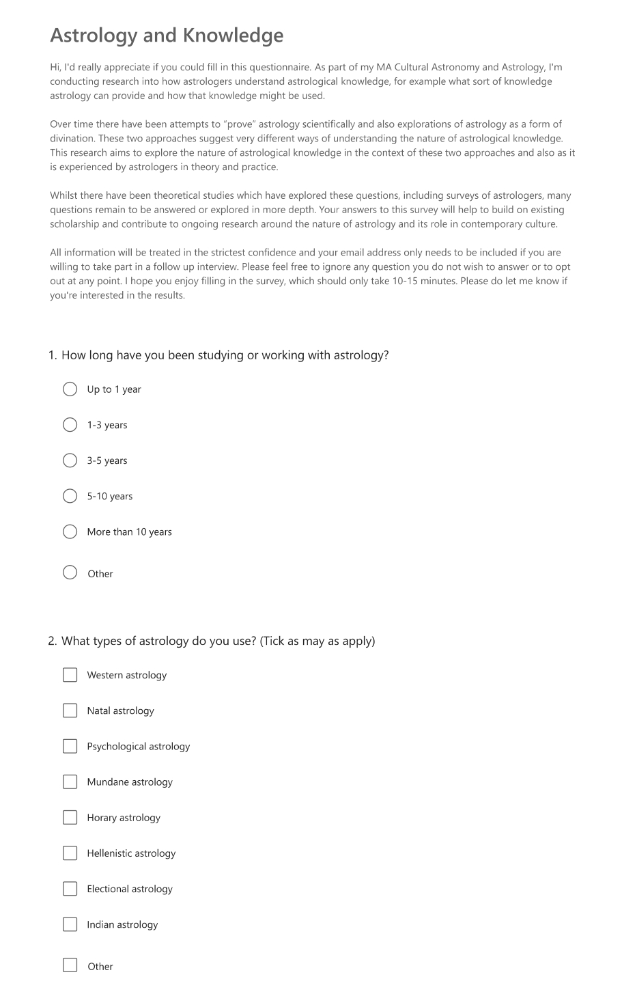

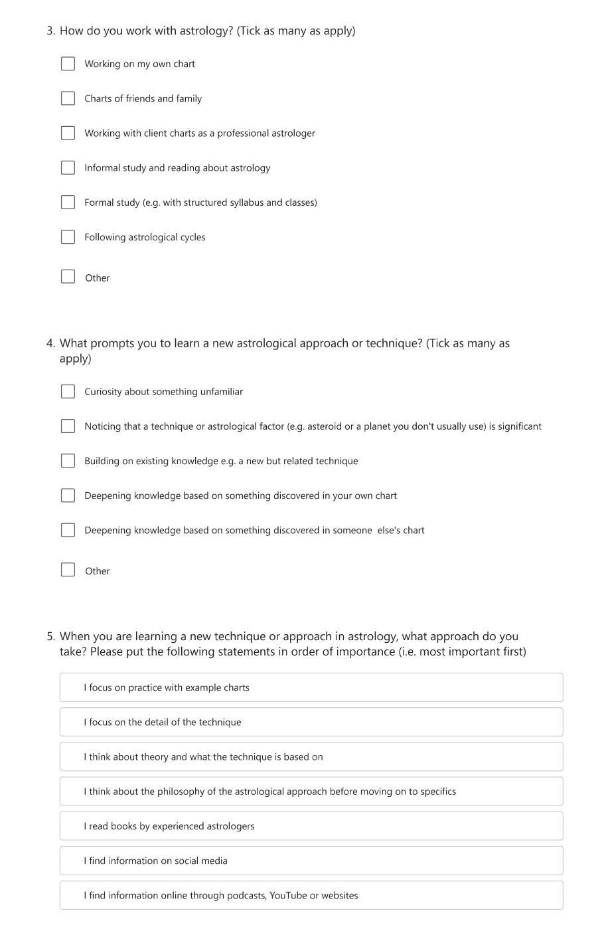

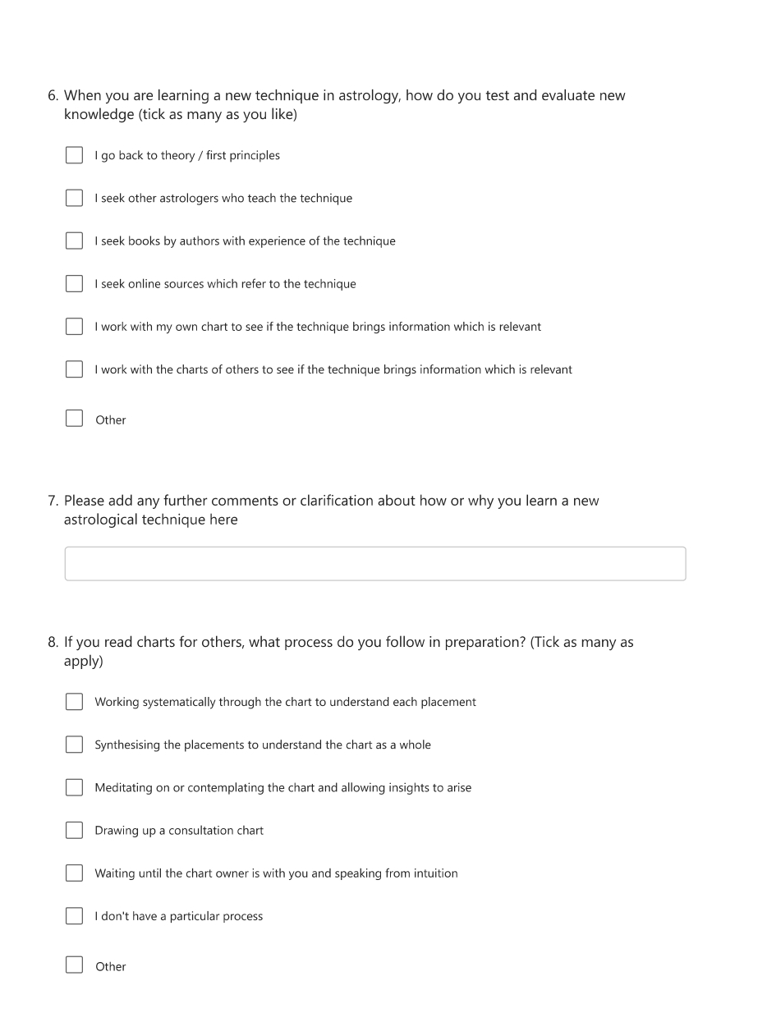
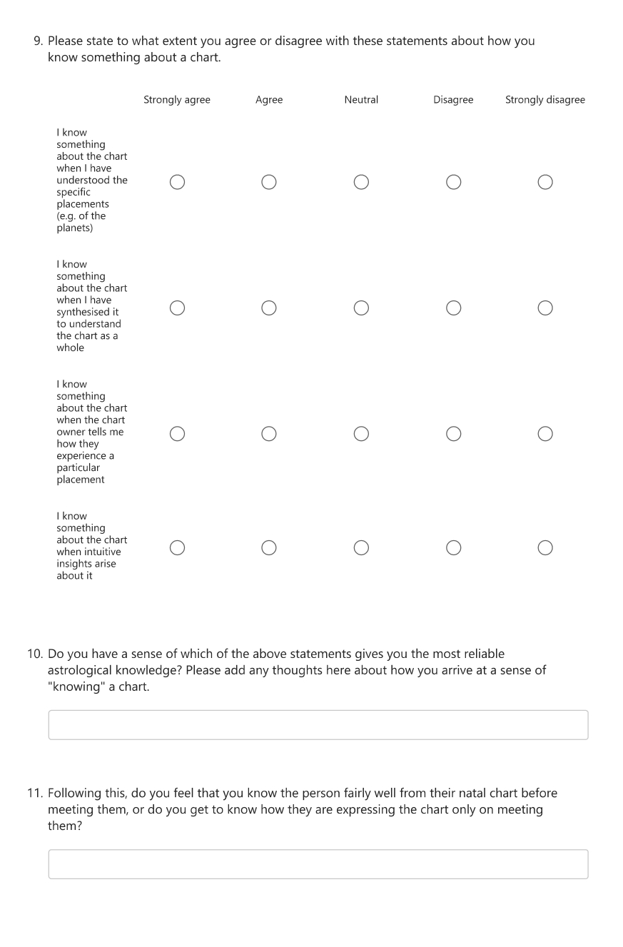

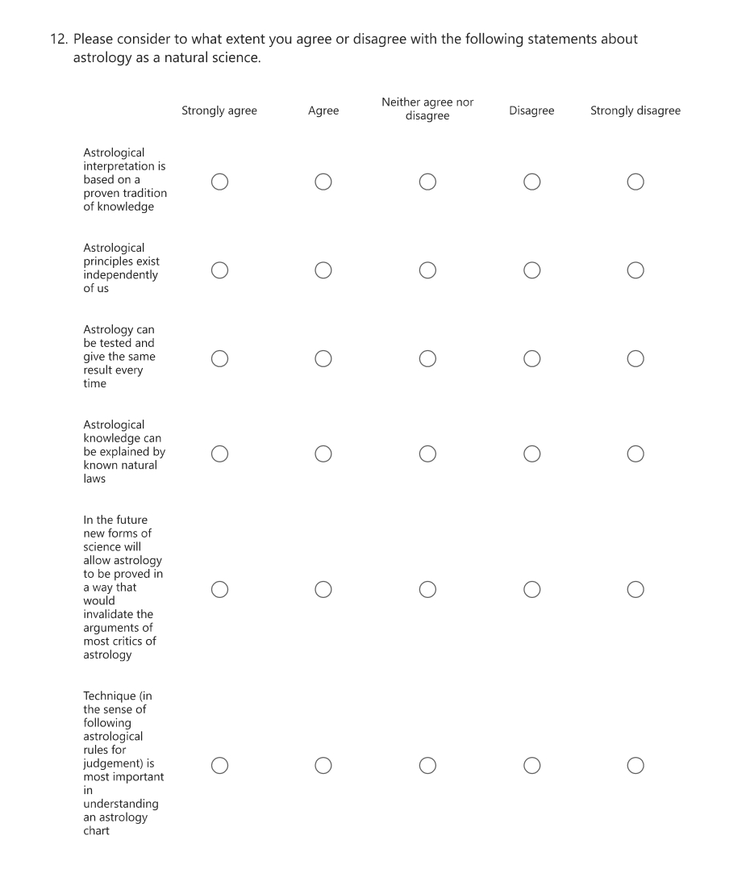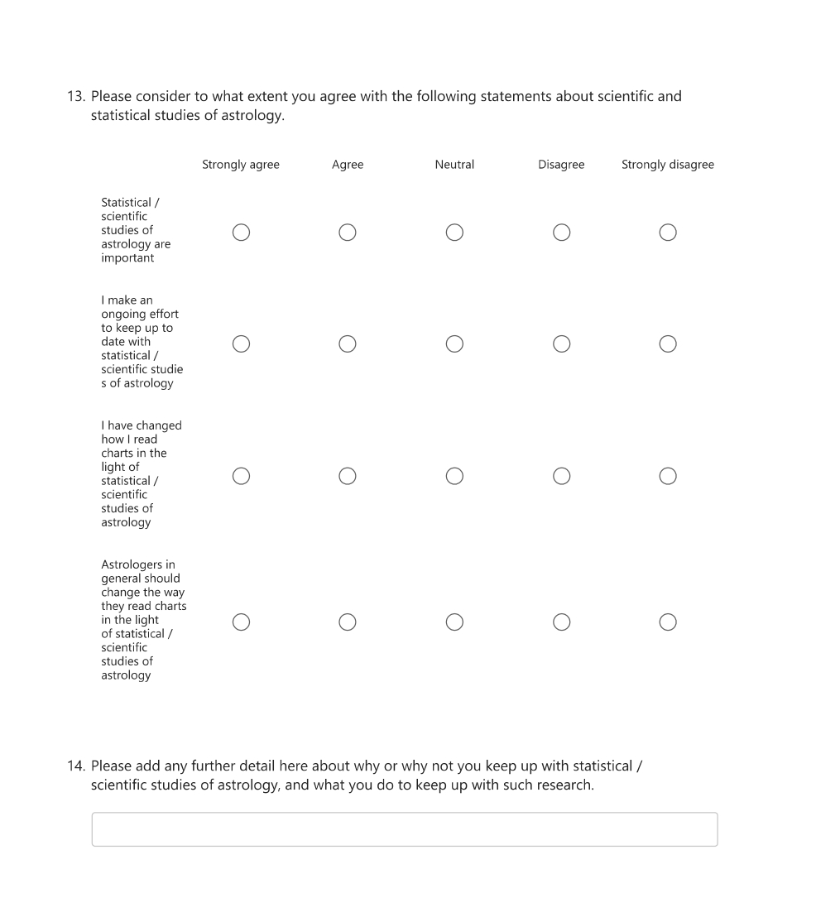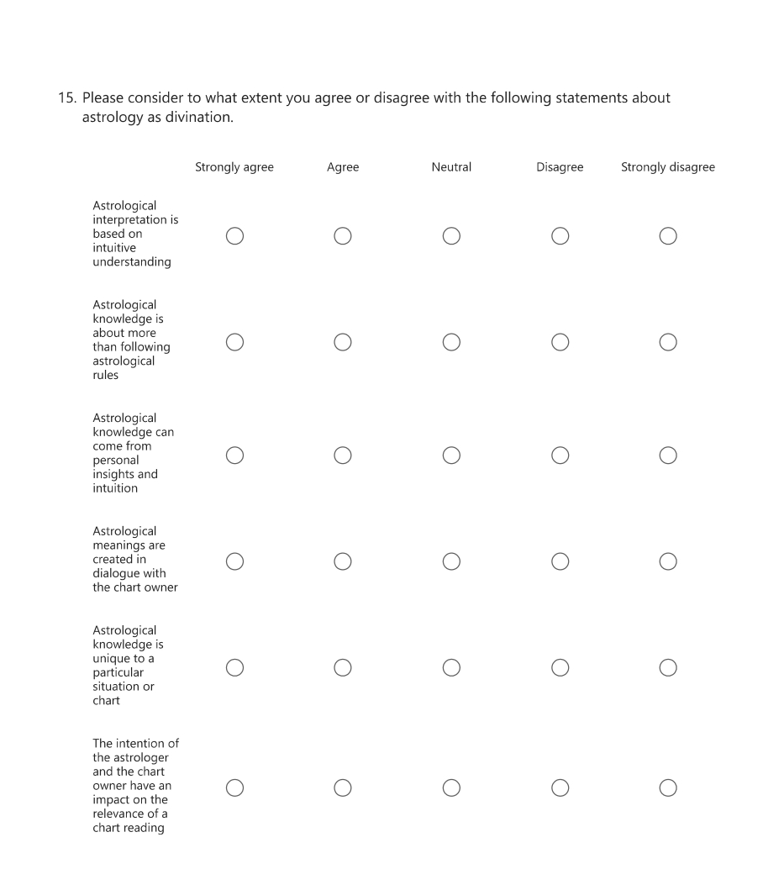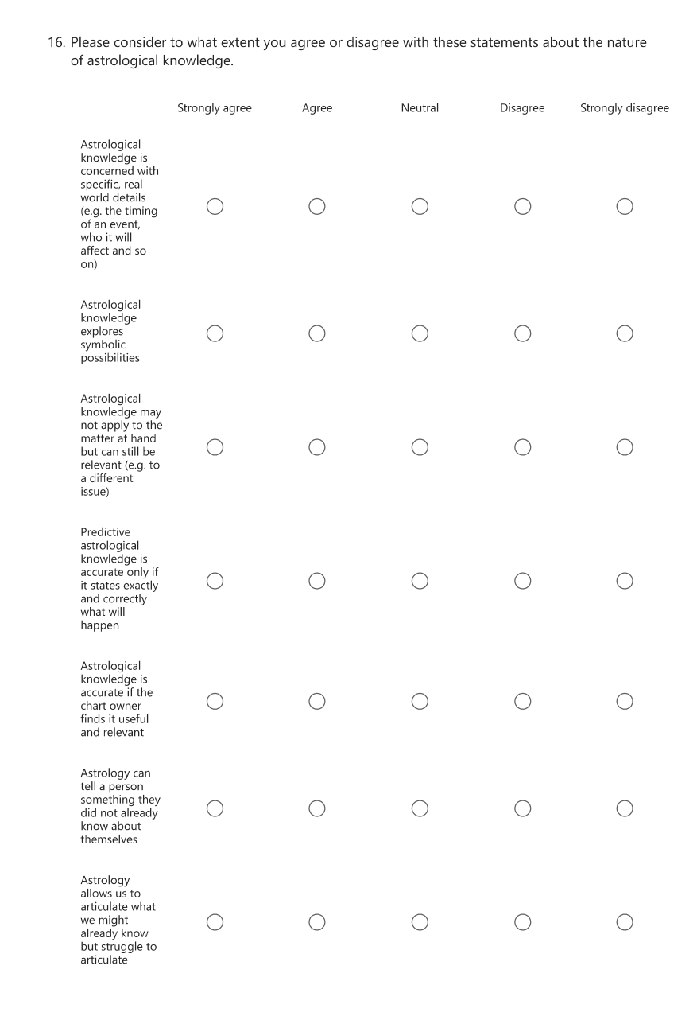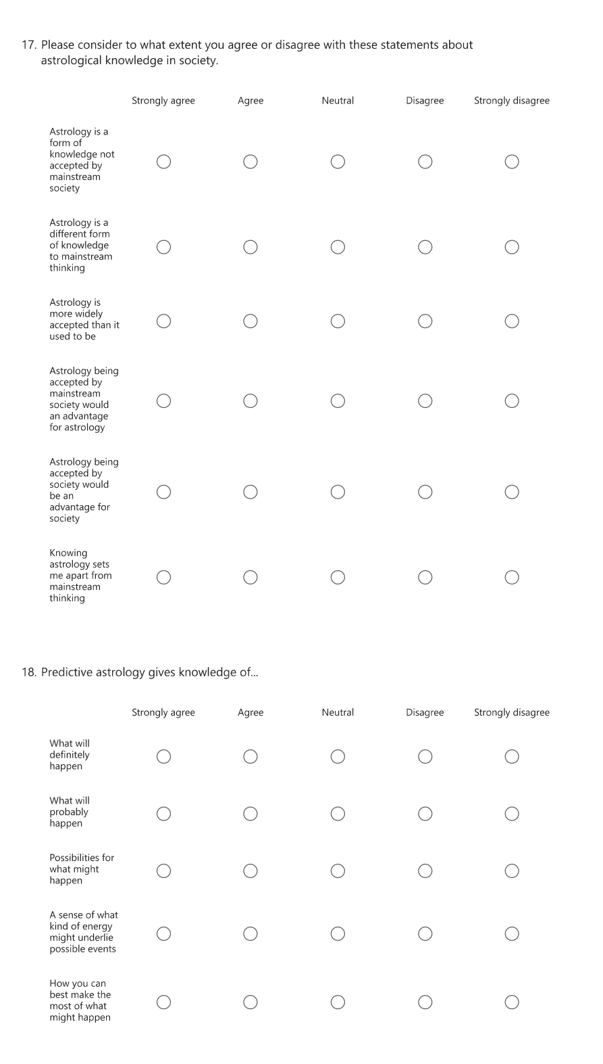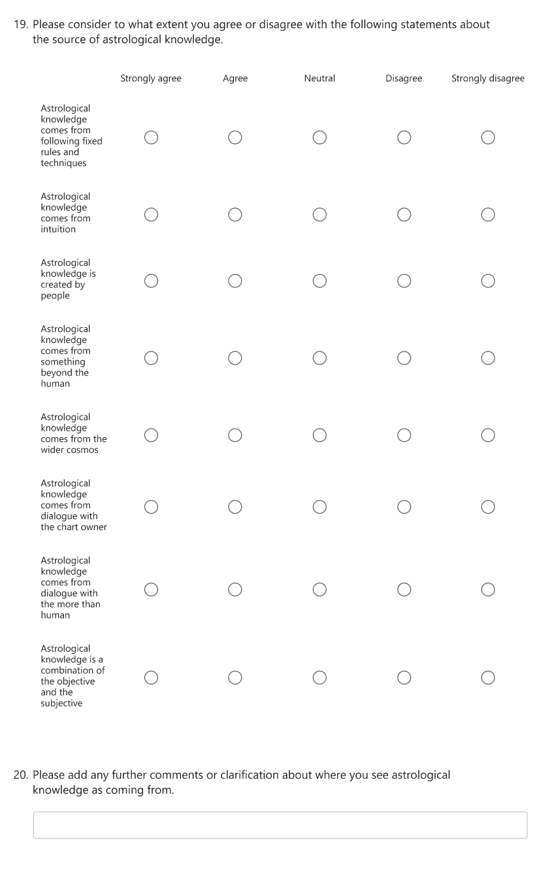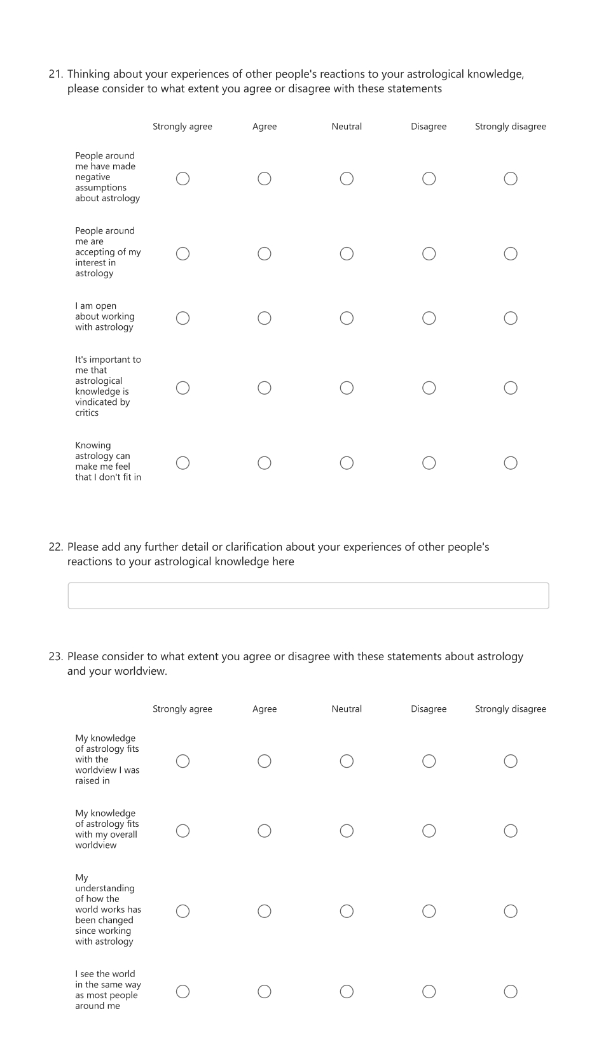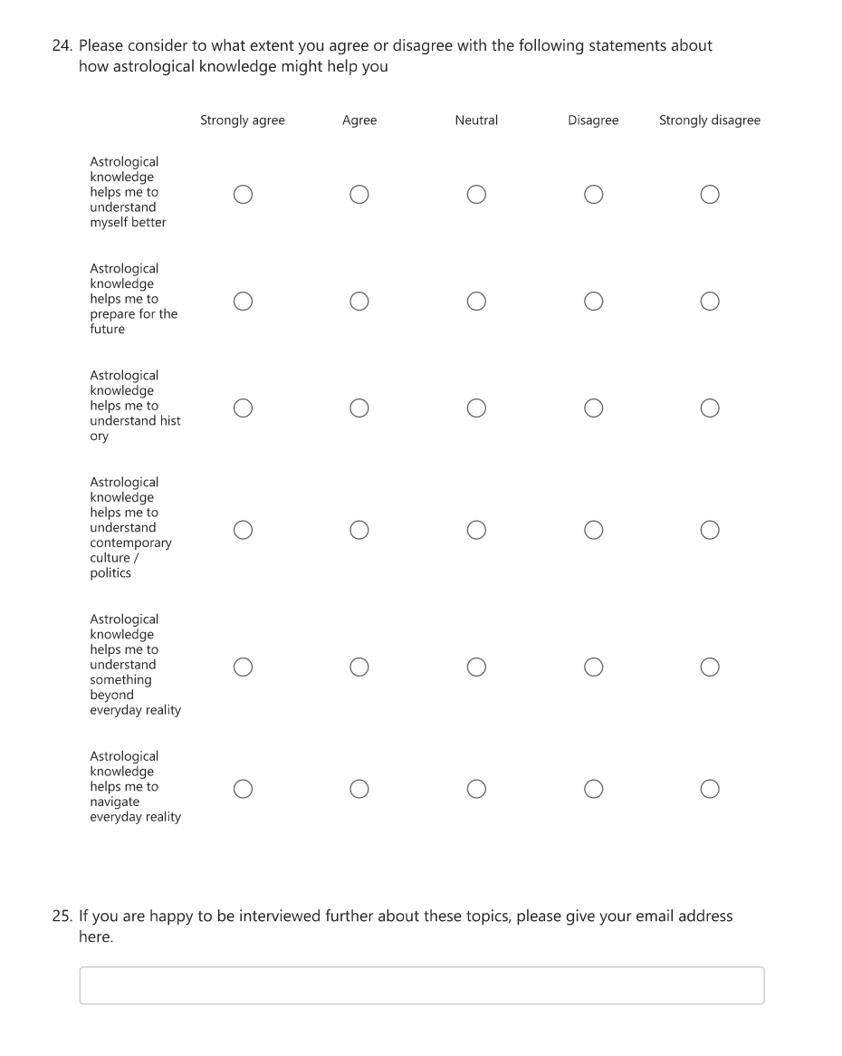

Appendix 2 - Interview structure and questions

The basic structure followed in the semi-structured interviews is given below. Adjustments were made for individual interviewees based on their questionnaire responses.

Can you tell me about your journey with astrology so far – how you got into it, how you work with it now

What type of astrology do you focus on?
Do you work with different types and do you understand them differently / how they work?
What does each type offer / when would you use each type?

What has been your experience of learning astrology?
(ask about formal / informal – preferred sources and reasons for them.
Also how astrological knowledge is “interiorised” (Heilan) to become tacit)
How can you tell when you know enough about a particular technique to get reliable knowledge from it / to use it for example in consultations?

When learning new technique / area of astrology – or astrology at all – how do you arrive at reliable knowledge?
How do you decide which teachers / books etc are reliable?
Do you draw on experience of own chart / others charts?
Do you use charts of “famous people” as way of practising / learning? How does this help / work? Use of biography?
Do you stick to “tradition” or develop your own ideas?

What can be known objectively in an astrology chart?
What needs to include the subjective / intuitive to count as knowing?

Do you see astrology as being part of a particular framework? E.g. would you see it as a science, as an art / craft, as divination
Why / why not?
Build on science / divination statements from survey

Astrological consultations

How do you stay objective / open about a chart – if you “find out” something you are not sure about sharing e.g. sensitive topics

Have you had any moments of recognition / knowing in consultation – can you tell?
Any examples of clients saying something is resonant / true or indicating that in a different way e.g. from body language

Any experiences of client not agreeing / actively disagreeing with an interpretation – how did you deal with that?

If agreed ‘Astrological knowledge helps me to understand something beyond everyday reality’ – what is that something and how does astrological knowledge help you understand it?

Teaching astrology

If you teach astrology, do you have any insights about the nature of astrological knowledge from your teaching – for example from the best ways that students learn or that you share information?

Wouter J. Hanegraaff, Esotericism in Western Culture; Counter-normativity and Rejected Knowledge, (London: Bloomsbury Academic, 2025), p. 37.
Wouter J. Hanegraaff, Esotericism in Western Culture, p. 22.
Wouter J. Hanegraaff, Esotericism in Western Culture, p. 199.
Nicholas Campion, Astrology and Cosmology in the World’s Religions (New York: New York University Press, 2012), p. 1.
Joanna Watters, Introducing Venus https://www.skyscript.co.uk/venus1.html [Accessed 4/3/2026]
Nicholas Campion and Liz Greene, ‘Introduction: Astrologies: Plurality and Diversity’ in Astrologies: Plurality and Diversity in the History of Astrology, ed. by Nicholas Campion and Liz Greene (Lampeter: Sophia Centre Press, 2011), pp. 12-13.
Konrad Klawikowski, ‘Recovering “Rejected” Knowledge: Explaining the Epistemological Strategies of Contemporary Astrologers’ (Unpublished PhD thesis, University of Edinburgh, 2024), p. iii.
Karin Knorr Cetina, ‘Culture in global knowledge societies: knowledge cultures and epistemic cultures’, Interdisciplinary Science Reviews, 32(4) (2007), p. 363.
Konrad Klawikowski, Recovering “Rejected” Knowledge, p. 118.
Karin Knorr Cetina, ‘Culture in global knowledge societies’, p. 363.
Omri Elisha, ‘Mirrors of the Past: Time and Historical Consciousness in Contemporary Western Astrology’ Comparative Studies in Society and History, 67(1) 2025, p. 227.
Nicholas Campion and Liz Greene, ‘Introduction: Astrologies: Plurality and Diversity’ pp. 12-13, already cited above.
Claudius Ptolemy, Tetrabiblos, trans. by Frank Egleston Robbins, (Cambridge, MA: Harvard University Press, 1940), 3.13, p.333.
William Lilly, Christian Astrology ... in Three Books. the First Containing the use of an Ephemeris ... the Second ... how to Judge Or Resolve all Manner of Questions ... the Third ... to Judge upon Nativities, (London: Thomas Brudenell, 1647). https://www.proquest.com/books/christian-astrology-three-books-first-containing/docview/2230612262/se-2. [Accessed 12/3/2026], p. 76.
Robert Hand, Horoscope Symbols, (Atglen, PA; Whitford Press, 1981), p. 54.
Michael Harding, Hymns to the Ancient Gods, (London: Arkana, 1992), p. 6.
Michael Harding, Hymns to the Ancient Gods, p. 81.
Roy Willis and Patrick Curry, Astrology, Science and Culture: Pulling down the Moon, (Oxford: Berg, 2004), p. 70.
Joanna Komorowska, ‘Philosophy among Astrologers’, Culture and Cosmos, Vol 11(2), 2007, p. 73.
Karl Popper, The Logic of Scientific Discovery (London: Routledge, 2002), p.23.
Geoffrey Dean, Arthur Mather, David Nias and Rudolf Smit, ‘Understanding Astrology: A critical review of a thousand empirical studies 1900-2020’ https://www.astrology-and-science.com/UA-1.pdf [Accessed 5/3/2026]
Roy Willis and Patrick Curry, Astrology, Science and Culture, p. 106.
Roy Willis and Patrick Curry, Astrology, Science and Culture, p. 57.
Roy Willis and Patrick Curry, Astrology, Science and Culture, p. 58.
Dimitry Okropiridze, ‘Interpretation Reconsidered: The Definitional Progression in the Study of Esotericism as a Case in Point for the Varifocal Theory of Interpretation’ in New Approaches to the Study of Esotericism, edited by Egil Asprem and Julian Strube, Brill, 2021, pp. 217–40. JSTOR, http://www.jstor.org/stable/10.1163/j.ctv1sr6jm4.15. [Accessed 14/3/2026], p. 225.
Konrad Klawikowski, ‘Recovering “Rejected” Knowledge’, p. 267.
Plato. Theaetetus. Sophist. Translated by Harold North Fowler. Loeb Classical Library 123 (Cambridge, MA: Harvard University Press, 1921) 201c, p. 223.
Garry Phillipson, ‘Astrology and Truth: A Context in Contemporary Epistemology’ (Unpublished PhD thesis, University of Wales Trinity Saint David, 2020), p. 86.
Marcus Tullius Cicero, De Senectute De Amicitia; De Divinatione, trans. by William Armistead Falconer (Cambridge, MA: Harvard University Press, 1923), 2.43, p. 473.
Hanegraaff, Wouter J. ‘Rejected Knowledge…: So You Mean That Esotericists Are the Losers of History?’ in Hermes Explains: Thirty Questions about Western Esotericism, edited by Wouter J. Hanegraaff et al., (Amsterdam: Amsterdam University Press, 2019), p. 150.
Rienk Vermij and Hiro Hirai, ‘The Marginalization of Astrology: Introduction’, Early Science and Medicine, vol. 22, no. 5/6, 2017, pp. 406.
Konrad Klawikowski, ‘Recovering “Rejected” Knowledge’, p. 15.
Richard Dawkins, ‘The Real Romance in the Stars’, Independent on Sunday, 31 December 1995, http://​www.​independent.​co.​uk/​opinion/​the-real-romance-in-the-stars-1527970.​html Accessed 8/3/2026
Michael York, Insider/Outsider Methodological Problems with the Study of Astrology, British Association for the Study of Religion 50th Anniversary Conference, Oxford (13-16 September 2004), p.6.
Susannah Crockford, ‘A Mercury Retrograde Kind of Day: Exploring Astrology in Contemporary New Age Spirituality and American Social Life’, Correspondences, 6.1 (2018), p. 73.
Garry Phillipson, ‘Astrology and Truth: A Context in Contemporary Epistemology’, p. 321.
Konrad Klawikowski, ‘Recovering “Rejected” Knowledge’, p. 195.
Alison Gwendy Bird, ‘Astrology in Education: An Ethnography’ (Unpublished DPhil Thesis, University of Sussex, 2006), pp. 79-80.
Alison Bird, ‘Astrology in Education: An Ethnography’, p. 109.
Alison Bird, ‘Astrology in Education: An Ethnography’, p. 134.
Nicholas Campion, Astrology and Popular Religion in the Modern West: Prophecy, Cosmology and the New Age Movement, (London: Routledge, 2012), p. 179.
Nicholas Campion, Astrology and Popular Religion in the Modern West, p. 208.
Nicholas Campion, Astrology and Popular Religion in the Modern West, p. 208.
A. P. Ashwin Kumar, ‘Astrology: An Action Theoretic Re-description’, Global Philosophy, 34(1), Article 17 (2024). https://doi.org/10.1007/s10516-024-09729-y [Accessed 14/3/2026], p. 17.
Konrad Klawikowski, ‘Recovering “Rejected” Knowledge’, p. 259.
Omri Elisha, ‘Mirrors of the Past’, p. 233.
Rod Chang, Comets in Astrology, (Swanage: The Wessex Astrologer, 2025)
James Brockbank, ‘The Responsive Cosmos: an enquiry into the theoretical foundation of astrology’ (Unpublished DPhil Thesis, University of Kent, 2011), p. 340.
James Brockbank, ‘The Responsive Cosmos’, p. 367.
James Brockbank,‘The Responsive Cosmos’, p. 368.
Konrad Klawikowski, ‘Recovering “Rejected” Knowledge’, p. 187.
Geoffrey Dean, Arthur Mather, David Nias and Rudolf Smit, ‘Understanding Astrology: A critical review of a thousand empirical studies 1900-2020’ https://www.astrology-and-science.com/UA-1.pdf [Accessed 5/3/2026]
Garry Phillipson, Astrology in the Year Zero, (Lampeter; Sophia Centre Press, 2025) p. 100.
Garry Phillipson, Astrology in the Year Zero, p. 103.
Geoffrey Dean, assisted by Arthur Mather and 52 collaborators, Recent Advances in Natal Astrology: A Critical Review, 1900 – 1976 (Subiaco, Western Australia: Analogic, 1977), p. 554.
Nicholas Campion, ‘Modern Western Astrology as Indigenous Thought and Practice,’ in Astrology and Western Society from the First World War to Covid-19, edited by William Burns, (Springer International Publishing AG, 2023). ProQuest Ebook Central, http://ebookcentral.proquest.com/lib/trinity/detail.action?docID=30784224. Accessed 8/3/2026], p. 16.
Ze Hong and Joseph Henrich, ‘The Cultural Evolution of Epistemic Practices: The Case of Divination’, Human Nature (Hawthorne, N.Y.), 32.3 (2021), p. 623.
Ze Hong and Joseph Henrich, ‘The Cultural Evolution of Epistemic Practices’, p. 624.
Garry Phillipson, Astrology in the Year Zero, p. 171.
Alison Gwendy Bird, ‘Astrology in Education: An Ethnography’, p. 101.
Wouter J. Hanegraaff, ‘How magic survived the disenchantment of the world’, Religion, 33 (4) (2203), pp. 376-377.
Dennis Elwell, Cosmic Loom, (London: Urania Trust, 1999), p. 8.
Dennis Elwell, Cosmic Loom, p. 6.
Bernadette Brady, Cosmos, Chaosmos and Astrology: Rethinking the nature of astrology, (Lampeter: Sophia Centre Press, 2014), p. 10.
Garry Phillipson, ‘Modern Science, Epistemology and Astrology’, Correlation, Vol.23(2) 2006, p. 20.
Geoffrey Cornelius, The Moment of Astrology: Origins in Divination, (Bournemouth, The Wessex Astrologer, 2003), p. 304.
James Brockbank, ‘The Responsive Cosmos’, p. 52.
James Brockbank, ‘The Responsive Cosmos’, p. 7.
Geoffrey Cornelius, The Moment of Astrology’, p. 104.
Lindsay Radermacher, ‘The Role Of Dialogue In Astrological Divination’, (Unpublished MPhil thesis, University of Kent at Canterbury, 2011), p. vii.
Lindsay Radermacher, ‘The Role Of Dialogue In Astrological Divination’, p. 67.
Nicholas Campion, ‘Is astrology a symbolic language?’ in Sky and Symbol: Proceedings of the Ninth Annual Sophia Centre Conference, 2011, edited by Nicholas Campion and Liz Greene (Lampeter: Sophia Centre Press 2013), p. 9.
Lindsay Radermacher, ‘The Role Of Dialogue In Astrological Divination’, p. 19.
Lindsay Radermacher, ‘The Role Of Dialogue In Astrological Divination’, p. 36.
Lindsay Radermacher, ‘The Role Of Dialogue In Astrological Divination’, p. 48.
Konrad Klawikowski, ‘Recovering “Rejected” Knowledge’, p. 169.
Geoffrey Cornelius, The Moment of Astrology, p. 222.
Geoffrey Cornelius, The Moment of Astrology, p. 222.
James Brockbank, ‘The Responsive Cosmos’, pp. 14-15.
Darrelyn Gunzburg, The Horoscopic Place: The Encounter between Astrologer and Client, https://repository.uwtsd.ac.uk/id/eprint/1323/ [Accessed 6/3/2026], p. 11.
Darrelyn Gunzburg, The Horoscopic Place, p. 49.
Garry Phillipson, ‘Astrology and Truth’, p. 240.
Konrad Klawikowski, ‘Recovering “Rejected” Knowledge’, p. 124.
Dimitry Okropiridze, ‘Interpretation Reconsidered’, p. 231.
Michael Polanyi, The Tacit Dimension, (Garden City, New York: Doubleday, 1967) on Internet Archive https://archive.org/details/tacitdimension0000mich_w4j8/page/n3/mode/2up [Accessed 18/3/2026], p. 4.
Michael Polanyi, The Tacit Dimension, p. 11.
Stephan Heilan, ‘Michael Polanyi’s concept of “tacit knowing”: its relevance to the practice and study of astrology,’ 1st Astra Project workshop: Reflections on the History and Historiography of Astrology, 6 November 2021, https://www.youtube.com/watch?v=SB7AoDw4Fk0 [Accessed 18/3/2026]
Wouter J. Hanegraaff, ‘How magic survived the disenchantment of the world’, p. 374.
Wouter J. Hanegraaff, ‘How magic survived the disenchantment of the world’, p. 377.
Lindsay Radermacher, ‘The Role Of Dialogue In Astrological Divination’, p. 60.
Garry Phillipson, ‘Astrology and Truth’, p. 245.
Garry Phillipson, ‘Astrology and Truth’, p. 246.
William James, The Meaning of Truth, (London: Flame Tree Publishing, 2024), p. 64.
Garry Phillipson, ‘Astrology and Truth’, p. 103.
William James, The Varieties of Religious Experience, (London: Fontana, 1971), p. 367.
Matthew Crippen, ‘William James and the Pragmatics of Faith: Bridging Science, Religion and Global Indigenous Epistemologies’ Religions, 16(9), 1116 (2025) https://doi.org/10.3390/rel16091116 [Accessed 18/3/2026], p. 17.
Alfred North Whitehead, Science and the modern world (United States: The MacMillan Company, 1925) on Project Gutenberg https://www.gutenberg.org/cache/epub/68611/pg68611-images.html [Accessed 14/32026], p. 202.
Alfred North Whitehead, Process and Reality: An Essay in Cosmology: Gifford Lectures Delivered in the University of Edinburgh during the Session 1927-28. (New York: Macmillan, 1929) on Internet Archive https://archive.org/details/processreality0000alfr/page/6/mode/2up [Accessed 3/3/2026], p. 7.
James Brockbank, ‘The Responsive Cosmos’, p. 360.
Konrad Klawikowski, ‘Recovering “Rejected” Knowledge’, p. ii.
Konrad Klawikowski, ‘Recovering “Rejected” Knowledge’, pp. 290.
Konrad Klawikowski, ‘Recovering “Rejected” Knowledge’, p. 295.
Susannah Crockford, ‘A Mercury Retrograde Kind of Day’, p. 49.
Susannah Crockford, ‘A Mercury Retrograde Kind of Day’, p. 51.
Egil Asprem, ‘Rejected Knowledge Reconsidered: Some Methodological Notes on Esotericism and Marginality.’ in New Approaches to the Study of Esotericism, edited by Egil Asprem and Julian Strube, Brill, 2021, pp. 127–46. JSTOR, http://www.jstor.org/stable/10.1163/j.ctv1sr6jm4.10 [Accessed 14/3/2026], p. 141.
Susannah Crockford, ‘A Mercury Retrograde Kind of Day’, p. 71.
Konrad Klawikowski, ‘Recovering “Rejected” Knowledge’, pp. 187.
Omri Elisha, ‘Mirrors of the Past’, p. 225.
Omri Elisha, ‘Mirrors of the Past, p. 241.
Omri Elisha, ‘Mirrors of the Past’, p. 246.
Garry Phillipson, ‘Astrology and Truth’, p. 18.
Alan Bryman, Quantity and Quality in Social Research, (London: Routledge, 1988), p. 116.
The Astrological Association, ‘About the Astrological Association’ https://www.astrologicalassociation.com/about-us/ [Accessed 13/3/2026]
Alison Bird, ‘Astrology in Education: An Ethnography’, p. 70.
Bernadette Brady, ‘Theories of Fate among Present-day Astrologers’ (Unpublished PhD thesis, University of Wales Trinity Saint David 2011), p. 175.
Michael York, Insider/Outsider Methodological Problems with the Study of Astrology, p.12.
Alison Bird, ‘Astrology in Education: An Ethnography’, p. 6.
Frances Clynes, ‘An Examination of the Impact of the Internet on Modern Western Astrology’, (Unpublished PhD thesis, University of Wales Trinity St David, 2015), p. 12
Anonymous, email 21/01/2026, quoted with permission.
Frances Clynes, ‘An Examination of the Impact of the Internet on Modern Western Astrology’, p. 12
Omri Elisha, ‘Mirrors of the Past’, p. 246.
Maggie Hyde, ‘The Judder Effect’, Astrological Journal Vol. 43 No. 5, Sept/Oct 2001, p. 48.
Konrad Klawikowski, ‘Recovering “Rejected” Knowledge’, p. 263.
Garry Phillipson, ‘Modern Science, Epistemology and Astrology,’ p. 20.
Garry Phillipson, Astrology in the Year Zero, p. 148.
Alison Bird, ‘Astrology in Education: An Ethnography’, p. 136.
For example: Joanna Watter, Introducing Mars, https://www.skyscript.co.uk/mars1a.html [Accessed 4/3/2026]
Geoffrey Cornelius, The Moment of Astrology, p. 55.
Lindsay Radermacher, ‘The Role Of Dialogue In Astrological Divination’, p. 34.
Lindsay Radermacher, ‘The Role Of Dialogue In Astrological Divination’, p. 91.
Konrad Klawikowski, ‘Recovering “Rejected” Knowledge’, pp. 275-276.
Ertel Suitbert, ‘Appraisal of Shawn Carlson’s Renowned Astrology Tests’, Journal of Scientific Exploration, Vol. 23, No. 2, (2009), p. 134.
Alison Bird, ‘Astrology in Education: An Ethnography’, p. 88.
Garry Phillipson, ‘Astrology and Truth’, p. 109.
Garry Phillipson, ‘Astrology and Truth’, p. 303.
Bernadette Brady, ‘Theories of Fate among Present-day Astrologers’, p. 289.
Geoffrey Cornelius, The Moment of Astrology’, p. 131.
Konrad Klawikowski, ‘Recovering “Rejected” Knowledge’, p. 35.
Konrad Klawikowski, ‘Recovering “Rejected” Knowledge’, p. 328.
Lindsay Radermacher, ‘The Role Of Dialogue In Astrological Divination’, p. 19.
Lindsay Radermacher, ‘The Role Of Dialogue In Astrological Divination’, p. 22.
Stephan Heilan, ‘Michael Polanyi’s concept of “tacit knowing’.
Lindsay Radermacher, ‘The Role Of Dialogue In Astrological Divination’, p. 70.
William James, The Varieties of Religious Experience, p. 367.
Garry Phillipson, ‘Astrology and Truth’, p. 238.
Darrelyn Gunzburg, The Horoscopic Place: The Encounter between Astrologer and Client, p. 8.
Lindsay Radermacher, ‘The Role Of Dialogue In Astrological Divination’, p. 162.
Wouter J. Hanegraaff, ‘How magic survived the disenchantment of the world’, p. 378.
Lindsay Radermacher, ‘The Role Of Dialogue In Astrological Divination’, p. 82.

