Organisational Change case study
Western Union Company

Name: Waruna Galagedara
Student No.: 2206302
Program: MBA
Module: Change and Stability Management
Lecturer: Marie Pitson
Module code: BMMB7000
Submission Deadline: 05th May 2023

- Executive Summary
Western Union Company’s board of Directors approved a plan to change its operating model, improve its cost structure, reduce headcount by 10%, and reorganise senior management in 2019. In this report, Lewin’s force field analysis, stakeholder analysis, PESTEL analysis, Lewin’s three-step model, and Kotter’s eight-step model are used to analyse the change at Western Union. The success or failure of the change management has an impact on the business risk and associated financial results (Sittrop and Crosthwaite, 2021). Western Union has failed to achieve its financial targets due to the global economic crisis and Russia’s invasion of Ukraine. However, WU company adopted Kotter’s change model and got successful in the other restructuring processes. The ability to adopt the change can improve the business’s success in the future. In the change management process communications are a vital part of the successful change and need to consistently communicate among the relevant parties. The researcher’s suggested recommendations at the end of the report, are to achieve successful change management in the fast-moving technological business environment.

Contents

Page No.
- Executive Summary 1
- Introduction
  - Introduction of the Company 4
  - Background of the change 5
- Definition of Change Management 5
- The type of change at WU 6
- The force field analysis 6
5.1 Driving Forces for change 8
5.2 Resistance force for change 9
6. The Stakeholders’ analysis 10
7. PESTEL analysis 13
- Application of Lewin’s Theory 14
- Application of Kotter’s Theory 15
- Assessment of change 18
- Conclusion 19
- Recommendation 20
- Bibliography 21
- Appendices 28

List of figures and Appendices
Figures
- Driving Forces and Resisters of Change in WU 7
- Analyse of Stakeholders 11

Appendices
- The pandemic exposed FinTech vulnerability 28
- Remittances growth rate of decline in Q3 22 29

- Introduction
2.1 Introduction of the company
The Western Union (WU) Company heading the global cross-border, cross-currency money movements and payments sectors. It serves over 200 countries in 130 currencies. WU connects consumers, businesses, financial institutions, and governments through wide-reaching networks, accessing billions of bank accounts, millions of digital wallets and cards, and a network of retail locations. It supports individuals and businesses around the world in savings, spending, and transferring money to provide more affluent financial futures for their families, friends, and communities (Western Union, 2023).
The company was established in 1851 with the goal of constructing a telegraph line connecting Buffalo, New York, and St. Louis, Missouri. After five years the company changed its name to Western Union Telegraph Company. In 1871 company introduced the money transfer services. Western Union offers its first charge card in 1914. The Western Union Telegraph Co. was restructured as the Western Union Corp. in 1988 to handle money transfers and related services in the face of the rapidly evolving technologies. In 1991, the company's name was changed to New Valley Corp. after selling some of its assets to AT&T and GM Hughes Electronics Corp. In 2006 it became a Public Limited company. WU offers money transfer services to every country in the world except Iran and North Korea. It operates 24 transactions per second (Western Union, 2023).

2.2 Background of the change
In the current rapid development of the business world, Companies need to adapt to the changes to compete for their market share (Ololade, 2022).
The public has used digital payment methods heavily following the occurrence of COVID-19 and it has given limitless benefits to the public (Gupta and Singhal, 2021). Digital payment systems act as a necessity for government payment in some countries. It helped to pay utility bills and fund transfers. People used e-payments to buy from online stores after the pandemic (Yu and Chung, 2022). The high volume of transaction failures, an increase in staff cost and data storage issues impacted FinTech (Financial Technology) revenue (Appendix 1) (Capgemini, 2023). External environmental factors such as economic trading conditions, adaptation of new technologies, changing customer needs and challenges from competitors forced the WU to go for a change.

The Western Union Company Board of Directors approved a plan on August 2019, to change the Company’s operating model and improve its business processes and cost structure by restructuring the company’s senior management, reducing its headcount, and uniting various facilities (Western Union, 2023b).

- Definition of Change management
According to the Association of Project Management (2023), change management is the broad strategy used to transition from the current state to the future desired by utilising a planned and structured approach with coordinating with stakeholders.
Prosci’s research (2023) describes change management as the application of structured processes and tools for leading people’s side of change to get the desired outcome.
Change management is an important part of the business process (Yazdanpanah, 2021).

- The type of change at WU

Western Union Board of Directors decided to change its operating model in 2019. Planned change is the purposeful effort by an organisation to influence the status quo of itself (Orunbon, 2022). Western Union change is a planned change adopted by the management. Burns (2004a) refers to incremental change as dealing with one problem and one objective at a time. The company’s target to reduce its headcount by 10% and improve operating profit margin to 23% in 2022 and return funds to shareholders by 2022 are the major objectives of the change. This change is applied on an incremental basis and affects the operations of the business. The change applied to the whole organization.

- The force field analysis

This method is used to plan and implement the changes. External and Internal forces consider for this analysis. (Thomas,1985). Driving forces might result from external factors and resistance forces results from internal factors (Bozak, 2003).
According to the theory if driving forces exceeds the resistance forces then the change can be implemented in the organisation. However, various complex forces can be affected to change due to rapid changes in the market environment, continuous changes in technologies and the upgrading of business models (Yang et al., 2021). The external factors can arise from law, norms, culture, and innovation. Internal factors such as leader’s cognition can lead to forces of change (Yang et al., 2021).

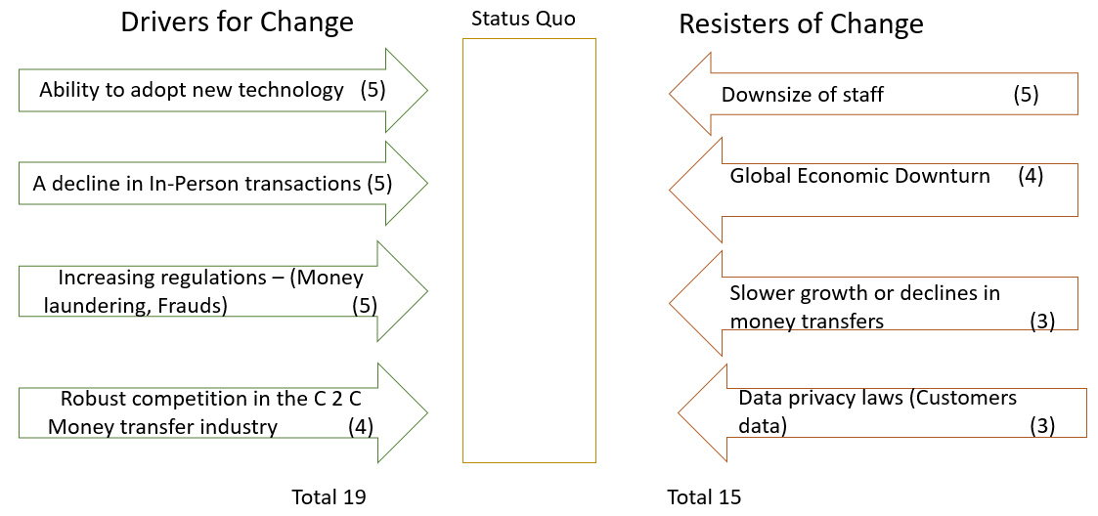
Figure 1 Driving Forces and Resisters of Change in WU

In this analyse driving forces received 19 points and Resisters got 15 points. Therefore, WU can implement the changes.

5.1 Driving Forces for Change
- Ability to adopt new technologies
Western Union planned to start Digital Banking Pilots in selected countries. It opened a WU shop directly at over 12,000 local and global merchants in more than 60 countries, which enables customers to send gifts to their families and friends in other countries (Western Union, 2021). WU has a wide range of technology-savvy service providers over the world. This facilitates WU to adopt new technologies quickly around the world.
- A decline in in-person transactions
COVID-19's global outbreak has affected people's daily lives all around the world. Lockdowns, social distancing, and stay-at-home directives are examples of public health precautions that have all been put into effect at the country levels. The daily activities of people all across the world have changed as a result of these policies (Jo et al. 2020). This affected the decline in in-person transactions and people use to go for online transactions (Tech Crunch, 2021). First-time customers of Western Union's online money transfer services must confirm their personal information in a face-to-face setting (Western Union, 2020). The company manages to introduce the electronic option to mitigate this issue.

- Increasing regulations to the money transfer sector
United Kingdom amended money laundering and transfer funds regulations after the EU exit in 2019 (Legislations.gov.UK, 2019). According to the amendments to the money laundering and terrorist financing regulations 2019, the maximum electronically deposited amount was reduced to 150 pounds from 250 pounds. (Financial Conduct Authority. 2023).
European Union has amended regulations in regard to wire transfers to protect people from fraud (European Banking Authority, 2023). These regulations force the WU to go for a change in its operating model.

- Robust competition in the C 2 C money transfer industry
The start-ups of Fintech businesses in the world challenge the WU businesses (Tech Crunch, 2021). Wise, Remitly, Paypal and MoneyGram are the main competitors of Western Union (Craft, 2023).

5.2 Resistance force for change
Resistance can be in various forms, lack of support to change or obstructions to change (Zikos, 2022). Piderit (2000) divides resistance to change into three categories: the first is emotional, the second is behavioural, and the third is cognitive. Individual people are not willing to accept the change due to psychological and behaviourally situations (Yang et al., 2021). People are normally resistant to change due to selfish motives and emotions (Darmawan, and Azizah, 2020). Group levels are more concerned about stability and security and they are resistant to change (Yang et al., 2021).

- Downsize of staff
The company’s target is to reduce its headcount by 10% and reorganise its senior management who reports to the Chief Executive Officer (Western Union 2023b).

- Global economic downturn
The World Bank predicted a sharp decline in remittances due to the global economic downturns induced by Covid 19 pandemic and the shutdown of countries (World Bank, 2020). Customers have reduced their money transfers due to the financial crisis.

- Slower growth or decline in money transfers
There is a slower growth and decline in the money transfer industry since 2019 (Refer to appendix 2) (FXCintelligence, 2022). Reduced household purchasing power and tighter monetary policy impacted the money transfers (IMF Blog, 2022).

- Data Privacy laws
Many governments have imposed data privacy laws, regulations and best practices to protect the datasets of people’s private and confidential information (Sekgoka et al., 2022). Amendments to these laws are resistant to change in the Western Union business since the software and applications are necessary to be updated from time to time due to constant change.

- The Stakeholders’ analysis

A stakeholder is a person, group, or organisation with a direct or indirect financial interest in a company. Stakeholders may or may not be official members of the organisation in which they have a stake (Ajaleen,2023). Stakeholders can be internal or external groups or individuals. Change procedures require the significant commitment, participation, and dedication of all relevant stakeholders, including employees, supervisors, and managers (Errida and Lotfi, 2021).
The following are the stakeholders of Western Union Company; Agents, Customers, Employees, Vendors, Government, Shareholders, competitors, banks, and civil society.

Analysis of stakeholders
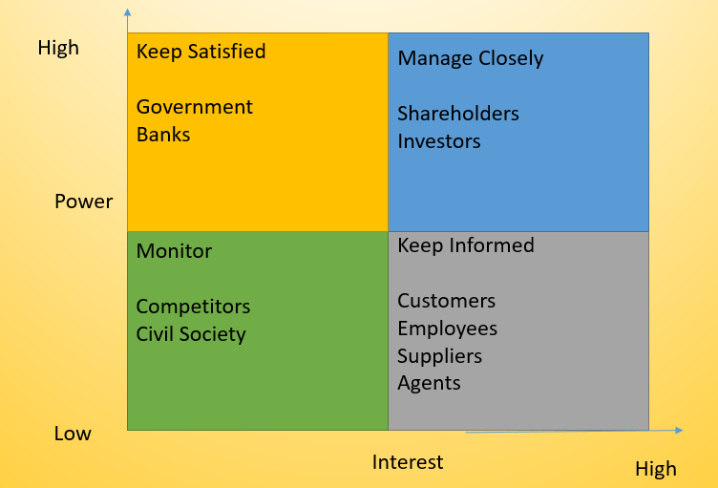
Figure 2 Analyse of stakeholders

Stakeholders can be categorised into the following four groups depending on their influences and interests. Firstly, the groups that have a lower interest and lower power, secondly, lower power and high-interest groups, thirdly high power and lower interest groups, and finally high power and high-interest groups.

- Lower power and Lower Interest Groups
Civil society and competitors fall to this group. They have less power and interest in regard to the change of the WU. However, they are significant to the company, and can’t be disregarded or ignored them. The best way to handle this group is to monitor their activities.

- High-power and lower-interest Groups
Among the stakeholders of the WU, the Government and banks are under this group. They have a high interest in the change of the company. Management needs to keep them satisfied with the change.

- High-interest and Lower power groups
Customers, employees, agents, and suppliers have a high interest in the change of Western Union, but they do not have enough power to resist it. The company needs to keep them informed about the changes.

- High-interest and high-power groups
Shareholders and Investors are under this group. The company needs to manage them closely. They might be helpful for the change.

- PESTEL analysis
This helps to identify the potential risk and threats to the change in the Western Union. External factors will be considered for this analysis. The company can mitigate the risk when it identifies the risk associated with the change. PESTEL is very effective for change management decisions when applied with the SWOT analysis.
PESTEL is an acronym for Political, Environment, Social, Technological, Environmental and Legal factors.
Political Factors | Economic factors
Political stability and decisions (Exit of EU)  Risk of military invasion (Russian –Ukraine)  Intellectual property protection laws  Trade regulations & tariffs related to Financial services  Taxation - tax rates and incentives  Industrial safety regulations in the Financial sector. | Exchange rates  Inflation  Discretionary Income  Economic Growth rate  The efficiency of the financial market
Social Factors | Technological Factors
Culture  Attitudes  Education level of the people  Leisure interest | Tech development of competitors  Rate of technological changes  Technology’s Impact on services provided.
Environmental factors | Legal factors
Weather  Climate change | Consumer protection and  e-commerce laws  Discrimination laws

Change management is a process that continuously changes the company’s direction, structure and capabilities depending on the internal and external environments.

- Application of Lewin’s Theory

Lewin believed a successful change project involved three steps which are Unfreezing, Changing, and Freezing (Burnes,2004). In this model, Lewin bypasses the employee’s feelings, attitudes and past experiences (Kritsonis, 2005).
- Unfreezing:
This involves processing fresh facts that highlight the shortcomings of the current situation and prompt change that is required for this situation (Orunbon, 2022). Cameron and Green mentioned that unfreezing is a current state by identifying the forces that are driving and preventing change, and imagining the final state of the change. At this stage driving forces need to be strengthened resistance forces should be minimised. Western Union has communicated with the staff about the change through open dialog from all levels of the company (Western Union, 2023c). The company paid $ 110 mn compensation to the staff and avoid the staff’s resistance to change (Western Union, 2023a).

- Changing:
Team members were encouraged to share their experiences and concerns about the change during this period. Continuous feedback will help to identify the problems and can mitigate them in this stage (Tracy, 2020). The movement to the new situation will take place at this stage (Zikos, 2022). Training and coaching programs need to be implemented. Recruiting staff with talents in the cloud, data architecture, and cyber security. Keep communicating a clear picture of the desired change is important at this stage.
- Freezing:
In this stage desired status quo is achieved and the need to avoid reverting to the previous status (Adelman-Mullally et al., 2023). This involves maintaining the change by training the staff, communication, performance appraisal, and rewarding for successes (Zikos, 2022). The organisational change, the company needs to change the previous culture, policies and procedures and adopt the new changes.

- Application of Kotter’s Theory

Many practitioners applied Kotter’s theory to change management theories. Kotter introduced an eight-step model for better change management. These steps need to follow one by one after completing the previous step. Lack of a clear vision, lack of leadership skills and poor communication are the main causes of change management failures (Errida and Lotfi, 2021). A lot of change management processes failed due to the early celebration of victory (Rassanjani, 2022).

- Establish a sense of urgency
Kotter stated that to do a change there should be a requirement for the change (Lambert, 2019). The driving forces of the Western Union Company were examined using Lewin's force field theory, which demonstrated the need for change. There were positive attitudes toward the change (Matama & Mkwizu, 2021) in the WU.

- Form a powerful coalition
Some authors reported that two-thirds of planned changes fail due to a lack of efficiency or integrity of leaders, or not concentrating on the people side of the change (Graamans et al., 2020). The coalition needs to be powerful and respected among the organisation. The organisational change largely depends on the power of the political actors engaged in the change (Rennkamp, 2019). WU appointed a committee to the restructuring process (Western Union, 2020a). The high power- high-interest groups are the most suitable team for the coalition. The committee needs to look at the stakeholders’ power and need to take necessary steps to pull lower interest groups to the higher interest level (Kotter 2007). All the stakeholders and the senior managers have a responsibility for the change in one way or the other.

- Create a vision
The Western Union Board of Directors has approved a plan for the change. It clearly showed their vision (Western Union, 2019). The change of operating model, improve its business process and cost structure, reduce the headcount by 10% and reorganise the senior management who are reporting to the CEO are consisted of the change. The management has introduced clear vision and methods to implement the change.
- Communicate the vision
WU has communicated the vision to stakeholders at the Investor Day meetings and at the Annual General Meetings (AGM). Every change has been communicated to the staff and the interested parties at the following AGMs.

- Empower others to act on the vision
In this stage, the company needs to identify and get rid of obstacles to the change. The coalition needs to encourage the stakeholders to take a risk in this situation. The company needs to change the process, if anything undermines the vision.

- Plan for and create short-term wins
In this process, short-term wins can be advertised through short-term visible improvements such as signboards and notice boards. Further, can publish the future status quo in the notice boards. The motivation of staff and involved parties and the reward of them is essential at this stage (Errida and Lotfi, 2021). The WU’s compensation committee appraises performance every year and paid incentives for the achievement of goals. If leaders can’t show positive outcomes quickly then it will reduce the satisfaction of the stakeholders.

- Consolidate improvements and produce still more change
- Institutionalise new approaches

- Assessment of change
The company paid USD 109.2mn as severance and employee benefits to the staff. Relocations, closures and consulting, and other expenses paid USD 42.5 mn as part of the restructuring process.

The company achieved the following targets as of 31st December 2022.
- Revenue of $ 4.5 billion down 12% from 2021.
- The company returned Seven hundred thirteen million to stockholders (781 mn in 2021)
- Digital Money transfer revenues decreased 3% from 2021
- Operating Income margin in 2022 of 20.4% compared to 22.1% in 2021
- The Company’s 2019 Restructuring initiative generated expense savings of approx., $ One hundred million in 2021 (Western Union, 2023a)
Currency fluctuations, Russia’s invasion of Ukraine, and the global economic crisis impacted to the achievement of the financial targets. The financial target is a part of the ‘improve business process and cost structure’ in the main changing plan. Russian invasion had a detrimental effect on the global major currencies. European currencies depreciated against the USD and Pacific region currencies strengthened while Middle East and African currencies remained unchanged (Abakah et al., 2022). This affects the people, importers, exporters and money transfer businesses around the globe. However, the company succeed in reducing its cost and saved USD hundred million in 2021.

- Conclusion
The Western Union company has a long history of changes in its operations. WU has implemented successful change management in its past history. The change in the organisation can happen due to various driving forces such as Environmental, Political, and Technological factors. WU identified macro-environmental effects on the business and change the operating model according to it. In this report, WU changes analyse from Lewin’s Force field analyse and Lewin’s three steps model, and Kotter’s eight-step model in deeply. Due to rapid changes in the money transfer business, WU adopted improvements to the operating model quickly. The company followed planned changes to the entire organisation. In this change, WU strengthened its operating model, launched and grew its Digital Business and expand its retail business successfully. Covid 19 pandemic lockdown effects and the digital transformation of online businesses forces WU to adopt the competitive operating model in the fintech industry. The company uses its higher interest parties to do successful change. Every year WU communicated its success through Investor meetings and AGMs. In the financial targets of the change, the company targeted a 23% of profit margin and 2.5 to 3 billion cash payback to shareholders by 2022. In human capital, the company targeted a 10% reduction and reorganise the senior management. Due to the global economic downturn and the Russian and Ukraine conflict obstacles to the achievement of successful change.

According to this study, Kotter's change model offers a systematic, sequential implementation procedure that reduced the uncertainty that the process can involve. The company has followed eight steps in the restructuring process. However, there are a lot of changes that have to be adopted in the future, such as improved customer and agent omni channels, and automated operational services to achieve the financial targets.
Constant communication, engagement of stakeholders and motivation of staff are the most successful factors of the change.

- Recommendations

The adaptation of changes is a vital part of the long existence of the companies. Every 2-3 years’ company needs to evaluate its current status quo and analyse the macro and micro environments for the change. If driving forces from the environment exceed the resistance forces, then the company needs to implement a change. In this research, WU change is impacted by global political and economic factors. According to Kotter’s model of change, a Vision should be created based on the current situation and should be revised from time to time. The top management has a greater role in the change management process. If top management gives strong support to the change processes, then it will run smoothly and successfully. In the future development of automated services, recommendations to use of artificial intelligence are necessary. Further recommended communicating the changes occasionally among stakeholders. In addition, the company needs to look ahead and prepare a vision and work on a plan B to ensure its survival in the competitive global business environment.

- Bibliography

Abakah, E.J.A., Adeabah, D., Tiwari, A.K. and Abdullah, M., (2022) ‘Analyzing the Effect of Public Sentiment Towards Economic Sanctions News during Russia-Ukraine Conflict on Blockchain Market and Fintech Industry’. Available at SSRN 4359071.

Adelman-Mullally, T., Nielsen, S. and Chung, S.Y., (2023). Planned change in modern hierarchical organizations: A three-step model. Journal of Professional Nursing, 46, pp.1-6.

Ajaleen, Y., Saadon, M., Al-Qaise, Y., Rozar, N. ,Btoush, Q, & Albtoosh, Q,, (2023). ‘The Impact of Stakeholder Behavior on Decision Making and Sustainability’. 1. 27.

Association for Project Management (2023) What is change management and organizational change? Available at: https://www.apm.org.uk/ resources/what-is-project-management/what-is-change-management (Accessed on 05th April 2023).

Bozak, M.G., (2003). ‘Using Lewin’s force field analysis in implementing a nursing information system’. CIN: Computers, Informatics, Nursing, 21(2), pp.80-85.

Built In (2023) Western Union Available at: https://builtin.com/company/western-union (Accessed: 07th April 2023).

Built In (2021) 22 companies spearheading digital innovation in their industries in 2021 Available at: https://builtin.com/company/western-union (Accessed: 01st April 2023).

Burnes, B. (2004) ‘Kurt Lewin and complexity theories: back to the future’, Journal of Change Management, 4(4), pp. 309-25 Available at : https://www.tandfonline.com/do i/full/10.1080/ 1469701042000303811? casa_token=7y7Dqz8FadYAAAAA%3A_5tq4s5gDkmUhU8WfvO9JmepddAFjv7sRb4AUQM2Gx2c7HfAWADzWOzfvAqKGxAFvTGfSXdCRj6I (Accessed: 18th April 2023).

Burnes, B., (2004a). Managing change: A strategic approach to organisational dynamics. Pearson Education. (Accessed: 20th April 2023).

Cameron, E. and Green, M., (2019). Making sense of change management: A complete guide to the models, tools and techniques of organizational change. Kogan Page Publishers.

Capgemini (2023) World FinTech Report 2021 Available at: https://fintechworldreport.com/resources/world-fintech-report-2021/# (Accessed: 18th April 2023).

Craft (2023). Western Union competitors and similar companies. Available at: https://craft.co/western-union/competitors (Accessed: 21st April 2023).

Darmawan, A.H. and Azizah, S.,(2020) ‘Resistance to change: Causes and strategies as an organizational challenge’. In 5th ASEAN Conference on Psychology, Counselling, and Humanities (ACPCH 2019) (pp. 49-53). Atlantis Press.

Errida, A. and Lotfi, B.,( 2021). The determinants of organizational change management success: Literature review and case study. International Journal of Engineering Business Management, 13, p.18479790211016273.

European Banking Authority (2023) Wire Transfer Regulations (WTR) Available at : https://www.eba.europa.eu /regulation-and-policy/single-rulebook/interactive-single-rulebook/101948 (Accessed: 21st April 2023).

Financial Conduct Authority (2023) Money Laundering regulations Available at: https://www.fca.org.uk/firms /financial-crime/money-laundering-regulations (Accessed: 21st April 2023).

FXCintelligence (2022) Remittance players see continued slower growth in Q3 2022 Available at: https://www.fxcintel.com/research/analysis/remittance-players-see-continued-slower-growth-in-q3-2022

Gupta, A. and Singhal, R., (2021). ‘Impact of COVID-19 on digital payment services at towns and villages.’ IJCRT2106045 International Journal of Creative Research Thoughts (IJCRT).

Graamans, E., Aij, K., Vonk, A. and ten Have, W., (2020). ‘Case study: examining failure in change management.’ Journal of Organizational Change Management, 33(2), pp.319-330.

IMF Blog (2022) Global economic growth amid gloomy and more uncertain outlook. Available at: https://www.imf.org/en/Blogs/Articles/2022/07/26/blog-weo-update-july-2022

Jo, H., Shin, E. and Kim, H.,( 2020). ‘Changes in consumer behaviour in the post-COVID-19 era in Seoul, South Korea.’ Sustainability, 13(1), p.136.

Kotter, J.P., (2007). ‘Leading change: Why transformation efforts fail.’ In Museum management and marketing (pp. 20-29). Routledge.

Kritsonis, A.,(2005). ‘Comparison of change theories’. International journal of scholarly academic intellectual diversity, 8(1), pp.1-7.

Lambert, D.E., (2019). ‘Addressing challenges to homeland security information sharing in American policing: Using Kotter’s leading change model.‘ Criminal Justice Policy Review, 30(8), pp.1250-1278.

Legislation.gov.uk (2019) The money laundering and transfer of funds (information) (Amendment) (EU Exit) Regulations 2019 Available at: https:// www. legislation. gov.uk/ (Accessed: 21st April 2023).

Matama, R & Mkwizu, K. (2021). ‘Redefining Sense-of-Urgency and Timeliness in Higher Education efficiency: Study of Uganda.’ (Accessed: 21st April 2023).

MK Tool Box Suite (2023) SWOT analysis of Western Union Available at: https://mktoolboxsuite.com/ swot-analysis-of-western-union/(Accessed: 18th April 2023).

Michigan State University (2021) Change management Defined Available at: https://www.michiganstateuniversityonline.com/resources/leadership/what-is-change-management/ (Accessed on 05th April 2023).

Money transfer comparison (2021) Most popular money scams Available at: https:// moneytransfercomparison.com/scams/ (Accessed: 06th April 2023).

Money transfer comparison (2022) Western Union (WU) Money Transfer Review Available at: https:// moneytransfercomparison.com /westernunion/#alternatives (Accessed: 06th April 2023).

Ololade, J. (2022). ‘Change Management -An application of Kotter's change management theory in implementing the Finance Business Partnering Model in a not-for-profit organisation -a case study of Organisation-QF’. Research Gate Available at: https://www.researchgate.net/ publication/ 364337304_ Change_Management_ An_application_ of_Kotter's_change_management _theory_in_implementing_the_ Finance_Business_Partnering_Model_in_a_not for-profit_ organisation_-a_case_study_of_Organisation-QF/citations (Accessed: 18th April 2023).

Orunbon, N. (2022). ‘Change and innovation processes in formal organisation.’ Available at: https://www.researchgate.net/publication/ 366642603_ CHANGE_ AND_INNOVATION_PROCESSES_IN_FORMAL_ORGANISATION (Accessed: 23rd April 2023).
Piderit, S. K. (2000). ‘Rethinking resistance and recognizing ambivalence: A multidimensional view of attitudes toward an organizational change.’ Academy of Management Review, 25(4), 783–794. DOI:10.5465/amr.2000.3707722

Prosci (2023). What is Change Management? Available at: https:// www.prosci.com/change-management (Accessed: 18th April 2023).

Rassanjani, S.,(2022). ‘Brexit and Change Management: A Case Study of the Royal Bank of Scotland.’ The International Journal of Business Review (The Jobs Review), 5(2), pp.143-150.

Rennkamp, B., (2019).’ Power, coalitions and institutional change in South African climate policy’. Climate Policy, 19(6), pp.756-770.

Sittrop, D. and Crosthwaite, C., (2021). ’Minimising risk—the application of kotter’s change management model on customer relationship management systems: A case study’. Journal of Risk and Financial Management, 14(10), p.496.

Sekgoka, C., Yadavalli, V. & Adetunji, O. (2022). ‘Privacy-preserving data mining of cross-border financial flows.’ Cogent Engineering. 9.10.1080/ 23311916.2022. 2046680.

Thomas, J., (1985). ‘Force field analysis: A new way to evaluate your strategy.’ Long range planning, 18(6), pp.54-59.

Tracy, J.A., (2020). ‘Be a champion for change by using Lewin’s 3-stage Model of Change.’ RDH, 40(2), pp.18-20. (Accessed: 18th April 2023).

Tech Crunch (2021) How Western Union is fighting back against fintech startups. Available at: https://techcrunch.com/2021/06/28/how-westernunion-is-fighting-back-against-fintech-startups/ (Accessed on 24th April 2023).

Western Union (2019). Western Union Investor Day Available at: https:// s21.q4cdn.com/100551446/files/doc_news/WU-Investor-Day-Press-Release_FINAL-9.23.19-2-PM.pdf (Accessed on 30th April 2023).

Western Union (2020) Our response to Covid 19 Available at https:// www.westernunion.com/blog/en/our-response-to-covid-19/(Accessed on 15th April 2023).

Western Union (2020a) Annual Reports 2019-Annual-Report-2020-Proxy-Statement Available at : https://s21.q4cdn.com/100551446/files/doc_financials/ 2019/ar/2019-Annual-Report-2020-Proxy-Statement.pdf (Accessed: 08th April 2023).

Western Union (2021) Western Union Advances Global Consumer Ecosystem Available at: https://ir.westernunion.com/news /archived-press-releases/press-release-details/2021/Western-Union-Advances-Global-Consumer-Ecosystem/default.aspx (Accessed on 05th April 2023).

Western Union (2023) About us, Available at:https://corporate.westernunion.com (Accessed on 05th April 2023).

Western Union (2023a) 2021 Annual Report and 2022 proxy statement Available at : https://ir. westernunion.com/investor-relations/financial-information/annual-reports/default.aspx (Accessed on 05th April 2023).

Western Union (2023b) Environmental, Social and Governance https://corporate.westernunion-microsites.com/wp-content/uploads/2022/06/WU-ESG-Report-2021.pdf (Accessed: 08th April 2023).

Western Union (2023c) Western Union: An employer of choice for employee engagement https://www.westernunion.com/ blog/en/employee-engagement/(Accessed: 08th April 2023).

World Bank (2020) World Bank Predicts Sharpest Decline of Remittances in recent history Available at: https://www.worldbank.org/en/news/press-release/ 2020/ 04/22/world-bank-predicts-sharpest-decline-of-remittances-in-recent-history#: ~:text=WASHINGTON%2C%20April%2022%2C%202020%20—, COVID-19% 20 pandemic%20and%20shutdown. (Accessed on 24th April 2023).

Yang, Y., Liu, Q., Song, J. and Zhou, M., (2021). The influence mechanism of financial shared service mode on the competitive advantage of enterprises from the perspective of organizational complexity: A force field analysis. International Journal of Accounting Information Systems, 42, p.100525.

Yazdanpanah, J. (2021). ‘Change management in McDonald's.’ Available at: https://www.researchgate.net/publication/348937325_Change_management_in_McDonald%27s (Accessed: 08th April 2023).

Yu, Y. and Chung, T., (2022). ‘Electronic Payment Performance: A Trend and Contextual Analysis of Its Social Impact on Secured E-Payment in 2016-19.’ In Handbook of Research on Social Impacts of E-Payment and Blockchain Technology (pp. 196-228). IGI Global.

Appendices
- The pandemic exposed FinTech vulnerability

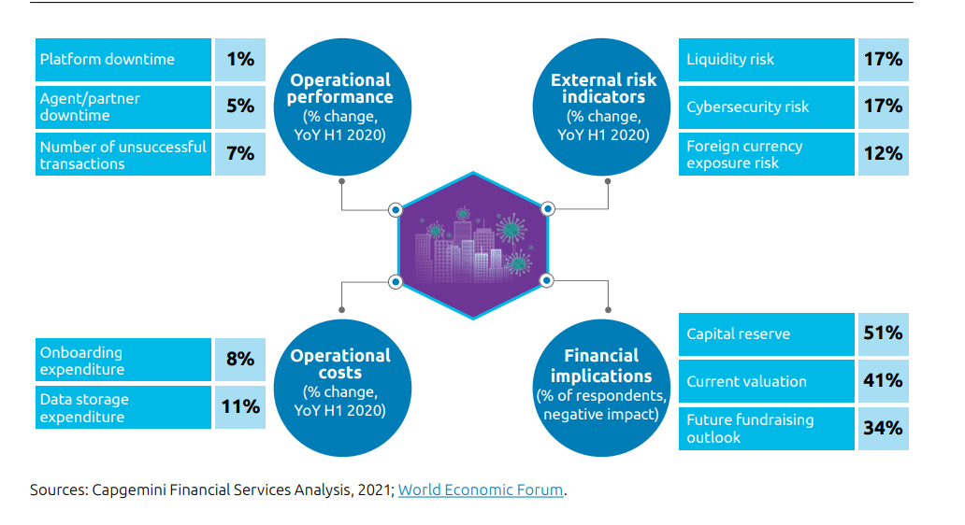

2.

