

Changemakers: Creativity and Value Creation
Professions (BMHP5014)

Student name: Onyemaechi Christian Meregini
Student number: 2413001
Lecturer’s name: Laila Surani

Topic:
Component 1: Online portfolio of set exercises

Date of Submission
15th April 2026

Table of contents
Task 1, Defining Key Concepts in Practice…………………… …..……… 3 - 4
Task 2. Staff Burnout …………………………………….…………..….…….. 5 – 6
Task 3, Gibbs’ Reflective Circle…………………………...………………..… 7 - 8
Task 4, Case Study Analysis …………………………………..……..……… 9- 10
Task 5, Staff Stress and Burnout in Health and Social Care ……………. 11 –12
Task 6, Medical Technology …………………………………………..……… 13 – 14
Task 7, NHS Leadership Framework ………….. ……………………..……. 15 – 17
Task 8, Self-Reflection Journal Entry ……………………………………………….. 18
References ………………………………………………………………………………… 19 - 20

TASK 1
Defining Key Concepts in Practice: innovation, creativity, value creation, and change.:
Innovation, creativity, value creation, and change are key concepts that support effective practice in health and social care. These concepts help professionals respond to complex needs, improve outcomes, and use resources responsibly while maintaining person-centred care.
Innovation refers to the introduction and implementation of new ideas, approaches, or services to improve outcomes. In health and social care, innovation is important because services must respond to increasing demand and complex needs. For example, using assistive technology such as remote monitoring for an older adult with dementia can reduce risks, promote independence, and prevent hospital admissions. This demonstrates how innovative approaches can improve both wellbeing and service efficiency. The Diffusion of Innovations theory explains how new ideas are adopted within organisations and highlights the importance of leadership and collaboration in embedding new practices (Rogers, 2003). Innovation in healthcare has been described as the implementation of new practices intended to improve quality and outcomes (Greenhalgh et al., 2004).
Creativity involves generating new and useful ideas to address challenges in practice. Creativity is important because individuals’ needs often require flexible and personalised solutions rather than standardised services. For example, a practitioner supporting a person living with dementia may develop a personalised daily routine using familiar activities, visual prompts, and music therapy to reduce anxiety and promote engagement. This creative approach supports wellbeing and reduces reliance on restrictive interventions. The strengths-based practice model supports creativity by focusing on individual abilities and resources (Saleebey, 2013). Amabile (1996) defines creativity as producing novel and useful ideas within a specific context.
Value creation refers to achieving improved outcomes while making effective use of resources. This concept is important as health and social care services must balance quality care with financial sustainability. For example, providing reablement following hospital discharge can help a person regain independence in daily activities, reducing the need for long-term care. This improves wellbeing and reduces ongoing costs. The value-based healthcare model emphasises outcomes that matter to individuals relative to cost (Porter, 2010).
Change refers to the process of moving from current practice to improved ways of working. Change is necessary to implement new policies, improve service delivery, and respond to emerging needs. For example, introducing multidisciplinary meetings for complex cases can improve coordination and reduce duplication. Lewin’s change management model highlights the stages of unfreezing, changing, and refreezing to embed sustainable practice (Lewin, 1951).

Week 1 Forum

How Has Innovation Changed The World
by Onyemaechi Christian Meregini - Thursday, 12 February 2026, 10:07 AM
Number of replies: 0
- Innovation has changed the world in many ways, for example, Innovation has improved the standard of living in societies with new ideas to improve health.
- Innovation is creating and teaching people how to maintain healthy life styles in order to enhance their living standards.
- Innovation is teaching people to maintain clean environment to enable them live healthy lives.
(Extract From Group Class Work On Wk1 Forum)

…………………………………………………………………………………………………………

Task 2
Staff Burnout
Staff burnout is a significant problem in health and social care because it affects workforce wellbeing, service delivery, and outcomes for people receiving care. The mind map places staff burnout at the centre and identifies key causes such as high workload, staff shortages, long hours, and limited managerial support. These pressures lead to impacts including reduced quality of care, increased sickness absence, high staff turnover, and risks to service user safety. The solutions identified include improved supervision, flexible working, wellbeing support, and increased staffing. This reflects systems thinking, which recognises that organisational pressures influence individual performance and outcomes across the service (Meadows, 2008). It also links to the Social Determinants of Health, as working conditions and organisational environment affect staff wellbeing and, in turn, quality of care (Marmot, 2010). Addressing burnout therefore improves both workforce sustainability and service user outcomes. See figure 1 below:
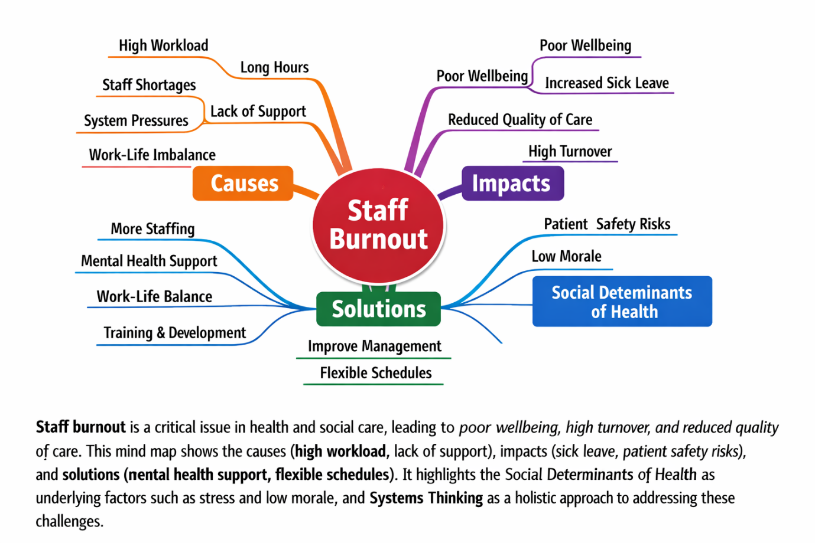
Figure 1: Mind map illustrating causes, impacts and solutions to staff burnout in healthcare (Author’s own, informed by literature).

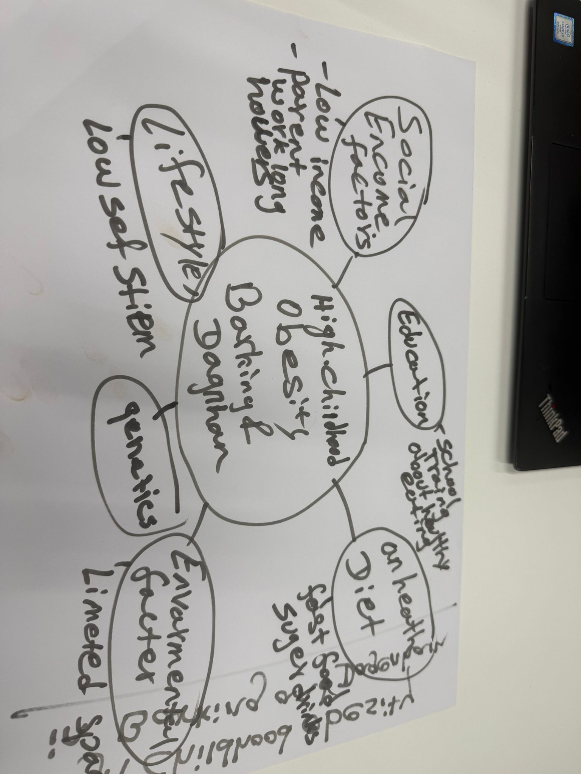
Figure 2, Mind Mapping (Group Class Work On Wk2 Forum)
…………………………………………………………………………………………………………

Task 3
Reflective Model: Gibbs’ Reflective Cycle (1988)
Description:
The convergent and divergent thinking activity involved generating ideas as a group and then narrowing them down to a practical solution. Divergent thinking focused on producing multiple ideas, while convergent thinking involved evaluating and selecting the most appropriate option. Divergent thinking encourages creativity and exploration, whereas convergent thinking focuses on analysis and decision-making (Cropley, 2006).
Feelings:
Initially, I felt more comfortable using convergent thinking, as I tend to focus on practical solutions. However, during the brainstorming stage, I recognised the value of divergent thinking in encouraging creativity and inclusive participation.
Evaluation:
The activity worked well because the group generated a wide range of ideas before agreeing on one solution. This allowed everyone to contribute and prevented premature decision-making. However, I noticed that I moved quickly toward narrowing options, which may have limited further creative input.
Analysis:
Using divergent thinking helped me appreciate different perspectives, while convergent thinking supported structured decision-making. Gibbs’ model emphasises reflection to improve future practice, which helped me recognise my tendency toward solution-focused thinking (Gibbs, 1988).
Conclusion and Action Plan:
I learned that balancing both thinking styles improves teamwork and problem-solving. Next time, I will allow more time for brainstorming, encourage quieter members to contribute, and avoid moving too quickly to decisions.
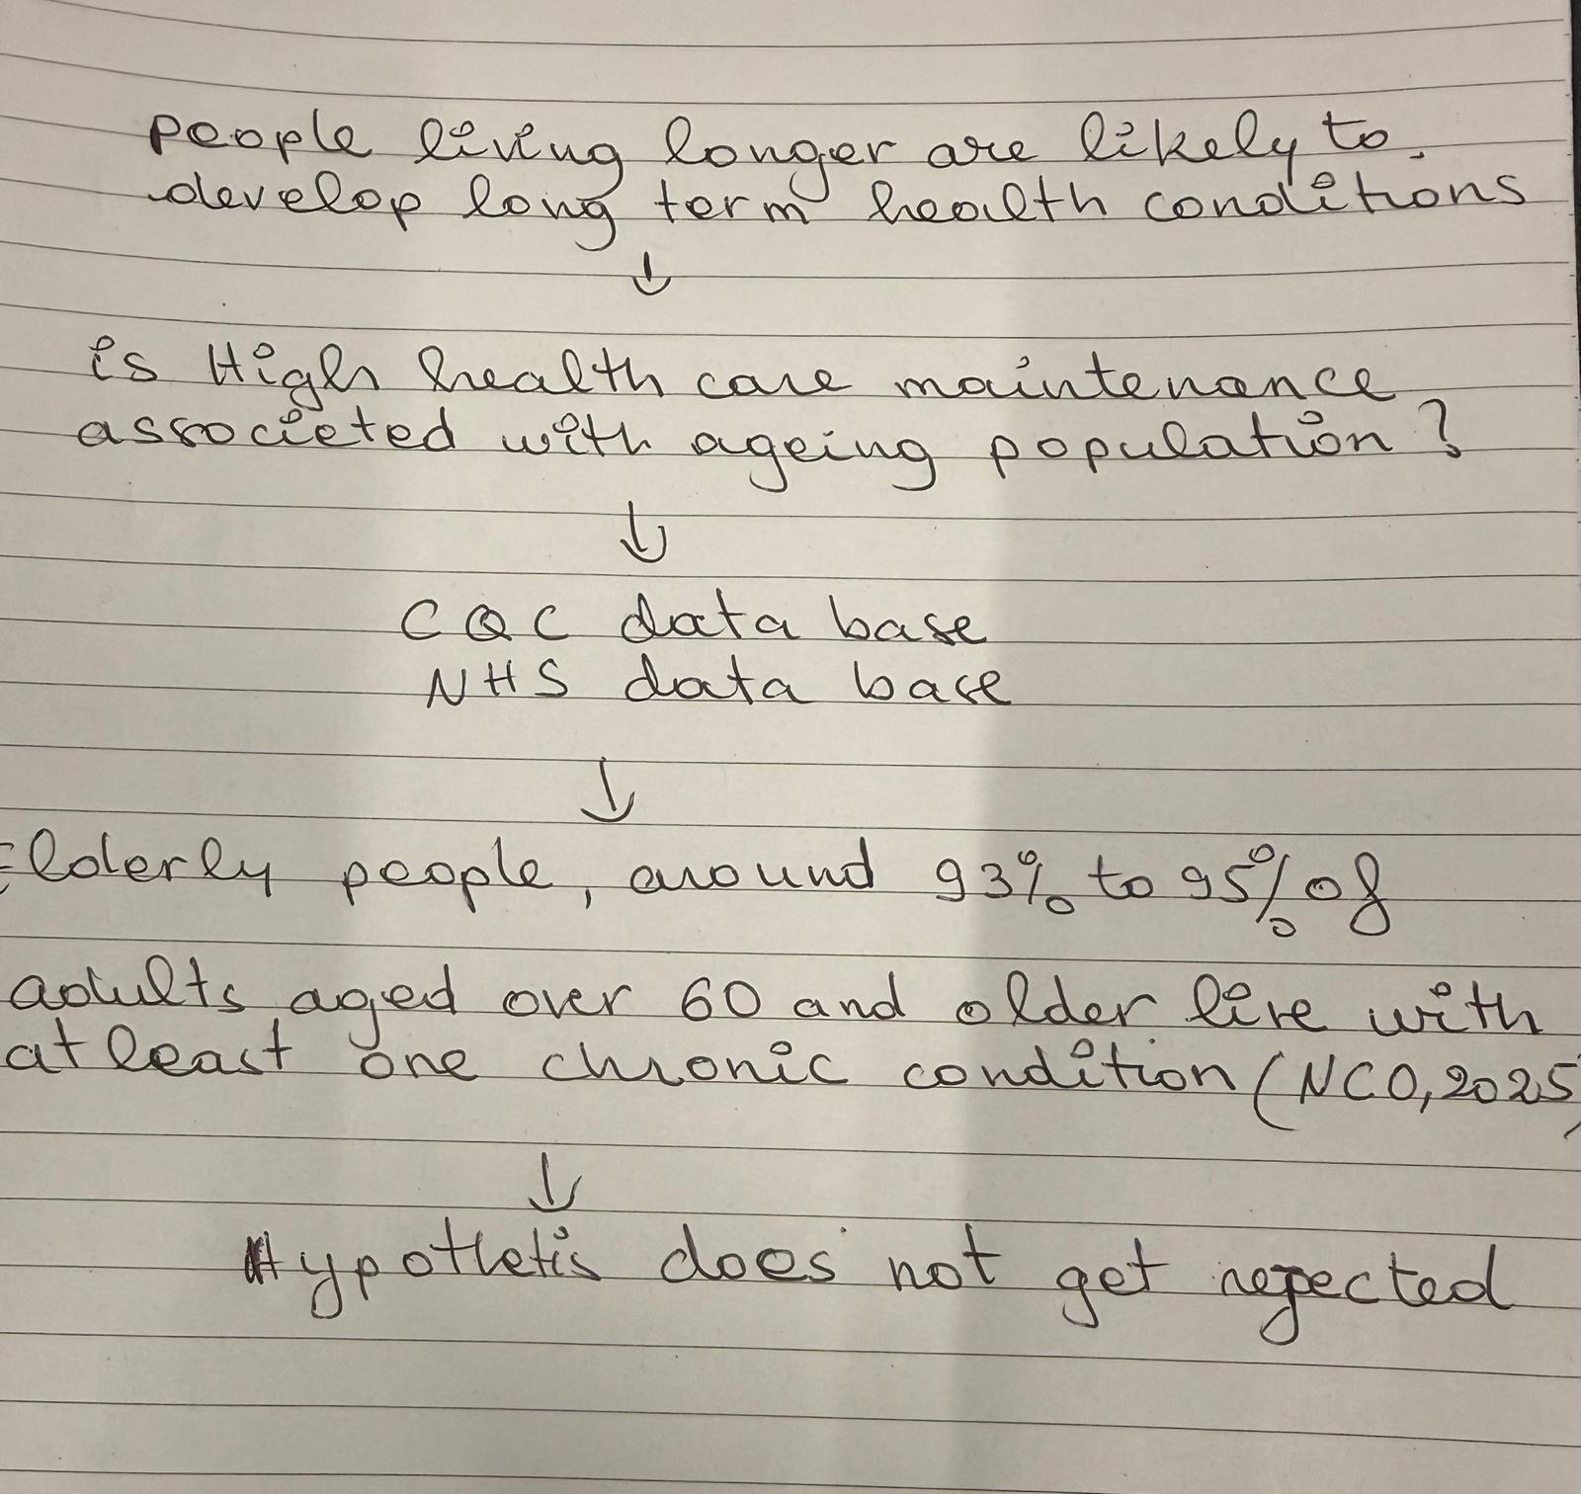
Figure 3, NHS Task on Deductive Reasoning {Group Class Work On Wk3 Forum}

……………………………………………………………………………………………………………

Task 4
Case Study Analysis of a UK Innovation
NHS Virtual Wards were introduced to address increasing hospital demand, long waiting times, and bed shortages. Many patients who were medically stable still required monitoring, which delayed discharge and reduced capacity. Virtual wards allow patients to receive hospital-level care at home through remote monitoring, regular clinical reviews, and multidisciplinary input. This innovation benefits service users by enabling them to remain in familiar surroundings, improving comfort, independence, and recovery. Staff and the wider system benefit through improved patient flow, reduced admissions, and more efficient use of hospital beds (NHS England, 2023).
The approach is creative because it redesigns traditional hospital care using digital technology and integrated working across community and acute teams. Instead of care being limited to physical wards, technology supports observation, communication, and decision-making remotely. This reflects systems thinking, where services are redesigned across organisational boundaries to improve outcomes (Meadows, 2008).
Reported outcomes include reduced hospital admissions, shorter lengths of stay, and improved patient satisfaction. NHS England reports that virtual wards support earlier discharge and help manage demand safely in the community (NHS England, 2023). This model could be used elsewhere, particularly for frailty, respiratory conditions, or post-operative care, demonstrating scalability across health and social care settings.
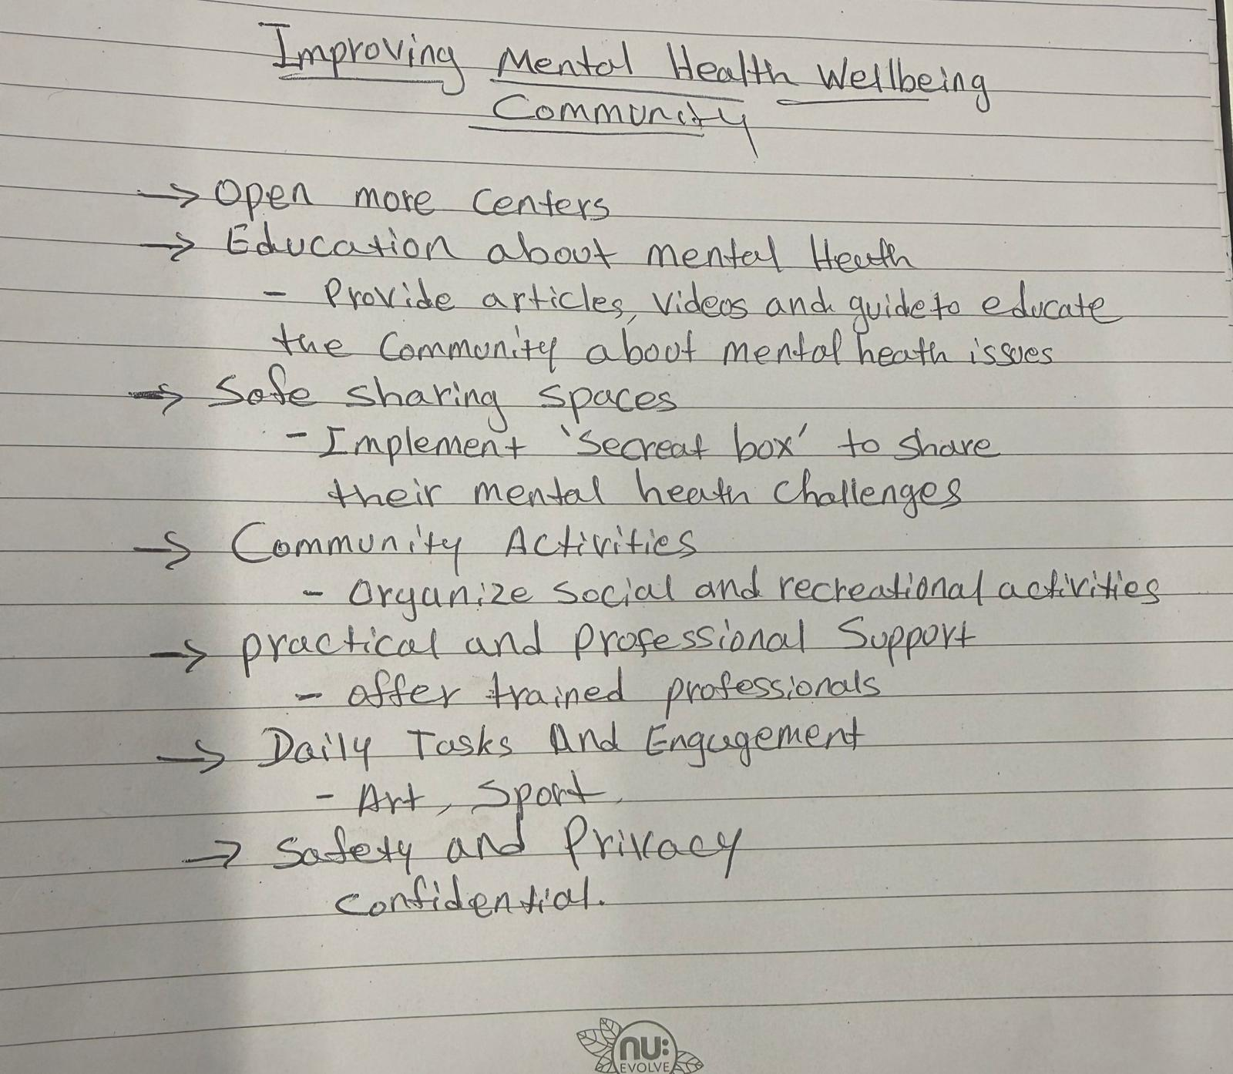
Figure 4, Divergent & Convergent Thinking {Group Class Work On Wk4 Forum}
…………………………………………………………………………………………………………..

Task 5
Current Issue: Staff Stress and Burnout in Health and Social Care
Staff stress is a persistent issue in health and social care, affecting workforce wellbeing and service quality. One study by Schaufeli and Bakker (2004), based on the Job Demands–Resources (JD-R) model, found that burnout develops when job demands such as workload, time pressure, and emotional labour exceed available resources like supervision, autonomy, and team support. The authors suggest that high emotional demands and insufficient organisational support are key causes of stress. This helps explain why practitioners managing complex cases, safeguarding work, and high caseloads often experience emotional exhaustion in day-to-day practice.
Similarly, a study by Maslach and Leiter (2016), grounded in Maslach Burnout Theory, identified workload, lack of control, insufficient reward, breakdown of community, and value conflict as major contributors to burnout. Their research emphasises organisational factors, particularly mismatch between staff values and service pressures. This helps explain stress in care settings where staff feel unable to provide person-centred care due to time constraints or staffing shortages.
Both articles agree that excessive workload and limited support are primary causes of staff stress. However, Schaufeli and Bakker (2004) focus on the balance between demands and resources, while Maslach and Leiter (2016) emphasise organisational culture and value mismatch. In real care settings, this appears as rushed visits, high sickness absence, and reduced time for meaningful engagement with service users. These frameworks help explain how organisational pressures contribute to burnout and highlight the importance of supervision, manageable workloads, and supportive leadership.

Mind map referencing:
Maslach-based burnout research identifies high workload, low staffing, long shifts, low autonomy, and poor leadership as key predictors of burnout in healthcare staff, with outcomes including reduced quality of care and increased errors.
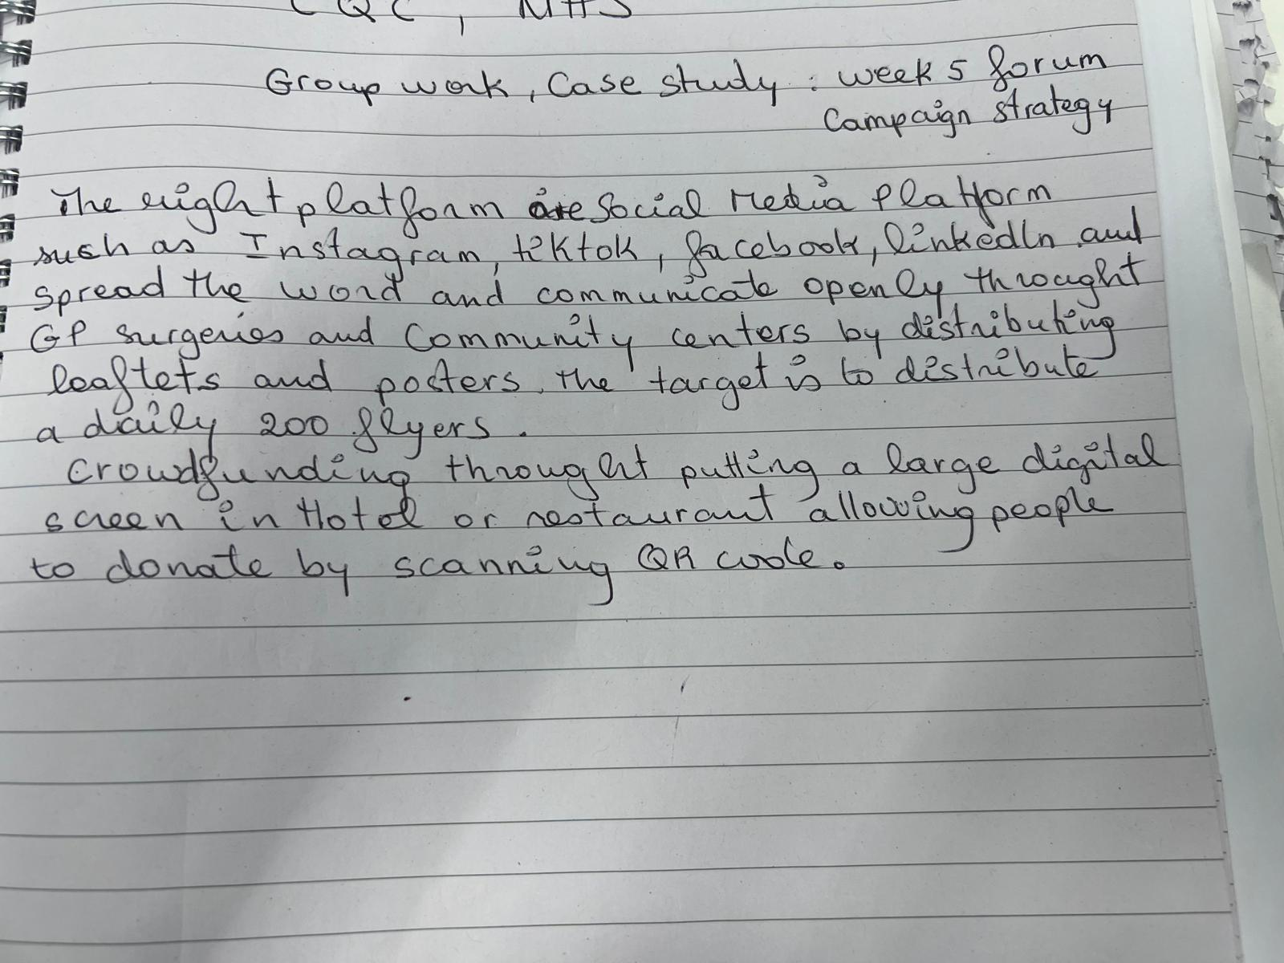
Figure 5 Campaign Strategy {Group Class Work On Wk5 Forum}
……………………………………………………………………………………………………………

Task 6
1) Benefit of wearable health technologies
Wearable health technologies such as smartwatches can support the management of chronic conditions by enabling continuous monitoring of vital signs and early detection of deterioration. For example, individuals with heart conditions can use smartwatches to monitor heart rate and detect irregular rhythms, prompting early intervention. This can reduce hospital admissions and support self-management. The Technology Acceptance Model suggests that individuals are more likely to use wearable devices when they perceive them as useful and easy to use, improving engagement with long-term condition management (Davis, 1989). Research has shown wearable technologies can improve monitoring and encourage behavioural change in chronic disease management (Piwek et al., 2016).
2) Electronic Health Records (EHRs) and communication
Electronic Health Records improve communication by allowing healthcare professionals to access shared, real-time patient information across services. For example, a GP, hospital clinician, and social worker can view medication changes, care plans, and risk information, reducing duplication and errors. This improves coordinated care and decision-making. EHRs enhance multidisciplinary working and reduce fragmented communication. Studies indicate that EHRs improve care coordination and patient safety by facilitating information sharing between providers (Kruse et al., 2017). The Technology Acceptance Model highlights that when systems are perceived as useful and user-friendly, staff are more likely to adopt them effectively (Davis, 1989).
3) Digital technology supporting preventative care
Digital technology supports preventative care by encouraging early intervention and healthy behaviours. For example, a mobile health app that reminds individuals to exercise, monitor blood pressure, and attend screening appointments can reduce risk of cardiovascular disease. In social care, remote monitoring sensors can identify reduced mobility or changes in routine, prompting early support. These tools promote independence and prevent escalation of needs. Digital health interventions have been shown to support prevention and health promotion through behaviour tracking and feedback (WHO, 2019). Adoption of these tools is supported by the Technology Acceptance Model, as perceived usefulness encourages engagement.

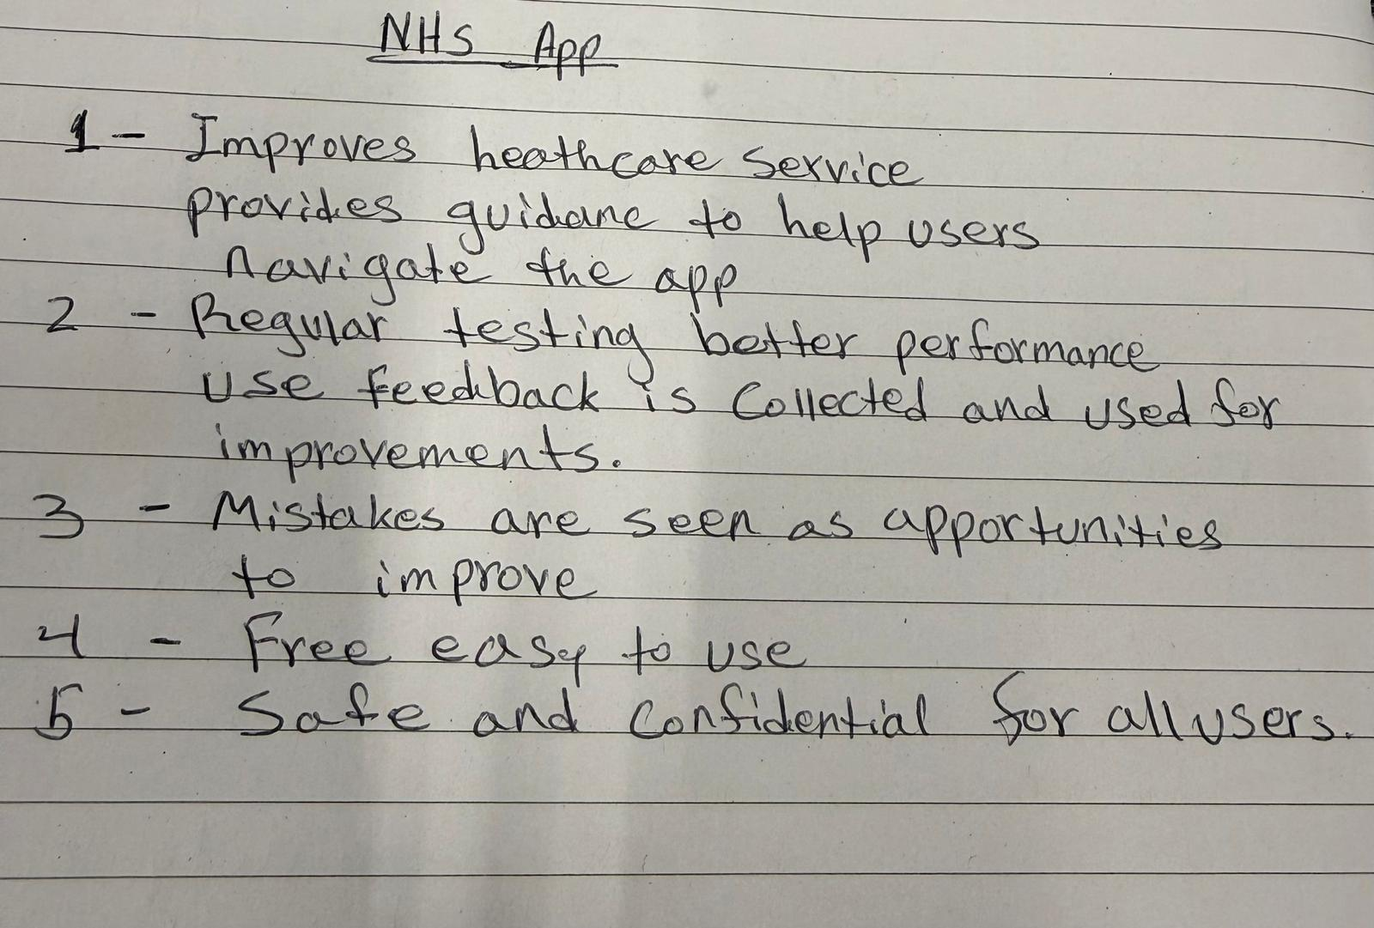
Figure 6, Story on NHS App (Group Class Work On Wk6 Forum)
…………………………………………………………………………………………………………

Task 7

1. NHS Leadership Framework
The NHS Leadership Framework, now reflected in the NHS Healthcare Leadership Model, outlines key behaviours expected of leaders at all levels in health and social care. The framework includes behaviours such as leading with care, sharing the vision, engaging the team, influencing for results, evaluating information, connecting services, and holding to account. These behaviours focus on improving quality of care, supporting staff, and promoting innovation. The framework is important because leadership in health and social care is not limited to management roles; all professionals are expected to demonstrate leadership to improve outcomes and service delivery. Effective leadership supports collaborative working, encourages creativity, and ensures services are responsive to changing needs. The framework also aligns with Transformational Leadership, which emphasises inspiring teams, promoting innovation, and improving practice through shared vision and support (Bass and Avolio, 1994). By applying these behaviours, leaders can improve staff wellbeing, encourage innovation, and enhance service user outcomes (NHS Leadership Academy, 2013).

2. Leadership Behaviour: Leading with Care
Leading with care involves showing empathy, supporting staff wellbeing, and creating a psychologically safe environment. A leader using this behaviour may encourage creativity by allowing staff to share ideas without fear of criticism. For example, a team leader may hold reflective sessions where staff suggest new approaches to reduce delayed discharges. By listening and valuing contributions, staff feel empowered to innovate. This approach reflects Transformational Leadership, where leaders motivate and support teams to improve practice (Bass and Avolio, 1994). Supporting staff wellbeing also improves morale, reduces burnout, and enhances patient care, as staff are more engaged and able to deliver person-centred support.

3. Reflective Journal Entry (Creativity and Value Creation)
During this module, my understanding of creativity and value creation in health and social care has developed significantly. Initially, I viewed creativity as developing entirely new ideas. However, I now recognise that creativity also involves adapting existing services, improving communication, and finding person-centred solutions within limited resources. Activities such as mind mapping, convergent and divergent thinking, and analysing innovations like virtual wards helped me understand how creativity supports problem-solving in practice.
I also learned that value creation focuses on improving outcomes while using resources effectively. This changed my perspective, as I now see that creative approaches such as reablement, digital technology, and strengths-based practice can improve independence while reducing long-term costs. This aligns with transformational leadership, which encourages innovation and supports teams to improve care delivery (Bass and Avolio, 1994).
This learning will shape my future practice by encouraging me to think more creatively, challenge traditional approaches, and focus on outcomes that matter to service users. I will also aim to support team discussions, promote new ideas, and contribute to service improvements that enhance wellbeing and independence.

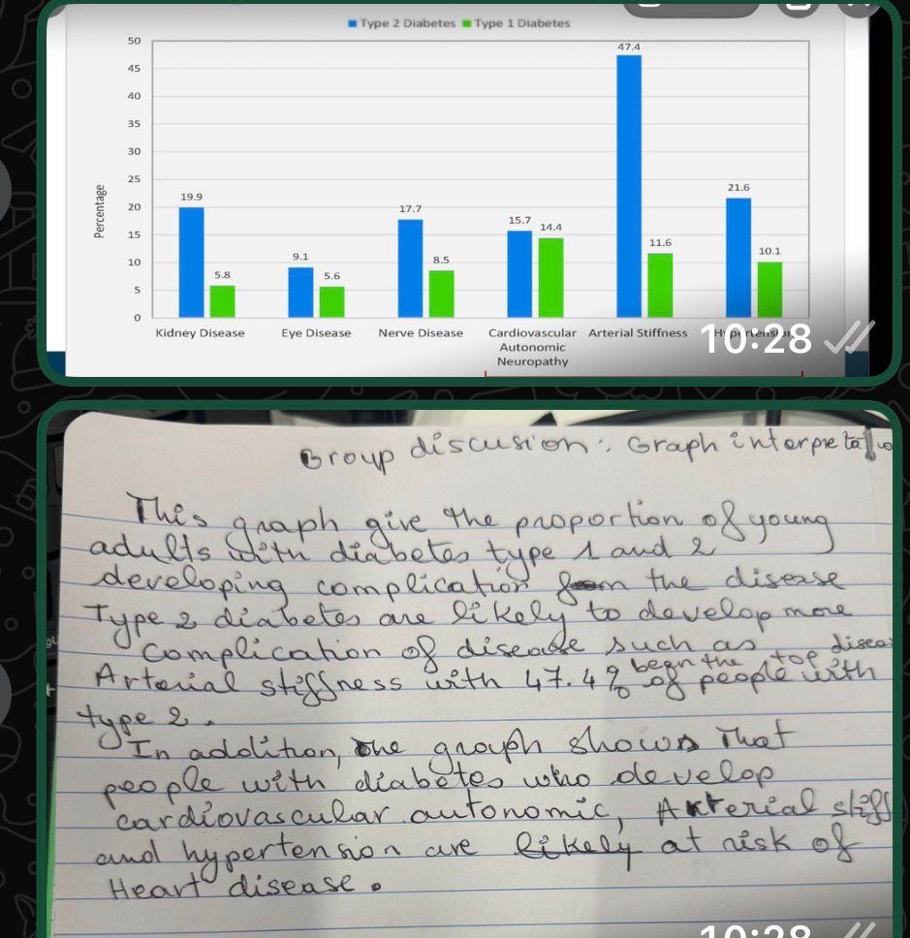
Figure 7, Graph Analysis {Group Class Work On Wk 7 Forum}
……………………………………………………………………………………………………………

Task 8
Self-Reflection Journal Entry (Gibbs’ Reflective Cycle)
Using Gibbs’ reflective model (1988), I reflected on how my understanding of creativity, innovation, and value creation developed during this module. Initially, I viewed innovation as large-scale change driven by management. However, through activities such as the convergent and divergent thinking exercise and analysing digital health innovations, I recognised that creativity also occurs in day-to-day practice through problem-solving and person-centred planning. This shifted my perspective to seeing innovation as small, practical improvements that enhance outcomes.
I learned that value creation involves improving wellbeing while using resources effectively. For example, strengths-based care planning or assistive technology can promote independence and reduce long-term support needs. This aligns with Transformational Leadership, where professionals encourage new ideas to improve practice (Bass and Avolio, 1994).
In future roles, I will apply this learning by encouraging creative problem-solving, exploring preventative options, and focusing on outcomes important to service users. I will also contribute ideas within teams and support innovative approaches that improve independence and quality of care.

WORD COUNT ANALYSIS
The total word count of my paper is within 2200 words, but the references and uploads from our class forum work added extra 688 words.

Reference List
Amabile, T. (1996). Creativity in Context. Boulder: Westview Press.
Greenhalgh, T. et al. (2004) ‘Diffusion of innovations in service organisations’, Milbank Quarterly, 82(4), pp. 581–629.
Lewin, K. (1951) Field Theory in Social Science. New York: Harper & Row.
Porter, M. (2010) ‘What is value in health care?’, New England Journal of Medicine, 363(26), pp. 2477–2481.
Rogers, E. (2003) Diffusion of Innovations. 5th edn. New York: Free Press.
Saleebey, D. (2013) The Strengths Perspective in Social Work Practice. Boston: Pearson.
Marmot, M. (2010) Fair Society, Healthy Lives: The Marmot Review. London: The Marmot Review.
Meadows, D. (2008) Thinking in Systems: A Primer. White River Junction: Chelsea Green Publishing.
Dall’Ora, C. et al. (2020) Burnout in nursing: a theoretical review. Human Resources for Health, 18, pp. 1–17.
BMC Psychology (2024) Workload, job burnout and healthcare quality among nurses. BMC Psychology.
Cropley, A. (2006) ‘In praise of convergent thinking’, Creativity Research Journal, 18(3), pp. 391–404.
Gibbs, G. (1988) Learning by doing: A guide to teaching and learning methods. Oxford: Oxford Polytechnic.
Meadows, D. (2008) Thinking in systems: A primer. White River Junction: Chelsea Green.
NHS England (2023) Virtual wards including hospital at home. London: NHS England.
Maslach, C. and Leiter, M.P. (2016) ‘Understanding the burnout experience: recent research and its implications for psychiatry’, World Psychiatry, 15(2), pp. 103–111.
Schaufeli, W.B. and Bakker, A.B. (2004) ‘Job demands, job resources, and their relationship with burnout and engagement’, Journal of Organizational Behavior, 25(3), pp. 293–315.
Davis, F.D. (1989) ‘Perceived usefulness, perceived ease of use, and user acceptance of information technology’, MIS Quarterly, 13(3), pp. 319–340.
Kruse, C.S., Stein, A., Thomas, H. and Kaur, H. (2017) ‘The use of electronic health records to support population health’, Journal of Medical Systems, 41(11), pp. 1–16.
Piwek, L., Ellis, D.A., Andrews, S. and Joinson, A. (2016) ‘The rise of consumer health wearables’, PLoS Medicine, 13(2), e1001953.
World Health Organization (2019) WHO guideline: recommendations on digital interventions for health system strengthening. Geneva:
Bass, B.M. and Avolio, B.J. (1994) Improving organizational effectiveness through transformational leadership. Thousand Oaks, CA: Sage.
NHS Leadership Academy (2013) The healthcare leadership model. Leeds: NHS Leadership Academy.
Bass, B.M. and Avolio, B.J. (1994) Improving organizational effectiveness through transformational leadership. Thousand Oaks: Sage.
Gibbs, G. (1988) Learning by doing. Oxford: Oxford Polytechnic.
………………………………………………………………………………………………

