John Hughes
1708241

HTML and CSS Web Development Assignment

Internet Technology and Security

ACCA4018

Contents

Introduction

Requirements

Implementation

Evaluation

Usefulness, usability and utility

Search Engine Optimisation

Accessibility

References

Abstract

The purpose of this report is to provide a description of the website created for the assignment, its intended audience and relevance. Screenshots of the finished website are provided as an example of how the website appears.
It also contains screenshots of the validation results using validator.w3.org. All warnings and errors found in the validation are addressed, with the aim of fixing each of them, but errors that are not fixed are explained to the best of the author’s knowledge.
Lastly, the report also contains research on three specific topics of significant importance in the use of html, all research is cited and referenced.

Requirements

The chosen theme of the website is on Swansea City Football Club. Its purpose is intended to provide links to news articles and information on the club’s history and its upcoming season.
It consists of five web pages featuring a home page that features links to news articles, a list of fixtures for the upcoming season, the current players that make up its playing squad, a list of historical achievements and a contact form for fans to get in touch and ask questions about all things Swansea City AFC. The website is aimed at any football fan interested in the club, with particular relevance to Swansea supporters.

Implementation
The home page consists of a nav bar from bootstrap that provides links to the other web pages.. The main section features a Bootstrap carousel with three pictures alternating. It then has three Bootstrap cards below it. Each card provides a link to an external site providing more information on the subject
The next page features a squad list for the current season using a table with Bootstrap classes for the text to be presented clearly and easy to read.
There is also a page featuring the squad list using the same method as the fixture list page using a table with bootstrap classes. The squad lists show the current player lists, their squad numbers and playing position.
The Honours list is also done with the same method and displays a list of the clubs achievements from their highest league position, to all of the tournament wins in the clubs history.
The contacts page invites the user to ask any questions about the subject, Swansea city AFC. This was done using a contact form from bootstrap but it does not function as it isn’t set up with a server.

Screenshots of the completed website are shown below starting with the home page, which needs three pictures to display the majority of the page

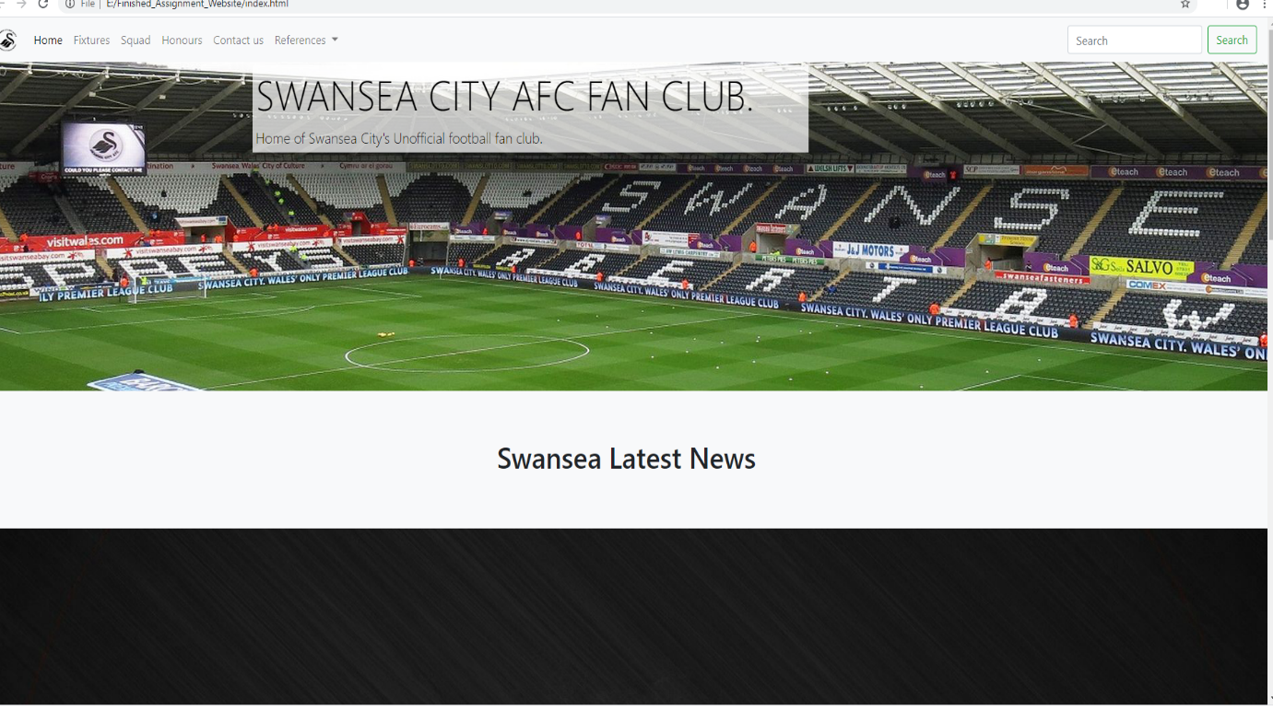

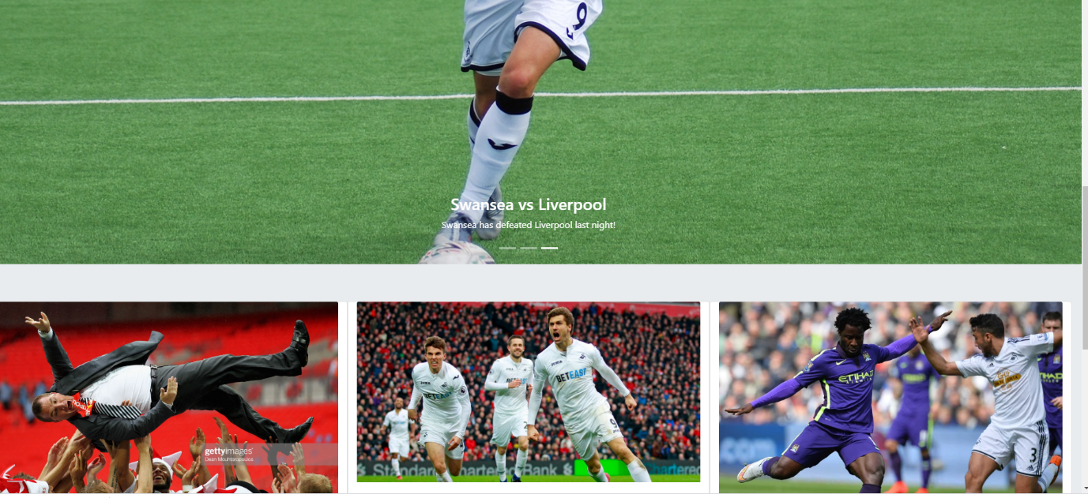
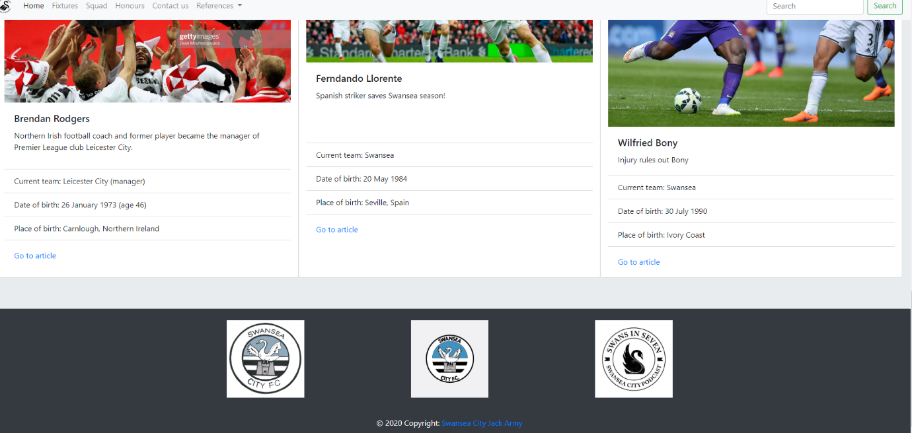

The following screenshots show the fixtures web page;
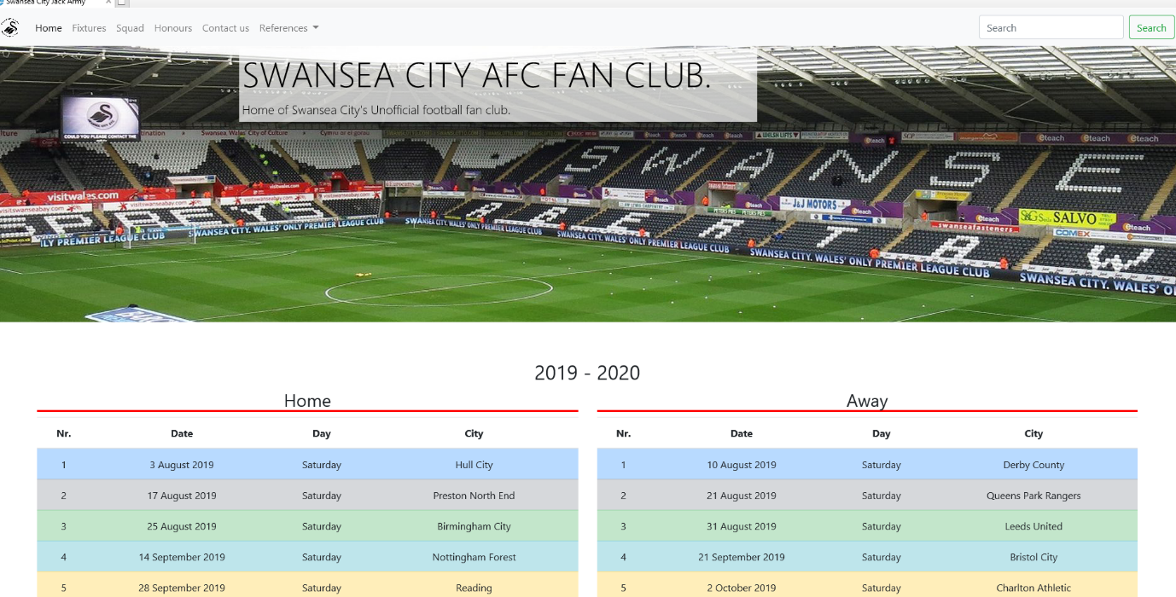

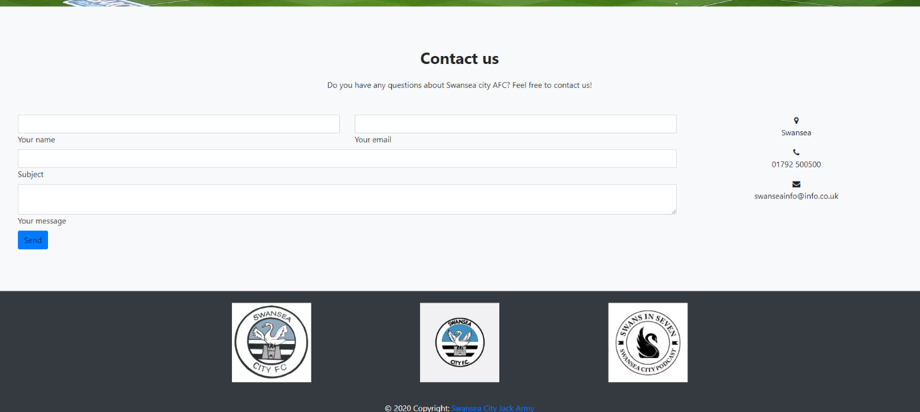

The html was validated using http://validator.w3.org. The screenshots of validation results are shown below;
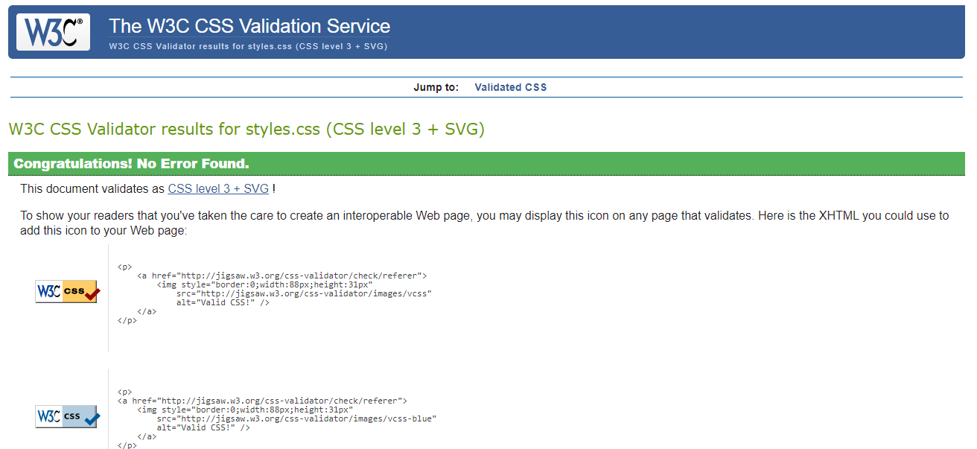
The CSS was validated and shown no errors

The index page was validated with these 6 errors shown below
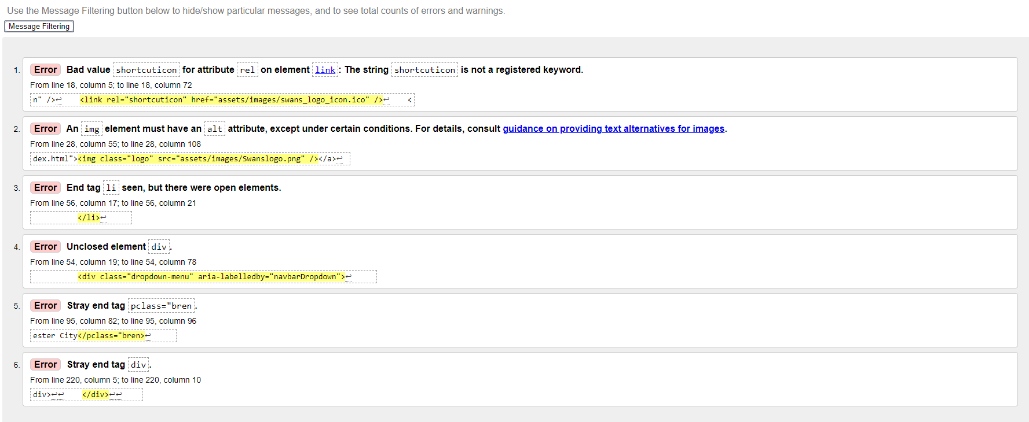

For error no1, a space was required between shortcuticon, at the start of line 18. This fixed the error, a screenshot of the fix is shown below;
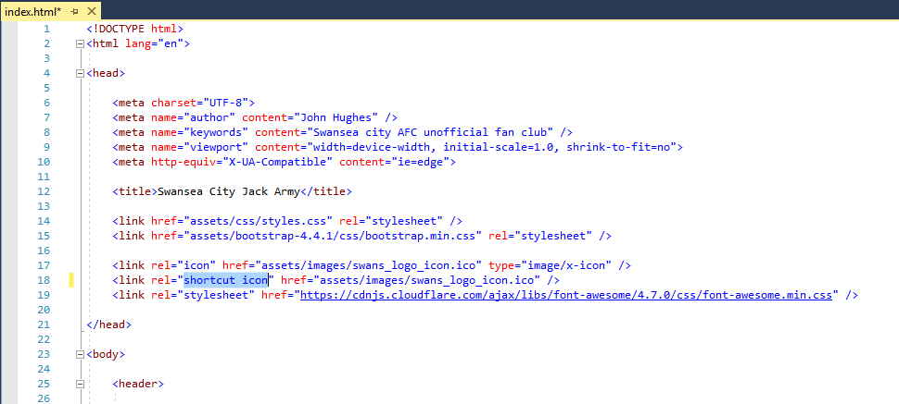

For error 2, an alt element was added at end of line 28, in the form of alt=”myimage” as shown in screenshot below;

For error 3, the missing div element was added after line 55, as shown in screenshot below;
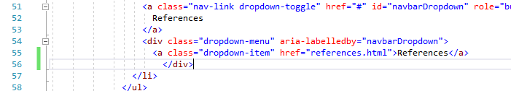

For error 4, a space was added in pclass at the end of line 96, as shown in screenshot below;

Errors 5 did not work out as expected. The pclass error was corrected but then further new errors were somehow surfaced. The new validation came up with a further 5 new errors as shown below;
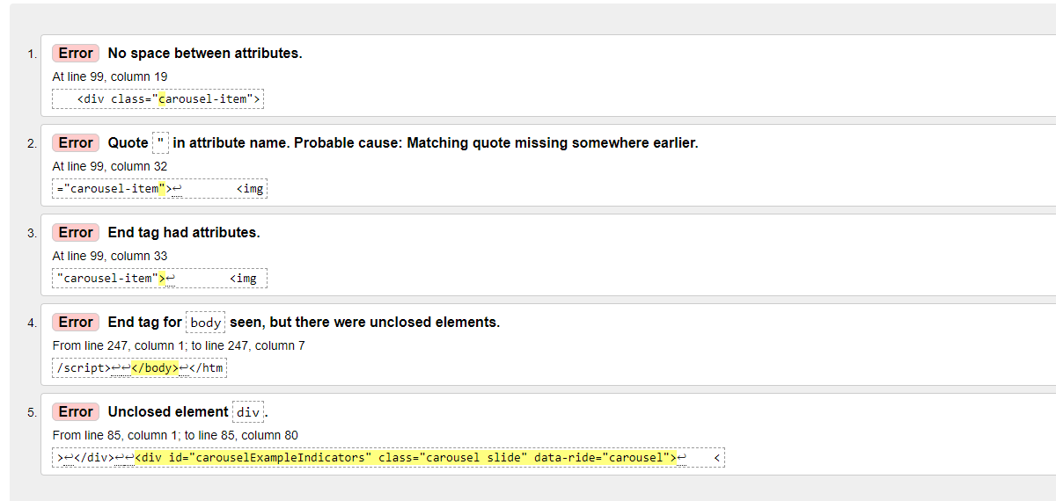
From here, I could not understand why the new errors surfaced. The correction for error five was changed back and left remaining.

Error 6 had a similar outcome also. I tried removing the stray end tag but it did not correct the problem, and created further problems. The final outcome was with 2 errors outstanding as shown in the screenshot below
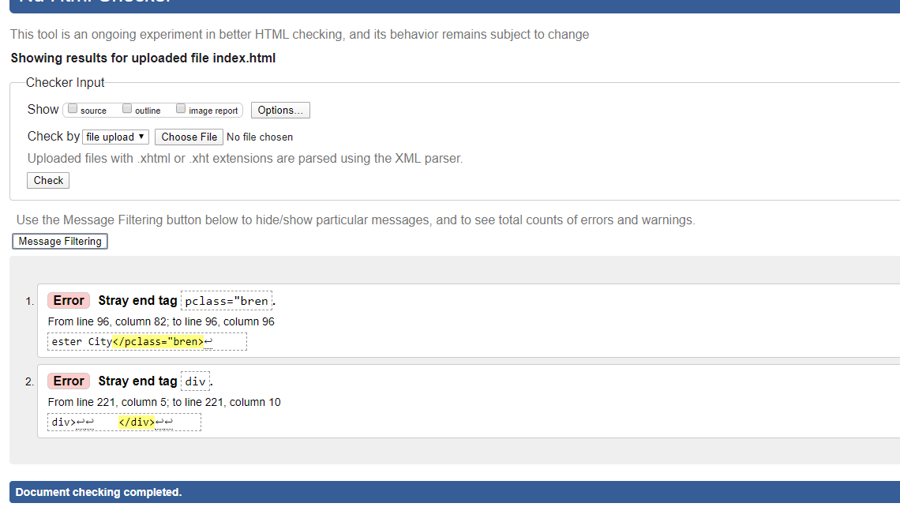

Evaluation

4.1 Usefulness, usability and utility

According to Jakob Nielson, websites should follow ten general principles for good usability, called heuristics. These are listed on his web document as follows [1];
- “Visibility of system status - The system should always keep users informed about what is going on, through appropriate feedback within reasonable time.” [1]

- “Match between system and the real world – The system should speak the users' language, with words, phrases and concepts familiar to the user, rather than system-oriented terms. Follow real-world conventions, making information appear in a natural and logical order.” [1]

- “User Control and Freedom – Users often choose system functions by mistake and will need a clearly marked "emergency exit" to leave the unwanted state without having to go through an extended dialogue. Support undo and redo.” [1]

- “Consistency and Standards – Users should not have to wonder whether different words, situations, or actions mean the same thing. “ [1]

- “Error Prevention – Even better than good error messages is a careful design which prevents a problem from occurring in the first place. Either eliminate error-prone conditions or check for them and present users with a confirmation option before they commit to the action.” [1]

- “Recognition Rather Than Recall – Minimize the user's memory load by making objects, actions, and options visible. The user should not have to remember information from one part of the dialogue to another. Instructions for use of the system should be visible or easily retrievable whenever appropriate.” [1]

- “Flexibility and efficiency of use – Accelerators — unseen by the novice user — may often speed up the interaction for the expert user such that the system can cater to both inexperienced and experienced users. Allow users to tailor frequent actions.” [1]

- “Aesthetic and minimalist design – Dialogues should not contain information which is irrelevant or rarely needed. Every extra unit of information in a dialogue competes with the relevant units of information and diminishes their relative visibility.” [1]

- “Help users recognize, diagnose, and recover from errors – Error Messages should be expressed in plain language (no codes), precisely indicate the problem, and constructively suggest a solution.” [1]

- “Help and documentation - Even though it is better if the system can be used without documentation, it may be necessary to provide help and documentation. Any such information should be easy to search, focused on the user's task, list concrete steps to be carried out, and not be too large.” [1]
The website has good usability features and has responsiveness for mobile, tablet and laptop compatibility. It has consistency with clear and concise text. All pages are linked and function as expected

4.2 Search Engine Optimisation

Vangie Beel states that Search engine optimisation (SEO) is a practice used in web development that intends to increase the amount of traffic to a website. Its main aim is to achieve a high-ranking placement in search engines that results in it being placed as near to the top of a search page as possible [2].
According to Michael R. Baye, Babur De Los Santos and Matthijs R. Wildenbeest, there are two types of search results, organic and sponsored. Organic search means results that are found from searching the kewords. Sponsored results would mean that you have to pay to have your website near the top of the results. This can be effective for gaining traffic but, with the use of SEO, organic search results can be even more successful [3].

The website has SEO features such as meta tags used in the head section. Such tags include author, website title and keyword phrases. It also features alt attribute to improve high-ranking placement

Accessibility

As stated in Jim Thatcher’s book, Web Accessibility: Web Standards and Regulatory Compliance, It is important that the web is accessible to all users, without discriminating against users with disability. Therefore WCAG was designed to conform to International Standards Organisation (ISO) [4]
According to Thatcher, WCAG 2.1 ( Web Content Accessibility Guidelines) is a recommendation (June 2018) for becoming the lastest ISO standard
His book explains the four main principles as follows [4];

- Perceivable – The information intended for the user must be presentable and processable, making it easy to perceive. Information that is not formatted in this manner must not be accessible

- Operable – The interface must function in a proper manner. All interactions should work correctly with features and interactions working as intended

- Understandable – All information on the interface should be easy to understand. This should be achieved with consistency across the entire site. Text should be clear and consistent. The expectation of an action or function should be obvious and reliable.

- Robust – Websites should meet the reasonable expectation of the user. In modern terms, the site should be fluid, meaning it is supported on a number of commonly used platforms, tablet, mobile etc.
The website is perceivable to the user with all information presentable and easy to ready. It is operable with all pages linked. All information is clear and easy to understand. The tables were time consuming in adding lots of text but resulted in clear and concise information. Unfortunately, the squad and fixtures information would need updating at the end of each season which could be quite time consuming again, especially the fixtures which would need rewriting entirely. This is no problem to the users, who only see the information in a presentable manner and understandable. The website is robust, it is supported on a number of platforms including Chrome, Internet Explorer and Firefox. It is also fluid and compatible on a number of devices with varying screen sizes.

References

References

[1] | J. Nielson, “10 Usability Heuristics for User Interface Design,” 24th April 1994. [Online]. Available: https://www.nngroup.com/articles/ten-usability-heuristics/. [Accessed 6th January 2020].
[2] | V. Beel, “SEO - search engine optimization,” [Online]. Available: https://www.webopedia.com/TERM/S/SEO.html. [Accessed 7th December 2020].
[3] | B. D. L. M. R. W. Michael R. Baye, “Search Ebngine Optimisation: What Drives Organic Traffic To Retail Sites,” Journal of Economics andManagemnet Strategy, vol. 25, no. 1, pp. 6-31, Spring 2016.
[4] | J. Thatcher, Web Accessibility: Web Standards and Regulatory Compliance, Chicago: Berkeley, 2006.

marking criteria and Student FEEDBACK

This section details the extent to which the assessment criteria are demonstrated by you, which in turn determines your mark. The marks available for each category of skill are shown. Lecturers will use the space provided to comment on the achievement of the task(s), including those areas in which you have performed well and areas that would benefit from development/improvement.

Common Assessment Criteria Applied (Assignment 1) | Marks available | Marks  awarded
1. Engagement with Literature Skills

Demonstrates good introduction of the concepts but there is an over-reliance on reference source material and the supporting related research is missing. Please note that you are required to use reference sources to help you write about research topics in your own words and not just copy and paste from the reference sources as also evidenced by your high Turnitin score. Please note that the University considers this to be an academic misconduct, known as over-reliance on reference materials, see more here: https://www.uwtsd.ac.uk/media/uwtsd-website/content-assets/documents/academic-office/aqh-chapters/chapters---en/Academic-Misconduct-Policy.pdf. (Grade mark: 52.00%) | 25 | 13
2. Knowledge and Understanding Skills

Demonstrates a fair understanding of the standards used to design and implement a website, but you were not really able to interpret or fix the validation errors. Generally, aim to improve your understanding of some of the basic concepts e.g. learn how to properly nest and close tags and how to properly enclose attribute values in quotation marks. A good evaluation of the website based on the specified criteria has been provided, but I would have liked to see further evidence of tools used to support the evaluation of your website according to the three concepts. (Grade mark: 50.00%) | 20 | 10
3. Cognitive and Intellectual Skills

4. Practical Application Skills

A good attempt featuring a simple website with well-thought-out content. There is, however, room for improvement. Aim to improve your use of the CSS grid system to achieve better page layouts that are also responsive. Although you have attempted to use the grid classes, you have not really used these correctly. Some other things to note: make sure your tags are properly nested and closed and attributes are properly enclosed in quotation (speech) marks. On the home page in particular, improve the display and positioning of the "Above the fold" content - see your report for more information. Remember to add an alt attribute to all your images for accessibility. Use alternative text descriptions that are meaningful and help users who are unable to view the images to have some understanding of what they are displaying. (Grade mark: 64.00%) | 50 | 32
5. Transferable Skills for Life and Professional Practice

The report is of a good standard. See your report for additional suggested improvements. Please see comments above under engagement with literature skills. (Grade mark: 60.00%) | 5 | 3

Assignment Mark (Assessment marks are subject to ratification at the Exam Board. These comments and marks are to give feedback on module work and are for guidance only until they are confirmed. ) | Late Submission Penalties (tick if appropriate) |  | 58%
 | Up to 1 week late (40% Max) |  | 58%
 | Over 1 week late (0%) |  | 58%

