The Impact of Heart Disease on Public Health in the United Kingdom

Student Name: Sasha Mohammed
Student Number: 2429698
Module Code and Title: LCHS4008- Introduction to Public Health
Lecturer: Christopher Mafuva
Assignment: Assessment 2 – Report on a Health Issue

Contents
Introduction 3
Community Impacts of Cardiovascular Disease 4
Determinants That Influence Health and Quality of Life 5
Enhancing Health and Social Care Collaboration 6
Conclusion 7
References 9

Introduction
Cardiovascular disease (CVD), often known as heart disease, encompasses a range of conditions that affect the heart and blood vessels. Common examples include coronary artery disease, heart rhythm abnormalities, congenital heart defects, and heart failure. Among these, coronary heart disease (CHD) is the most common and usually develops when arteries become narrowed or blocked due to plaque accumulation (British Heart Foundation, 2023).
Cardiovascular disease remains the primary contributor to global mortality, accounting for millions of deaths annually. Globally, CVD is responsible for around 17.9 million deaths each year—approximately 31% of all global fatalities (World Health Organization, 2023). In the United Kingdom, heart and circulatory diseases are responsible for roughly 160,000 deaths annually, equivalent to one in four deaths (British Heart Foundation, 2023). In addition to mortality, cardiovascular disease affects around 7.6 million people living with heart and circulatory conditions in the UK, contributing to long-term illness and reduced quality of life (British Heart Foundation, 2023). Hypertension, a major risk factor for CVD, affects approximately one in four adults in England (NHS, 2023).
Rates of premature cardiovascular death are significantly higher in deprived areas, reflecting persistent health inequalities across the UK (Marmot et al., 2020). People from lower socioeconomic backgrounds often experience delayed diagnosis, reduced access to preventative care, and poorer health outcomes. These disparities highlight the need for targeted public health strategies that address both clinical and social determinants of health.
The NHS Long-term Plan prioritises early detection, lifestyle interventions, and community engagement to reduce the burden of cardiovascular disease (NHS England, 2019). Public health frameworks such as the Ottawa Charter emphasise equity, empowerment, and supportive environments as key to tackling preventable health issues (World Health Organization, 1986).
This report draws on secondary data from credible UK and international sources, such as NHS, NICE, and WHO, to explore the wider effects of cardiovascular disease and evaluate collaborative approaches in public health practice. CVD is not only a clinical challenge but also a test of how well the UK addresses preventable diseases through policy and community action (Marmot et al., 2020).

Community Impacts of Cardiovascular Disease
Cardiovascular disease (CVD) continues to exert a profound influence on healthcare systems, communities, and families across the United Kingdom. The overall economic burden is substantial, with estimates suggesting that heart and circulatory diseases cost the UK economy approximately £9 billion annually. This figure includes hospital admissions, prescription medication, productivity losses, and premature mortality linked to cardiovascular complications (Public Health England, 2020). As the population ages and lifestyles change, the National Health Service (NHS) faces increasing pressure to provide long-term treatment, surgical interventions, and ongoing monitoring for patients living with CVD.
Beyond the financial strain, the condition has far-reaching social consequences. Individuals diagnosed with CVD often experience reduced independence, limited ability to work, and diminished quality of life. Family members and carers frequently assume unpaid caregiving responsibilities, which can negatively affect their mental health, financial stability, and career prospects. These ripple effects highlight that cardiovascular disease is not simply a medical issue but a social challenge that reshapes household dynamics and community wellbeing.
The burden of CVD is not evenly distributed. Research demonstrates that people from South Asian and Black African backgrounds are at greater risk due to higher prevalence of type 2 diabetes and hypertension within these groups (NHS, 2023). Similarly, residents of deprived communities face disproportionate challenges, including limited access to healthcare services, reduced health literacy, and barriers to maintaining consistent treatment. These inequalities deepen cycles of disadvantage, reinforcing poor health outcomes and widening gaps in life expectancy (Marmot et al., 2020).
At the community level, the emotional impact of CVD is significant. Families often report heightened stress, anxiety, and grief when dealing with chronic illness or premature death. Carers may struggle with isolation and burnout, particularly when support networks are weak. These psychosocial effects contribute to broader public health concerns, as communities with high rates of CVD often experience reduced social cohesion and increased demand for mental health services (The Health Foundation, 2023).
National initiatives have been introduced to mitigate these impacts. The NHS Health Check Programme aims to identify individuals at risk of developing CVD and encourage healthier lifestyles through early intervention. Campaigns such as Change4Life promote dietary improvements and physical activity, while local authorities invest in community-based programmes to support prevention. However, despite these efforts, inequalities persist. People in rural or disadvantaged areas may encounter barriers to accessing services, understanding medical advice, or sustaining long-term lifestyle changes, which undermines the effectiveness of national strategies (The King’s Fund, 2023).
Overall, the community impacts of cardiovascular disease extend well beyond the individual patient. The condition imposes economic costs, reshapes family roles, and reinforces health inequalities across society. Addressing these challenges requires not only medical treatment but also comprehensive public health approaches that prioritise equity, prevention, and community engagement.

Determinants That Influence Health and Quality of Life
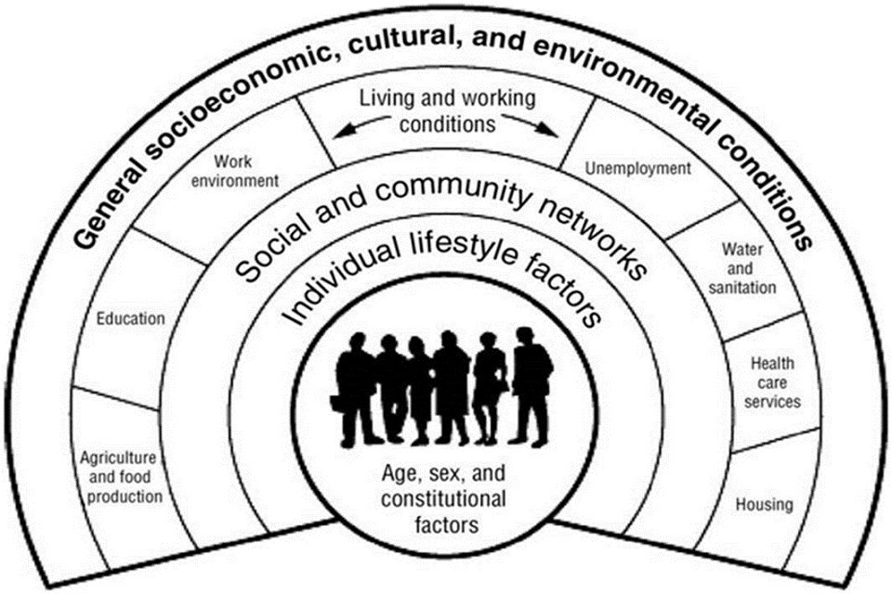
A range of interrelated factors influence the development and progression of cardiovascular disease (CVD), shaping how the condition affects individuals, families, and local communities (as illustrated in Figure 1, adapted from Dahlgren and Whitehead, 1991).

Figure 1: The Dahlgren and Whitehead (1991) model of the social determinants of health (adapted from Dahlgren and Whitehead, 1991).

Obesity and poor nutrition
Excess body weight is a major contributor to cardiovascular disease because it raises blood pressure, disrupts glucose regulation, and elevates cholesterol levels, all of which heighten the likelihood of coronary heart disease and stroke. Diets rich in saturated fats, refined sugars, and salt accelerate these metabolic risks. In the United Kingdom, approximately 26% of adults are classified as obese (NHS, 2023), compared with a global prevalence of around 13% (World Health Organization, 2023). Communities with lower socioeconomic status often face restricted access to affordable, nutritious food, which intensifies health inequalities (Marmot et al., 2020).
Insufficient physical activity
A sedentary lifestyle undermines cardiovascular fitness, contributes to weight gain, and increases the risk of hypertension. Over time, these factors combine to raise the probability of premature cardiovascular mortality. Data show that about one‑third of UK adults do not meet recommended activity levels (Public Health England, 2020), while worldwide, one in four adults is insufficiently active (World Health Organization, 2023). Barriers such as unsafe neighbourhoods, limited green spaces, and financial constraints reduce opportunities for exercise, particularly in deprived areas (The Health Foundation, 2023). These risk factors highlight the need for coordinated interventions, which are explored in the following section on collaboration

Enhancing Health and Social Care Collaboration

Effective collaboration between government agencies, healthcare providers, and community organisations is essential in reducing the burden of cardiovascular disease (CVD). Tackling obesity and poor diet has been a major priority, with fiscal and educational interventions introduced to shift population behaviour. The Soft Drinks Industry Levy, commonly known as the “Sugar Tax,” has encouraged manufacturers to reformulate products, resulting in a significant reduction in sugar content across many beverages (Public Health England, 2020). While this policy demonstrates how government regulation can influence industry practices, its impact has been uneven, with consumption patterns remaining higher among deprived groups. This highlights the need for complementary strategies that address affordability and accessibility of healthier options.
National campaigns such as Change4Life have sought to promote healthier eating and physical activity among families. These initiatives use mass media, school-based programmes, and community engagement to encourage lifestyle changes. However, evaluations suggest that while awareness has increased, sustained behavioural change is limited, particularly in communities facing socioeconomic barriers (NHS England, 2019). This illustrates the importance of tailoring interventions to local contexts and ensuring that resources are equitably distributed.
Collaboration also extends to promoting physical activity. Local authorities have invested in active travel schemes, including cycling infrastructure and pedestrian-friendly urban design, to embed exercise into daily routines. These initiatives align with the NHS Long-term Plan, which emphasises prevention and community-level health promotion (NHS England, 2019). Yet uptake varies, with rural areas and disadvantaged communities often lacking safe or accessible facilities. This demonstrates the need for cross-sector partnerships that integrate transport, housing, and public health planning.
Healthcare providers play a crucial role through cardiac rehabilitation programmes, which combine supervised exercise, dietary guidance, and psychological support. Evidence shows these programmes reduce hospital readmissions and empower patients to manage their recovery (British Heart Foundation, 2023). Collaboration between hospitals, primary care, and voluntary organisations ensures continuity of care, but access remains inconsistent, with some regions reporting limited provision.
Overall, collaboration in addressing CVD demonstrates both successes and challenges. Policies such as the Sugar Tax and Change4Life show the potential of national initiatives, while local schemes and rehabilitation programmes highlight the importance of community-level action. To maximise impact, partnerships must prioritise equity, ensuring that interventions reach those most at risk and reduce health inequalities rather than reinforce them.

Conclusion
Cardiovascular disease (CVD) continues to represent a major challenge to public health in the United Kingdom, contributing substantially to illness, disability, and early death. Although many cases are preventable through lifestyle modification, the condition persists due to a mix of behavioural, social, and biological factors.
This report focused on two principal determinants—obesity/poor nutrition and insufficient physical activity—and evaluated targeted interventions addressing these risks within UK public health practice.
The far-reaching effects of CVD extend beyond the patient, impacting families, communities, and the healthcare infrastructure. Effective collaboration between health and social care professionals is essential to delivering responsive, inclusive, and person-focused care. Integrating digital tools, education, and community engagement fosters improved health outcomes and greater patient empowerment.
Public health strategies should continue to emphasise prevention, early detection, and the reduction of inequalities. This aligns with the social model of health set out in the Ottawa Charter (World Health Organization, 1986), highlighting equity, empowerment, and supportive environments as vital components of sustainable wellbeing.
Ultimately, achieving long-term progress in cardiovascular health depends on sustained investment, stronger community partnerships, and continuous evaluation of prevention programmes. Without such commitment, current gains risk being undermined by persistent inequalities, making equity the decisive factor in building a resilient and inclusive health system for future generations.

References

- Dahlgren, G. and Whitehead, M. (1991) Policies and strategies to promote social equity in health. Stockholm: Institute for Futures Studies.

- Marmot, M., Allen, J., Boyce, T., Goldblatt, P. and Morrison, J. (2020) Health equity in England: The Marmot Review 10 years on. London: Institute of Health Equity.
- National Health Service (NHS) (2023) Cardiovascular disease prevention. London: NHS.
- NHS England (2019) The NHS Long Term Plan. London: NHS England.
- National Institute for Health and Care Excellence (NICE) (2020) Cardiac rehabilitation and secondary prevention. London: NICE.
- Public Health England (2020) Cardiovascular disease prevention: Overview. London: Public Health England.
- The Health Foundation (2023) Tackling the causes of poor health. London: The Health Foundation.
- The King’s Fund (2023) Working together to improve cardiovascular care. London: The King’s Fund.
- World Health Organization (1986) Ottawa Charter for Health Promotion. Geneva: World Health Organization.
- World Health Organization (2023) Cardiovascular diseases (CVDs). Geneva: World Health Organization.

