Unit name: Strategic Management and Sustainability

Module code: BMBM6015
Google Strategic Analysis and Sustainable Strategy Development Report
Prepared for: Robyn Griffiths
Written by: Jincheng Wang
Student ID: 2409058
Date submitted: 21 March 2025

A 2000-word report submitted in fulfilment of the requirements for Course BMBM6008, global ethics, University of Wales Trinity Saint David

Executive Summary
This report critically analyses the strategic position of Google, evaluating its external and internal environments, formulating competitive strategies, and providing recommendations for sustainable growth. Google operates in the highly competitive technology industry, facing challenges such as market saturation, regulatory scrutiny, and increasing environmental expectations. The report applies PESTEL and Porter’s Five Forces for external analysis, Resource-Based View (RBV) and Value Chain Analysis for internal analysis, and explores strategic positioning using Porter’s Generic Strategies. Recommendations focus on sustainability, ethical considerations, and long-term growth.

Contents
Executive Summary 2
1. Introduction 4
2.1 PESTEL Analysis 6
2.2 Key Economic Trends 8
3. Internal Analysis of Google 9
3.1 Resource-Based View (RBV) of Google 9
3.2 Value Chain Analysis of Google 10
3.3 SWOT Analysis of Google 10
4. Strategy Formulation & Competitive Positioning 11
5. Sustainability & Strategic Recommendations 12
5.1 Sustainability Initiatives 12
5.2 Strategic Recommendations 13
6. Conclusion 14
Reference List 15

1. Introduction
Google, a subsidiary of Alphabet Inc., is one of the world’s leading technology companies, renowned for its search engine, cloud computing, artificial intelligence (AI), and digital advertising services. Since its inception in 1998, Google has expanded its operations globally, offering a wide range of products such as Google Search, Android, YouTube, and Google Cloud. The company’s strategic significance stems from its dominance in the digital economy and its role as a key player in shaping global technological trends.
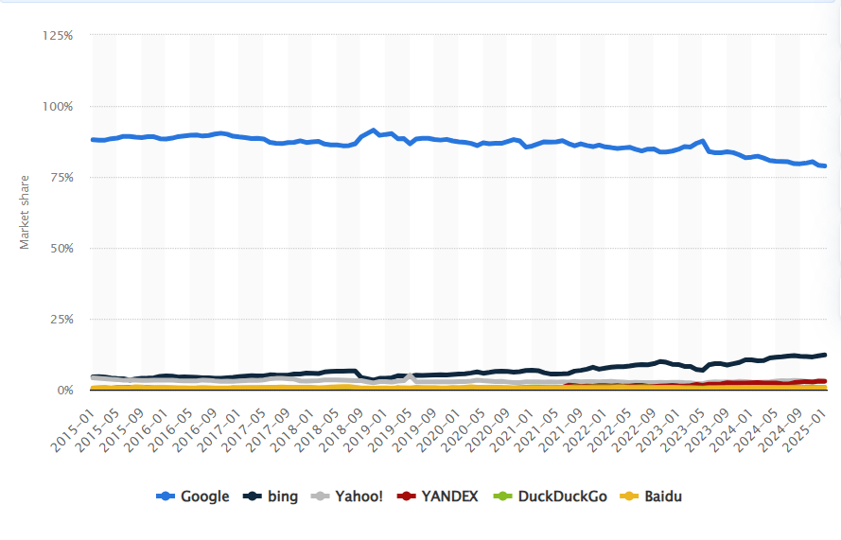
Figure 1: Market share of leading desktop search engines worldwide from January 2015 to January 2025
Source: Statista (2025)
Damola and Kean (2025) in their report they mention that strategic analysis of Google is essential due to its influence on global markets, data-driven business models, and the increasing scrutiny regarding its market power, data privacy practices, and sustainability initiatives. Daniel, Michael and Victoria mentioned (2022) in their study that the firm operates in a highly competitive and rapidly evolving industry, making continuous strategic adaptation crucial for long-term success.
Billy's (2024) article in Time Weekly mentions that Google faces multiple economic and strategic challenges. Regulatory pressures, antitrust scrutiny, and growing concerns about data privacy pose legal and operational risks. The increasing dominance of AI and machine learning necessitates continuous investment in innovation to maintain a competitive edge. Additionally, environmental sustainability challenges, such as the energy consumption of data centers, require effective sustainability strategies to align with global climate goals.
This report critically evaluates Google’s strategic position through external and internal analysis. It assesses its competitive environment, resource capabilities, and value chain efficiency before formulating strategic recommendations to enhance long-term sustainability and competitiveness.
2. External Analysis of Google
Abdullah, Liyana and Elaheh (2018) mentions that the PESTEL framework systematically encompasses political, economic, social, technological, environmental, and legal dimensions, thereby comprehensively mapping all macro-environmental variables that could influence an organization’s strategic landscape. In contrast, Porter’s Five Forces model exclusively concentrates on analyzing competitive dynamics within specific industries—such as supplier power, threat of substitutes, barriers to entry, and buyer bargaining power—while remaining largely oblivious to the fundamental impacts exerted by macro-level external forces on industry structures. Therefore, it is more appropriate to choose PESTEL in analyzing the overall characteristics of Google's external environment.

2.1 PESTEL Analysis
Political Factors:
He, Lu, and Wu (2019) note that Google faces increasing regulatory scrutiny, particularly in the U.S. and EU, where stricter antitrust and data privacy laws have been introduced. The EU’s GDPR requires Google to adjust its operations to ensure compliance, though critics argue it may hinder innovation and impose high costs on tech giants like Google (Liu, 2022).In the U.S., Lauren (2024) points to antitrust investigations aimed at curbing Google’s monopolistic practices, which could lead to structural changes in its business model. However, some scholars argue that these interventions may not promote meaningful competition and could harm smaller players by stifling innovation (Smith, 2023).These contrasting perspectives suggest that while regulatory scrutiny is necessary for consumer protection and competition, the effectiveness of such measures is still debated. Google’s strategies must balance legal compliance with maintaining market leadership amid these political pressures.
Economic Factors:
Google’s revenue is heavily reliant on advertising, making it vulnerable to macroeconomic fluctuations. Inflation, exchange rate volatility, and economic downturns can reduce advertising budgets, directly impacting Google’s income. For instance, during recessions, businesses often cut marketing expenditures, leading to reduced ad spend on Google’s platforms. Additionally, exchange rate fluctuations can affect the profitability of its international operations, as a substantial portion of its revenue is generated outside the U.S.
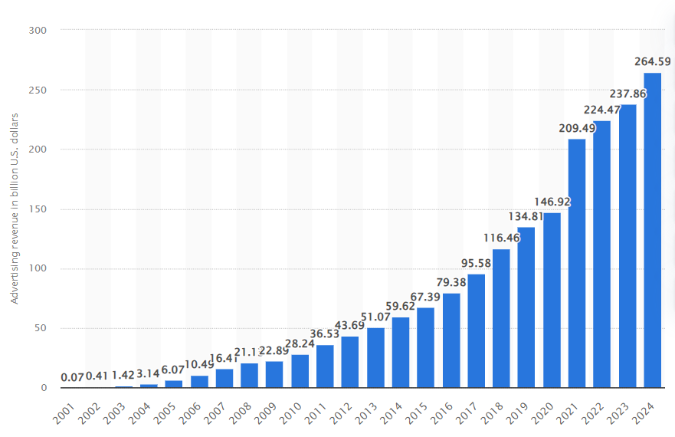
Figure 2: Advertising revenue of Google from 2001 to 2024
Source: Statista (2025)
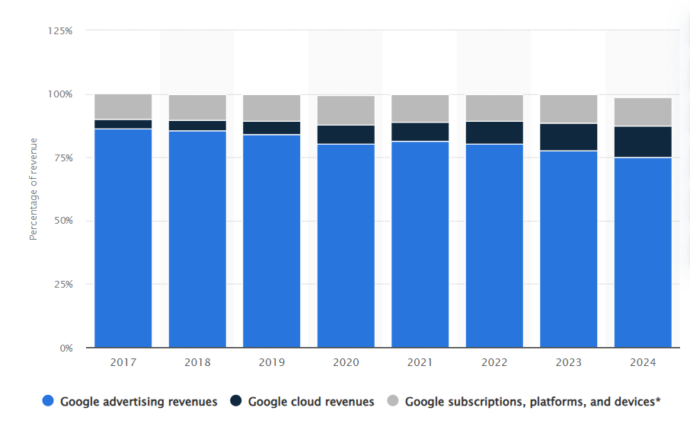
Figure 3: Distribution of Google segment revenues from 2017 to 2024
Source: Statista (2025)
Social Factors:
Anne-Sophie, Gilles N'Goala and Audrey (2019) Shifts in consumer behavior, driven by increased digital literacy and growing privacy concerns, significantly influence Google’s product development and service offerings. Users are demanding greater transparency and control over their data, prompting Google to enhance privacy features and adopt more user-centric policies. Furthermore, the rise in digital literacy has elevated expectations for innovative, intuitive, and secure digital solutions, compelling Google to continuously refine its offerings to meet evolving consumer needs.
Technological Factors:
Advancements in AI, cloud computing, and 5G networks present both opportunities and challenges for Google. Sean (2025) argues that Google must invest heavily in R&D to maintain its innovation leadership, continuously integrating emerging technologies like generative AI and edge computing. However, some critics warn that an over-reliance on innovation could be risky if the market shifts towards new technologies where Google isn’t a leader (Brown, 2024).Others, like Taylor (2023), suggest that focusing on innovation might be excessive and that diversification into stable markets could provide more predictable returns. This highlights the need for Google to balance cutting-edge innovation with long-term market stability in response to rapid technological changes.
Environmental Factors:
Google (2023) has pledged to achieve carbon-free operations by 2030, reflecting its commitment to sustainability. Amber (2024) mentioned that the energy-intensive nature of its global data centers poses significant challenges. While the company has made progress in adopting renewable energy, scaling these efforts to meet its ambitious environmental goals remains a complex and costly endeavor.
Legal Factors:
Google faces ongoing antitrust lawsuits and must navigate a complex web of global data protection laws. Legal challenges, particularly in the U.S. and EU, allege anti-competitive practices and could result in substantial fines or operational restrictions. Compliance with diverse regulatory frameworks, such as GDPR, adds complexity to its operations, requiring robust legal and operational adjustments to mitigate risks.

2.2 Key Economic Trends
Increasing Investment in AI and Machine Learning: Companies are allocating substantial resources to develop AI-driven technologies, from search algorithms to automation tools. Google, in particular, is enhancing its AI capabilities in search, cloud computing, and autonomous systems, ensuring that it remains at the forefront of digital innovation. Kevin (2024) mentioned that this trend is expected to accelerate as AI integration becomes a core component of business operations worldwide.
Rising Competition in Digital Advertising and Cloud Computing Sectors: Omdia (2021) mentioned that Google’s dominance in digital advertising is being challenged by competitors such as Meta, Amazon, and TikTok, which are capturing larger shares of the online ad market. Additionally, in cloud computing, Google Cloud faces stiff competition from Amazon Web Services (AWS) and Microsoft Azure, requiring continuous investment in infrastructure, AI-driven services, and enterprise solutions to maintain competitiveness.
Growth in Ethical and Sustainable Business Practices: Consumers and investors are increasingly prioritizing sustainability, pushing tech companies to adopt more ethical business models. Google has committed to operating carbon-free by 2030, investing in renewable energy, and reducing its digital carbon footprint. These efforts align with global sustainability trends and regulatory requirements, enhancing Google’s brand reputation while mitigating environmental impact.

3. Internal Analysis of Google

3.1 Resource-Based View (RBV) of Google
Google’s competitive advantage is driven by its extensive resources and capabilities.
Tangible Resources: Google operates a vast network of global data centers that power its search engine, cloud services, and AI-driven applications. Its cutting-edge AI infrastructure, including proprietary chips like Tensor Processing Units (TPUs), enhances computational efficiency. Additionally, Alphabet’s substantial financial resources enable continuous investment in innovation, acquisitions, and sustainability efforts.
Intangible Resources: Google’s brand is one of the most recognized worldwide, reinforcing consumer trust and market dominance. Its extensive data analytics capabilities, powered by machine learning and big data, provide a significant competitive edge in advertising, search, and AI development. Moreover, Google’s highly skilled workforce, particularly in AI and software engineering, drives technological advancements and product innovation.
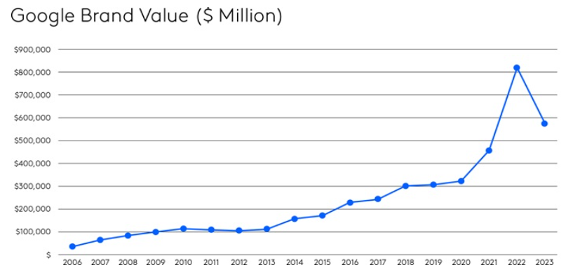
Figure 2:Google Brand Value
Source: Kantar BrandZ

3.2 Value Chain Analysis of Google
Primary Activities: Google optimizes inbound logistics through efficient data management and AI-driven insights. Reuters (2024) mentioned that Its operations are centered around continuous innovation in AI and cloud computing, ensuring high-quality product development. Outbound logistics focus on seamless cloud service delivery, supported by extensive global infrastructure. Marketing efforts are primarily ad-driven, leveraging Google Ads and digital platforms for targeted outreach. Lastly, Google enhances customer service through user-centric applications, chat support, and AI-powered assistance tools.
Support Activities: Google’s HR practices emphasize innovation and talent acquisition, attracting top engineers and AI researchers. Strategic partnerships with hardware and software firms drive technological synergies. Additionally, its advanced IT infrastructure, including cloud networks and AI-driven analytics, enhances efficiency and scalability across its value chain.

3.3 SWOT Analysis of Google
Strengths: Google holds a dominant position in search, digital advertising, and cloud computing, benefiting from strong brand recognition and a vast global user base. Karen (2024) mentioned that its advanced AI capabilities enhance product innovation, including personalized search, automated services, and targeted advertising. The company’s extensive financial resources support continuous investment in research, acquisitions, and infrastructure expansion.
Weaknesses: eMarketer (2024) mentioned that Google’s revenue model remains heavily dependent on digital advertising, making it vulnerable to fluctuations in the ad market and regulatory interventions. Additionally, growing regulatory scrutiny and antitrust lawsuits in key markets such as the U.S. and EU pose legal and financial risks. Privacy concerns and data protection regulations may also limit its data-driven business strategies.
Opportunities: Expanding into AI-driven products, cloud computing, and sustainability initiatives presents growth potential. Google’s continued focus on enterprise solutions, such as Google Cloud, offers diversification beyond ad revenue. Additionally, investments in quantum computing, smart devices, and digital health could open new revenue streams.
Threats: Increasing regulatory pressures, antitrust actions, and data privacy concerns pose significant risks to Google’s operations. Cybersecurity threats, including potential data breaches, could damage brand trust. Furthermore, intensifying competition from Amazon, Microsoft, Apple, and emerging AI-driven platforms could challenge its market leadership.

4. Strategy Formulation & Competitive Positioning
Porter’s Generic Strategies:
Google primarily employs a differentiation strategy by offering unique, AI-driven services and a seamlessly integrated ecosystem of products, such as Google Search, YouTube, and Android. These services are designed to provide superior user experiences, leveraging advanced algorithms, machine learning, and data analytics to maintain a competitive edge. Warren (2024) mentioned that in the cloud computing sector, Google adopts a cost leadership approach to compete with rivals like Amazon Web Services (AWS) and Microsoft Azure. By optimizing infrastructure and offering competitive pricing, Google Cloud aims to attract cost-sensitive enterprises while still differentiating through its AI and data analytics capabilities.
Ansoff’s Matrix:
Market Penetration: Google enhances user engagement through personalized services, AI-powered recommendations, and data-driven advertising strategies. Improvements in Google Search, YouTube algorithms, and Google Assistant help retain users and increase interaction.
Market Development: Expanding into emerging markets, Google tailors its products to local needs. Initiatives such as Google’s Android One and offline-friendly services like YouTube Go enable accessibility in regions with limited internet connectivity.
Product Development: Google heavily invests in AI-driven healthcare, leveraging machine learning for diagnostics, predictive analytics, and telemedicine. Additionally, its autonomous vehicle division, MICHAEL (2024) mentioned that Waymo, is pioneering self-driving technology, pushing the boundaries of transportation innovation.
Diversification: Hartmut (2024) mention Google is exploring renewable energy and quantum computing to expand beyond its traditional technology-focused business model. Its investments in sustainability align with the growing global emphasis on green technologies. Quantum computing, through its Quantum AI research division, aims to revolutionize problem-solving in fields like cryptography and drug discovery.
Mergers & Acquisitions (M&A):
Google’s M&A strategy plays a critical role in bolstering its technological capabilities and market position. Julia and Hal (2017) refer to acquisitions such as DeepMind have strengthened its leadership in AI research, enabling breakthroughs in areas like healthcare and robotics. The acquisition of Fitbit has allowed Google to enter the wearables market, integrating health and fitness data into its ecosystem. These strategic acquisitions not only enhance Google’s product offerings but also provide access to new markets and talent, ensuring its continued dominance in the tech industry. Through targeted M&A, Google mitigates risks associated with internal R&D while accelerating innovation and diversification.

5. Sustainability & Strategic Recommendations

5.1 Sustainability Initiatives
Google has prioritized sustainability as a central aspect of its operations, committing to achieve 24/7 carbon-free energy by 2030. This ambitious goal involves transitioning all data centers and office operations to carbon-free electricity, significantly reducing the company's dependence on fossil fuels. In addition, Google has allocated substantial investments in renewable energy projects, such as wind and solar farms, to further its clean energy agenda.
However, questions arise regarding the financial and strategic impact of these sustainability efforts. While these initiatives may enhance Google’s reputation, the long-term profitability and return on investment are less clear. Are these efforts truly driving value, or are they primarily a public relations move to meet growing consumer and investor demand for green practices?
Externally, Google has faced criticisms about its sustainability approach, particularly regarding transparency and the real impact of its renewable energy investments. Sam (2024) mentioned that the company’s commitment to sustainability might be driven more by image-building than by a genuine attempt to lead the green energy revolution.
Lindsey (2024) mentioned that from a competitive strategy perspective, Google's sustainability initiatives may align with its broader goals of innovation and market leadership, potentially enhancing its brand appeal among environmentally-conscious consumers and investors. However, balancing sustainability with profitability remains a challenge, as some argue that significant investments in green energy could affect Google’s overall cost structure, at least in the short term.

5.2 Strategic Recommendations
Enhance Sustainability Reporting
Google should increase transparency by providing more detailed and accessible reports on its environmental and social impact. Regular updates on carbon emissions, energy efficiency improvements, and sustainability projects will help build trust with consumers, investors, and regulatory bodies.
Diversify Revenue Streams
To reduce dependence on digital advertising, Google should continue expanding its cloud computing and AI-driven solutions. Google Cloud can provide AI-powered services to businesses in sectors like healthcare, finance, and retail, ensuring stable revenue growth beyond ad-based monetization.
Strengthen Ethical AI Practices
As AI adoption grows, Google must develop and enforce stricter ethical AI frameworks to ensure fairness, transparency, and inclusivity. Addressing concerns around algorithmic bias, data privacy, and AI accountability will help maintain public trust and regulatory compliance.
Expand Green Technologies
Google should further invest in renewable energy, carbon capture technologies, and circular economy initiatives. Exploring sustainable materials for hardware production and improving e-waste recycling programs can contribute to a greener tech industry.
Foster Partnerships
Collaborating with governments, NGOs, and environmental organizations will enable Google to play a more active role in global sustainability efforts. Joint initiatives in areas like climate research, smart cities, and green infrastructure will strengthen its leadership in corporate sustainability.

6. Conclusion
Google, a global technology leader, stands at a pivotal juncture where its strategic decisions will shape the future of the digital economy. This report has critically analyzed Google's strategic position using SWOT analysis, revealing its strengths in search, AI, and cloud computing, alongside weaknesses like heavy reliance on advertising revenue and regulatory challenges.
The external analysis highlighted significant threats from antitrust scrutiny and data privacy regulations, while also identifying opportunities in AI-driven innovations and sustainability. Google's internal capabilities, such as its vast data centers and skilled workforce, provide a strong foundation for innovation and competitive advantage.
To navigate these complexities, Google must enhance transparency in sustainability reporting, diversify its revenue streams beyond advertising, and strengthen ethical AI practices. To navigate these complexities, Google must enhance transparency in sustainability reporting, diversify its revenue streams beyond advertising, and strengthen ethical AI practices.

Reference List
Barkley, W. (2024). Google Cloud Named a Leader in Forrester Wave for AI Platforms. [online] Google Cloud Blog. Available at: https://cloud.google.com/blog/products/ai-machine-learning/google-cloud-named-a-leader-in-forrester-wave-for-ai-platforms.
Birch, K. and Adediji, D. (2025). Undermining competition, undermining markets? Implications of Big Tech and digital personal data for competition policy. Big Data & Society, 12(1). doi:https://doi.org/10.1177/20539517241311584.
Dahut, K. (2024). Google AI for Public Sector 2024: Innovations Transforming Government. [online] Google Cloud Blog. Available at: https://cloud.google.com/blog/topics/public-sector/a-look-back-at-the-ai-innovations-transforming-the-public-sector.
eMarketer (2024) 'Google ad growth bolsters Alphabet’s Q3, despite regulatory challenges', eMarketer, 30 October. Available at: https://www.emarketer.com/content/google-ad-growth-bolsters-alphabet-s-q3--despite-regulatory-challenges
Fast, V., Schnurr, D. and Wohlfarth, M. (2022). Regulation of Data-driven Market Power in the Digital Economy: Business Value Creation and Competitive Advantages from Big Data. Journal of Information Technology, 38(2), p.026839622211143. doi:https://doi.org/10.1177/02683962221114394.
Feiner, L. (2024). Judge rules that Google ‘is a monopolist’ in US antitrust case. [online] The Verge. Available at: https://www.theverge.com/2024/8/5/24155520/judge-rules-on-us-doj-v-google-antitrust-search-suit.
Gani, A., Shuib, L. and Yadegaridehkordi, E. (2018). Pestel Analysis. [online] Available at: https://www.researchgate.net/profile/Elaheh-Yadegaridehkordi/publication/341190360_COMRAP_2018/links/5eb2ec0b45851523bd4708f1/COMRAP-2018.pdf#page=43.
GOOGLE (2023). Our Goals for Sustainable Operations - Google Sustainability. [online] Google. Available at: https://sustainability.google/operating-sustainably/.
Harrelson, S. (2024). Web Page Monitored. [online] Samharrelson.com. Available at: https://samharrelson.com/2024/12/11/beyond-the-corporate-gloss-a-deeper-critique-of-googles-2024-environmental-report/ [Accessed 14 Jan. 2025].
Ichhpurani, K. (2024). Build, deploy, and promote AI agents through Google Cloud’s AI agent ecosystem. [online] Google Cloud Blog. Available at: https://cloud.google.com/blog/topics/partners/build-deploy-and-promote-ai-agents-through-the-google-cloud-ai-agent-ecosystem-program.
Jackson, A. (2024). Google’s Journey Towards Carbon-Free Data Centres.Datacentremagazine.com. Available at: https://datacentremagazine.com/critical-environments/googles-journey-towards-carbon-free-data-centres [Accessed 20 Nov. 2024].
Kinney, S. (2025). Google touts AI infrastructure as ‘powerful foundation’ for growth. RCR Wireless News. Available at: https://www.rcrwireless.com/20250205/ai-infrastructure/google-ai-infrastructure-powerful-foundation-for-growth [Accessed 20 Mar. 2025].
Li, H., Yu, L. and He, W. (2019). The impact of GDPR on global technology development. Journal of Global Information Technology Management, 22(1), pp.1–6. doi:https://doi.org/10.1080/1097198X.2019.1569186.
LIEDTKE, M. (2024). Waymo now open to anyone who wants a driverless ride in LA. AP News. Available at: https://apnews.com/article/waymo-robotaxi-los-angeles-ride-hailing-6cacfec81ebc451dfba8e03ba19b7a08.
Neven, H. (2024). Meet Willow, our state-of-the-art quantum chip. [online] Google. Available at: https://blog.google/technology/research/google-willow-quantum-chip/.
Omdia. (2021) 'Google, Amazon, Meta, Apple command almost 70% of the online advertising market: Omdia', Media Brief. Available at: https://mediabrief.com/gama-online-advertising-market-omdia/
Perrigo, B. (2024). Sundar Pichai. TIME. Available at: https://time.com/7012748/sundar-pichai-2/
Portes, A., Gilles N'Goala and Cases, A.-S. (2019). Looking for transparency in data and digital marketing practices: an empirical investigation on the roles of consumer digital literacy and privacy concerns. Looking for transparency in data and digital marketing practices: an empirical investigation on the roles of consumer digital literacy and privacy concerns. [online] Available at: https://www.researchgate.net/publication/333634546_Looking_for_transparency_in_data_and_digital_marketing_practices_an_empirical_investigation_on_the_roles_of_consumer_digital_literacy_and_privacy_concerns.
Powles, J. and Hodson, H. (2017). Google DeepMind and Healthcare in an Age of Algorithms. Health and Technology, 7(4), pp.351–367. doi:https://doi.org/10.1007/s12553-017-0179-1.
Reuters (2024). Google Cloud partners with Air France-KLM on AI technology. Reuters. [online] 4 Dec. Available at: https://www.reuters.com/technology/artificial-intelligence/google-cloud-partners-with-air-france-klm-ai-technology-2024-12-04/.
Wilkinson, L. (2024). Google’s AI efforts slow sustainability gains. [online] CIO Dive. Available at: https://www.ciodive.com/news/google-sustainability-AI-environmental-impact/720756/

