
Programme: Master of Business Administration
Module Code: LCMB7003
Module: Strategic Management
Assignment Title: Assessment component - Individual report
Lecturer: Andry Rakotovololona
Student Name: Rabbi Islam
Student ID: 2504996
Assignment Title: Report
Word Count: 5019

Table of Contents
1. Introduction 3
1.1 Research Objectives 3
2. Literature Review 4
3. External and Internal Environment Analysis 5
3.1 External Environment Analysis: PESTEL Framework 5
3.2 Internal Environment Analysis: Strategic Capabilities of Sainsbury 7
4. CSR and Sustainability Objectives 10
5. Comprehensive and holistic perspective: Balanced Scorecard 11
6. Strategic Decisions and Action 15
6.1 Change Management and Strategic Implementation. 16
7. Strategic Analysis and Recommendations 17
8. Conclusion 20
Reflective Account 21
Description 21
Feelings 21
Evaluation 22
Analysis 22
Conclusion 22
Action Plan 23
References 24

Section 1

1. Introduction
The UK grocery retail industry is highly competitive and rapidly evolving, driven by changing consumer preferences, the growth of online shopping and intense price competition from "low cost" retailers. Supermarkets increasingly struggle to hold their position and profitability. One problem is the "stuck in the middle" dilemma for mid-market retailers like J Sainsbury plc, who sit between low price point retailers such as Aldi and Lidl, and high price point retailers who provide superior quality and service. When "stuck in the middle", as Porter suggests, businesses can suffer from diminished profitability and competitive edge. Sainsbury, as the second-largest supermarket retailer in Great Britain with 15% market share and a turnover of £31.5 billion, is a significant business in the UK. This report assesses the firm's strategy, external competitive context, and internal resources using a number of strategic models.

1.1 Research Objectives
- To understand the role of the external macro-environment in shaping Sainsbury's strategic position, in terms of its competitors, regulatory environment and technological developments in the retail industry.
- To assess the sustainability of Sainsbury's competitive advantages by analysing its strategic resources and capabilities.
- To understand Sainsbury's existing strategic position by examining its financial performance, value proposition, and its efficiency-innovation balance.
- To offer evidence-informed strategic recommendations that help to improve Sainsbury's competitive position and drive sustainable growth.

2. Literature Review
Strategic management is the management of organisations to achieve competitive advantage in a changing world. Johnson, Scholes and Whittington (2020) describe it as the long-term direction and scope of an organisation which matches its capabilities to its changing environment to achieve a sustainable advantage. Grant (2019) has a different view: strategic management is identifying and undertaking actions to enhance long-term performance. These are important differences: Johnson focuses on adaptation, Grant on planning. Both are required in today's business.
Porter (1985) describes it as performing a value-creating strategy not simultaneously performed by any other firm, needing to create value, be unique and to sustain it in the face of competition. Barney's (1991) Resource-Based View definition holds that, over time, competitive advantage is determined by resources that are valuable, rare, inimitable and organisationally exploited. These definitions are different: Porter emphasises the need for strategic positioning and decision making, while Barney emphasises the need to focus on internal resources.
The VRIO framework operationalises this theory by evaluating resources in four ways. Resources with all four attributes are sources of sustained competitive advantage. Resources that are valuable and rare, but not immobile create temporary advantages. This model has become mainstream in the field of strategic management, as Johnson et al. (2020) and Grant (2019) endorse.
But a key research gap remains. The Resource-Based View account for static competitive advantage at a point in time but not for dynamic competitive advantage in a changing industry environment. Modern retailing requires ongoing capability building and organisational ambidexterity: balancing efficiency and innovation. The current analysis fills this gap by considering not just the advantages Sainsbury has, but how it can renew its advantages to adapt to disruptive change.

External and Internal Environment Analysis

3.1 External Environment Analysis: PESTEL Framework
This section critically evaluates these dimensions using PESTEL analysis, identifies key success factors and strategic challenges, and applies the VRIO framework to assess the firm’s internal capabilities.

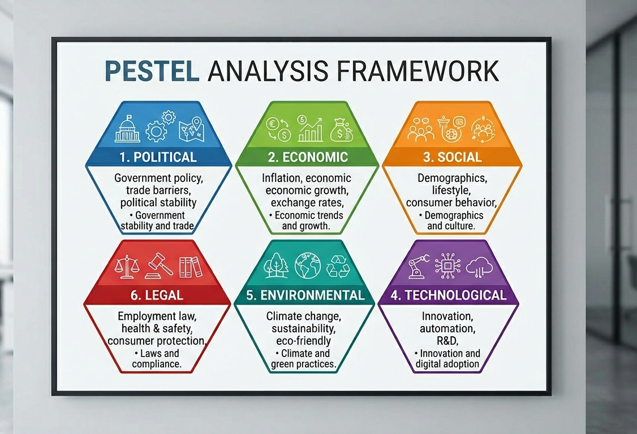
Figure 1: PESTLE Framework (Self-generated)

The Political Factors: The political environment is very major in influencing the strategic decision of Sainsbury. The regulatory environment of the UK, which has emerged after Brexit, has brought about complexities in the supply chain management especially concerning import tariffs, customs clearance, and freedom of movement (Mintel, 2024). This has forced Sainsbury to re-align its sourcing policies whereby more focus is given to suppliers within the country in order to cushion against disruptions. Moreover, food prices, minimum wage, and sustainability policies set by the government have raised the cost of operation and the company has to strike a balance between profitability and compliance.

The Economic Factors: On the economic front, the retail market in the UK has had ongoing inflationary pressures especially on the food prices that directly influence consumer buying behaviour. The increased living expenses have made the value-like consumption a trend that has favoured the discount retailers like Aldi and Lidl (Statista, 2025). To counter this, Sainsbury has been able to strategically enhance its price match promotions and increase its own-label products to stay competitive.

The Social Factors: The social aspects are also vital in determining Sainsbury strategic path. The shift in consumer preferences to healthier, ethically sourced, and sustainable products has forced the company to increase its range of organic and plant-based products. The rising value of convenience has also led to the growth of investment on online grocery services and fast delivery facilities. In addition, product assortment and marketing plan have been affected by demographic changes such as an ageing population and multi-cultural communities.

The Technological Factors: Sainsbury has invested in digital transformation, such as its online grocery service, data analysis and the implementation of loyalty programmes, such as Nectar. These investments in technology allow personalised marketing and better customer experience, which is essential in differentiation. Nevertheless, the swift technological change demands constant investment, and the inability to match the rivals, such as Tesco and Amazon, might lead to loss of market share (Euromonitor, 2024).

The Environmental Factors: Environmental factors are now taking over centre stage with sustainability now being the key strategic focus. Sainsbury has made the efforts of attaining net-zero carbon emission by 2040 and minimising plastic packaging in its operations. These programs are in line with consumer demands and regulatory provisions, but they are also associated with high cost.

The Legal Factors: Strategic environment is also influenced by legal factors. Operational integrity is necessary in adhering to food safety standards, employment regulations as well as competition regulations. The UK Competition and Markets Authority (CMA) pay close attention to big retailers, which restricts their possibilities to play the game of aggressive prices or takeovers.

3.2 Internal Environment Analysis: Strategic Capabilities of Sainsbury
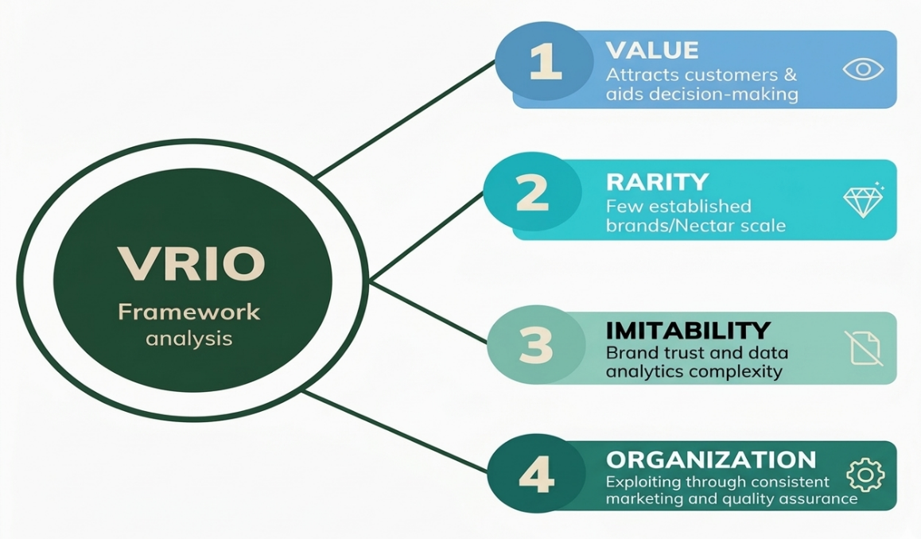
To conduct a stricter analysis of the internal environment of Sainsbury, it is necessary to go beyond a descriptive application of VRIO to the critical analysis based on the resource-based theory.
Figure 2: VRIO Framework (Self-Generated)

The Resource-Based View suggests that only when resources are valuable, rare, and difficult to copy, and are well organised, firms can develop sustained competitive advantage (Barney, 1991).
Value: Brand reputation is one of the most important assets of Sainsbury. The brand itself is obviously a valuable one, being linked with the quality, trust, and ethical sourcing, which are still valued by the UK consumers, especially in the middle-income segment (Mintel, 2024). The brand is moderately rare in terms of rarity; the rivals like Tesco and Marks and Spencer also have a strong brand identity, but in large-scale retailers with the same heritage and trust, there are few. Nevertheless, brand reputation imitation is not very straightforward. Competitors will find it hard to match or surpass 150 and more years of heritage, but they can invest in branding, quality perception, and customer experience to close the divide. This diminishes the resource uniqueness in the long term. At an organisational level, Sainsbury successfully utilises its brand by being able to maintain marketing, developing own-label, and communicating sustainability. Brand reputation therefore offers a short-lived to medium competitive advantage, but not an impregnable one.
Rarity: The other essential ability is the data analytics and loyalty ecosystem of Sainsbury and its Nectar programme. This is a very useful ability since it allows the company to obtain in-depth customer information, customise their offers and enhance demand predictions. The recent data indicate that data-driven retailing emerges as a major differentiator in the UK grocery industry, as companies use big data to improve customer retention and basket size (Euromonitor, 2024). But when it comes to rarity, these capabilities are becoming more widespread among large retailers, with Tesco Clubcard advanced analytics. Data ecosystems are moderately imitable; it is possible to purchase the technology, but the size of data, the history and the relationships between the ecosystems (e.g. cross-brand collaboration in Nectar) introduces certain obstacles. Sainsbury is in a good position to harness this potential with data being integrated both online and offline. Thus, this resource will give short-term competitive advantage, and its maintenance will require constant investment in technologies and innovation.
Imitability: The supply chain and operational infrastructure of Sainsbury are also a core capability. This encompasses its distribution network across the nation, relationships with suppliers and its systems of inventory management. The usefulness of this ability cannot be contested, especially in a context where supply disruptions and cost pressures are the main features (Statista, 2025). Yet, it is not exceptional, since other competitors like Tesco and Asda also have an equally advanced system of logistics. Regarding imitability, on the one hand, supply chain networks are difficult to imitate because they require considerable investment and time development; on the other hand, they can be replicated in large-scale competitors. In this respect, Sainsbury is well coordinated and efficient organisationally. Therefore, supply chain capability is a source of competitive parity and not sustainable advantage as it is a pre-requisite to survival and not a source of differentiation.
Organization: The other resource that is significant is Sainsbury multi-channel retail integration, especially after acquiring Argos. This will enable the company to integrate grocery retailing with general merchandise and have convenient click-and-collect options. The importance of this integration is seen in the fact that it makes customers more convenient and offers more cross-selling opportunities. Compared to its competitors, this capability is a little unique in terms of rarity, with not all competitors having a similarly integrated general merchandise operation. Nonetheless, imitability is moderate; it might be hard to specifically duplicate the partnership of Argos, but substitutions can be created by rival companies or in-house.

4. CSR and Sustainability Objectives
The corporate social responsibility (CSR) policy of J Sainsbury plc has been a part of the global business strategy especially in the face of a growing stakeholder requirements and regulatory demands. With respect to environment, Sainsbury has progressed to achieve net-zero carbon emission by 2040, and has also introduced new initiatives to reduce plastic packaging and food waste. These targets align to the regulatory and growing consumer preference for sustainable products (Sainsbury, 2024). Sustainability efforts help risk mitigation in the long term, since it addresses climate change related supply chain disruptions and potential regulatory penalties. But the extent to which such initiatives create competitive advantage is questionable. Given the fact that sustainability has become a common goal for most of the major retailers in the UK, such initiatives can be seen as a legitimacy-seeking behaviour. The second key element in Sainsbury's CSR is social responsibility. Sainsbury also has taken part in community engagement, fair employment and supplier relations in their efforts to boost their social reputation. The challenge is, however, in translating these benefits into hard numbers, especially in a price-sensitive market and where customers might be more focused on the price rather than the ethical aspect of the product. CSR practice should be financially linked to the business objectives of the organisation. This is a manifestation of the notion of shared value, as social and environmental activities add to economic performance (Porter and Kramer, 2011).

5. Comprehensive and holistic perspective: Balanced Scorecard
A thorough study of J Sainsbury plc needs to go beyond the analysis and individual study and take the holistic approach to the study which incorporates financial performance, customer value, operational priorities and strategic capabilities. In this section, the performance of Sainsbury is assessed in four related aspects, namely, revenue performance, customer value proposition, efficiency versus innovation balance, and VRIO capability mapping.
Figure 3: Sainsbury’s revenue over the years (Sainsbury Annual Report)
Year | Revenue (£ Billion) | Growth Trend | Key Insight
2020 | 28.9 | ↑ | Pandemic-driven grocery demand
2021 | 29.0 | → | Stable growth, strong grocery performance
2022 | 29.9 | ↑ | Recovery + Argos contribution
2023 | 31.5 | ↑ | Inflation-driven revenue increase
2024 | 31.5+ | → | Growth stabilised, margin pressure

The financial performance of Sainsbury in the last few years indicates its ability to survive, as well as structural pressure in the UK retail environment. The company has recorded a fairly constant growth in revenues, according to its latest annual reports, which relied mainly on the sales in the grocery sector and the need to purchase more necessary products (Sainsbury’s, 2024). But this growth should be viewed in a critical manner. Although the revenues are robust, profitability has been limited due to the increasing operating costs, inflation and cut-throat price wars. This implies that increase in revenue does not always translate to better financial performance. Rather, it points out to a central strategic crisis: Sainsbury is growing its top line and experiencing margin pressure. In terms of Balanced Scorecard, it can be implied that the financial performance becomes more and more dependent on cost management and operational efficiency instead of its reliance on the sales growth.

Figure 4: Customer Value Proposition Matrix (Self-generated)
A customer value proposition matrix can be used to gain a better insight into how Sainsbury can create value to its customers. This is a price to perceived quality matrix. Sainsbury is in a mid-to-high quality/price position, selling a variety of goods, including higher-quality products and own-labelled products. Nevertheless, when it comes to price, it places itself higher than discount stores like Aldi but lower than high-end stores. The positioning forms a hybrid value proposition where the customers are anticipating quality as well as affordability. Although this strategy will enable Sainsbury to reach a wide range of customers, it will also bring about strategic ambiguity. Competitive advantage can be undermined in cases of unclear positioning as Porter (1985) contends.
Figure 5: Efficiency vs Innovation Matrix of Sainsbury (Self-generated)
The efficiency versus innovation matrix can be used to analyse another vital dimension of the strategic position of Sainsbury. Sainsbury is performing well on the efficiency axis and its long-established supply chain, its massive operation, and its incorporation of Argos have helped it to achieve high performance in the efficiency axis. Sainsbury is not leading in terms of innovation strategy as compared to its competitors who are heavily invested in advanced analytics and automation (Euromonitor, 2024). This positioning puts the company in a quadrant that is highly efficient but with moderate innovation. Although, this guarantees long term stability, it is a worry with long term competitiveness since, over time, sustained advantage is more and more about innovation-based capabilities.

Resource / Capability | Valuable | Rare | Inimitable | Organised | Competitive Implication
Brand Reputation | ✔ | ✔ | ✖ | ✔ | Temporary Advantage
Nectar Data System | ✔ | ✖ | Β | ✔ | Temporary Advantage
Supply Chain | ✔ | ✖ | ✖ | ✔ | Competitive Parity
Argos Integration | ✔ | ✔ | Β | ✔ | Short-term Advantage
Sustainability Strategy | ✔ | ✖ | ✖ | ✔ | Competitive Parity
✔ = Yes | ✖ = No | β= Partially
Figure 6: VRIO Capability Mapping (Based on the analysis)
This view is further supported by the VRIO capability mapping of the strategic value of the key resources of Sainsbury. The brand reputation of the company becomes a valuable and not very common resource which helps to gain customer trust and loyalty. Nonetheless, it has average imitability, because rivals have an opportunity to invest in branding and quality image. This implies that brand reputation is a short-lived yet not entirely sustained advantage. Equally, the data capabilities of Sainsbury, especially its Nectar loyalty programme, are enticing and relatively hard to replicate owing to the amount of data and channel integration. These functionalities allow custom marketing and better understanding of customers, which helps in positioning. However, with the expansion of data analytics in the industry, the scarcity of the same is lessening.
The VRIO mapping shows that Sainsbury has a mix of resources that are valuable, yet few of them can be considered as the ones that can be used to achieve a sustained competitive advantage.

6. Strategic Decisions and Action
The business-level and corporate-level perspectives of the strategic choices that J Sainsbury plc is able to make can be explained. The main strategic dilemma at the business level is whether to pursue cost leadership or differentiation. On the corporate level, the organisation needs to identify how far diversification and expansion can enhance its competitive status.
Business Level Perspective: On the business level, Sainsbury has traditionally followed a hybrid approach, trying to strike the right balance between quality and affordability. Nonetheless, Porter (1985) holds that such a strategy exposes a company to the danger of being trapped in the middle where they will not be able to gain cost leadership or distinctive differentiation. This risk is more pronounced in the UK grocery market at the moment. Cost leadership has been achieved by discount retailers like Aldi and differentiation by high-end retailers with high quality and experience. Sainsbury, on the other hand, has to contend with both competitors at the same time.
A strategic alternative would be to shift further towards cost leadership. Furthermore, it would be challenging to reach the actual leadership in terms of cost due to structural benefits of discount competitors such as less complex supply chains and a restricted variety of products (Mintel, 2024).
Sainsbury could also use differentiation strategy as the second option basing on quality and sustainability and customer experience. Studies indicate that differentiation strategies are more lasting when intangible assets like brand and customer relations are strong (Barney, 1991). Hence, a more evident change towards differentiation seems to be the more feasible strategic option.
Corporate level perspective: On the corporate level, Sainsbury has already engaged in diversification by acquiring the company of Argos which has allowed the company to venture into general merchandise and create a multi-channel retail format. This diversification has made it more convenient to the customers and operational efficiency improved by a common infrastructure. The strategic worth of this diversification is however determined on how well the synergies can be realised. Although the process of integrating Argos has enabled Sainsbury to enhance its competency in its omnichannel, it does not essentially change its competitive standing in the grocery market.
The other possible corporate-level strategy is international expansion. Nonetheless, this alternative is quite risky. The success of UK retailers in their previous efforts to go international has been a problem in the past, implying that this course of action is not the most efficient utilization of resources (Johnson et al., 2020).
According to this analysis, the best strategic option that Sainsbury can adopt is to enhance its differentiation strategy and consolidate its existing diversification. The company can develop a more differentiated market position through concentrating on quality, sustainability, and customer experience.

6.1 Change Management and Strategic Implementation.
These strategies can be implemented, and this requires the organisation to effectively handle change. The digital transformation and integration of Argos, as well as the management of its change, have shown that Sainsbury has a decent ability to change management. These activities involved many changes in the organisation, technology and operations. The successful implementation of the Argos suggests that the organisation is able to implement complex changes.
However, not all change initiatives have been as effective. Competition by price with the discount retailers has pressurized margins without necessarily giving the long run differentiation. This is indicative of a wider strategic implementation issue: to match organisational capabilities with strategic goals. The literature on change management underscores the significance of having a clear vision, involvement of employees and alignment of the organisation (Kotter, 2012). Although Sainsbury has achieved some achievements in these respects, it should be emphasized that more strategic clarity is required to make sure that change initiatives are consistent with a long-term strategy.
Sainsbury is undergoing some critical strategic decisions both at business level and corporate level. The best way to achieve sustainable competitive advantage is a shift towards differentiation, backed by efficient change management and operational integration. The effectiveness of such a strategy however, lies in how the organisation can match its resources, capabilities and culture to its strategic goals.

7. Strategic Analysis and Recommendations
Using the SWOT analysis, the Matrix of Ansoff and the BCG Matrix, it is possible to gain a better insight into the strengths, limitations, and strategic opportunities of the organisation. In terms of SWOT, Sainsbury has a number of strengths. Its good brand image, which has been earned over decades, still leads to customer trust and loyalty (Mintel, 2024).
Figure 7: SWOT Analysis (Source: Author)
Strengths | Weaknesses
Strong brand reputation | Mid-market positioning (unclear identity)
Extensive store network | High-cost structure
Argos integration (omnichannel) | Margin pressure from price competition
Established supply chain | Limited differentiation vs competitors
Opportunities | Threats
Growth of online retail | Discount retailers (Aldi, Lidl)
Demand for sustainable products | Inflation & cost-of-living crisis
Expansion of private-label products | Changing consumer behaviour
Data-driven personalization | Intense industry competition

Regarding opportunities, the opportunities of strategic growth lie in the further development of online grocery retail and the growing interest in sustainable products. According to recent industry statistics, consumers in the UK are looking more and more at the value aspect, which puts extra strain on the middle-level retailers (Statista, 2025).
The Matrix of Ansoff offers more understanding of the strategic development possibilities of Sainsbury. The company has majorly concentrated on market penetration and product development. Market penetration strategies include price matching and promotion campaigns which are meant to enhance market share in the already existing markets.

Figure 8: Ansoff Matrix (Source: Author)
 | Existing Markets | New Markets
Existing Products | Market Penetration  • Price matching vs Aldi  • Promotions & loyalty (Nectar)  • Increasing basket size  Focus: Defend market share | Market Development  • Expansion into new regions (limited)  • Targeting new segments (e.g., convenience shoppers)  Focus: New customer groups
New Products | Product Development  • Private-label expansion  • Premium & sustainable products  • Ready-to-eat & health-focused lines  Focus: Differentiation | Diversification  • Argos integration (non-food retail)  • Financial services & digital offerings  Focus: Risk + growth

More ambitious strategies are market development and diversification. Although to some extent this diversification has been realized with the acquisition of Argos, more diversification must be done with care. Diversification by entering unrelated markets could lead to loss of strategic focus and a rise in risks. In the same way, expansion into foreign markets is characterized by considerable challenges, such as steep investment rates and the lack of familiarity with competition (Johnson et al., 2020). Sainsbury should therefore focus on product development and selective market penetration as opposed to aggressive expansion.
The BCG Matrix further provides more insight into the portfolio positioning of Sainsbury. The grocery business which is the heart of Sainsbury business can be termed as a Cash Cow. It is in a mature market with comparatively stable demand and comes up with a steady revenue but minimal growth. The online and digital segment, in turn, is a Star, which is associated with the high growth potential and the growing role in the retail industry. This is one of the critical areas to invest in to be competitive in the future.

Figure 9: BCG Matrix (Self-generated)
 | High Market Growth | Low Market Growth
High Market Share | Stars  - Online Grocery & E-commerce Digital/Nectar ecosystem | Cash Cows  - Core Grocery Retail (Supermarkets)
Low Market Share | Question Marks  - Argos (General Merchandise)  - Rapid delivery services | Dogs  - Underperforming stores/locations  - Low-margin legacy operations

As a company of Sainsbury, Argos can be considered a Question Mark. Although it has a potential of growth due to its integration on an omnichannel, its long-term profitability is uncertain. Lastly, some of the underperforming segments or stores can be termed as the Dogs that add insignificant value and should be looked into strategically.

Relying on this combined analysis, we can make a number of strategic proposals. To begin with, Sainsbury should focus on differentiation as opposed to trying to compete on price alone. This is in line with the argument by Porter (1985) that differentiation offers a more sustainable competitive advantage as compared to cost competition in most industries. Second, the company needs to invest more in the digital capabilities and data analytics. This is a vital strategic development area due to the development of online stores and the need to provide tailored customer experiences (Euromonitor, 2024). Third, Sainsbury’s needs to streamline its portfolio by focusing on growing areas like online retail and reviewing those that are not performing. Lastly, the organisation must improve its sustainability strategy to go past compliance and concentrate on innovation.

8. Conclusion
Our strategic analysis of J Sainsbury plc reveals a company with strong branding, streamlined operations and a position of strength in a competitive environment. However, it struggles with its mid-market positioning, price competition, economic volatility and evolving customer preferences. Using PESTEL, VRIO, SWOT, Ansoff's Matrix and the Balanced Scorecard, the company is competitive, but does not have a strong competitive advantage. Looking forward, to enhance growth prospects, Sainsbury should emphasise greater differentiation, digital innovation, and sustainability efforts, while continuing to be efficient.
Section 2

Reflective Account
This reflective report will be on my research, analysis and report writing process of the strategic management report on J Sainsbury plc. I have adopted Gibbs' Reflective Cycle (1988) in six stages of description, feelings, evaluation, analysis, conclusion and action plan to structure this report. This model allows a reflective and critical analysis of the process and learning.

Description
The first stage is description, which involves description of my actions in the assignment. Firstly, I have selected J Sainsbury plc as my organisation as it is important in the UK retail industry and the data is current. I began with a reading of the assignment brief to get the assignment requirements, particularly the one of critical analysis using strategic analysis frameworks such as PESTEL, VRIO and the Balanced Scorecard. This was followed by extensive secondary research involved sources such as the annual reports of the companies, market research reports and academic literature. I wanted to gather relevant and current data to support my analysis. After gathering enough information, I organized the report into explicit parts, making sure that the report was aligned with the assessment criteria. I then used the applicable models to study the external and internal environment of the organisation, and critically assess the strategic position of the organisation and provide recommendations.

Feelings
The second phase, feelings, cogitates about my preliminary reactions and feelings during the process. At the outset of the assignment, I was somehow intimidated by the scope of the task, especially the need to combine several strategic frameworks into a logical analysis. Also, a question mark on how to get past the descriptive writing to get to a more critical tone was present and that is needed to get higher marks. Nonetheless, later in the course of the research, I felt more confident about my knowledge of the organisation and the implementation of strategic models. It was more interesting and made me feel closer to the analysis because of the process of working with real-world data. I was confident in my skills to form a critical and structured argument by the time I got to the latter stages of writing.

Evaluation
The evaluation phase entails an evaluation of what was done well and poorly. The fact that I used recent and credible sources was one of the strengths of my approach as it contributed to the quality and relevance of the analysis. Using the information in company reports and industry research, I was capable of providing evidence to back my points as opposed to making broad assumptions. Further, the application of the structured frameworks (PESTEL and VRIO) served to structure my analysis and make sure that the main areas of the environment of the organisation were addressed in a systematic way. Nonetheless, some challenges existed. Among the constraints was the early propensity to be overly descriptive as opposed to critical. To illustrate, during the initial phases of writing the draft, I found myself justifying extraneous variables without comprehensively examining the strategic connotations of the same. The other challenge was the word count, and the depth of analysis, since it involved giving much care to the most pertinent points.

Analysis
The analysis phase helps one have a better insight into the experience as it connects it to the theoretical concepts. Looking at this process, it is evident that strategic analysis is not the same as merely knowing the frameworks but being able to use them critically. Strategic management theory states that PESTEL and VRIO tools are the most useful in cases where they are used to draw insights instead of merely describing circumstances (Johnson et al., 2020). The turning point in my assignment was when I stopped describing factors and assessing their influence on the strategic choices of Sainsbury. An example is that instead of just recognising economic influences like inflation, I examined how the influences affected consumer behaviour and compelled the organisation to initiate price-conscious strategies. This shift really helped in improving my research.

Conclusion
I reflect what I have learnt. Overall, this assignment has enabled me to improve my skills in carrying out critical and systematic strategic analysis. I have mastered a better understanding of the application of theoretical frameworks to the real organisations and how to support arguments with evidence. Noteworthily, I have also discovered that to succeed in academic performance, I should go beyond description and demonstration to critical thinking. This involves challenging assumptions, assessing alternative points of view and connecting theory with practice.

Action Plan
Lastly, the action plan will explain how I will use this learning in future. When doing future assignments, I will start the research process sooner to give myself time to critically reflect and revise. Another aspect that I will work on is my capacity to combine theory and practice, where I will be more involved with the academic literature. I will also work on creating a more systematic method of taking notes that will ensure that I arrange information better and prevent redundancy. The other major aspect that needs to be improved is the writing style. I will strive to use an academic tone that is clear and concise and at the same time make my arguments critical and well-founded. I would also prefer to have feedback on my final submission before submitting the work because it may offer a great deal of insight regarding an improvement.

References
Barney, J. (1991) ‘Firm resources and sustained competitive advantage’, Journal of Management, 17(1), pp. 99–120.
Euromonitor (2024) Grocery retailing in the United Kingdom. London: Euromonitor International.
Grant, R.M. (2019) Contemporary strategy analysis. 10th edn. Oxford: Wiley.
Johnson, G., Scholes, K. and Whittington, R. (2020) Exploring strategy. 12th edn. Harlow: Pearson.
Kaplan, R.S. and Norton, D.P. (1992) ‘The Balanced Scorecard: Measures that drive performance’, Harvard Business Review, 70(1), pp. 71–79.
Kotter, J.P. (2012) Leading change. Boston: Harvard Business Review Press.
Mintel (2024) UK supermarkets market report. London: Mintel Group Ltd.
Porter, M.E. (1985) Competitive advantage: Creating and sustaining superior performance. New York: Free Press.
Porter, M.E. and Kramer, M.R. (2011) ‘Creating shared value’, Harvard Business Review, 89(1/2), pp. 62–77.
Reuters (2024) ‘Britain’s Sainsbury’s expects profit growth’, Reuters. Available at: https://www.reuters.com.
Sainsbury’s (2024a) Annual report and financial statements 2024. Available at: https://www.about.sainsburys.co.uk.
Sainsbury’s (2024b) Strategy update: Next Level Sainsbury’s. Available at: https://www.about.sainsburys.co.uk.
Sainsbury’s (2024c) Preliminary results for the 52 weeks ended 2 March 2024. Available at: https://www.about.sainsburys.co.uk.
Statista (2025) Market share of grocery retailers in the UK. Available at: https://www.statista.com.

