Module Title: Employability and Career Development

Student Name: Yuriy Shevtsiv

Student Number: 2509083

Assessment: Portfolio of Written Tasks

Module Code: LCLM4005

Lecturer’s Name: Inderjit Grewal

Comparison of Job Advertisements and Key Skills

Job Advertisement 1 – Assistant Facilities Manager

Company: Cobalt Recruitment
Location: West End, London
Salary: £40,000–£45,000 per annum
Contract: 12-Month Fixed Term Contract

Key Responsibilities:
• Support the Facilities Manager with day-to-day management of the property.
• Coordinate and monitor contractors and service partners.
• Support health & safety compliance and risk management.
• Help oversee planned maintenance and reactive works.
• Produce reports and maintain accurate records.

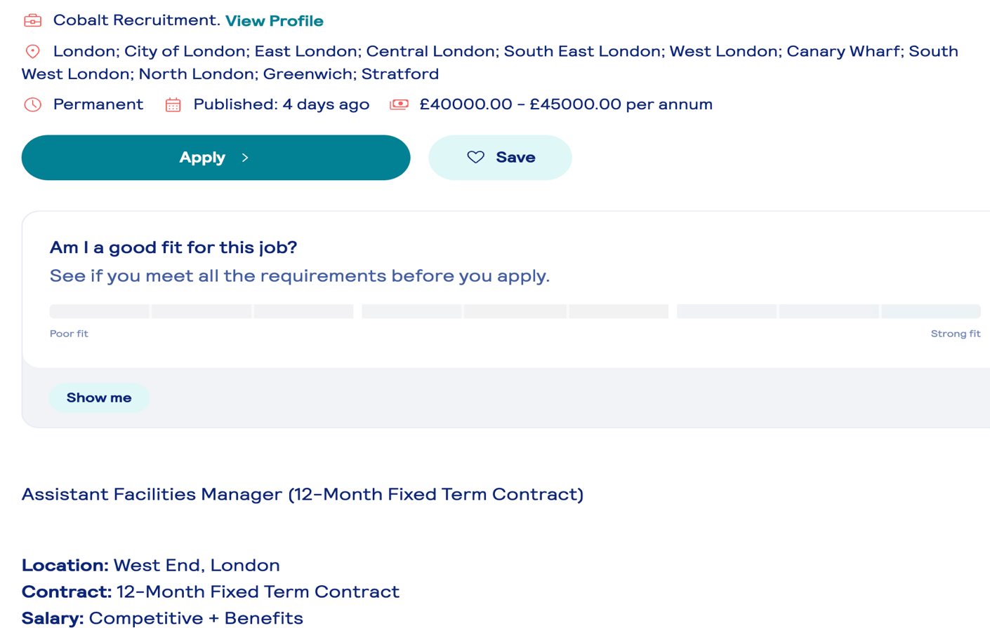
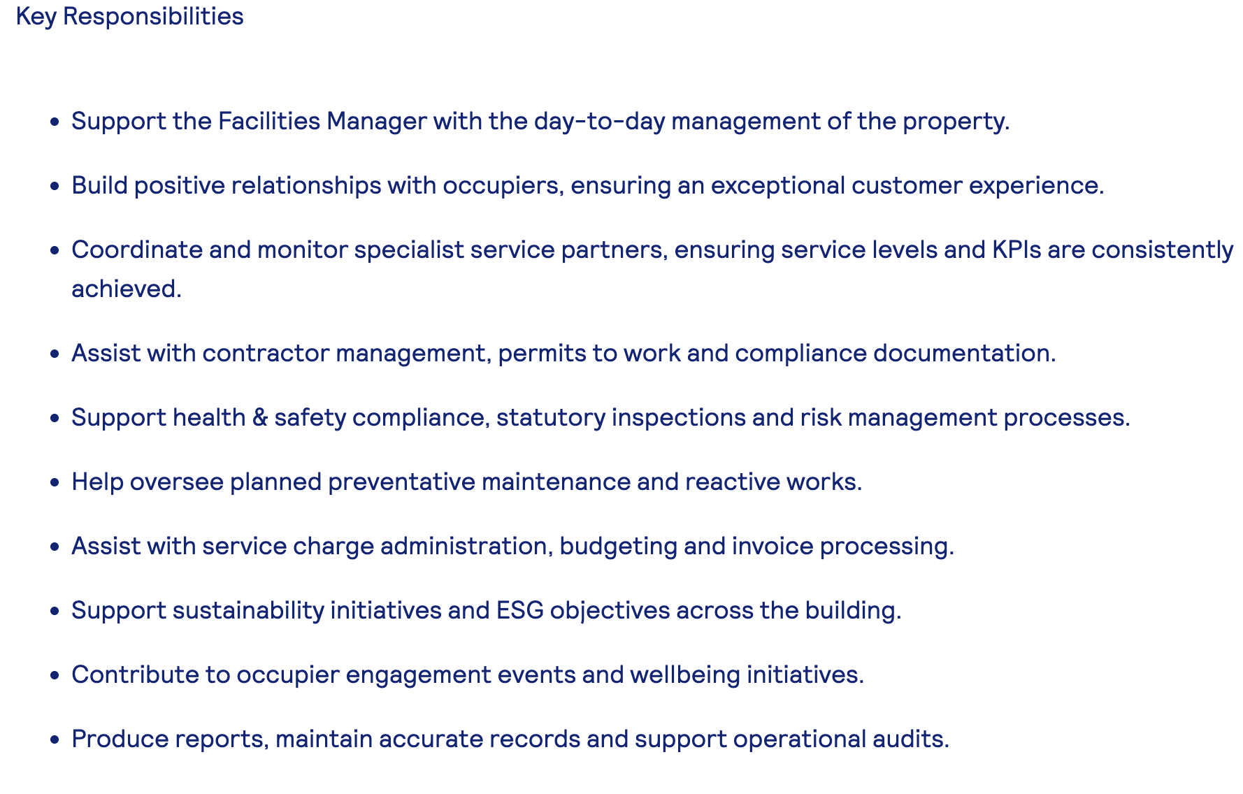

Job Advertisement 2 – Facilities Assistant

Company: Compass UK & Ireland
Location: North West London (NW1), NW1 4LE
Salary: £14.80 per hour
Contract: Part Time

Key Responsibilities:

• Undertake minor repairs and maintenance tasks.
• Ensure the exterior of the site is clean, tidy and maintained to a reasonable standard.
• Assist the facilities team with contractor control and ensure site policies and rules are followed.
• Open and/or close the building where required.
• Comply with Health & Safety regulations.

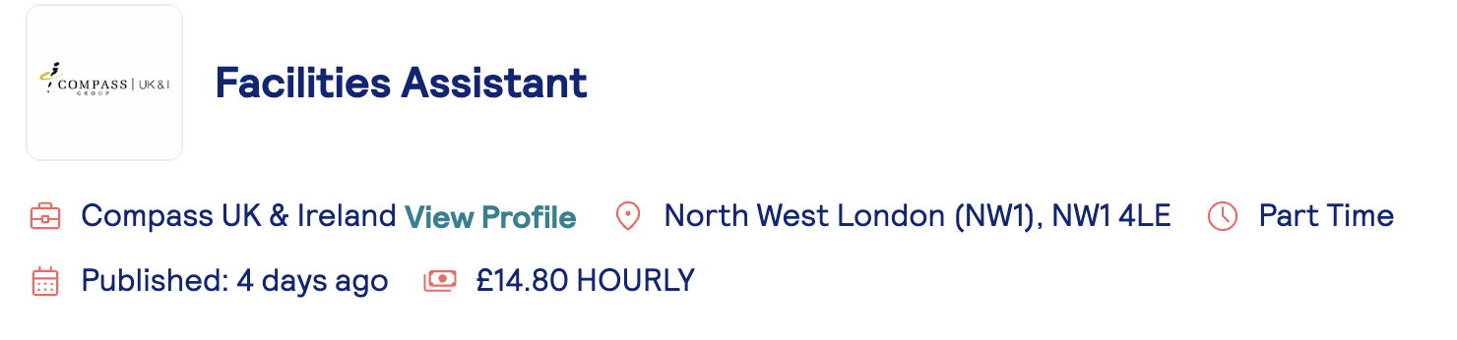

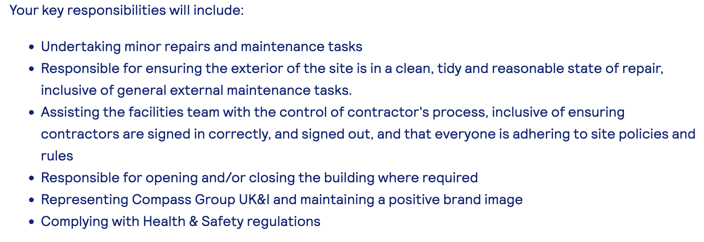

Key Skills and Knowledge

• Communication and interpersonal skills.
• Teamwork and ability to work with contractors and colleagues.
• Health and Safety knowledge.
• Organisation and time management skills.
• Basic maintenance and facilities management knowledge.
• Ability to follow procedures and maintain accurate records.

Common Skills and Knowledge Across Both Job Advertisements

I have found two job roles that are similar in requirements; the first one is an Assistant Facilities Manager position at Cobalt Recruitment, and the second one is a Facilities Assistant position at Compass UK & Ireland. Both job advertisements require similar skills and knowledge. Communication and teamwork are important because both roles involve working with colleagues, contractors and other people like clients. Health and Safety knowledge is also essential in both positions because of the tools that will be used and working in environments where there may be risks. Both jobs require good organisation, the ability to follow procedures and an understanding of maintenance and facilities operations (Cobalt Recruitment, 2026; Compass UK & Ireland, 2026).

Application of a Key Skill in My Future Role

Communication is one of the key skills I would use in my future role in facilities management. This is an important skill to have in the workplace (M. Curcuruto, M. A. Griffin, 2023) because it ensures that work is carried out with clarity amongst the team and with safety concerns in mind. I would need to communicate clearly with managers, colleagues, contractors and customers to make sure that work is completed correctly and safely. Good communication would help me explain maintenance issues, report problems and understand instructions. It would also help me build positive working relationships and deal with problems professionally. In my future employment, I would use this skill every day when organising work, discussing Health and Safety requirements and working with contractors. Developing my communication skills will therefore help me become more confident and effective in a facilities management role. This skill would also be important when unexpected problems occur. Clear communication would allow me to respond quickly, share accurate information with the right people and help find practical solutions. This would support a safe and efficient working environment.

Self-Assessment and Evidence of Readiness
SWOT Analysis
Strengths  - Over 15 years of practical experience in painting, decorating and property maintenance.  - Strong experience in planning work, organising materials and communicating with clients and contractors.  - Good understanding of Health and Safety requirements from working on construction sites. | Weaknesses  - Limited formal experience in facilities management.  - Need to improve my professional English, especially for meetings, reports and communication with managers.  - Need to develop my digital skills, especially Excel, CAFM systems and administrative reporting.
Opportunities  - Opportunity to complete the IWFM Level 3 qualification in Facilities Management.  - Opportunity to complete the IOSH Managing Safely course.  - Opportunity to use my university studies and practical experience to move into an Assistant Facilities Manager role. | Threats  - Competition from candidates who already have direct facilities management experience.  - Some facilities management jobs require professional qualifications and experience with CAFM systems.  - Strong English communication and reporting skills are required for many management roles.

Self-Assessment
My SWOT analysis shows that I have several strengths that can support my future career in facilities management. My practical experience in maintenance and decorating has helped me develop problem-solving skills and an understanding of how work should be organised and completed safely. I am reliable, responsible and able to manage my time effectively. I also have experience of working with big and small teams, contractors and clients, which has developed my communication and teamwork skills. I have had to manage health and safety concerns quickly and efficiently to ensure no one comes to harm. I have also used good communication to de-escalate situations where colleagues or customers have been angry and this would potentially stop work projects from being done on time. These strengths are important in facilities management because the role requires regular communication with colleagues, contractors and customers.
I have also identified areas that I need to improve. One of my main weaknesses is my English communication, particularly in professional situations. I may take longer to answer queries and I sometimes feel I lack the confidence to fully communicate my points to others. I would also like to improve my IT skills and gain more experience with reports and administrative tasks as this will help support my future goal of being self-employed and so I will be able to carry out all admin tasks with confidence. Although I have strong practical experience, I currently have limited formal experience in facilities management. Developing these areas will help me become more confident and prepared for a management role.
My SWOT analysis also identifies several opportunities for my future development. Continuing my education and completing professional training can help me gain the knowledge required for facilities management. I can also improve my English and IT skills and gain additional qualifications in Health and Safety. My existing practical experience provides a good foundation that I can build on as I progress towards a facilities management role.
There are also some threats that could affect my career development. Facilities management positions can be competitive, particularly for applicants without direct management experience. Technology and workplace systems are also changing quickly, so I will need to continue developing my digital skills. Balancing employment, study and professional development may also be challenging. However, good organisation and continuous learning can help me manage these challenges.

Evidence of Readiness
My practical work experience provides strong evidence of my readiness for future employment and career development. Through my experience in maintenance and decorating work, I have developed practical skills, responsibility and the ability to work independently. I regularly organise my tasks, follow instructions and complete work within agreed deadlines. This experience has also taught me how important it is to maintain good standards of quality and safety in the workplace as a legal requirement as well as good professional practice.
Working with other people has helped me develop communication and teamwork skills. I communicate with colleagues, supervisors, contractors and customers in different work situations. I have learned to listen carefully, understand instructions and discuss problems when they occur. I also understand the importance of being reliable, arriving on time and completing my responsibilities professionally. These skills are directly relevant to facilities management, where effective communication and cooperation are essential.
My current university studies are another important part of my preparation for future employment. Through my course, I am developing my knowledge of business, communication, teamwork and professional practice. Completing assignments and presentations has also helped me improve my English, IT skills, research skills and confidence. I am becoming more comfortable using digital tools to prepare documents, organise information and present my work clearly.
I am also willing to continue learning and developing professionally. I recognise that I still need more direct experience in facilities management, particularly with administrative tasks, reporting and digital systems. However, my practical experience, understanding of Health and Safety, university studies and willingness to learn provide a strong foundation for further development. I believe these experiences demonstrate that I am ready to take the next steps towards a career in facilities management.

Employment Goals and Personal Development Plan

Employment Goals
My short-term employment goals are to improve my English communication and digital skills and to gain more experience with reports and administrative tasks. Over the next 6–12 months, I aim to become more confident when communicating in professional situations and using IT systems. These goals are important because communication, reporting and digital skills are essential in facilities management.
My long-term goal is to progress into a facilities management role. Over the next two to three years, I want to combine my practical work experience with my university education and further professional development. I would also like to gain relevant Health and Safety and facilities management qualifications. Achieving these goals will help me move from practical maintenance work towards a role with greater responsibility and management duties.

Personal Development Plan
Action | Timeline | Resources  Needed | Measurement
Improve my English communication skills | 6 – 12  Months | British Council English Online, Duolingo, BBC Learning English and regular speaking practice. | Increased confidence in professional communication as well as improvement in my assignments which I will be able to trace through feedback and the marks awarded
Improve my IT and digital skills | 6 – 12  Months | Creating further University assignments. I will also attend workshops run by the university to improve my digital skills | Ability to use workplace software confidently
Develop reporting and administrative skills | 6 – 12  Months | Workplace practice and university assignments which are likely to be longer in length and will require more structure | Complete reports and records accurately
Gain Facilities management knowledge and experience | 2 – 3  years | Further training, qualifications such as IWFM Level 3 and IOSH Managing Safely, and practical experience. | Progress into a facilities management role with the aim of applying for such roles by 2028

References
Cobalt Recruitment (2026) Assistant Facilities Manager. Job advertisement, London.
Compass UK & Ireland (2026) Facilities Assistant. Job advertisement, North West London.
Curcuruto, M. and Griffin, M.A. (2023) ‘Upward safety communication in the workplace: How team leaders stimulate employees’ voice through empowering and monitoring supervision’, Safety Science, 157, p. 105947.
Locke, E.A. and Latham, G.P. (2002) ‘Building a practically useful theory of goal setting and task motivation: A 35-year odyssey’, American Psychologist, 57(9), pp. 705–717.
Weihrich, H. (1982) ‘The TOWS matrix—A tool for situational analysis’, Long Range Planning, 15(2), pp. 54–66.
Yorke, M. (2006) Employability in higher education: What it is – what it is not. York: Higher Education Academy.

