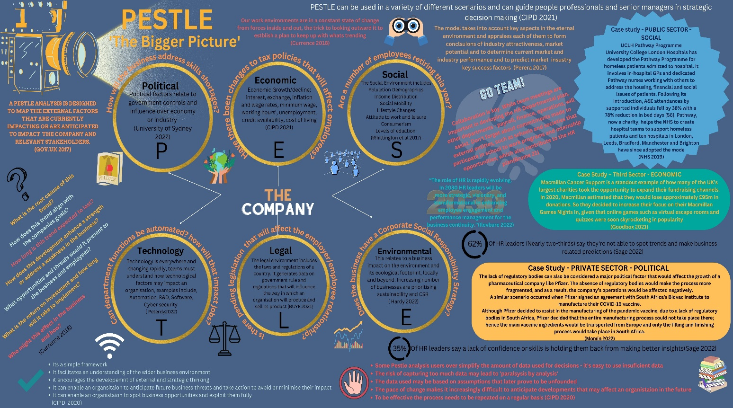

Infographic references

Victoria Jeffreys (1303685)
University of Wales Trinity St David
16th December 2022
Word Count: 965

Citations (also on Infographic)
(GOV.UK, 2017) (CIPD, 2021) (University of Sydney, 2022) (Perera, 2017) (Whittington, et al., 2017) (Buye, 2021) (Hardy, 2022) (Brome, 2021) (Currence, 2018) (Peterdy, 2022) (Brome, 2021) (Sage, 2022) (Sage, 2022) (CIPD, 2021) (Momin, 2022) (NHS, 2019) (Goodbox, 2021)

References
Brome, A., 2021. SHRM - The HR Department in Planning Mode. [Online]
Available at: https://www.shrm.org/resourcesandtools/hr-topics/behavioral-competencies/pages/the-hr-department-in-planning-mode.aspx?_ga=2.121340040.1663357677.1671013980-1488801608.1671013979
[Accessed 14 December 2022].
Buye, R., 2021. Critical examination of the PESTEL Analysis Model, Berlin: ResearchGate.
CIPD, 2021. PESTLE analysis. [Online]
Available at: https://www.cipd.co.uk/knowledge/strategy/organisational-development/pestle-analysis-factsheet
[Accessed 14 December 2022].
CIPD, 2021. PESTLE Analysis. [Online]
Available at: https://www.cipd.co.uk/knowledge/strategy/organisational-development/pestle-analysis-factsheet?pdf=true
[Accessed 14 December 2022].
Currence, J., 2018. SHRM - Cultivate Critical Evaluation with a PESTLE Analysis. [Online]
Available at: https://www.shrm.org/hr-today/news/hr-magazine/0618/pages/cultivate-critical-evaluation-with-a-pestle-analysis.aspx?_ga=2.57380010.1663357677.1671013980-1488801608.1671013979
[Accessed 14 December 2022].
Goodbox, 2021. A guide to overcoming challenges in fundraising. [Online]
Available at: https://www.goodbox.com/2021/10/biggest-challenges-in-fundraising/
[Accessed 14 December 2022].
GOV.UK, 2017. Department for Digital, Culture, Media and Sport. [Online]
Available at: https://www.gov.uk/government/publications/libraries-alternative-delivery-models-toolkit/stage-2-the-case-for-change
[Accessed 14 December 2022].
Hardy, N., 2022. Breath HR. [Online]
Available at: https://www.breathehr.com/en-gb/blog/topic/performance-and-productivity/what-is-a-pestle-analysis-and-why-is-it-important-to-hr
[Accessed 15 December 2022].
Momin, A., 2022. Pestle Analysis. [Online]
Available at: https://pestleanalysis.com/pfizer-pestle-analysis/
[Accessed 14 December 2022].
NHS, 2019. NHS - Stronger NHS action on helath inequlaities. [Online]
Available at: https://www.longtermplan.nhs.uk/online-version/chapter-2-more-nhs-action-on-prevention-and-health-inequalities/stronger-nhs-action-on-health-inequalities/
[Accessed 14 December 2022].
Perera, R., 2017. The Pestle Analysis. 1st ed. Sri Lanka: Nerdynaut.com.
Peterdy, K., 2022. Corporate Finance Institute - PESTEL Analysis. [Online]
Available at: https://corporatefinanceinstitute.com/resources/management/pestel-analysis/
[Accessed 14 December 2022].
Sage, 2022. Sage - HR in 2030, UK: Sage.
University of Sydney, 2022. Marketing: PESTLE Analysis. [Online]
Available at: https://libguides.library.usyd.edu.au/c.php?g=508107&p=5994242
[Accessed 14 December 2022].
Whittington, R. et al., 2017. Expolring Strategy ( Text and cases. 12th Edition ed. UK: Pearson.

