Component 2 – Research Report
Student Name: Sidi Mohamed Athmani
Student Number: 2123160
Lecturer Name: Ngozi Ibeji
BMSW4003_BIRM
Digital Skills and Research Methods

Abstract
Finding the digital tools which are used by college students to increase collaboration and describing the skills which are required in using the tools effectively in students is the main purpose of the report. The researcher has conducted a Microsoft Office survey form for collecting the data. The current research has selected the philosophy of the research interpretive to discuss the original scenario of the current use of digital media. The research has been conducted with 4 main digital communication technologies which are WhatsApp, Moodle, OneDrive, and MS Team. 6 participants show their interest and agreed to take part in the questionnaire and answer the questions. The result of the report has been presented using graphs and charts. Some skills and knowledge are required for using digital technology in business organizations which are word processing skills and managing privacy settings etc. Therefore, digital communication technologies are crucial for increasing collaboration in business organizations and digital skills help to use the technologies effectively.

Table of Contents
Abstract 2
Introduction 4
Research design 5
Research question 5
Methods 5
Main research method 6
Techniques and procedures of the data collection and analysis 6
Ethical considerations 6
Results 8
Discussion 13
Conclusion 15
References 16
Appendix – Copy of the Questionnaire 17

Introduction
The research report aims to find the digital tools which are used by college students to increase collaboration and describe the skills which are required in using the tools effectively in the students. The researcher has conducted a Microsoft Office survey form for collecting the data. The current research has selected the philosophy of the research interpretive to discuss the original scenario of the current use of digital media. The researcher will try his best to collect authentic and reliable information. Participants have voluntarily participated in the research. Sources of finding, affiliations in any structure and any conflicts of wiliness have been alleged (Teixeira da Silva, 2019). The research will be conducted with 4 main digital communication technologies which are WhatsApp, Moodle, OneDrive, and MS Team (Israel et al, 2021). The research result will be provided in the result section with a graph and chart. The result will be discussed in the report. The report will be conducted for finding the answers to research questions and the questionnaire provided in the appendix section.

Research design

Research question
The three research questions for this report have been provided in the below section-
The three research questions have been provided for the report:
- What are the most used digital media in conducting research and study by the students?
- To what extent the students are engaging themselves in using the social media tools in collaborating with each other?
3. What are the recommendations for students on using the successful media in collaborating the study?

Methods
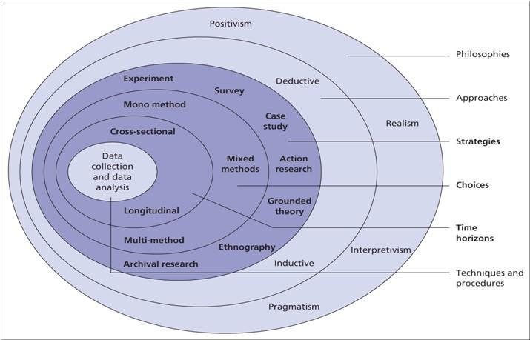

Figure: Research Onion (Melnikovas, 2018)

Main research method
The current research has selected the philosophy of the research interpretive to discuss the original scenario of the current use of the digital media and the way of incorporating the digital skills by the media on them (Ilomäki et al, 2016). Here, the cause is the help to the research questions by asking the participants the way of using digital media and developing their skills. Researchers will use the deductive approach in this research to help the collection of the survey based on primary data on limited samples from the college student population. The strategy of surveying the college students has been selected in the present strategy with the justification of the suitable mode of collecting data online for respecting the health guidelines of COVID-19 for public health safety (Ahmad et al, 2021). While the justification of the choice of the quantitative research has been justified for presenting the percentage and numerical form of what portion of students are using the different modes and mediums in the collaboration and communication (Cotos et al, 2020). As the data has been gathered in a single period of the cross-sectional body in 2022, the research has avoided the time series method for the research for completing the data collection within a particular time.

Techniques and procedures of the data collection and analysis
The researcher has conducted a Microsoft Office survey form for collecting the data in which an internet link has provided to the participants who were college students studying in a similar program (Dusek et al, 2015). 6 participants have taken part in the data collection process when online links of responding to 13 questions have supported the students to provide their answers. In the questionnaire form that is provided in appendix 1, the researchers have added 13 questions with the clause of the close-ended questions in which the degree of responses has been designed in a form of yes, no, null and Likert scale for knowing the agreeing and disagree degree with the researchers. Here, the researcher has used simple random sampling for justifying the reason for being fair and ethical in the study.

Ethical considerations
The researcher has tried his best to collect authentic and reliable information. Participants have voluntarily participated in the research. To encourage the participant to participate, the researcher has offered some incentives (Afkinich and Blachman-Demner, 2020). The researcher has maintained ethics in both primary and secondary research. During data collection, the researcher has shown enough respect to the participants and prioritized those (Saunders et al, 2018). Before asking the question, the research has obtained the full consent of the participants and ensured that their information privacy will be fully provided. Sources of finding, Affiliations in any structures and any conflicts of will have been alleged. The research relates to communication which has been completed with honesty and clearness (Richter et al, 2016). Any wrong information and biased demonstration of primary data getting have fully avoided conducting the research. Therefore, the researcher has maintained ethics from data collection to providing research results.

Results
In the result section, the researcher has presented the result of the research with Graphs and charts based on the survey questionnaire.
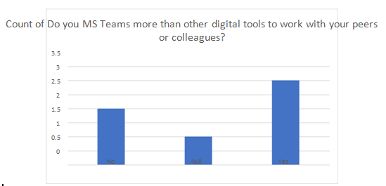
Figure: Do you use MS Teams more than other digital tools to work with your peers or colleagues?
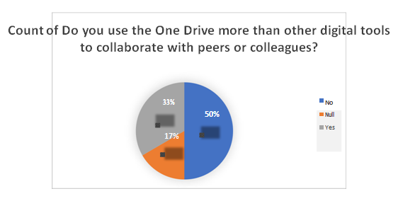
Figure: Do you use the OneDrive more than other digital tools to collaborate with peers or colleagues?
From the above two charts and graphs, MS Team is preferable for the students whose use rate is 60% as their digital tools to collaborate with their colleagues and friends. On the other hand, 50% of the participants have marled OneDrive as it is not preferable more than MS Team.

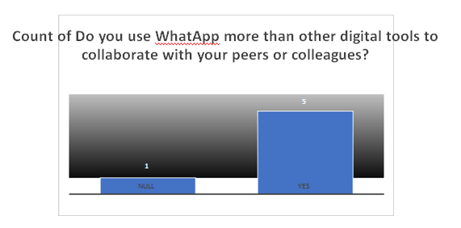
Figure: Do you use WhatsApp more than other digital tools to collaborate with your peers or colleagues?
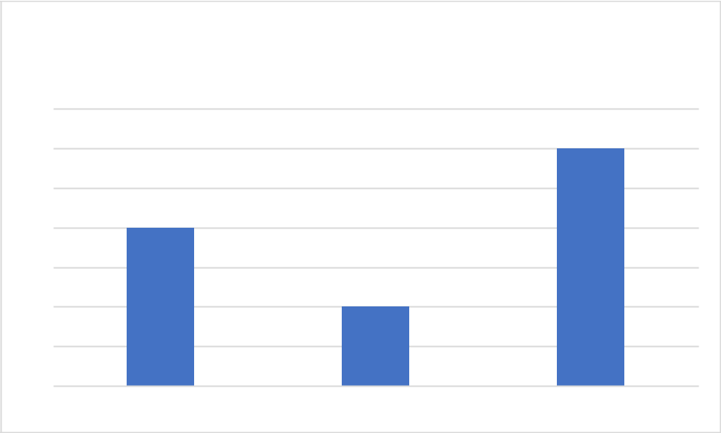

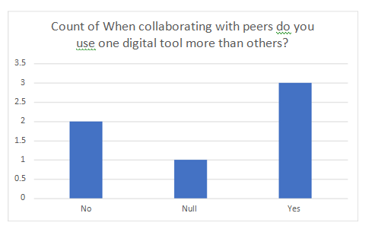
Figure: When collaborating with peers do you use one digital tool more than others?
Students are asked about digital tools and 5 students of 6 students have said that they prefer WhatsApp to collaborate with peers and colleagues. They use this tool for online communication when more than 50% of the participants use multiplatform as digital tools.
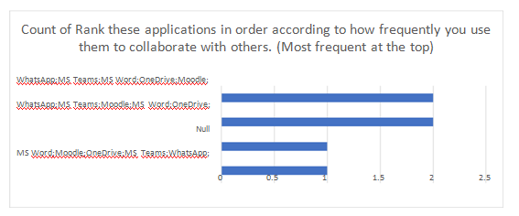
Figure: Rank these applications in order according to how frequently you use them to collaborate with others. (Most frequent at the top)
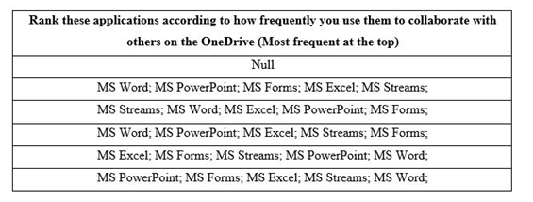
Figure: Rank these applications according to how frequently you use them to collaborate with others on the OneDrive. (Most frequent at the top)
Researchers asked the participants about the academic applications’ ranking like Microsoft services and their forms in which 70% of the students have marked in MS Word, MS PowerPoint, and Excel more repeatedly when WhatsApp and MS teams were used as communication platforms for the students.
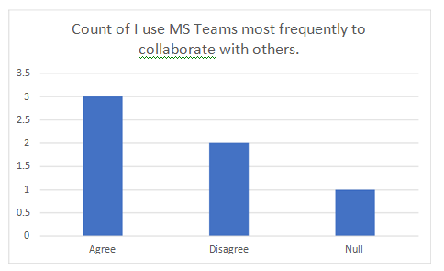
Figure: I use WhatsApp more than I use MS Teams to collaborate with others
In the perspective of using MS Team for collaboration with others, 3 participants from the 6 participants have marked that they used this platform for effective team collaboration and study when 2 students did not agree with the statement.
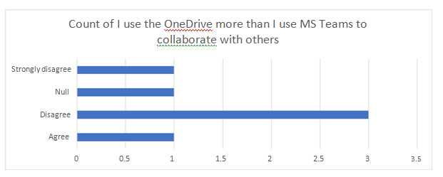
Figure: I use the OneDrive more than I use MS Teams to collaborate with others
In the case of using OneDrive, 1 and 3 students have respectively strongly disagreed and disagreed that they did not cloud platform more than MS Teams which points out less use of this cloud service among them.
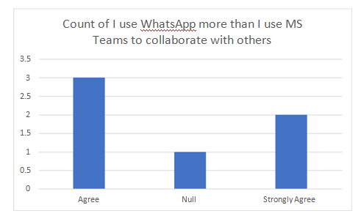
Figure: I use WhatsApp more than I use MS Teams to collaborate with others
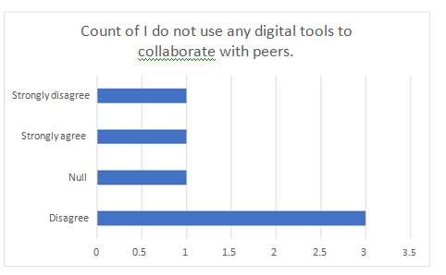
Figure: I do not use any digital tools to collaborate with peers.
When researchers asked the participants about WhatsApp, more than 70% of the participants have marked in agreed that they used the platform at least more than other digital tools because of confirmed by the above charts.

Discussion
As the researcher has added the research questions based on included the literature review that has raided in the instruction, the following section has pointed out the ways of showing the results which supported the argument and questions.
When the researcher asked to ask the value and preferences of the usage of various communication tools in the digital media and platforms, more than 60% of students answered that they preferred WhatsApp and MS Teams to communicate with their peers and colleagues. In this regard, the literature has argued primarily about the advantage or importance of the use of the applications in which the result has proved that some digital tools like WhatsApp and MS Teams are preferable to the participants than other tools like OneDrive and Messenger apps (Evans, 2017). As WhatsApp and MS Teams provide comfortable services and play a significant role in which the unlimited data sharing and multi-files management have supported the participants to use the platforms.
The results of the study have found the way of using academic and online applications by asking questions to the students and respondents to rank services and tools (Wang et al, 2020). The research has pointed out that students have argued about using MS Word, MS PowerPoint, and MS Excel because these services can be found free of cost and subscription cost is zero. The cloud-computing based services including their MS Forms have pointed out that college student uses cloud-based services provided in each application (Almajalid, 2017). As a result, the individual integration of the OneDrive services has achieved less popularity and usage rate among the students.
From the data taken by the researcher in this study, the result has approximated that almost all the students think about the interface of the user and experience while selecting the tools (Gibbs and Owens, 2012). Of the 6 participants, 5 participants have said that they choose the MS team for sharing their study-related course materials and conducting their communication with the teacher about their study-related queries. Kuhn and Maleki (2017) have shown that a similar phenomenon in which the research has operated that in the current century, everything on the platform with a simple and compatible user interface attracts the most users. In this case, the illustration in the literature review has connected with a similar concern, the preferable choice of digital platforms and gained skills in the operation of the facilities and services are relied on the experiences and simplicity of the users of the services given by the digital tools.
In the recommendation sector, it is recommended to the users of the digital told and platforms that the users require to take online training to effectively use the cloud services like Google Drive and OneDrive because the services are effective to access the course materials from by place of the world (Ghaffari and Lagzian, 2018). Moreover, it is also suggested to endorse the major course modules in the college standard to create the student be able to use the multidisciplinary applications like Google Classroom, Blackboard and Moodle that can enhance their area of knowledge to access the advanced setting for finding their valuable data and course-related materials.

Conclusion
After analyzing, the report it can be said that digital communication technologies are crucial for increasing collaboration and digital skills help to use the technologies effectively. The researcher has tried his best to collect authentic and reliable information. 6 participants have taken part in the online questionnaire survey. The researcher has used the deductive approach in this research to help the collection of the survey based on primary data. To collect the data, the researcher has conducted a Microsoft Office survey form in which an internet link has been provided to the participants who were college students studying in a similar program. From the result, it is found that most college students use WhatsApp and MS Team in their communication and collaboration. Some skills and knowledge are required for using digital technology which are word processing skills, managing privacy settings and email etc. Students require completing online training sessions to develop their digital skills for effectively using the technologies. Therefore, digital technologies are crucial for collaboration, efficiency and employability.

References
Afkinich, J.L. and Blachman-Demner, D.R., (2020). Providing incentives to youth participants in research: A literature review. Journal of Empirical Research on Human Research Ethics, 15(3), pp.202-215.
Ahmad, N., Hasan, M.G. and Barbhuiya, R.K., (2021). Identification and prioritization of strategies to tackle COVID-19 outbreak: A group-BWM based MCDM approach. Applied soft computing, 111, p.107642.
Almajalid, R., (2017). A survey on the adoption of cloud computing in education sector. arXiv preprint arXiv:1706.01136.
Cotos, E., Huffman, S. and Link, S., (2020). Understanding Graduate Writers' Interaction with and Impact of the Research Writing Tutor during Revision. Journal of Writing Research, 12(1).
Dusek, G., Yurova, Y. and Ruppel, C.P., (2015). Using social media and targeted snowball sampling to survey a hard-to-reach population: A case study. International Journal of doctoral studies, 10, p.279.
Evans, D.S., (2017). Why the dynamics of competition for online platforms leads to sleepless nights but not sleepy monopolies. Available at SSRN 3009438.
Ghaffari, K. and Lagzian, M., (2018). Exploring users’ experiences of using personal cloud storage services: a phenomenological study. Behaviour & Information Technology, 37(3), pp.295-309.
Gibbs, F. and Owens, T., (2012). Building better digital humanities tools. DH Quarterly, 6(2).
Israel, C., Olarewaju, O., Wing, J., Naicker, N. and Jali, L., (2021). ENSURING BUSINESS CONTINUITY IN HIGHER EDUCATION DURING LOCKDOWN 2020: A FACULTY RESPONSE AT THE DURBAN UNIVERSITY OF TECHNOLOGY. African Perspectives of Research in Teaching and Learning, 5(2), pp.99-114.
Kuhn, K.M. and Maleki, A., (2017). Micro-entrepreneurs, dependent contractors, and instaserfs: Understanding online labor platform workforces. Academy of Management Perspectives, 31(3), pp.183-200.
Ilomäki, L., Paavola, S., Lakkala, M. and Kantosalo, A., (2016). Digital competence–an emergent boundary concept for policy and educational research. Education and information technologies, 21(3), pp.655-679.
Melnikovas, A., (2018). Towards an explicit research methodology: Adapting research onion model for futures studies. Journal of Futures Studies, 23(2), pp.29-44.
Richter, S.R., Vineet, V., Roth, S. and Koltun, V., (2016), October. Playing for data: Ground truth from computer games. In European conference on computer vision (pp. 102-118). Springer, Cham.
Saunders, B., Sim, J., Kingstone, T., Baker, S., Waterfield, J., Bartlam, B., Burroughs, H. and Jinks, C., (2018). Saturation in qualitative research: exploring its conceptualization and operationalization. Quality & quantity, 52(4), pp.1893-1907.
Teixeira da Silva, J.A., Dobránszki, J., Bhar, R.H. and Mehlman, C.T., (2019). Editors should declare conflicts of interest. Journal of Bioethical Inquiry, 16(2), pp.279-298.
Wang, X., Hegde, S., Son, C., Keller, B., Smith, A. and Sasangohar, F., (2020). Investigating mental health of US college students during the COVID-19 pandemic: Cross-sectional survey study. Journal of medical Internet research, 22(9), p.e22817.

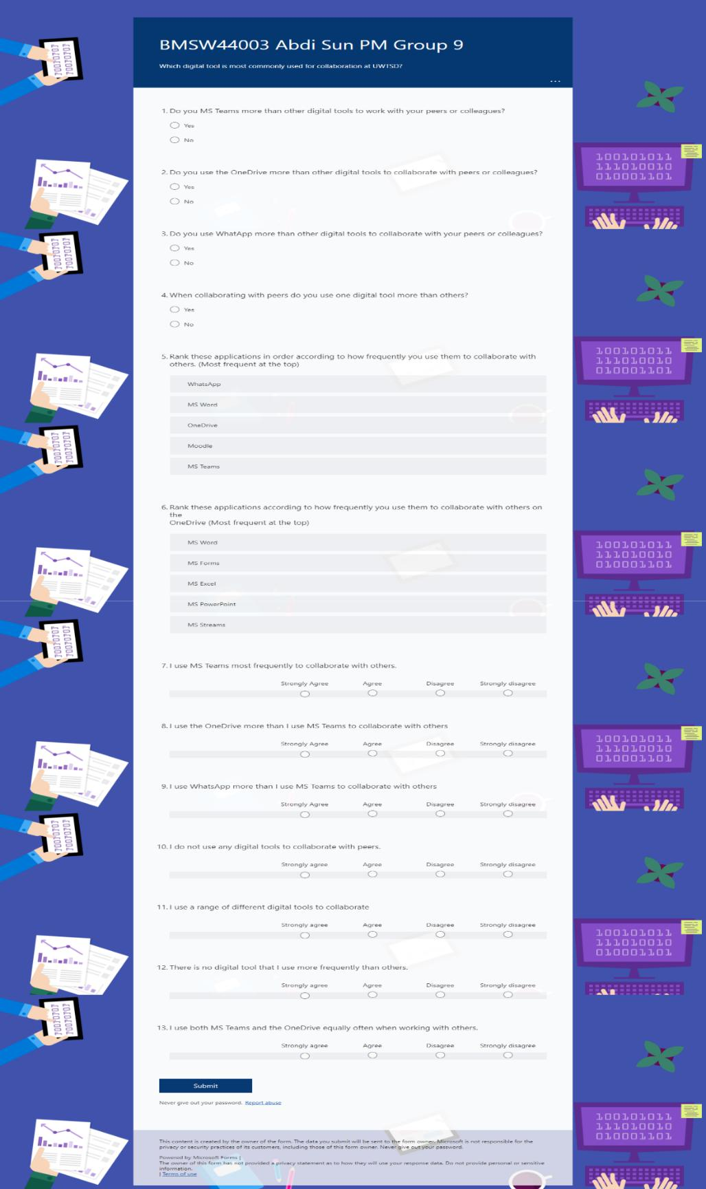
Appendix – Copy of the Questionnaire

