Elyse Hopkins P147297
BA (Hons) Illustration
Sarah Tombs
Q.3 How Do We Remember?

Analyzing the Effects of Memory, Commemoration and Remembrance Through Individuals Affected by War

The role of commemoration and remembrance in the society has a vast impact on sentimentality as humans; the suggested purpose is to contain the memory whether it be in a positive or a negative way. This leaves a psychological effect for individuals, especially those who were affected to the cause of the commemoration, to name an example a veteran of the first World War. Commemoration could be regarded as a historical reminder for future generations; to never forget a life changing event that would make an impact on the present day. As a society we celebrate memory or remembrance in different ways; for personal use which holds the memories of love and happiness with family and friends and capturing moments of enjoyment, which become keepsakes over time. We as humans also celebrate collectively, perhaps as a group, a community or greatly as a worldwide connection. A prime example would be photographs to capture memorable moments or to record life events.
Back in the early 19th Century the first technique of processing photographs was created by Joseph-Nicéphore Niépce, a French inventor who in 1826 invented a way of creating a “permanent photographic image” (Brittanica : date unknown). The technique was experimenting with lithograph and using a heliograph to reflect light using a mirror to create the image and the use of chemicals to sensitize metal plates, camera obscura, perhaps it can be argued to be one of the earliest forms of a lightbox film camera, (Jack and Beverly Wilgus, 2004 ) as the process is similar, ( Harry Ransom Centre, Date unknown). Previous to the invention of cameras and photography, painting the subjects were the only forms of recording the moments, therefore photography quickly became popular as it was not only more time efficient, it was new and exciting. Although this technique of photography would be less time consuming as other forms of media at the time, Niépce’s photographs would take as long as 8 hours to process. Fortunately, another French artist and photographer Louis Daguerre reduced the process time from 8 hours to 30 minutes which furthered the popularity of photographic film and created Daguerreotype. Similar to Niépce’s use of chemicals to create light sensitive surfaces to project an image, in this case using unexposed silver plates painting iodine mixed with bromine buffed onto the plates (daguerreobase, date unknown).

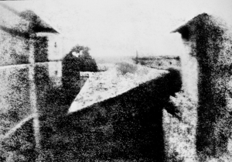
Figure 1: Joseph- Nicéphore Niépce (1826 – 1827) Point De Vue Du Gras Heliograph

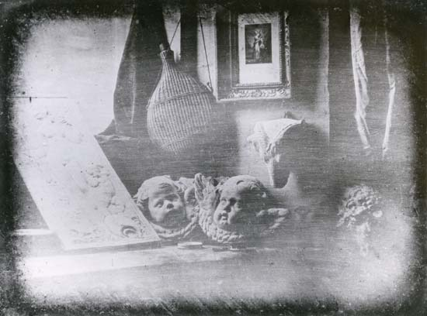
Figure 2: Louis Daguerre (1837) Still Life Daguerreotype
The two figures above represent both Niépce and Daguerre’s methods of capturing an image; figure 2 is clearer hence Daguerreotype was more successful and popular to use in photography at the time. Due to this, Niépce and Daguerre created a partnership, at this time, only the wealthy could afford to have photographs taken, so there was a diversity of social status between the rich and the poor of obtaining photographs (daguerreobase, date unknown). Capturing images of the deceased grew in popularity using Daguerreotype, arguably an association that many make when seeing and discussing Daguerreotype photography; or war time photographs. Therefore, alongside using photographs for memorable and happy events, they were to also record deaths and be used to make reminders of loved ones. The use of photographs particularly became popular during the first and second world wars, perhaps this was due to traumatic events occurring and the need to capture those moments for its historical value.
During the 1st and 2nd world war, photographs and paintings were huge forms portraying the horrors of war; from artists capturing not only the physical grief but the psychological stress. Soldiers would also illustrate being in the trenches such as David Jones.

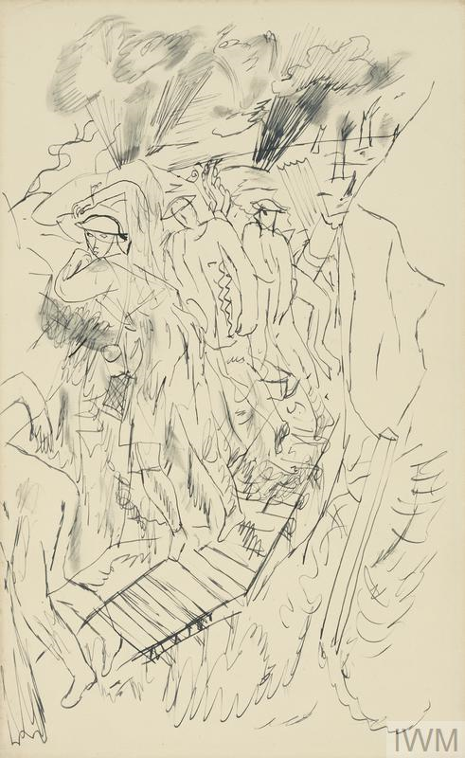
Figure 3: David Jones (1936) Life in the Trenches ink on paper, 33 x 20.4 cm
The Illustration above depicts soldiers in the trenches, the mark making of the drawing gives the viewer an impression of unease and “rushed” which could implicate the emotion that was felt at the time it was illustrated, “Jones regarded the war in epic terms, imbued with religious, moral and mythic overtones”. “The infantry men almost merge into one as they move along the trench, the narrowness of the duckboards emphasizing their precariousness as they teeter on the edge of safety amidst the explosion of shells” (2014 : 28), the importance of these types of illustrations lie within the honesty and accurate depiction of the living and working standards the soldiers had to endure whilst fighting with their lives in the name of their King and country. Similarly, photographs show the realities of war as many photographers also manned the trenches in their effort to capture the mass death in an honest light so that the people back home may understand the sacrifice their children loved ones made. it is suggested that as well as photographs showing the realities of war, the soldiers themselves portrayed their own perspective through the medium of art to express their current emotional state, perhaps grief and fear? Paintings and photos were popular in the World Wars, portraits of loved ones off to fight wars and “in action” photographs that showed distressing contents, representing of what it’s like being at the front line.
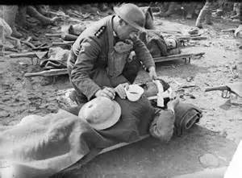
Figure 4: Ernest Brooks (1917) A Padre Gives a Drink to a Badly Wounded Soldier
The soldier’s perspective on the War would have had a psychological effect on the men’s mental health; many would suffer from post-traumatic stress disorders and shell-shock, therefore it could be argued that the soldiers may have perceived their memories of war in a warped and frightening way.
The notion of how memories were perceived followed into the second world war; the rise of the Nazi’s and the alienation of specific factions, namely the Jews in Europe. This brought psychological trauma and confusion, due the different interpretation of life, such as how the majority of Germany’s nation were left with a false representation of what Adolf Hitler’s motives were; they were led to be given a false reality and promised an utopian like vision of what Germany could be; the Nazi’s lied in their regime to convince the German public to go to war, “The Nazi regime even staged a border incident designed to make it appear that Poland initiated hostilities” “ Nazi propagandists convinced some Germans that the invasion of Poland and subsequent occupation policies were justified. For many others, the propaganda reinforced deep-seated anti-Polish sentiment.” (ushmm, date unknown).
This suggests that much of the German public’s interpretation of Nazi Germany was warped, as they were led believe in a vision that couldn’t be further from the truth. Children were the easiest to manipulate and brainwash in Hitler’s regime, “From the 1920s onwards, the Nazi Party targeted German youth as a special audience for its propaganda messages. These messages emphasized that the Party was a movement of youth: dynamic, resilient, forward-looking, and hopeful. Millions of German young people were won over to Nazism in the classroom and through extracurricular activities” (ushmm, date unknown) it implies that the Nazi were portraying a fun, happy illusion of war for the youth to like the idea of going to war and rather to make it into a “game”. This in contrast to the fun exciting summer camp like activities Hitler youth’s endured; it was a hellish nightmare for the minorities and Jewish children of Europe, they suffered the hard labor within the concentration camps. Children were also used as experiments, stripping them of their innocence and their ordinary childhood to be used as human guinea pigs, twin children were favorited during these experiments; “Mengele would get very excited when he found twins” Dr Mengele or known as the “Angel Of Death” was intrigued in the experimentation of children with genetic anomalies, (Auschwitz, 2017).
“Besides having blood drawn, the twins underwent various medical experiments. Mengele kept his exact reasoning for his experiments a secret. Many of the twins that he experimented on weren't sure for what purpose the individual experiments were for or what exactly what was being injected or done to them” (Jennifer Rosenberg, 2017). The article expresses that Mengele took an interest to these children and gave them special treatment of playing, giving “chocolate and candy”, to even referring to him as “uncle Mengele” (Jennifer Rosenberg, 2017) this suggests Mengele wanted to portray himself as a good character; it’s not clear why his intentions were to appear nice initially, perhaps not cast fear into the children? These acts of kindness would soon end as the children would be sent off to be experimented on, Mengele’s experiments included a variety of gruesome procedures that led to illness, mutilation and death- “After one of those injections I became very ill, with a very high fever… my legs and arms were swollen and very painful. I was trembling as the August sun was burning my skin, I had huge red spots covering my body.” (Buzzfeedvideo:2017). These experiments on the children would not only have left psychological damage but it’s a physical reminder to what happened to them. The way the children were treated during the 1st and 2nd world war and how they perceived it could not be imagined from an adult’s perspective; the raw heart break and anguish of losing loved ones and enduring torture in which a child should never experience.
Overall, both world wars had a devastating impact on the lives of millions, thus to commemorate the events that happened communities and countries made events such as Remembrance Day or commemorative statues, art pieces, memorabilia to never forget what took place in the past “For centuries, commemorative statues, buildings and monuments have been erected in memory of those who perished in wars, natural disasters, major accidents and even terrorist attacks. Citizens from all over the world join forces and create public remembrances of those killed during these historic events. It is because of this reason why we establish memorials -- so future generations will understand the sacrifices made by those who died.” – (Beth Adomaitis: 2017). The way we celebrate the likes of the world wars in the 20th century differs from how we would celebrate in modern day; statues of the fallen soldiers in the war and wearing poppies to show respect, (BBC: 2014) to modern art pieces that signify an event that occurred such as The German memorial in Berlin to commemorate the murdered Jews;
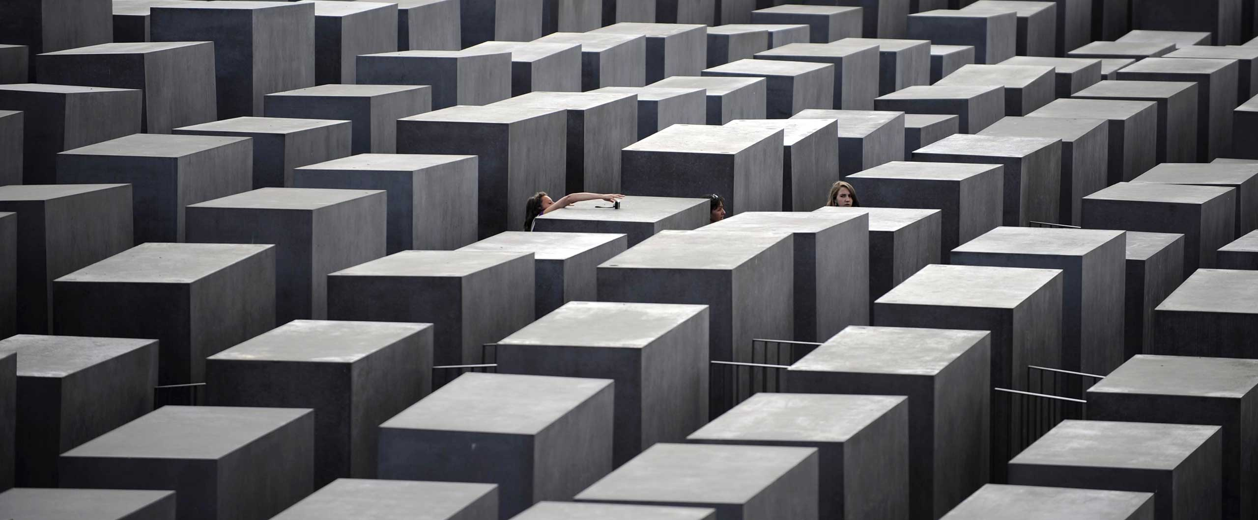
Figure 5: Peter Eisenman (2005) Memorial of the Murdered Jews of Europe
The figure above shows 2711 concrete blocks; representing “tombstones” and each block is different in height, which children would play on them, (Berlin :2017). This is intriguing as this form of memorial is a free access to all and that “children would climb” on the monumental pieces, in contrast adults would be more reserved or more respectful to these monuments. It could be argued that the modern memorials of events are more interactive compared with statues or the memorabilia of World War 1; another example would be the Jewish museums in dedication of World War 2 that show not only what happened at the time but also to celebrate the culture and religion; to move forward from the past (Jewish museum : date unknown). This implicates the way culture has perhaps changed over time, there is potentially better understanding for all age groups; most especially children to learn of the importance of what went on through interaction. Furthermore, it’s possible that another purpose of commemoration and remembrance is to educate for the future generation to understand and ensure that events like the world wars would not happen again. Overall From researching and analyzing the ways photographs and art was used to commemorate War; research has suggested that war was interpreted differently in the respect that how children of that time experienced war differently to the soldiers. It shows how people perceived memories or events in their lives differently to one another possibly due to their upbringing, societal differences and quality of life?

Bibliography
Websites
Anon, (2017). What is a Daguerreotype. [online] Available at: http://http;//www.daguerreobase.org/en/knowledge-base/what-is-a-daguerreotype [Accessed 14 Dec. 2017].

Anon, (2017). What is the purpose of a Photograph?. [online] Available at: https://www.quora.com/What-is-the-purpose-of-a-photograph [Accessed 14 Dec. 2017].

Anon, (2017). When Was The camera Invented. [online] Available at: https://www,reference.com/history/first-camera-invented-422579aae26bb8a8 [Accessed 14 Dec. 2017].

BBC Guides. (2017). Did shell shock make us serious about mental health?. [online] Available at: http://www.bbc.co.uk/guides/zwg9kqt [Accessed 14 Dec. 2017].

BBC News. (2017). The twins of Auschwitz. [online] Available at: http://www.bbc.co.uk/news/magazine-30933718 [Accessed 14 Dec. 2017].

Brightbytes (2017). What is a camera obscura?. [online] Available at: http://brightbytes.com/cosite/what.html [Accessed 14 Dec. 2017].

Encyclopedia Britannica. (2017). daguerreotype | photography. [online] Available at: http://www.britannica.com/technology/daguerreotype [Accessed 14 Dec. 2017].

Encyclopedia Britannica. (2017). Nicephore Niepce | French inventor. [online] Available at: http://britannica.com/biography/Nicephore-Niepce [Accessed 14 Dec. 2017].

Hrc.utexas.edu. (2017). Joseph Nicéphore Niépce: The First Photograph. [online] Available at: http://www.hrc.utexas.edu/exhibitions/permanent/firstphotograph/niepce/#top [Accessed 14 Dec. 2017].

Iwm.org.uk. (2017). Life in the Trenches: Sketch A (Art.IWM ART 15122). [online] Available at: http://www.iwm.org.uk/collections/item/object/14471 [Accessed 14 Dec. 2017].

Iwm.org.uk. (2017). THE BATTLE OF PASSCHENDAELE, JULY-NOVEMBER 1917 (Q 2855). [online] Available at: http://www.iwm.org.uk/collections/item/object/205194742 [Accessed 14 Dec. 2017].

Nicephore Niepce House Photo Museum. (2017). Nicéphore Niépce House Museum inventor of photography - Nicephore Niepce House Photo Museum. [online] Available at: http://www.photo-museum.org/ [Accessed 14 Dec. 2017].

NightWatch Paranormal. (2017). Daguerreotype Death portraits. [online] Available at: http://www.nightwatchparanormal.com/daguerreotype-death-portraits.html [Accessed 14 Dec. 2017].
The Jewish Museum. (2017). About. [online] Available at: http://thejewishmuseum.org/about#jewish-museum-history [Accessed 14 Dec. 2017].

ThoughtCo. (2017). Meet Louis Daguerre: Father of Daguerreotype Photography. [online] Available at: http://www.thoughtco.com/louis-daguerre-daguerreotype-1991565 [Accessed 14 Dec. 2017].

ThoughtCo. (2017). Mengele's Children: The Twins of Auschwitz. [online] Available at: http://www.thoughtco.com/mengeles-children-twins-of-auschwitz-1779486 [Accessed 14 Dec. 2017].
Books
Art from the First World War. (n.d.). .

Bohm-Duchen, M. (1995). After Auschwitz. Sunderland [u.a.]: Northern Centre for Contemporary Art [u.a.].

Carmichael, J. (2003). First World War photographers. London: Routledge, p.28.

Kurlander, E. (n.d.). Hitler's monsters.

Struk, J. (2011). Photographing the Holocaust. London [u.a.]: I.B. Tauris.
Online Videos:
BuzzFeedVideo (2017) I Survived The Holocaust Twin ExperimentsAvailable at: https://www.youtube.com/watch?v=gdgPAetNY5U (Date Accessed: 18/03/2018)

