Weka Tutorial - Part 1

Introduction

This is a tutorial for those who are not familiar with Weka, the data mining package we'll be using in DH&BI, which was built at the University of Waikato in New Zealand. Weka is an open source collection of data mining tasks which you can utilize in a number of different ways. It comes with a Graphical User Interface (GUI).

Weka is installed on all the machines in AS218, but you can also download it to use at home. There are a number of different versions, depending on which operating system you're using. The downloads and installation instructions can be found at Weka's homepage. It will work on PCs and MACs

First Steps

Start up Weka (it's listed under All Programs, You'll have a choice between the command line interface (CLI), the Experimenter, the Explorer and Knowledge flow. Initially, we'll stick with the Explorer. Once you click on that you'll see the (initially empty) main GUI.

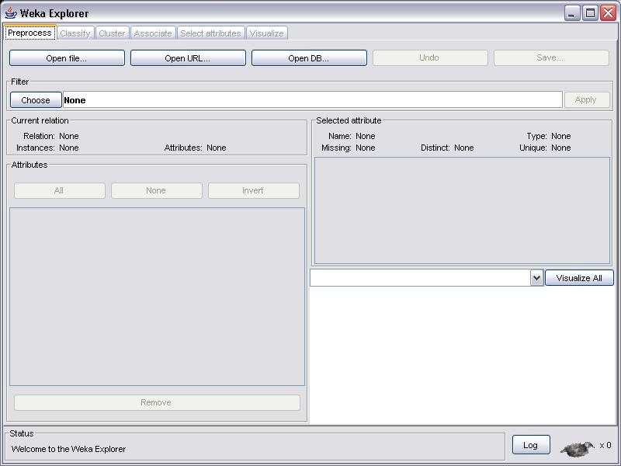

You now have a number of choices, but before you can work with any data, you'll have to load it into Weka. Rather than opening a file we’ll go straight to a file on the internet. Click Open URL and type the following address:
http://www.hakank.org/weka/iris.arff

The Iris flower dataset is a famous dataset from statistics and is heavily borrowed by researchers in machine learning. It contains 150 instances (rows) and 4 attributes (columns) and a class attribute for the species of iris flower (one of setosa, versicolor, virginica)
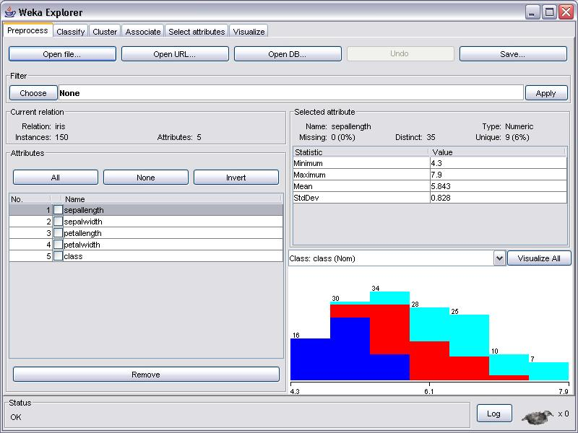

You'll notice that Weka now provides some information about the data, such as for example the number of instances, the number of attributes, and also some statistical information about the attributes one at a time.
Figure out how to switch between attributes for which this statistical information is displayed.

Visualisation
There are a number of ways in which you can use Weka to visualize your data. The main GUI will show a histogram for the attribute distributions for a single selected attribute at a time, by default this is the class attribute. Note that the individual colors indicate the individual classes (the Iris dataset has 3). If you move the mouse over the histogram, it will show you the ranges and how many samples fall in each range. The button VISUALIZE ALL will let you bring up a screen showing all distributions at once as in the picture below. Take some time to look at the image and what it tells you about the attributes.

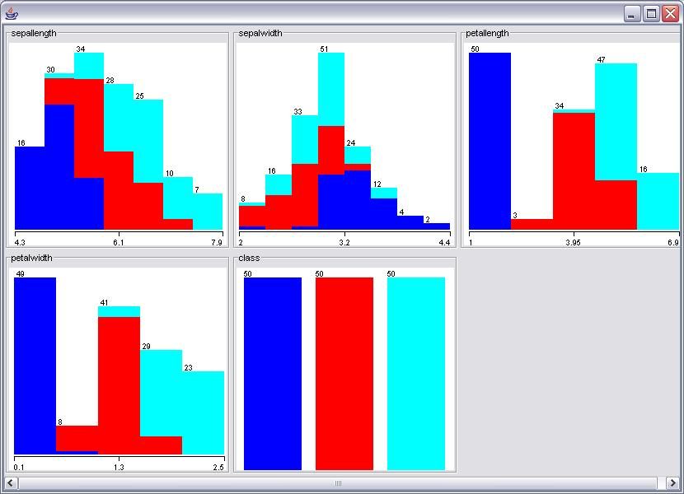

There is also a tab called called VISUALIZE. Clicking on that will open the scatterplots for all attribute pairs:

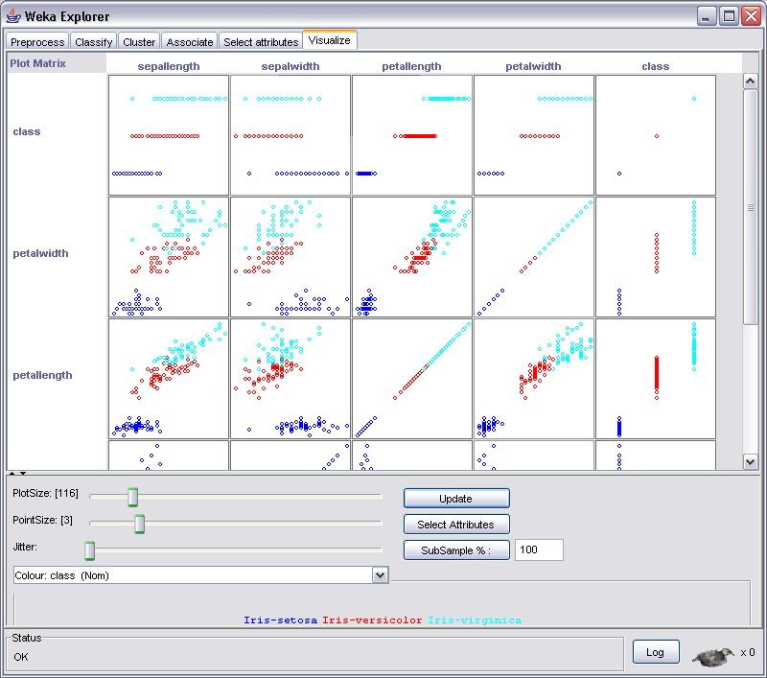

From these scatterplots, we can infer a number of interesting things. For example, in the picture above we can see that in some examples the clusters (for now, think of clusters as collections of points that are physically close to each other on the screen) and the different colors correspond to each other such as for example in the plots for class/(any attribute) pairs and the petalwidth/petallength attribute pair, whereas for other pairs (sepalwidth/sepallength for example) it's much harder to separate the clusters by color.

By default, the colors indicate the different classes, in this case we used red and two shades of blue. Left clicking on any of the highlighted class names towards the bottom of the screenshot allows you to set your own color for the classes. Also, by default, the color is used in conjunction with the class attribute, but it can be useful to color the other attributes as well. For example, changing the color to the fourth attribute by clicking on the arrow next to the bar that currently reads Color: class (Num) and selecting petalwidth enables us to observe even more about the data, for example the fact that for the class/sepallength attribute pair, which range of attribute values (indicated by different color) tends to go along with which class.

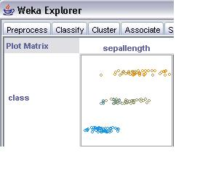
The log file
The log file is used to keep track of what you did. Clicking on LOG in your main GUI will bring up another window which will show exactly what you did, in this case it shows that we loaded the Iris data set and applied a filter.

A good youtube video tutorial using Weka and the Iris data can be found at :
https://www.youtube.com/watch?v=aF7FEjplYPg

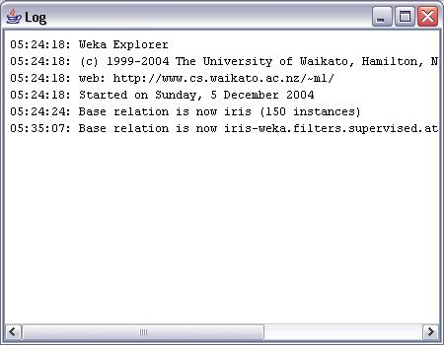

Note: to get a screenshot of the active window, press ALT + PrtSc. You can then paste it from the clipboard to another application, for example paint.
Making your own arff file
To use Weka with a data set that isn't included in the package already, the data you want to examine needs to be in a certain format. If you open the Iris data for example using a text editor, you'll notice that in addition to the data, it contains information about the data. Part of the Iris data file is shown below.

Easiest way to create an arff files is to create a table with headers in excel. Save this to .csv format. Then follow this 30 second tutorial:

http://shouldline31.blogspot.co.uk/2010/08/convert-csv-to-arff-using-weka-36.html

Additional information about Weka's data format ARFF.

So far so good? Let’s do some data analysis….

Regression
Regression is the easiest technique to use, but is also probably the least powerful (funny how that always goes hand in hand). This model can be as easy as one input variable and one output variable (called a Scatter diagram in Excel, or an XYDiagram in OpenOffice.org). Of course, it can get more complex than that, including dozens of input variables. In effect, regression models all fit the same general pattern. There are a number of independent variables, which, when taken together, produce a result — a dependent variable. The regression model is then used to predict the result of an unknown dependent variable, given the values of the independent variables.
Everyone has probably used or seen a regression model before, maybe even mentally creating a regression model. The example that immediately comes to mind is pricing a house. The price of the house (the dependent variable) is the result of many independent variables — the square footage of the house, the size of the lot, whether granite is in the kitchen, bathrooms are upgraded, etc. So, if you've ever bought a house or sold a house, you've likely created a regression model to price the house. You created the model based on other comparable houses in the neighborhood and what they sold for (the model), then put the values of your own house into this model to produce an expected price.
Let's continue this example of a house price-based regression model, and create some real data to examine. These are actual numbers from houses for sale in my neighborhood, and I will be trying to find the value for my own house.

Table 1. House values for regression model
House size (square feet) | Lot size | Bedrooms | Granite | Upgraded bathroom? | Selling price
3529 | 9191 | 6 | 0 | 0 | £205,000
3247 | 10061 | 5 | 1 | 1 | £224,900
4032 | 10150 | 5 | 0 | 1 | £197,900
2397 | 14156 | 4 | 1 | 0 | £189,900
2200 | 9600 | 4 | 0 | 1` | £195,000
3536 | 19994 | 6 | 1 | 1 | £325,000
2983 | 9365 | 5 | 0 | 1 | £230,000
3198 | 9669 | 5 | 1 | 1 | ????
The good news (or bad news, depending on your point of view) is that this little introduction to regression barely scratches the surface, and that scratch is really even barely noticeable. There are entire college semester courses on regression models, that will teach you more about regression models than you probably even want to know. But this scratch gets you acquainted with the concept and suffice for our WEKA tests in this article. If you have continued interest in regression models and all the statistical details that go into them, research the following terms with your favorite search engine: least squares, homoscedasticity, normal distribution, White tests, Lilliefors tests, R-squared, and p-values.

Building the data set for WEKA
To load data into WEKA, we have to put it into a format that will be understood. WEKA's preferred method for loading data is in the Attribute-Relation File Format (ARFF).

Create an excel spreadsheet:

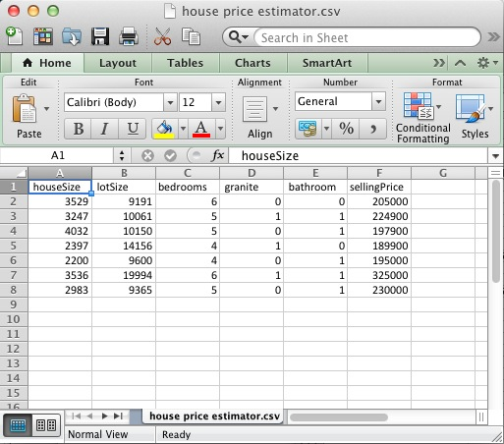

save this as: houseprice_estimator.csv in a place you can remember (desktop or docs folder).

Now go back to the GUI interface for Weka:


Click on Tools>ArffViewer>File>Open

Locate your houseprice_estimator.csv
Double click on the file and Save As>Arff

Now open the Weka explorer menu and load your new ARFF file.
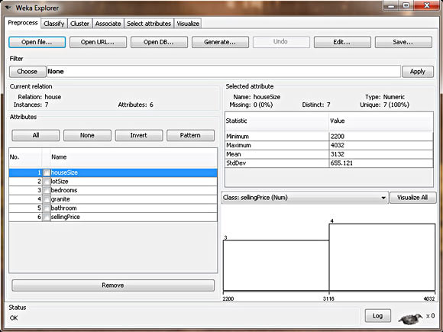

In this view, WEKA allows you to review the data you're working with. In the left section of the Explorer window, it outlines all of the columns in your data (Attributes) and the number of rows of data supplied (Instances). By selecting each column, the right section of the Explorer window will also give you information about the data in that column of your data set. For example, by selecting the houseSize column in the left section (which should be selected by default), the right-section should change to show you additional statistical information about the column. It shows the maximum value in the data set for this column is 4,032 square feet, and the minimum is 2,200 square feet. The average size is 3,131 square feet, with a standard deviation of 655 square feet. (Standard deviation is a statistical measure of variance.) Finally, there's a visual way of examining the data, which you can see by clicking the Visualize All button. Due to our limited number of rows in this data set, the visualization is not as powerful as it would be if there were more data points (in the hundreds, for example).
Enough looking at the data. Let's create a model and get a price for my house.
Creating the regression model with WEKA

To create the model, click on the Classify tab. The first step is to select the model we want to build, so WEKA knows how to work with the data, and how to create the appropriate model:
- Click the Choose button, then expand the functions branch.
- Select the LinearRegression leaf.
This tells WEKA that we want to build a regression model. As you can see from the other choices, though, there are lots of possible models to build. Lots! This should give you a good indication of how we are only touching the surface of this subject. Also of note: There is another choice called SimpleLinearRegression in the same branch. Do not choose this because simple regression only looks at one variable, and we have six. When you've selected the right model, your WEKA Explorer should look like the Figure below:
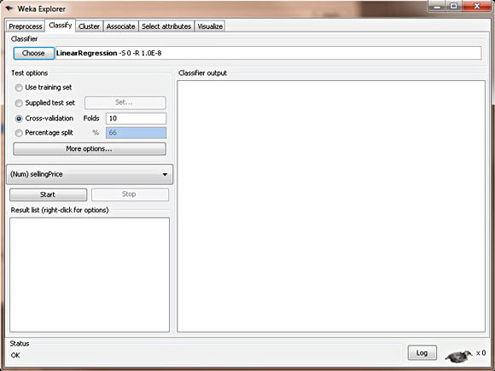

Now that the desired model has been chosen, we have to tell WEKA where the data is that it should use to build the model. Though it may be obvious to us that we want to use the data we supplied in the ARFF file, there are actually different options, some more advanced than what we'll be using. The other three choices are Supplied test set, where you can supply a different set of data to build the model; Cross-validation, which lets WEKA build a model based on subsets of the supplied data and then average them out to create a final model; and Percentage split, where WEKA takes a percentile subset of the supplied data to build a final model. These other choices are useful with different models, which we'll see in future articles. With regression, we can simply choose Use training set. This tells WEKA that to build our desired model, we can simply use the data set we supplied in our ARFF file.
Finally, the last step to creating our model is to choose the dependent variable (the column we are looking to predict). We know this should be the selling price, since that's what we're trying to determine for my house. Right below the test options, there's a combo box that lets you choose the dependent variable. The column sellingPrice should be selected by default. If it's not, please select it.
Now we are ready to create our model. Click Start. Figure 5 shows what the output should look like.

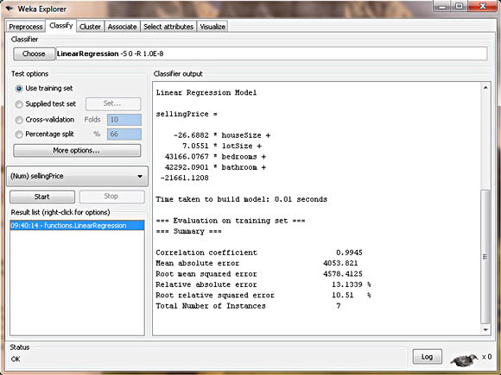

Interpreting the regression model
WEKA doesn't mess around. It puts the regression model right there in the output, as shown below:

sellingPrice = (-26.6882 * houseSize) +
(7.0551 * lotSize) +
(43166.0767 * bedrooms) +
(42292.0901 * bathroom)
- 21661.1208

It has create an algorithm to work out selling prices of property based on the attributes we chose.

House value using regression model

Plugging in the attributes of my house (maybe using excel) I can estimate its selling price.

sellingPrice = (-26.6882 * 3198) +
(7.0551 * 9669) +
(43166.0767 * 5) +
(42292.0901 * 1)
- 21661.1208

sellingPrice = 219,328

However, data mining isn't just about outputting a single number: It's about identifying patterns and rules. It's not strictly used to produce an absolute number but rather to create a model that lets you detect patterns, predict output, and come up with conclusions backed by the data. Let's take another step and interpret the patterns and conclusions that our model tells us, besides just a strict house value:
- Granite doesn't matter— WEKA will only use columns that statistically contribute to the accuracy of the model (measured in R-squared, but beyond the scope of this article). It will throw out and ignore columns that don't help in creating a good model. So this regression model is telling us that granite in your kitchen doesn't affect the house's value.
- Bathrooms do matter— Since we use a simple 0 or 1 value for an upgraded bathroom, we can use the coefficient from the regression model to determine the value of an upgraded bathroom on the house value. The model tells us it adds $42,292 to the house value.
- Bigger houses reduce the value— WEKA is telling us that the bigger our house is, the lower the selling price? This can be seen by the negative coefficient in front of the houseSize variable. The model is telling us that every additional square foot of the house reduces its price by $26? That doesn't make any sense at all! Bigger is better!. How should we interpret this? This is a good example of garbage in, garbage out. The house size, unfortunately, isn't an independent variable because it's related to the bedrooms variable, which makes sense, since bigger houses tend to have more bedrooms. So our model isn't perfect. But we can fix this. Remember: On the Preprocess tab, you can remove columns from the data set. For your own practice, remove the houseSize column and create another model. How does it affect the price of my house? How does this new model make more sense? (My amended house value: $217,894).

Note to statisticians
This model breaks several requirements of a "proper" linear regression model, since every column isn't truly independent, and there aren't enough rows of data to produce a valid model. Since the primary purpose of this article is to introduce WEKA as a data-mining tool, we are oversimplifying the example data.

