

Engineering application and study skills
Jonathan Pugh
1808090
27/3/20

Session 1 laith workshop
Date: 30/09/19
Instructors: Andrew Tibbott & David Cooper
Aim: health and safety with a brief discussion of how things work
PPE: Safety boots
Safety boots
Safety googles
Lab coat
Removal of any jewellery (watches ect)
After health and safety brief from Andy and Dave we were shown how to use and safe practice of the tools and machinery in the workshop
We achieved a basic understanding of the workshop safety procedures and how to use the machinery correctly.

Session 3 engine rebuild
Date: 17/10/20
Time: 9am
Instructors: Barry
P.P.E.:
- Steel toe cap boots
- Lab coat
- Protective eyewear (where needed)

Aim: Measure the piston and rebuild the engine block
- lay out the equipment
- measure the width and length of the piston head and record the results in the given handbook (018 Workshop zetec Engine Measurements)
- using the micrometre measure:
all measurements will be in mm
the 4 piston crowns
4 piston skirts
5 main crankshaft journal diameters
4 big end journal diameters
Thrust washer on main end bearing 3
All cylinder bore values
Cylinder 1 stroke
All main bearings (make sure you measure both halves, top and bottom)
All big end bearings (top and bottom again)
Inlet valve spring free length
Inlet valve stem diameter
Inlet valve head diameter
- once you have all the measurements recorded you can then calculate the actual engine capacity(cc)
- use the equation 0.7854 x bore(cm) x bore(cm) x stroke(cm) x number of cylinders
- after the logbook is completed and all measurements have been taken then start the rebuild process
- It is a good idea to use a technical data sheet with all the correct torque setting on for reference
- Using the tools provided re insert the engine parts that we set aside earlier
- Re insert the piston with the piston tool so that the piston rings are correctly positioned
- Re attach the piston caps and torque them down to the correct spec
- Attach the crank cover and tighten correctly
- The pickup pipe can now be installed on the bottom end
- Once the pickup pipe is correctly fastened, we then re attached the sump
- Using the engine crate, we rotated the engine 180* to begin work on the top of the block
Observations:
the previous rebuild was done very poorly and most of the bolts were either stripped bent snapped or just missing. We tried to correctly re insert and repair the block as much as possible but there was a lot of damage we couldn’t repair. One thing that should be mentioned is that the size of the piston crown was sometimes bigger than the bore of the engine so that it seemed as if it shouldn’t fit. However this being said the cylinders are not perfectly cylindrical meaning that the measurements would need to be done with a laser micrometre to show exact results

What we achieved from the session:
the measurements were all taken and most of the block had been rebuilt ready for next week. The tools and remaining engine pieces were correctly stored and cleaned away

Feedback:
I would like to see the engines be correctly rebuilt with the missing bolts fitted and a laser micrometre used to show the exact measurements of the cylinder

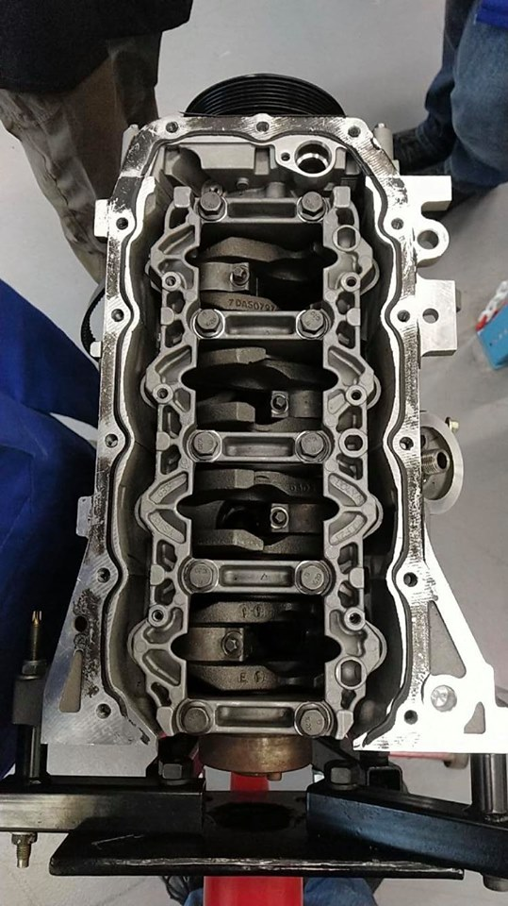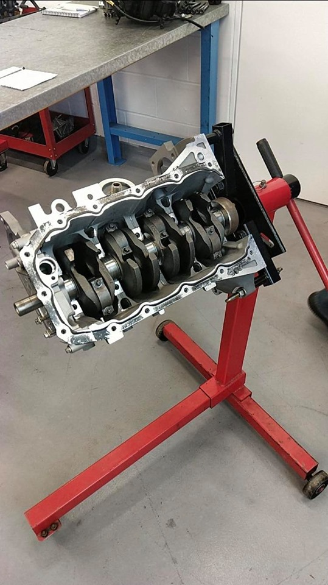

Guest lecture
Date:
Time:
Location:
Speaker:
Unfortunately I did not attend any guest lectures due to prior commitments

