University of Wales Trinity Saint David
School of Engineering

Engine Performance Characteristics
Vehicle Technology (M4X00394)

Harry Rivers
1902574
January 7th 2020

Contents
1 Introduction 1
1.1 Aims 1
1.2 Objectives 1
2 Experimental Procedure 2
3 Results 4
4 Results Analysis 6
5 Evaluation 10
6 References 11

Introduction

Aims
- Data that allows me to create graphs and easily spot trends
- Verify my graphs by comparing them to external no biased sources

Objectives
- I will achieve this aim by using the correct and verified equations in my spreadsheet, this will allow me to make sure that my data is correct and will lead to a graph that meets my aim
- The graph will be verified by researching into graphs that can verify the same trends in the graphs as me or help

Experimental Procedure
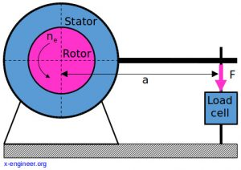
Figure 1 – Dynamometer (x-engineer, 2017)
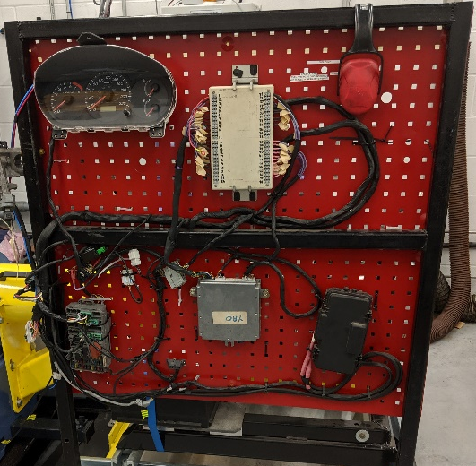
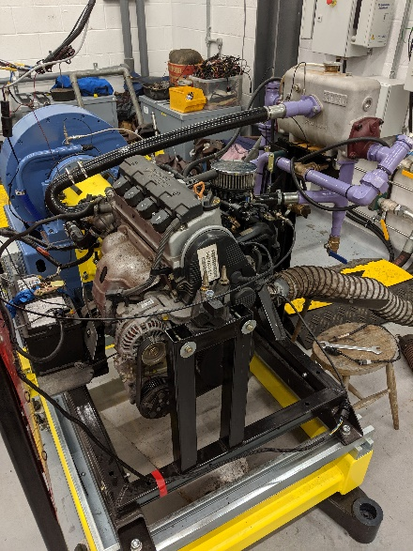
‘The dynamometer is basically a brake (mechanical, hydraulic or electrical) which absorbs the power produced by the engine.’ (x-engineer, 2017) There are two ways to control the dynamometer, first option is to control the system manually. When the system is controlled manually the user has to change the speed of the dyno (rpm) and the load placed on the dyno. When doing this method if both dials aren’t being operated in sync it will cause the engine to stall. The image below is an example of two people operating the dyno manually.
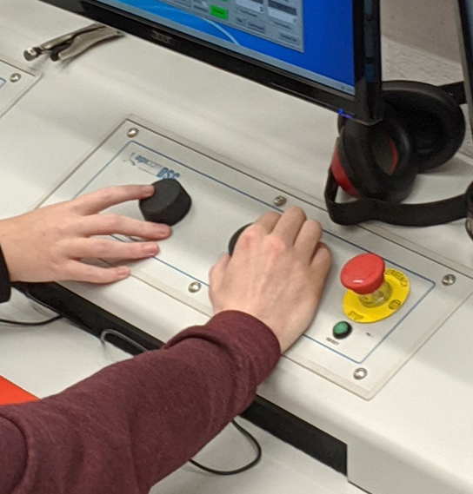
The second way of getting data from the dyno is by the computer controlling the dyno. When letting the computer control the dyno, the user can set the maximum engine speed they want, they can set a time for how long they want the dyno to stay at a certain rpm and can set at what points they want data to be gathered from the dyno. The second method is the better option as it stops any human error from occur when gathering data, this is good as the user knows that their data is reliable. The data collected from the dyno was the load on the engine (N), the engine/dyno speed (rpm) and the fuel flow rate (I/min). Once all this data has been gathered it should be placed in a spreadsheet.

Results
From the experiment I got my values for Load (N), Dyno Speed (rpm), Fuel Flow Rate (I/min) and Lambda. Also, from the day I got the values for Baro (mBar) which was 1027.85 bar, Humidity (%) with a value of 31.38 and Ambient temp (Degrees C) with a value of 25C. To calculate the value of torque is used the equations T=WR, W is the value of the load and R is the radius of the torque arm. The value for R was found on the side of the machiene in millimeteres so it needed to be converted into meteres.
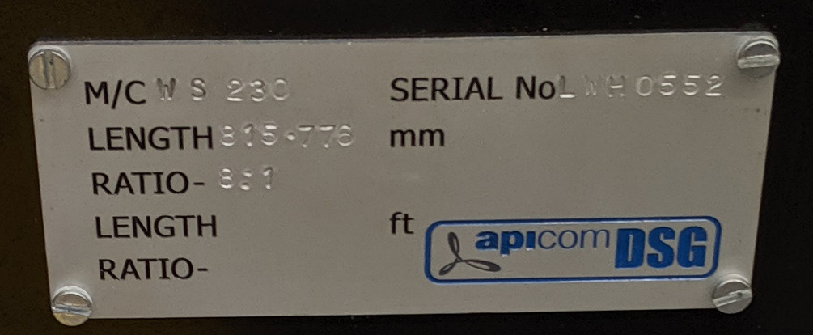
To calculate the Brake Power produced I used the equation $BP=\frac{2πNT}{60}$ where N is the engine/dyno speed and T is the Torque. I got the value for N from my experiment, the value for torque was calculated from the previous equation. When it came to calculating the corrected power the equation, I used this equation $Ps=BP\frac{1.01325}{p_{a}}\sqrt{\frac{T_{a}}{293}}$ in this equation Ta is the temperature of the day and Pa is the pressure for that day. Ta is the same as the ambient temperature which had a value of 25C. Pa has the same value as Baro which is 1027.85 mBar. As this value is in millibar it has to be converted into bar by dividing the value by 1000. Before I calculate the specific fuel consumption, I firstly have to convert the volumetric flow rate units as this will allow me to get the S.F.C units as kg/kWh. Firstly, I converted the volumetric flow rate from I/min to kg/min by multiplying by the specific gravity of fuel. I found the value for the specific gravity of fuel by searching for documents that had close to the same values the most common value I found is 0.739.
Figure 2- Specific Gravity of Fuel (Engineering Tool Box, 2003)
Secondly, I converted the value from kg/min to kg/hour my dividing the value I got by 60. Finally, to convert the value to kg/kWh I divided the value in kg/hour by the brake power I had calculated earlier. After I converted the units, I can now calculate the specific fuel consumption using the equation $S.F.C=\frac{V×0.75×60}{t×1000×BP}$ when calculating the S.F.C for the values of V and T is used the value I acquired from converting my volumetric flow rate to kg/kWh. I then calculated the rest of the equation separately, BP is equal to the value of the brake power, I then multiplied the value I just got by the volumetric flow rate to get the S.F.C. To calculate the piston area of the engine the equation I used was $A=\frac{πd^{2}}{4}$ d in this equation is equal to bore of the piston, I found this value in the Honda shop manual where it is shown as 75mm.
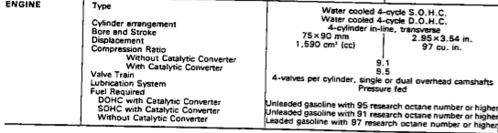
Figure 3- Bore, stroke and number of cylinders in the engine (Honda shop manual 1987)
To calculate the B.M.E.P I used the equation, $B.M.E.P=\frac{BP×60×2}{L×A×N×n}$ in this equation L is the stroke which has a value of 90mm, I found this number through the Honda shop manual, A is the piston area and n is the number of pistons. I found this number through research I have done on the engine. The final equation I used was, $η_{t}=\frac{(BP/1000)}{S.F.C (\frac{kg}{sec})×C.V}$ this equation allowed me to calculate the thermal efficiency. The only unknown in this is the C.V which is the calorific value of the fuel, I found this value by researching the average. The value I came across was ‘45.5 MJ/kg’ European Automobile Manufacturers Association (2016) this value is on the ACEAs website.
Due to all these methods I have been able to achieve my 2nd aim as the graphs that have been created from these results give me good trends to talk about and compare to other graphs.

Results Analysis
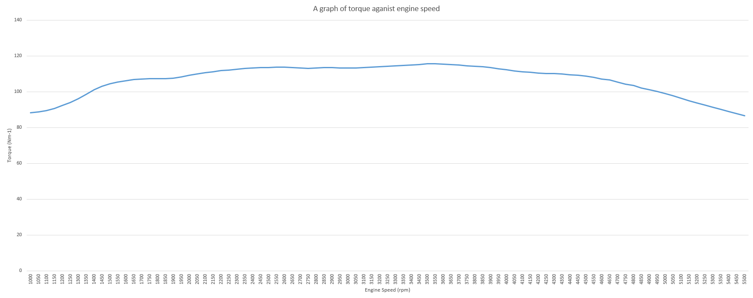
This is a graph showing the comparison between the torque values I calculated and the engine speed. The torque value on the graph is rapidly increasing from 88.40 Nm⁻¹ to 106.26 Nm⁻¹ when the engine speed is increased from 1000 rpm to 1600 rpm. Torque then slowly increases from 106.26 Nm⁻¹ to 115.62 Nm⁻¹ whilst the engine speed increases at a constant rate from 1600 rpm to 3500 rpm. Finally, the value of torque decreases to 88.69 Nm⁻¹ from 115.62 Nm⁻¹ whilst the engine speed is increasing at the same rate and increases to 5500 rpm. ‘The reason is that, in general, the torque curve does not drop off (%-wise) as rapidly as the RPM is increasing (%-wise).’(EPI inc 2011) This verifies what is happening on my graph as when the engine speed keeps increasing the Torque then starts to drop off.
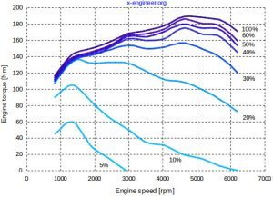
Figure 4- Graph of Torque against engine speed (x-engineer, 2017)
This verifies my graph as the trend of the lines at a higher load are similar to mine. This would be caused by the same reasons as my graph, this shows that my results for torque seem to be correct as the trend on the graph can be seen other graphs.
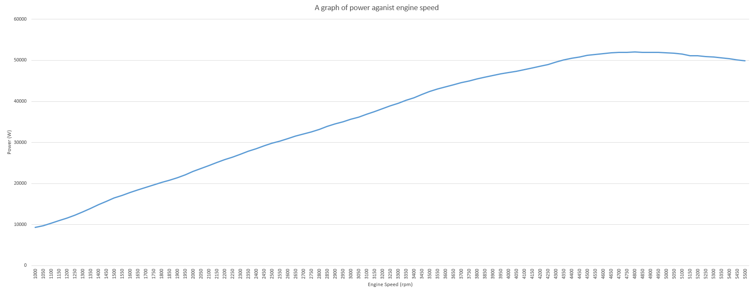
This graph shows how the power changes as the engine speed increases. The power starts at 9257.5 W when the engine speed is at 1000rpm. As the engine speed increases the power increases at the same time until the engine speed reaches 4800 where after this point the power starts decreasing from 52000W to 50000W.
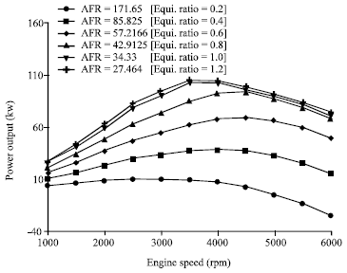
Figure 5- graph of power against engine speed M.M. Rahman, M.K. Mohammed and R.A. Bakar, (2009).
This helps me verify my graph of power against engine speed as the trends seen in my graph are the same as the ones seen in figure 5. Both of the graphs can be backed up with research, ‘Power increases with increases of engine speed at certain level. The power decreases at higher engine speed after certain level due to the friction losses and becomes the dominant factor at very high speed.’(M.M. Rahman, M.K. Mohammed and R.A. Bakar, (2009). This statement describes what is happening on my graph as well as the one seen in figure 5.

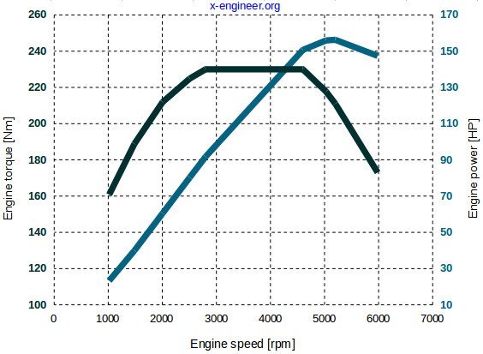
Figure 6 – Engine torque against engine speed and power (x-engineer, 2017)
Using this graph, I can verify that my first two graphs are correct as when I compare the trend lines on this graph it is similar to the ones on my two graphs. It also backups the statement behind the reasoning on why the power and torque change as the engine speed increases.
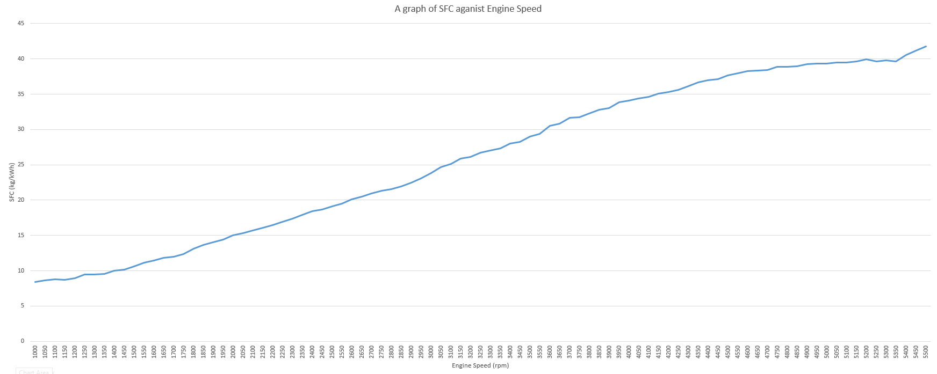
This is a graph of specific fuel consumption against the engine speed as seen from my graph the SFC increases at the same time as the engine speed. After doing researching it looks like my results could be wrong, when I compare my trend line to the trendline of other graphs.
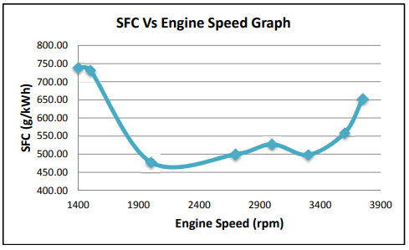
Figure 7- SFC against engine speed Rahman (2012) P.9
As the engine speed increases the SFC decreases until it is at 2000 rpm where it starts to increase until 3000 rpm. Then the value decreases slightly until about 3500 rpm where it starts to increase again. When compared to my tend line from my graph they are completely different. This makes the viability of my results decrease as the graph can’t be verified with other external data.

Evaluation
In conclusion I feel like I have performed well in the as I managed to get the majority of my graphs to be accurate and able to be backed up with research. When It comes to the aims, I set for myself at the start I feel confident in the majority of the answers I have produced as I was able to achieve some of the goals, I had set for myself at the start of the project. For my first objective I set myself the goal of getting verified and correct data, I achieved this goal by researching the numbers I need for the certain equations for example I had to research the bore and stroke of the engine to help me be able to calculate values for the piston area and the B.M.E.P. For my second objective I wanted to verify my graphs are correct by looking for graphs that repeated the same trends as my graph. I fully completed this goal on the first two graphs as they both had trends that are the same as graphs that I had found from research. When it came to my 3rd graph of SFC against engine speed when looking for graphs that produced a similar trend to mine, I couldn’t find any, this made me believe that the equation I had used were incorrect. When using the same equations for SFC that my research had found I still couldn’t get a graph that followed the same trend. When looking back at the project I think I could have improved my performance by trying to use different formulas throughout my database to see which ones work in each section as testing multiple gives me the greatest chance of finding the correct results. I think the investigation could have been improved by doing multiple test in the dyno of different engine speed at different test intervals and when under different amounts of load as this would let you be able to compare the engine under different situations.

References
Engineering ToolBox, (2003). Liquids - Specific Gravities. [online] Available at: https://www.engineeringtoolbox.com/specific-gravity-liquids-d_336.html [Accessed: 3rd January 2020]
X-engineer, (2017) Power vs Torque. [online] Available at:http://www.epi-eng.com/piston_engine_technology/power_and_torque.htm [Accessed: 2nd January 2020]
European Automobile Manufacturers Association (2016) Differences between Diesel and Petrol [online] Available at: https://www.acea.be/news/article/differences-between-diesel-and-petrol [Accessed: 3rd January 2020]
M.M. Rahman, M.K. Mohammed and R.A. Bakar, (2009). Trends of Rotational Speed on Engine Performance for Four Cylinder Direct Injection Hydrogen Fueled Engine. Trends in Applied Sciences Research, 4: 188-199. [online] Available at: https://scialert.net/fulltextmobile/?doi=tasr.2009.188.199#f7 [Accessed: 3rd January 2020]
Epi Inc (2011) Power and Torque. [online] Available at: http://www.epi-eng.com/piston_engine_technology/power_and_torque.htm [Accessed 2nd January]
RAHMAN, MR, (2012) Internal Combustion Engine Performance Characteristics. Available at: https://pdfs.semanticscholar.org/303d/1e751fb288760dfb2a868c76ea1fef7f7c3a.pdf [Accessed 3rd January]
Honda CRX Workshop Manual (1987)

