

Assignment Title:
Case Study Audit

MSc Property and Facilities Management

TABLE OF CONTENTS
1.0 INTRODUCTION 3
2.0 AIM AND OBJECTIVES 4
3.0 METHOD 4
3.1 CASE STUDY 4
3.2 CIRCULAR ECONOMY 5
3.3 WASTE STREAMS 6
3.4 PROCESS MAP 7
3.5 CALCULATIONS FOR UP-CYCLING 7
4.0 RESULTS AND DISCUSSION 7
5.0 CONCLUSION 8
6.0 REFERENCES 9
7.0 APPENDIX 10
7.1 Celtic Horizons Current Waste Management Process Map 10
7.2 Ifor Jones Court Waste Stream Management Flow Chart 11
7.3 Ifor Jones Court Waste Stream (Copper) Life Cycle Process Map 12

1.0 INTRODUCTION
Over the past five decades the world’s population has more than doubled with the human population today being approximately 7.7 billion (Cleland,2013). This continually rising population and an ever-changing economic climate, has brought a growing demand on our finite natural resources. These facts, coupled with concerns surrounding climate change has pushed the global agenda of sustainable development goals. This agenda has placed significant pressure on world leaders, to reduce the waste they generate. This is a programme that has the support of the majority of developed countries around the world. There is a collective effort to reduce, firstly the carbon footprint generated by extracting these natural materials, and secondly to decrease the demand for natural resources to ensure that these materials are available to future generations.

This project will investigate the subject of sustainable process and examine the life cycle of natural materials by evaluating the disposal options available when they come to the end of their primary use.

The project will be divided into four main sections. The first section will start by outlining the aims and objectives. The second section will show the methodology that was used for the project and present a case study. The second section will then go on to consider the case study will show the different types of waste material that were generated as part of a building refurbishment. Process maps will be produced and utilised with the theory of circular economy to analyse which waste material can be used to incorporate the up-cycling process. Calculations will be shown to establish the amount of revenue that could potentially be generated as a result of incorporating up-cycling into the project.

The project will then conclude with a results and discussion section and will finish with a conclusion.

2.0 AIMS AND OBJECTIVES
The aim of this project is to analyse the subject area of circular economy and up-cycling processes. The objective of this project is to identify waste streams within a workplace that could potentially incorporate circular economy and establish whether the identified waste streams could become a profitable source of income for an organisation.

3.0 METHOD
The methodological approach for this project will be quantitative. The research design will focus on simple data collection in order to determine the research goal which is to establish the viability of the use circular economy within an organisation.

3.1 CASE STUDY
There are currently three accepted means of waste disposal which could be used at Celtic Horizons, which are namely liner economy, chain economy and circular economy. Celtic Horizons is a SME operating within the construction industry and therefore, generates significant quantities of waste despite the relatively small size of the organisation. At present all waste generated by Celtic Horizons is disposed of by way of linear economy shown in fig1 (Bue, 2015). This waste is collected and segregated by third party contractors and becomes part of the chain economy. Depending on the waste stream, some of the waste generated by Celtic Horizons has the potential to become part of circular economy.
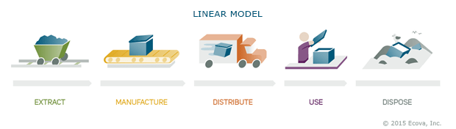

The purpose of this project is to establish whether circular economy could be introduced into Celtic Horizons’ business model, in an effort to eliminate waste and also save on waste disposal costs. The project will also try to identify whether up-cycling waste streams can be achieved, to generate revenue for the business. Fig2 shows the foundation of circular economy (Bue, 2015).
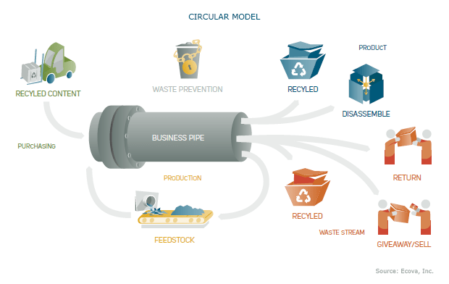

3.2 CIRCULAR ECONOMY
Sustainability has become a major focal point in the architecture, engineering and construction (AEC) sectors since the 1992 United Nations Framework Convention on Climate Change (UNFCCC) in Rio De Janeiro. The conference is seen by many leaders in the field as the major starting point towards a more sustainable future.
Circular Economy is a fast-growing topic area within business across the United Kingdom and Europe. At its simplest circular economy is defined by Ghisellini, Cialani and Ulgiati, (2016) as a system that is designed to be restorative and regenerative. The term ‘systems’, is important, and refers to the process which allows waste to be regenerated i.e. to become a material that can be reused. According to Kalmykova, Sadagopan and Rosado, (2018) circular economy is expected to promote economic growth by generating new businesses and job creation. It has also been suggested that it will reduce material costs which in turn will reduce price volatility. The fundamental goal of circular economy however, is to avoid and reduce waste streams from sources of an economic process, so reusing and recycling are based on reducing. (Yang and Feng, 2008).

3.3 WASTE STREAMS
The building chosen for the case study belongs to the United Welsh Housing Association. The building is Ifor Jones Court which is a living plus scheme located in Cardiff, South Wales. The building was undergoing a refurbishment and a number of elements within the building were replaced. It had been identified that some of the elements produced waste streams that had the potential to incorporate circular economy and generate revenue through the upcycling process.

Following the refurbishment works, some waste streams were identified as suitable for circular economy. The waste generated from the refurbishment were quantified as follows:

Works | Product | Quantity
Door and Handrail Replacement | Wood | 71 Hardwood Doors  255 LM hardwood Handrail
Heating Replacement | Copper and Steel | 600 LM Copper tube 15mm  86 Radiators
Flooring Replacement | Carpet/Textile | 300 SQM

Following some research, it was established that all three of the products could be reused or recycled. However, there was a significant difference between the waste streams, when up-cycling and returns in revenue were considered. The wood taken for the doors and handrails and the carpet could be reused or recycled. However, those waste streams were unlikely to generate revenue through the upcycling process. It was also far more difficult to source a vendor to collect those materials. Therefore, the waste stream chosen to incorporate circular economy was the copper tube. The rationale for this decision was that those products have excellent potential for upcycling. The copper tube taken from the refurbishment was 15mm x 0.7mm x 3m seamless round half hard copper tube, manufactured to BS EN 1057 – 250.

3.4 PROCESS MAP
Process Mapping is the technique of using flowcharts to illustrate the flow of a process, from the most macro perspective to the level of detail required to identify opportunities for improvement (Bailey, 2019). By using process mapping, this project is able to identify the upcycling process of the waste material identified on the case study. Three process maps (see appendix) have been designed for this project. The first process map shows the current methods used by Celtic Horizons for waste disposal. The second process map relates to this project and identifies the waste streams and which materials can incorporate circular economy and upcycling. The third process map identifies the life cycle of the chosen waste stream and shows the process of this material from extraction and the options available following the end of its primary use.

3.5 CALCULATIONS FOR UP-CYCLING
The following table shows the calculations for the return in revenue that were generated based on the waste streams identified for up-cycling. The prices based on information provided by Letsrecycle, (2019) and are accurate prices as of March 2019.
Material | Qty | Total weight (Kg) | Up-cycling Value (Kg) | Up-Cycling Return
Copper Tube | 600 LM | 168 | £3.80 | £638.40
Steel Radiators | 86 | 3118.26 | £0.15-£0.16 | £467.74

4.0 RESULTS AND DISCUSSION
The figures shown, demonstrate that there is value to upcycling materials from this refurbishment project. The monetary value that is gained from this project is minor however, should this system be incorporated over a number of projects the return in revenue could become quite significant in a short space of time. From this project alone, there is the potential to generate over £1,100 from waste material using the two waste streams identified. Under normal circumstances Celtic Horizons would dispose of this waste by hiring a skip, paying a contractor, who would then segregate the waste.

5.0 CONCLUSION
In conclusion it is clear that in reality circular economy and upcycling are in their early stages of development for SMEs such as Celtic Horizons. Even though these principles have been common place for a number of years many organisations have had little or no interaction with circular economy. There can however, be other benefits to incorporating circular economy for a business, such as promoting a reputation as being an innovative and forward-thinking business.
Circular economy works. Even where the recyclable waste material will not generate a profit for the business, free collection reduces the need for expensive waste collection and as a result the waste material will still become part of the upcycling process.
In order to drive circular economy forward and more emphasis needs to be placed on its benefits by the Government and Local Authorities. There is real potential for business generation as a result of circular economy and practical support, education and incentives could promote and create business opportunities for the collection and distribution of recyclable and reusable waste materials.
Should the means of recyclable waste disposal become more conventional then it is likely that more SME businesses would embrace circular economy on all waste streams across their business. However, at the present time many recyclable waste streams are not economically viable for a business due to time constraints on projects. Therefore, businesses will continue to use the Linear and Chain economy methods until a business case can be made to incorporate circular economy at source.

6.0 REFERENCES
- Bailey, M. (2019). Process Mapping. [online] Cedu.niu.edu. Available at: https://www.cedu.niu.edu/~bailey/ftf564/pmapping.pdf [Accessed 3 Mar. 2019].
- Bue, E. (2015). How Long Can Our Linear Waste Economy Continue? [online] ENGIE Insight. Available at: https://www.engieinsight.com/blog/2015/09/long-can-linear-waste-economy-continue/ [Accessed 8 Feb. 2019].
- Cleland, J. (2013). World Population Growth; Past, Present and Future. Environmental and Resource Economics, 55(4), pp.543-554.
- Ellenmacarthurfoundation.org. (2019). What is a Circular Economy? | Ellen MacArthur Foundation. [online] Available at: https://www.ellenmacarthurfoundation.org/circular-economy/concept [Accessed 9 Feb. 2019].
- Kalmykova, Y., Sadagopan, M. and Rosado, L. (2018). Circular economy – From review of theories and practices to development of implementation tools. Resources, Conservation and Recycling, 135, pp.190-201.
- Yang, S. and Feng, N. (2008). A case study of industrial symbiosis: Nanning Sugar Co., Ltd. in China. Resources, Conservation and Recycling, 52(5), pp.813-820.
- Ghisellini, P., Cialani, C. and Ulgiati, S. (2016). A review on circular economy: the expected transition to a balanced interplay of environmental and economic systems. Journal of Cleaner Production, 114, pp.11-32.
- Letsrecycle.com. (2019). Ferrous scrap metal prices 2019 - letsrecycle.com. [online] Available at: https://www.letsrecycle.com/prices/metals/ferrous-metal-prices/ferrous-scrap-metal-prices-2019/ [Accessed 14 Mar. 2019].

7.0 APPENDIX

7.1 Celtic Horizons Current Waste Management Process Map
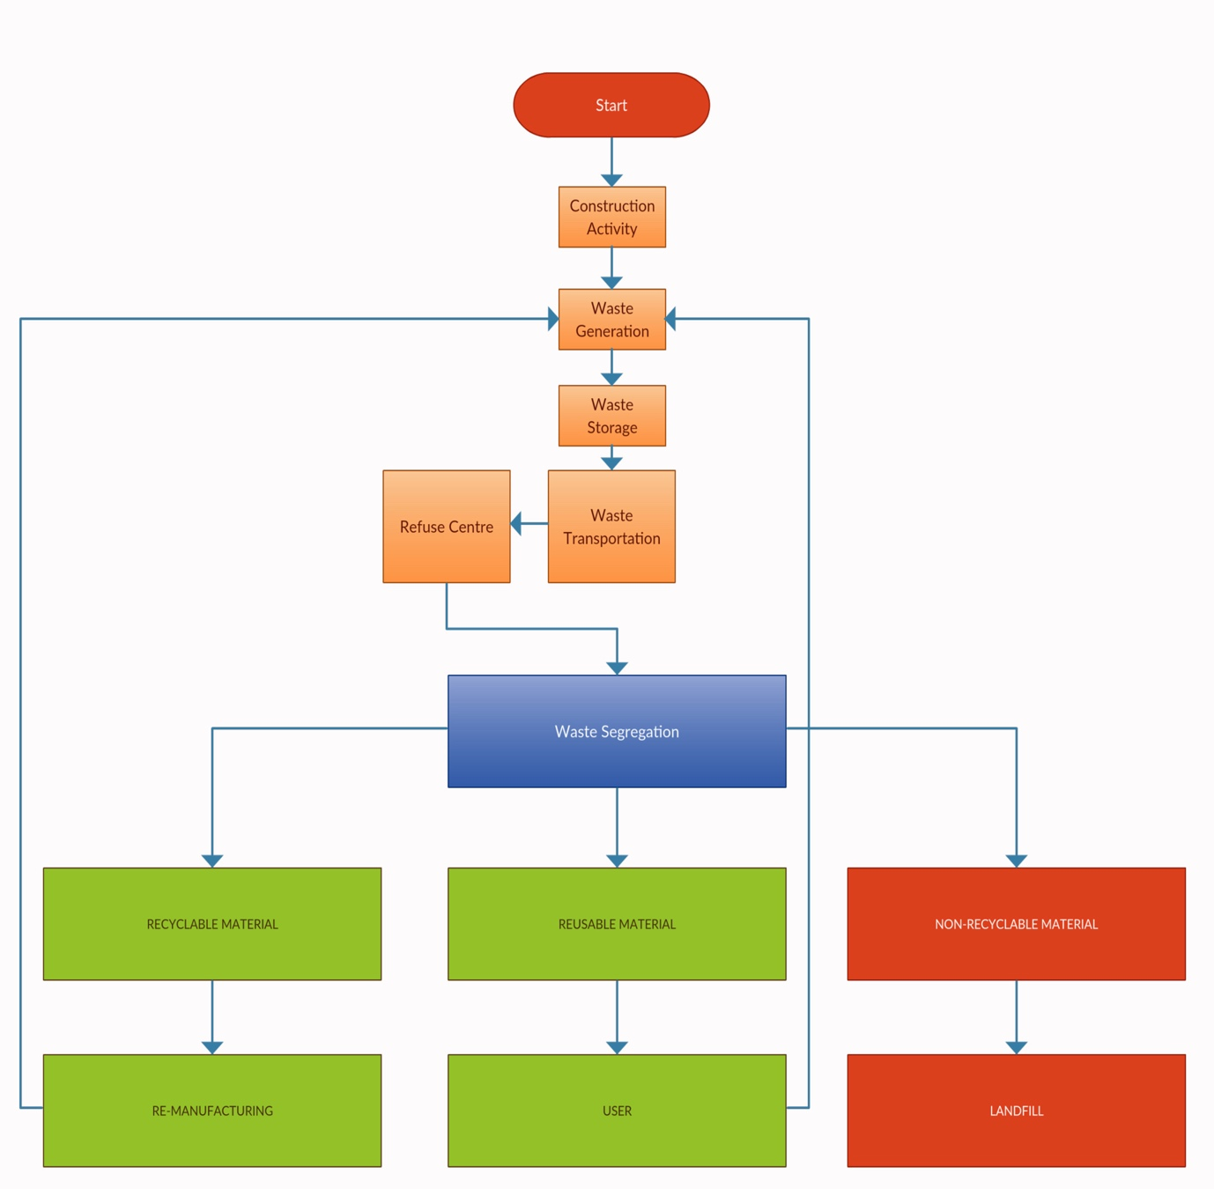

7.2 Ifor Jones Court Waste Stream Management Flow Chart

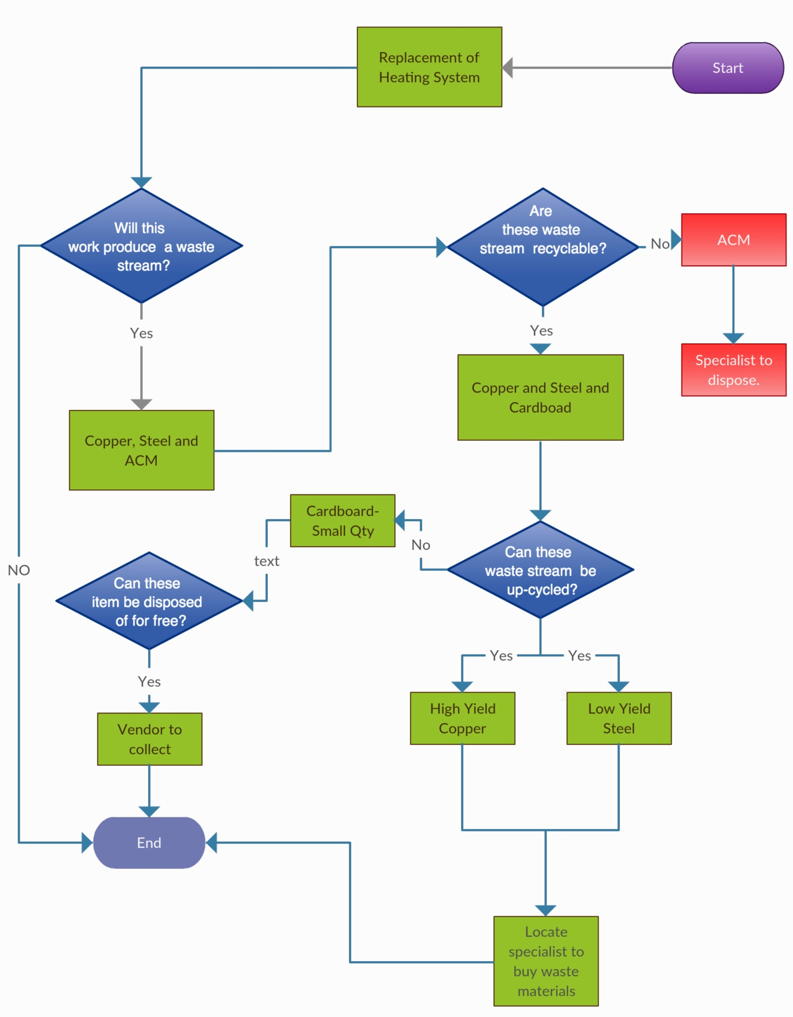

7.3 Ifor Jones Court Waste Stream (Copper) Life Cycle Process Map


