The purpose of this Tourism Review is to encourage the British tourists to visit Indonesia, and Bali in particular, in the context of tourism industry trends, changes, impacts and opportunities in the age of globalisation.

Global tourism overview

Wall, G. and Mathieson, A. (2006) illustrate the role in the context of the many world`s largest industries, referring to Tourism, as one of the fastest-growing industry, having a major importance on economic, environmental and social impacts in destination areas. The rapid expansion of tourism has positive aspects as creating new jobs, economical growth, environment conservation, however studies find that some negative aspects, opposite to the positives, in concern of physical and social problems in the hosting areas.

According to the World Tourism Oragisation (WTO 2020), 2018 was the ninth consecutive year of sustained growth in the Tourism Industry, which continued to expand over time, despite occasional shocks, demonstrating the sector`s strength and resilience.
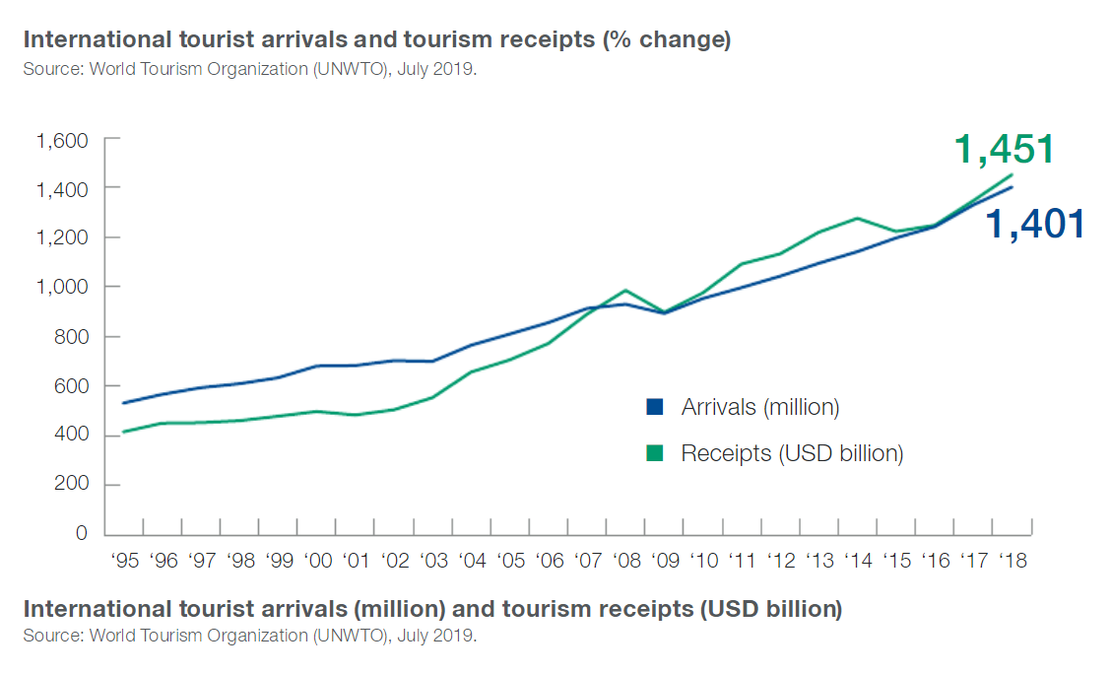
In the following chart, it may be observed that the tourism began to expand in 1950`s in Europe and Americas, were the developed countries are, while in Asia, Africa Middle East the tourism began on early 70`s. However, the tourism industry knows a rapid expand and it is looks to have a significant grow in the next few years.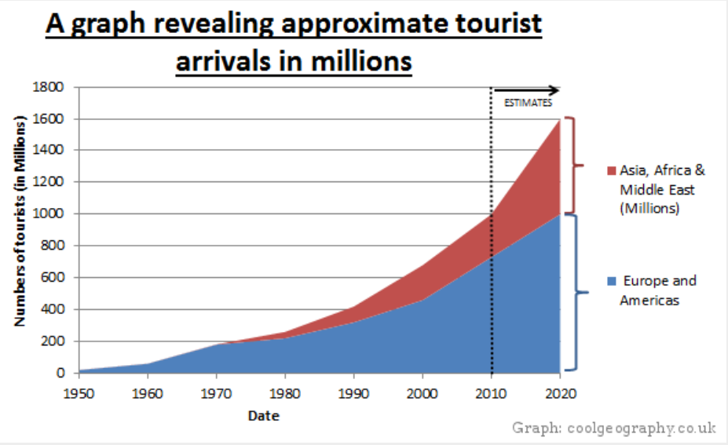
source: www.responsibletravel.com
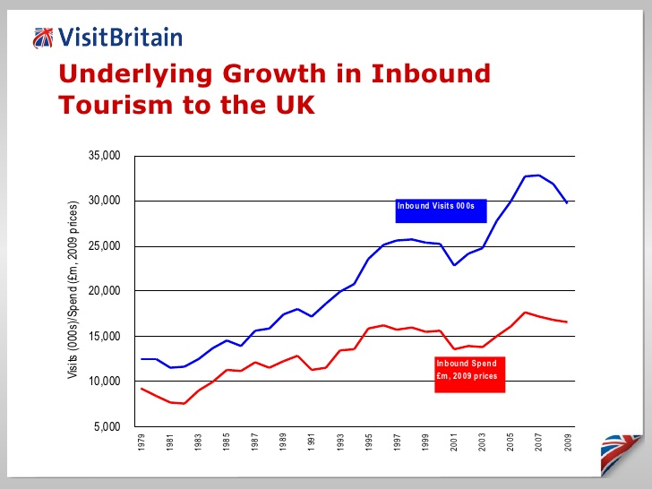
In the actual UK Economy`s context, Britons are more likely to visit overseas countries, and it is a good opportunity to fulfil their dream of visiting Bali in Indonesia to learn about Balinese Culture, the stunning geography from volcanic mountains, tropical forests, rice fields to the stunning beaches around the island.

REPUBLIC OF INDONESIA

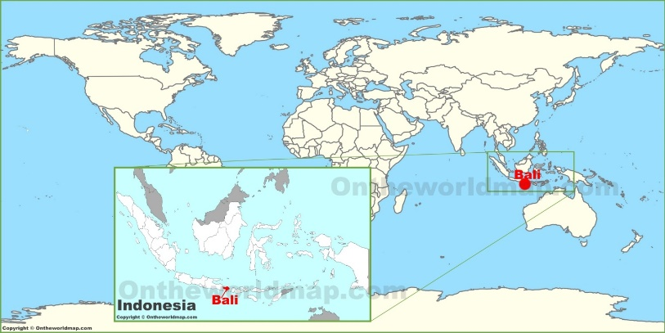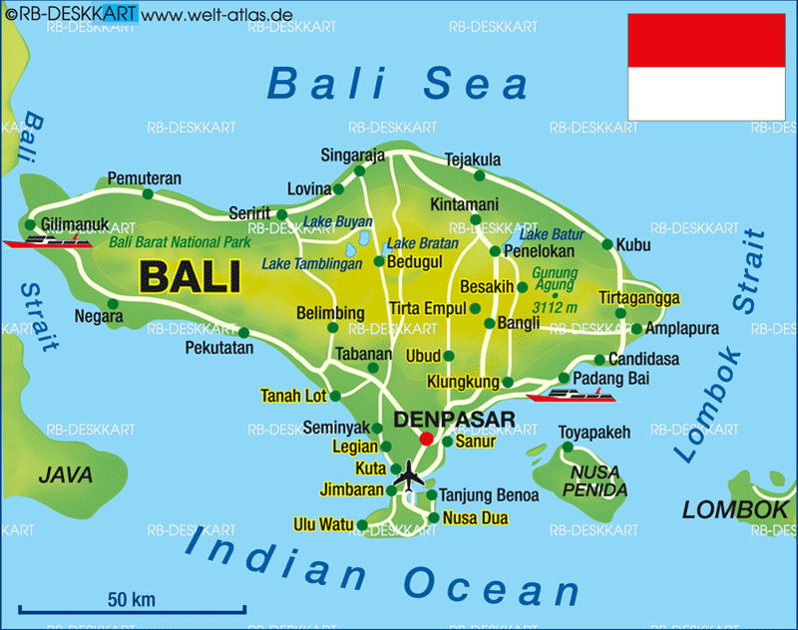
Source: http://ontheworldmap.com Source: www.welt-atlas.de

The Republic of Indonesia, the world`s largest archipelagic country, is a transcontinental country spread over 17,000 islands situated between Indian and Pacific Ocean along the Ring of Fire and right at the heart of coral triangle, the world`s precious (Indonesia.travel 2020).

Indonesia is a sovereign presidential constitutional republic and in terms of population size is the fourth largest in the world totalling around 260 million individuals (Indonesia-investemns.com), in more than 200 ethnic groups with over 300 spoken languages, and it may be named the ultimate in diversity. Indonesia is blessed with a significant different people, culture, customs, traditions, landscapes, unique flora and fauna, tourists paradises and endless spectacular wonders (Indonesia.travel 2020).

Jakarta is the capital of Republic of Indonesia, with over 10 million inhabitants, the largest and the busiest city in Indonesia, as well the economic, cultural and political centre of the country. It is situated in Java, the world`s most populated island (Indonesia-investemns.com). The Government plans to change the capital city in the future, from Jakarta to the region of East Kalimantan, however, Indonesia is not the first country who decides to change its capital, Pakistan, Brazil and Nigeria have changed their capital cities (BBC, 2019). More studies are to be conducted furthermore for the capital relocation megaproject (Jakartaglobe.id, 2019).

In terms of religion and beliefs, Indonesia has a Muslim majority, approximately 87 percent of the total population where the Islamic doctrine play large role in politics, economy and society. However, Indonesia is not an Islamic nation, there are also Protestants, Catholics, Hindus among a small group who practice Buddhism and Confucianism (Indonesia-investemns.com). Referring to Bali, Hinduism is the most predominant religion consisting in approximately 90 percent of Balinese (Holidify.com) with a significant impact to the customs, traditions and the way of life, which also makes the Cultural Tourism to be part of the Official Tourism Policy of Bali under The Bali Sustainable Development Project from 1992 (Wall, G. and Mathieson, A.,2006, p.320).

BALI

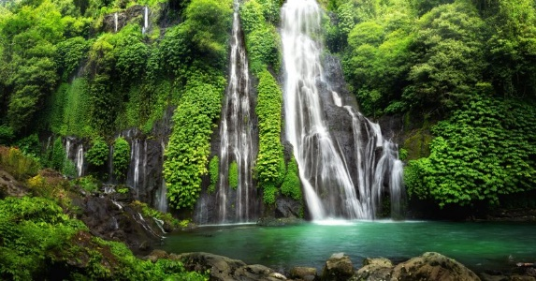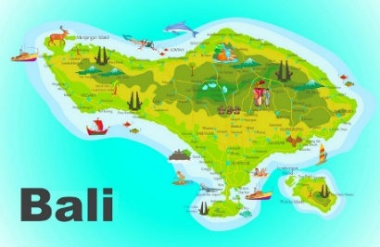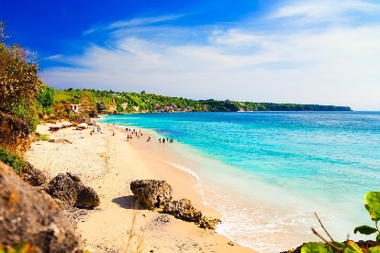
Sources: Akisoto.com google.com Au.hotels.com

Bali is the most popular tourist destination of Indonesia suitable for people who love culture, nature, beaches, diving, waves, traditions, resorts, water sports, mountain hiking and the list is may be infinite. The current Bali`s capital city is Denpasar having around half million inhabitants, and before 1958, the capital city was Sinaraja (akisoto.com).

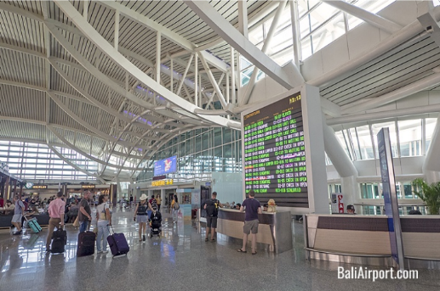
Bali Nguragh Rai International Airport is the main tourist entrance to the island, situated in a range of 13 km south of Denpasar and it is the second busiest international airport of Indonesia (Baliairport.com) welcoming approximately 5.2 million foreign tourists (TheJakartaPost.com).
Life expenditure and currency in Bali
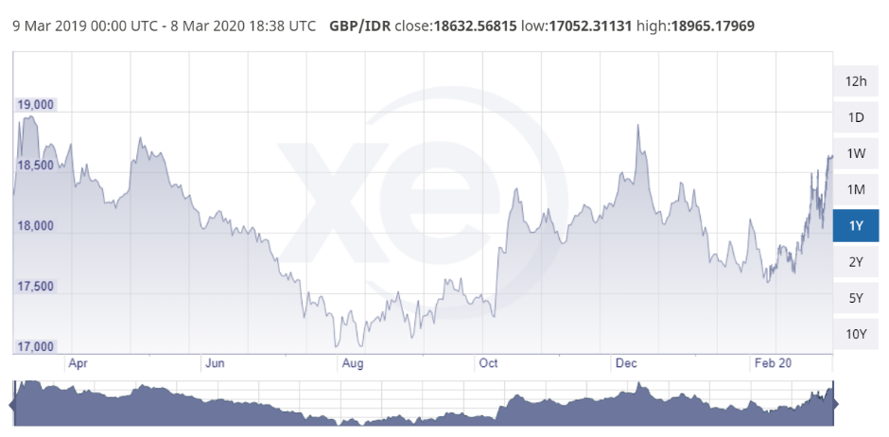
The currency of Bali is Indonesian Rupiah, namely IDR and rate of exchange varies to the British Sterling Pound, namely GBP and it is most recommended as
Source: xe.com
Britons to exchange the currency within the UK for the best rates, prior to departure (Xe.com, 2020).
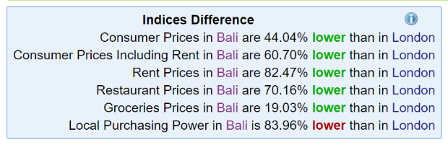
Cost of living comparison between London and Bali in general terms are significant
lower, which make the holidaymakers to
source: numbeo.com
spend less for the value of services and attractions in Bali (Numbeo.com, 2020).

Transport in Bali

For long distances locals and tourists use trains, buses or driving cars, which they may have different fares depending on distance, route, comfort, or the time of the day with fares in a range from 1,500 Rupiah to 10,000 Rupiah per stop.
For short distances in this small island, locals and tourists make an use of taxis, the most efficient and convenient way, chartered or metered, fares are set by the local and they are quite inexpensive comparing to the other countries fares, from 1,500 Rupiah up to 3,000 Rupiah.
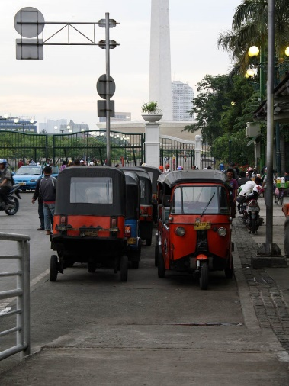
Bicycles, motorbikes or Ojeks, which they are motorbikes hired with its rider, are very common in Denpasar and all over the island and can be rented on daily basis from Rental Traders or from locals. This is the fastest and economical way to cope with the very busy traffic and congestions in the peak time. (Bali Tourism Board, 2020).

Types of tourists, needs, expectations and impact

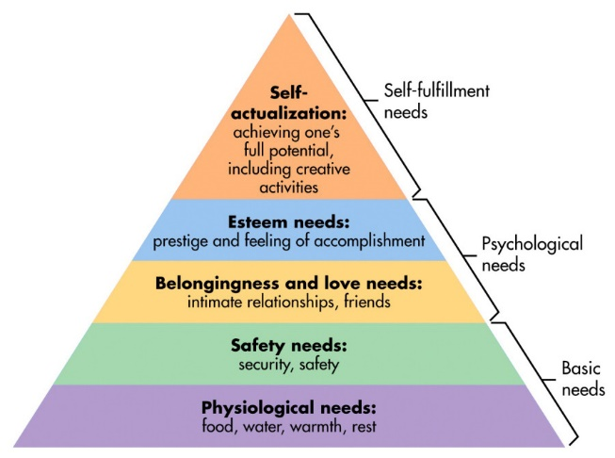
Vickers, A. (2013) illustrates that the main attractions are situated in the south, the heart of Bali, where Denpasar lies, surrounded by volcanic mountains in the East, which divides the island in two major forms of relief, mountain and coasts and beaches.
McLeod, S (2018) illustrates the Maslow`s Hierarchy of Needs as shown in the chart, as starting from basic needs of food and shelter, upon security needs, to intimate relationships as friends, going further to the esteem needs such as prestige and feeling accomplishment and finally to achieve the top for self-actualization when the individual hit the full potential and the desire to become the most that one can be.
Bali is the perfect land for British tourists to achieve self-actualization aims as the island have a significant opportunities and attractions to meet all the tourists needs.
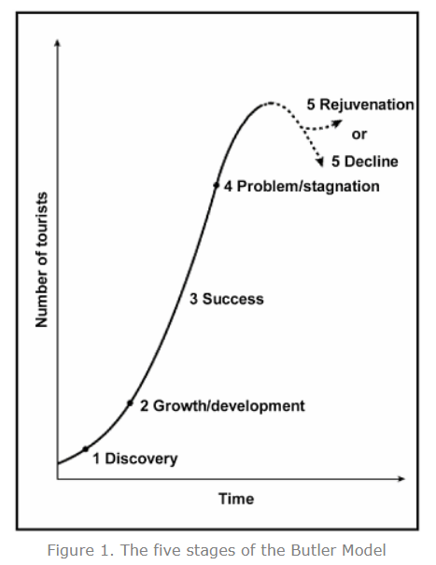
Doxey (1976) cited in Wall, G. and Mathieson, A. (2006) illustrates the potential impact of tourism upon the social, environmental and economic criteria which my have occur in different stages as euphoria, apathy, irritation, antagonism and saturation among the residents and locals. In the present days, Bali it is in a constant stage of euphoria and acceptance.

The Butler`s Model of tourism breaks down the tourism development upon five stages as Discovery, where the people discover new places, Growth and Development where Bali knew its growth in late 90`s, Success stage where Bali have been since 2010, Problem – Stagnation stage when now Bali is on stagnation because of Coronavirus Covid-19 world pandemic, and waiting for a boost of incoming tourists soon, and final stage of Decline or Rejuvenation, where Bali has not yet in this stage. (Geographyfieldwork.com).

Woods (1980) cited in Wall, G. and Mathieson, A. (2006, p.54) suggest that the tourism is seen as an external force having impacts on the static force, the locals, as in a ‘billiard ball’ effect and later have been observed as part of an equilibrium, like a symbiosis, when everyone involved as nature, locals, tourists support and sustain each other for the common benefit and growth.

Safety in Bali

Bali it is known as fairly safe tourist destination compared to the other destination in the world, however some incidents as theft, accidents, terrorism and recently the Coronavirus contamination may occur, despite the fact of Bali not having any casualties on the pandemic threat by now.
The alcohol intoxication with the local home made alcoholic Arak it is likely to happen among the tourist which they are not used with strong alcohol drinks. The drug consumption is prohibited, and death penalty may apply even for consumption, to not mention the drug dealing. Most of police officers may pose in drug dealers so drug consumption it is highly not recommended.
Violent crimes are not a common in Bali, however, the tourists may be a vistim. It is recommended to keep the belongings safe. (LonelyPlanet.com, 2020).
Gov.UK (2020) suggest that some travels to be reduced within 4 kilometres of the Mount Agung in Bali due to the possible volcanic activities and the Britons can travel for 90 days without a visa.

Cultural Tourism in Bali and Attractions

Rice fields

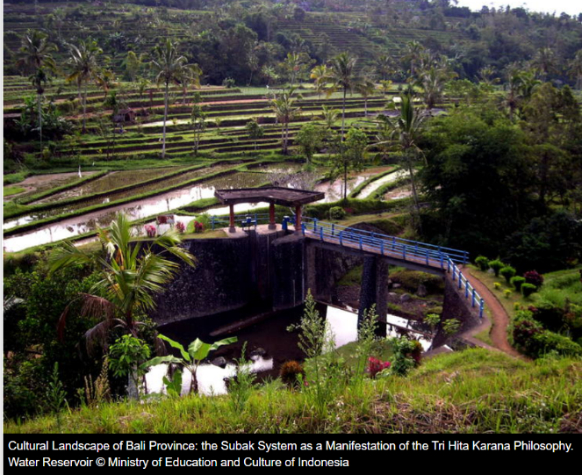
UNESCO (2020) recognise the cultural landscapes of Bali consisting in five rice terraces spread over 19,500 ha, known as “Subak” as heritages and protected areas.
The techniques used by the Balinese on farming rice relates over 2,000 years of cultural exchange between Bali and India and made Bali to be the most prolific rice grower in the archipelago although has been identified some issues in supporting a dense population.

Temples in Bali
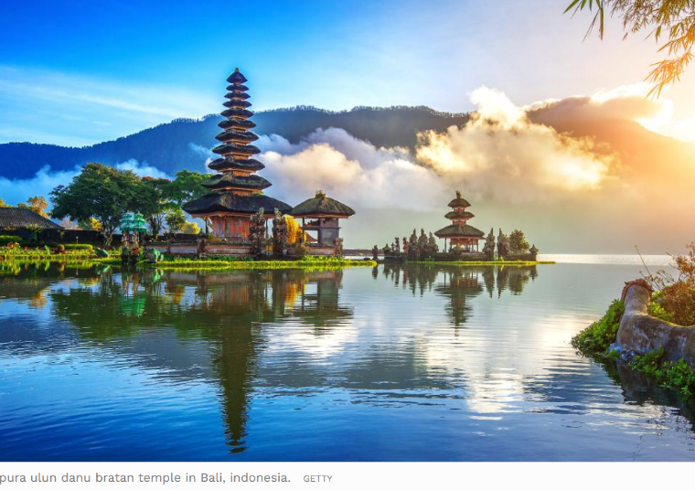
Ulun Danu Temple is the largest temple in Bali, situated on the highlands of the mountainous region of Bedgul, at approximately 1,500 meters above the sea level.
It is in a calm and relaxing area next to the Lake Beratan, the second largest lake in Bali. The existence of this temple has been recorded as far as early 1556, and the entrance fee is around 50,000 Rupiah, less than 3 Sterling Pound. The area surrounding the temple it is believe to be dated in the megalithic period , dated 500 BC. (Indonesia.travel 2020).

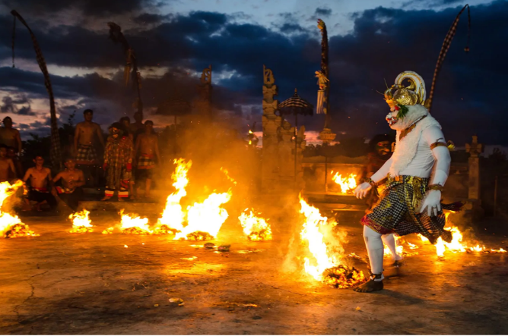
Uluwatu Temple is one of the six keys temples which they are considered to be Bali`s ‘spiritual pillars’. It is situated at 70 meters above the sea level on top a abrupt cliff facing the ocean and having the beautiful sunsets esplanade.
Any visitor to this temple has to wear a sarong, a traditional cloth. It is well known that there are no public transport to this place, and the macaques can pinch your belongings as sunglasses, caps, or even the photo or video cameras from tourists (Hotels.com).
At this temple a traditional dance is performed in two shows per day, namely the Bali Dance. This dance it has his routs in the early 15th century when the Bali`s art culture changed and emerged with Balinese and Hindu believes. In this way, the ancient Hindu Traditions are incorporated with drama that illustrates the story of a character from Hindu scripture who fights demon and evil spirits, beautifully mixed through dance and music. (Bali Spirit, 2020).

The Bali Tourism industry it may be seen as an its starting stages of development despite the significant progresses made in the past years. Bali is a destination that matches both tourist profiles, the adventurous ones and the safe ones, in the same time. The Britons appear to dedicate their time for holidays and may be seeking the holiday of their dream and Bali is on e of this destinations which me be included in the as named ‘the bucket list’ for its significant offers.

Hotels in Bali

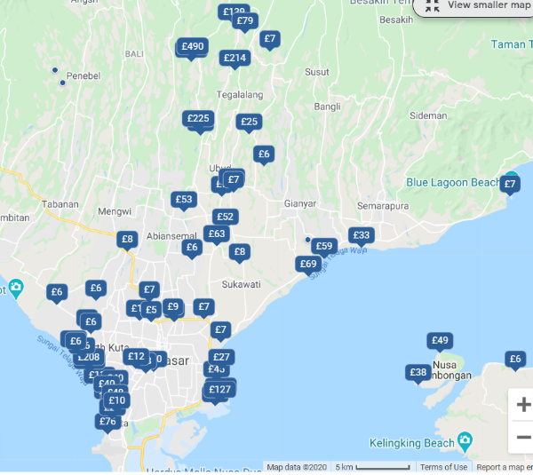
The hotels in Bali are concentrated in the torurist area of Kuta and Syminiak, where tourist all over the world enjoy the water sports. Prices are in the range from just 7 Sterling Pounds per night for a room in a guest house to over 500 Sterling Pounds for a 5 star resort . Most hotels are very well established with quality toiletries and facilities, which meets the tourism demands. The staff is multilingual, speaking English, Spanish, French and Chinese.

In conclusion, Bali is one of the world`s most wanted attractions, a tourist paradise, an ultimate in diversity and a place which brings joy and unforgettable memories to the British tourists, by meeting people, places and activities.

References

Akisoto (2020), ‘Bali Indonesia – Bali For Beginers’, [Online]. Available: https://akisoto.com/bali-indonesia-bali-for-beginners/ [2020, March, 8].
Bali Airport (2020), ‘Bali Airport Indonesia’, [Online]. Available: https://www.baliairport.com/, [2020, March, 8].
Bali Spirit (2020), ‘Your guide to Holistic Bali’, [Online]. Available: https://www.balispirit.com/community/blog/traditional-balinese-dance, [2020, March, 8].
Bali Tourism Board (2020), ‘Land Transportation’, [Online]. Available: https://www.balitourismboard.org/bali_local-transport.html, [2020, March, 8].
BBC (2019), ‘Indonesia Picks Borneo Island as Site of New Capital’, [Online], Available: https://www.bbc.co.uk/news/world-asia-49470258, [2020, March, 8].
Geography Field Work (2020), ‘The Buttler Model of Tourist Resort Development’, [Online]. Available: https://geographyfieldwork.com/ButlerModel.htm, [2020, March, 8].
GOV (2020), ‘Foreign Travel Advice Indonesia’, [Online]. Available: https://www.gov.uk/foreign-travel-advice/indonesia, [2020, March, 8].
Holidify (2020), ‘Religion in Bali: Explore Balinese Hinduism and More’, [Online]. Available: https://www.holidify.com/pages/religion-in-bali-1468.html, [2020, March, 8].
Hotels (2020), ‘Uluwatu Temple in Bali’, [Online]. Available: https://au.hotels.com/go/indonesia/uluwatu-temple, [2020, March, 8].
Indonesia Travel (2019), ‘About Indonesia’, [Online]. Available: https://www.indonesia.travel/gb/en/general-information/about-indonesia, [2020, March, 8].
Indonesia-investments (2020), ‘Population of Indonesia’, [Online], Available: https://www.indonesia-investments.com/culture/population/item67?, [2020, March, 8].
Jakartaglobe (2019), ‘Study Reveals New Capital City Megaproject to Profit Indonesia`s Ologarchs’, [Online]. Available: https://jakartaglobe.id/news/study-reveals-new-capital-city-megaproject-to-profit-indonesias-oligarchs, [2020, March, 8].
Lonely Planet (2020), ‘Dangers & Annoyances’, [Online]. Available: https://www.lonelyplanet.com/indonesia/bali/safety, [2020, March, 8].
McLeod, S (2018), ‘Maslow`s Hierarchy of Needs’, [Online]. Available: https://www.simplypsychology.org/maslow.html, [2020, March, 8].
Numbeo (2020), ‘Cost of Living Comparison Between London and Bali’, [Online]. Available: https://www.numbeo.com/cost-of-living/compare_cities.jsp?country1=United+Kingdom&city1=London&country2=Indonesia&city2=Bali, [2020, March, 8].
The Jakarta Post (2018), ‘Bali Airport Records 5.2 million Foreign Tourists’, [Online]. Available: https://www.thejakartapost.com/news/2018/11/19/bali-airport-records-52-million-foreign-tourists.html, [2020, March, 8].
Unesco (2020), ‘ Cultural Landscape of Bali Provence: the Subak System as a Manifestation of the Tri Hita Karana Philosophy’, [Online]. Available: https://whc.unesco.org/en/list/1194/, [2020, March, 8].
Vickers, A (2013) Bali: A Paradise Created, [Online]. Available: https://books.google.co.uk/books?id=y17MAgAAQBAJ&printsec=frontcover&source=gbs_ge_summary_r&cad=0#v=onepage&q&f=false, [2020, March, 8].
Wall, G. and Mathieson, A. (2006), Tourism Change, Impacts and Opportunities. Edinburgh Gate: Pearson.
Wonderful Indonesia (2020), ‘Ulun Danu Beratan: Iconic Temple on Lake Beratan’, [Online]. Available: https://www.indonesia.travel/uk/en/destinations/bali-nusa-tenggara/bali/ulun-danu-beratan, [2020, March, 8].
WTO (2020), International Tourism Highlights, 2019 Edition [Online] Available: https://www.e-unwto.org/doi/pdf/10.18111/9789284421152, [2020, march, 8].
Images:
http://ontheworldmap.com/indonesia/islands/bali/bali-on-the-world-map.html
https://akisoto.com/bali-indonesia-bali-for-beginners/
https://www.welt-atlas.de/map_of_bali_6-67

