  SWOT Analysis for green build construction  University of Wales Trinity St David | Tomos Butterworth (2409888).  2409888

Table of Contents

1.0 Background of Green Build……………………………………………………………. 2
2.0 Purpose…………………………………………………………………………………..2
3.0 SWOT Analysis of Green Build……………………………………………….………..3
3.1 Strengths………………………………………………………………………………3
3.2 Weaknesses…………………………………………………………………………..4
3.3 Opportunities………………………………………………………………………….5
3.4 Threats………………………………………………………………….……………..6
4.0 Management Strategies and Controls…………………………………………………8
5.0 Conclusion……………………………………………………………………………….8
6.0 Risk Register……………………………………………………………………………10
7.0 References………………….…………………………………………………………..11

1.0 Background of Green Build
Green Build is a small-to-medium enterprise operating within the construction sector that specialises in retrofitting projects, mainly functioning within the supermarket industry. Working as a main contractor for clients, such as Tesco, to carry out renovations quickly to ensure regular operations aren’t disrupted without compromising quality.
The company operates outside of opening hours, including undertaking work during overnight shifts, which allows the store to remain operational during the day without compromising the company's profits. This places Green Build in a specialised niche, allowing for a skilled workforce to work within a live environment. As an SM enterprise working within local authority frameworks in Wales, Green Build must work with British standards and construction regulations, including working within health and safety regulations, including following guidance from the HSE, environmental protection, and quality assurance.

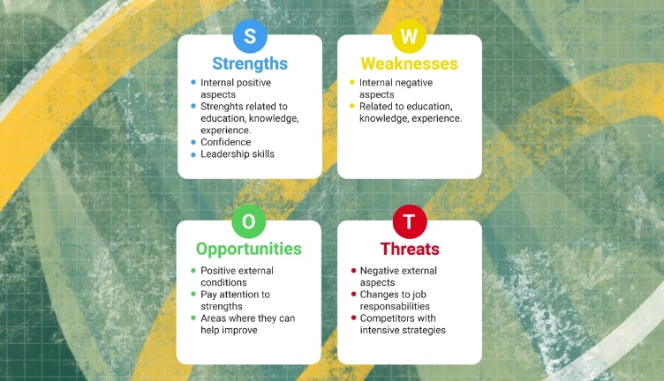
2.0 Purpose
A SWOT is a tool used to evaluate 4 key aspects in the construction industry: strengths, weaknesses, opportunities and threats, as shown in Figure 1 (Dojo Business, 2023). In an industry that’s constantly evolving, such as construction, it is essential to identify ways to become more efficient and to be able to understand the factors impeding the company (Dojo Business, 2023). Within the construction industry—particularly for SMEs operating in framework agreements—this analysis is essential to: Identify internal strengths and limitations, respond to external market pressures, improve quality, environmental performance, and health & safety standards, and develop mitigation strategies through effective management.
Figure 1. a SWOT matrix (Jason, 2025)
3.0 SWOT Analysis of Green Build
3.1 Strengths
Green Build benefits significantly from operating predominately during closing hours, which reduces risk to both workers and the public. With work being undertaken without the public being present, work can be completed efficiently with improved site safety. This can be controlled with strict supervision, ensuring there are no issues regarding fatigue for workers. In 24-hour stores, work may have to be completed during open hours. Working in populated areas can reduce the risk of isolated injuries for workers.
The company operates in a specialised field, working predominantly within retrofitting, allowing for workers to develop high levels of expertise, improving quality and efficiency. Skilled, efficient labour has been found to improve project outcomes and reduce the amount of rework that needs to be undertaken (Hussain et al., 2020). Efficient management can ensure that this is a strength, working with targeted training to develop workers' skills.
The use of existing welfare facilities, such as toilets, cooking, and break facilities within supermarkets, reduces the need for temporary site setups, increasing time efficiency and lowering costs whilst taking into consideration environmental conditions. This consideration aims to support sustainable building practices, which are being increasingly prioritised in the UK (Maqbool et al., 2023). Furthermore, as work is conducted in a dry, clean environment, shower facilities aren’t needed.
By operating within supermarket framework agreements, it allows Green Build to develop long-term relationships with clients, providing repeat work, which can help improve financial stability. Strong relationships can lead to improved communication between client and contractor and help to develop a level of trust, allowing the project to run more efficiently.
Due to being a SME, communication between management, worker supervisors, and workers on site can be more direct compared with larger enterprises with more staff. Fast and effective communication can improve worker decision-making, helping to reduce mistakes which can delay the project (Pollack, 2024). This is particularly important while working in the vicinity of the public, where changes to access and working areas need to be communicated efficiently and immediately. This efficient communication also helps to improve health and safety coordination, as threats to the safety of workers must be stated immediately.

3.2 Weaknesses
As a SME, Green Build faces financial limitations which restrict its ability to absorb major unexpected costs (Salisbury et al., 2024). This issue can be mitigated by strong and thorough financial management. Operating within a niche retrofit market exposes the company to competition from larger firms entering the sector. Furthermore, larger contractors can offer lower rates due to the size of the company, having a much greater financial scope.
Furthermore, working in live environments, such as supermarkets, introduces additional risks. If inventory is damaged, Green Build would have to absorb the financial burden. This shows the importance of a risk assessment and method statements in such environments.
Being a SME, the reliance on subcontractors can lead to financial loss and an inconsistency in quality and safety. Effective contractor management, including extensive monitoring and Pre-Qualification Questionnaires (PQQs), is essential to mitigate this risk (British Safety Council, n.d). Due to being a small/medium enterprise, Green Build cannot own its own plant and machinery, hiring equipment for the retrofitting work. This can become a financial burden on the company, increasing project costs and causing scheduling issues if the plant is unavailable. This dependence on external factors can reduce Green Build's operational flexibility.
As a specialised contractor, Green Build may be heavily reliant on a few clients for most of the income. Any instability can cause financial loss due to a loss of work. This level of dependence may reduce the financial bargaining power of the company, possibly being forced into taking lower contracts to ensure a steady rate of work. However, by prioritising efficiency and reliability, clients should offer reasonable deals due to the high level of work being completed.

3.3 Opportunities
Construction in the UK has shifted its demands towards retrofitting and other sustainable refurbishment options, being driven by net-zero targets and efficiency requirements (UK Parliament, 2025). This presents a major growth opportunity for Green Build, becoming industry leaders.
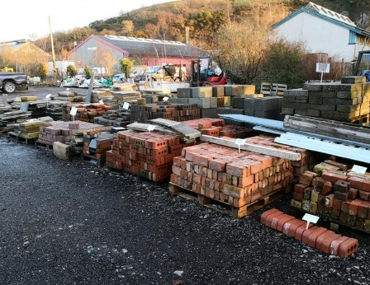
There are also opportunities to generate extra revenue through reclamation yards, as shown in figure 2, using materials in the original store to resell. This supports Green Build's principles of a circular economy. The UK government promotes the reduction of waste and the reuse of scrap material as part of its environmental strategy (GOV.UK, 2023). By reducing waste using reclamation yards and using high-quality recycled materials, Green Build will place itself in a stronger environmental position, improving the likelihood of winning framework contracts due to a shift in priorities towards sustainability.
Figure 2. A brick reclamation yard in Powys (Salvo, 2020)

Green Build prides itself on quality performance and time efficiency. With quality and time being of the upmost importance, pricing will increase. The company can justify higher rates due to consistent quality being produced for the client, strengthening its position in the retrofitting sector. This can eventually allow the company to expand its reach outside of South Wales, becoming a nationwide contractor. Another development strategy for Green Build is the partnership with local colleges and universities with apprenticeship schemes, aiming to develop high-quality staff from young, giving work to local youths-aiming to tackle the labourer gap left since the Covid-19 outbreak and Brexit. This, however, could cause a decrease in quality due to inexperience. To combat this, highly trained staff will be directly involved in any work they conduct, with the site manager ensuring their quality is on par with what has been stated in the original contract.
Furthermore, Green Build can place itself in the forefront of construction technology, including using Building Information Modelling (BIM), creating greater efficiency and quality, placing itself at an advantage over smaller companies relying on traditional methods (Gajjar, 2024).
A greater number of clients require refurbishment work to be completed with little disruption to regular operation. Green Build has experience working in live supermarket environments and has placed itself as a market specialist in low-disruption, sustainable construction. This creates opportunities to expand into sectors such as healthcare and education, where efficiency and low levels of disruption are essential. These key skills can allow Green Build to expand outside of Wales. Expanding geographically can reduce reliance on a local market, increasing opportunities for growth in finance and workers. Careful management is essential to expanding the company, ensuring that this reach does not negatively impact quality and health and safety.

3.4 Threats
There are many threats to a small/medium enterprise that needs to be managed to allow for long-term success. One of the most significant threats to Green Build is the skilled labourer shortage (Construction Job Board, 2025). A lack of highly trained labourers leads to significant delays as well as reduced quality and productivity, ultimately affecting the client’s satisfaction. To counteract this issue, Green Build has introduced apprentice schemes in colleges and universities. However, under-18s, the most common ages in apprentice schemes, cannot work past 12pm according to the Working Times Regulations (1998).
Working antisocial hours, especially during store closure, can deter skilled staff from joining and remaining for a prolonged period of time at the company. Night work can have a negative impact on employees' mental and physical health, increasing the likelihood of reckless behaviour and accidents on site. Effective management can reduce these issues by introducing shift rotation, greater pay compared to other contractors, and welfare support to employees.
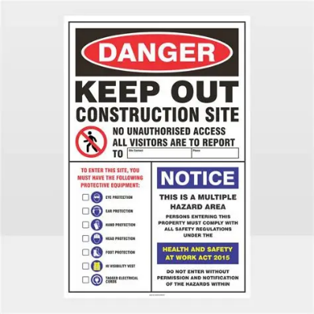
However, working in live retail environments introduces additional risks involving the public. Customers may enter restricted areas, increasing the likelihood of slips and trips, as well as the theft of equipment and tools. This risk can be mitigated through physical barriers, clear signage, and constant site supervision, as shown in figure 3. This can cause project delays. Project delays, particularly within a supermarket environment, can be particularly challenging due to the high level of coordination needed to work around busy hours. Delays reduce revenue for the store, disrupt customers, and damage Green Build and the client’s reputations. Effective project management and client and contractor communication is essential to minimising this risk.
Figure 3. Signs used to deter the public (Mitre10, 2026)
Any incidents involving poor work, ignoring of health and safety, or environmental damage could significantly damage Green Builds and the client’s reputation (Health and Safety Consultancy, 2019). In construction in the UK, reputation is heavily linked with future contractor opportunities, negative publicity can result in loss of contracts and reduced competitiveness in the job market. To combat this, the implementation of strict quality and health and safety procedures can reduce the likelihood of these issues consistently occurring.
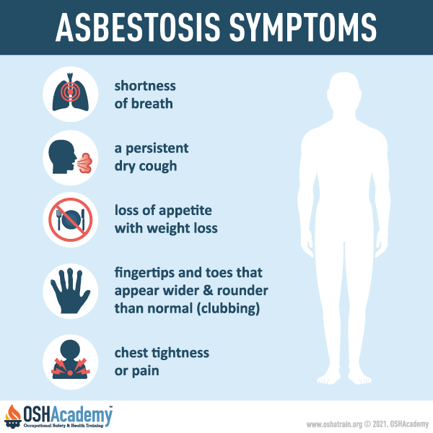
Furthermore, when retrofitting older stores, the risk of hazardous materials, such as asbestos, must be taken into consideration. Prolonged exposure to asbestos can cause serious illness, including asbestosis and mesothelioma, with symptoms shown in figure 4 (GOV.UK, 2024). These symptoms mirror common illnesses, being harder to detect. Asbestos remains one of the largest and deadliest health risks to workers in the construction industry. Therefore, Green Build must ensure that the building is surveyed for asbestos prior to work being conducted, hiring specialists where needed.
Figure 4. The Main Asbestosis Symptoms (OSH Academy, 2023)
Finally, operating machinery and any deliveries during the night can cause noise and light pollution for houses in the area. Complaints from residents can cause delays, possibly negatively affecting relationships with clients and local communities. Green Build can manage this threat by limiting the operation of noisy equipment to agreed times, using quieter tools where possible. Delivery times must be introduced during quieter times in the store, usually evenings, before the work can be completed.

4.0 Management Strategies and Controls
Effective management is crucial to ensuring the company can control risks, maintain the quality of the work, and remain industry leaders within the retrofitting industry. As a small/medium enterprise working in live, populated environments, strong and efficient management systems are crucial to ensuring the health and safety of workers and the population and overall project efficiency. To ensure the work being produced is to a high standard, it is important to have quality management systems, including inspections, hiring quality assessors, and clear communication between workers. Ensuring all workers are aligned helps improve the quality being produced, ensuring the work follows ISO 9001-2026 (Keen, 2026).
Health and safety on site are the greatest threat that must be managed. It is particularly important due to the company working during night shifts or within occupied retail environments. Green Build must work within the CDM (2015) regulations. Thorough briefing of the work and ‘toolbox talks’ must be regularly undertaken to minimise the risk of injury on site.

5.0 Conclusion
Overall, the SWOT analysis helps to show that Green Build can grow into the retrofitting and refurbishment sector of construction due to its experience in live supermarket environments. Green Build benefits greatly from a skilled, specialised workforce, efficient communication due to a small number of workers, strong client relationships with companies such as Tesco, and Asda, and its ability to combine quality work within time constraints with minimal delays. These crucial strengths support Green Build's extremely high standards of quality, health and safety, and efficiency. However, the SWOT analysis has also highlighted important weaknesses that need addressed that can limit long-term growth. Financial limitations, such as the reliance on subcontractors, such as hiring plant, the dependence on key clients, and a restriction on flexibility place pressure on Green Build in an increasingly competitive and saturated market. Furthermore, with workers potentially required to work throughout the night, it creates health and safety challenges which require additional and effective surveillance as the chance of injury can increase when workers are tired (Online CPD Academy, 2026). Night work can also increase the likelihood of health complications, with night workers experiencing a significantly increased risk of heart attacks and strokes (Online CPD Academy, 2026). Despite the weaknesses, Green Build has significant opportunities for expansion.
The increased demand for sustainable construction projects in the UK places the company in a strong position. Opportunities, such as the expansion into digital technologies, such as BIM, can develop the company into an industry leader. In addition, the introduction of schemes, such as hiring apprentices, has helped Green Build expand and develop the workforce. However, many external threats remain. Threats, including the skilled labourer shortage, asbestos risks, and disruptions cause reputational damage to the company. If these external risks are not correctly managed, the company could face negative impacts in project delivery, overall reducing the chance of further working relationships and opportunities.
The retrofitting industry is highly saturated. To remain competitive and continue to win contracts, Green Build must continue its management practices, ensuring the company stays within environmental guidelines, prioritises the health and safety of workers and the public, and ensure all work is up to contractual standards. However, to ensure the company does not ‘stand still’ in a forever progressing industry, Green Build must invest in its workforce, ensuring it has the capacity to retain highly skilled workers. The company must also invest in communication systems and continue to develop its sustainable construction practices to ensure that risks are effectively controlled. This will help to support future growth opportunities.
Through strategic management and planning, Green Build has the opportunity to expand its workforce, continuing to develop skills that can apply to different retrofitting sectors. This can expand the company into retrofitting industries such as education and healthcare. This can place Green Build at the forefront of environmentally friendly, efficient retrofitting projects in Wales, and potentially the UK.

6.0 Risk Register
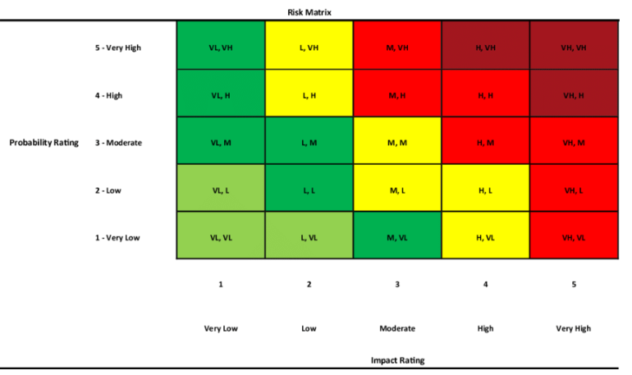
Figure 5. The Risk Matrix (Manuwa, 2025).

Risk Number | Risk Description | Probability | Impact | Risk Score | Mitigation
1 | Slips, trips, and falls. | 4 | 3 | 12 | Ensure staff are careful and aware on site.
2 | Delay due to weather | 3 | 1 | 3 | Ensure any outdoor work is completed according to forecasts.
3 | Departure of key personnel | 3 | 5 | 15 | Offer incentives to keep hold of valuable workers.
4 | Lack of plant availability. | 2 | 5 | 10 | Ensure plant is hired well ahead of time to avoid conflict.
5 | Change in working times | 3 | 3 | 9 | Ensure that contractual variation is effectively communicated and prices changed accordingly.
6 | Client dissatisfaction | 1 | 4 | 4 | Ensure work is of client satisfaction throughout retrofitting process so delays can be managed.
7 | Theft and vandalism | 2 | 2 | 4 | Ensure constant surveillance and deterrence.
8 | Transport issues due to night shift work. | 2 | 2 | 4 | Encourage workers to ‘car share’ to avoid transportation issues, which results in a loss of efficiency.
9 | Fatigue due to night shift work. | 4 | 5 | 20 | Ensure shift rotation between staff to avoid fatigue.
10 | Public objections to work | 2 | 3 | 6 | Ensure clear and honest communication between the contractor and the public.
11 | Lack of Communication | 1 | 4 | 4 | Ensure that, prior to work beginning, the client is on board with the construction and displays good communication.
12 | Financial roadblocks | 2 | 4 | 8 | Ensuring funding is available before work due to Green Build being a SME, ensure any loss of finances is claimed back from the client.
13 | Change in political priorities | 2 | 1 | 2 | Ensure that work stays consistent during political change.
14 | Low demand for work | 1 | 4 | 4 | Ensure work is of a high quality to attract repeat clients.
15 | Asbestos Contact | 3 | 5 | 15 | Run asbestos surveys prior to work being started and wear appropriate PPE.

7.0 References
British Safety Council (n.d) Effective contractor management: A practical guide to improving health and safety performance. Available at: https://www.britsafe.org/blog/effective-contractor-management-health-safety-guide (Accessed: 7 May 2026).
Construction Job Board (2025) The Skilled Labour Shortage in UK Construction – Hiring Trends & Opportunities 2025, 11 August. Available at: https://www.constructionjobboard.co.uk/blog/93/the-skilled-labour-shortage-in-uk-construction-%E2%80%93-hiring-trends-&-opportunities-2025/ (Accessed: 9 May 2026).
Dojo Business (2023) The SWOT of a construction company (with examples). Available at: https://dojobusiness.com/blogs/news/construction-company-swot (Accessed: 19 March 2026).
Gajjar, K.S. (2024) How BIM Helps Construction Teams Improve Efficiency and Accuracy?. Available at: https://www.bimassociates.com/blog/bim-benefits-construction-process/ (Accessed: 9 May 2026).
GOV.UK (2023) The waste prevention programme for England: Maximising Resources, Minimising Waste. Available at: https://www.gov.uk/government/publications/waste-prevention-programme-for-england-maximising-resources-minimising-waste/the-waste-prevention-programme-for-england-maximising-resources-minimising-waste#construction (Accessed: 9 May 2026).
GOV.UK (2023) Asbestos: toxicological overview. Available at: https://www.gov.uk/government/publications/asbestos-properties-incident-management-and-toxicology/asbestos-toxicological-overview (Accessed: 11 May 2026).
Health and Safety Consultancy (2019) The Consequences of Not Following Health and Safety Regulations in the UK. Available at: https://www.frsafetysolutions.co.uk/health-and-safety-regulations/ (Accessed: 11 May 2026).
Hussain, S. Xuetong, W. and Hussain, T. (2020) ‘Impact of Skilled and Unskilled Labor on Project Performance Using Structural Equation Modelling Approach', Sage Journals. Available at: https://journals.sagepub.com/doi/10.1177/2158244020914590#con2 (Accessed: 6 May 2026).
Jason, A. (2025) ‘How to Write a SWOT Analysis: Tips, Examples & Template’, Essay Pro, 29 January. Available at: https://essaypro.com/blog/how-to-write-a-swot-analysis (Accessed: 11 May 2026).
Keen, R. (2026) ‘ISO 9001:2026 — What You Need to Know’, ISO 9001 Checklist, 25 March. Available at: https://www.iso-9001-checklist.co.uk/iso-9001-2026-revision.htm (Accessed: 11 March 2026).
Manuwa, T. (2025) ‘Probability vs Impact Matrix: How to Analyse and Prioritise Project Risks’, Dee Project Manager, 19 October. Available at: https://deeprojectmanager.com/probability-and-impact-matrix/ (Accessed: 11 May 2026).
Maqbool, R. Arul, T. and Ashfaq, S. (2023) ‘A mixed-methods study of sustainable construction practices in the UK’, Journal of Cleaner Production, 430 (10). Available at: https://www.sciencedirect.com/science/article/pii/S0959652623032456 (Accessed: 6 May 2026).
Mitre10 (2026) Keep Out Construction Site Sign W: 914mm, L: 609mm. Available at: https://www.mitre10.co.nz/shop/hy-ko-keep-out-construction-site-sign-w-914mm-l-609mm/p/296734 (Accessed: 11 May 2026).
Morris, A. (2026) ‘Working Time Regulations 1998: 2026 Employer’s Guide’, Davidson Morris, 9 January. Available at: https://www.davidsonmorris.com/working-time-regulations-1998/ (Accessed: 9 May 2026).
Online CPD Academy (2026) ‘Shift Work and Fatigue Statistics UK: The Definitive Guide (2026)’, 20 April. Available at: https://onlinecpdacademy.co.uk/blog/shift-work-and-fatigue-statistics-uk (Accessed: 11 May 2026).
Pollack, J (2024) ‘Construction Communication: Importance & Strategies to Improve’, Pollack Peacebuilding Systems, 3 December. Available at: https://pollackpeacebuilding.com/blog/construction-communication/ (Accessed: 11 May 2026).
Salisbury, D. Sheppard, J. and Smith, P. (2024) What key issues are SMEs facing this year?. Available at: https://ww3.rics.org/uk/en/journals/construction-journal/smes-2024-economic-outlook.html (Accessed: 7 May 2026).
Salvo (2020) West Wales Reclamation. Available at: https://www.salvoweb.com/directory/30046-west-wales-reclamation (Accessed: 9 May 2026).
UK Parliament (2025) Retrofitting homes for net zero. Available at: https://www.bbc.co.uk/news/live/c1l2gp47693t?page=6 (Accessed: 9 May 2026).

