
BA Business Management
Introduction to Leadership and Management
Module Code LCBB4008
Lecturer: Dr. Laila Maazouz
Student name : Gina Raducan
Student ID 2232821

Introduction
Leadership is an important term in organisational management that refers to the ability to influence , encourage , and empower people to contribute to the organisation’s performance and success. Various academic definitions provide viewpoints on leadership ,but one frequently referenced by Peter Northouse (2022) describes leadership as ‘’ a process whereby an individual influences a group of individuals to achieve a common goal.’’ Leadership is important because it determines the direction of the organization , encourages personnel , and fosters an environment favourable to attaining organizational goals . Leaders can inspire change , create creativity , and preserve team harmony , which is vital for organizational success , especially in today’s dynamic business climate.

Leadership Style

Daniel Goleman, a psychologist, science writer, and author, is most recognized for his research on emotional intelligence and leadership. His 1995 book "Emotional Intelligence: Why It Can Matter More Than IQ" is credited with popularising the notion of emotional intelligence. In addition, he has written several books on leadership styles. One of these is "Leadership That Delivers Results."
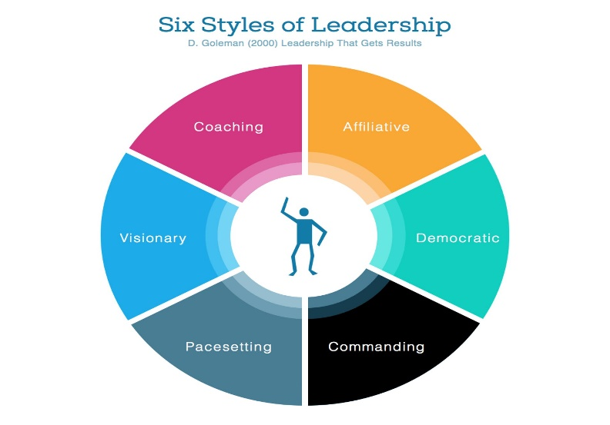

- Commanding Leadership Style - An authoritative leader provides a clear vision and direction for their team, allowing flexibility in achieving goals, inspiring and motivating them through their vision.
- Visionary Leadership Style - This style is characterized by a leader's ability to inspire others with a compelling vision for the future.
- Affiliative Leadership Style - Affiliative leaders prioritize building relationships, fostering harmony within their teams, and creating a supportive, inclusive environment, emphasizing that "people come first
- Democratic Leadership Style- Democratic leaders involve team members in decision-making processes, valuing their input and promoting collaboration.
- Pacesetting Leadership Style - Pacesetting leaders set high performance standards, expect their team to meet or exceed them, and lead by example, often taking on a significant workload themselves.
- Coaching Leadership Style - Coaching leaders prioritize skill development in their team members through guidance, feedback, and support, emphasizing long-term growth and development.
Facebook (Meta): Transformative Leadership Facebook, now known as Meta, is a global leader in social networking and digital communication. Mark Zuckerberg, the company's co-founder and former CEO, is credited with establishing transformational leadership in the organisation. Transformational leadership is defined as the ability to effect major change in an organisation by inspiring and encouraging individuals to go above and beyond their own interests for the sake of the organisation. Transformational leaders, such as Zuckerberg, focus on developing a vision for the future, conveying it to staff, and cultivating an environment that encourages creativity and innovation. For example, Zuckerberg's ambition to transition Facebook from a social networking platform to a metaverse exemplifies transformational leadership. This transformation demanded major innovation and new skill sets.
Benefits:
- Innovation and Creativity:
Transformational leadership promotes a culture of innovation. Employees are encouraged to think imaginatively, which can result in considerable improvements in products and services.
- Employee Motivation:
Transformational leaders can greatly increase staff enthusiasm and job satisfaction by linking them with the company's goal.
Disadvantages:
-Risk of Burnout:
Constant innovation and high expectations might lead to burnout among employees.
- Dependency on Leader:
Transformational leadership can develop a reliance on the leader for guidance, which might impede decision-making at lower levels.
Adaptation to Situations: Zuckerberg's leadership style changed based on the obstacles the firm experienced. For example, during the 2016 presidential election, Facebook was chastised for its part in spreading misinformation. Zuckerberg had to adapt his leadership style from transformational to transactional, focussing on policy implementation, upgrading the content moderation system, and dealing with regulatory scrutiny.
Amazon: Autocratic Leadership Amazon, one of the world's largest e-commerce and cloud computing corporations, is renowned for its founder Jeff Bezos' ‘’autocratic leadership’’. Autocratic leadership entails making decisions unilaterally, with little input from subordinates. Bezos was known for taking a hands-on Bezos on his own.
Autocratic leadership at Amazon allowed the company to react fast in a highly competitive sector. Bezos' clear vision and tight control over operations enabled the company to evolve quickly while maintaining a customer-centric strategy. His commitment on high standards, also known as "striving for perfection," drove Amazon to constantly enhance its services. Advantages of autocratic leadership include the ability to make quick decisions, which is crucial in fast-paced businesses such as e-commerce.
- Clear Direction: Employees are given clear directions, which reduces misunderstanding and ensures that everyone understands the company's aims.
Reduced Employee Input:
Employees under this leadership style may feel their opinions are not valued, which can impede creativity and innovation.
- Depressed Spirit:
Low morale and job unhappiness can result from a top-down approach, especially if staff members feel overworked or unappreciated.
Adaptation to Circumstances: Bezos's management approach has changed as the company has grown and faced obstacles. For instance, the leadership style had to adapt when Amazon grew internationally in order to fit various corporate settings and cultural norms. Amazon's leadership style became more participative, incorporating local leaders in strategic choices, particularly in locations where collaborative decision-making is valued.
Personal Experience in Leadership: Managing a Project Group Previously, I led a team responsible for creating a new software product at a mid-sized technology company using a democratic leadership style. Democratic leadership, sometimes referred to as participative leadership, is delegating decision-making authority to team members and promoting candid dialogue.
Benefits:
High Engagement: Members of the team felt appreciated and involved, which strengthened their dedication to the project.
- Diverse Ideas: The collaboration atmosphere fostered diverse viewpoints, resulting in more inventive solutions. One of the disadvantages of this approach is that it can be time-consuming as it requires participation from all team members, which can lead to a delayed decision-making process.
-Risk of Conflict: Opinion differences occasionally resulted in disputes, which required cautious management.
-Situation Adjustment: In a crucial stage of the project, I had to briefly adopt a directive leadership approach when making fast judgments to fulfil a deadline. To keep the project on schedule, this required giving clear directions and making judgments on my own. It is crucial to modify leadership approaches based on the circumstances, as I learned from this experience.

Combining Theory and Personal Experiences In my own experience, the transition from democratic to directive leadership is consistent with the ‘’contingency theory’’ of leadership, which posits that a leader's efficacy is contingent upon the circumstances. Fiedler's Contingency Model states that leaders should evaluate the circumstances and choose the best course of action. In my experience, the democratic method performed best during the planning and brainstorming stages of the project, whereas the directive approach performed better at the high-pressure phase.

Conclusion
In summary, To sum up, being a leader is a dynamic process that calls for adaptability and flexibility. Examples from Amazon and Facebook show how many leadership philosophies can work well in various organisational settings. My own experience emphasises even more how crucial it is to modify one's leadership approach depending on the particular demands of the circumstance. Maintaining effectiveness and long-term success will depend on an organization's capacity to transition between different leadership philosophies as it encounters new difficulties in a world that is changing quickly. Future leaders should concentrate on creating a flexible leadership style that can be adjusted to meet the particular requirements of every circumstance.

Reference:
- Cole , G.A. and Kelly , P. Phil (2020)Management theory and practice. Ninth edition/Gerald A. Cole , Phil Kelly . Andover :Cengage Learning
- Kotter , J.P. (1990) ‘’What Leaders Really Do’ ’Havard Business Review , 68(3), 103-111.
- Needle , D. Burns , J.(2019) Business in context : an introduction to business and its environment. Seventh edition. Andover : Cengage Learning
- Northouse , Dr. Peter G.(2020) ‘’Leadership:Theory and Practice
- Robbins , S.P. , Coulter , M.K. and Randel A .(2021) Management .Global edition . Harlow ,England : Pearson Education.
- How does Amazon Do Performance Management? Forte, OLR & Pip explained (2021) PerformYard. Available at: https://www.performyard.com/articles/how-does-amazon-do-performance-management#:~:text=Bezos%20is%20known%20to%20lead,at%20the%20best%20possible%20price.&text=But%20Amazon%20arguably%20gets%20its,both%20consumer%20and%20employee%20behavior. (Accessed: 23 August 2024).
- (No date) Facebook leadership style . Available at: https://api.mdsoar.org/server/api/core/bitstreams/53018f25-419f-4740-8c27-9246b9976089/content (Accessed: 23 August 2024).

