  - Company Background:

Bellway is a large property development company based in Newcastle upon Tyne, England. They are a public limited company founded in 1946 and have been trading for over 70 years. In 2019, their number of employees was at a staggering 2,980. Steering the ship is CEO Jason Honeyman and Chairman Paul Hampden Smith. Bellway is most recently recognized for their declining of the government’s job retention scheme. The property development company were eligible for the scheme and even furloughed over 3000 of their employees in the months of April and May. Very impressively, the company instead payed full basic salaries to all of their employees. In an interview by The Guardian, CEO Jason Honeyman stated that companies such as themselves had benefited from the governments “help – to – buy” scheme and said it would be “disingenuous” for them to accept support from the government. Bellway’s aims are very much based on customer satisfaction, as well as meeting the needs of “Bellway4Good’ committee which strives for less environmental impact and increase in energy efficient methods of building homes. For a rough idea of the scale of Bellway’s work; in 2014/2015 the number of houses sold by the firm was 7,752. Although the quantity of work undertaken is forever increasing, they ensure that the quality of their homes and the standard of their workforce is not neglected. In a report given by the former Chief executive back in 2015, he stated that their commitments at that period included increasing the amount of waste diverted from landfill to 92.9%. In addition to this, they installed energy efficient lighting to all new houses built from 2015 to the present day. They also work closely with charities such as The British Heart Foundation and Construction of Youth Trust. These commitments have all been followed through until today, including other upcoming aims and objectives that the property firm is proud to announce.

1.2 Objectives of the Report:

My objectives for this report are to show clear understanding of Bellway homes’ internal and external strategies for maintaining a competitive position within their industry’s market. In addition to this I will be analyzing the company’s competitive strategy as well as their business level strategy. This should allow me to gain insight into how a company of this caliber thrives to become the largest in the UK in their profession of building and developing properties to cater the needs of people from all walks of life. I have chosen Bellway Homes for their exceptional feedback and customer satisfaction history to date. They are a well-established company that exceed expectations for a company of its type. They have a very unique style of ensuring perfection every time, and their good work does not go unnoticed in the construction industry.

1.3 Competitive Strategy/ Business Level Strategy

To determine the competitive and business level strategy of Bellway, firstly we’d need to determine the actual meaning of these. Michael Porter described this as “taking offensive or defensive actions to create a defendable position in an industry” (Porter, M. 1980). He stated, “In differentiation strategy, a firm seeks to be unique in its industry along some dimensions that are widely valued by buyers” (Porter, M. 1980). These theories can be seen compatible to the strategy of Bellway, especially when looking at how unique and Bellway is to their competitors, and the distance they go to ensure customer satisfaction and industry dominance. Their product and service is comes across as very honest and bold, which is what I feel Michael Porter meant when he mentioned various dimensions that would be widely valued by buyers.

In addition to this, Henry Mintzberg described strategy as being a plan. “Some sort of consciously intended course of action; a guideline or a set of guidelines to deal with a situation (Mintzberg, H. 1987). Strategic planning first became acknowledged as a tool for the behavior of businesses in 1960. In Mintzberg’s words, it was seen as “the best way to devise and implement strategies that would enhance the competitiveness of each business unit” (Mintzberg, H. 1994). In his book ‘The Fall and Rise of Strategic Planning’, he described strategic planning as not an act of strategic thinking, as strategic planning is a form of analysis, whereas strategic thinking is synthesis (Mintzberg, H. 1994).

Authors Gerry Johnson and Kevan Scholes feels that it’s very important to consider the strategy development of an organization. These can be seen as a mixture of two factors. The first being the intended strategy. In contrast, the alternative type is seen as emergent (Johnson, G. Scholes, K. Whittington, R. 2008) In the diagram below we can see the theories of these authors more practically.

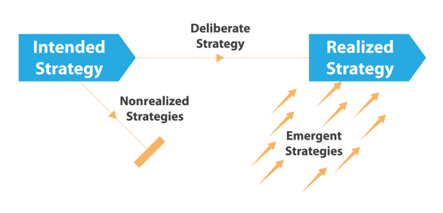
This is a simplified version of what Johnson, Scholes and Whittington mentioned in their book. This diagram is of Henry Mintzberg’s research in 1985. Putting this into practice with Bellway Homes, we realize that their intended strategy is to beat competitors by supplying a high - quality workforce and offer a range of employee training. They display their brand and service as premium in order to attract a specific clientele. This strategy is initially their intended strategy. It is seen as a long - term goal and usually takes years upon years to successfully execute, depending on the size and expectations of the company. Although the intended strategy is usually well prepared by professionals, various factors come into play that can be seen as threatening to the initial strategy. These factors could include internal things such as a change in management or financial issues, or a cutback in resources needed to carry out the strategy. The external factors may include political or legal changes, or on occasions environmental changes can take a negative effect. When these changes take place, the intended strategy is reverted to the realized strategy. If in the unlikely event of the intended strategy being untouched any factors and staying on – route, this is known as an emergent strategy.

With Bellway being a large property company, there are hundreds of factors that can easily jeopardize their strategy process. It’s also hard to determine these factors in the fast changing world we currently live in. Richard Rumelt once said “Strategic Management as a field of inquiry is firmly grounded in practice and exists because of the importance of it’s subject, and not because of its theatrical coherence (Rumelt et al, 1991). To try and determine these factors, a professional PESTEL analysis is carried out on the company. This analysis will pinpoint various factors that could affect the company. The factors examined come under Political, Economic, Social, Technological, Environmental and Legal. Below is a SWOT analysis for Bellway.

2.1 PESTEL Analysis on Bellway Homes PLC

Political:
Bellway currently operate in more than 12 different countries. Although globalization of the company is a great way to expand their brand and service, and keep ahead of competition, this comes with some political difficulties. Every year the minimum wage increases and with over 3000 employees, Bellway have to take this into consideration. This makes it difficult for Bellway to predict any future happenings and causes uncertainty financially. In contrast to this, the consumer buying power is mostly influenced by their income, meaning the more the consumer earns, the higher the buying power for Bellway’s products and services. The government also takes a vital part in the external factors that could impact Bellway. Things such as safety regulations within the industry can result in higher standards to meet, which leaves Bellway with a tighter margin when employing and training their workforce. This can potentially result in hiring standards slipping, and more unskilled workers becoming part of the workforce. Just like most companies, the variation of tax can cause negative impact, and the property industry is no exception. As stated before, Bellway have over 3000 employees, which are all subjected to employer tax for Bellway. On the other hand, with the consumer being taxed their spending power decreases and they usually become safer with their money, holding onto savings and ISAs in case of emergencies, whereas this money usually would be spent in the property industry potentially. A factor that has recently affected the housing market is the increase in pricing of construction material. This leaves property investors profit margins lower, and the risk of building or developing properties higher, which has a ripple effect within the industry.

Economical:
Various macro factors such as inflation rates, saving rates, interest rates and foreign exchange rates come into play with the property industry more than other industries. This is often down to foreign investors investing in property over – seas. A typical property investor spends hours monitoring these rates, and a sudden change can cause a collapse in the industry. Take the stock market crash of September the 29th, 2008 for example. In this event, the Dow Jones’ average fell 777.68 percent and Americans lost lifetime savings and retirement bonds. It takes many years for the economy to recover from an event such as this one.

Social:
These factors primarily revolve around the attitude of individuals in the industry at a certain time. These can range from consumers, workers and even stakeholders. Using the current Covid – 19 pandemic as an example, the behavior of individuals within the industry has drastically changed. In the book of ‘Psychology of Organizations’, it explains how the behavior of others influence the next persons behavior, this is usually subconsciously. (Katz, D and Kahn, R) With people becoming more socially cautious, their financial behavior has also become inconsistent. They’re now more likely to hold onto savings and money put aside to invest. And with news of another housing market crash in the future, this will undoubtably take away the attractiveness of building, developing or investing in property.

Technological:
In today’s fast changing world, and technology becoming more advanced and common in various industries, Bellway have to adapt and try to include technology throughout various sectors of their business. Due to competitors mainly concentrating on advancing technology, and less other things such as workforce, it’s likely for Bellway to fall behind and their competitors to gain on them in the market. These impacts may include value chain structure in consumer goods, or the impact of pricing within the industry.

Environmental:
Peoples different views and morals on the environmental impact partly depends on the location. For example, the environmental standards expected for us here in the United Kingdom is considerably higher than the standards expected of emerging markets such as Argentina, South Africa or China. Here in the UK, our climate changes and we experience the 4 seasons, usually to full extent. This can have an impact on the construction industry as planning forward can be very hard when there’s uncertainty of climate. Having a long period of constant rain can cause a delay in a lot of the work undertaken by Bellway’s. The company would also have to take people’s attitudes on green living, recycling and waste and the endangerment of animals into consideration, as well as deforestation in exchange of new property. UK currently has approximately 12 million square miles of wooded area, this makes up around 12.9% of the country’s land surface; this is about (38%) of the European average, these areas are fast becoming urbanized.

Legal:
The property and construction industry come with a hefty load of rights and laws. These can include factors such as copy right, patents, intellectual property laws, data protection laws, health and safety laws, discrimination laws and consumer protection laws. A great example of this is the General Data Protection Regulation that was introduced in the UK in May 2018.

2.2 Stakeholder Analysis for Bellway PLC

“The idea that corporations have stakeholders has now become common place in the management literature – both academic and professional” (Donaldson and Preston, 1995)

Bellway have a range of different stakeholders that invest and hold shares in their company. The analysis below shows other key factors that Bellway need to take into consideration as they can have great impact on the way Bellway Function

High
Regulations
Manage Closely
Keep Satisfied

Community
Government

Customers
Power
Contractors
Landowners
Keep Informed
Monitor.
Suppliers
Competitors

Low Interest High

Bellway PLC share – holders:

- Standard Life Aberdeen PLC 7,219,186 shares 5.86%
- Dimensional Fund Advisors LP 6,148,373 shares 4.99%
- Polaris Capital Management LLC 4,958,192 shares. 4.02%
- Credit Suissie Securities (Europe) LTD 3,890,282 shares 3.38%

2.2. Bowmans Strategic Clock

Bowmans strategic clock is a management tool that was created by Cliff Bowman and David Faulkner. It was created with the intentions of making companies aware of their market position (Faulkner, D. Bowman, C. 1995). According to (Johnson et al 2011), The clock helps managers understand the changing requirements of their markets and what they can do to alternate the positioning and maintain a competitive advantage.

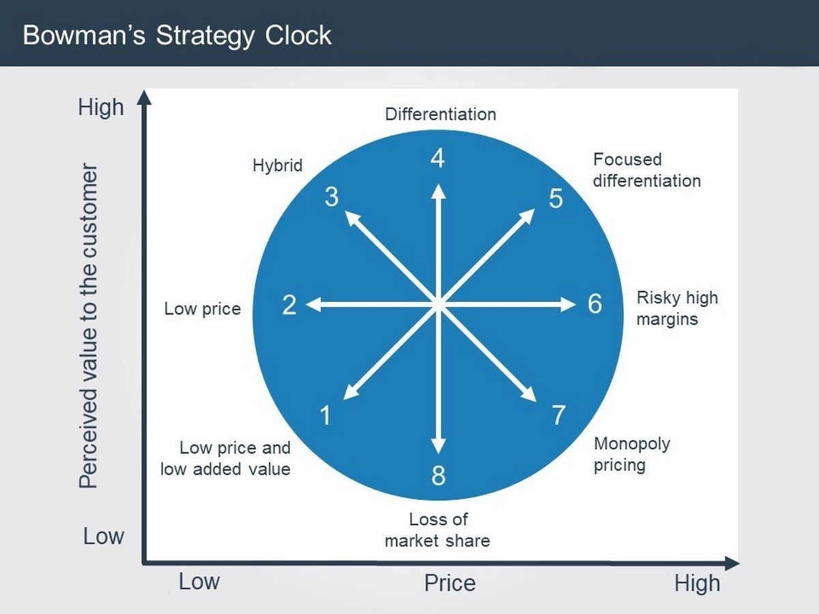

In Bowmans clock, there are 8 different strategic positions. These positions explore the options a business has to place their product and/or service. In addition to this, there are two dimensions to look at, price, and perceived value. Bellway PLC have taken the strategy of Focused Differentiation (Position 5). Taking this strategy allows Bellway to position their products and service in a high price category, while carrying out the highest quality of work. This position is usually adopted by premium brands, and as a part of their strategy, Bellway are maintaining the premium quality reputation.

2.3 - Porters 5 Forces

This strategic management tool was first described by Michael Porter in his 1979 Harvard Business Review (Porter, M and Kramer, M 1979). It’s primarily used to identify a company’s structure to determine corporate strategy.

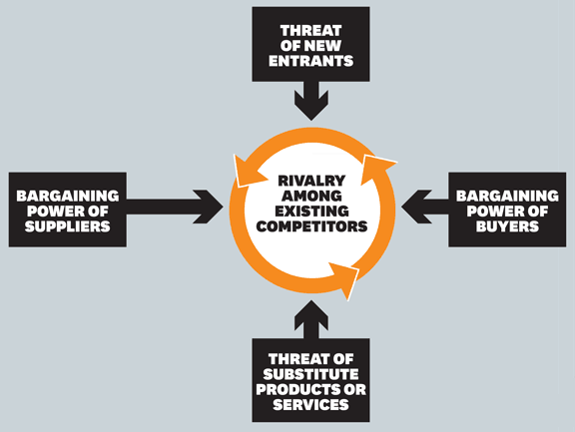

Bellway PLC adopt

SWOT Analysis for Bellway Homes (In order of importance)

Strengths:

As expected from a company with the success that Bellway has achieved over the years, there are plenty of strengths to list on their performance and where they’re currently at within their current market. For me, their main strength is one that stands out as being the reason behind their major success over the years with receiving 9/10 customer satisfaction. Bellway are constantly offering training programs to their workforce in order to keep them skilled and up to date with the on - going changes that face the property industry every year. This puts Bellway ahead of market competitors that pay less attention to their workforce and let some unskilled or inexperienced workers slip through the net, thus being a weak link in their chain, potentially jeopardizing the outcome of their overall work. Due to having such a highly skilled workforce, Bellway receives many good reviews from customers, which increases the workforce’s morale and motivation to stay on top in their industry. It’s safe to say that the firm’s biggest asset is their workforce, and they’ll continue to highly invest in training resources to keep benefiting their employees.

Bellway also have a good relationship between their dealers and distributors.

References

Prately, N. 7th of October, 2020. Bellway Homes, The Guardian. Retrieved from: https://www.theguardian.com/business/bellway (Accessed on 10/10/2020)

Ayres, T. 2014. Bellway Homes, About us. Retrieved from: https://www.bellway.co.uk/about-us (Accessed on 10/10/2020)

Porter, M. 1980. Competitive Strategy – Techniques for Analyzing Industries and Competitors. (Accessed on 10/10/2020)

Sharp, B. 1991. Marketing Intelligence and Planning. Volume 9. Retrieved from: https://www.researchgate.net/profile/Byron_Sharp/publication/235286366_Competitive_Marketing_Strategy_Porter_Revisited/links/00b4952a62d90679d2000000.pdf (Accessed on 10/10/2020)

Mintzberg, H. The Strategy, Concept 1: Five Ps of Strategy. October 1st 1987. Retrieved from: https://journals.sagepub.com/doi/abs/10.2307/41165263#articleCitationDownloadContainer (Accessed on 10/10/2020)

Mintzberg, H. The Fall and Rise of Strategic Planning. January – February 1994. Retrieved from: http://libroweb.alfaomega.com.mx/book/385/free/data/Materiales/Capitulo01/TheFallAndRiseOfStrategicPlanning.pdf (Accessed on 11/10/2020)

Johnson, G. Scholes, K. Whittington, R. Exploring Corporate Strategy, 8th Edition 2008. Retrieved from: https://books.google.co.uk/books?hl=en&lr=&id=1bEJPZwP2KMC&oi=fnd&pg=PR17&dq=exploring+corporate+strategy&ots=N-SyksYeiT&sig=_rPRYszt-YNuD-tuI9kOn47sWw0&redir_esc=y#v=onepage&q=exploring%20corporate%20strategy&f=false (Accessed on 11/10/2020)

Intended, Realized and Emergent Diagram. Picture retrieved from: https://www.google.com/url?sa=i&url=https%3A%2F%2Fecampusontario.pressbooks.pub%2Fstrategicmanagement%2Fchapter%2Fintended-emergent-and-realized-strategies%2F&psig=AOvVaw3qjMi2IlwQRfrwyDxIgCpR&ust=1602779024648000&source=images&cd=vfe&ved=0CAMQjB1qFwoTCLimtqW_tOwCFQAAAAAdAAAAABAE (Accessed on 11/10/2020)

Rumelt, R. Strategic Management Journal 1991. (Accessed on 11/10/2020)

Lusk, V. Stock Market Crash of 2008. June 2019. Retrieved from: https://www.wealthsimple.com/en-gb/learn/2008-market-crash (Accessed on 12/10/2020)

Katz, D. Kahn, R. The Social Psychology of Organizations. Retrieved from: https://pdfs.semanticscholar.org/85f7/dadae6fc51905bd314871b7458cf0f5bade1.pdf (Accessed on 12/10/2020)

Ies.Uk. What is Deforestation? Retrieved from: https://www.ies-uk.org.uk/deforestation.php (Accessed on 13/10/2020)

Akinbode, A. Grewal, G. Olson, K. (April 2018) Legal Issues for Those Running UK Construction Business – Spring 2018. Retrieved from: https://www.mondaq.com/uk/construction-planning/693928/legal-issues-for-those-running-uk-construction-businesses--spring-2018 (Accessed on 13/10/2020)

Donaldson, T and Preston, L. 1995. Donaldson, T. and Preston, L., 1995. The Stakeholder Theory of the Corporation: Concepts, Evidence and Implications. The Academy of Management Review, Vol. 20, No. 1. (Jan., 1995), pp. 65-69.
Bellway PLC. Shareholders October 15, 2020. Retrieved from: https://www.bellwayplc.co.uk/investor-centre/shareholder-information/major-shareholders (Accessed on 14/10/2020)

Faulkner, D. Bowman, C. The Essence of Competitive Strategy, Prentice Hall, 1995. Retrieved
from: https://moodle.uwtsd.ac.uk (Accessed on 14/10/2020)

Johnson et al 2011. Retrieved from: https://moodle.uwtsd.ac.uk (Accessed on 14/10/2020)

Bowmans Clock Picture Diagram. Retrieved from: https://www.google.com/url?sa=i&url=https%3A%2F%2Fwww.marketing91.com%2Fwhat-is-bowmans-strategy-clock%2F&psig=AOvVaw0mxjkfnypQ9zDglXgEl7Tv&ust=1602892002518000&source=images&cd=vfe&ved=0CAMQjB1qFwoTCPCIp5Xkt-wCFQAAAAAdAAAAABAJ (Accessed on 15/10/2020)

Riley, J. Bowmans Strategic Clock. Retrieved from: https://www.youtube.com/watch?v=hsV1mraa4AI (Accessed on 15/10/2020)
Porter, M. Kramer, M. 1979. Harvard Business Review. The Link Between Competitive Advantage and Corporate Social Responsibility. Retrieved from: https://aameg.org/wp-content/uploads/2013/10/Porter-Kramer-Strategy-Society-The-Link-between-Competitive-Advantage-CSR-2006.pdf (Accessed on 15/10/2020)

Porters 5 Forces Picture Diagram. Retrieved from: https://www.google.com/url?sa=i&url=https%3A%2F%2Fhbr.org%2F2011%2F12%2Fthe-charts-that-changed-the-world&psig=AOvVaw3hUYJRa8NNo4wcEkcXGy1N&ust=1602894513725000&source=images&cd=vfe&ved=0CAMQjB1qFwoTCNDyxcLtt-wCFQAAAAAdAAAAABAE (Accessed on 15/10/2020)

