Evaluation of the Environmental Impact Assessment
of Morlais Tidal Stream Energy
Alex Dunstan 2304994

Abstract
The Morlais tidal stream project EIA has been criticised by wildlife groups for its lack of consideration for local wildlife within a protected conservation area. Despite keeping the best interests of the community of Anglesey at the forefront of the EIA, a clash of interests makes the building of this project controversial. Cross party support from the Senedd and large amounts of EU funding mean there are no signs of the project slowing down, this makes mitigation measures essential in reducing harm to the local environment, which is a significant part of the EIA. The EIA carefully follows relevant policy which can be criticised just as much as the EIA itself.
Key words: Tidal Stream, EIA, Water Mammals, Public, AONB, Anglesey, RSPB

Contents
Abstract 1
1.0 Introduction 3
2.0 The EIA process 5
2.1 Screening 6
2.2 Scoping 7
2.3 Baseline assessment 8
3.0 Context around Anglesey 9
3.1 The Welsh Government 9
3.2 Legislation 9
4.0 Key issues 11
4.1 Water mammals 11
4.2 Birds 12
4.3 Public opinion 12
4.4 Waste 13
4.5 Tourism 14
4.6 Traffic 15
5.0 Mitigation 16
5.1 Innovative Mitigation Strategies 16
5.2 Mitigation criticisms 17
6.0 Conclusion 17
References 19

1.0 Introduction
This report evaluates the Environmental Impact Assessment (EIA) process using the case study of the Morlais Tidal Stream Energy project. The EIA was constructed by Menter Mon a social enterprise based in Anglesey. The project is funded significantly by the Welsh Government and through EU donations. Despite this project having environmental benefits in the long term, by producing green renewable energy it has been criticised for its lack of consideration of the surrounding environment. Some of the main criticisms are regarding the lack of awareness of protected wildlife species in the area. This is essential for a project situated on Holy Island in Anglesey which is marked as an ‘Area of Outstanding Natural beauty’ (AONB), ‘Special Area of Conservation’ (SAC) and a ‘Site of Special Scientific Interest’ (SSSI). Holy Island is a popular tourist destination with several caravan parks and tourist attractions that are visited by thousands of people every year. This shows the importance of preserving the area’s environment because of the economic and social benefits for the local area. The report analyses the various criticisms and key impacts of the EIA including its potential harm to wildlife, its effects to the local community and an assessment of potential mitigation measures, setting these out in order of their impact significance. The report evaluates the relevant environmental policies that relate to Morlais’ EIA including recent Welsh Government policy that promotes the use of renewable energy, UK and EU legislation protecting the environment from intentional harm.

2.0 The EIA process

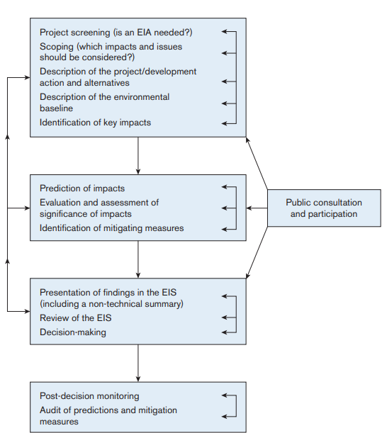

Figure 1 (Glasson and Therivel, 2013)
According to Glasson and Therivel (2013) an EIA will likely follow the above steps in order to effectively contribute to sustainable development. However, the process should be a cyclical activity rather than the process following a linear fashion so that feedback and interaction can be provided throughout the steps.

2.1 Screening
The screening process will determine whether an EIA is required depending on the projects size, location or the nature of the project itself. An EIA was required for the Morlais project, and it was determined as a schedule 1 project. This was because of the size of the project having an onshore and offshore site which can both significantly impact the local environment. This process was carried out by local planning authorities rather than Menter Mon or Natural Resources Wales who constructed the EIA. This is based under the 2017 Town and Country Planning Regulations, as a part of the Town and Country Planning Act 1990 (UK Government, 2020). However, these regulations have been criticised for being somewhat vague, so local authorities can be left to their own judgement but will most likely be encouraged to undertake an EIA for discretion (UK Government 2020).

2.2 Scoping
Considerations were made during the scoping phase of the EIA; an example being ensuring that the onshore cables were built underground to preserve the natural beauty of the site's location. The scoping process set out that the natural beauty near the onshore location needed to be preserved. This decision was made early in the EIA process so consistencies could be made in decision making. Therefore, the scoping process can be seen by some as the most important stage of an EIA as if issues are not identified early it can result in delays in decision making and an inadequate EIA altogether or other issues may be addressed in too much detail leading to a waste of time and resources. (Weston, 2000). Much like screening, the scoping process relies on intuitive assessments in order to create an effective EIA report and comply with relevant policy and legislation (Wood 2014). Taking early precautions such as these is an effective way of showing that Morlais is a project that wants to enhance the environment of Anglesey by producing green energy and managing the project in a way that minimal damage is done to the local environment.

2.3 Baseline assessment

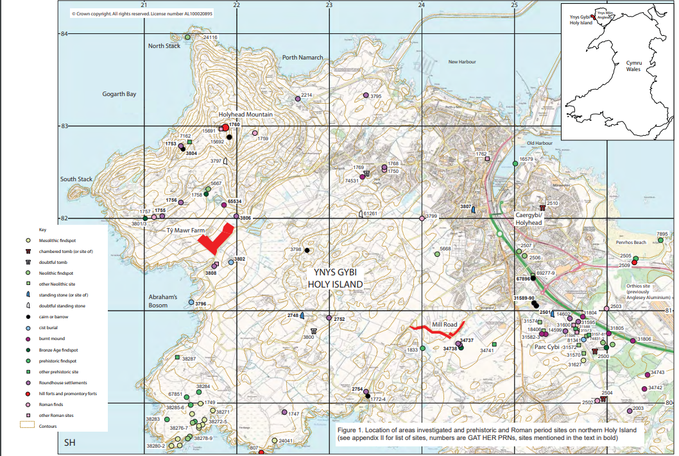
Figure 2

The EIA goes into detail about the surrounding environment of the chosen demonstration zone. By describing the size and scale of the project area with annotated maps and diagrams such as figure 2. Marking out prehistoric and Roman sites on the map is used to show how non overlap with the chosen-on land location of Ty Mawr farm which is marked in red. This was essential because the chosen area Holy Island is marked as an ‘Area of Outstanding Natural beauty’, ‘Special Area of Conservation’ and a ‘Site of Special Scientific Interest’. The chosen site is legally protected by Article Six of the Habitats directive as a Natura 2000 site, so only ‘positive conservation’ measures can take place (Jones, 2012). This judgement being made early in the EIA is essential to set out consistencies in decision making.

3.0 Context around Anglesey
Being a local social enterprise, Menter Mon claims it has the best interests of the people of Anglesey in mind suggesting that the energy created by Morlais tidal stream will go to the people of Anglesey and North Wales and more. However, the way this is written seems very vague which can create concerns for local residents of Anglesey that the energy created may not stay in Wales. This resonates with the history of the Llyn Celyn reservoir that flooded and forcibly removed the North Welsh village of Capel Celyn for water entirely used by Liverpool despite protest across Wales from locals and MPs (Atkins, 2018). This is still in the minds of the people of North Wales and therefore reassurance that the Morlais project will provide energy solely for Wales would be necessary. In order to combat this issue Menter Mon may need to ensure the public of the benefits of a new renewable energy source for Wales and how it can benefit the local community.

3.1 The Welsh Government
The project has been widely supported by the Welsh Government as climate minister Julie James confirmed £31m of EU funding will be given to the programme (Jones-Pearson, 2022). As well as support from Plaid Cymru leader and Anglesey MS Rhun Ap Iorwerth and the Welsh Conservatives. The desired outcome for the Welsh Government is to push this project through, much of environmental policy is built on economic benefits rather than benefits of wildlife or the natural world. Even significant policies like the 1981 Wildlife which was constructed by a neoliberal Thatcher government, which historically would have prioritised deregulation within environmental policy. An EIA can sometimes have a political agenda to assist the develop of a project rather than preserving the environment or assessing alternatives (Mitchell and McManus, 2013). An example of this being in Western Australia’s mining industry where the social license to operate is neo liberalised meaning that there is not enough sufficient attention given to negative environmental and social impacts (Brueckner et al 2014). Despite the Morlais project’s widespread support across the Senedd, it is important that environmental concerns in the EIA are carefully considered to allow the project to work without harming the environment rather than rushing through the EIA for the sake of saving costs to push the tidal energy project through.

3.2 Legislation
The EIA that is built on the environmental policy of the EU, UK and Welsh governments would want projects like Morlais to be built. Thus, their policy and legislation would prioritise economic benefit over issues regarding local wildlife and biodiversity (Biermann, 2022). Other than the economic benefits of tourism in the area which can be easily neglected, a market value cannot be put on wildlife or clean water (Beatley, 1989). Although Wales and in this case, Anglesey especially economically benefits from tourism, the total annihilation of the environment for the sake of economic benefit is unlikely to occur. Whereas in a less economically developed country such as Rwanda the EIA process can be far less effective as the priority is usually based around economic benefit even if it means putting wildlife or the natural environment at risk. Weaker institutional structures and weaker environmental policy will often lead to a weaker EIA (Marara et al 2011) making it essential that the EIA carefully follows policy from the Welsh, UK and European Government. Whereas in Wales an EIA must be in line with the Welsh Governments targets and goals such as the Future Generations Act 2015. Judging how an EIA stays in line with relevant environmental policy can be an effective way of determining its success (Jenkins, 2018). Wales’ recent environmental policy has been internationally applauded. The Future Generations Act 2015 was praised by Hillary Clinton in her visit to Swansea University, as she stated she was a “big fan of the Wellbeing and Future Generations Act” (Thomas 2023). However other UK legislation has been criticised. An example of this being the UK’s Town and Country Planning Act 2017 which can leave local authorities down to their own judgement of whether an EIA should be constructed (UK Government, 2020).

4.0 Key issues
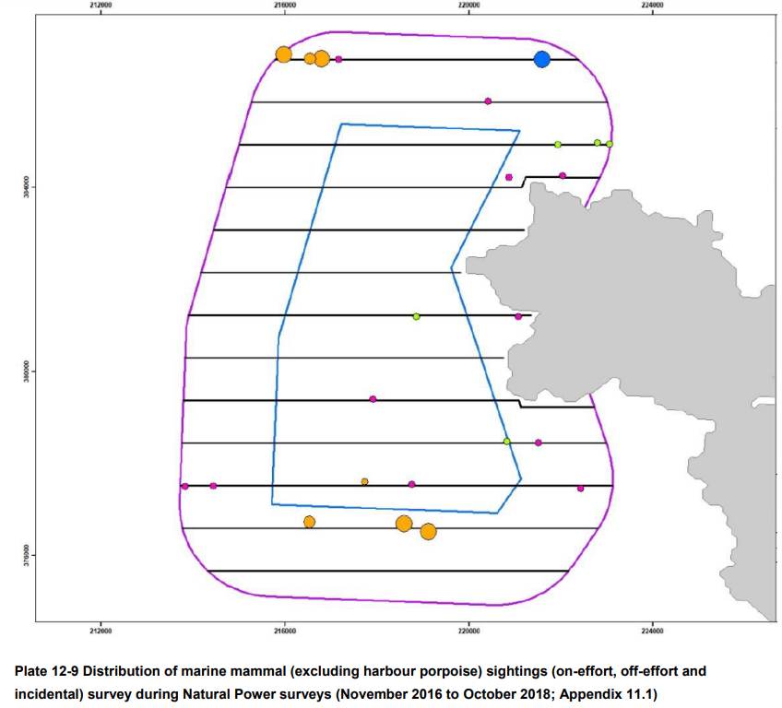
Figure 3

4.1 Water mammals
The local marine wildlife was considered carefully in the EIA putting emphasis on water mammals in the area such as grey seals, harbour seals, bottlenose dolphins and minke whales. This was essential as these animals are legally protected by the 1981 Wildlife and Countryside Act preventing them from intentional harm. Thus, surveying methods were used to identify numbers of water mammals in the area with the same method being used for species of fish and shellfish which is seen in figure 3. However, there was no description of migratory patterns of basking sharks and very little detailing of habitat locations. This can be a significant issue in the EIA as basking sharks are protected under the 1981 Wildlife Act and further issues occur as the species are within a SAC (Frost et al 2016). Adhering legislation like the 1981 Wildlife and Countryside Act is essential in making the EIA legitimate. An effective EIA uses relevant legislation aligned with principles of sustainable development to ensure environmental considerations are integrated throughout decision making (Jay et al 2007). Despite attempts to gain further information on water mammals that are known to migrate from Ireland however there was no response from Irish authorities. The report indicates the potential harm to wildlife such as fish overlapping with the project and bottlenose dolphins potentially colliding with infrastructure. However, the report gives very little detail about how these issue may be prevented. After surveying and consulting with local fishers on the population levels of water mammals it was concluded that due to the low population level of these water mammals in the area, the risk of harming them was also low. It is still essential to have the foresight to strategically plan, in case a bottlenose dolphin was to collide with the tidal stream turbines. The outcome of this could lead to the shutdown of the project entirely as it would be breaking the 1981 Wildlife Act which legally protects water mammals from intentional harm. The report also ignores possible future increases in the population of bottlenose dolphins which may increase the risk of the harm to wildlife. Therefore, approaches should be made to analyse signals, interpret information and implement the outcomes in case this catastrophic even were to occur (Cook et al 2014).

4.2 Birds
The major impacts are assessed throughout the EIA within different segments. One that should have been addressed further it caused was the disruption of birds which feed on the fish located in the MDZ area. This was addressed in the EIA saying there is potential for diving birds to ‘collide’ with the tidal stream turbines. The RSPB reserve ‘South Stack’ is in close proximity with the onshore location of Morlais. RSPB Cymru released an article stating grave concerns with the project, estimating that 60% of the guillemots and 98% of the razorbills could be lost causing massive damage for local preserved wildlife but also for the South Stack reserve which gains over 250,000 tourists each year (Kudelska, 2019). Although this issue was addressed using surveying, which highlighted guillemots and razorbills could be affected, these were the only bird species’ that were analysed. Other species such as puffins are located in the South Stack reserve and thus should have also been included in the EIA. To analyse this impact further, additional discussions about other bird species in the area with the RSPB should have been undertaken and included in the EIA to ensure a more accurate representation of the bird population.

4.3 Public opinion
The public were consulted at a later stage of the EIA during the assessment of key impacts. The key impacts were identified including both adverse and beneficial and their magnitude was to be evaluated. Consulting the public allowed questions to be broken down into their constituent parts. This can allow reasoned judgements to be made with supported technical and non-technical evidence (Lawrence, 2007). An EIA is a public document as it is designed for stakeholders to be informed about how they will be impacted by a project being used as a guidance for public consumption to demonstrate how environmental considerations are recognised and addressed (Morgan, 2012). Menter Mon hosted meetings where the public’s issues were discussed. A major issue of these meetings was that almost all of the groups that asked questions belonged to kayaking or sailing clubs. These groups are very specific concerns and therefore wider concerns from broader representation of the communities were not considered. Within this session the majority of the participants agreed that the current location of South Stack was the best location for the project out of the proposed locations. The EIA did not detail if wildlife protection groups such as the RSPB or Wildlife Trust were asked to join the held meetings. In this case this would have been especially important as wildlife groups have expressed their disapproval of the project's location. Welsh television presenter Iolo Williams made a statement on the Facebook page ‘South Stack Heritage Group’ about issues with the current location starting a petition to put a stop to the project altogether that currently has almost 12,000 signatures (Williams, 2020). There was no mention of this in the EIA despite documents being released up to two years after the petition was made. Despite being a difficult situation for Menter Mon, a public meeting with the South Stack Heritage Group and other wildlife protection groups could have been held. Discussing clear mitigation strategies whilst addressing the significant issues of how Morlais effects local wildlife, can be an effective way of improving Morlais’ public image.
Local fishers were consulted as part of the EIA as they could likely be affected by fish migration around the MDZ which was considered a potential impact. This form of collaborative decision making is effective in involving the community so they can respond to Morlais with any questions or complaints on what they deem as acceptable and unacceptable in the project (Taylor et al 1998). However, it was not stated if the ‘local fishers’ worked for a commercial fishing company or went fishing as a hobby. This would have been an important consideration as the two would likely have had different perspectives on how the project effects them, showing further vague wording in the EIA.
In 2019 Menter Mon sent letters through the doors to people in Anglesey, detailing the effects of the project and the impacts to the community. This is an effective way of informing local people who will want to know more about the project, especially if they do not have access to the internet. Similar update letters on the project were sent in 2020 however, hard copies were not sent due to COVID. This could be an issue for some people in the community who may not have internet access although this would be a hard criticism as Menter Mon might be required to take these precautions because of COVID restrictions.

4.4 Waste
In order to preserve the natural beauty of Holy Island waste matter needs to be effectively managed. This issue was not addressed in enough detail with only a small segment on waste management being provided stating a private company “Browns Recycling Group” was used. Although the Environmental Permitting Regulations were followed by Browns Recycling Group, it is less reassuring as a private company could take shortcuts when following regulations and prioritise profit over conservation of the area (Siregar, 2021). The Morlais project is built around Menter Mon being a local social enterprise with the best interests of the people of Anglesey at the forefront. Utilising a private company dilutes this branding and could cause issues in the conservation of the Area of Outstanding Natural Beauty (AONB). It is not clear how far due diligence went in scrutinising the partnerships with Browns Recycling Group. Natural Resources Wales (NRW) will manage inspections to prevent issues such as flooding or spillage. However, NRW may have wanted to take a step back from waste management due to their recent scandal of being caught dumping sewage near a dolphin habitat for over a decade (Horton, 2023). So hiring a private external company for waste management may have been a more effective way of maintaining a better public image for Morlais. Due to NRW being heavily criticised in the media for its poor waste management. There are no estimates on the quantities or types of waste matter that could be produced or how problems would be dealt with if they were to occur. This would cause great concern if waste is not managed effectively and harming the nearby biodiversity that was pointed out during scoping. Incorrectly dumped waste containing hazardous toxins can cause devasting issues to ecosystems. It is essential that waste is effectively managed by environmental policy and regulations, which in this case will be enforced by inspections from NRW (Gaur et al 2020).

4.5 Tourism
The report details how the sites around Holy Island and Anglesey rely upon tourism for its local economy. Using NOMIS reports which estimate that 3000 jobs are provided in the Accommodation and Food sector, making it the highest employment sector in Anglesey. These businesses would likely rely on tourism to survive as the report details that several caravan parks and cafes are situated in close proximity to the on-land demonstration zone. Taking these factors into account during the scoping process as another proposed location slightly further North was dismissed due to noise pollution potentially affecting residents in Holyhead. Menter Mon would already be aware of how economically reliant on tourism Anglesey is so it can be taken as a positive that reports were conducted. However, this was an issue that was addressed by the public in meetings, very little potential impacts to tourism have been assessed in the EIA. Other than describing walking routes along Holyhead Mountain and kayaking areas in Gogarth Bay. However, there is no potential impacts of noise pollution or how it could obstruct views of the bay. This would have been an important issue for potential impacts to be addressed further as many local people would likely rely on tourism for work. Tourism in Anglesey can play an important part in the environmental conservation of the area. Tourists visiting nature reserves in the area like the South Stack nature reserve leads to further education about the importance of conservation and more financial spending that goes back into the preservation of the environment (Buckley, 2011).

4.6 Traffic

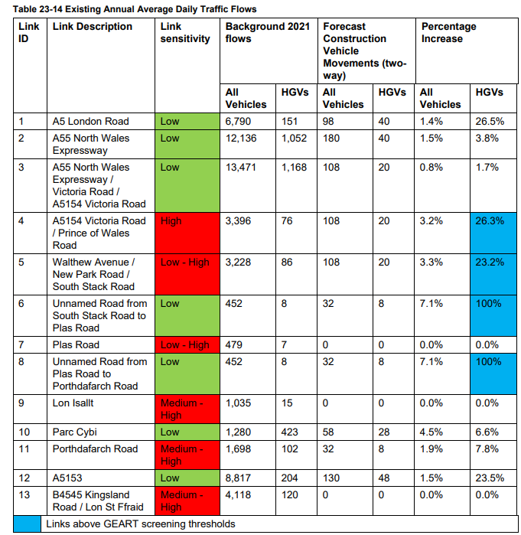
Figure 4

Traffic was an issue that was addressed in detail as this is required in an Environmental Statement and the project is deemed as a Nationally Significant Infrastructure Project (NSIP) due to Welsh government policy and the North Wales Joint Local Transport Plan 2015. This section provides survey results of traffic levels on roads leading to the on-land site and the magnitude of increased traffic due to the transport of resources and building of underground cables. Conducting surveys and creating tables such as figure 4, shows the amount of thought Menter Mon has for the local community. Informing the public this way on an EIA which the public have access to, is an effective way of involving them in decision making and showing a degree of care to the community (Nadeem and Fischer 2011). Some of the only times that local communities can get involved in environmental decision making is when an EIA is conducted in their area. Assessing the opinion of the public can give greater legitimacy to the building of a project as local communities are the ones who will have to live with the consequences of negative environmental impacts in their area. Thus, local communities can provide a greater knowledge of culturally significant buildings than an external third party. Their opinion can be voiced through meetings or forums are important in providing valuable feedback to improve the quality of an EIA (Hasan et al 2018).

5.0 Mitigation
Strategies and plans for the potential negative impacts that were identified throughout the EIA are made on how they can be avoided or reduced. Several mitigation assessments were conducted by an external experienced environmental science expert from the University of Portsmouth who had been in the field for over “20 years” and has assessed the mitigation of other tidal stream projects in the UK previously. Using an independent expert as opposed to someone from Menter Mon or NRW would reduce any bias in their mitigation assessment, giving accountability in decision making. From the mitigation section of the EIA several surveying strategies were undertaken to assess the mitigation impacts of ecology such as impacts to the seabed and migratory fish. Much of this was included in the Environmental Monitoring and Mitigation Plan. These claimed that the tidal stream impacts would be minimal however, it stated that little is known about migratory fish patterns around tidal stream turbines. Therefore, further research should have been taken to assess these potential impacts in order to create a more effective mitigation strategy if issues were to arise (Munn 1979). A whole segment of the Mitigation plan was dedicated to marine mammals due to their required protection under the 1981 Wildlife Act.

5.1 Innovative Mitigation Strategies
Innovative strategies were thought of such as tagging seals so they could be monitored carefully to prevent harm from collisions with the tidal stream turbines. Using other tidal stream projects around the UK of how they have dealt with similar issues is a clear way of showing how these mitigation strategies can work. Using underwater cameras to monitor other marine mammals which can be very costly, but shows they are taking mitigation measures for marine mammals very seriously. The main criticisms regarding the Morlais project were surrounding its lack of care for the preservation of wildlife. Despite efforts to track seals, these criticisms can be attributed to a lack of research around tidal energies effect on wildlife as a whole. The Welsh Government announced plans for £750,000 for tidal energy research in an attempt for Wales to become a ‘World Leader’ in tidal energy technology (GOV.Wales, 2023). Although plans for where this funding is likely to go are currently unclear, directing parts towards innovative mitigation strategies to further protect wildlife is necessary. This is especially important in the case of the Morlais project’s location as it is surrounded by wildlife and preservation areas like the South Stack Nature Reserve.

5.2 Mitigation criticisms
Mitigation is often based around proposals that need to be monitored and enforced in order to be effective. Mitigation can also range from compensating for damage or repairing the environment after impacts have occurred (Mitchell, 1997). Menter Mon are aware that some impacts such as an increase in traffic are inevitable. Therefore, to compensate local residents were informed about this as it was deemed as a fairly minor issue that could not be helped. Similarly, to the concept of the EIA as a whole, mitigation measures can be assessed for their impacts to determine how beneficial they will be (Tinker et al 2005). Such as in the case of informing the public about the proposal, discussions were made about the most effective way of informing the public during COVID restrictions.
It is also important to note that the mitigation plans were approved by NRW which can give the surveys greater legitimacy. However, as NRW is a Welsh government sponsored body it is well within their interests to approve the Morlais tidal project due to the amount of funding they have already put into the project. Therefore, it can be more effective to have these approved further from another external expert rather than by NRW.
The policy of tagging seals can provide a rich source of data for future tidal stream projects. However, tagging itself is not preventing harm to seals but merely a way of informing of the extent of harm to the water mammals and other wildlife it is not therefore mitigating the risk.

6.0 Conclusion
Due to the size of Menter Mon’s Morlais project the EIA was vastly detailed and broad, clearly stating the key environmental impacts that are affected by the project. It is clear that the EIA addressed many of the main concerns of the project in detail. However, despite these efforts further criticisms can be made that these were only plans and proposals rather than sufficient action being taken immediately such as the policy of tagging water mammals. Consistent surveying techniques were used to analyse the baseline conditions of flora and fauna in the onshore project area. Protecting these areas by its strategy on clearing waste from the project will be extracted. As well as analysing the impacts of traffic which is likely to be an important issue to work commuters in Anglesey. It is fair to say Menter Mon upheld their public image of being a local social enterprise with Anglesey's best interests in mind by holding public meetings and keeping local residents up to date with information regarding Morlais. However, the Morlais project was publicly criticised on the issue of bird preservation, meaning not enough mitigation strategies or acknowledgement of this issue was put into the EIA. This was a main issue with the Morlais EIA as well as other valid criticisms of being too vague on potential issues with marine wildlife colliding with tidal stream turbines.
It is important to note that an EIA is steered and heavily influenced by the policy it follows with much of environmental policy in the UK and EU being based around neoliberalism and market deregulation. There are often loopholes and shortcuts that can be taken in vague policy such as the Town and Country Planning Regulations 2017. These policies are often built around favouring economic benefit rather than protecting the environment (Igoe, 2007). In the case of the Morlais project, the approval of the EIA was imperative to ensure that a large, publicly funded project was allowed to proceed.

References
Beatley, T., 1989. Environmental ethics and planning theory. Journal of Planning Literature, 4(1), pp.1-32.
Biermann, F., 2022. The future of ‘environmental’policy in the Anthropocene: Time for a paradigm shift. In Trajectories in Environmental Politics (pp. 58-77). Routledge.
Brueckner, M., Durey, A., Pforr, C. and Mayes, R., 2014. The civic virtue of developmentalism: on the mining industry's political licence to develop Western Australia. Impact Assessment and Project Appraisal, 32(4), pp.315-326.
Buckley, R., 2011. Tourism and environment. Annual review of environment and resources, 36, pp.397-416.
Cook, C.N., Inayatullah, S., Burgman, M.A., Sutherland, W.J. and Wintle, B.A., 2014. Strategic foresight: how planning for the unpredictable can improve environmental decision-making. Trends in ecology & evolution, 29(9), pp.531-541.
Frost, M., Bayliss‐Brown, G., Buckley, P., Cox, M., Dye, S.R., Sanderson, W.G., Stoker, B. and Withers Harvey, N., 2016. A review of climate change and the implementation of marine biodiversity legislation in the United Kingdom. Aquatic Conservation: Marine and Freshwater Ecosystems, 26(3), pp.576-595.
Gaur, V.K., Sharma, P., Sirohi, R., Awasthi, M.K., Dussap, C.G. and Pandey, A., 2020. Assessing the impact of industrial waste on environment and mitigation strategies: A comprehensive review. Journal of hazardous materials, 398, p.123019.
Glasson, J. and Therivel, R., 2013. Introduction to environmental impact assessment. Routledge.
GOV.Wales (2023) First minister announces £750,000 fund for tidal lagoon research, GOV.WALES. Available at: https://www.gov.wales/first-minister-announces-fund-for-tidal-lagoon-research (Accessed: 13 December 2023).
Hasan, M.A., Nahiduzzaman, K.M. and Aldosary, A.S., 2018. Public participation in EIA: A comparative study of the projects run by government and non-governmental organizations. Environmental Impact Assessment Review, 72, pp.12-24.
Horton, H. (2023) Welsh water admits spilling untreated sewage near Dolphin Habitat for decade, The Guardian. Available at: https://www.theguardian.com/environment/2023/oct/19/welsh-water-admits-spilling-untreated-sewage-near-dolphin-habitat-for-decade (Accessed: 07 December 2023).
Igoe. (2007). Neoliberal conservation: a brief introduction. Conservation and Society., 5(4).
Jay, S., Jones, C., Slinn, P. and Wood, C., 2007. Environmental impact assessment: Retrospect and prospect. Environmental impact assessment review, 27(4), pp.287-300.
Jenkins, V., 2018. Sustainable management of natural resources: lessons from Wales. Journal of environmental law, 30(3), pp.399-423.
Jones, P.J., 2012. Marine protected areas in the UK: challenges in combining top-down and bottom-up approaches to governance. Environmental Conservation, 39(3), pp.248-258.
Jones-Pearson, B. (2022) Morlais tidal project on Anglesey gets £31m EU funding, BBC News. Available at: https://www.bbc.co.uk/news/uk-wales-60833908 (Accessed: 01 December 2023).
Kudelska, L. (2019) South stack and why we are objecting to the Tidal Energy Demonstration Zone, South Stack and why we are objecting to the Tidal Energy Demonstration Zone - South Stack Cliffs - South Stack Cliffs - The RSPB Community. Available at: https://community.rspb.org.uk/placestovisit/southstackcliffs/b/southstackcliffs-blog/posts/south-stack-and-why-we-are-objecting-to-the-tidal-energy-demonstration-zone (Accessed: 27 November 2023).
Lawrence, D.P., 2007. Impact significance determination—designing an approach. Environmental Impact Assessment Review, 27(8), pp.730-754.
Marara, M., Okello, N., Kuhanwa, Z., Douven, W., Beevers, L. and Leentvaar, J., 2011. The importance of context in delivering effective EIA: Case studies from East Africa. Environmental Impact Assessment Review, 31(3), pp.286-296.
Mitchell, J., 1997. Mitigation in environmental assessment-furthering best practice. EA-LINCOLN-, 5, pp.28-29.
Michell, G. and McManus, P., 2013. Engaging communities for success: social impact assessment and social licence to operate at Northparkes Mines, NSW. Australian Geographer, 44(4), pp.435-459.
Morgan, R.K., 2012. Environmental impact assessment: the state of the art. Impact assessment and project appraisal, 30(1), pp.5-14.
Munn, E., 1979. Environmental impact assessment.
Nadeem, O. and Fischer, T.B., 2011. An evaluation framework for effective public participation in EIA in Pakistan. Environmental Impact Assessment Review, 31(1), pp.36-47.
Siregar, I., 2021. CSR-based corporate environmental policy implementation. British Journal of Environmental Studies, 1(1), pp.51-57.
Tague, N. (2022) Tender open for Anglesey Tidal Power Project, Place North West. Available at: https://www.placenorthwest.co.uk/tender-open-for-anglesey-tidal-power-project/ (Accessed: 23 November 2023).
Taylor, C.N., Bryan, C.H. and Goodrich, C., 1998. Social assessment: theory, process and techniques. Centre for Resource Management.
Thomas, K. (2023) Clintons’ visit to Swansea University puts focus on leadership for future generations, Swansea University. Available at: https://www.swansea.ac.uk/press-office/news-events/news/2023/11/clintons-visit-to-swansea-university-puts-focus-on-leadership-for-future-generations.php (Accessed: 29 December 2023).
Tinker, L., Cobb, D., Bond, A. and Cashmore, M., 2005. Impact mitigation in environmental impact assessment: paper promises or the basis of consent conditions?. Impact Assessment and Project Appraisal, 23(4), pp.265-280.
UK Government (2020) Environmental impact assessment, GOV.UK. Available at: https://www.gov.uk/guidance/environmental-impact-assessment (Accessed: 04 December 2023).
Willliams , I. (2020) South Stack Heritage Group, Facebook. Available at: https://www.facebook.com/SouthStackHeritageGroup/videos/iolo-williams-on-the-the-morlais-project/688211638497193/ (Accessed: 07 December 2023).
Wood, C., 2014. Environmental impact assessment: a comparative review. Routledge.

