Name : Sara Ayele
Student number : 2532183
Module code and title : LCHS4003 Introduction to health and social care
Lecturer name : Sam Parker

Task 1 : Residential care homes
What are Residential care homes and what do they do?

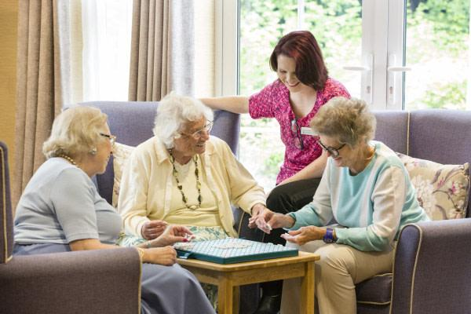
Residential care homes is social care service that provides housing , personal care and daily life support for people unable to live independently at home. Residents of these care homes receive everyday support whilst living in a safe environment surrounded by nurses who are trained to provide a safe and comfortable environment. Nurses provide a range of daily services such as personal care , meals , medication support , social activities and access to healthcare for residents. Residential care homes are usually suitable for elderly patients who need support , those with disability issues and individuals with personal needs requiring care.

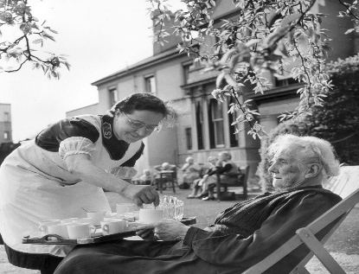
How have residential care homes developed over the years?
Early forms of residential care homes came in the 19th century through workhouses, intially established by the Poor Law Amendment act 1834. These workhouses were created in order to offer food and shelter to those who were unable to support themselves including older adults. However at this time , living conditions were harsh and did not focus on the wellbeing of residents.

Following the creation of the NHS in 1948 , responsibility for Health and social care saw a large improvement. Local authorities took a larger accountability in assigning accomodation for those requiring support replacing many workhouses with newly built care homes creating a sense of comfort for residents in thses care homes and offering a better environment for those residents.
During the 1980’s amd 1990’s , the amount of privately owned residential care homes increased. During this period , government policies encouraged greater choice whilsts ensuring standards of quality were met in order to improve the service quality of homes such as the Care Standards Act ( 2000 ) which established national standrds for care in England by regulating staffing. Today , residential care homes are inspected and regulated by the Care Quality Comission ( CQC ) to ensure provision of safe , effective , caring , responsive and well led services.

The current functioning of residential care homes in the UK
Residential care homes have a vital role in the social care system. Aeging popoulation combined with an increased life expectancy has led to growing demand for residential care services. Many residents require support due to dementia , physical disability or long-term health conditions.
The Care Quality Commission reports that the majority of care homes are rated ‘good’ , alhough some have room to improve to ensure reisdents receive consistently safe and effective care.


Challenges faced by residential care homes:


One of the biggest challenges faced by care homes is staff shortages. High vacancy rates and difficulties in recruiting carers who are qualified can affect quality of care of residents. In order to address this the government have invested in workforce development , training and recruitment initiatives.

The second big challenge that care homes face is the growing demand for residential care. People are living longer and more individuals require support for dementia and other long-term health issues. As demand increases , residential care homes need more staff , larger facilities and greater funding. However , resources have not risen at the same rate. This can create waiting lists , place pressure on existing services and make it more difficult for care homes to maintain high standards of care. The ONS reports that the UK’s 85+ population is projected to rise further contributing to this issue of high demand.
References :
Care Quality Commission (2023) Residential adult social care services
Department of Health and Social Care (2021) People at the Heart of Care: Adult Social Care Reform White Paper.
NHS (2023) Care homes.
Skills for Care (2023) What is adult social care?
Care Quality Commission (2023) About us and how we regulate adult social care.
Legislation.gov.uk (2000) Care Standards Act 2000.
The National Archives Poor Law Amendment Act 1834.
NHS England (2023) The history of the NHS.
Care Quality Commission (2023) Appendix: CQC ratings charts.
Office for National Statistics (2024) Population projections for the UK.

Task 2 : Ambulance services
Introduction
Ambulance services are very important towards modern health and social care. They provide fast , efficient transportation to hospitals allowing for patients to be treated quicker and saving patients lives by doing so. This has become increasingly important as more patients suffer from life-threatening injuries/illness and require immediate attention from doctors and nurses. This report will detail how it originated and how it functions in the modern day in order to achieve its desired intentions.

Origins and development of service
The modern day ambulance service originates from the French revolution in the 18th century introduced by Baron Dominique Jean-Larrey originally named the “ flying ambulance “, a horse-drawn carriage designed to quickly transport casualties away from the battlefield in order to administer emergency treatment ( Robertson-Steel 2006). This system showed an increase in survival rate due to the rapid evacuation and execution of medical treatment on wounded soldiers influencing medical practices on military in Europe and South America.

During the 19th century , the need for ambulance services was accelerated due to the industrial revolution in the UK causing an increase in urbanisation and factory accidents. Dedicated ambulance services were then introduced worldwide with one of the first being the Bellevue Hospital in New York in 1869 ( Manish N Shah , Uni of Rochester) . Horse-drawn carriages were developed into motorised vehicles across the 20th century further improving response times and expanding the area of coverage for the given service.

How do Ambulance services function today?
In the modern day , ambulance services have evolved from primarily being used for transporting the injured or ill and now can provide emergency treatment pre-hospital. The NHS has adopted ambulance response measures prioritizing patients on a level of necessity rather than a first come first serve basis , ensuring that those in higher need of emergency treatment such as stab wounds are prioritized over those with less need such as minor illnesses like cold’s and flu’s ( NHS England ).
One major strength of modern ambulance services is the expanded role of paramedics, who are able to diagnose and treat patients at the scene rather than increasing the number of unnecessary hospital admissions. The use of “ hear and treat” , treating patients over the phone and “ see and treat “ , treating patients at their home has further helped the overcrowding of hospitals in the UK relieving pressure on resources with ambulances equipped with electronic patient records , GPS navigation and cardiac monitoring treatment helping combine efficient transportation with useful medical treatment by paramedics ( National Institute for health and care excellence ) .
However , Ambulance services face significant challenges. Increasing demand, staff shortages , funding issues , rising numbers of delays in transporting patients to emergency care often lead to longer wait times. Delays in handovers between ambulances and hospitals causes a lack of availability of ambulances for new emergencies. Additionally, growing pressure on paramedics leads to burnout and work stress which may negatively impact patients and the overall efficiency of services ( care quality commission ).

Significance in enhancing the quality of life of service users
Ambulance services have a crucial role to play in improving the quality of life for service users by providing rapid medical intervention during emergencies. Fast response times can positively impact the chances of survival for critical patients experiencing life-threatening conditions such as heart attack , stroke and severe trauma. Early assessment and treatment by paramedics can prevent a patients condition from deteriorating before they reach hospital , leading to improved health outcomes and reducing the risk of long-term disability ( NHS England 2024 ).
Alongside emergency transport , modern ambulance services now focus on delivering patient centred care. Paramedics are trained to assess patients at the scene and determine the most appropriate course of action which may involve treating patients in their own home. This approach helps to reduce unnecessary hospitalization whilst ensuing patients receive the necessary care and treatment. ( NICE 2018 ).

Ambulance services also provide emotional reassurance to patients and families during high stress situations. Effective communication, compassionate care and professional decision-making all contribute towards reducing anxiety and increasing trust in healthcare professionals ( Care quality commission 2025 ).

Conclusion
To conclude , Ambulance services have heavily developed since originating in the French revolution from horse-drawn carriages to advanced healthcare mobile units. Advancements in technology , clinical training and emergency response systems have enabled ambulance services to give rapid diagnosis and treatment when necessary at the scene with the option of transporting patients towards hospitals. Paramedics have an important role in this as they give the final say as to whether administer treatment and patients homes , the scene of emergency or whether transportation to hospital is necessary in high pressure situations. Although there are challenges such as workplace pressure , increasing demand and a shortage of workers , Ambulance services remain an integral part of the healthcare system.

References
Ament , S.A. (2015) A brief history of emergency medical services in the United States.
National Health Service ( NHS ) ( 2024 ) How to use the NHS ambulance service.
Robertson-Steel, I ( 2006) 'Evolution of triage systems', Emergency Medicine Journal, 23(2), pp. 154–155.
Shah M.N. (2006) 'The formation of the emergency medical services system', American Journal of Public Health, 96(3), pp. 414–423.
National Institute for health and care excellence ( NICE ) ( 2018 ) Emergency and acute medical care in over 16s: Quality statement 1 – Ambulance services.
NHS England ( 2026 ) About urgent and emergency care.
Care Quality Commission ( 2025 ) Core services: NHS trusts – Ambulance core services.

