Dissertation – Proposal
Level 6
Module code: LCBB6000
Student name: Mariana - Larisa Neagoe
Student ID : 1921885
Proposed research title: Leadership and Crisis Management: Lessons from COVI-19 Pandemic in Starbucks Organization
(Qualitative analysis based on interviews)
Name of the university: University of Wales Trinty Saint Davies
(London Campus)
Submission date: 23rd of August 2024

Abstract
The COVID-19 epidemic has posed major obstacles for businesses globally, including Starbucks UK, a prominent player in the global coffee industry. This study examines Starbucks UK's leadership and crisis management strategies during the pandemic, focusing on the company's handling of staff well-being, customer happiness, and operational disruptions. The aim of this research is to understand the leadership methodologies, decision-making frameworks, and crisis management strategies that allowed Starbucks UK to continue its operations and protect its reputation during the crisis through qualitative interviews with key figures within the organization. Furthermore, the research highlights significant insights and optimal methodologies that may direct subsequent crisis management endeavors in analogous circumstances.
This study emphasizes the significance of adaptable leadership and effective communication in overcoming adversity, fostering resilience, and sustaining corporate operations. The findings contribute to the ongoing debate about crisis leadership, notably in the commerce and service industries. Essentially, the study offers guidelines on how organizations may adopt diverse leadership philosophies and put comprehensive crisis management plans in place to more effectively prepare themselves for future crises.

Contents
Abstract 2
INTRODUCTION 3
Purpose of the Research 3
Aim 4
Objectives 4
Research Questions 5
CRITICAL LITERATURE REVIEW 5
Literature overview 5
Theoretical Frameworks and Models of Crisis management 6
Advantages and Disadvantages of crisis management 6
METHODOLOGY and METHODS 7
Research Philosophy 7
Research Paradigm 7
Research Approach 7
Research Methodology 7
Research Strategy 8
Data Collection Methods/Tools 8
Methods of data Analysis 8
Discussion 9
Provisional Work Schedule 9

INTRODUCTION
The COVID-19 pandemic has had a profound impact on the world, changing entire industries and putting the adaptability of businesses to the test. The epidemic posed serious issues for Starbucks UK, a well-known international chain of coffee shops, necessitating quick thinking, efficient crisis management, and flexible leadership. (Starbucks, 2020)
This study lays the framework for a detailed examination of how Starbucks UK's leadership managed the issue and modified their strategies to effectively address the pandemic's consequences. The goal is to provide an in-depth comprehension of the real-world issues and leadership abilities needed during a crisis by conducting a qualitative analysis through interviews.
In order to keep the organization stable during a crisis, strong leaders must be able to navigate through uncertainty, act quickly, and effectively communicate information. Starbucks UK's leadership was faced with the challenge of managing not just the company's immediate operational problems but also the long-term consequences for the company's culture and relationships with its clientele (Boin et al., 2017). This research is a unique opportunity to investigate how various leadership philosophies and crisis management techniques affect an organization's capacity to recover.

Purpose of the Research
The purpose of this study is to investigate Starbucks UK's crisis management and leadership strategies during the COVID-19 epidemic. The study intends to provide light on the tactics and processes of decision-making that helped the business get through the crisis through qualitative interviews with significant players in the organization. This analysis will shed light on how successful crisis management and leadership may raise an organization's adaptability and effectiveness in difficult circumstances.

Aim
To carefully evaluate Starbucks UK's crisis management and leadership strategies during the COVID-19 outbreak. The goal of the research is to understand how these strategies affect the company's adaptability to difficulties, employee support, and the continuity of business operations. It also seeks to identify important results that may direct future crisis management initiatives.

Objectives
- To analyze how Starbucks UK's leadership adapted their strategies and decision-making processes during the COVID-19 crisis and examined effective communication and leadership styles.
- To evaluate Starbucks UK's crisis management tactics, including operational adjustments, health and safety measures, and customer service adaptations, to maintain business operations and customer satisfaction.
- To assess employee support initiatives during the pandemic, explore health and safety protocols, mental health support, and financial assistance
- To put in place Future Crisis Management Strategies
- To identify key lessons and best practices from Starbucks UK's crisis response and management on Covid-19 period.

Research Questions
- Which employees assistance initiatives were in place throughout the pandemic, and what influence did they have on morale and productivity?
- How did the leadership of Starbucks UK change their methods and processes to make decisions throughout the COVID-19 pandemic?
- What unique crisis management strategies was Starbucks UK using to handle the day-to-day issues and guarantee the security of its customers?
- What were the most significant lessons learned from Starbucks UK's management of the COVID-19 crisis?
- What best practices can organizations use to help them tackle similar crises in light of Starbucks UK's experience?

CRITICAL LITERATURE REVIEW
The literature related to leadership and emergency management provides a robust framework for assessing Starbucks UK's response to the COVID-19 pandemic. Effective emergency management requires clear communication, strong leadership, operational adjustments, and personnel support. By analyzing these facets, the study aims to identify significant lessons learned and practical approaches that might guide the organization's emergency response plans in the future.

Literature overview
The manner in which a leader gives instructions, makes choices, and affects organizational results is known as their leadership style. It has a direct effect on success, productivity, and team dynamics.
Crises are sudden and unpredictable events that require a quick response to reduce potential damage to an entity's functioning or image. (Mitroff, 2004)
This review of the literature addresses how different styles of leadership and methods related to crisis management are explained, as well as how they interconnect to impact an organization's ability to function efficiently in times of difficulty.
With the goal to more properly prepare businesses for future crises, Starbucks UK's COVID-19 response offers valuable lessons in effective leadership and crisis management.

Theoretical Frameworks and Models of Crisis management
Starbucks UK used a variety of theoretical frameworks and models to effectively manage their crisis management during the COVID-19 pandemic. By utilizing the Crisis Management Lifecycle Model, Incident Command System, Situational Crisis Communication Theory, and Resilience Framework, Starbucks was able to overcome the challenges posed by the pandemic, adapt their business practices, assist their employees, and maintain stakeholder confidence. These models provided important insights into crisis management and offered perspectives for upcoming crisis management techniques.

Advantages and Disadvantages of crisis management
Starbucks encountered difficulties during the COVID-19 outbreak, highlighting the value of flexible leadership, lucid communication, and careful planning. Starbucks used a range of leadership strategies to effectively manage the outbreak. Using a transformational leadership style aids leaders in persuading staff members in crisis management scenarios.

METHODOLOGY and METHODS

Research Philosophy
Interpretivism research philosophy will be employed as it significantly centres around grasping the experiences of people and subjective significance. It empowers the detailed knowledge of their approaches, and different choices and influences on the management of crisis. This philosophy is significant for evaluating how individuals responded to and answered the crisis of the pandemic situation (Sanchez et al., 2023).

Research Paradigm
Primary qualitative research techniques will be employed along with Interpretivism to investigate the main interpretations and subjective encounters due to the crisis that was faced during the pandemic situation. This should be possible by focusing on the perception of the importance as well as viewpoints that will add to the activity.

Research Approach
The inductive examination approach will be employed in this exploration concentrate as it empowers the improvement of theories connected with observed encounters and examples/patterns. It permits the examination study to execute new speculations and experiences from subjective information (O'Kane et al., 2021). This approach is important for assessing how pioneers dealt with the pandemic crisis.

Research Methodology
In this examination, mono-research techniques will be utilized for this subject to keep a predictable and centered approach. It ensures the complete collection of information as well as investigation. The usage of the mono-qualitative strategies incorporates interviews empowered for the in-depth examination of the encounters of the pioneers and reactions during the pandemic emergency.

Research Strategy
A qualitative examination strategy will be utilized for this exploration study to get profound and explicit knowledge as well as encounters of pioneers during the pandemic emergency. This methodology predominantly aids the investigation of motivations, conduct and strategies providing rich and explicit information.

Data Collection Methods/Tools
Primary Qualitative methods for the collection of data will be utilized to gather information from 5 members by asking 5 interview questions to obtain explicit knowledge and encounters on the leadership due to the pandemic emergency. This method incorporates in-depth interviews that empower detailed investigation of the individual reaction and experiences into the systems connected with the management of crisis and the course of decision-making (Snijkers et al., 2023).

Methods of data Analysis
A descriptive data analysis strategy will be utilized to interpret the information in this exploration study. This strategy helps with summing up and arranging the qualitative information that has been collected from interviews connected with the crisis faced during the pandemic situation. This analysis method includes categorizing responses, themes and patterns to facilitate structured and transparent presentations of the approaches and experiences that provide in-depth interpretations and comprehensions.
The collected data will be safely stored on the hard drive of the computer without any access to the internet as per the '' Data Protection Act 2018” and GDPR. It makes sure that there is no possibility of an online data theft or data breaches.

Discussion
This research has immense significance and ramifications for firms in a range of industries, in addition to Starbucks. This qualitative analysis provides practical advice to help organizations create stronger, more flexible, and resilient companies that can thrive even in the face of uncertainty by looking at the leadership and crisis management tactics used during the COVID-19 pandemic.
It's critical to acknowledge the study's limitations even if the qualitative analysis of crisis management and leadership during the COVID-19 outbreak at Starbucks UK has the potential to provide insightful information. These include participant bias, small sample size, constrained generalizability, and the subjective characteristic of qualitative data. We may mitigate the impact of these constraints and make sure the study's findings are interpreted correctly by being aware of them.

Provisional Work Schedule
This schedule is created by the help of Gantt Chart and it will outline the main phases and their time allocation. It is an efficient time management way from September to December, when the paper work has to be submitted.
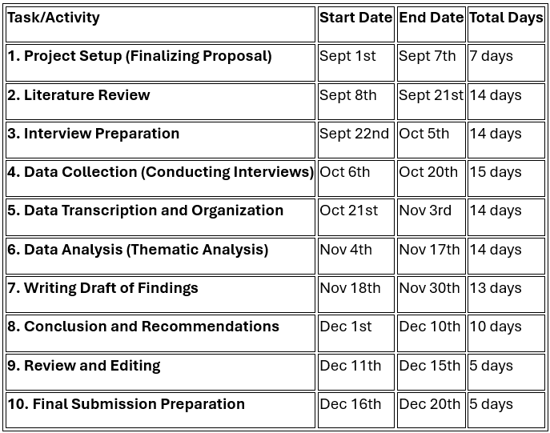
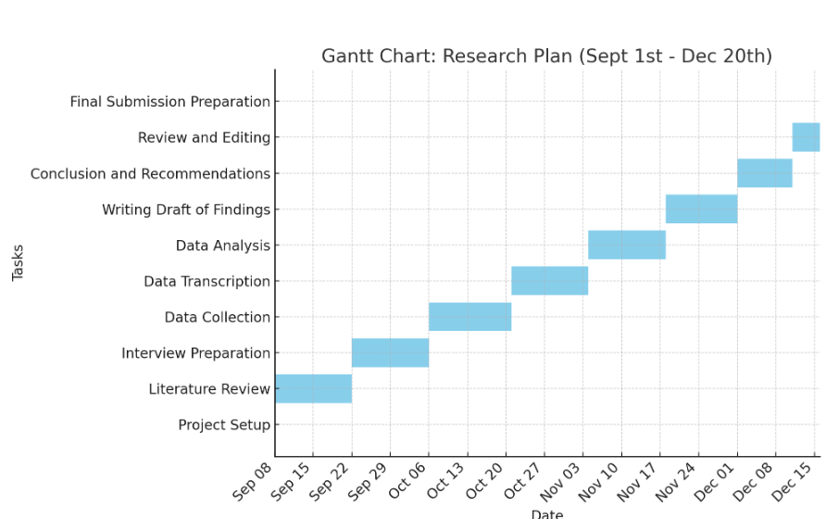

References
Avolio, B. J., & Bass, B. M. (1995). Individualized Consideration Viewed at Multiple Levels of Analysis: A Multi-Factor Theory of Leadership. The Leadership Quarterly, 6(2), 199-218.
Bass, B. M., & Riggio, R. E. (2006). Transformational Leadership. Lawrence Erlbaum Associates.
Boin, A., Hart, P. 't, & Kuipers, S. (2017). The Politics of Crisis Management: Public Leadership under Pressure. Cambridge University Press.
Coombs, W. T. (2007). Ongoing Crisis Communication: Planning, Managing, and Responding. Sage Publications.
Drucker, P. F. (2006). The Effective Executive: The Definitive Guide to Getting the Right Things Done. HarperBusiness.
Greenleaf, R. K. (1977). Servant Leadership: A Journey into the Nature of Legitimate Power and Greatness. Paulist Press.
Grewal, D., Roggeveen, A. L., & Nordfält, J. (2020). The Future of Retailing: How COVID-19 Will Shape the New Normal. Journal of Retailing, 96(2), 145-157.
Hamel, G., & Välikangas, L. (2003). The Quest for Resilience. Harvard Business Review, 81(9), 52-63.
Harvard Business Review. (2020). How Companies Can Support Employee Mental Health During the COVID-19 Crisis.
Hersey, P., Blanchard, K. H., & Johnson, D. E. (2013). Management of Organizational Behavior: Utilizing Human Resources. Pearson.
Kapucu, N., & Van Wart, M. (2006). The Evolution of Emergency Management and the Role of Leadership. Public Administration Review, 66(s1), 28-41.
Kouzes, J. M., & Posner, B. Z. (2017). The Leadership Challenge: How to Make Extraordinary Things Happen in Organizations. Wiley.
Liden, R. C., Wayne, S. J., Zhao, H., & Henderson, D. (2008). Servant Leadership: Development of a Multidimensional Measure and Multi-Level Assessment. The Leadership Quarterly, 19(2), 161-
Mitroff, I. I., & Anagnos, G. (2009). Finding the Upside of the Downturn: Crisis Management in the Age of COVID-19. Palgrave Macmillan.
Mitroff, I. I. (2004). Crisis Leadership: Planning for the Unthinkable. Jossey-Bass.
O’Kane, P., Smith, A. and Lerman, M.P., 2021. Building transparency and trustworthiness in inductive research through computer-aided qualitative data analysis software. Organizational Research Methods, 24(1), pp.104-139.
Pfeffer, J. (2010). Power: Why Some People Have It—and Others Don't. HarperBusiness.
Sanchez, J.I., Bonache, J., Paz-Aparicio, C. and Oberty, C.Z., 2023. Combining interpretivism and positivism in international business research: the example of the expatriate role. Journal of World Business, 58(2), p.101419.
Starbucks Corporation. (2020). Starbucks Global Impact Report. Retrieved from Starbucks Global Impact.
Sendjaya, S., Sarros, J. C., & Santora, J. C. (2008). Defining and Measuring Servant Leadership Behavior in Organizations. Journal of Management Studies, 45(2), 402-424.
Snijkers, G., Bavdaž, M., Bender, S., Jones, J., MacFeely, S., Sakshaug, J.W., Thompson, K.J. and Van Delden, A., 2023. Advances in business statistics, methods and data collection: introduction. Advances in Business Statistics, Methods and Data Collection, pp.1-22.
Weick, K. E., & Sutcliffe, K. M. (2007). Managing the Unexpected: Resilient Performance in an Age of Uncertainty. Jossey-Bass.
Waddell, D., & Sohal, A. S. (1998). Resistance to Organizational Change: The Role of Change Management. International Journal of Operations & Production Management, 18(2), 142-168.

