

School of Engineering

Technical Report
Emily-Kate Flewin – 1801668
Engineering Applications and Study Skills – M4X02063

Contents
Introduction 3
Background Research 4
Methodology 7
Discussion and Conclusion 8
Bibliography 9

Table of Figures

Figure 1: Working on Motorcycles with hand tools - Motorcycle Workshop risk assessment front 5
Figure 2: Working on Motorcycles with hand tools - Motorcycle Workshop risk assessment back 5
Figure 3: Fuel or Oil Spillage - Motorcycle workshop risk assessment front 6
Figure 4: Fuel or Oil Spillage - Motorcycle workshop risk assessment back 6

Introduction

This is a technical report on a practical session as part of the motorcycle engineering course. The practical session was on the 9/10/18. The objective of the practical session is to strip and rebuild an engine.
The skills and knowledge that will be gained from the workshop will be knowledge of the components in an engine, the method of stripping an engine, the method of rebuilding an engine, knowledge of storing components, knowledge of tools required to strip and rebuild an engine as well as the skills to fix any future issues with an engine.

Background Research

There are many health and safety rules that had to be followed in the practical sessions. One of those being that before the practical sessions began, everyone who was attending the practical sessions had to complete an introductory workplace health and safety online course. This ensure that whoever was in the workplace had the correct knowledge of health and safety to work safely. Along with this, whoever was attending the practical had to sign a register as well as sign to confirm that they are trained in using hand tools safely. A code of conduct is outlined by the university that ensures that whoever is attending can work safely during the practical session.
The PPE required for the practical sessions was:
- Steel toe-cap boots
- Overalls or dust coat
- Gloves
There are acts and legislations put in place to ensure the safety of whoever attends the practical sessions. One of the pieces of legislation is COSHH. The control of substances hazardous to health regulation 2002 is a piece of legislation that has been put in place to prevent exposure to hazardous substances (Anon., ), in the practical sessions this could be coolant or oil, even fuel from the engine.
Another piece of legislation covering the location of the practical session is RIDDOR. Reporting of injuries, diseases and dangerous occurrences regulation 2013 requires that, in this case, the person in control of the location of the practical session must report certain workplace incidents, diseases caused by the occupation and dangerous occurrences (Anon., ).
The Health and Safety at work act 1974 is another piece of legislation covering the location of the practical session. This act requires the responsible person to ensure the health and safety of anyone attending the practical session. This is relevant to the practical session and the responsible person should take measures to control slips and trips (Anon., 1991), for example tripping on a component or equipment or slipping on oil, fuel or coolant.
Finally, the most important legislation covering working in the location of the practical session is the risk assessments. This is a required document in any working environment to ensure the health and safety of whomever is attending. A risk assessment will look at any issues, accidents or incidents that could happen in the working environment and elect a level of risk that it poses to anyone working in that environment. See below the risk assessments relevant to the practical sessions and their location.

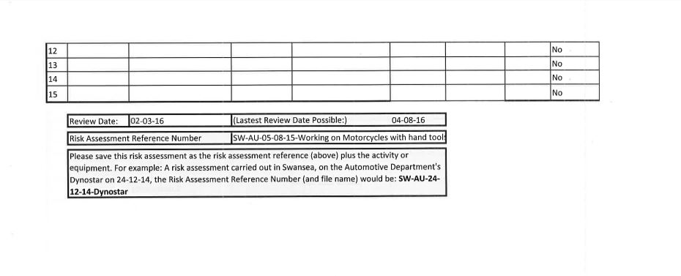
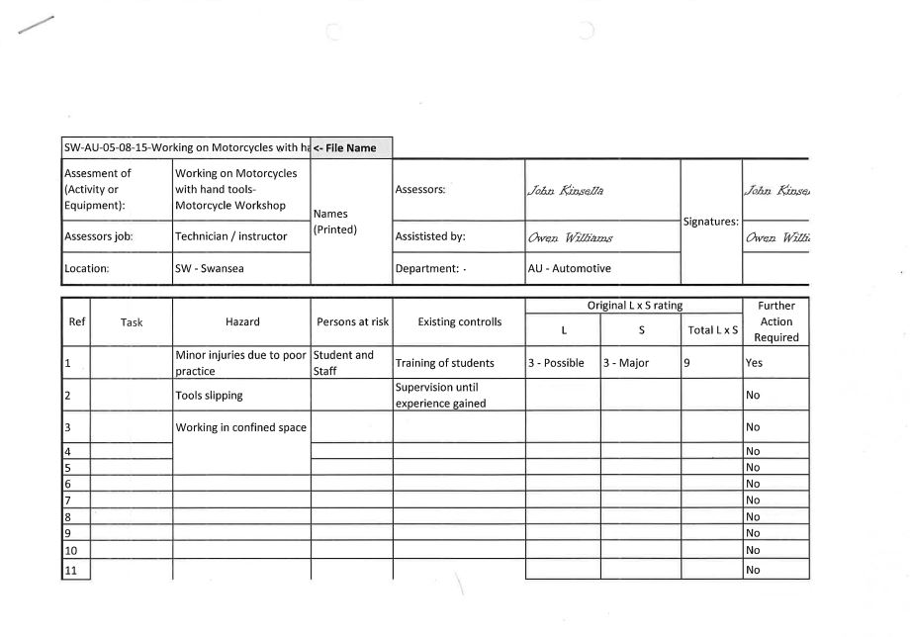
(Kinsella, 2016)
Figure 2: Working on Motorcycles with hand tools - Motorcycle Workshop risk assessment back
Figure 1: Working on Motorcycles with hand tools - Motorcycle Workshop risk assessment front
(Kinsella, 2016)

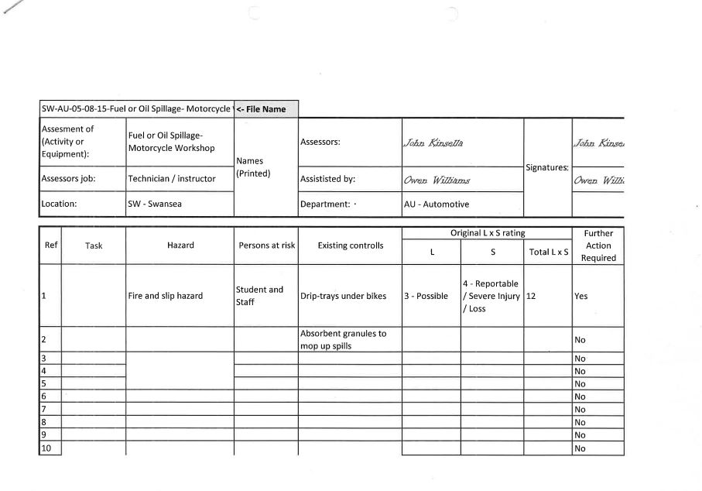
Figure 3: Fuel or Oil Spillage - Motorcycle workshop risk assessment front
(Kinsella, 2016)
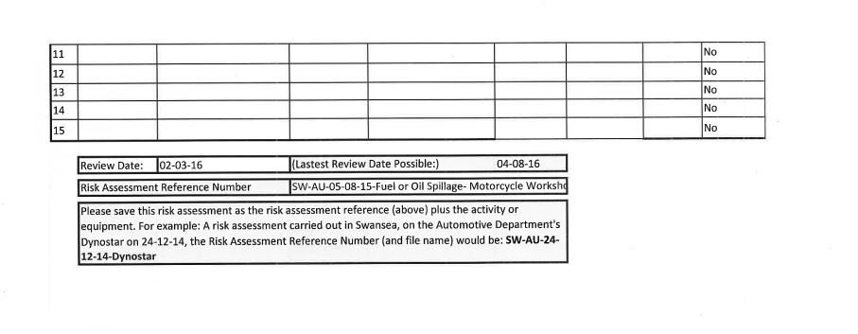
Figure 4: Fuel or Oil Spillage - Motorcycle workshop risk assessment back
(Kinsella, 2016)

Methodology

Equipment:
- Ratchet
- 8mm socket
- 10mm socket
- 17mm socket
During this practical session on the 9/10/18, the processes that were used were ones to deconstruct an engine. As each part of the engine was deconstructed and removed, it was placed in a clearly labelled transparent bag for storage.
- A clip was removed in order to remove the gudjon pin.
- The piston was then removed from the connecting rod.
- After, the base gasket was removed from the engine.
- An 8mm socket and rachet was used to remove two bolts from the starter motor.
- The starter motor gear and pin were removed.
- The starter motor was removed.
- An 8mm socket and rachet was used to remove four bolts from the pickup cover.
- An 10mm socket and rachet was used to remove the final bolt.
- Removed the pickup housing.
- An 17mm socket and rachet was used to remove the bolt holding the ignition rotor.
- Removed the ignition rotor.

Discussion and Conclusion

The key points taken from the practical session was learning to keep work stations clean and organised in order to increase productivity. This allows lowers the risk of incidents or accidents occurring to anyone attending the practical session in the place of work.
Learning to take photos of the engine for reference, which allows whoever to check the progress of the engine strip. This also allows the ability to check over the work if they have any issues during the rebuild.
Acquiring the knowledge to keep parts stored correctly and keep parts labelled in order to increase productivity and keep the workplace clean. On top of this it keeps the workplace safe as there is no risks that could cause harm to anyone attending the practical sessions.
Understanding that tools should be cleaned when they are no longer being used and returned to their allocated location. Further allowing the risk factor of someone being harmed in the workplace to be lowered and there will be no risks such as impact risk, trip risks and puncture risks, from screwdrivers, ratchets and wrenches being left around.
In conclusion, at the end of the sessions the engine had been carefully and correctly stripped and after had been rebuilt. As well as this, the knowledge of how to correctly and carefully strip and engine had been learnt and the purpose of the practical session had been achieved.

Bibliography

Anon., 1991. Health and Safety at Work etc Act 1974. [Online]
Available at: http://www.hse.gov.uk/legislation/hswa.htm
[Accessed 1 2 2019].
Anon., . Control of Substances Hazardous to Health (COSHH). [Online]
Available at: http://www.hse.gov.uk/coshh
[Accessed 1 2 2019].
Anon., . RIDDOR - Reporting of Injuries, Diseases and Dangerous .... [Online]
Available at: http://www.hse.gov.uk/riddor/
[Accessed 1 2 2019].
Kinsella, 2016. Fuel or Oil Spillage - Motorcycle workshop. Swansea: s.n.
Kinsella, 2016. Working on Motorcycles with hand tools - Motorcycle Workshop. Swansea: s.n.

