Arsylwr: Mr Jack Rose Athro dan sylw: Mr Ben Murphy
Taflen Arsylwi 03/02/2020
Dosbarth: 8R Dyddiad: 3/02/20
Focws yr Arsylwad: (Aseiniad) Pa effaith a gaiff clod ar agweddau tuag dysgu?
- Isel eithafol 2.Isel 3.Cymedrol 4.Uchel 5.Uchel eithafol

 | Agwedd tuag at y wers | Sylwadau pellach
Disgybl A  Disgybl B  Disgybl C | 1 2 3 4 5  1 2 3 4 5  1 2 3 4 5 | 0-5 Munud – Dosbarth yn fywiog wrth ddod i mewn , cymryd amser i setlo gan ofyn cwestiynau amherthnasol. Serch hynny pob disgybl yn ymateb yn dda ac yn barod i weithio.
 | Agwedd tuag at y dasg | Sylwadau pellach
Disgybl A  Disgybl B  Disgybl C | 1 2 3 4 5  1 2 3 4 5  1 2 3 4 5 | Pob disgybl yn dangos agwedd dda tuag at y dasg, er bod rhai yn siaradus nad yw yn broblem. O fewn 5 munud, pob disgybl yn gweithio’n galed.  20-40 canol y wers
 | Safon y waith | Sylwadau pellach
Disgybl A  Disgybl B  Disgybl C | 1 2 3 4 5  1 2 3 4 5  1 2 3 4 5 | Ddim yn gallu gweld safon gwaith pob disgybl, nad oedd lle i grwydro.  Amser am y brif dasg – nad oedd digon o amser i’r disgyblion gorffen y brif dasg.
 | Iaith Corfforol | Sylwadau pellach
Disgybl A  Disgybl B  Disgybl C | 1 2 3 4 5  1 2 3 4 5  1 2 3 4 5 | Pob disgybl yn edrych yn barod i weithio, nad oedd unrhyw arwydd bod disgybl wedi diflasu yn ystod y wers.  Pob disgybl yn hyderus i ateb cwestiynau  Anodd i weld wyneb pob disgybl oherwydd cynllun eistedd y dosbarth.
 | Parodrwydd i ateb cwestiynau | Sylwadau pellach
Disgybl A  Disgybl B  Disgybl C | 1 2 3 4 5  1 2 3 4 5  1 2 3 4 5 | Disgybl yn edrych am sylw, athro wedi delio gyda’r sefyllfa yn dda.  Ateb anghywir - athro wedi ateb gydag iaith bositif  “ateb gwych ond nid yr un” disgybl C wedi ymateb yn dda i hyn.  Pob disgybl yn hyderus i ateb cwestiynau, amgylchedd positif.
.

Observer: Ben Murphy | Teacher Observing: Jack Rose  Taflen Arsylwi 04/02/2020
Class: 9 | Date: 4.6.20
Focus of the observation: How does praise have an effect on pupils’ attitude towards learning?

1- Extremely Low 2- Low 3- Moderate 4- High 5- Extremely high
Students | Attitude towards the lesson | Further Comments
Student A:  Student B:  Student C: | 1 2 3 4 5  1 2 3 4 5  1 2 3 4 5 | The attitude towards learning was good, each of the three students were engaged and on task throughout the lesson.  All students reacted with a sense of unexpected excitement towards the prospect of working above their level, especially when the teacher praised their previous work
Students | Attitude towards the tasks | Further Comments
Student A:  Student B:  Student C: | 1 2 3 4 5  1 2 3 4 5  1 2 3 4 5 | Again, each pupil was on task, the attitude was great to see.  Well done to pupil x and y for using their white boards for working out – some students reacted to this by using them.
Students | Standard of the work | Further Comments
Student A:  Student B:  Student C: | 1 2 3 4 5  1 2 3 4 5  1 2 3 4 5 | As it is a numeracy lesson and students were either correct or incorrect, it was difficult to judge the standard. Each student was correct in their answers by the verbal feedback given by the teacher.
Students | Body Language | Further Comments
Student A:  Student B:  Student C: | 1 2 3 4 5  1 2 3 4 5  1 2 3 4 5 | Body language is difficult to judge as some students may rest their head in their hand but it could be a comfort thing. Every student was on task and done the work correct. I feel body language did not prove anything in this lesson.
Students | Willingness to answer questions | Further Comments
Student A:  Student B:  Student C: | 1 2 3 4 5  1 2 3 4 5  1 2 3 4 5 | Students were a bit timid to answer questions, with an obvious lead learner, therefore the willingness to answer was demanding.
Cyfweliad 03/02/2020
Beth oedd eich barn am y wers?
A: Wnes i fwynhau’r wers. Roedd y wers yn dda
B: Wnes i fwynhau gwylio clip fideo o Greta, roedd hyn wedi rhoi ysbrydoliaeth i fi i ysgrifennu araith dda.
C: Roedd y wers yn dda, rodd lot o wahanol bethau i wneud, pethau hwyl.

2. Beth ddysgoch chi yn y wers?
A: Wnes i ddysgu am golera yn ystod y chwyldro diwydiannol
B: Wnes i ddysgu er bod bywyd wedi gwella am rai roedd bywyd yn anodd i lot o bobl
C: Dysgais am y gwahanol broblemau oedd yn wynebu pobl Cymru yn ystod y cyfnod.

3. A oedd unrhyw beth nad oeddech yn ei ddeall?
A: Na
B: Na
C: Na

4. Sut y gallem wella'r wers?
A: efallai clywed gwaith rhai disgyblion
B: dim byd
C: dim byd

5. Beth ydych chi'n ei hoffi neu'n ei gasáu am y gwaith grŵp/pâr?
A: Ti’n gallu siarad gyda disgyblion arall a chlywed syniadau nhw
B: Mae’n torri'r wers lan, ddim yn dawel am y wers gyfan
C: Dwi ddim yn mwynhau gwaith par, gormod o sŵn weithiau.

6. Yn eich barn chi, ydych chi'n meddwl bod canmoliaeth yn helpu tuag at eich dysgu a'ch dealltwriaeth?
A: Dwi ddim yn meddwl fod effaith mawr ar fy ngwaith ond dwi’n mwynhau’r wers yn fwy pam mae’r athro yn hapus

B: dwi’n hoffi’r faith fod yr athro yn becso dros y gwaith
C: Dwi ddim hoffi pam mae’r athro yn siarad amdanaf i o flaen pawb

7. A yw canmoliaeth am i chi barhau i weithio?
A: weithiau
B: Dwi’n hoffi’r faith fod yr athro yn cymryd sylw o’r gwaith. Mae hyn yn fel arfer wneud i fi trio yn fwy caled tro nesaf.
C: Na, does dim effaith

8. Sut mae'n teimlo pan fydd yr athro yn eich canmol?

A: Pan mae’r athro yn dangos fod nhw’n gwerthfawrogi eich gwaith neu ateb ..mae’n dangos fod nhw eisiau chi i lwyddo a nhw’n becso dros eich gwaith ..os nad oes ateb neu glod does dim teimlad da
B: Ie, dwi’n debyg. Wasted yn mynd i’r wers nesaf yn hapus os mae’r wers di mynd yn dda.
C: Dwi ddim yn hoff iawn o glod o flaen y dosbarth, weithiau dwi’n teimlo’n embaresed os mae pawb yn edrych

Nodiadau ychwanegol :
Interview 04/02/2020

- What did you think about the lesson?
A: I think the lesson was good.
B: I enjoyed it because I learnt a lot about a subject I have never heard of, so that was cool.

C: I enjoyed the lesson and how we can spell our names in binary, it is fascinating to see.
- What did you learn in the lesson?
A: I learnt what is binary and how to spell my name in Binary.
B: I learnt a lot, I had no idea how a computer works and what signals they send for us to see what we see. It is really amazing and I am glad I now know it.

C: I learnt how to convert normal numbers into binary and how to convert letters and my name into binary. It was really cool to see what the computer sees when I type stuff out.

- Was there anything you did not understand?
A: I didn’t understand the binary table and how we got it.
B: I understood everything.
C: I understood everything too.

- How could we improve the lesson?
A:
B: I don’t know how you can improve the lesson, I enjoyed it.
C:

- What do you like or dislike about the group / pair work?
A: I understand more when working with someone else.
B: I liked the pair work, it gives us a chance to talk and work with our friends.
C: I don’t mind paired work but prefer to work on my own.
- In your opinion, do you think praise helps towards your learning and understanding?
A: I like it when teachers tell me I’m doing good.
B: It is a feel good factor when teachers say I am doing well or well done, it makes me want to work for them.

C: I’m not sure if it helps towards my understanding, but I agree, it is a feel good factor and makes you want to work more.

- Does praise have a positive impact on you?
A: Yes.
B: Yes, I feel that I want to give more effort in the lesson when the teacher says I am doing a good job or well done for that.

C: Yes, like the question before, it gives you a feel good feeling and makes you want to work for that teacher.

- Does praise motivate you to do better and to work harder?”.
A: Yes.
B: Yes, I feel that I want to give more effort for that teacher and want to learn more because I feel more confident when I am being told I am doing good.

C: I don’t really like people especially teachers making a fuss of me, it feels nice but I rather them to it a different way.

EXTRA NOTES:
I’d much prefer it to be verbal praise rather than rewards, I feel that you can give verbal praise all the time and it feels good to be praised, with rewards they will seem meaningless and would be too much going on in the lesson. It just complicates everything and would probably slow the lesson down.

FFURFLEN GYDSYNIo
TEITL Y PROSIECT: Pa effaith a gaiff clod ar agweddau tuag dysgu?

Enw’r Ymchwilydd:

- Cadarnhaf fy mod wedi darllen a deall y ffurflen wybodaeth sydd wedi ei dyddio ar gyfer yr astudiaeth uchod.

- Deallaf fod cyfranogiad fy mhlentyn yn wirfoddol ac rwy’n rhydd i dynnu’r caniatâd yn ôl ar unrhyw adeg, heb roi rheswm.

- Rwy'n deall y gall fy mhlentyn ddewis tynnu'n ôl ar unrhyw adeg, heb roi rheswm.

- Rwy'n deall y bydd y wybodaeth a roddir gan fy mhlentyn yn cael ei defnyddio mewn aseiniad Prifysgol.

- Deallaf na fydd fy enw yn ymddangos ar unrhyw bryd.

- Cytunaf i fy mhlentyn gymryd rhan yn yr astudiaeth uchod.

_____________________ _____________________________ __________
Enw’r plentyn Llofnod y rhiant Dyddiad

_

Ar ôl ei llenwi, dychwelwch yn yr amlen a roddwyd i Mr Ben Murphy erbyn y 16/01/20

Diolch.

Ben Murphy

ffurFlen wybodaeth
TEITL Y PROSIECT: Pa effaith a gaiff clod ar agweddau tuag dysgu?

Annwyl Rhiant / Warcheidwad:

Fy enw i yw Ben Murphy ac rwy'n astudio am gymhwyster TAR yn Yr Athrofa, Prifysgol Cymru y Drindod Dewi Sant. Ar hyn o bryd, rydw i'n ddarpar athro yn Ysgol Cymraeg Bro Morgannwg ac yn addysgu yn nosbarth eich plentyn.

Hoffwn wahodd eich plentyn i gymryd rhan yn fy mhrosiect ymchwil. Teitl y prosiect yw "pa effaith y mae canmoliaeth yn ei chael ar agwedd tuag at ddysgu" a fy nod yw ymchwilio i effaith canmoliaeth ac adborth cadarnhaol ar agwedd myfyrwyr tuag at ddysgu cyn ac ar ôl cael canmoliaeth neu adborth cadarnhaol gan aelod o staff . Trwy gyfranogiad eich plentyn o fewn y wers, bydd eich plentyn yn cael ei arsylwi drwy gydol y broses, gan nodi unrhyw newidiadau ar ôl cael canmoliaeth. Bydd eich plentyn wedyn yn rhan o gyfweliad gyda dau gyd-fyfyriwr ac un ymchwilydd arall, bydd y proses cyfweld, gobeithio, yn penderfynu barn eich plentyn ar sut aeth y wers.

Bydd pob enw yn cael ei gadw'n hollol gyfrinachol a dim ond minnau a'm partner ymchwil fydd yn ei adnabod. Mae cyfranogiad eich plentyn yn yr astudiaeth hon yn gwbl wirfoddol felly gallwch chi neu'ch plentyn dynnu'n ôl o'r astudiaeth ar unrhyw adeg. Bydd gofyn i'ch plentyn roi ei gydsyniad cyn dechrau'r astudiaeth yn ogystal.

Ar ôl dadansoddi'r data a gafwyd o'r arsylwadau gwersi a'r cyfweliad grŵp, byddwn yn falch o roi copi o'r canfyddiadau i chi ar eich cais. Bydd canlyniadau'r ymchwil yn cael eu trafod mewn aseiniad Prifysgol a fydd yn cyfrannu at fy nghwrs TAR. Caiff canlyniadau'r astudiaeth hon eu storio ar One Drive Prifysgol a chaiff yr holl ddata crai eu dinistrio unwaith y bydd yr asesiad wedi'i farcio.

Diolch i chi ymlaen llaw am eich amser. Os oes unrhyw gwestiynau'n codi, mae croeso i chi gysylltu â mi ar unrhyw bryd.

Yn gywir,

Ben Murphy

FERSIYNAU SAESNEG I’W DEFNYDDIO YN OGYSTAL OS FYDD ANGEN

CONSENT FORM

PROJECT TITLE: What impact does praise have on attitude towards learning ?

Name of Researcher:

Please initial box

1.I confirm that I have read and understand the information sheet for the above study.

2. I understand that my child’s participation is voluntary and that I am free to withdraw my child from the study at any time, without giving any reason.

3. I understand that my child can choose to withdraw at any time, without giving a reason.

4. I understand that the information given by my child will be used in a university assignment.

5. I understand that my child’s name will not appear at any time.

6. I agree for my child to take part in the above study.

_____________________ _____________________________ __________
Child’s name Parent signature Date

When completed, please return in the envelope provided to Mr Ben Murphy by the 16.01.20

Thank you.

INFORMATION sheet

PROJECT TITLE: What impact does praise have on attitude towards learning ?

Dear Parent / Guardian,

My name is Ben Murphy and I am studying for a PGCE at Yr Athrofa, University of Wales Trinity Saint David. I am currently a student teacher within Ysgol Gymraeg Bro Morgannwg and am teaching in your child’s class.

I would like to invite your child to participate in my research project. The title of the project is “what impact does praise have on attitude towards learning” and I aim to research the effect of praise and positive feedback on students’ attitude towards learning before and after receiving praise or positive feedback from a member of staff. Through your child’s participation within the lesson your child will be observed throughout, noting any changes after receiving praise. Your child will then be part of an interview with two fellow students and one other researcher, the interview proses will hopefully determine your child’s opinion on how the lesson went.

All names will be kept strictly confidential and will only be known by myself and my research partner. Your child’s participation in this study is completely voluntary so you or your child can withdraw from the study at any stage. Your child will also be asked to give their assent before the beginning of the study.

After careful and precise analysis of the data obtained from the lesson observation and group interview, I would be happy to provide you with a copy of the findings at your request. The results of the research will be discussed in a university assignment that will contribute to my PGCE course. The results of this study will be stored on university one drive and all raw data will be destroyed once the assessment has been marked.

I thank you in advance for your time. If any questions do arise, feel free to contact me at your convenience.

Yours sincerely,

Ben Murphy

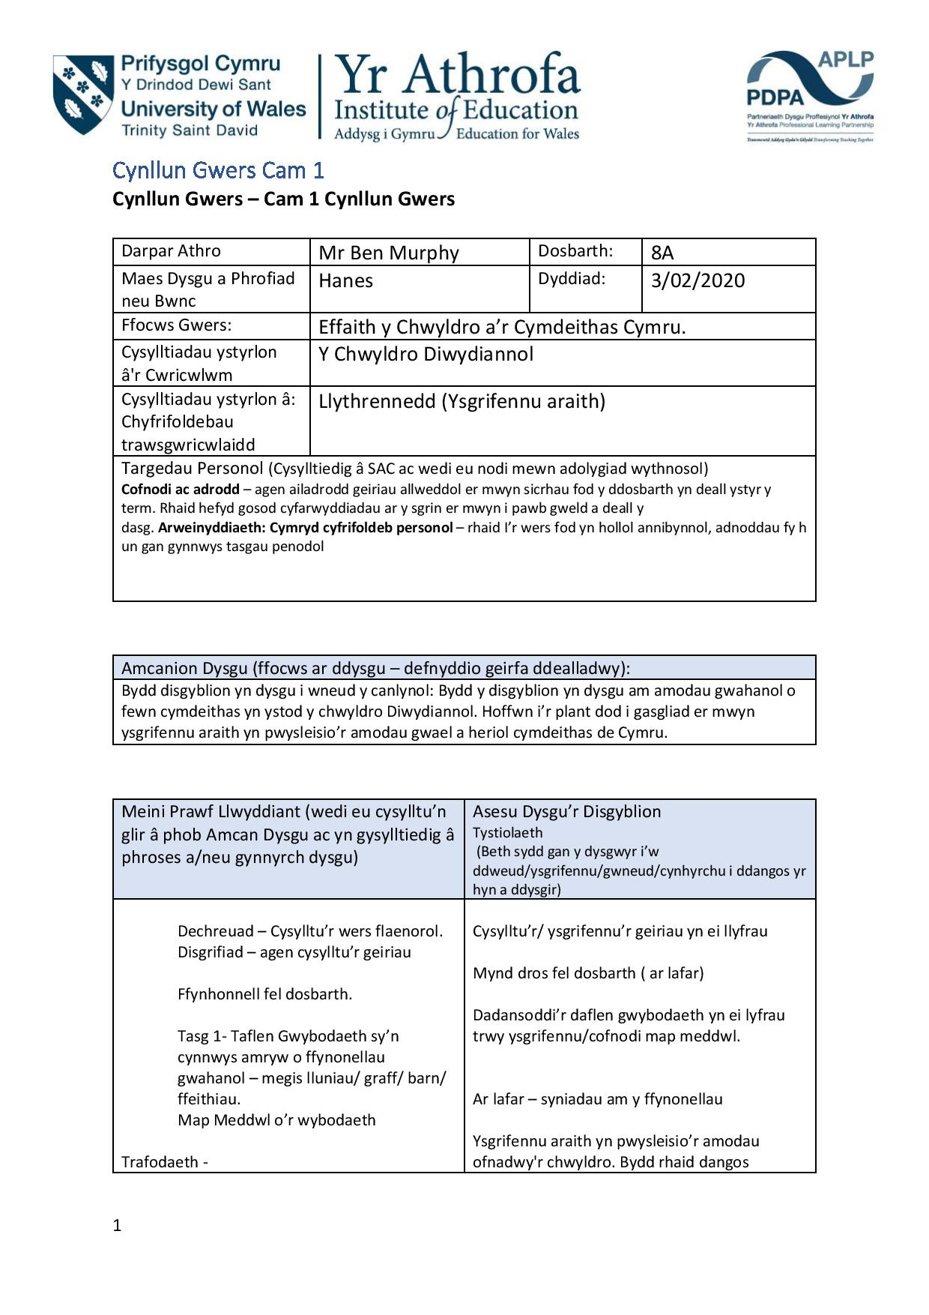
Cynllun Gwers Cymraeg 03/02/2020
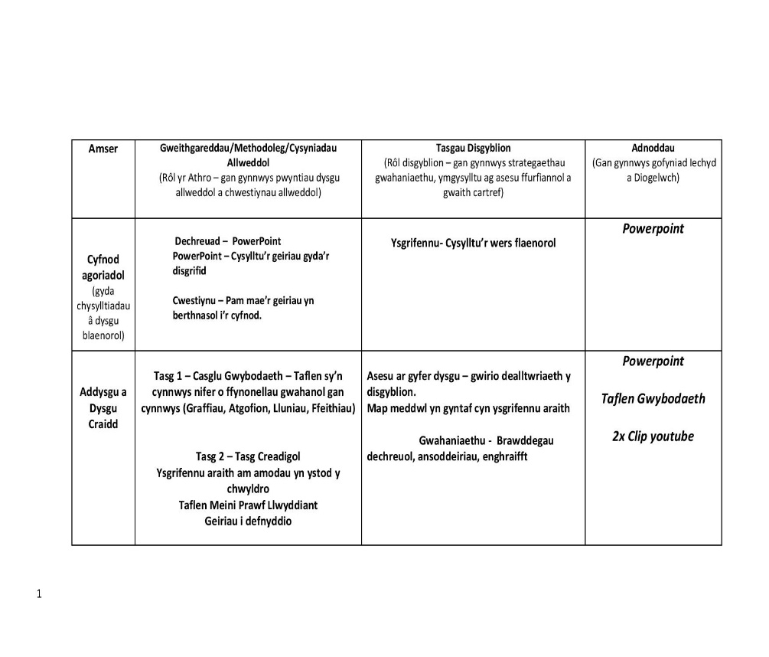
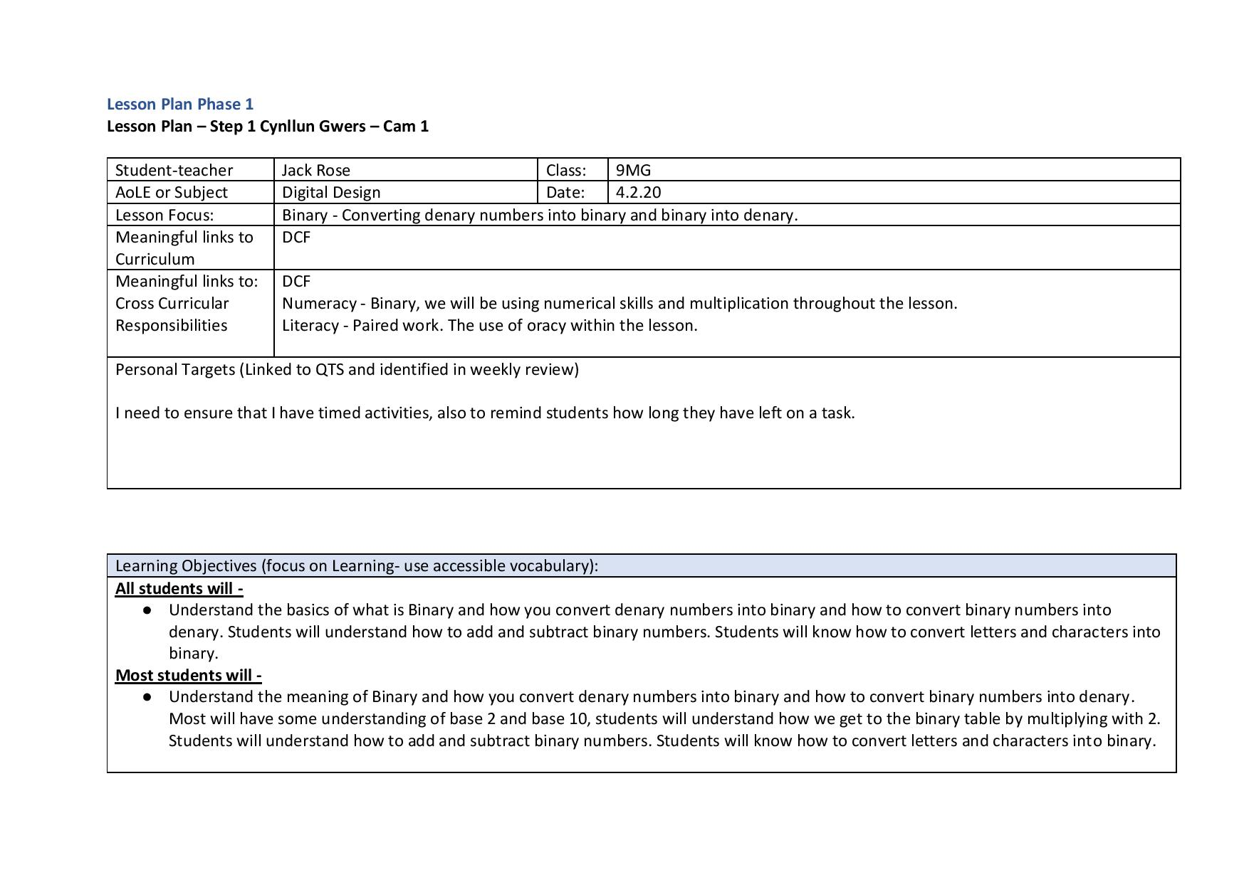
Cynllun Gwers English 04/02/2020
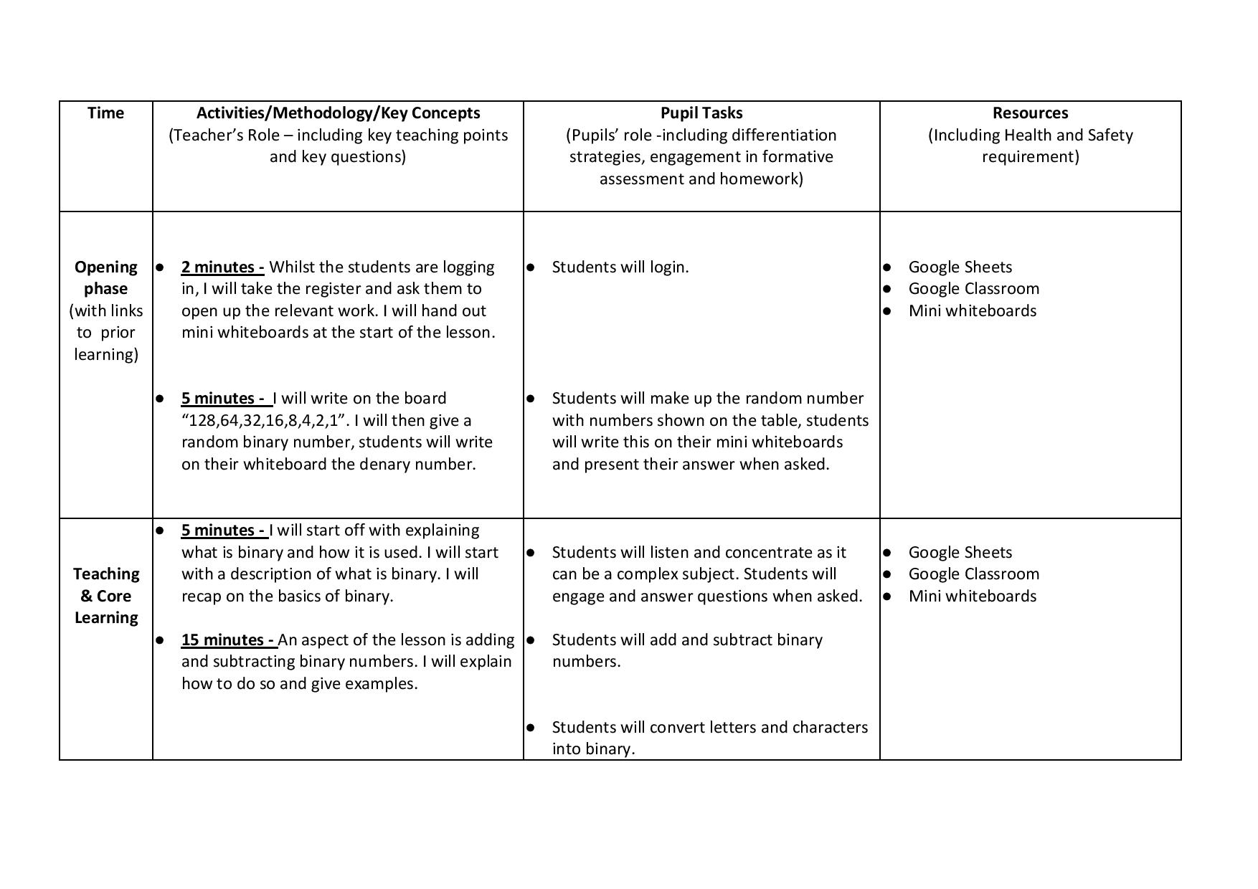
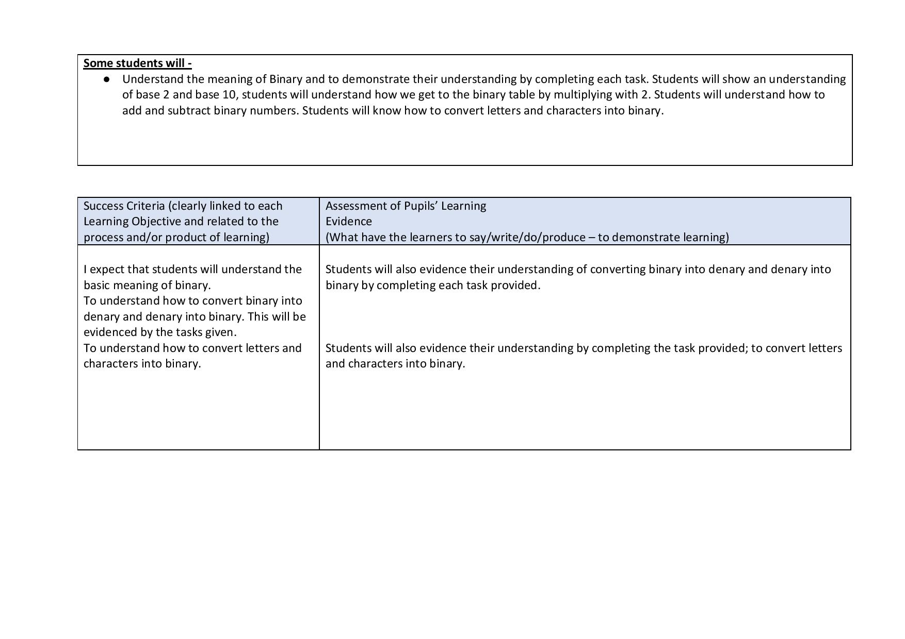
Taflen Adfyfyrio
Ben Murphy a Jack Rose
Nodiadau.

