
LEVEL 7 ASSESSMENT SPECIFICATION

Student name: | Gurumukh Singh Pavitar Singh Sandhu | Student ID number: | 2434321
Programme: | Master of Business Administration
Module: | Marketing Management
Module code: | LCMB7024 | Contribution to Overall Module Assessment (%): | 100%
Lecturer: | Dr Laila Maazouz (London) | Internal Verifier: | Vasilios Tavlaridis/ and Hoang Dang Nguyen
Assignment Title: | Assessment component 1: Marketing Environment Analysis | Word count (or equivalent): | 2,500 words  (± 10%)
Submission deadline: | 21st November 2025 by 2pm | Return date of provisional marks & written feedback: | 19th December 2025
Submission method: | All written assessments, where practical and possible, must be submitted via Turnitin unless otherwise instructed by the Lecturer. (Please DO NOT put this assessment specification into Turnitin or it will match many similarities with other students’ submissions.)  Alternative submission method (if applicable):  Late submission of the assessment will result in a late penalty mark:.  Work which is submitted up to 1 week late will be capped at 50% for the first attempt and will be awarded a mark of 0% for re-assessment. Late submission penalties may be lifted only if there is an approved extenuating circumstances claim.  Work submitted more than 1 week late will be considered as a non-submission and will not be marked. The work may be considered as a submission for reassessment if offered by an Examining Board or if there is an approved extenuating circumstances claim.
Academic honesty / referencing: | Academic honesty is required. In the main body of your submission you must give credit to authors on whose research and ideas your work is based. Append to your submission a reference list that indicates the books, articles, etc. that you have used, cited or quoted in order to complete this assessment.

Upon the successful completion of this module, the student should be able to:
- Critically appraise key marketing activities and the contribution of the marketing department to the organisation.
- Anticipate and critically evaluate future developments in the field of marketing especially through technology.
Module Learning Outcomes (from module syllabus)

Table of Contents
Introduction 5
Task 1: Macro Environment Analysis 5
1.1 Technological Factors 5
1.2 Economic Factors 9
Task 2: Strategic Responses of Pioneers and Followers 12
2.1 Strategic Response to Technological Variables. 12
2.2 Strategic Responses to Economic Factors 14
Conclusion 18
References 19

List of Figures
Figure 1: Worldwide Semiconductor Revenues. 6
Figure 2:Global Smartphone Market Trends (2020–2024). 7
Figure 3: Global Smartphone Shipments – Apple vs Samsung (2024). 10
Figure 4:Global Smartphone Brand Usage Trends. 13
Figure 5: U.S. Smartphone Brand Preference by Generation. 15
Figure 6: Strategic Responses of Apple (Pioneer) vs Samsung (Follower). 17

Abbreviation | Full Form
AI | Artificial Intelligence
ASP | Average Selling Price
CapEx | Capital Expenditure
IDC | International Data Corporation
NPUs | Neural Processing Units
QoQ | Quarter-on-Quarter
R&D | Research and Development
USD / USD $ | United States Dollar
YoY | Year-on-Year

Introduction
This report analyses the smartphone industry in the world using Apple as a pioneer and Samsung as a fast follower. It considers two macro forces: technological and economic forces, and analyses how they present both firms with opportunities and threats. Two questions guide the study, namely how these macro changes impact pioneers and followers, and how each organisation strategically responds to stay competitive.

Task 1: Macro Environment Analysis
This section evaluates how technological and economic macro-environment factors offer opportunities and threats to Apple as a first mover and Samsung as a second mover in the world smartphone market. The external marketing environment has a high impact on the competition and growth of companies. The analysis explains the pioneer and follower positions based on existing innovation and marketing literature, which contributes to the fact that each company reacts to the changes in the macro-environment in its own way.

1.1 Technological Factors
Technological factors are variables of PESTLE analysis that relate to the presence, accessibility, and progress of technology. These may involve the rate of software development, digital marketing breakthroughs, sustainable technology usage and emerging information management systems (Eierle et al., 2021).
Recent smartphone technology trends (2022–2025).
The period of 2022-2025 marked a major technological shift in the smartphone industry that revolutionised the manufacturing and use of the devices. In 2024, global 5G connections numbered around 2.25 billion, with more people having access to faster and more secure networks (Nguyen, 2025). On-device AI and generative AI have become the norm, with Apple releasing Apple Intelligence and Samsung releasing Galaxy AI in the S24 lineup, allowing functions such as image editing, text summarisation, and live translation without the use of the cloud.
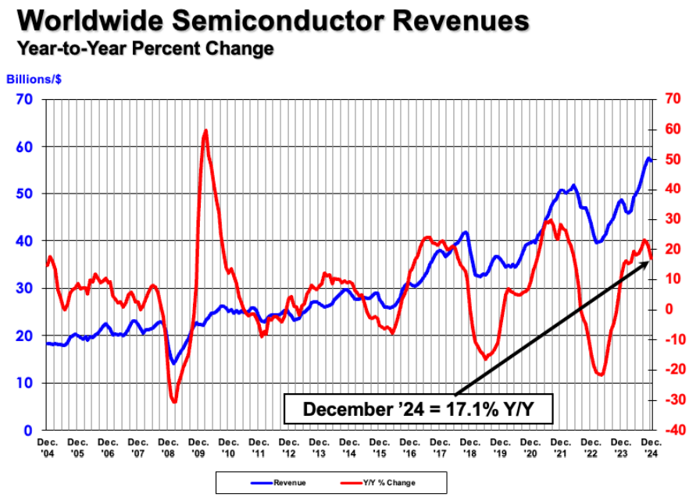
Figure 1: Worldwide Semiconductor Revenues.
Source: (Semiconductor Industry Association, 2025).
Enhancements in semiconductors and neural-processing units led to efficiency as semiconductor sales totalled USD 627-630 billion worldwide in 2024 (Semiconductor Industry Association, 2024). The high demand for high-end devices led to a record ASP of USD 356 (Counterpoint Research, 2024).

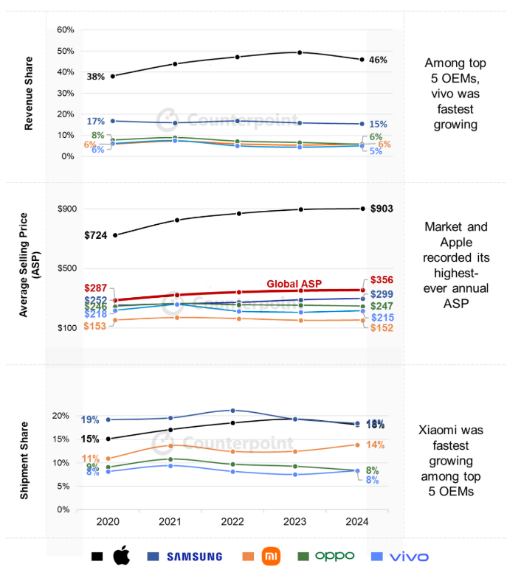
Figure 2: Global Smartphone Market Trends (2020–2024).
Source: (Counterpoint Research, 2024).
The figure demonstrates that the company in the period between 2020 and 2024, Apple has grown its revenue share by 38% to 46% as compared to Samsung, which remained at an average selling price of $256 to $299, indicating that Apple has a higher premium positioning.
Opportunities for Apple (pioneer).
- Integrate hardware + software + services: Close integration (custom chips + iOS + services) allows Apple to provide high-quality, privacy-sensitive AI functions that command a premium. Such integration is backed by the 2024 R&D expenditure of Apple, which amounted to USD 31.37 billion (U.S. Securities and Exchange Commission, 2024). However, Close integration increases fixed cost and platform risk, and if competitors narrow imitation lags, Apple will have to maintain an evidently high-quality on-device AI to command a willingness to pay a premium.
- Monetise services and ecosystem: Artificial intelligence capabilities have the potential to drive Apple service consumption (App Store, iCloud), promoting recurring income and customer retention as same-device AI is appreciated by customers. The indicators of the increasing significance of services can be observed in the financial statements of Apple and the market research (Apple Inc., 2024). However, the regulation and regional attach rates are limits to services ARPU, and thus growth can moderate in remedy markets despite installed-base stickiness that promotes resilience.
Threats to Apple.
- Competition from lower-cost AI phones. In the emerging markets, Apple is sensitive to demand as slower income growth and inflation minimise upgrades. In Greater China, its revenue decreased by 7.7 % to USD 66.95 billion, and market share decreased to 15 % as shipments fell by 17 % (Reuters, 2025).
- Regulation and privacy scrutiny: Rising regulation of AI and data. Governments are adding regulations to AI and data; new regulations may constrain certain AI capabilities or may enforce expensive compliance (Apple Inc., 2024).
Opportunities for Samsung (follower)
- Scale AI across many models: Samsung has introduced AI to its Galaxy S and Galaxy A smartphones to a wide range of customers at different price points. By the first quarter of 2024, Samsung regained the global lead with a market share of 20% with a year-on-year increase in shipments of 7.8 % (AP News, 2024).
- Leverage component strengths: The heavy investment by Samsung in chips, display, and memory improves product performance. Its capital spending in 2024 amounted to KRW 53.6 trillion (or around USD 39 billion), which increased the integration of AI and efficiency of its manufacturing (Samsung Global Newsroom, 2025).
Threats to Samsung (follower)
- Margin squeeze: The profits of Samsung are also under pressure due to Chinese competitors such as Xiaomi or Transsion, whose shares in the market have increased 34 % and 85 % per year in early 2024 in terms of market share, increasing the price competition (AP News, 2024).
- Trade volatility and input costs: Currency changes and uncertainty in global trade are endangering the cost of components, up in a 19.1% increase in global semiconductor sales in 2024 (Semiconductor Industry Association, 2025).
This is followed by economic factors that are evaluated to demonstrate the varying effects of pricing pressures, inflation, income levels and global market dynamics on pioneers and followers.

1.2 Economic Factors
The economic factors are inflation, consumer income, interest rates, exchange rates and global supply-chain costs, which influence pricing and production decisions, which influence demand, profitability, and efficiency (Chaves-Vargas et al., 2024). Following the pandemic, global inflation increased and reduced slowly decreased. This is illustrated by the fact that in 2024, the headline inflation stood at 5.8%, which is expected to decline to 4.3% in 2025 and will help in sustaining the consumer purchasing power and stabilise production costs (IMF, 2025). The global semiconductor market sales have reached USD 627.6 billion in 2024, which is 19.1% higher than the year before (Semiconductor Industry Association, 2025). In Q2 2025, Smartphone shipments increased 1 % year-over-year to 295.2 million units, and ASP increased to USD 356 (International Data Corporation, 2025).
Opportunities for Apple (Pioneer)
- Premium pricing: ASP of global smartphones in 2024 was USD 356, and the premium segment (ASP ≥ USD 600) has become 25 % of the market, which enables Apple to reap high margins and increase services revenues (Counterpoint Research, 2024).
- Supply resilience: Apple is spending USD 31,370 million on R&D in 2024, which is to support hardware-software integration and easy production during supply shocks (U.S. Securities and Exchange Commission, 2024).
Threats for Apple (Pioneer)
- New market sensitivity: Sales in Greater China declined 8 % to USD 66,952 million in 2024, and shipments declined by 17 % and market share by 18 % to 15 % (Bullfincher, 2025; Mo and Goh, 2025).
- Exchange rate and trade risk: Due to its operations worldwide, Apple is subject to exchange risks and tariffs, even though its gross margin remains healthy at 37.2% in 2024 (U.S. Securities and Exchange Commission, 2024).
Opportunities for Samsung (Follower)
- Scale advantage: KRW 53.6 trillion (approximately USD 39 billion) invested in research and development by Samsung in 2024 enhances its manufacturing, integration of AI, and cost-saving (Samsung Global Newsroom, 2025).
- Focused on the middle-income group: Samsung reclaimed its position at the top of the world in Q1 2024 with a market share of 20.8 per cent, and shipments increased by 7.8 per cent to attain 289.4 million units (AP News, 2024).
Threats Samsung (Follower)
- Margin squeeze: In 2024, Xiaomi increased global shipments by 16% on a year-over-year basis, which adds pressure on Samsung prices (Counterpoint Research, 2025).
- Input cost volatility: Trade risks and currency changes can increase the cost of the component, even as 19.1% of the world sales of semiconductors increase in 2024 (Semiconductor Industry Association, 2025).
Compare innovation responses.
Apple (pioneer) concentrates on deep integration with the design of custom chips like the A-series and Neural Engine, upon which it delivers OS-level AI features like Apple Intelligence. This plan is in line with the high-end positioning and privacy of users as practised by Apple. In 2024, the company also invested in its ecosystem of innovation, investing USD 31.37 billion in R&D (U.S. Securities and Exchange Commission, 2024). Moreover, Samsung (follower), in its turn, focuses on fast scaling and hardware leadership, integrating AI functions throughout Galaxy brands and capitalising on the advantages in cameras, displays, and memory. In 2024, it was spending KRW 53.6 trillion (approximately US39 billion) on capital expenditure to develop semiconductor and device-solution development to speed up AI integration (Samsung Global Newsroom, 2025).

Task 2: Strategic Responses of Pioneers and Followers
This section is a critical assessment of the innovative and imitative strategic responses of Apple to technological and economic shifts and Samsung to technology and economic shifts, as outlined in Task 1. Apple (leader) and Samsung (follower) adjust to the evolving technology and economic conditions. According to the marketing strategy theories, the analysis reveals the reasons why pioneers and followers respond differently to the same environmental stimulus. To match the smartphone market, Apple invests USD 31.37 billion in R&D to combine AI, hardware, and services, whereas Samsung invests KRW 53.6 trillion (USD 39 billion) to scale AI to devices (U.S. Securities and Exchange Commission, 2024), and Samsung (Samsung Global Newsroom, 2025).
Technological responses are analysed initially since innovation capability is a strong differentiator of pioneer and follower behaviour in the smartphone industry.

2.1 Strategic Response to Technological Variables.
The technology focus of Apple has placed it in a position to differentiate using high-level features, and as a result, it continues to be highly profitable due to its capability to focus on innovation, integration, and premium positioning in the ecosystem. The continued investment in the R&D and ecosystem design by Apple can be discussed as the Differentiation Strategy of Porter, according to which companies compete not in terms of price but in terms of unique value. Its ongoing product and service innovations also resonate with the Product Development Strategy of Ansoff since Apple has, over the years, been innovative in the current markets as it seeks to build on its brand loyalty and profitability. In 2024, the company spent USD 31.37billion on R&D in order to combine custom chips, iOS, and AI services (U.S. Securities and Exchange Commission, 2024). This technology made it possible to introduce Apple Intelligence, which improved the performance of on-device AI but made it worth a high ASP of $356 (Counterpoint Research, 2024). The strategy adopted by Apple promotes a high brand loyalty and strong ecosystem, indicative of differentiation strategies in the marketing mix by focusing on product quality, customer experience and monetisation of its services (Lim, 2023). Nonetheless, the dependence on the high pricing leaves Apple vulnerable to the sensitivity in emerging markets and high research and development expenses, which underscores the dangers of an intensive customer orientation.
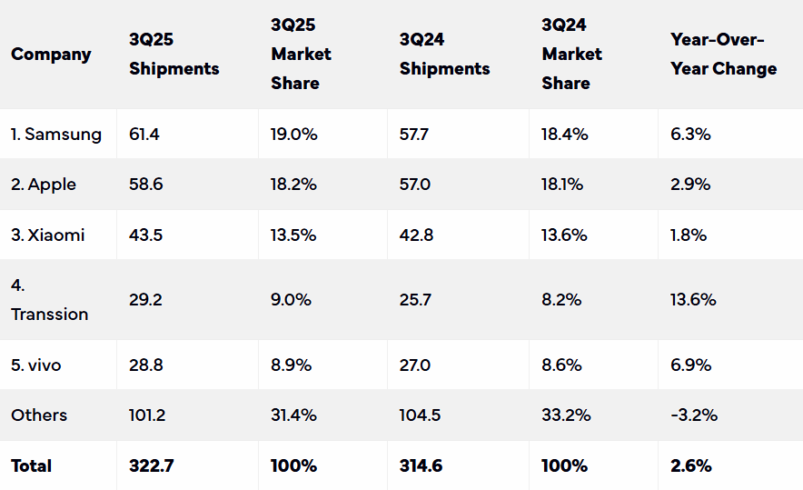
Figure 4: Global Smartphone Brand Usage Trends
Source:(IDC, 2025).
As Figure 4 shows, Samsung dominates the world smartphone market with a market share of 19.0 per cent in 3Q 2025, followed by Apple with a market share of 18.2 per cent. Despite a relatively modest increase in shipments, Apple, in its turn, lost its niche to Samsung due to the wider range of models. The information brings to the fore the role of innovation and product range in brand competitiveness and market share across the globe.
Samsung is oriented toward mid-market, fast scaling, hardware leadership, and cost efficiency. Samsung exhibits a typical Follower Advantage Strategy by quickly embracing and enhancing the innovations made by the pioneer. This strategy represents the Cost Leadership Strategy introduced by Porter, which focuses on efficiency and low prices to capture a broader market share (Jerab and Mabrouk, 2023). It is also guided by the Innovation Diffusion Theory, which stipulates that follower firms will monitor the performance of the pioneer company in the market and then make mass-market adjustments (Alyoussef, 2023). In 2024, shipments of smartphones worldwide reached more than 270 million units, and Samsung once again led the market with a market share of 20.8 in the first quarter (AP News, 2024). The KRW 53.6 trillion (approximately USD 39 billion) capital expenditure boosted the semiconductor manufacturing and AI integration throughout the Galaxy S and A lines (Samsung Global Newsroom, 2025). The strategy followed by Samsung corresponds to the models of customer behaviour, serving price-sensitive consumers, and the marketing mix presented by means of functional product design and competitive prices (Lim, 2023). Although the method lowers the risk of innovation and expands its market reach, it lowers cohesion in the ecosystem and restricts the growth of its premium margin relative to Apple.

2.2 Strategic Responses to Economic Factors
The responses of the economy also exemplify pioneer and follower strategies. Apple has used high pricing, supply strength, and concentration. Apple, with a premium device and an ASP of $356 in 2024 (Counterpoint Research, 2024) and 25% of the market represented by high-quality devices, has a high margin and enhances service monetisation. Its strong R&D spending guarantees resilience in production during the volatility of the supply chain (U.S. Securities and Exchange Commission, 2024). Nevertheless, Apple dropped by 8 % to USD 66.95 billion in Greater China, where shipments decreased by 17 % showing emerging-market sensitivity and vulnerability to the currency and trade risks (Bullfincher, 2025; Mo and Goh, 2025). Marketing-wise, this portrays selective targeting in the marketing mix that emphasises the premium product differentiation rather than the volume.
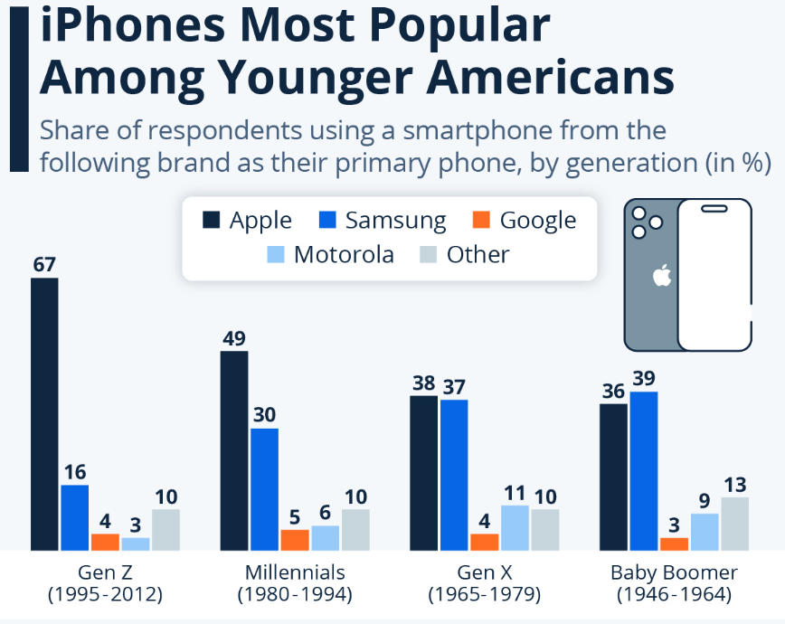
Figure 5: U.S. Smartphone Brand Preference by Generation.
Source:(Zandt, 2024).
Gen Z and millennials in the U.S. use iPhones at 67% and 50% respectively, versus 16% and 30% of Samsung. This generational gap is indicative of more general economic trends: younger consumers are more willing to pay to use premium devices, which is the basis of Apple's high-ASP strategy, whereas Samsung appeals to more price-sensitive cohorts. The trends indicate how the income levels, pricing elasticity and economic preferences influence the demand of pioneer and follower firms.
Samsung chooses an intermediate market, the economy of scale, and cost control, where capital investment is involved to enhance production efficiency and artificial intelligence (Samsung Global Newsroom, 2025). Its 289.4 millenary shipments in 2024 (AP News, 2024) point to a business approach of focusing on accessibility and wide market penetration, which is in line with the volume-based pricing and affordability of its products. Although this helps in market share expansion and mitigating the price competition pressure, profitability is exposed to the threat of Chinese competitors like Xiaomi that saw their shipment improve by 16 % the previous year (Counterpoint Research, 2025). The customer-centric approach of Samsung involves the adoption of various segments but is based on cost optimisation instead of ecosystem differentiation.

2.3 Comparison and Synthesis
The comparison of the two companies shows systematic differences; Apple, a pioneer, invests heavily in the technological differentiation and ecosystem integration, which has high profitability, brand loyalty, and premium positioning, but is threatened with new markets and high costs of R&D. As a follower, Samsung focuses on scaling, hardware optimisation, and affordability, which allow covering the market on a large scale and competing on the middle market but restrict ASP and ecosystem synergy. These variations are supported by marketing theory: Apple uses differentiation approaches and selective pricing in the 4Ps model, and Samsung uses market penetration and cost leadership, representing the customer adoption behaviour and the middle-level target market.
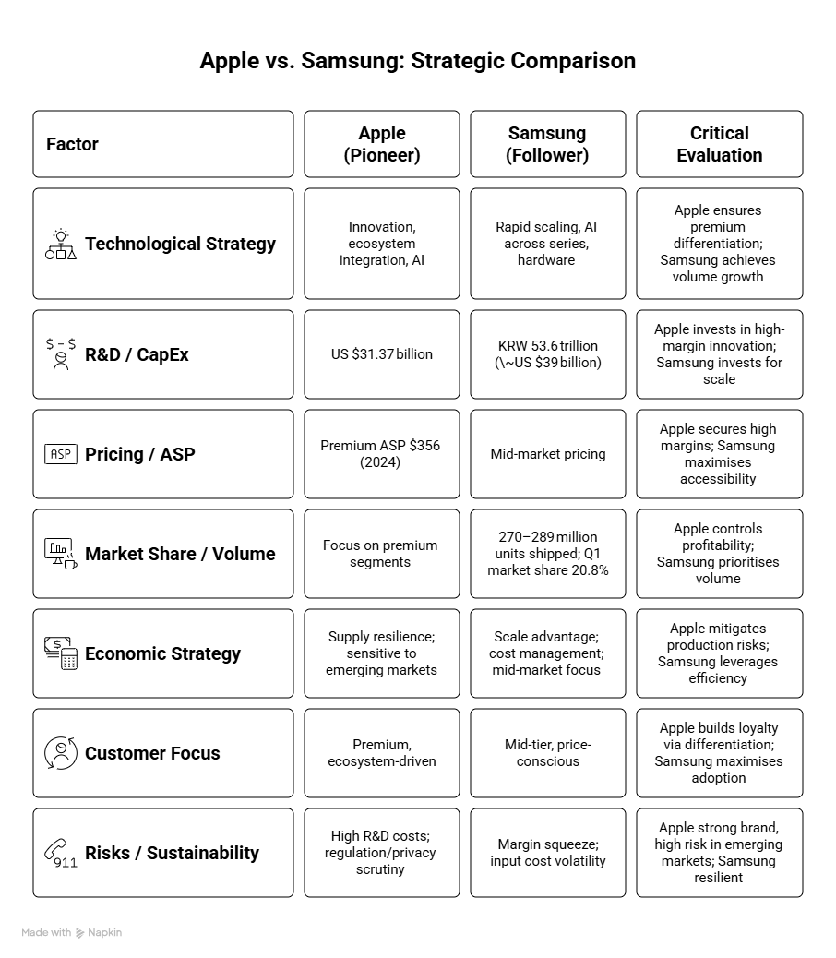
Figure 6: Strategic Responses of Apple (Pioneer) vs Samsung (Follower).
Source: By the author.

Conclusion
The report has demonstrated how competition in the smartphone market in the world is influenced by technological and economic forces. Apple is an innovator that goes first, applies early innovation, ecosystem integration, and premium positioning, whereas Samsung is primarily a follower that scales innovations in the mid- and high-end markets. As it was observed in the analysis, 5G, AI, and broader economic circumstances provide both opportunities and threats to both companies. Overall, the strengths of Apple are in unstoppable innovation and a powerful ecosystem, and those of Samsung are in size and low cost, i.e. every company must keep changing its strategy to be competitive.

References
Alyoussef, I.Y. (2023). The impact of massive open online courses (MOOCs) on knowledge management using integrated innovation diffusion theory and the technology acceptance model.Education Sciences,13(6), p.531. The Impact of Massive Open Online Courses (MOOCs) on Knowledge Management Using Integrated Innovation Diffusion Theory and the Technology Acceptance Model
AP News. (2024). Global smartphone shipments climb nearly 8% in first quarter as Samsung retakes the lead. Associated Press, 15 April. Available at: http://apnews.com/article/smartphone-apple-samsung-e5a0c4c9a7a058e82bd1707cd8f28986 (Accessed: 5 November 2025).
Apple Inc. (2024). Form 10-K for the fiscal year ended September 28, 2024. Washington, D.C.: United States Securities and Exchange Commission. Available at: https://s2.q4cdn.com/470004039/files/doc_earnings/2024/q4/filing/10-Q4-2024-As-Filed.pdf (Accessed: 6 November 2025).
Bullfincher. (2025). Apple Revenue Breakdown By Region. Available at: https://bullfincher.io/companies/apple/revenue-by-geography (Accessed: 7 November 2025).
Chaves-Vargas, J. C., Ribes-Giner, G., and Moya-Clemente, I. (2024). Effect of the economic, social, and technological factors on sustainable entrepreneurship over time.Journal of Business Research, 173, 104829. https://www.sciencedirect.com/science/article/pii/S0148296323008160
Counterpoint Research (2024). Global Smartphone Market 2024: Revenues Resume Growth. Available at: https://counterpointresearch.com/en/insights/global-smartphone-market-2024? (Accessed: 7 November 2025).
Eierle, B., Hartlieb, S., Hay, D.C., Niemi, L. and Ojala, H. (2021). External Factors and the Pricing of Audit Services: a Systematic Review of the Archival Literature Using a PESTLE Analysis. AUDITING: a Journal of Practice & Theory, 41(3), pp.95–119. doi: https://doi.org/10.2308/AJPT-2019-510.
International Data Corporation (IDC) (2025). Worldwide Smartphone Market Grows 1.0% in Q2 2025. Available at: https://my.idc.com/getdoc.jsp?containerId=prUS53684525(Accessed: 11 Nov 2025).
International Monetary Fund (2025). World Economic Outlook – April 2025. Available at: https://www.imf.org/en/Publications/WEO/Issues/2025/04/22/world-economic-outlook-april-2025 (Accessed: 12 Nov 2025).
Jerab, D. and Mabrouk, T. (2023). Achieving competitive advantage through cost leadership strategy: Strategies for Sustainable Success.Available at SSRN 4574945. ssrn_id4574945_code1647352.pdf
Lim, W.M. (2023). Transformative marketing in the new normal: A novel practice-scholarly integrative review of business-to-business marketing mix challenges, opportunities, and solutions.Journal of Business Research,160, p.113638. Transformative marketing in the new normal: A novel practice-scholarly integrative review of business-to-business marketing mix challenges, opportunities, and solutions - ScienceDirect
Mo, L. and Goh, B. (2025). Apple loses smartphone sales crown in China, drops to third in 2024. Reuters, 17 January. Available at: https://www.reuters.com/technology/apple-smartphone-shipments-china-fell-25-q4-canalys-says-2025-01-16 (Accessed: 8 November 2025).
Nguyen, V. (2025). Global 5G Adoption Skyrockets to 2.25 Billion, Four Times Faster Than 4 G. [online] 5G Americas. Available at: https://www.5gamericas.org/global-5g-adoption-skyrockets-to-2-25-billion-four-times-faster-than-4g/. (Accessed: 3 November 2025).
Samsung Global Newsroom (2025). Samsung Electronics announces fourth-quarter and FY 2024 results. 31 January. Available at: https://news.samsung.com/global/samsung-electronics-announces-fourth-quarter-and-fy-2024-results? (Accessed: 7 November 2025).
Semiconductor Industry Association (2025). Global Semiconductor Sales Increase 19.1% in 2024; Double-Digit Growth Projected in 2025. Washington: SIA. Available at: https://www.semiconductors.org/global-semiconductor-sales-increase-19-1-in-2024-double-digit-growth-projected-in-2025(Accessed: 5 November 2025).
U.S. Securities and Exchange Commission. (2024). Apple Inc. Form 10-K for the fiscal year ended September 28, 2024. Available at: https://www.sec.gov/Archives/edgar/data/320193/000032019324000123/aapl-20240928.htm (Accessed: 12 November 2025).
Zandt, F. (2024). What Are the Most Popular Phone Brands in the U.S.? Statista, 14 August. Available at: https://www.statista.com/chart/32850/share-of-respondents-using-a-smartphone-from-the-following-brand-as-their-primary-phone-by-generation/(Accessed: 10 November 2025).

