Investigating the Effect of Noise in DSB- SC and FM Systems:

Theo Benjamin David Rose
2114615
L5 – Radio Frequency Systems (ACDA5019)
Embedded Electronics Degree Apprenticeship
Table of Contents
Introduction 3
Background Research 4
AWGN 4
AM 4
FM 4
Simulink Model Block Diagrams 5
Simulated Outputs 7
Task 1 – Investigating Amplitude Modulation 7
Task 2 – Investigating Double Side Band Supressed Carrier (DSB-SC) AM 11
Sine Wave 12
Multimedia Audio File 14
Audio File with Added Noise 16
Task 3 – Investigating Frequency Modulation 19
Sine Wave 20
Multimedia Audio File 23
Multimedia Audio File with Added Noise 25
Analysis of Results 27
Task 1 – Results 27
Task 2 – Results 28
Task 3 – Results 29
Conclusion 30
References 31

Introduction

This report will be analyzing different aspects of double side band suppressed carrier (DSB-SC) amplitude modulation as well as frequency modulation by assessing the Simulink model’s performance. These analog techniques will also be tested against additive white gaussian noise to see the effect of signal to noise ratio to the performance of that modulation technique. DSB-SC will also be further investigated to see how a critical, over and under modulation index affects the modulated carrier wave.

Background Research

AWGN

Additive white gaussian noise is a Simulink block that will be used to simulate noise for these modulation techniques to assess its performance. This works by applying a simple noise model that represents electron motion in the RF front end of the receiver [1]. The noise applied is spectrally flat across the entire bandwidth and contains equal spectral power at all frequencies [1].

AM

The two variants of amplitude modulation that will be simulated are DSB and DSB-SC. DSB- SC is a modified version of AM that removes almost all the carrier wave frequency leaving just the double side bands [2]. Which results in significant power savings but has the drawback that diode detector can no longer be used for demodulation [2]. AM is commonly used in car radios but has a few niche use cases such as sending data over radar signal without interfering with the original purpose of detection [3].

FM

Frequency modulation is where the carrier wave is varied by the amount proportional to the amplitude of the signal wave and at a frequency of the modulating signal [2]. Frequency modulation has the advantage of performing better when it comes to signal to noise ratio [2].

Simulink Model Block Diagrams

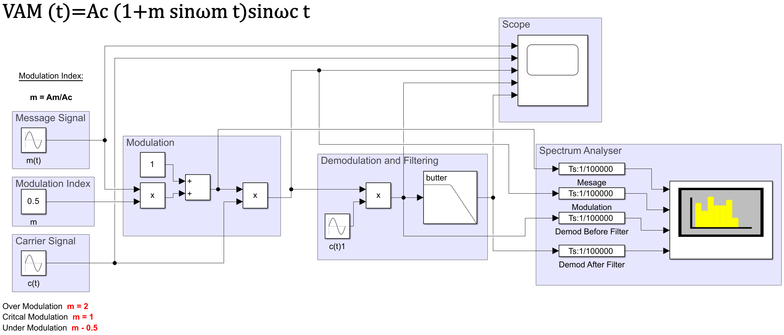
Figure 1 - AM Modulation Simulink Model
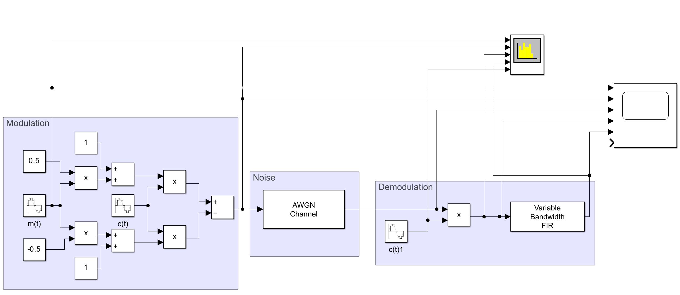
Figure 2 - AM DSB-SC Modulation Simulink Model

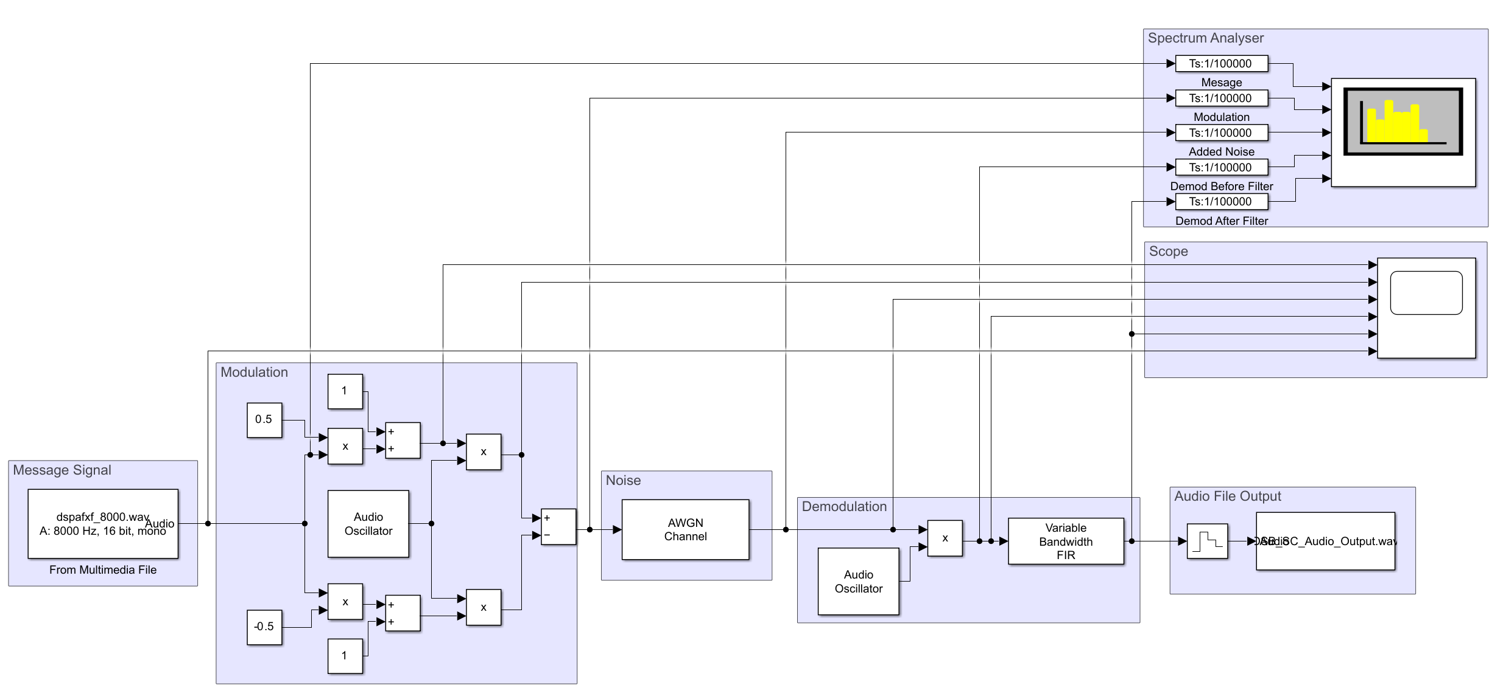
Figure 3 - AM DSB-SC Modulation Simulink Model with Multimedia File
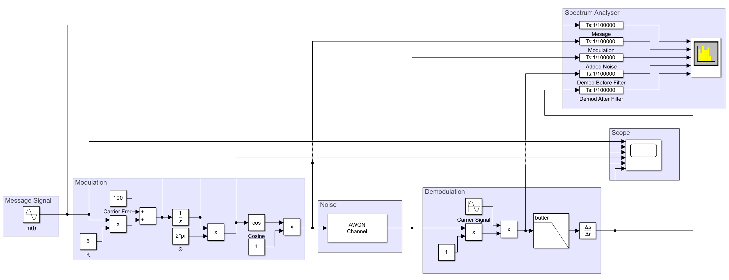
Figure 4 - FM Modulation Simulink Model
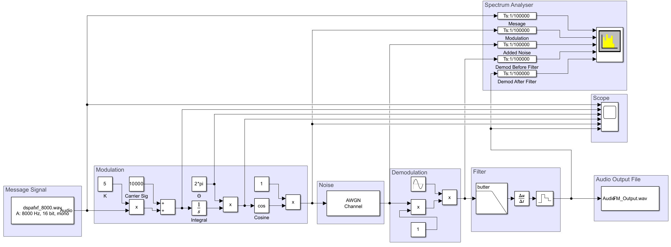
Figure 5 - FM Modulation Simulink Model with Multimedia File

Simulated Outputs

Task 1 – Investigating Amplitude Modulation

Using the Simulink model in figure 1 to investigate AM using the following equations to create the model:
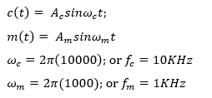
Equation 1 [4]
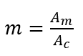
Equation 2 [4]
Where $A_{c}$ and $A_{m}$ is the amplitude of the carrier and message signal respectively. The modulation index is calculated by dividing the amplitude of the message signal by the amplitude of the carrier signal.
For this model the carrier frequency will be a 10KHz sine wave and the message signal will be a 1KHz.
The modulation index will be initially set to 0.5 as that as the last digit in my student number is 5. This will be changed when simulating over, under and critical modulation.

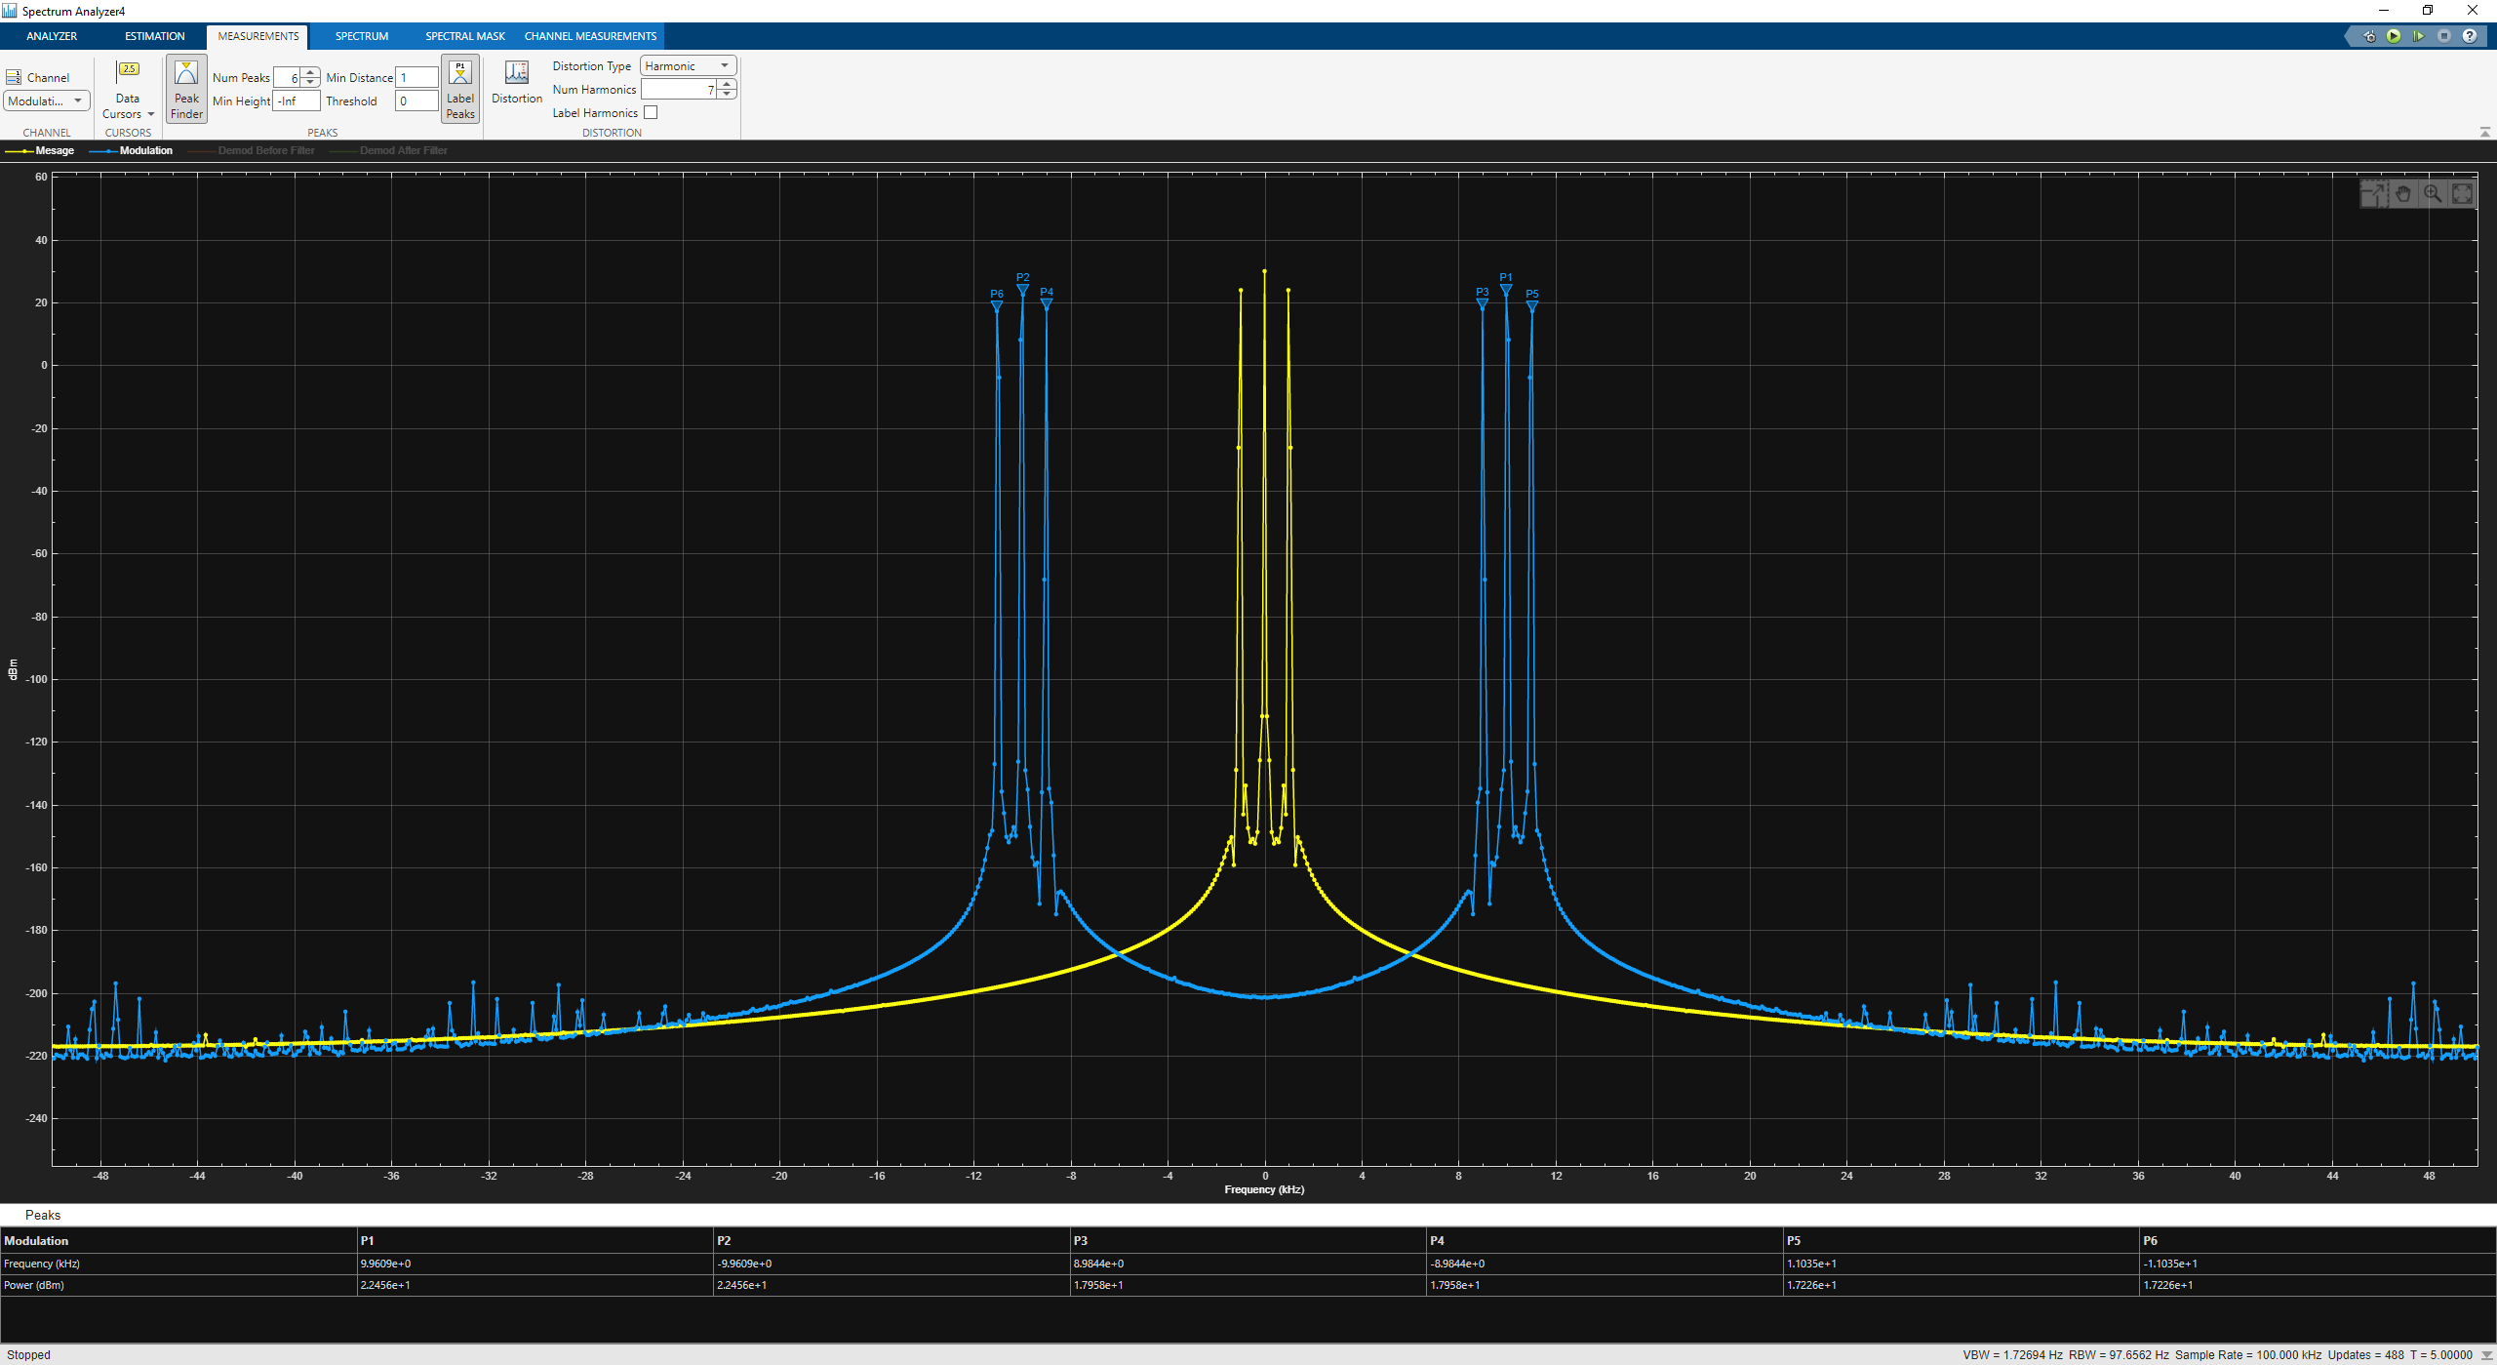
Figure 6
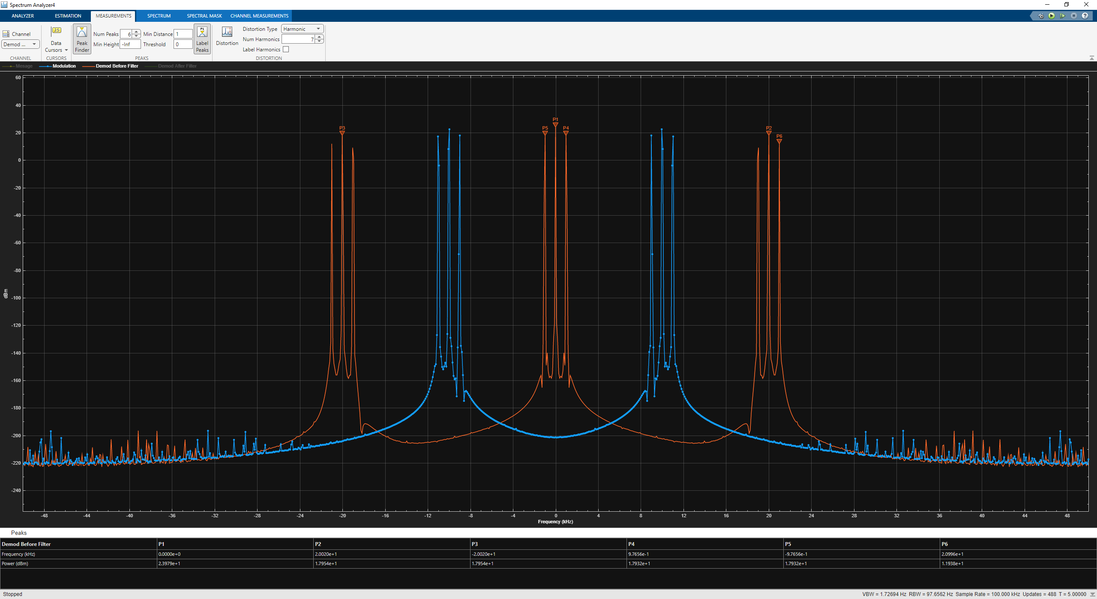
Figure 7
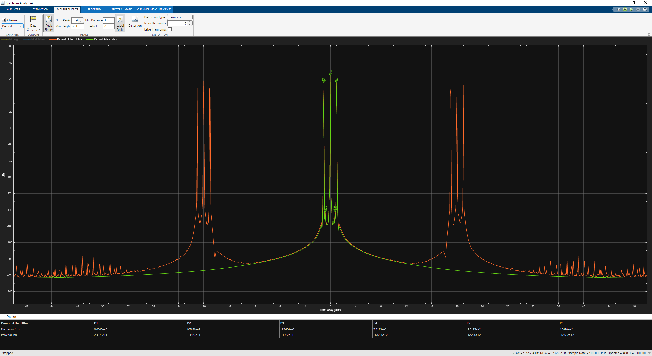
Figure 8
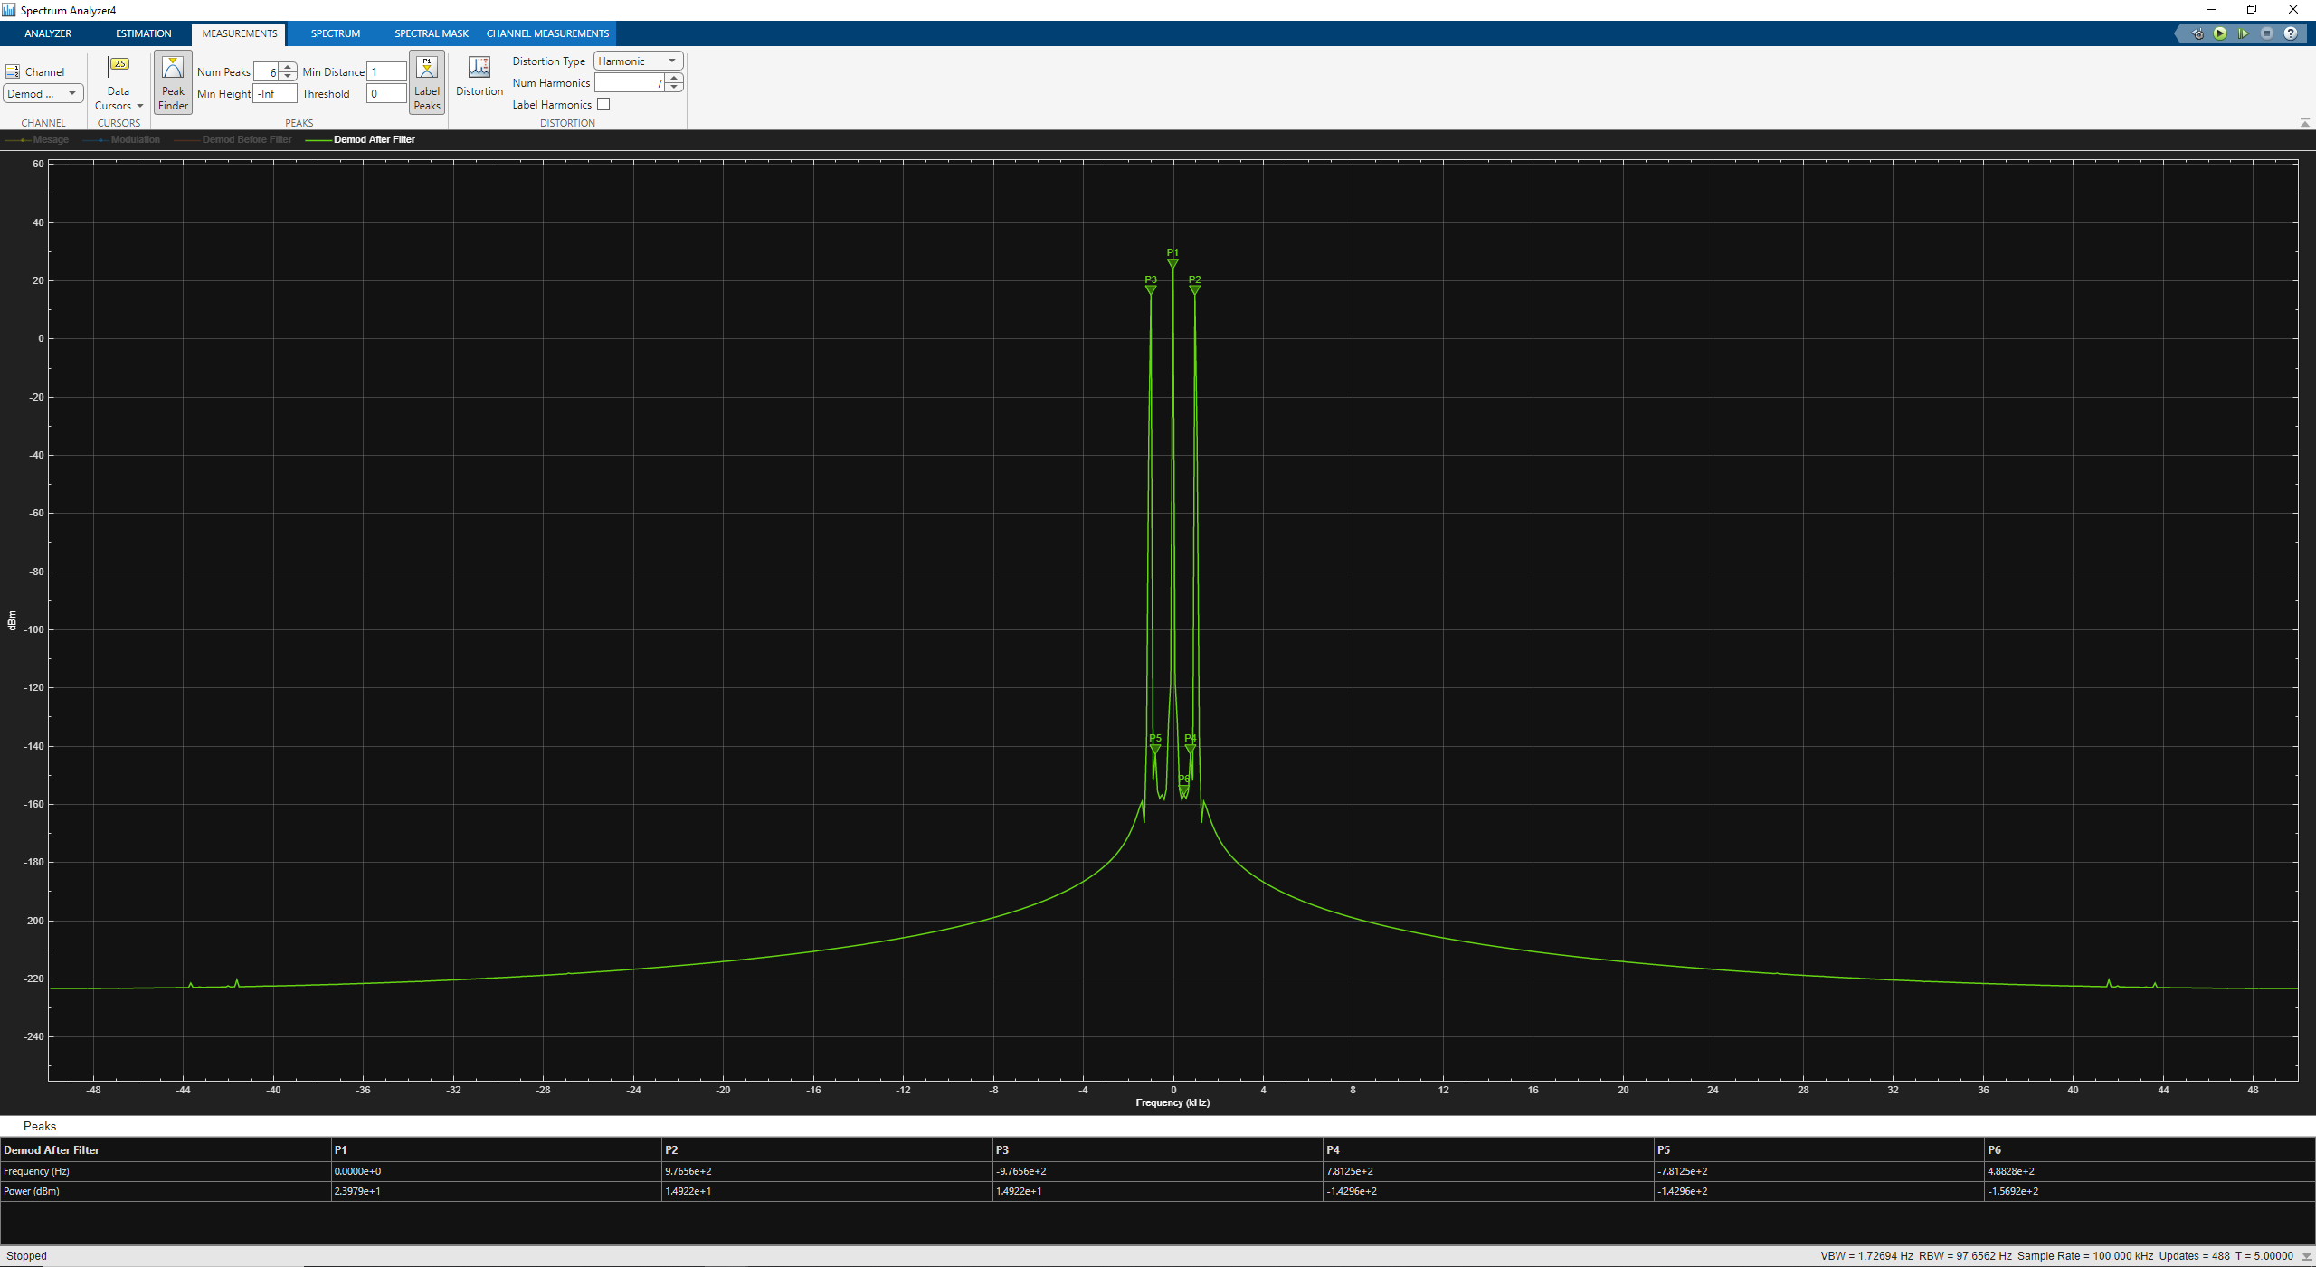
Figure 9
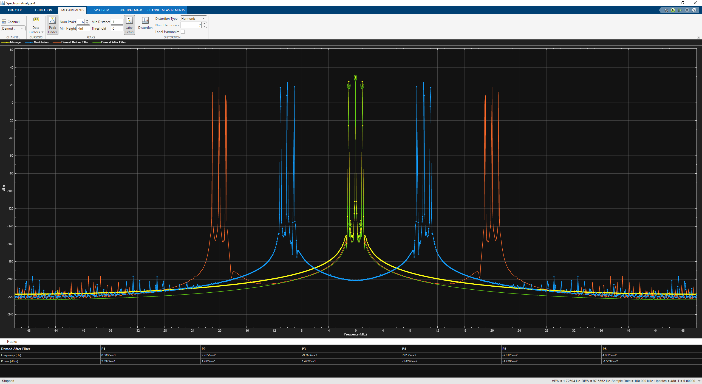
Figure 10

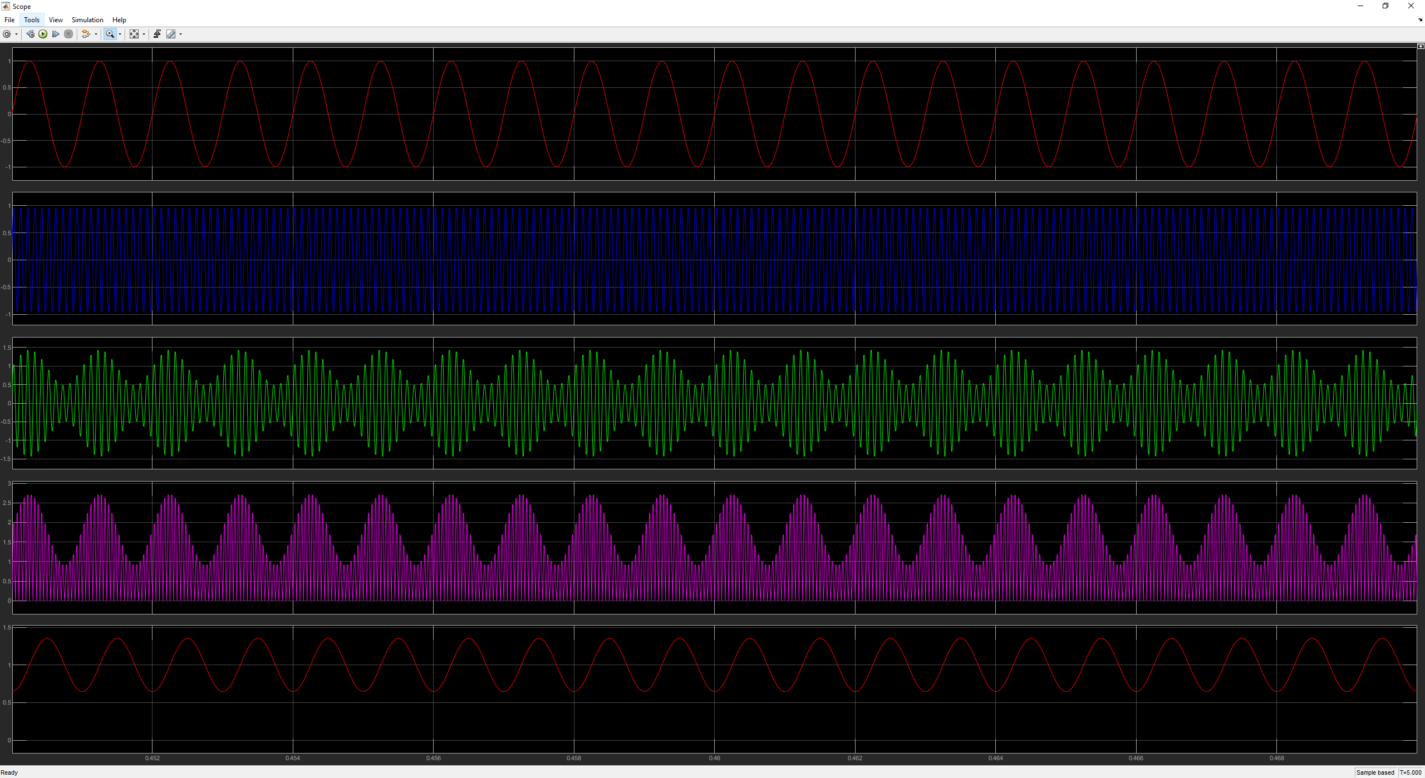
Figure 11
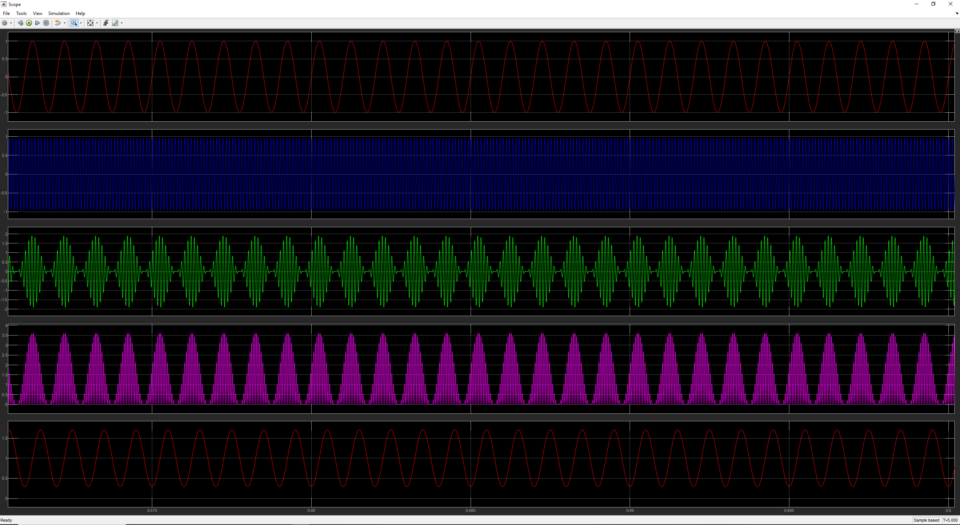
Figure 12
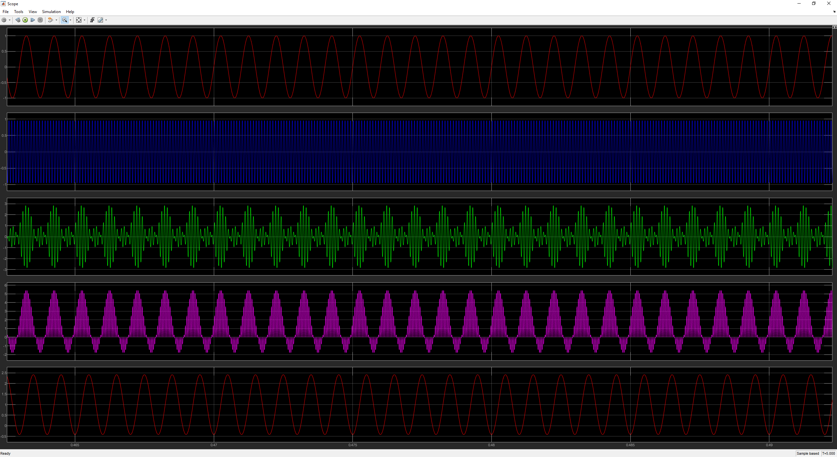
Figure 13

Task 2 – Investigating Double Side Band Supressed Carrier (DSB-SC) AM

Using the Simulink models in figure 2 and 3 to investigate AM DSB-SC using the following equations to create the model:
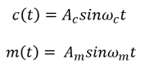
Equation 3 [4]
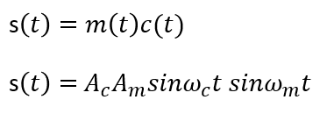
Equation 4 [4]
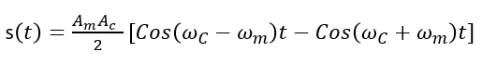
Equation 5 [4]
The first simulation will use a 100 Hz sine wave with a phase of 0 and the message signal will be a 20 Hz.
The second simulation will use an audio clip as the message and therefore the carrier signal will be 10,000 Hz and the message signal will be 8000 Hz.
This method of AM modulation is designed to supress the carrier signal as more than 1/3 of the transmitted power in normal AM is from transmitting the carrier signal.

Sine Wave

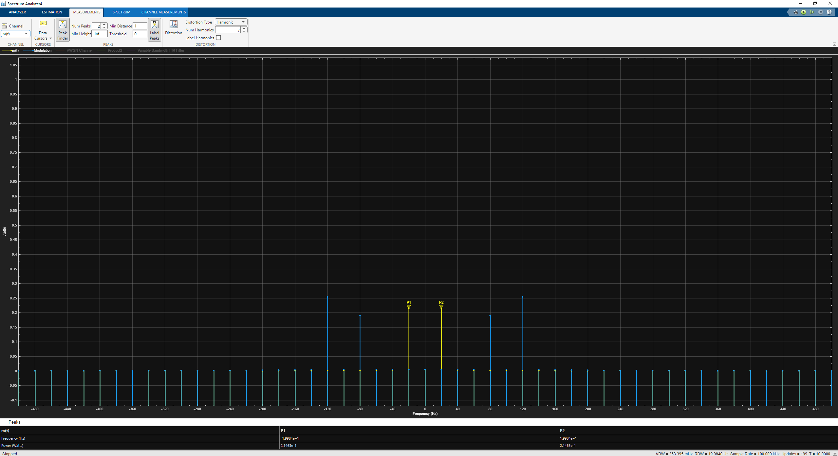
Figure 14
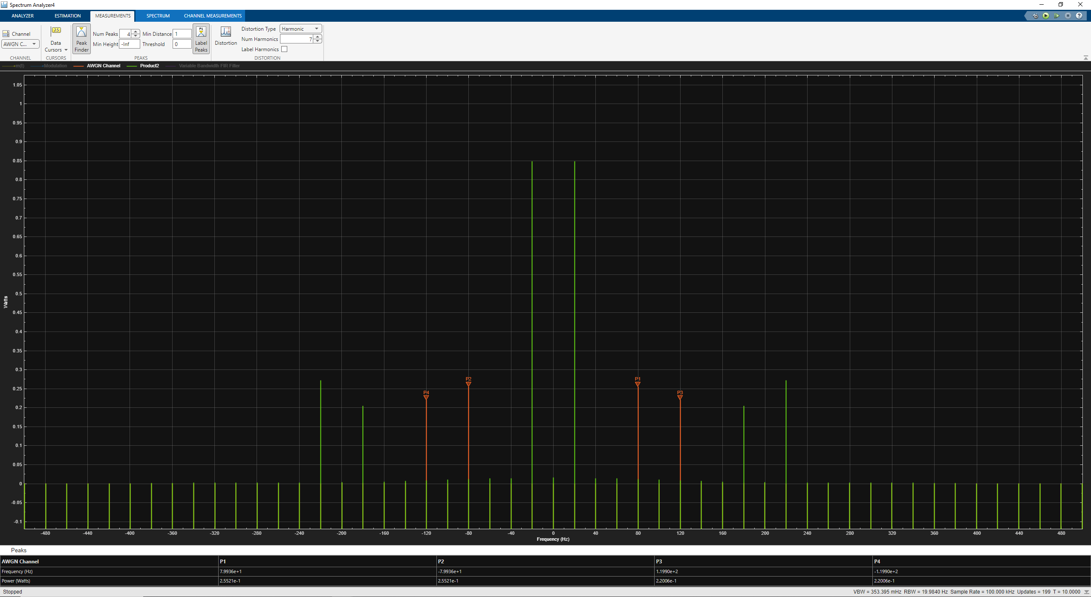
Figure 15
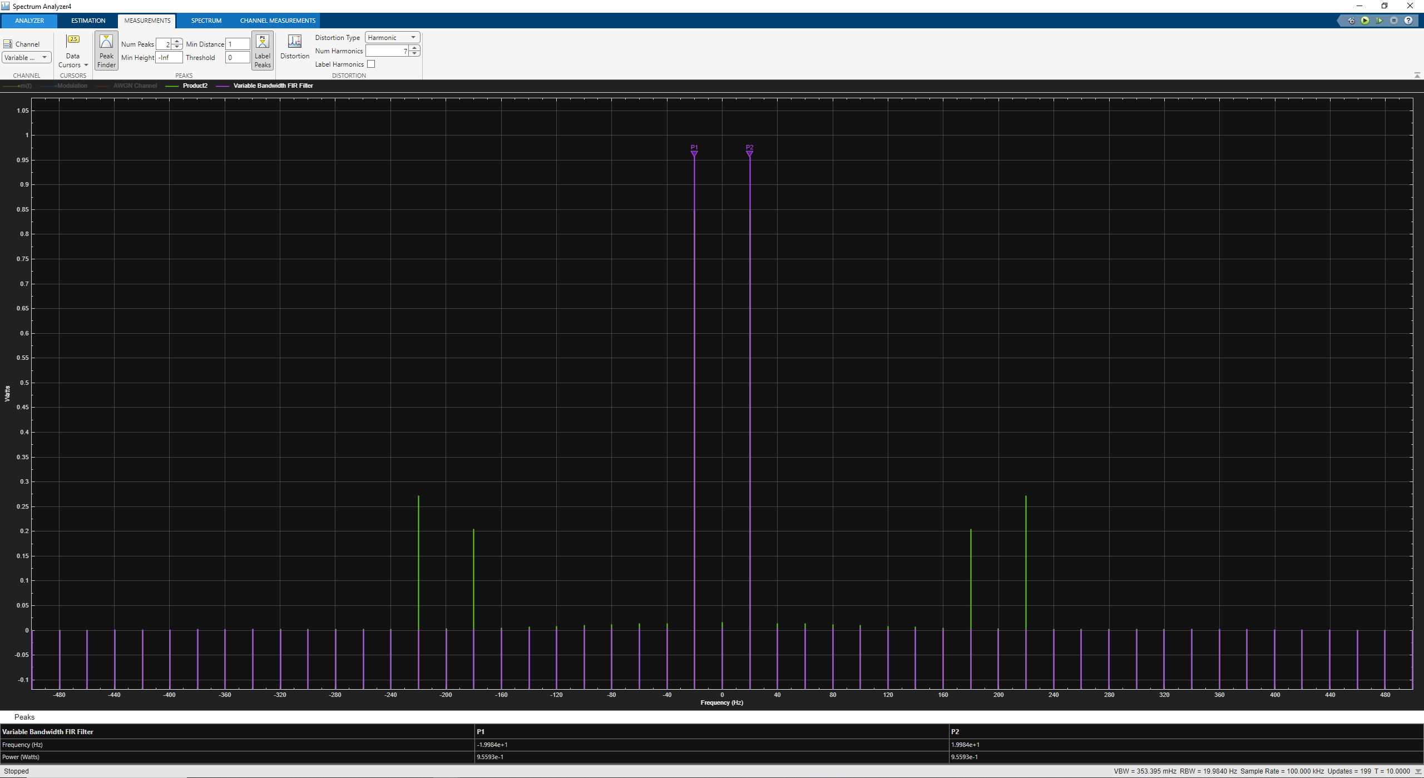
Figure 16
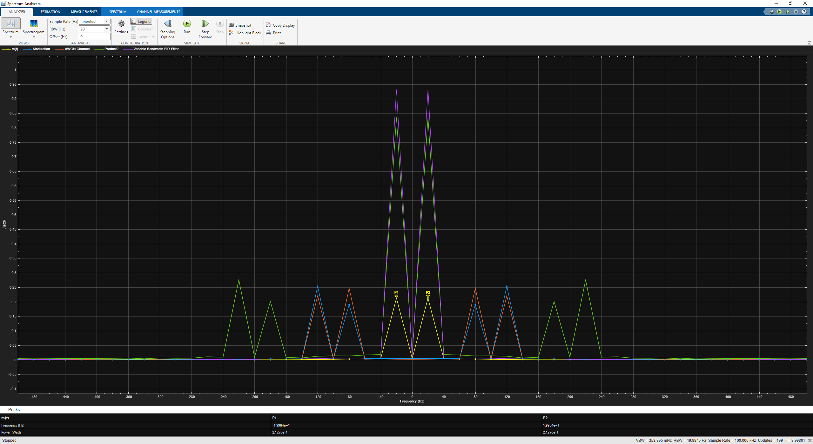
Figure 17
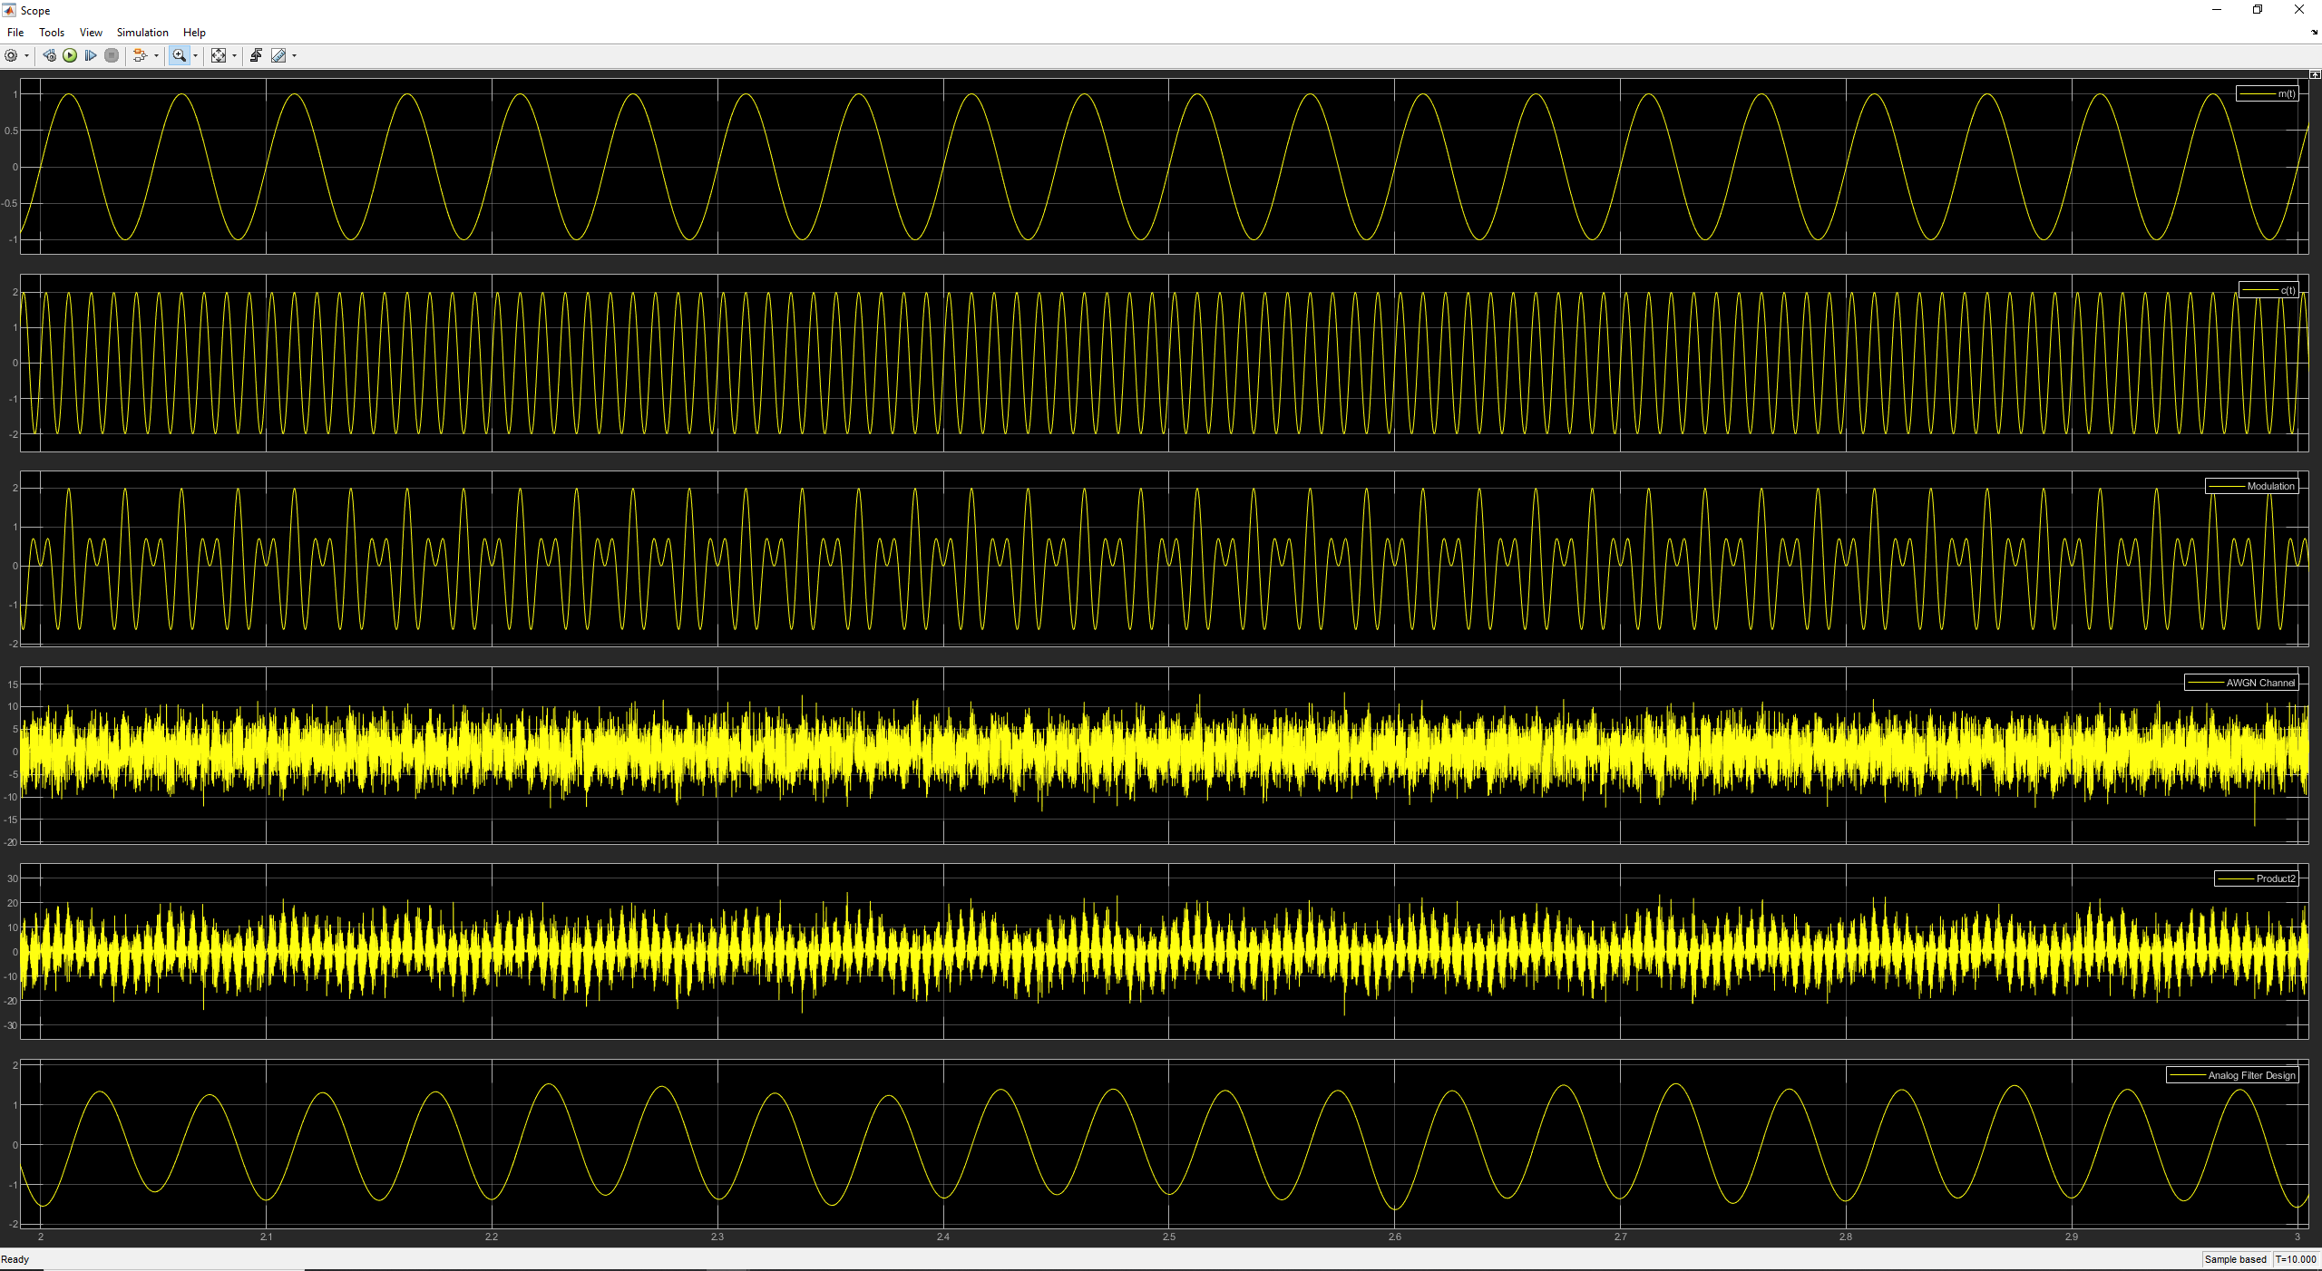
Figure 18

Multimedia Audio File

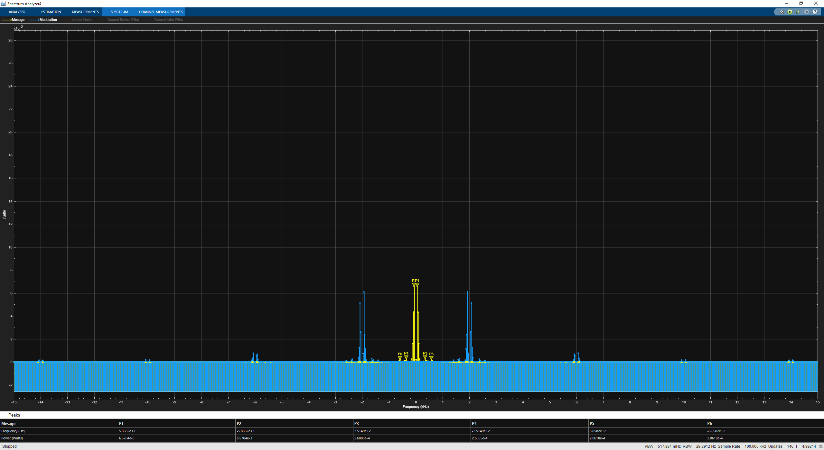
Figure 19
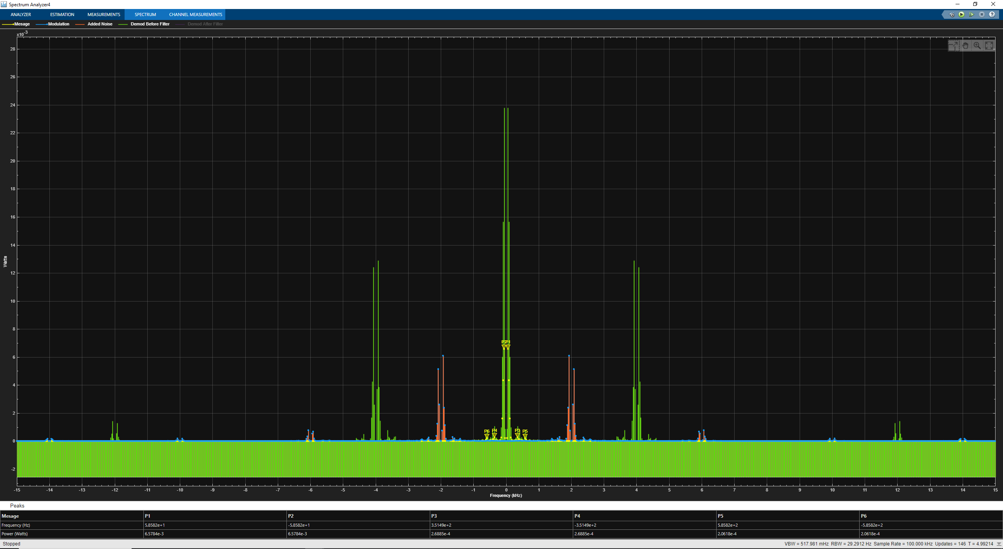
Figure 20
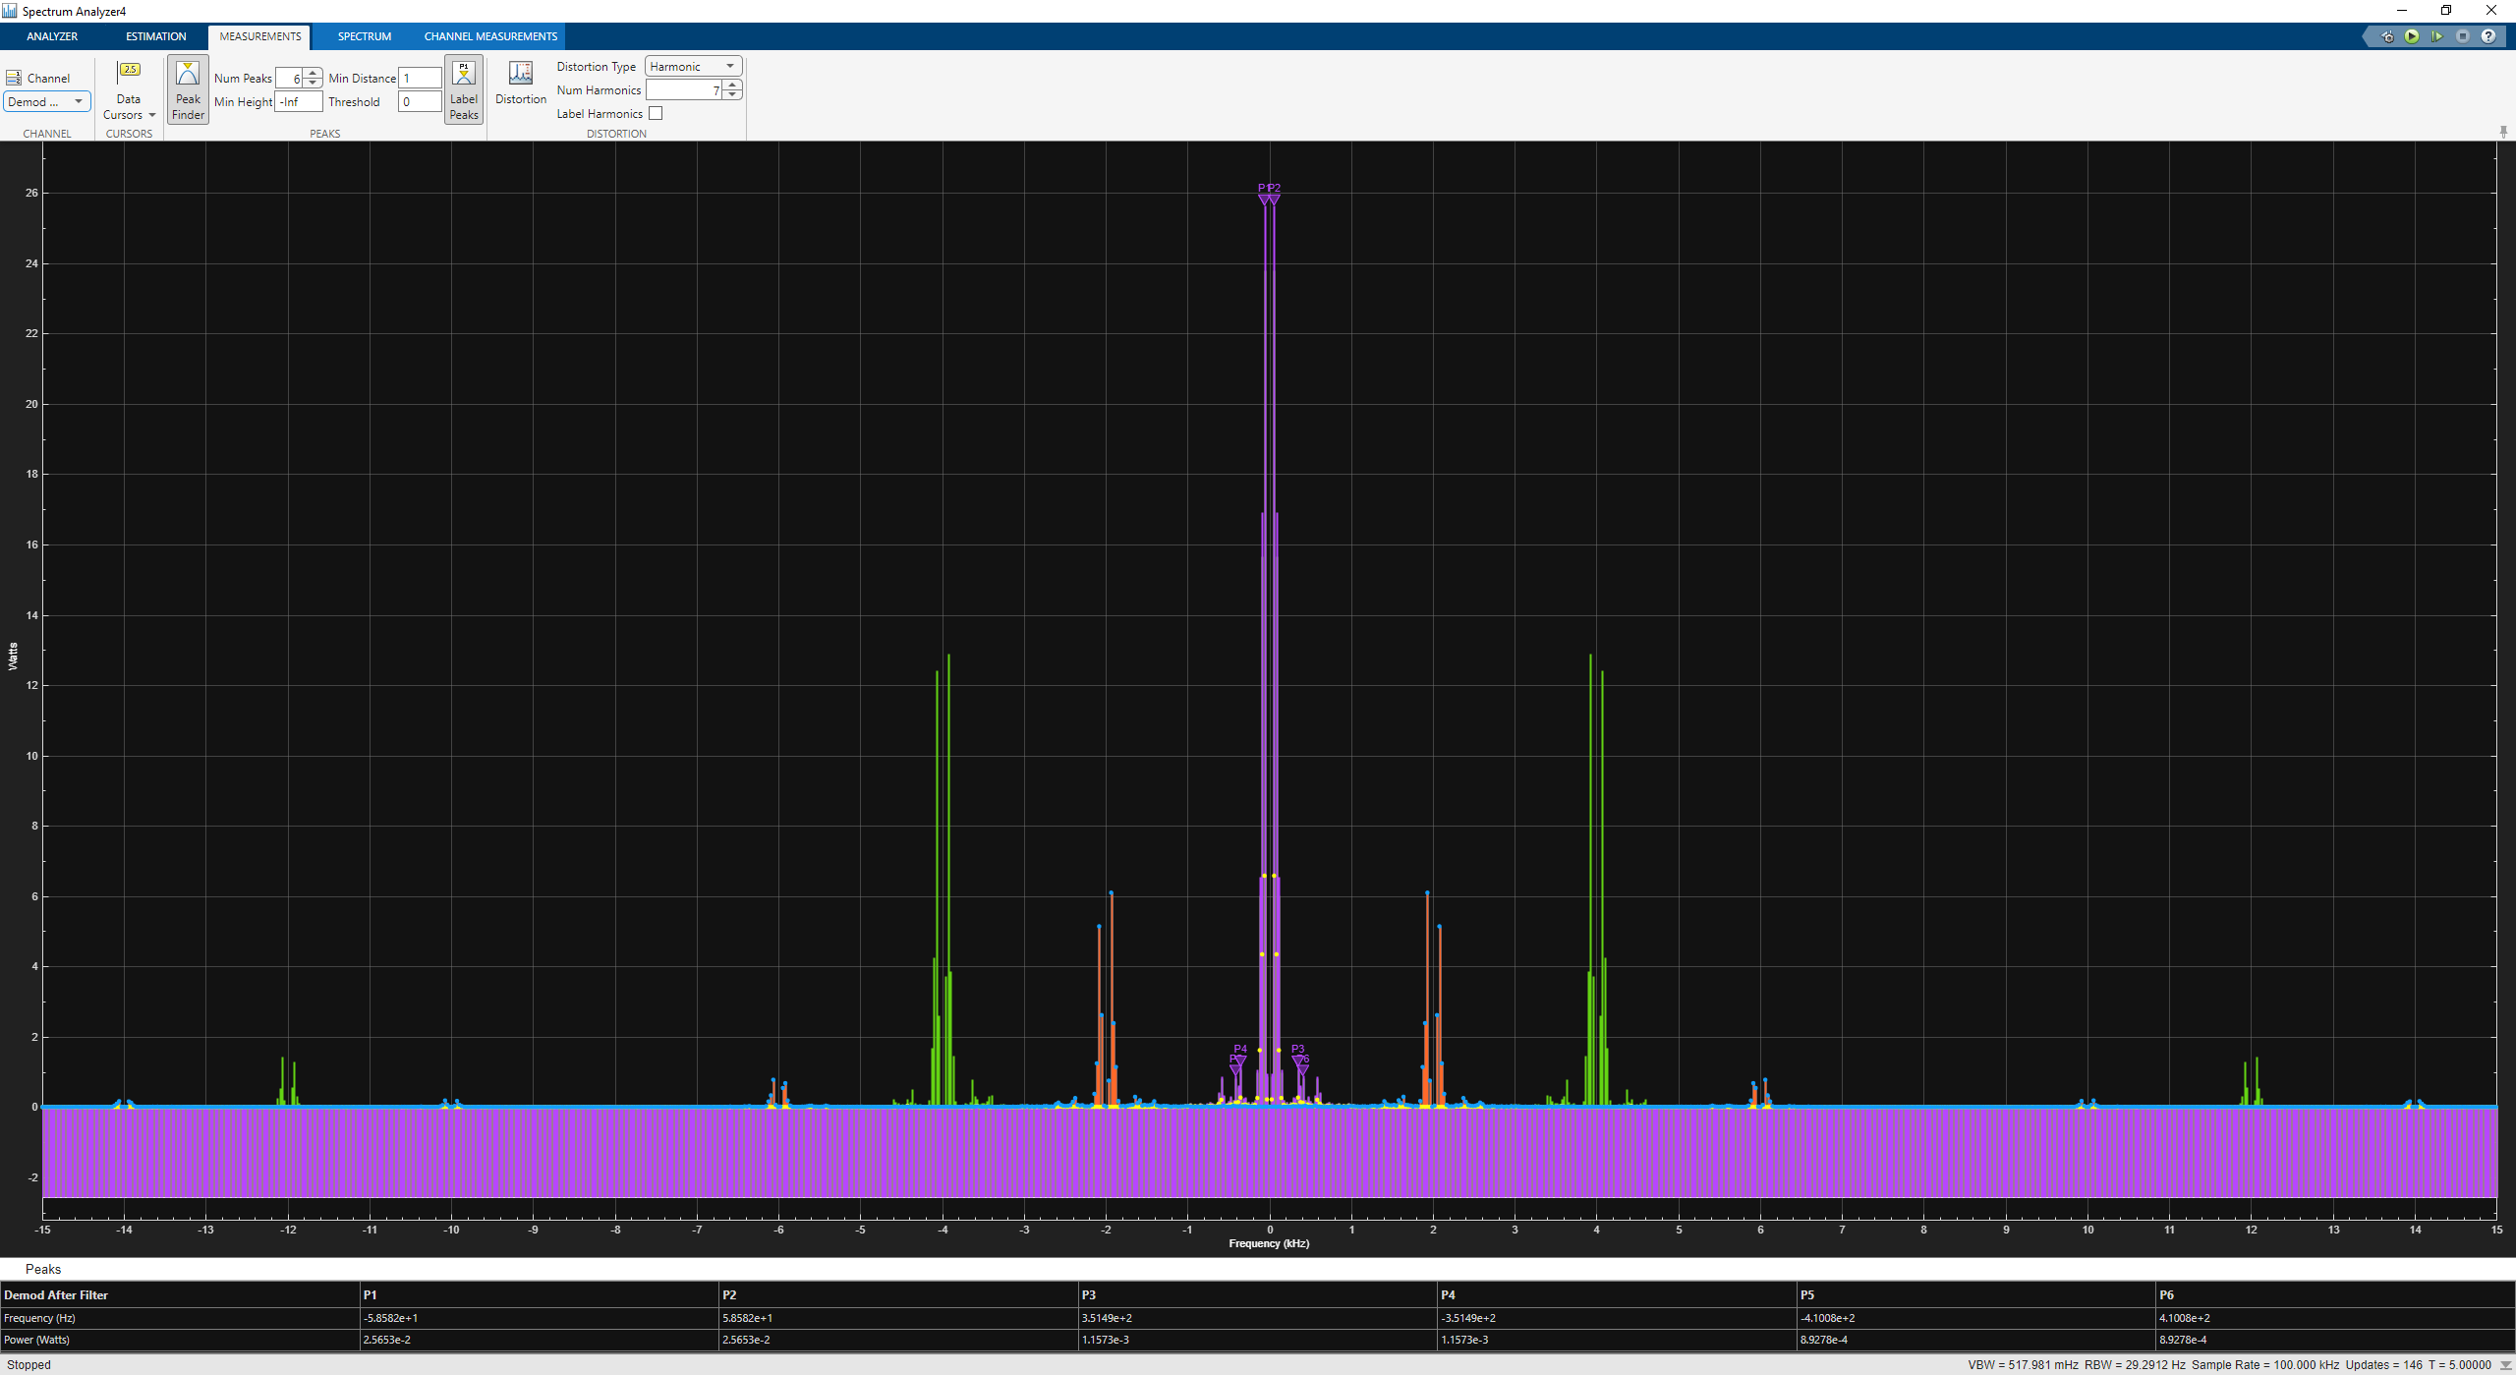
Figure 21
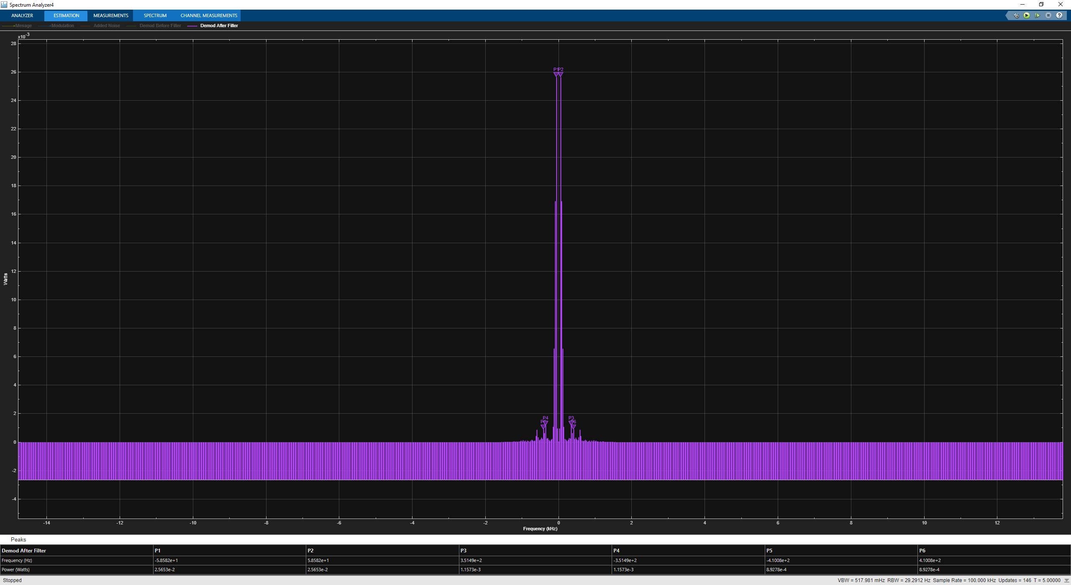
Figure 22
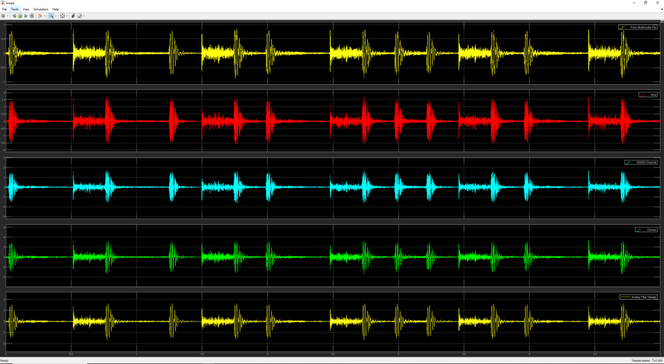
Figure 23
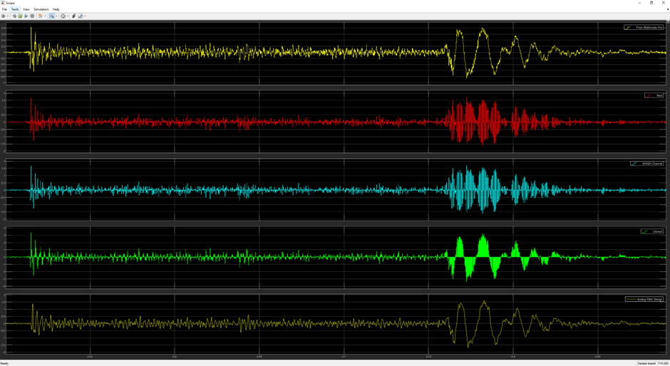
Figure 24

Audio File with Added Noise

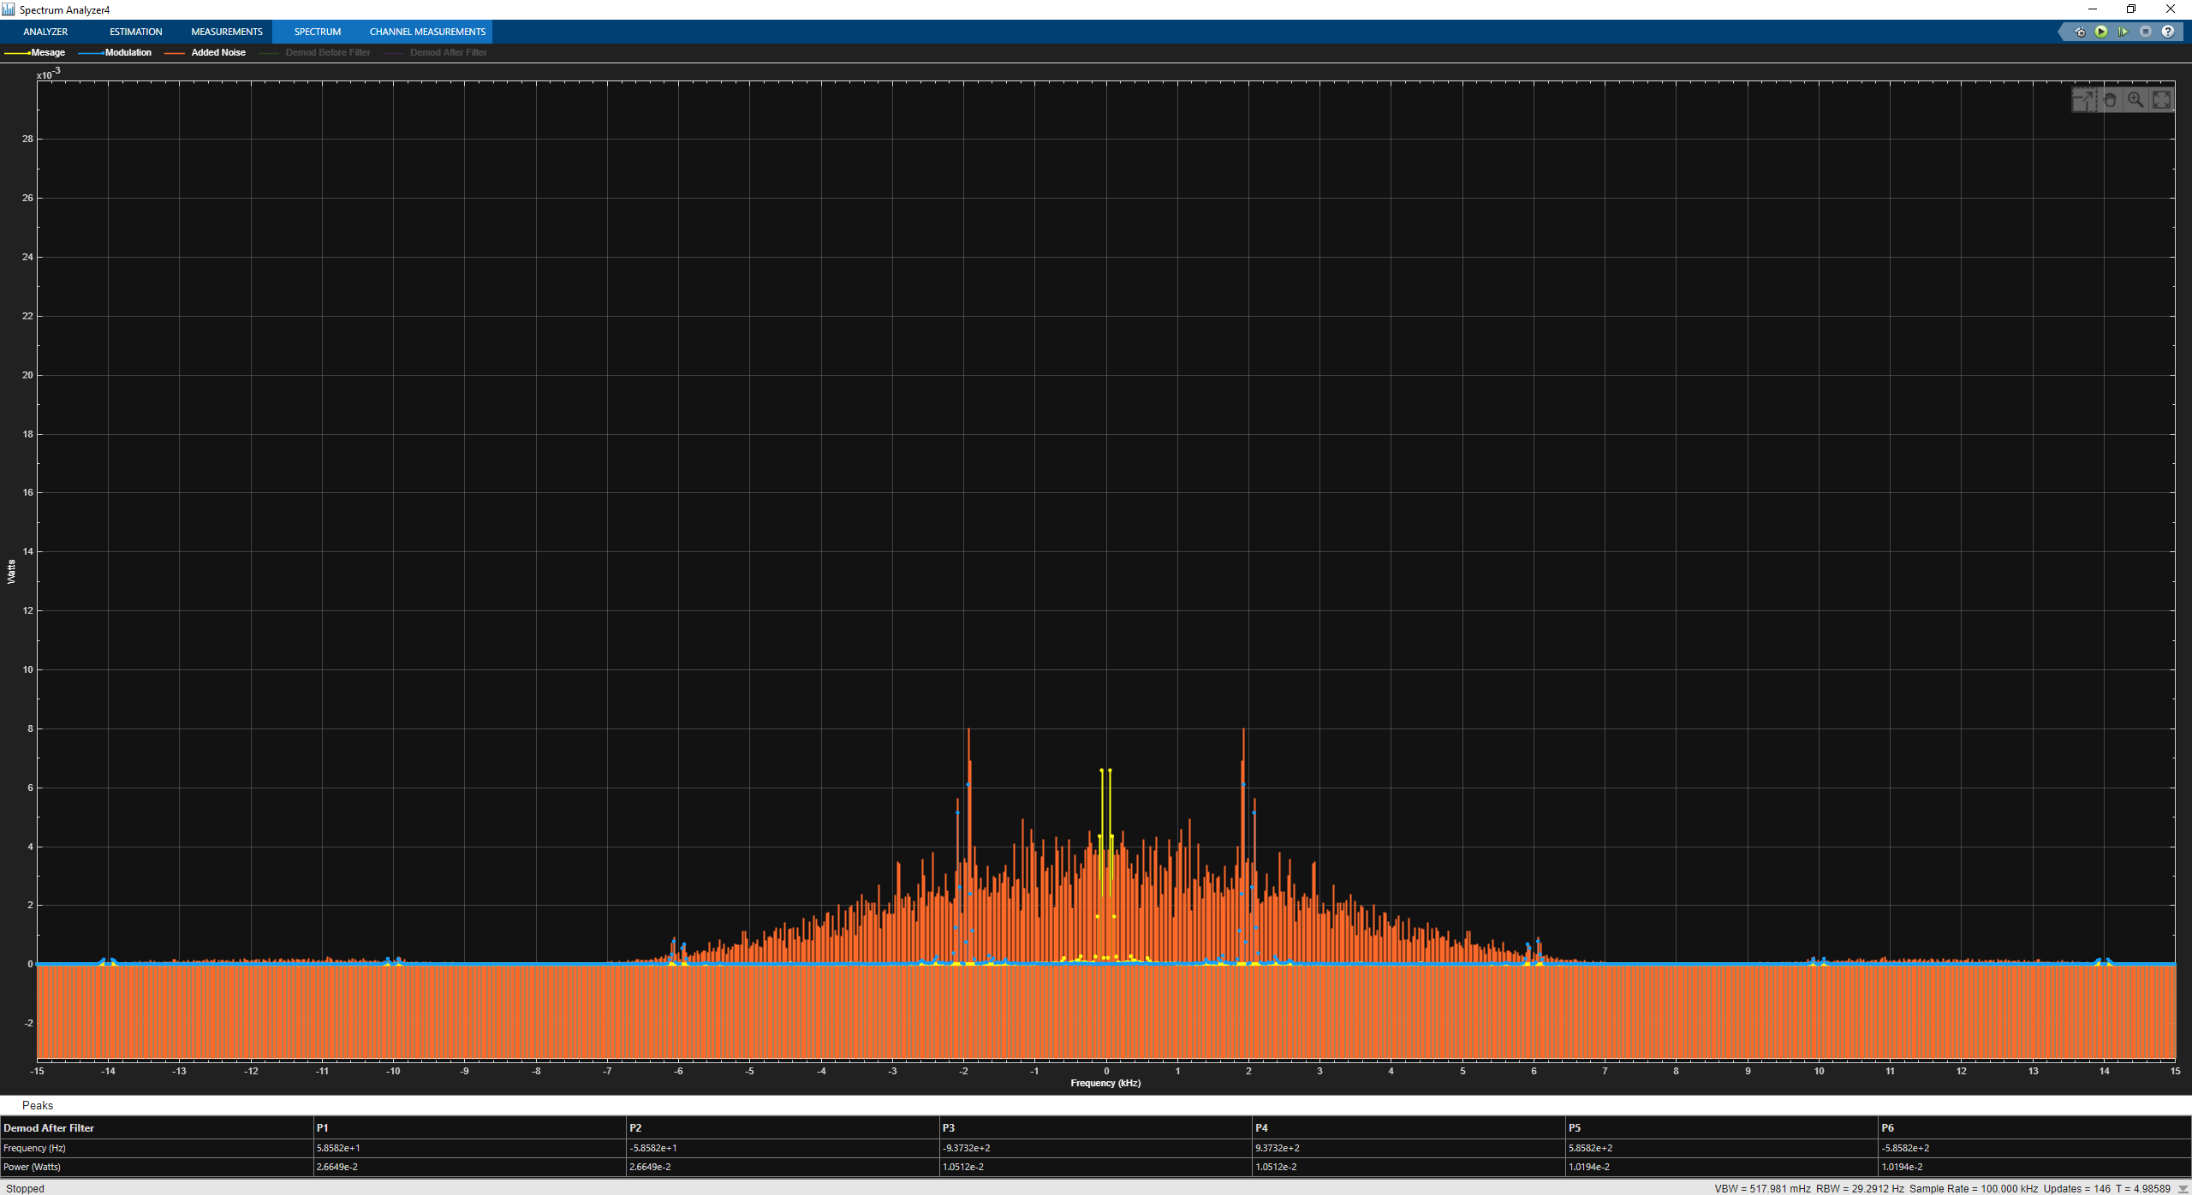
Figure 25
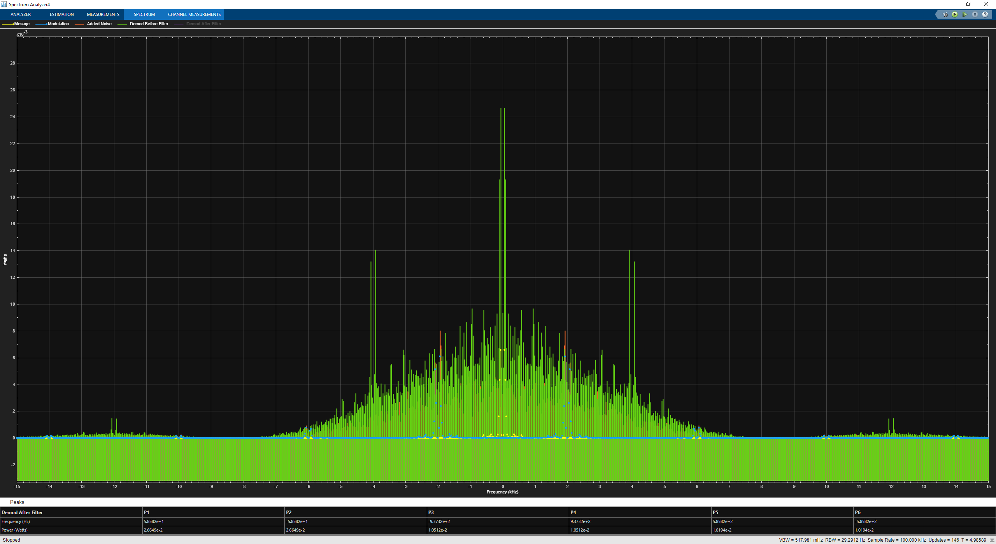
Figure 26
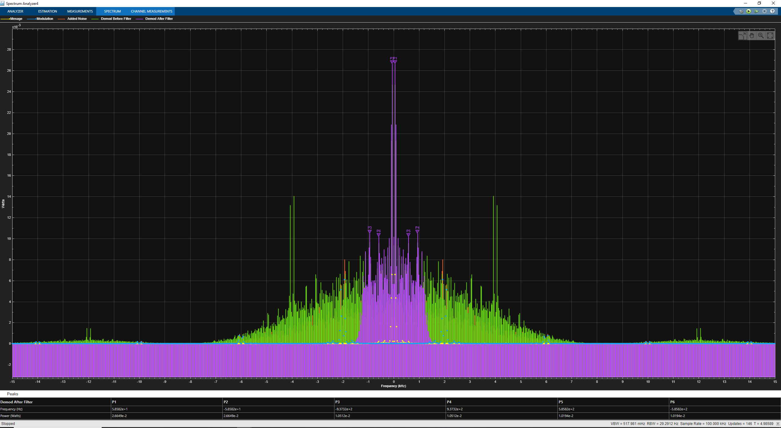
Figure 27

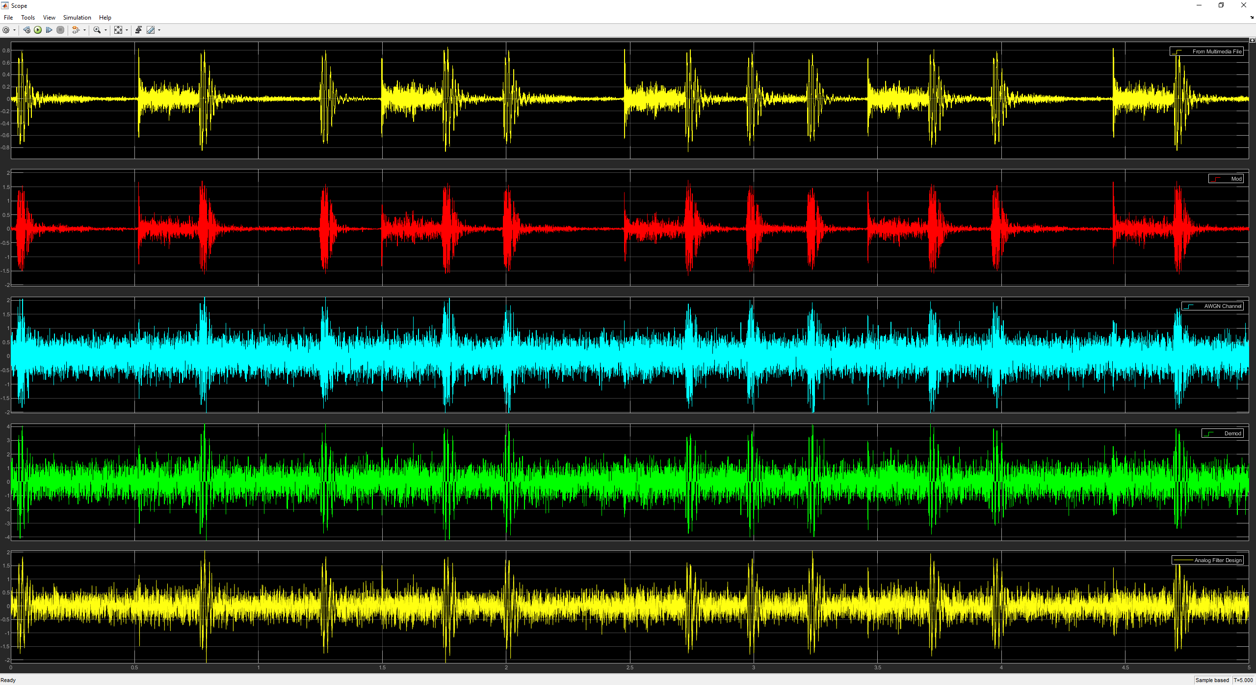
Figure 28
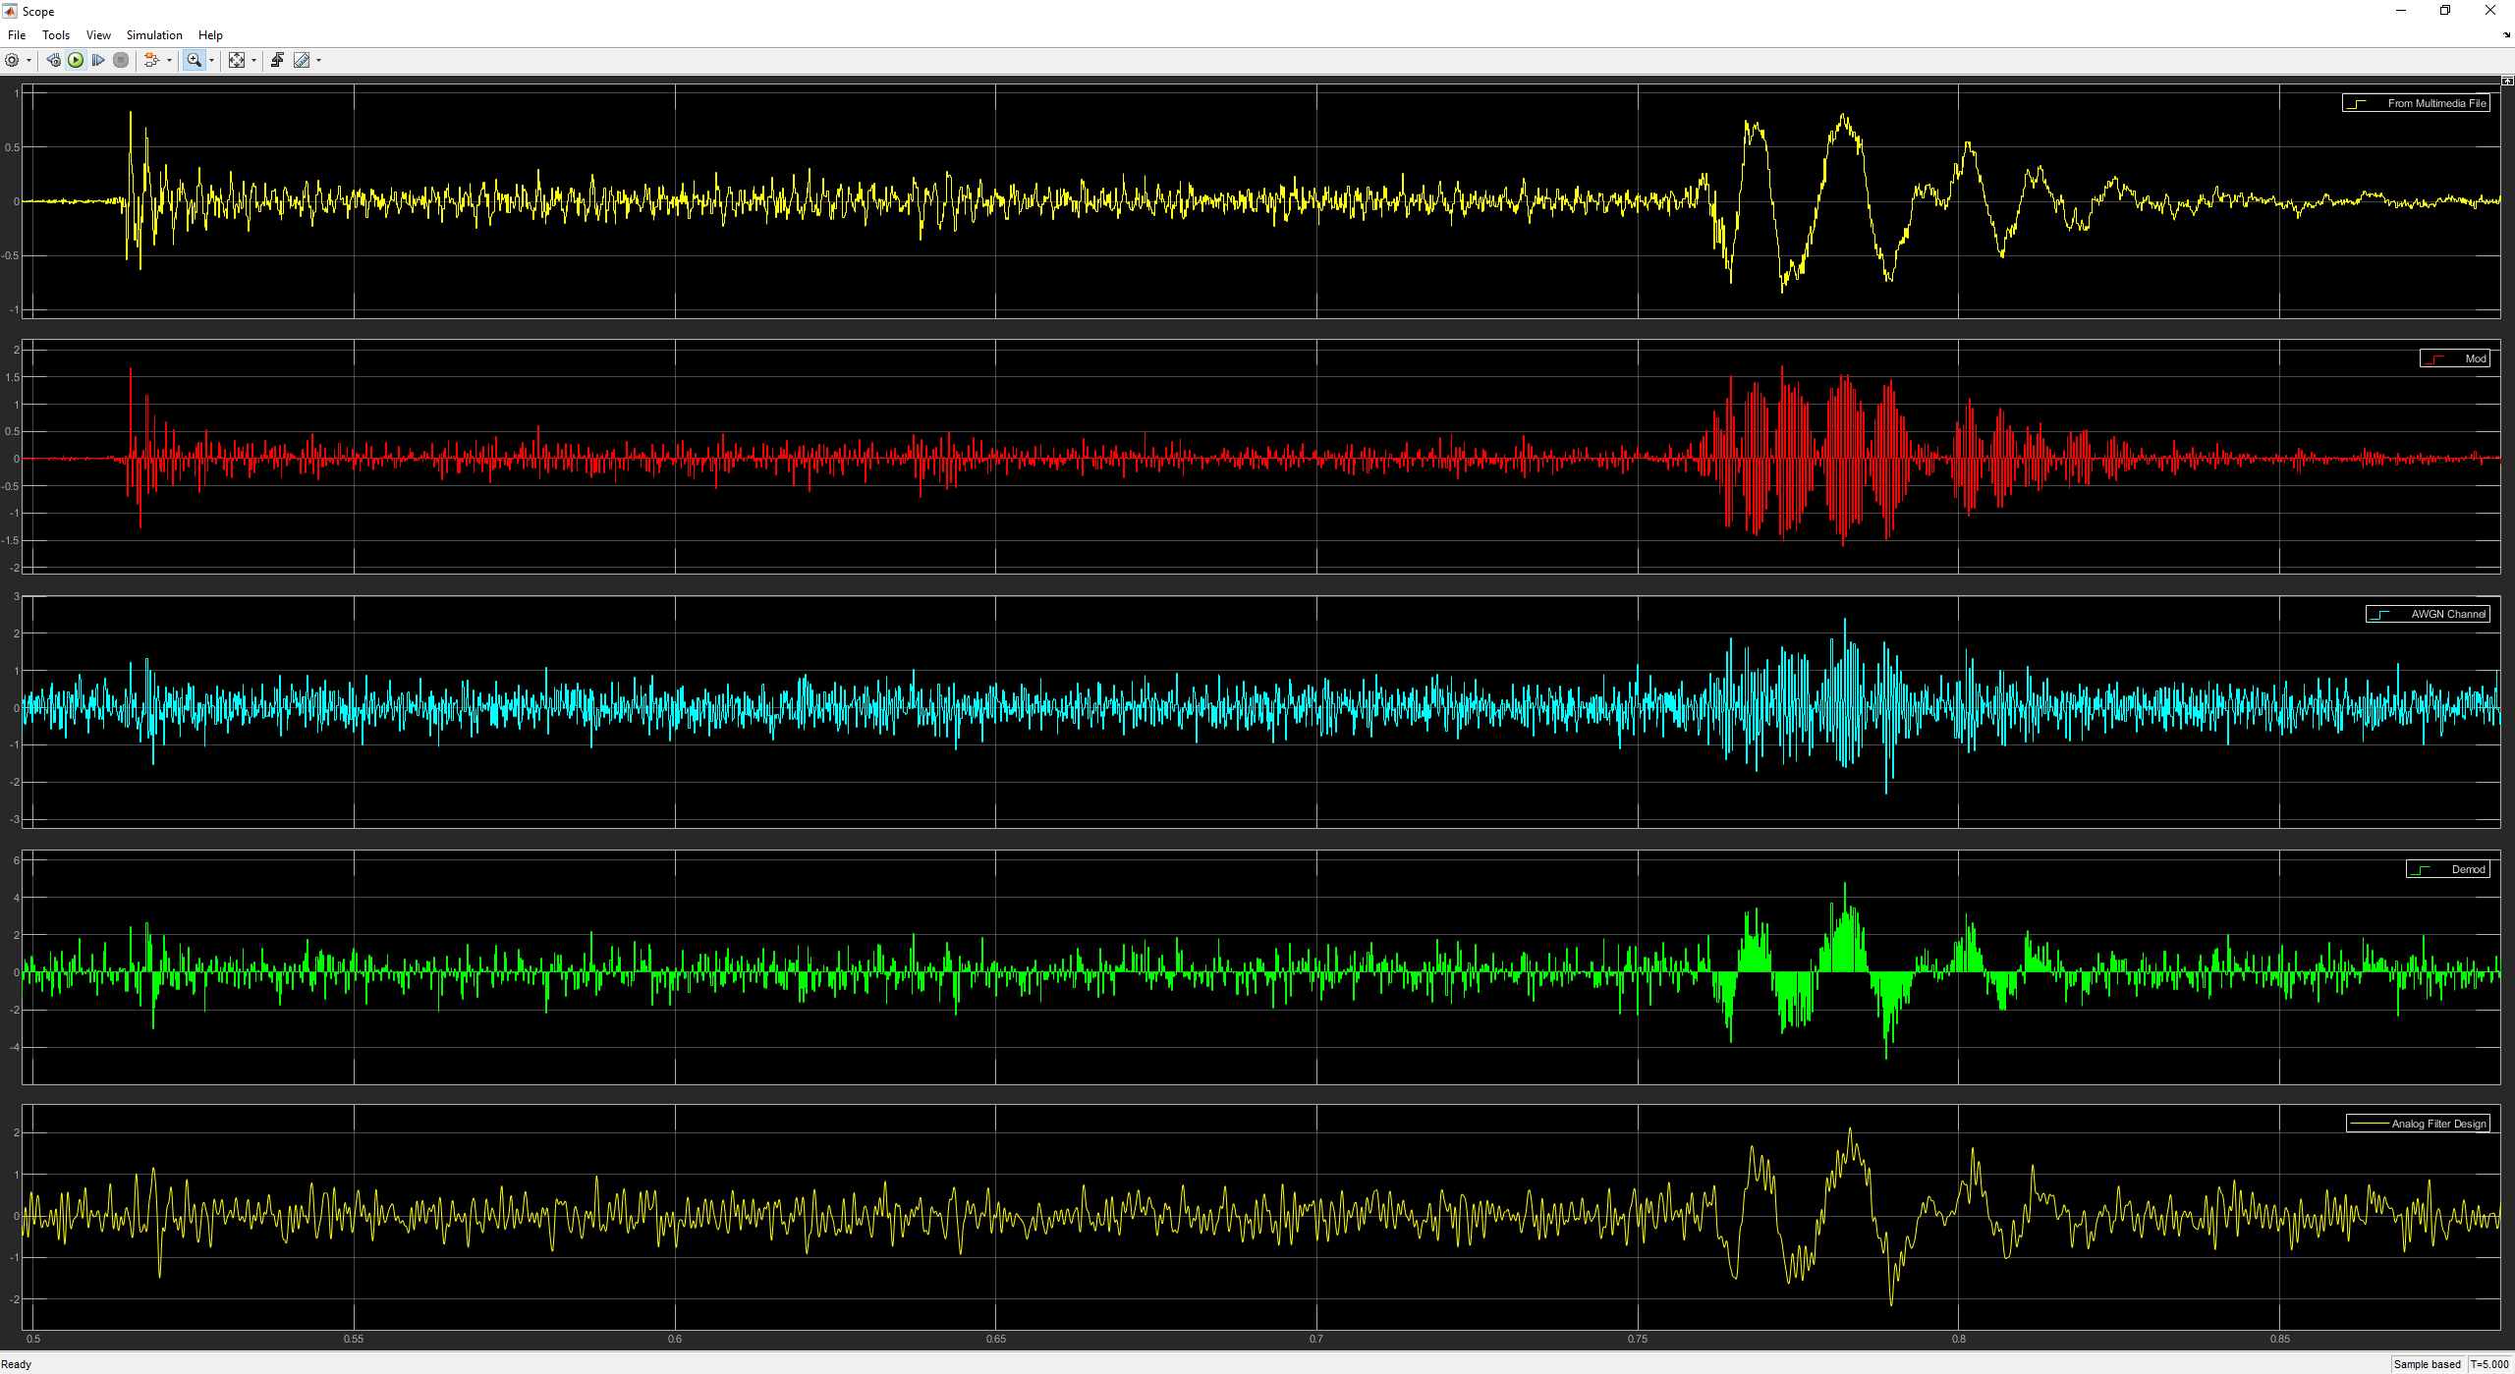
Figure 29
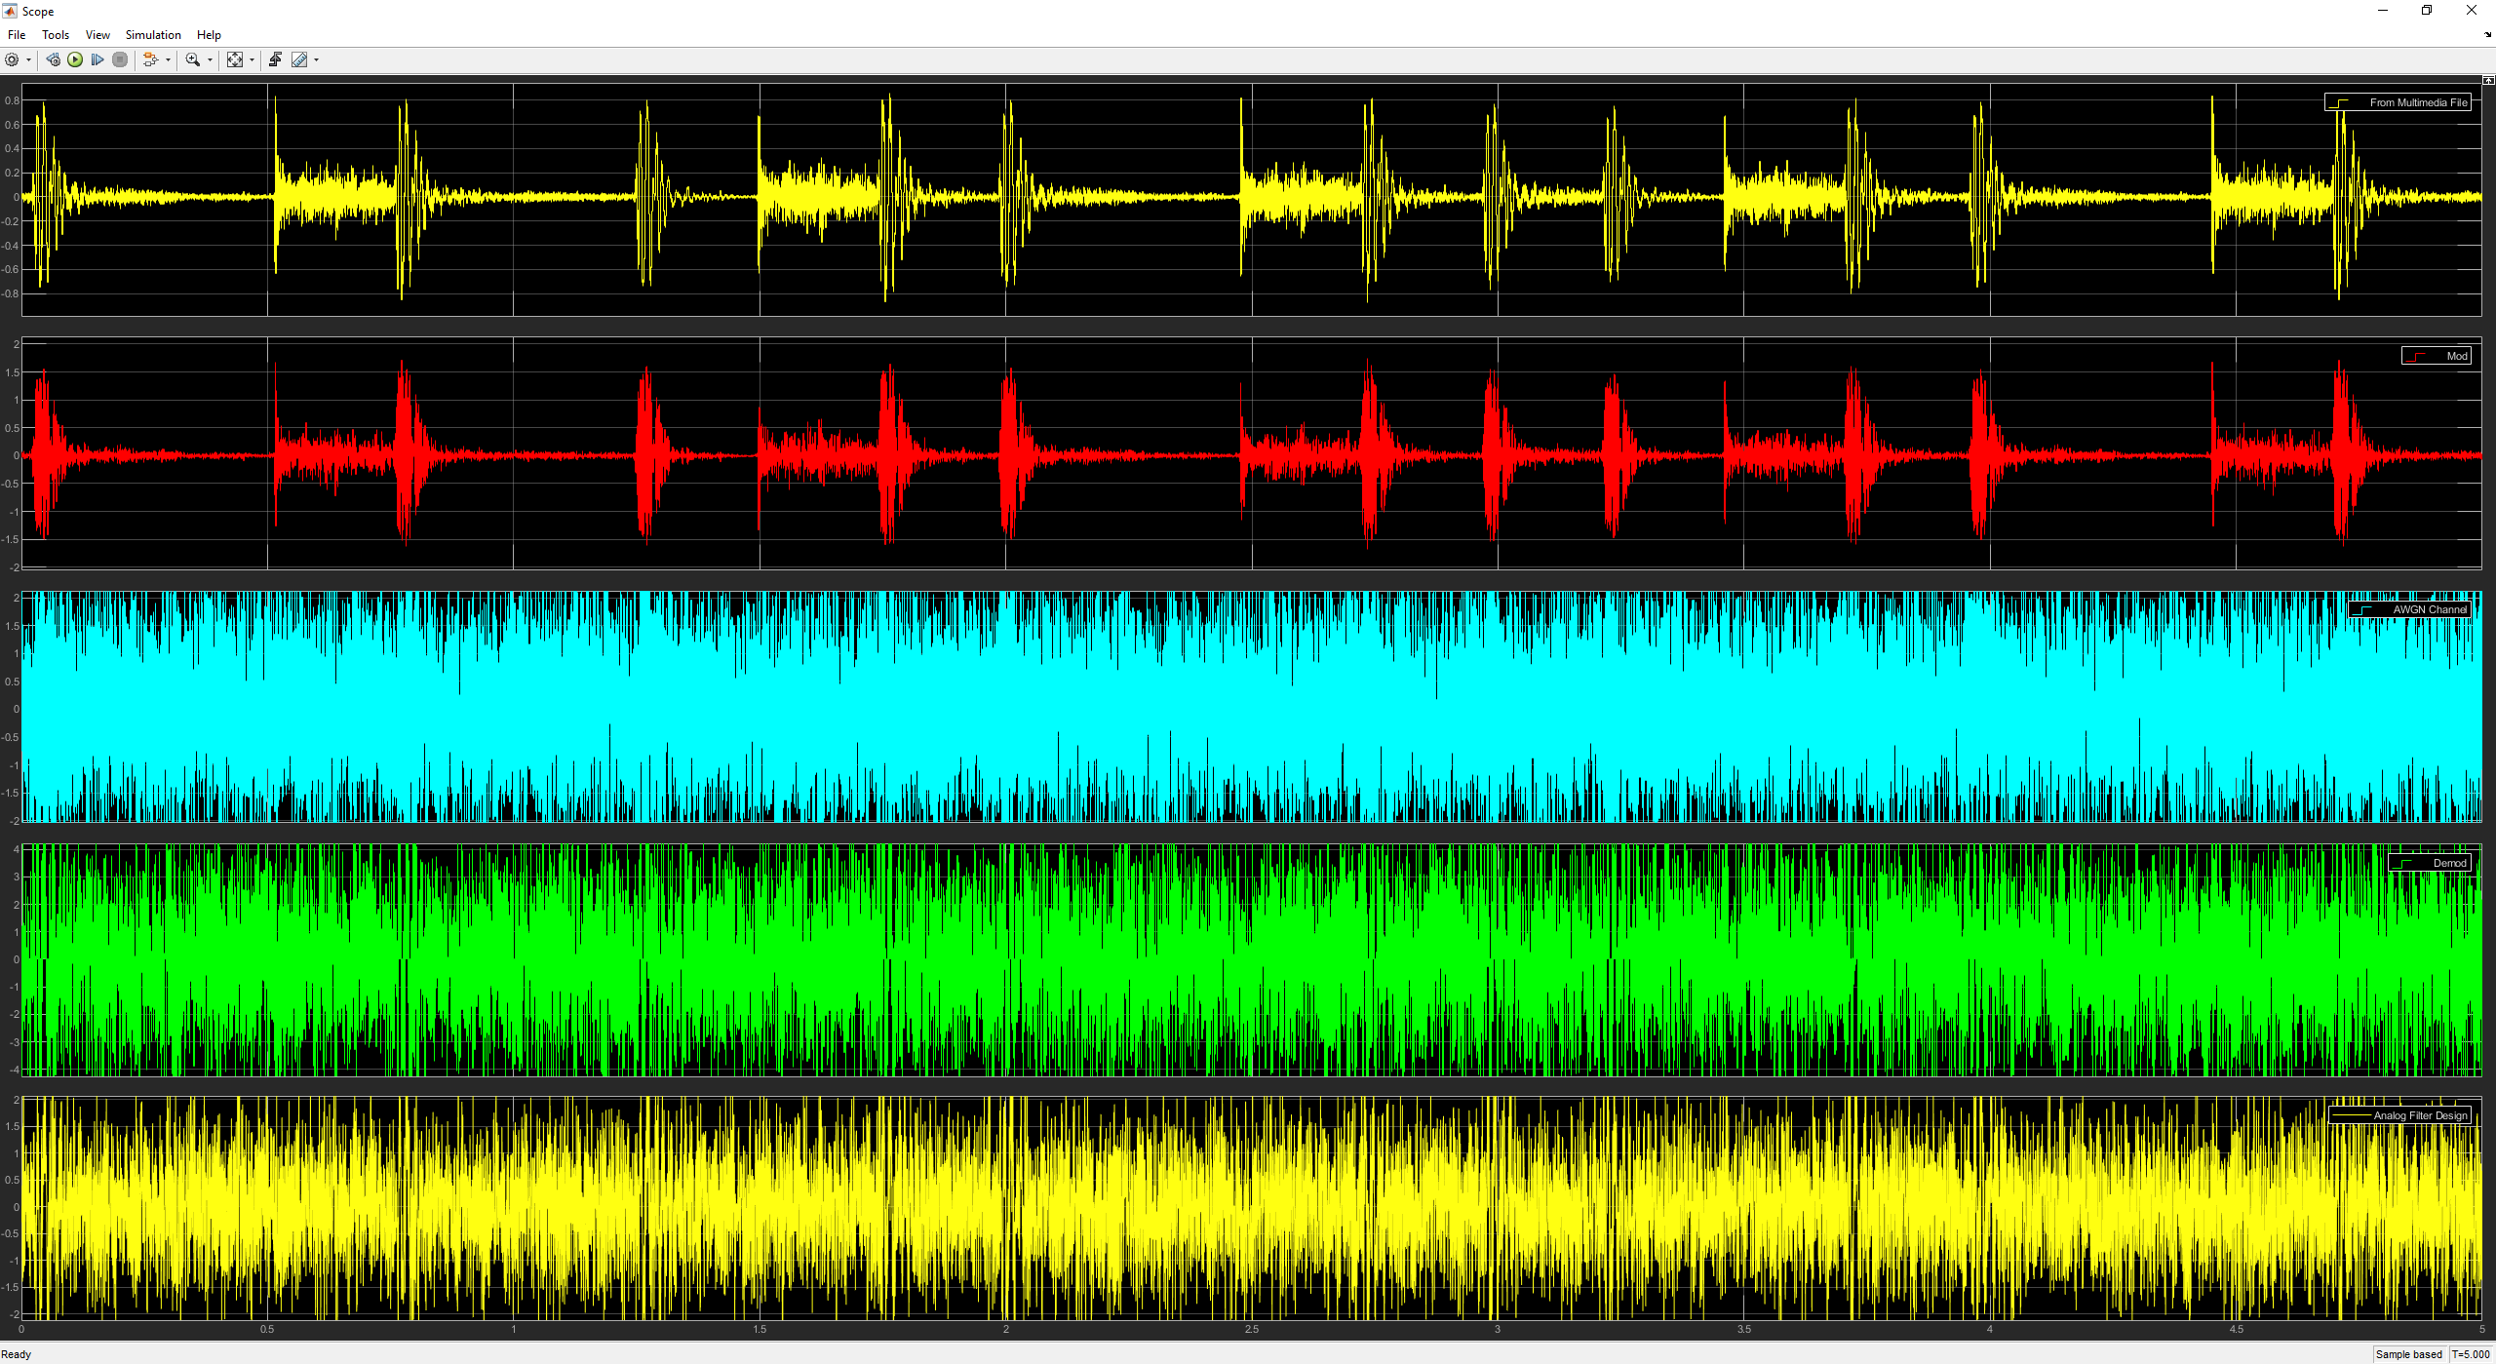
Figure 30

Task 3 – Investigating Frequency Modulation

Using the Simulink models in figure 4 and 5 to investigate FM, with a sine wave and multimedia as the message signal, using the following equations to create the model:
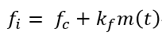
Equation 6 [5]
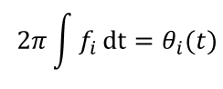
Equation 7 [5]
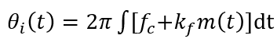
Equation 8 [5]
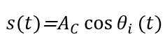
Equation 9 [5]
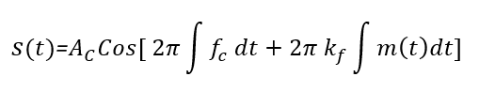
Equation 10 [5]
The first simulation will use a 10 Hz sine wave and the carrier frequency of 100 Hz.
The second simulation will use an audio clip as the message and therefore the carrier signal will be 10,000 Hz and the message signal will be 8000 Hz both will have the same phase of 0.
This method of FM is designed to change the frequency of the modulated wave when the message signal reaches its peaks.

Sine Wave

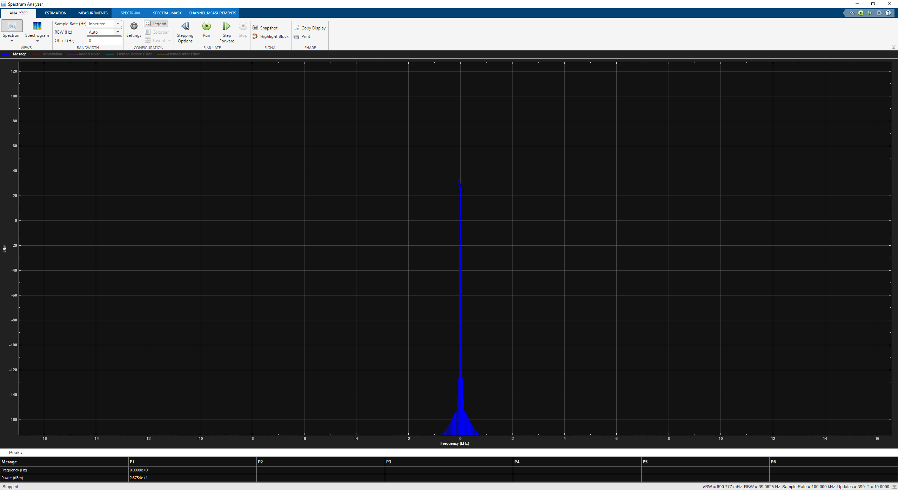
Figure 31
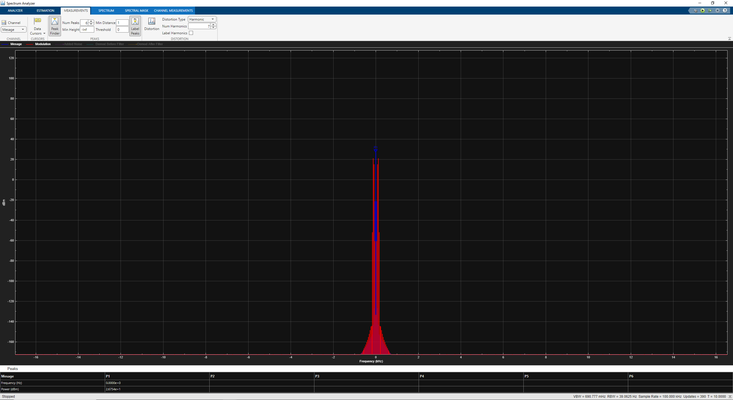
Figure 32
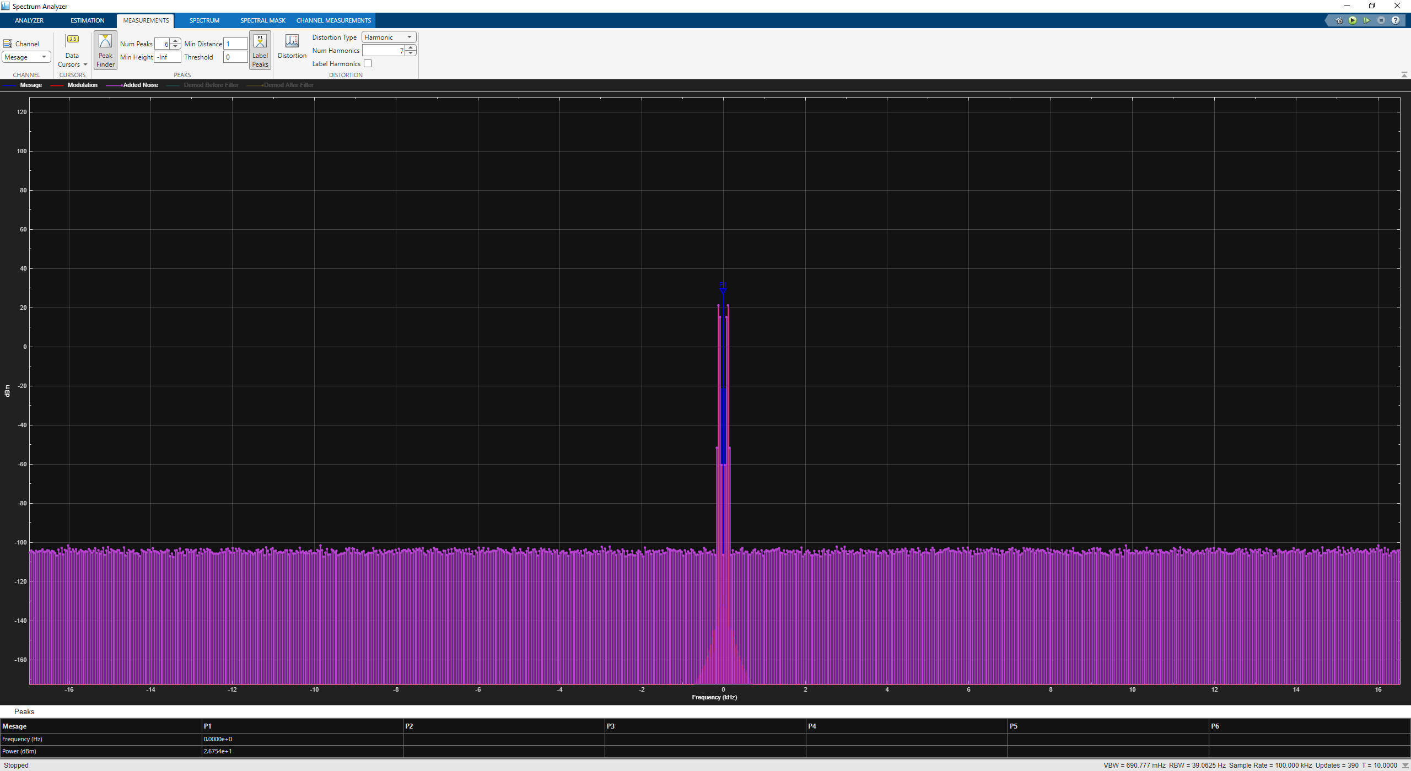
Figure 33
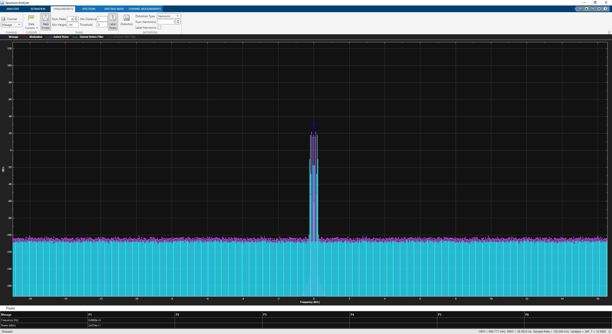
Figure 34
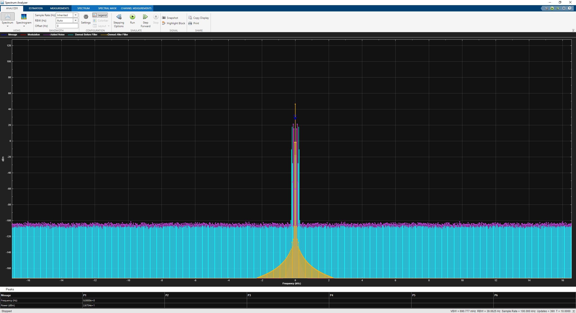
Figure 35
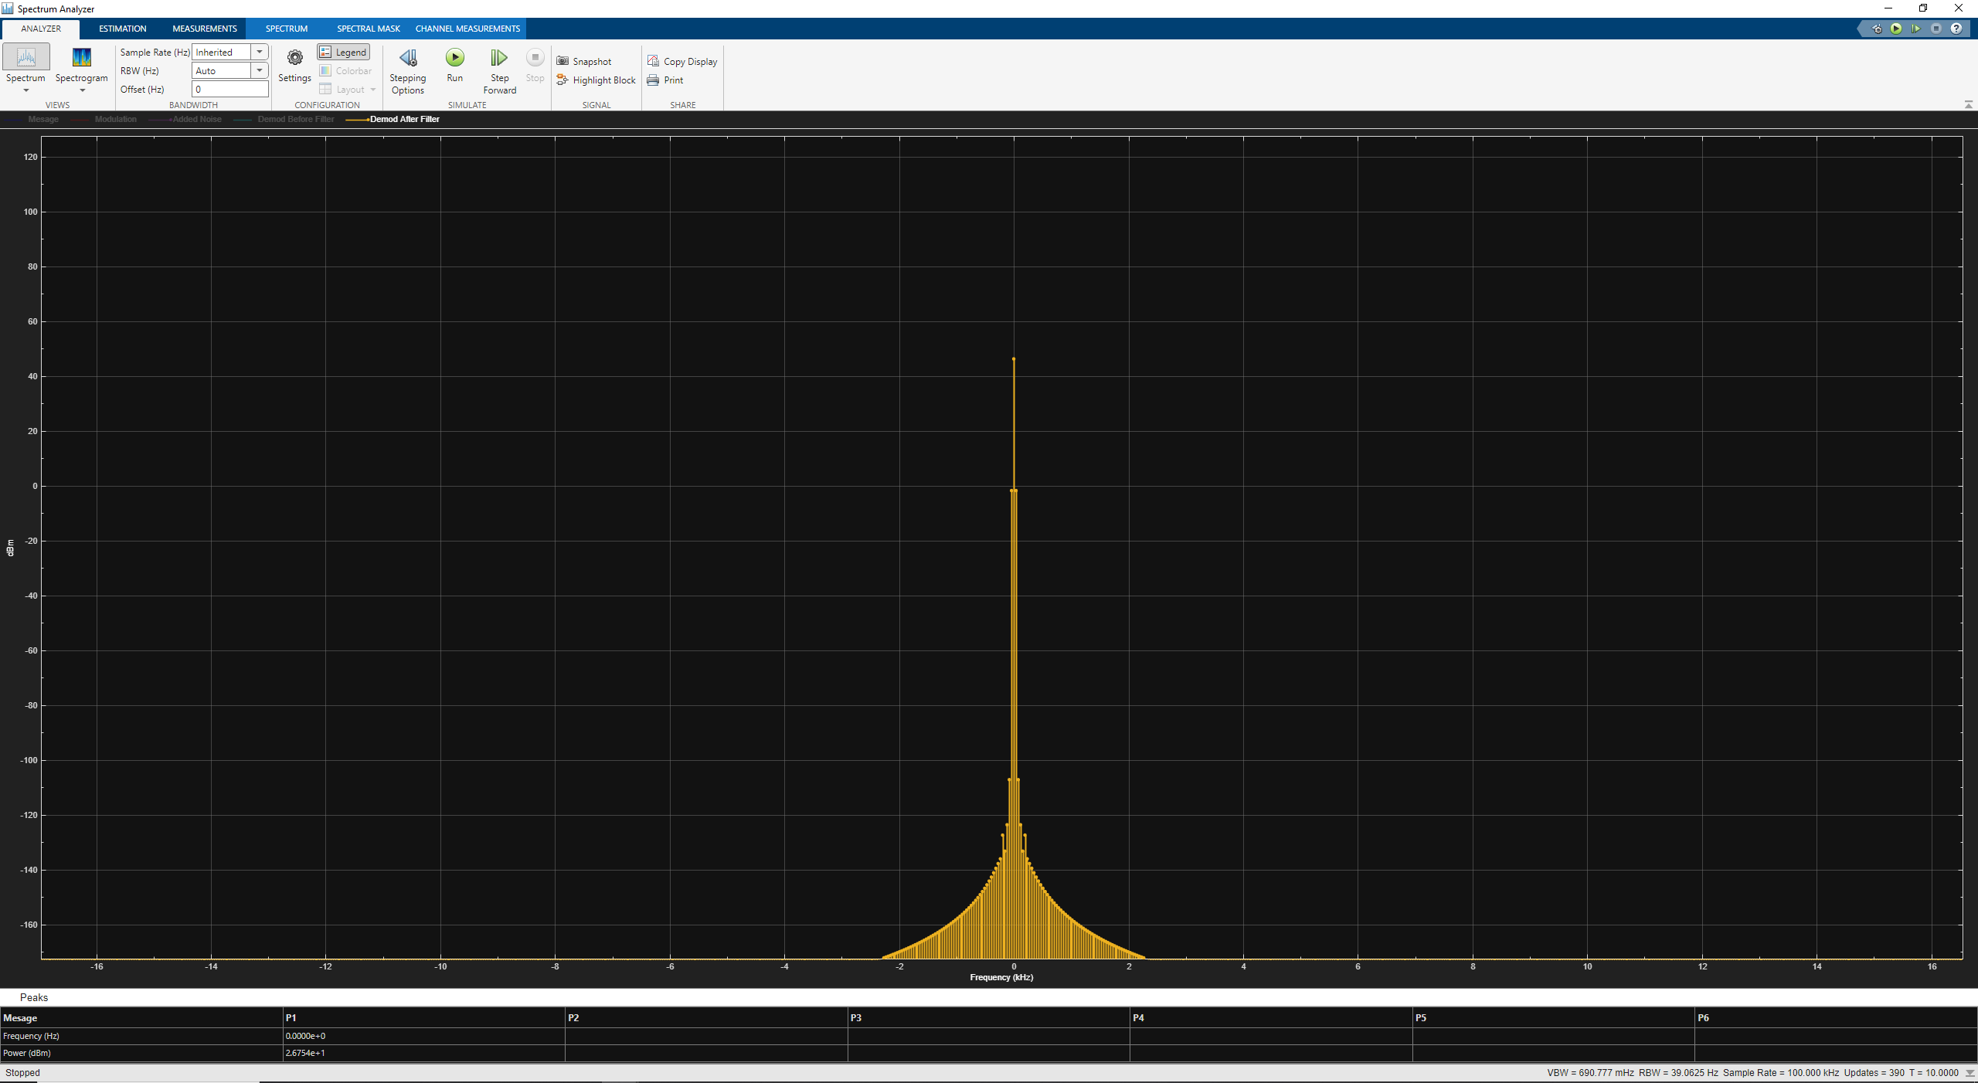
Figure 36
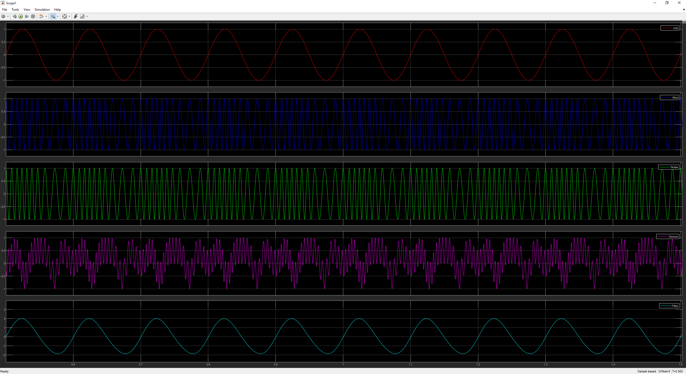
Figure 37

Multimedia Audio File

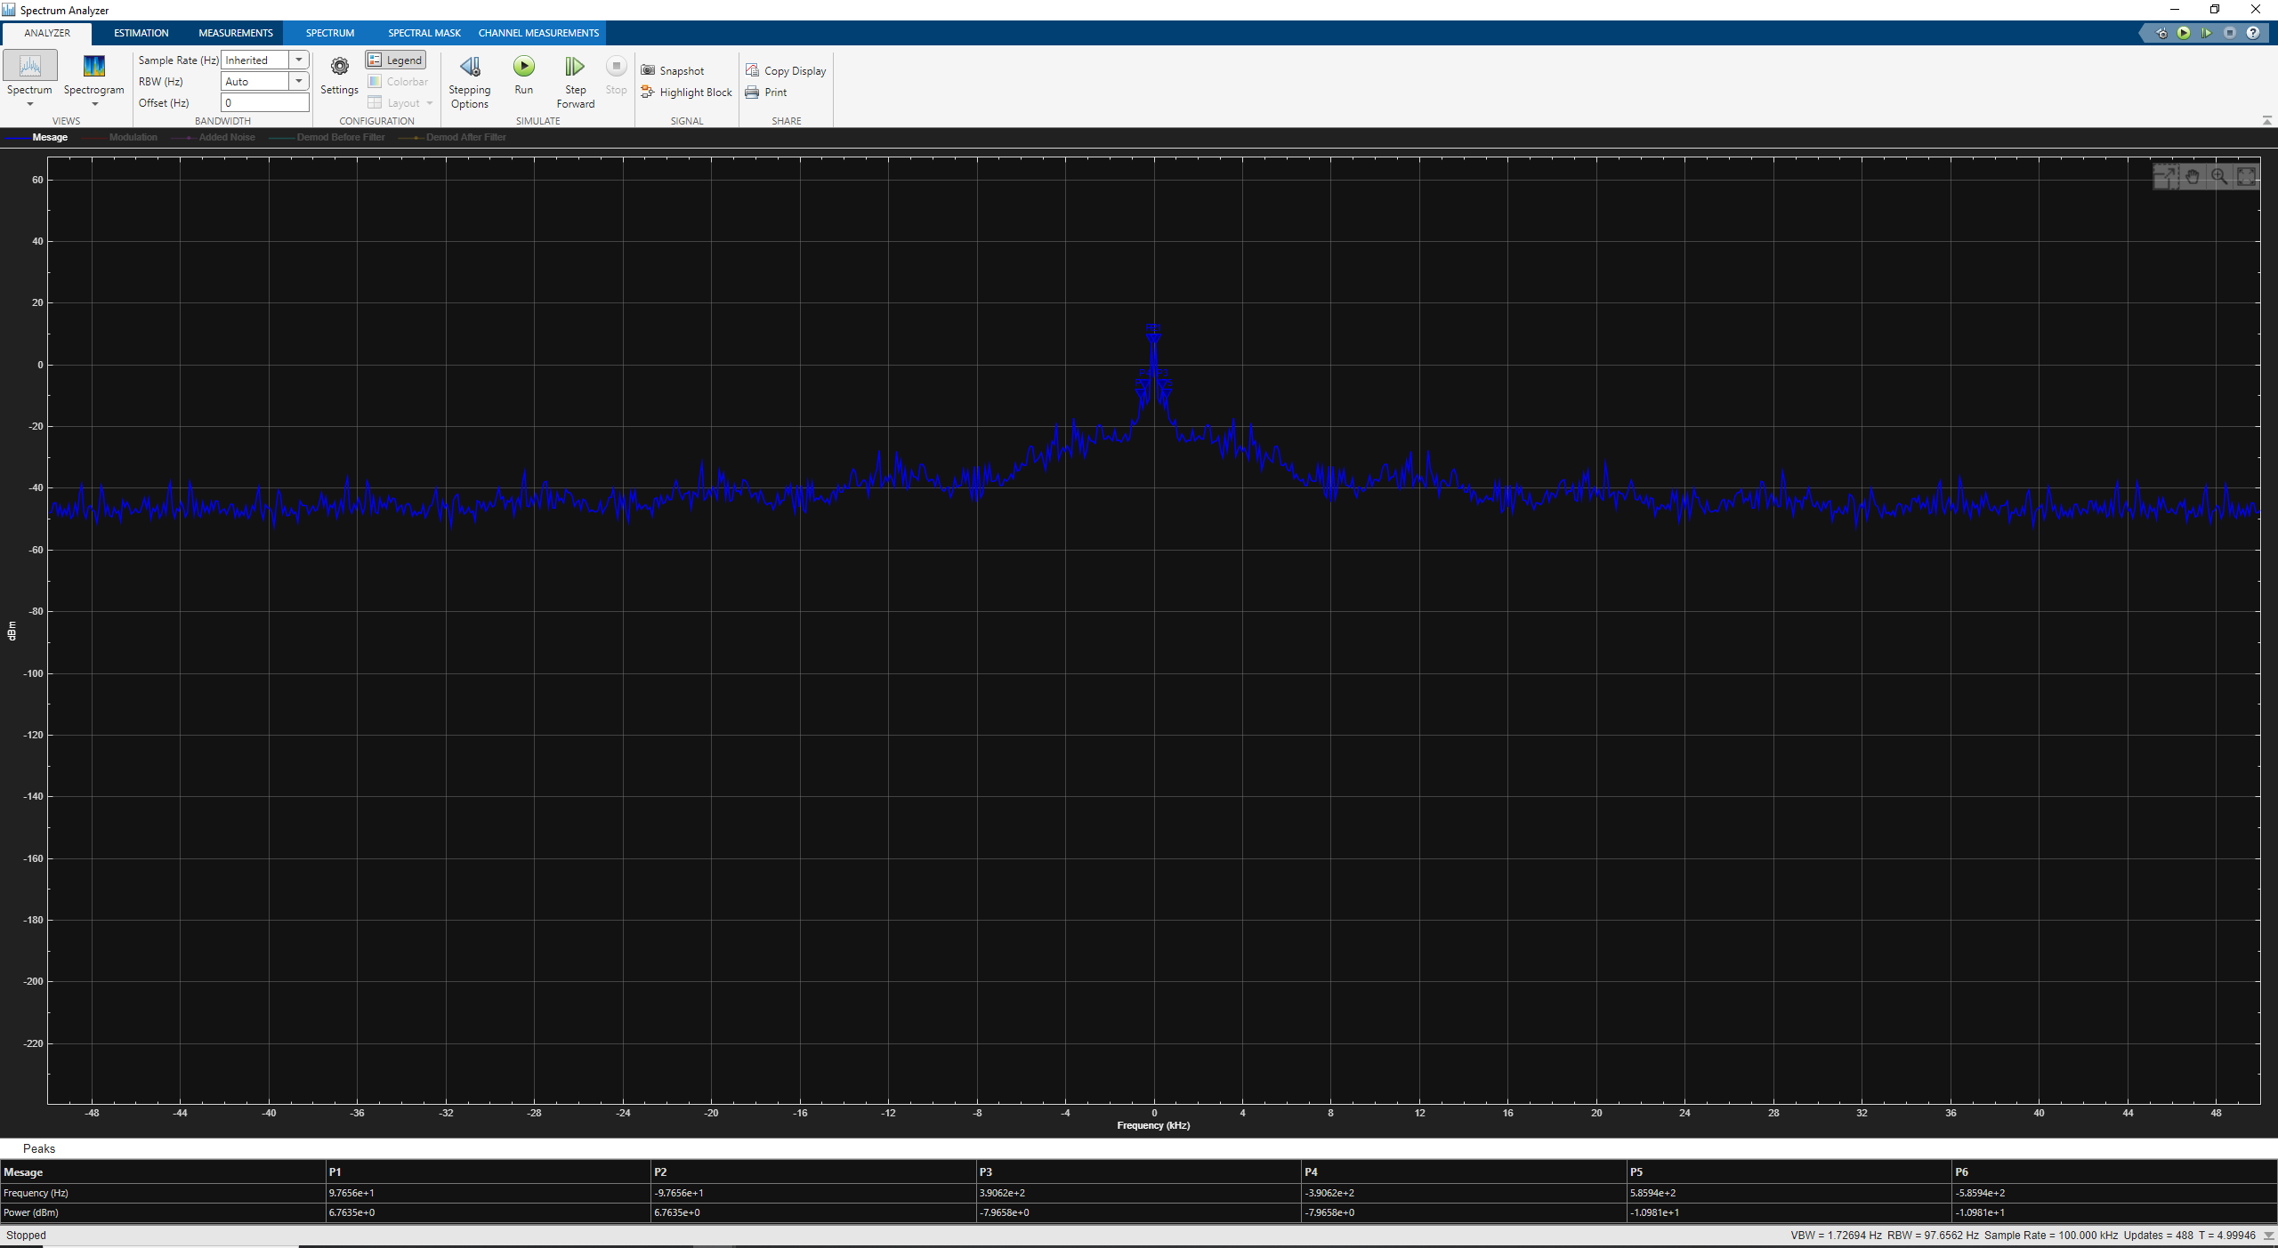
Figure 38
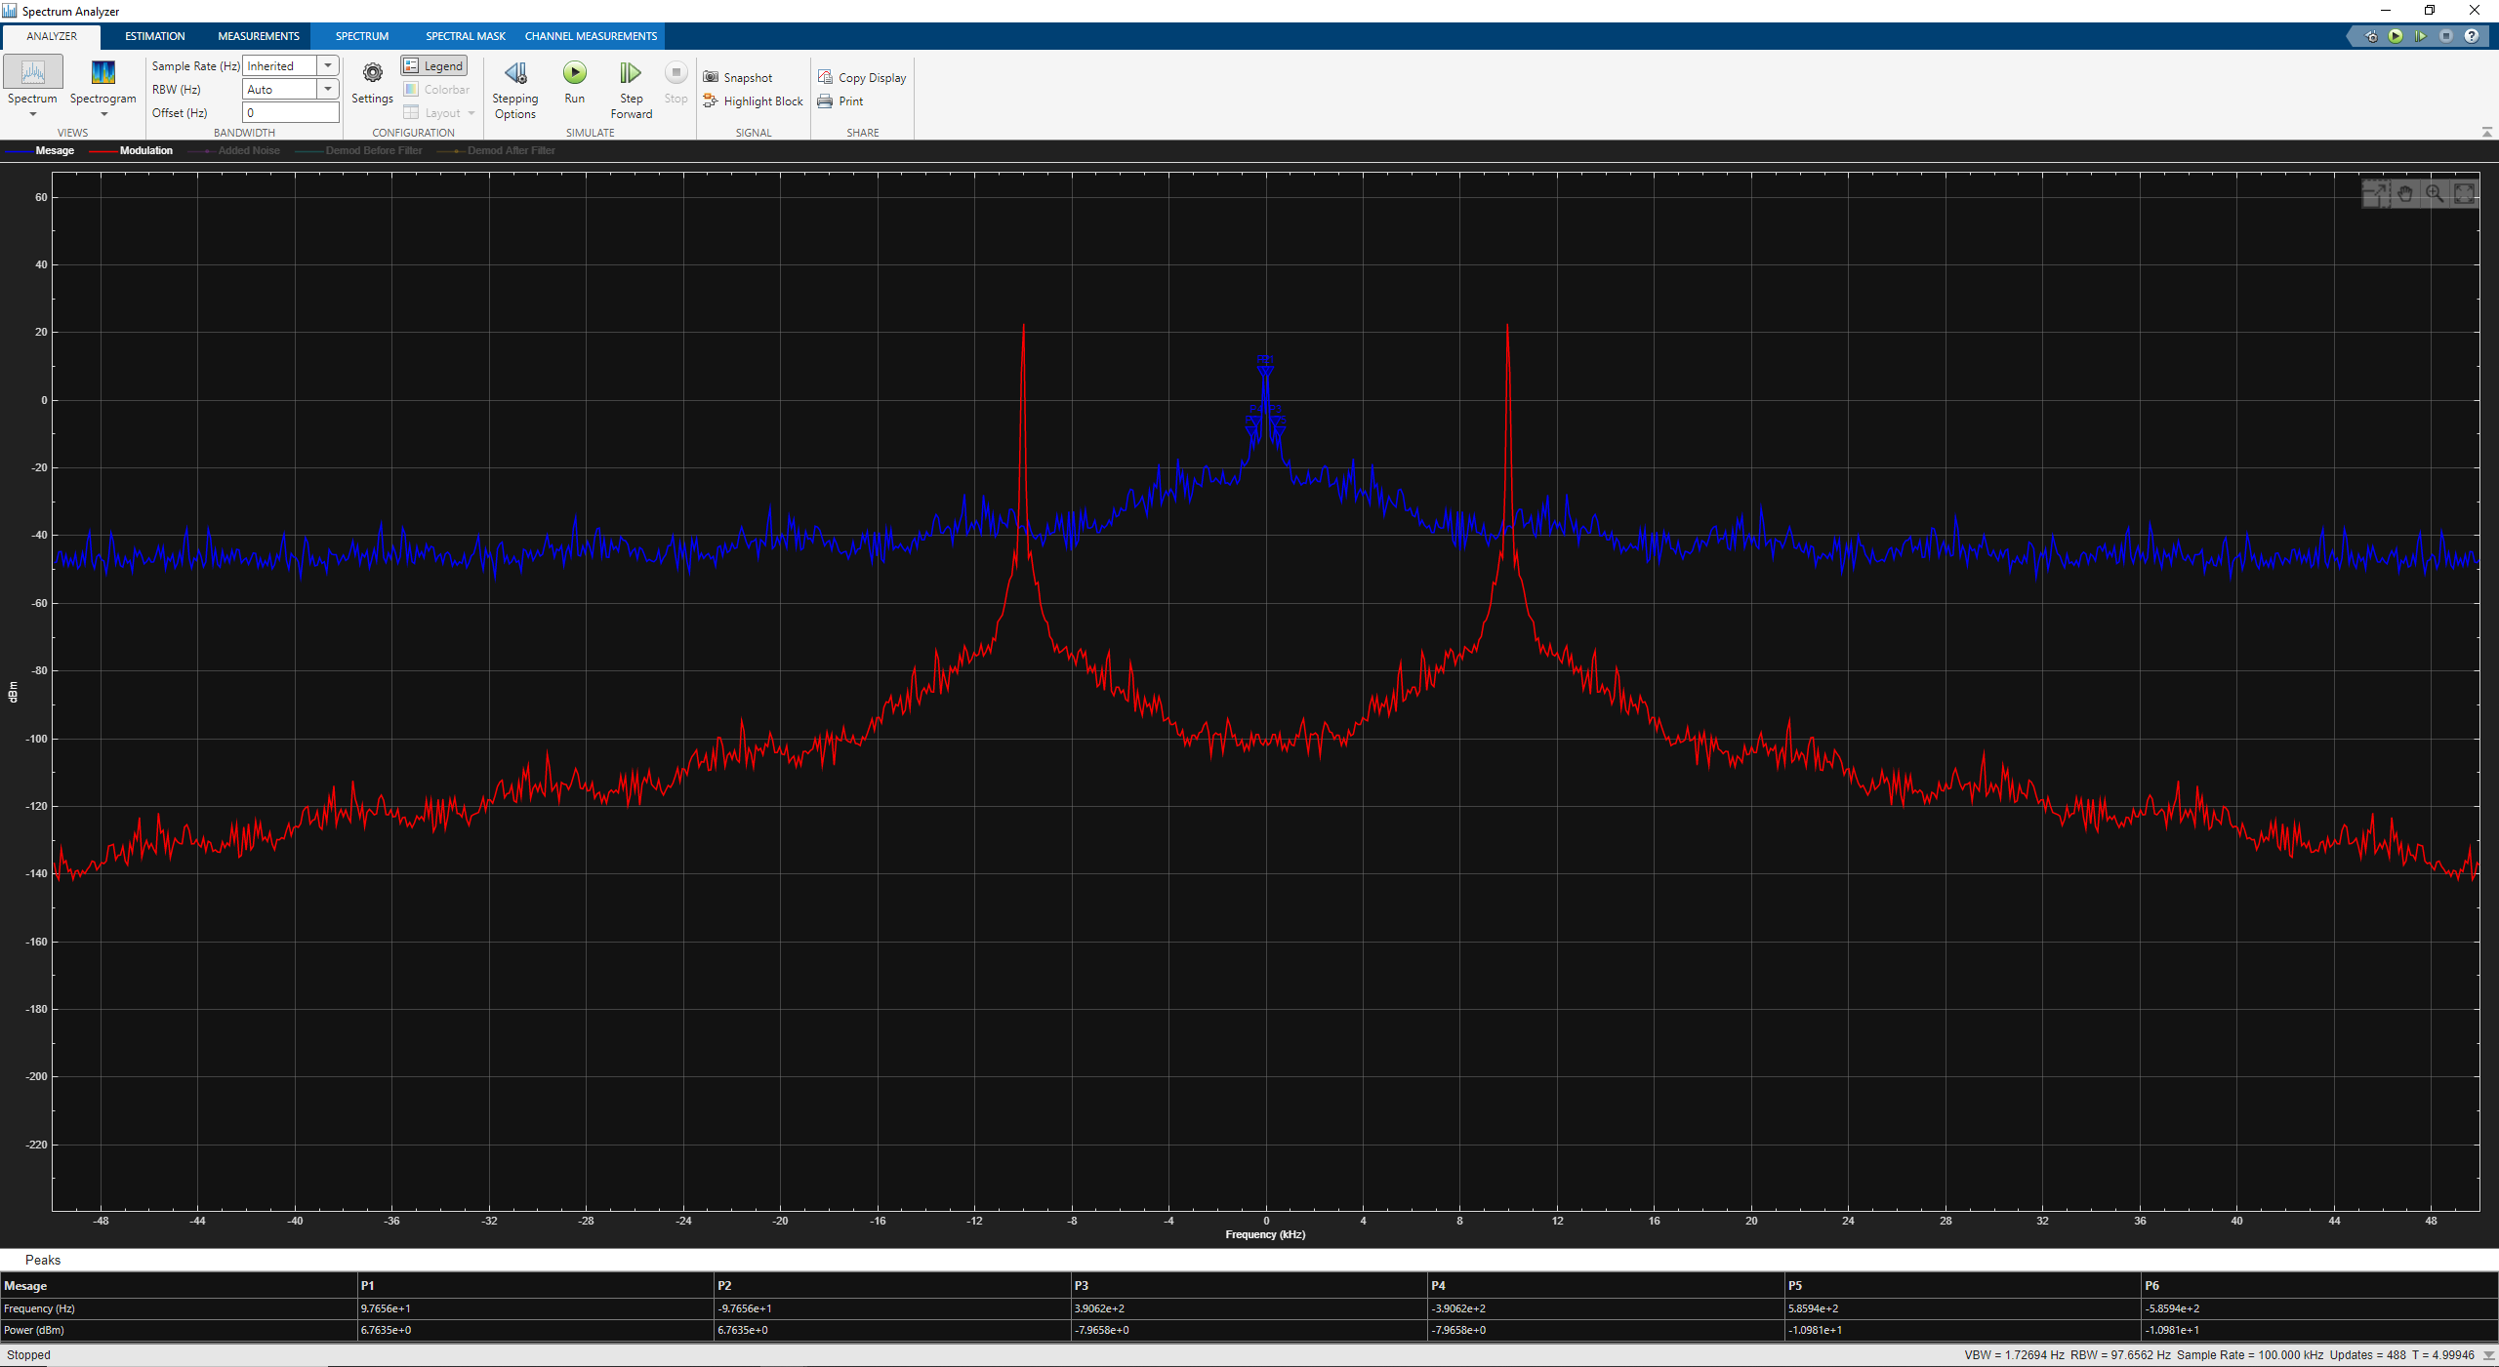
Figure 39
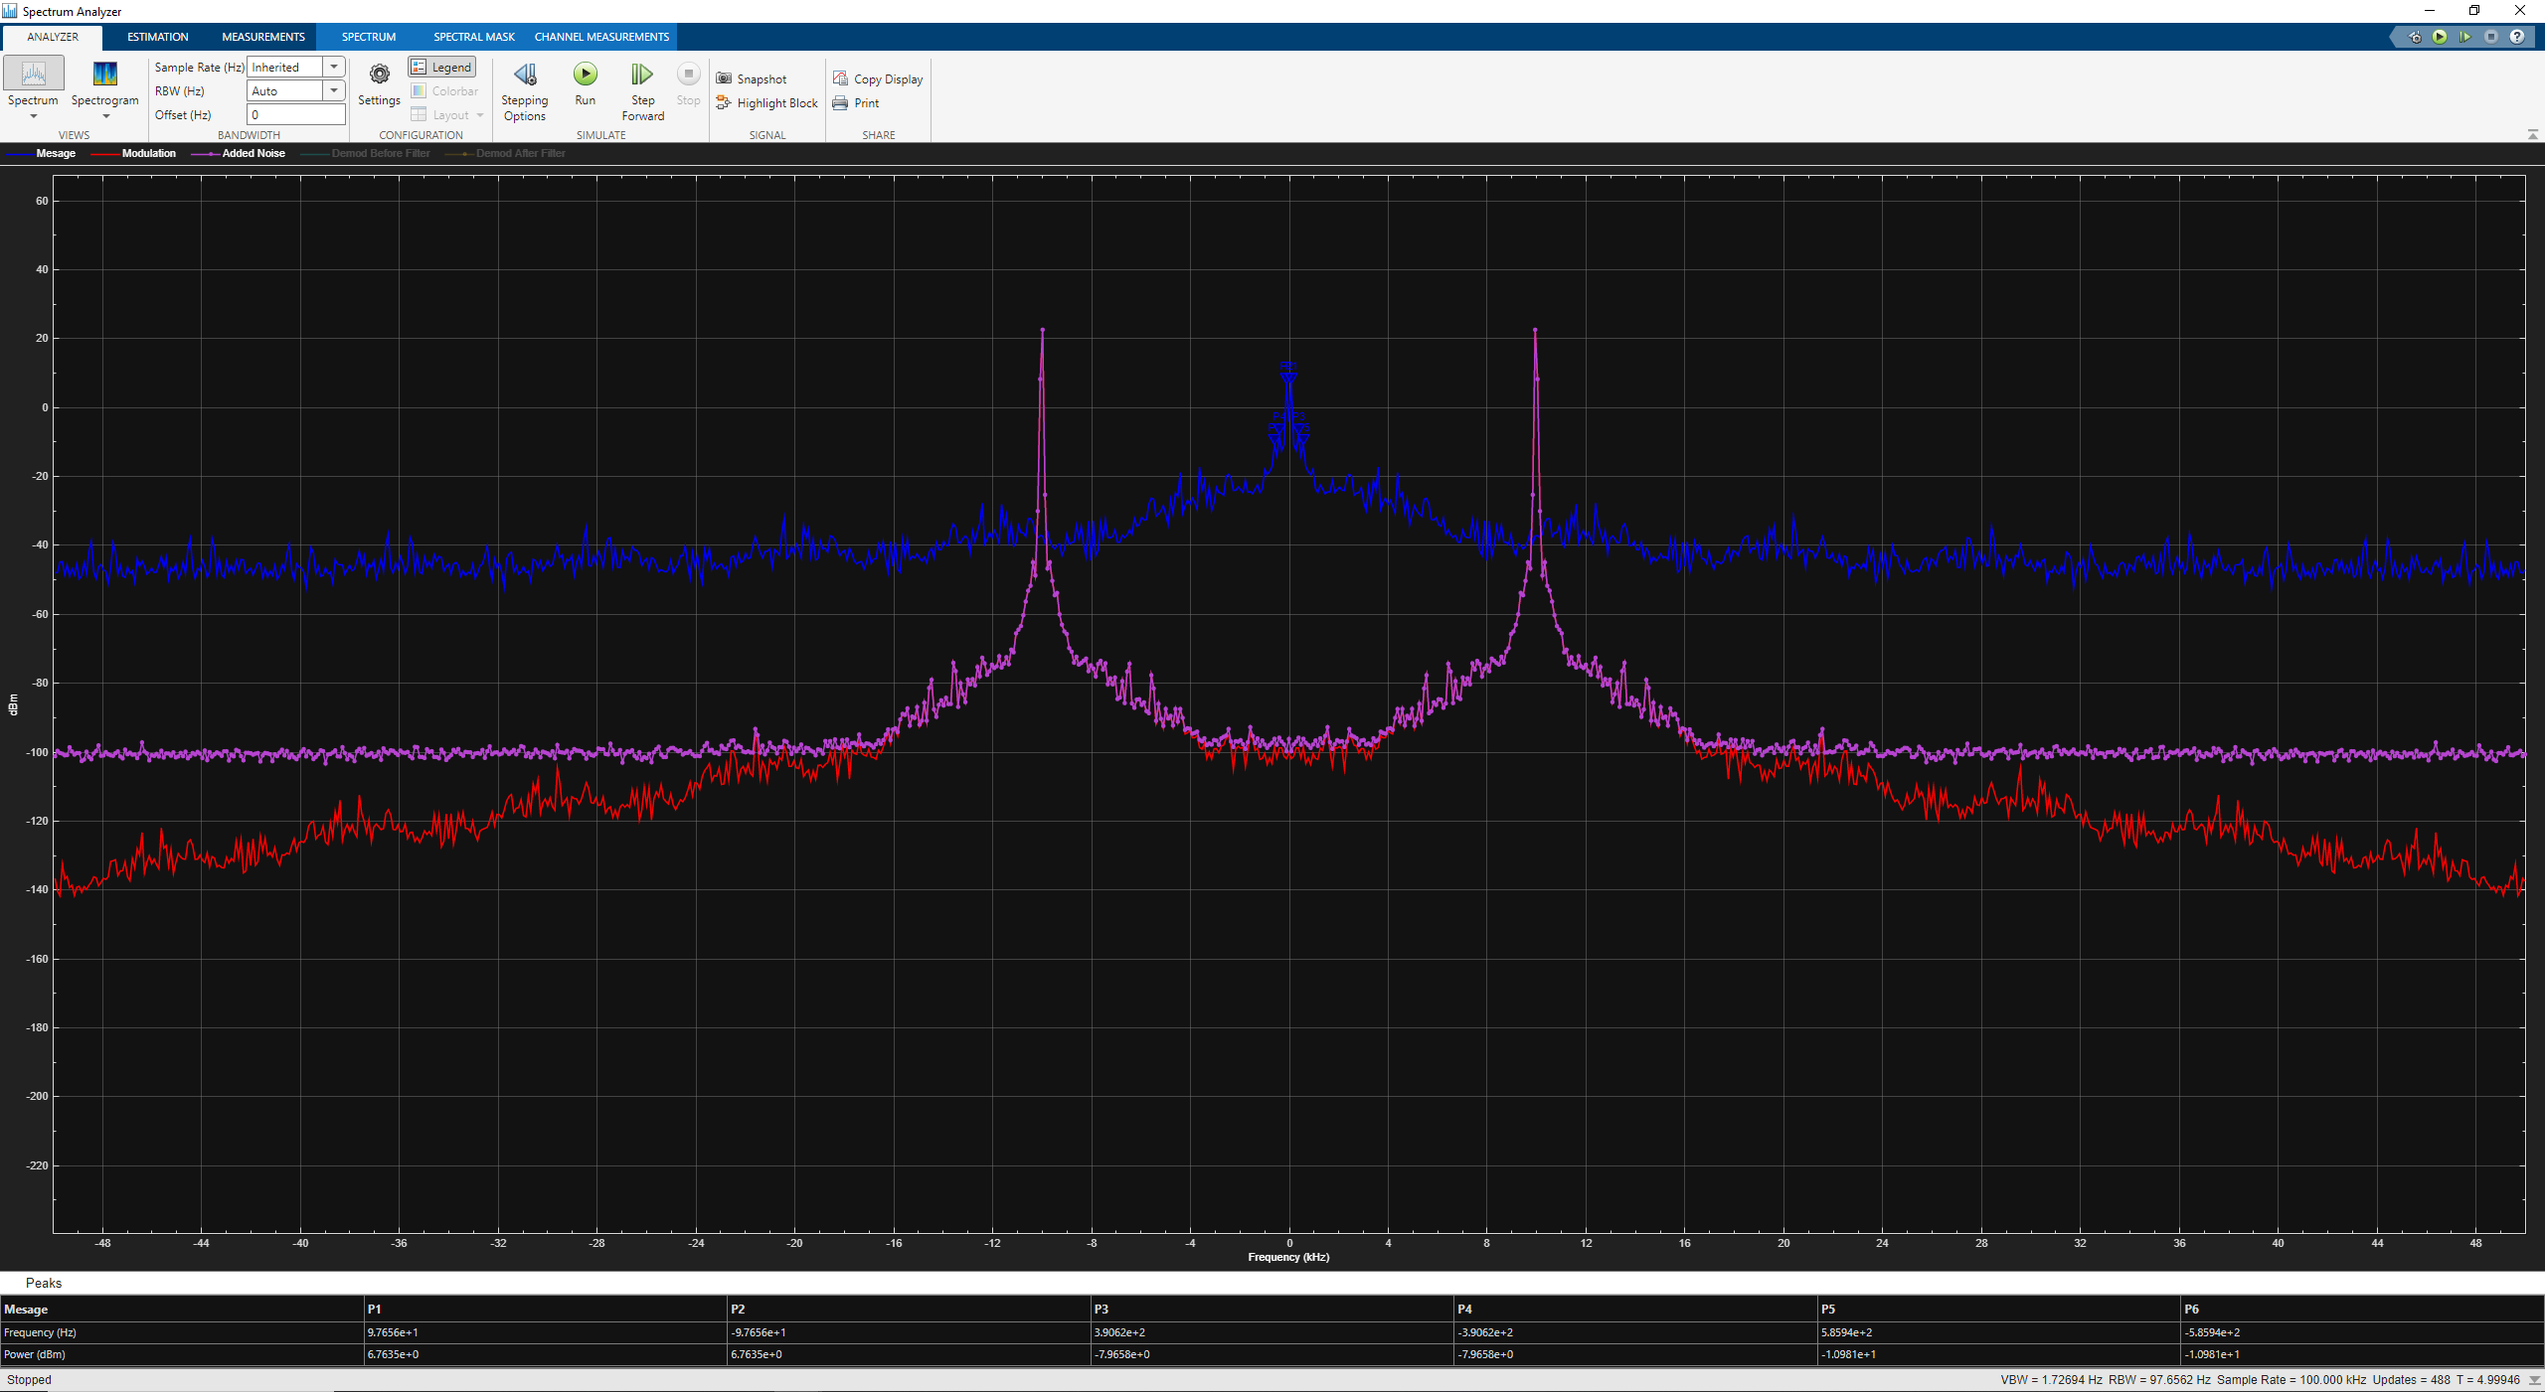
Figure 40

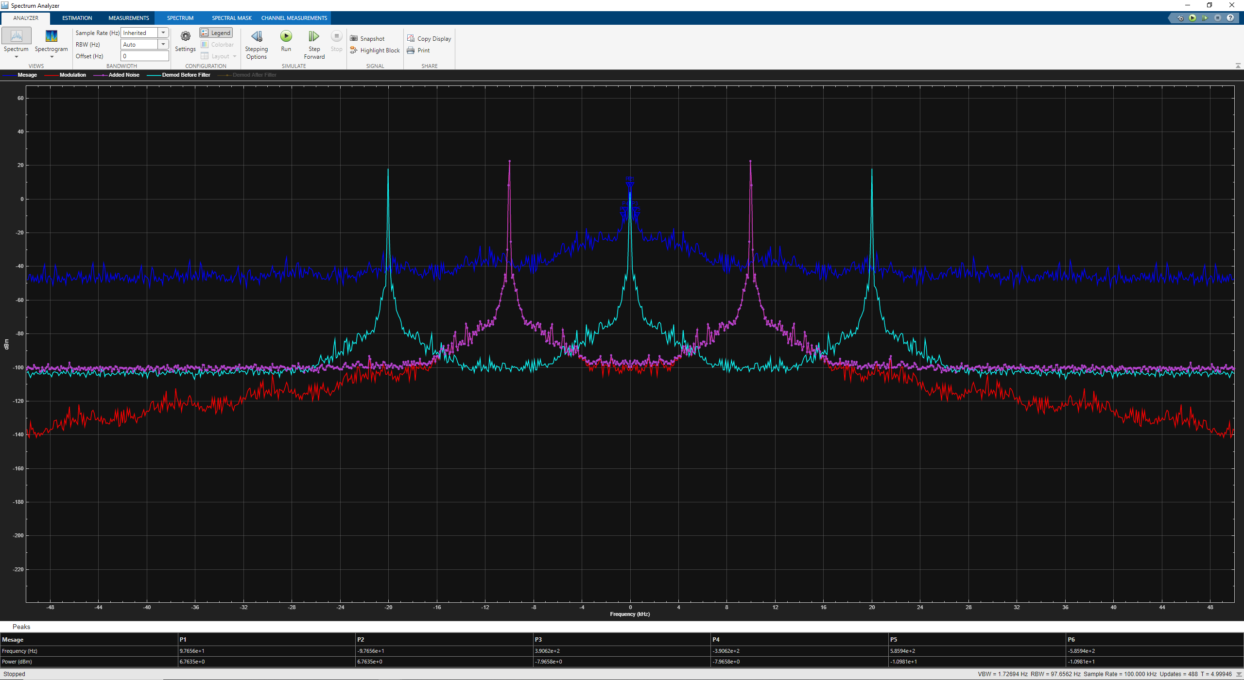
Figure 41
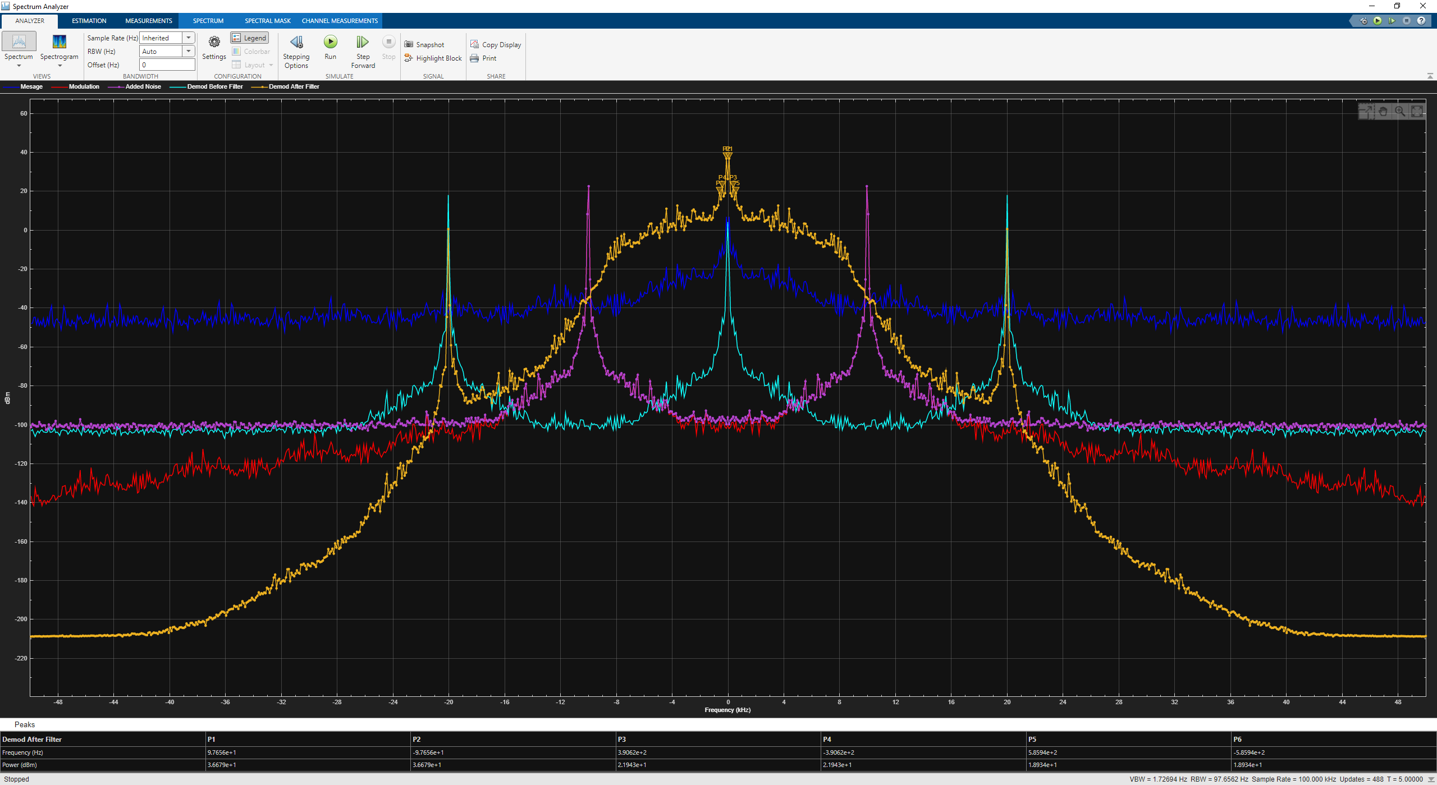
Figure 42
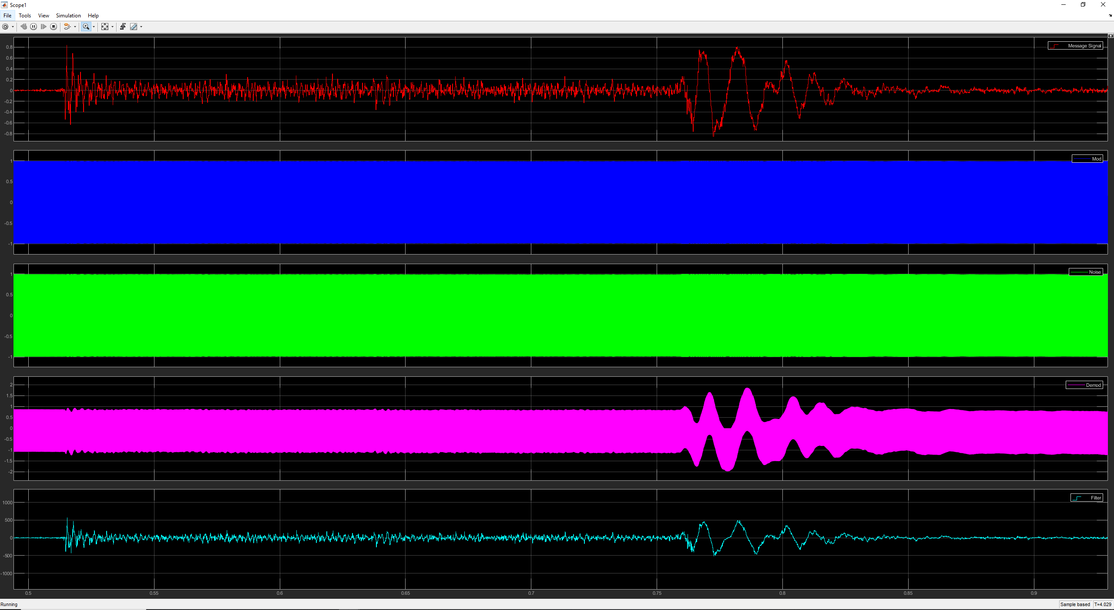
Figure 43

Multimedia Audio File with Added Noise

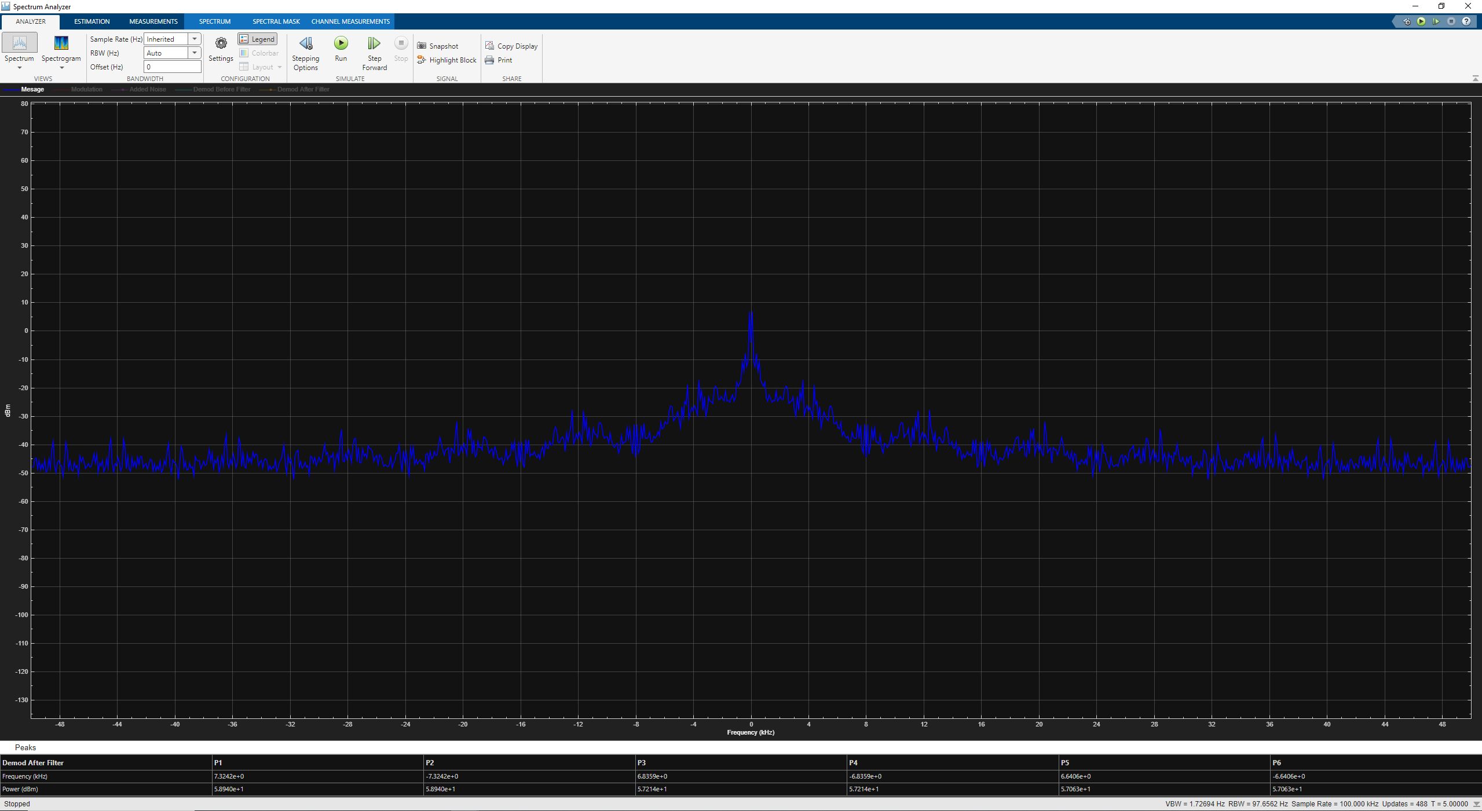
Figure 44
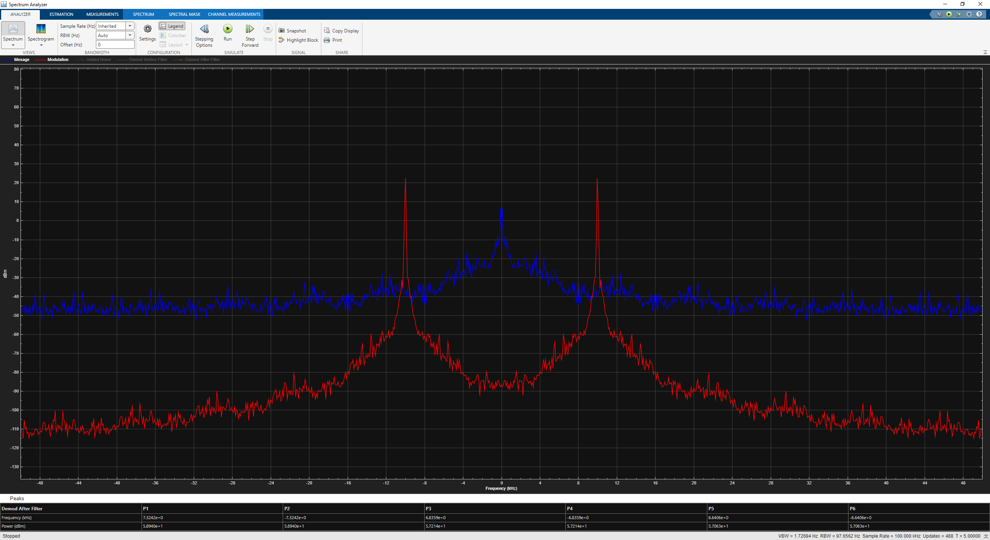
Figure 45
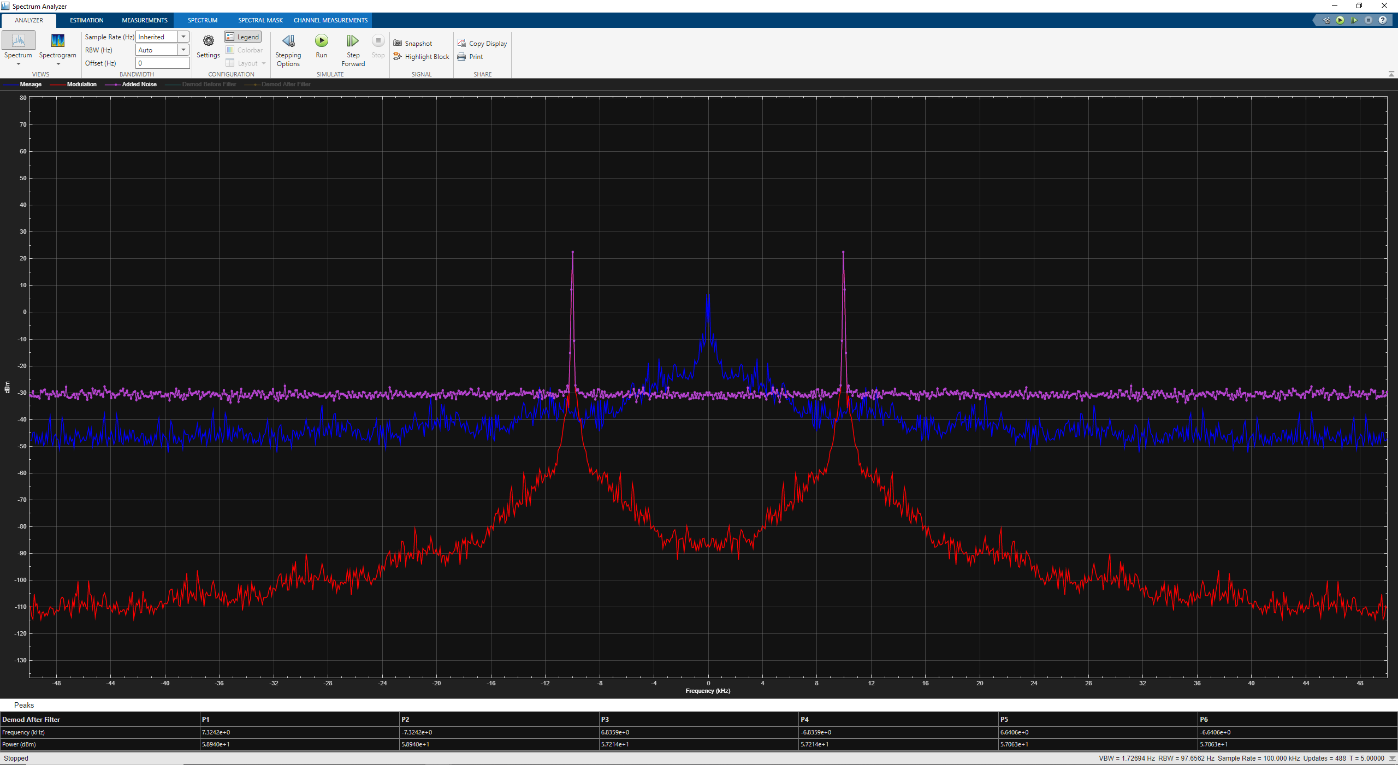
Figure 46
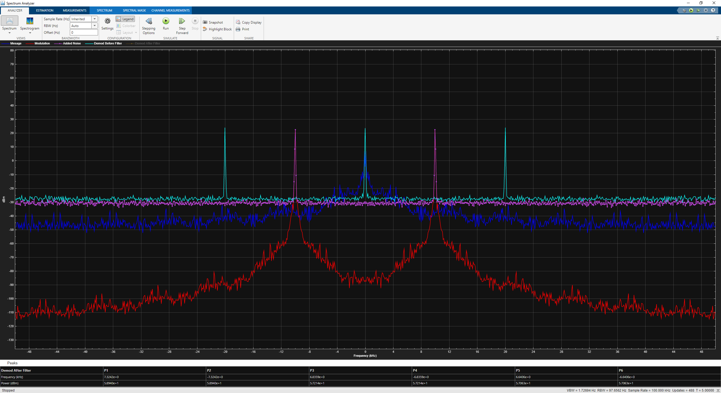
Figure 47
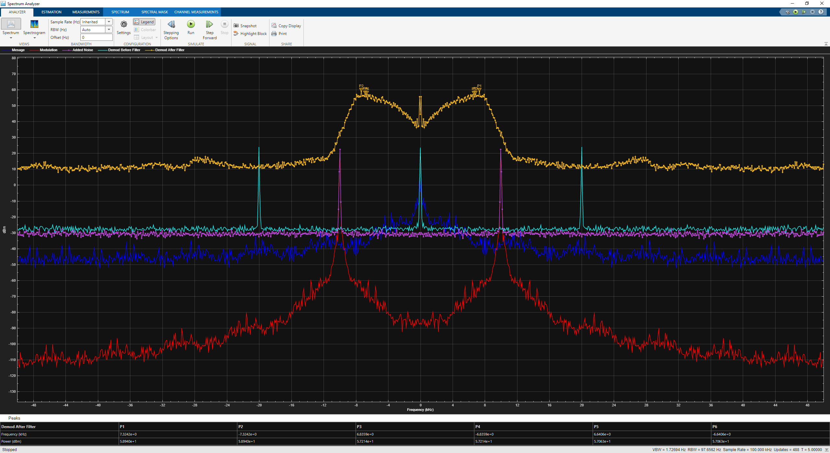
Figure 48
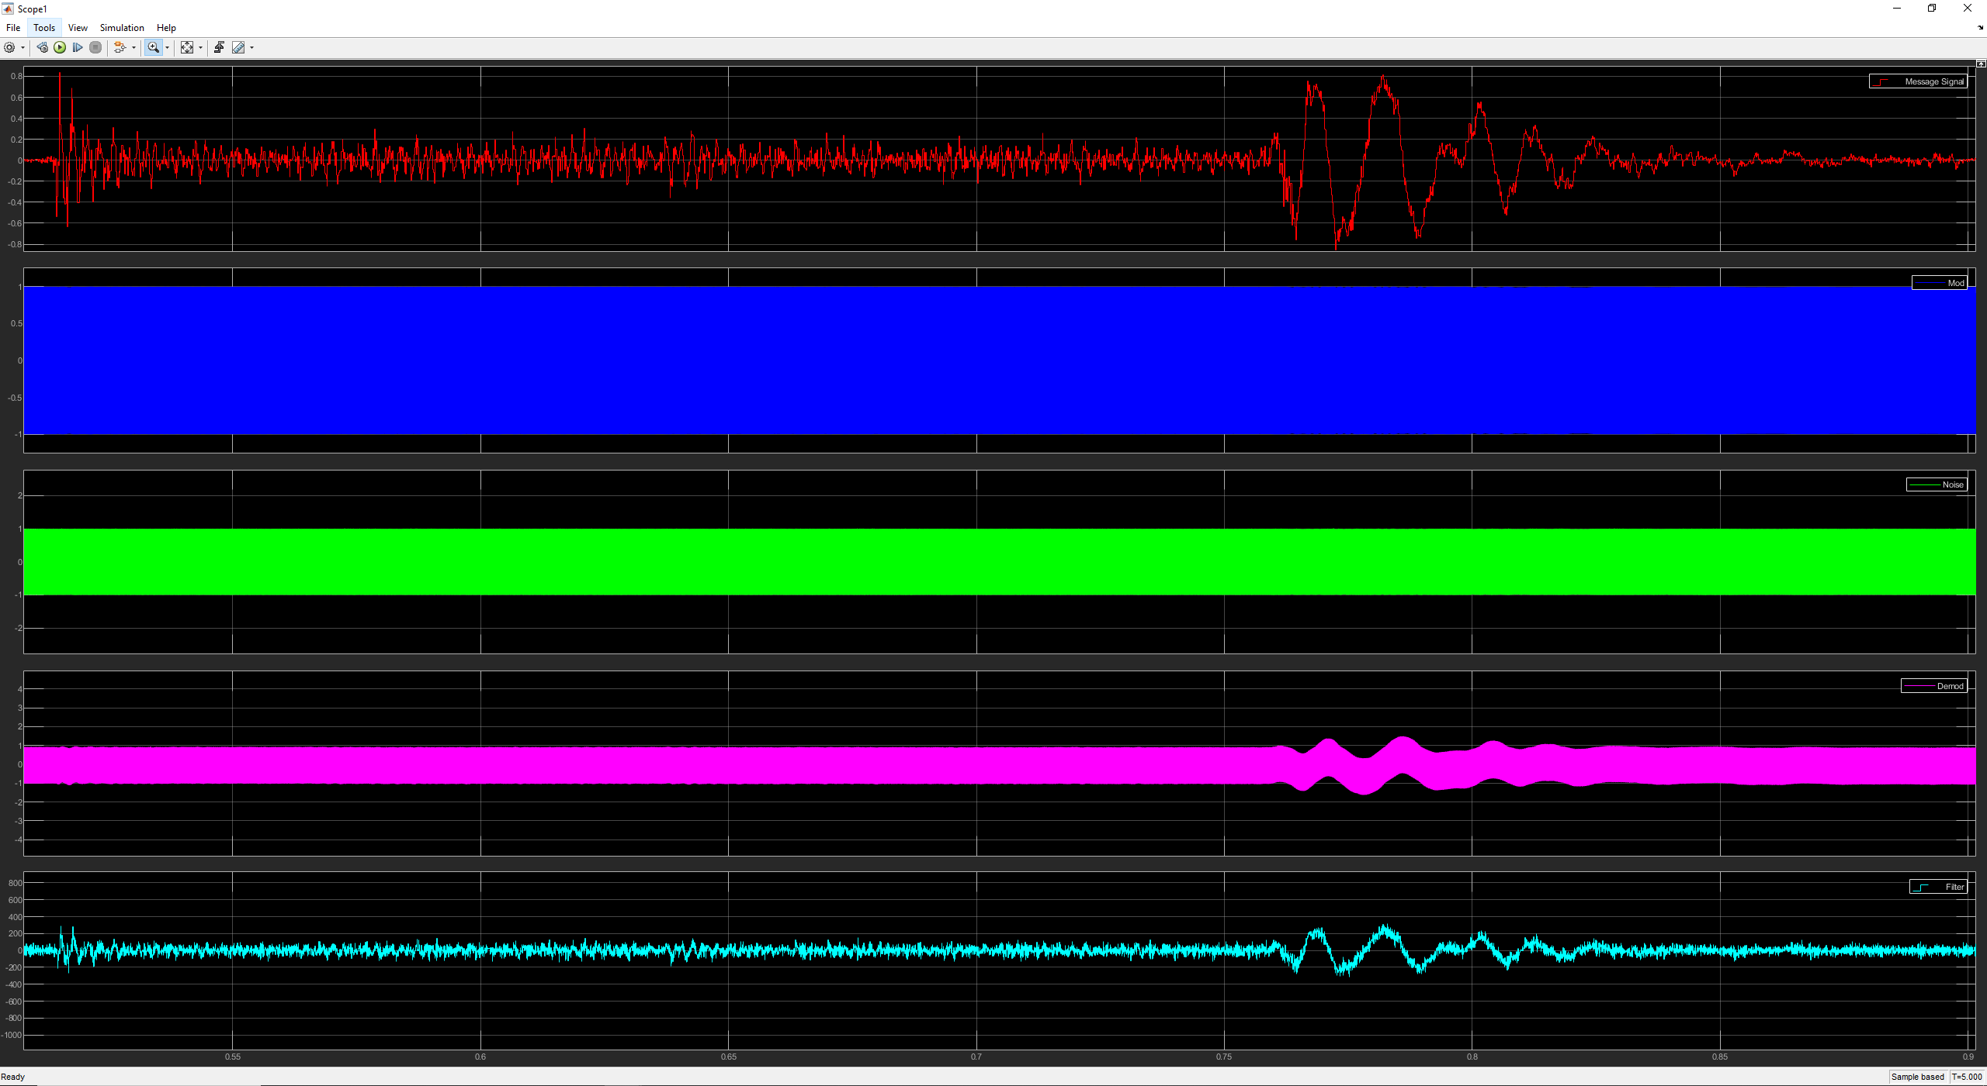
Figure 49

Analysis of Results

Task 1 – Results

As seen in figure [10] and [11] you can see that the Simulink model successfully modulates and demodulates the message signal (red signal). You can see that it has a slight delay between the transmitted message and the demodulated signal. Due to the signal passing through the filter which causes a delay. The modulated signal can be seen in green and shows the two dual side bands on top and bottom as well as the carrier signal in between. After demodulation you can see that the top band/positive side band remains. The filter will then remove the excess frequencies seen below the side band and will leave you with the demodulated message.
Varying the modulation index can cause critical, over and under modulation. As seen in figure [11] a modulation index of 0.5 has been used and therefore the modulated wave is currently under modulated. Figure [12] has a modulation index of 1 and therefore the signal has critical modulation. Finally figure [13] has a modulation index of 2 and therefore the signal is over modulated.
The ideal condition is to have critical modulation which means that the modulated wave has a modulation depth of 100% which means that the carrier falls to zero and will cause no distortion [4]. To achieve this the amplitude of the carrier wave must equal the amplitude of the message signal as shown in the equation [2] meaning that the modulation index will be 1 which is the result of perfect modulation is seen in figure [12].
Under modulation also causes no distortion but has a modulation depth of less than 100% and therefore under modulation isn’t perfect [4] but ultimately causes no distortion. This means that the carrier signal never reaches or crosses the zero point. This happens when the carrier amplitude is greater than the message signal as shown in the equation [2] this means the modulation index is less than 1 and the results can be seen in figure [11].
Over modulation causes distortion as it has a modulation depth of greater than 100% [4]. Which means that the carrier wave falls below the zero and the carrier therefore causes phase reversals [4]. For this to happen, the modulation index needs to be greater than 1 which happens when the amplitude of the message signal is greater than the carrier signal which is shown in the equation [2] and seen in figure [13].
As seen in figure [12] you can see that the modulated and demodulated signal have the same frequency. However, it is also seen that the demodulated and filtered signal’s amplitude varies depending on the modulation index. For critical modulation it slightly reduces the amplitude by 0.2, for under modulation the amplitude is reduced by more than 0.5 of the original signals and for over modulation the amplitude is increased by approximately 0.2. This trend is also seen in the modulated signal.

Task 2 – Results

As seen in figure [14] and [16] you can see that the original message signal (yellow) and demodulated signal (purple) are both in the same frequency. The only difference between the two signals is that the demodulated signal has a higher dBm than the original.
Figure [18] shows the original and demodulated signal in the time domain using a scope. You can see that the frequency of the demodulated signal is similar to the original and so is the phase. But there is a slight delay in the phase to the application of a filter during the demodulation stage. The effect of AWGN is also noticeable on the modulated signal as the signal is very difficult to identify using the scope.
Figure [19] shows the original message (yellow) and modulated message (blue) in the frequency domain and figure [21] shows the demodulated signal (purple). From this spectrum captures you can see that the peak finder has identified that the side bands are at the same frequency as the original. The only difference is that the demodulated signal has a larger output power than the original.
When adding noise to a modulation model it is expected to reduce the overall performance of the modulation technique. The figure [25] shows a spectrum capture of the same original multimedia message (yellow) being modulated (blue) but this time more noise has been added after the signal is modulated (orange). As you can see at this signal to noise ratio the modulated signal is completely overwhelmed by noise and will be difficult to demodulate and retain much of the message.
In figure [26] shown in green you can see what happens to the modulated signal when we begin to demodulate. Not only is the message signal power increased but so is all the surrounding noise when comparing this to figure [20] without any noise you can see that it is far easier to retain the whole message as a lot of it will be lost due to the excess noise. After the filtering in figure [27] you can see the large amount of noise that is still included in the final demodulated signal (purple) and therefore it will be distorted, and a lot of the data will be lost. Figures [28] – [30] show the effect of noise in the time domain instead of frequency. You can clearly see from figure [28] that all the lower amplitude frequencies are lost to noise when the signal get demodulated, and this is why the message sounds and looks distorted as some information is lost.
Noise interferes and degrades the original message by either overwhelming the signal causing data loss or by interfering with it causing fluctuations and slight changes that alter how the signal looks after demodulation. This can be seen in figure [29] as some of the higher amplitude frequencies don’t lose their overall shape but some of the other frequencies are completely lost after demodulation.

Task 3 – Results

As seen in figure [31] and figure [36] you can see a spectrum capture of the original signal (blue) and the demodulated signal (orange) in the frequency domain. Both have the same frequency, but the demodulated output has a higher dBm. Figure [37] shows the two signals in the time domain where the original message is red and the demodulated is light blue. From this we can see that the frequency and phase of the two waves are identical, but the amplitude of the demodulated signal is double the original.
The figures [38] and [42] show the spectrum capture of the original {blue} and demodulated signal (orange) in the frequency domain. As you can see, they are both within the same frequency and the demodulated signal is approximately double the original. Figure [43] shows this in the time domain and you can see how the signal still retains the same shape but is difficult to determine the amplitude due to the scaling of the axis.
When adding noise to the system you can see in figure [46] that the added noise (pink) slightly overwhelms the original signal (blue) which means that any information below or in the noise will be lost which leads to a distorted signal (orange) as seen in figure [48]. Figure [49] shows this in the time domain as seen by the light blue signal. When comparing figure [49] to figure [43] without noise you can see how the lower amplitudes are more distorted and the demodulated signal begins to lose information. This ultimately results in a distorted signal, and you will be able to hear the noise when playing back the file.

Conclusion

In conclusion, from these results it is apparent that these Simulink models can successfully modulate and demodulate a message signal whether that is a sine wave, or an audio file and the demodulated message is the correct frequency, phase and can be played back. However, with analogue modulation techniques noise will distort the original message with both AM and FM modulation techniques and because of this data can be easily lost. Through exploration of the modulation index the critical and under modulation cause no distortion to the message and are the ideal parameters when using AM. But having a modulation index of 1 cause over modulation which can cause distortions as the signal undergoes phase reversals [4].
The next steps for this work will be to look at different AM and FM techniques and assess their ability to cope with noise.

References

[1] | MathWorks, “MathWorks - AWGN,” MathWorks, [Online]. Available: https://uk.mathworks.com/help/comm/ref/awgn.html. [Accessed 2023 11 20].
[2] | J. S. A Butterfield, A Dictionary of Electronics and Electrical Engineering$, Oxford University Press, 2018.
[3] | V. Arya, P. Jishnu and K. P. Ray, “Study and analysis of DSB-SC-FMCW radar in SDR platform,” in IEEE; 2017 9th International Conference on Communication Systems and Networks (COMSNETS), 2017, 2017.
[4] | J. P. Devaraj, “Modulation and Demodulation,” UWTSD, 2023.
[5] | J. P. Devaraj, “Angle Modulation- FM,” UWTSD, 2023.
[6] | Mathworks, “MATLAB,” Mathworks, 2023.
[7] | M. Simon and C. Wang, “Differential Versus Limiter - Discriminator Detection of Narrow-Band FM,” vol. 31, pp. 1227-1234, 1983.
[8] | T. J. Dvorak, “Compatibility of Spread-Spectrum Signals with Narrow-Band FM Receivers in VHF Mobile Networks,” IEEE, 1979.

