

Problem solving and decision making
BMSW4004

Individual Report

STUDENT ID 2022842
Biser Kolev
Table of Contents
Introduction 3
Task 1 3
Nature and impact of job dissatisfaction 3
Cause and effect of job dissatisfaction 4
PESTLE of macro-environmental factors 5
Evaluation for alternative solutions for the issue 5
Aim to choose an appropriate solution for the issue 7
Planning for the implementation of the chosen solution and evaluation of the outcome 8
Conclusion 9
References 10

Introduction
- Problem-solving and decision-making are the skills that are necessary to adhere to both the organization and the employees. This is important because this provides help in the navigation of various situations that come up in a working environment.
- Problem-solving is a process that helps to navigate various situations within a workplace. The problem-solution is acknowledged for the creation of a solution that is required to address risks. These are often involved in making decisions.
Further, problem-solving has enabled the organization of the UK and its employees to identify and explore every opportunity that is involved in the environment. As viewed by Mohanty, (2021, p. 977), problem-solving has been exerted to bring control over the future of the organization. Thus, these are used within the critical part of daily life for both the employees and the organizations. While problem-solving skills are required within an organization, proper decision-making is the most important skill that is a necessity within a manager. The purpose of this study is to analyze the complex issue that the UK organization's employees are facing within their work environment.

Task 1

Nature and impact of job dissatisfaction
- Job dissatisfaction has been referred to as an unhappy or a negative feeling that is created in a working environment.
- Some of the job dissatisfaction is defined by the poor working conditions or lack of "team coordination" or "team leadership".
- Impact of job dissatisfaction ensures the employees with “lack of motivation”, “lack of interest”, “poor productivity”, “absenteeism”, “frustration”, and when these factors are high, there is a high turnover rate in an organization.
- Job dissatisfaction caused “underpayment methods”, “imbalance in the workplace and personal life”, and “increase in bad management and unsupportive head of the company”.
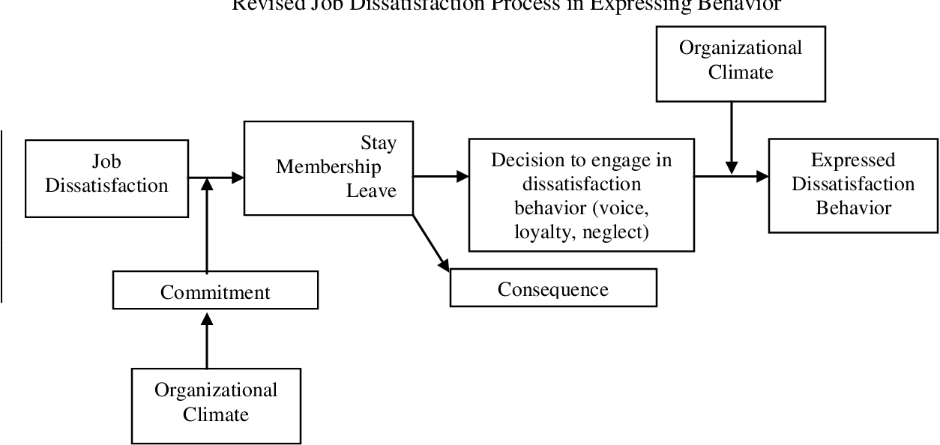
Figure 1: Responses of employees in job dissatisfaction
(Source: Klein and Crandall, 2018, p. 357)
Job dissatisfaction is the consequence that adversely affects both the employees and the organization measuring the worker's content that is within the job. Henceforth, through dissatisfaction, the employees do not feel any interest in their job (Klein and Crandall, 2018, p. 357). This increases in various professions and also through personal reasons that have a lack in the advancement, poor management, limitation with the work-life balance. At the time of the dissatisfaction, the employees are being compelled to find job opportunities that would give them satisfaction in different organizations. While other employees may not find any other organization, and stay and be unhappy, this is because they have a fear of changing their workplace. This is also due to the lack of the updated skills of the employees.

Cause and effect of job dissatisfaction
The cause of the job dissatisfaction:
- An increase in job dissatisfaction is due to the low payment methods, this initiates the issue in the payment of bills that includes limited income.
- While imbalance working and the personal life if not maintained harm the health of the employees as this impacts the productivity levels of the organization.
- The engagement of the employees has been considered as a direct outcome of a high-level of performance company culture, these initiates in the increase in performance of culture outline.
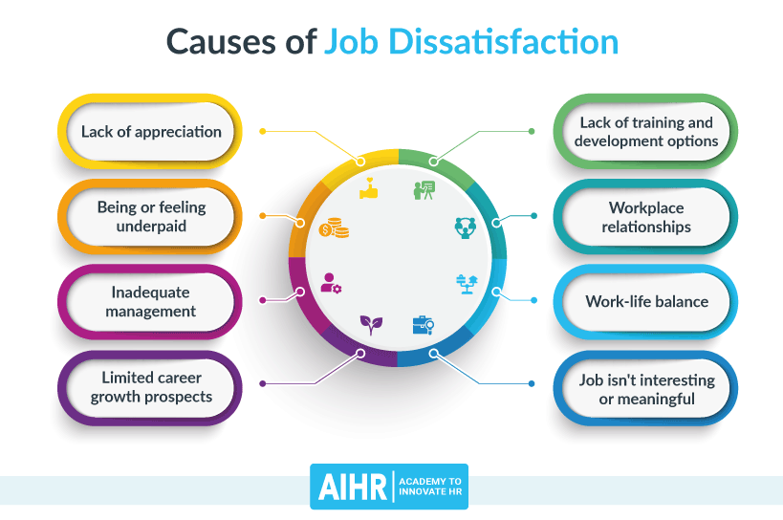
Figure 2: Job dissatisfaction causes
(Source: Haendler and Frysak, 2018, p. 400)
Low payment methods are further discussed to have a stretch for the employees' money that is further being chosen as a necessity for doing anything that is nice or is joyful for the employees. As opined by Lassoued et al. (2020, p. 779), no vacation does not provide fresh eyes and fresh minds. Earlier research has been provided that not taking a break from a working environment leads to a wide range that is welcomed with a mental and physical disability. No room for growth initiates the ease in the engagement of the employees and the working environment (Haendler and Frysak, 2018, p. 400). Any employee has the allowance to think that they cannot grow within the organization. Thus, this initiates in having different roles that are low therefore there is no motivation in the excellence of the employees.

PESTLE of macro-environmental factors
Pestle analysis is CI tools that can help companies have a deep analysis of the macro environment for their operational behavior. The key features that can describe the development of the macro environment can be explained through political economic social technological environmental as well as legal aspects.
Political
- Political stability inside the country
- Existence of tax reforms and policies
- Regulatory practices as well as government bodies
The political factors to a great extent affect the stability of the macro environment and the government's impact on the economy of a country. For example, taxation reforms, the intervention of laws, and fluctuation in the monetary policy are all the political aspects that immensely affect the stability in a macro environment (Xerri and Brunetto, 2018, p. 474). It has been observed that influential political members and their ideologies tend to impact image accounts. Taxation policies and intervention of laws account for 60% of the alteration that has been experienced in the management.
Economic
- Fluctuation in inflation rates
- Factors related to the specific industry
- Potentials expended by consumers
- Rate of unemployment
It must be acknowledged that the economic factors are highly responsible for affecting the business firms and their success terminology.
More of the impact can be evaluated through economic ups and downs in the management.
Further, the contemporary phase regarding the trade cycle such as expansion, consistency depression, etc is also an impactful factor (Casañ et al., 2021, p. 8756). Moreover, the internal and external factors of this specific industry are also responsible for the alteration in the environment regarding the management of the system can be observed. The impact can also be evaluated by analyzing the spending potential of the customers. The evaluation part also considers the contemporary interest rates data prevailing in the economic condition of the business.
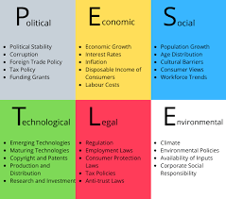
Figure: macro-environmental analysis
(Source: Casañ et al., 2021, p. 8756)

Socio-cultural
- Insight demography of the market
- Cultural as well as religious factors
- Lifestyle trends in the targeted market.
It must be understood that anything regarding social and cultural transformation in the organization can affect its development factor. Hence it is very important to acknowledge and analyze the factors regarding social and cultural aspects to get the complete information of the social environment for the managerial purpose of a business. It is the firm requirement of the management associates to completely study and prepare an outlet that can easily present the demographic stand of the market they are targeting. Without understanding the preferences and the buying patterns of consumers and clients it is quite impossible to crop out the idea for a better productive scenario. Moreover, the management needs to acknowledge the religious as well as cultural factors in the market trend. The very important part of the analysis is to acknowledge the influencing media and their role in the targeted market. Lastly, it requires acknowledging the lifestyle and customer preferences to ensure the survival of the business in that particular area.
Technological
- The emergence of new technological production
- Innovative and inspiring technology introduction.
- Level of maturity in the technology market.
It is very important to understand that technology factors can either offer outstanding opportunities to a firm or it can cause an immense threat to the firm stability. For better acknowledgment, it is very necessary to go with the trend by regularly learning new production ways and especially through technological aspects (Xerri and Brunetto, 2018, p. 474). Most emphasis must be given to the learning part of increasing output, production cost lowering, and managerial cost. With the enhancement of the existing production technology, the firm also needs to practice innovative production ways to keep itself competitive in the market. There must be a regular generation of innovative patterns and models that can ensure consumer retention as well as more customer interaction from the competitive firms. Moreover, emphasis must be given to the maturity level of the existing technology in the firm.
Legal factors
- Existence of challenging business laws
- International agreements as well as treaties regarding trade
- Local circulars and regional reforms
For a company in the domestic environment, it is easy to stabilize, thrive, and survive due to the presence of supportive political conditions and productive business laws and guidance (Jarrahi, 2018, p. 585). On the other hand for a business at a macro level especially in an international market or in a competitive area of the targeted market, it is very necessary to acknowledge the business laws that can ensure a reduction in the issues of the emerging company. In a competitive area, it is very necessary to understand the environmental laws as well as the safety guidelines that must ensure the health and security of the business associates and its depending clients and customers.
Environmental factor
- The emergence of environmental issues
- Acknowledgment of insurance policies
- Safe and secure waste disposal
On a major count, it has been observed that most of the industries suffer due to their poor coordination in maintaining a healthy environment in the internal as well as in the external area. It must be understood that environmental issues are not a direct responsibility of the industry but they must be ensured in the surrounding workplace. With innovative implementations, companies should offer efficient consumption of energy and power that can conventionally maintain the operational work form and offers healthy productivity all around the trading market to Abubakar et al. (2019, p. 111). Moreover, companies should ensure suitable insurance policies for their employees and clients. With the implementation of efficient power consumption, it is also necessary to ensure safe disposal and minimalism in the wastage of a company's outlet. There should be separate management in a company that can particularly deal with the disposal of hazardous material and also ensures lesser usage of chemical substances.

Evaluation for alternative solutions for the issue
- There is a necessity for the increase or the improvement of job dissatisfaction and provide job satisfaction to the employees, as this increases the productivity of the organization.
- It has been noted that the employees who have high job satisfaction, tend to achieve high productivity in the organization.
- The satisfaction is initiated with the flexible working hours and the bonus tied to target and profitability.
- The satisfaction is also increased with the championing professional growth of the employees.
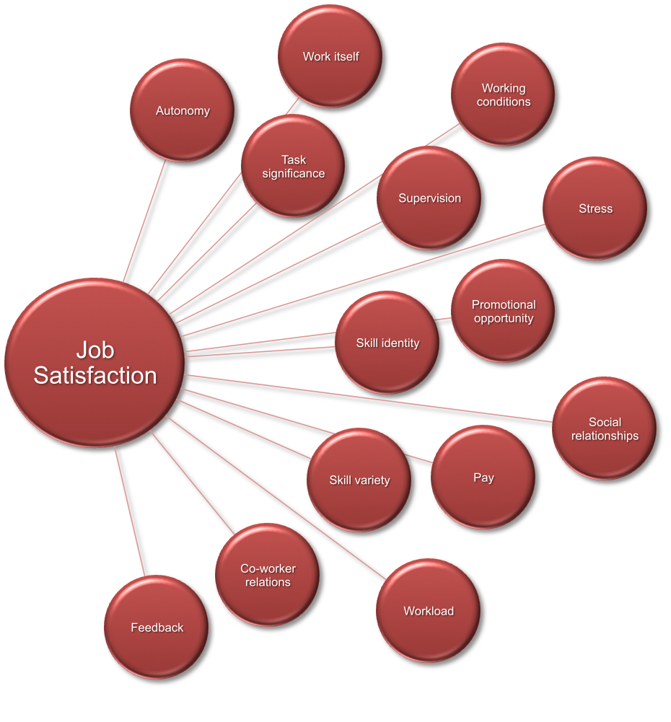
Figure 3: Job satisfaction needs
(Source: Jarrahi, 2018, p. 585)
For the adequacy within the management of the organization, this is initiated with the offering of autonomy and the trust of the employees that are united with the refraining from all the "micromanagement companies '. Moreover, the growth in the prospects can be improved with the internal mobility with the availability of the training and the development of the offerings. According to Abubakar et al. (2019, p. 111), in any organization, it is necessary to have improved team-building activities that help in increasing workplace productivity and in finding the commodities that are the forms of trustworthiness.
The upgrading of work-life is done with the initiation of overtime expectations and then provides the consistency that is being fixed within hourly workers (Jarrahi, 2018, p. 585). The employees are needed to be offered the choices that are having fixed hours and having a remote of the work options. This is also united with the encouragement of every employee in the UK organization that is facing job dissatisfaction to take advantage of the paying time off benefits.

Aim to choose an appropriate solution for the issue
- It is necessary to have job satisfaction in an organization and the employees of the organization, as job satisfaction leads to the improvement of an organization's productivity and thus a decrease in employee turnover.
- This also helps in the decrease in the job stress that is within a modern type of organization in the UK.
- Job satisfaction has led to a positive ambiance within an organization,
- This initiates with essence to ensure high revenues for the organization.
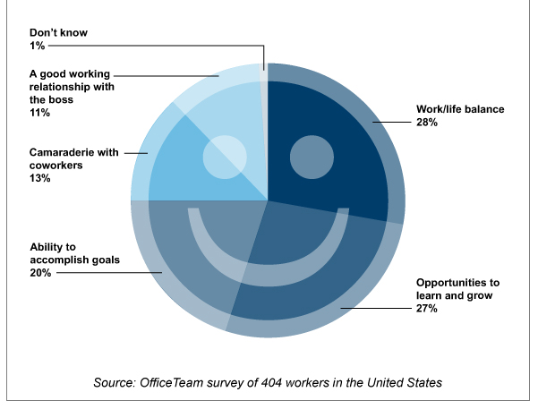
Figure 4: Job dissatisfaction in work attitudes and job motivation
(Source: Xerri, and Brunetto, 2018, p. 474)
Appropriate solutions are necessary to resolve the issue of job dissatisfaction among the employees of the UK organization. As opined by Newman et al. (2018, p. 8), employees' job satisfaction has the initiative to gain an increase of the attention that is involved within the researchers. Jobs have been provided to develop opportunities that are important and are signed with the demands of the employees to maintain satisfaction. This satisfaction is provided for the growth in the opportunities concerning employees, and their behavior within the organization.
The combat for the job dissatisfaction is being provided with a clear set of goals and further instructions which are being made to ensure the employees stay and stick to the organization. This gives the employees a sense of variety in the work and constant communication within their working environment. Dependability is recognized as a most essential skill that is applied in solving the issues that are being caused in an organization (Xerri and Brunetto, 2018, p. 474). This is a timely manner that is essential for the run of an organization. The employees have a high value of individuals that can be trusted for both identification and the implementation of the required solution for the fast and effective possible outcome.

Planning for the implementation of the chosen solution and evaluation of the outcome
- For improvement in job dissatisfaction, effective communication is necessary, and improved communication skills within a working space can increase company culture, productivity, and improvement within the team coordination.
- Moreover, this can help to emphasize the leadership qualities in an organization; this marks the main goal to inform and to update the policies of the company.
- Improved communication can explore the high demand for formal communicative presentations. Typically, this aims at a large audience target with “high rates in stakes” and “objectives” that involves “informing”, “influencing”, and “persuading”.
- Consumer communication improvement initiatives in the development of the market are necessary to form a positive impact on the company.
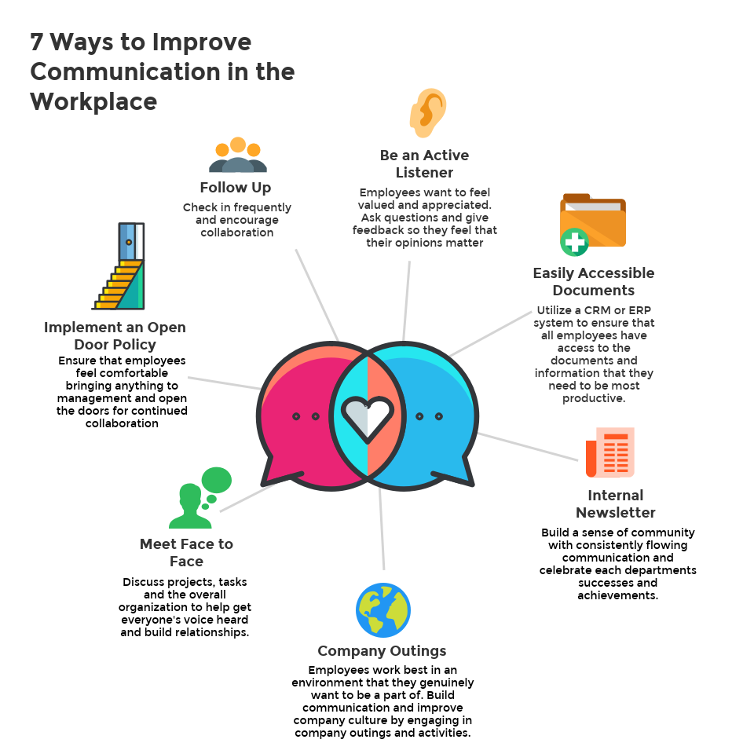
Figure 5: Communicational skills in an organization
(Source: Vardopoulos et al., 2021, p. 7134)
A manager is considered to build good communication skills as these are profound short and long-term benefits within an organization. Effective communication can improve in providing employee motivation and these results in better teamwork and an effective outcome. Leadership communication is initiated to deliver one-way communication that informs or updates all the memos that are about the company policy or are for the change in the direction. Leaders are useful for the communication to “persuade”, “communicate” and for the “inspiration” of the communication. As depicted by Do Thi et al. (2021, p. 3023), formal presentations are necessary for having a strong presence within an organization and to tend to share attention for the improvement of the company. Employees somewhat have a fear of speaking within a public area and this puts a shadow over the abilities of the employees. In general, consumer communication skills are considered as communication among employees. The organization is needed to have a deliberate and planned target that is required to be fulfilled by the employees of the organization (Vardopoulos et al., 2021, p. 7134). This initiates in creating a positive impression of the employees for the company and the products and its services.

Conclusion
- This report is based on the problem-solving and the decision making of the UK companies for the cause of job dissatisfaction among the employees.
- The report highlights the necessity of job satisfaction in organizations that provide impact over the poor working conditions and lack within the team coordination or team leadership.
The consequences of this issue affect the worker's content within the job. Low payment methods, imbalance of working and within the personal lifestyle and the company culture have been provided the impact over the organization. The needed solution that is implemented for the improvement in job dissatisfaction is improvement in communication skills. Communication skills help in promoting leadership communication and its qualities, formal communicative presentations, and improvement in consumer communication.

References
Abubakar, A.M., Elrehail, H., Alatailat, M.A. and Elçi, A., 2019. Knowledge management, decision-making style and organizational performance. Journal of Innovation & Knowledge, 4(2), pp.104-114.
Casañ, M.J., Alier, M. and Llorens, A., 2021. A Collaborative Learning Activity to Analyze the Sustainability of an Innovation Using PESTLE. Sustainability, 13(16), p.8756.
Do Thi, H.T., Pasztor, T., Fozer, D., Manenti, F. and Toth, A.J., 2021. Comparison of Desalination Technologies Using Renewable Energy Sources with Life Cycle, PESTLE, and Multi-Criteria Decision Analyses. Water, 13(21), p.3023.
Haendler, T. and Frysak, J., 2018. Deconstructing the Refactoring Process from a Problem-solving and Decision-making Perspective. In ICSOFT (pp. 397-406).
Jarrahi, M.H., 2018. Artificial intelligence and the future of work: Human-AI symbiosis in organizational decision making. Business Horizons, 61(4), pp.577-586.
Klein, G. and Crandall, B.W., 2018. The role of mental simulation in problem solving and decision making. In Local applications of the ecological approach to human-machine systems (pp. 324-358). CRC Press.
Lassoued, K., Awad, A. and Guirat, R., 2020. The impact of managerial empowerment on problem solving and decision making skills: the case of Abu Dhabi University. Management Science Letters, 10(4), pp.769-780.
Mohanty, S., 2021. Decision Making And Problem Solving. Springer. DOI, 10, pp.978-3.
Newman, A., Herman, H.M., Schwarz, G. and Nielsen, I., 2018. The effects of employees' creative self-efficacy on innovative behavior: The role of entrepreneurial leadership. Journal of Business Research, 89, pp.1-9.
Vardopoulos, I., Tsilika, E., Sarantakou, E., Zorpas, A.A., Salvati, L. and Tsartas, P., 2021. An Integrated SWOT-PESTLE-AHP Model Assessing Sustainability in Adaptive Reuse Projects. Applied Sciences, 11(15), p.7134.
Xerri, M.J. and Brunetto, Y., 2018. The impact of the perceived usefulness of workplace social networks upon the innovative behaviour of SME employees a social capital perspective. In Promoting Innovation in New Ventures and Small-and Medium-Sized Enterprises (pp. 445-475).

