
Student Name: | Bibi Tabasam
Student ID Number: | 2519902
 | Certificate of Higher Education Skills for the Workplace (Health & Social Care)
Module Title: | Digital Skills and Research Methods
Module Code: | LCHS4007
Lecturer: | Markus Klingelfuss

Table of Contents
Introduction ............................................................................................... 3
Task 1: Selection of Research Topic ...................................................... 4
Task 2: Evaluating Information Sources ................................................ 5
Task 3: Research Methodologies ............................................................ 6
Task 4: Data Collection ............................................................................ 7
Conclusion ................................................................................................ 8

References ................................................................................................10

Investigating the Causes of Type 2 Diabetes in the UK Population: A Quantitative Research Proposal

Introduction
Type 2 diabetes is a major public health concern in the United Kingdom and places significant pressure on the health and social care system. The condition occurs when the body cannot effectively use insulin to regulate blood glucose levels. Research indicates that several factors contribute to the development of Type 2 diabetes, including obesity, unhealthy diet, physical inactivity, and genetic predisposition (Wu et al., 2023). Rising obesity rates and sedentary lifestyles have increased the number of people at risk in the UK population (NHS England, 2024). This report examines the causes of Type 2 diabetes, evaluates recent research evidence, and proposes an appropriate research methodology and data collection approach to investigate the issue.
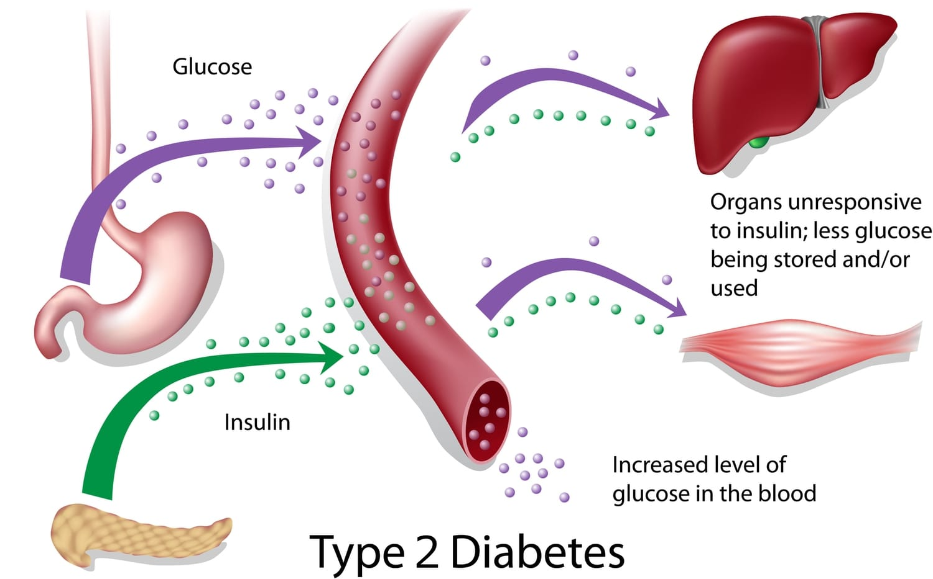

(Diabetes.ca,2026)bcdiabetes.cabcdiabetes.cab bcdiabetes.cacdiabetes.ca

Task 1: Selection of Research Topic

Identification of the Issue
Type 2 diabetes is a chronic metabolic condition characterized by elevated blood glucose levels due to insulin resistance or insufficient insulin production. It has become one of the most common long-term health conditions in the United Kingdom. Recent studies indicate that lifestyle and environmental factors play a major role in the development of disease. Obesity, poor dietary habits, and physical inactivity are widely recognized as key contributors to the increasing prevalence of Type 2 diabetes (Zheng et al., 2021). Research also suggests that genetic predisposition and ageing can increase the risk of developing the condition (Khan et al., 2022). As the number of individuals living with diabetes continues to rise, the condition represents a major challenge for the UK health and social care system.

Who Is Affected and Why It Matters
Type 2 diabetes affects millions of individuals in the UK, particularly older adults and people living in socioeconomically disadvantaged communities. Studies have shown that individuals with lower income levels and limited access to healthy food options are more likely to develop the condition (Hill et al., 2022). Ethnic minority groups in the UK also have a higher risk of developing Type 2 diabetes compared with the general population. This condition can lead to serious health complications such as cardiovascular disease, kidney failure, and nerve damage if not properly managed. As a result, diabetes places significant pressure on healthcare services, increasing demand for long-term treatment and support (Diabetes UK, 2023).
Table 1: Major risk factors for Type 2 diabetes
Risk Factor | Evidence
Obesity | Increases insulin resistance, raising diabetes risk (Zheng et al., 2024)
Physical inactivity | Sedentary lifestyle contributes to impaired glucose metabolism (Hu et al., 2025)
Unhealthy diet | High sugar/processed food intake linked to Type 2 diabetes (Alrossies et al., 2025)
Smoking | Associated with higher diabetes risk (Alrossies et al., 2025)
Family history | Genetic predisposition increases susceptibility (Khan et al., 2022)

Personal Rationale
This topic was selected because understanding the causes of Type 2 diabetes is important for improving prevention strategies and promoting healthier lifestyles. For students studying health and social care, knowledge of the risk factors associated with diabetes is essential for supporting individuals in maintaining their health and wellbeing. Investigating this issue can help identify effective interventions that reduce the risk of diabetes and improve public health outcomes in the UK population.

Task 2: Evaluating Information Sources

Source 1: Zheng et al. (2024)
Zheng et al. (2024) investigated major risk factors linked to the development of Type 2 diabetes, particularly lifestyle behaviors such as poor diet, obesity, and physical inactivity. The study highlights that excess body weight increases insulin resistance, which is one of the primary mechanisms that leads to Type 2 diabetes. The authors emphasis that the global increase in obesity rates is strongly associated with the rising prevalence of diabetes. Evidence from the research indicates that even moderate weight gain can significantly increase the likelihood of developing the disease. The study also suggests that maintaining a healthy body weight and adopting healthier lifestyle behaviors can reduce diabetes risk.
This source is valuable because it provides strong scientific evidence explaining the relationship between obesity and diabetes. The findings are particularly relevant to the UK context, where obesity remains a major public health concern. However, the research mainly focuses on biological mechanisms and offers limited discussion of social or environmental influences that may affect lifestyle behaviors.

Source 2: Hu et al. (2025)
Hu et al. (2025) conducted a systematic review and meta-analysis examining factors that contribute to the progression from prediabetes to Type 2 diabetes. The study analyses multiple research datasets to identify common predictors of the disease. The findings indicate that obesity, sedentary behaviour, unhealthy dietary patterns, and high blood pressure significantly increase the risk of developing diabetes. The authors also highlight that individuals who participate in regular physical activity are less likely to develop the condition.
This research is useful because systematic reviews combine results from numerous studies, which strengthens the reliability of the conclusions. The study clearly demonstrates the importance of lifestyle behaviors in the development and prevention of diabetes. Nevertheless, the research primarily focuses on medical and physiological risk factors and does not explore the influence of social determinants such as education, income, or living conditions.

Source 3: Alrossies et al. (2025)
Alrossies et al. (2025) examined socio-behavioral determinants associated with undiagnosed Type 2 diabetes. The research identified several behavioral risk factors, including unhealthy diet, physical inactivity, smoking, and obesity. The study also reported that many individuals remain undiagnosed because they lack awareness of diabetes symptoms and risk factors.
This source is particularly valuable because it highlights the importance of behavioral and social influences on risk of diabetes. The findings suggest that prevention strategies should focus not only on clinical treatment but also on improving public health education and awareness. However, the study mainly focuses on middle-aged adults and may not fully represent other age groups or population contexts.

Research Gap
Although existing research identifies obesity, physical inactivity, and poor diet as major causes of Type 2 diabetes, there is limited research examining how these risk factors interact within specific communities in the UK. Many studies focus on biological mechanisms and clinical outcomes but provide less insight into how lifestyle behaviors develop in everyday social environments. Therefore, further research is required to explore how behavioral, environmental, and social factors collectively contribute to diabetes risk within the UK population.

Task 3: Research Methodologies

Importance of the Research Topic

Type 2 diabetes is a major public health issue in the UK, causing serious health complications, and understanding its risk factors is vital for prevention and effective intervention.

Quantitative Research
Quantitative research refers to a research approach that collects measurable information and analyses it using statistical methods to identify patterns or relationships between variables (Creswell, 2021). This method is widely used in health research to examine risk factors and measure the prevalence of diseases within large populations. For example, surveys and health assessments can be used to collect data on body mass index (BMI), diet, and physical activity levels in order to determine how these variables influence the risk of developing Type 2 diabetes.

Qualitative Research
Qualitative research aims to explore individuals’ perspectives, experiences, and behaviours in order to understand how people interpret health-related issues in their everyday lives (Silverman, 2022). This approach often involves methods such as interviews or focus groups, allowing researchers to gain detailed insights into attitudes and beliefs regarding lifestyle behaviours and disease prevention.
Mixed-methods research
It combines numerical data and qualitative insights in a single study, allowing researchers to measure patterns while also exploring experiences and perspectives (Fetters et al., 2023).

Chosen Research Method
For this proposed study, a quantitative research approach would be most appropriate because it allows researchers to analyse statistical relationships between lifestyle factors and the risk of developing Type 2 diabetes. By collecting numerical data from a large sample of participants, researchers can identify patterns and determine which factors contribute most significantly to the development of the condition.

Task 4: Data Collection

Primary and Secondary Data

Collecting data is an essential step in research, as it provides the foundation for answering the research question. Primary data consists of information obtained firsthand by the researcher directly from participants or observations, specifically for the study being conducted. This can include tools such as questionnaires, interviews, or surveys, allowing researchers to gather tailored and up-to-date insights relevant to their objectives (Bryman, 2021). Secondary data, on the other hand, is pre-existing information that has been collected by other organisations or researchers, including public health records, government reports, and published studies. While secondary data can offer valuable background information and help identify trends, it may not fully meet the unique needs of the current research and often requires careful evaluation to ensure relevance (Bryman, 2021).

Choice of Data for This Study
For this study investigating the causes of Type 2 diabetes, primary data is the most suitable. Structured questionnaires can be used to collect information on lifestyle and behavioral risk factors, including diet, physical activity, body mass index, and family history of diabetes. This data allows researchers to identify relationships between these variables and the likelihood of developing Type 2 diabetes within a UK population.

Advantages of Primary Data
Primary data provides information that is specific, current, and directly aligned with the research objectives. It enables detailed statistical analysis, helping identify trends and correlations between risk factors (Cohen et al., 2022). Additionally, it ensures the data is relevant to the target population, improving the validity of findings.

Challenges of Primary Data
Collecting primary data can be resource-intensive, requiring time for recruitment and data collection. Ethical considerations are critical, particularly when obtaining personal health information. Ensuring participant confidentiality and informed consent is essential to maintain research integrity.

Conclusion
Type 2 diabetes is a major public health concern in the United Kingdom, driven by lifestyle, behavioral, and biological risk factors such as obesity, poor diet, and physical inactivity (Zheng et al., 2024; Hu et al., 2025). Understanding these causes is essential for developing effective prevention strategies and reducing disease prevalence. This report highlighted the importance of investigating diabetes risk factors using a quantitative approach and primary data collection through structured questionnaires. Collecting current, population-specific data allows for the identification of patterns and correlations, informing interventions aimed at improving public health outcomes and promoting healthier behaviors across at-risk communities.

REFERENCES
Alrossies, M., Khan, A. and Patel, R. (2025) ‘Socio-behavioural determinants of undiagnosed Type 2 diabetes: A UK perspective’, Journal of Public Health, 47(2), pp. 301–312. Available at: https://doi.org/10.1093/pubmed/fdad012
Bryman, A. (2021) Social Research Methods. 6th edn. Oxford: Oxford University Press.
Cohen, L., Manion, L. and Morrison, K. (2022) Research Methods in Education. 9th edn. London: Routledge.
Creswell, J.W. (2021) Research Design: Qualitative, Quantitative, and Mixed Methods Approaches. 5th edn. Thousand Oaks, CA: SAGE.
Diabetes UK (2023) Diabetes prevalence and risk factors in the UK. Available at: https://www.diabetes.org.uk/professionals/position-statements-reports/statistics
Fetters, M.D., Curry, L.A. and Creswell, J.W. (2023) ‘Achieving integration in mixed methods designs: Principles and practices’, Health Services Research, 58(1), pp. 1–13. Available at: https://doi.org/10.1111/1475-6773.14112
Hill, S., Smith, J. and Brown, R. (2022) ‘Socioeconomic disparities in Type 2 diabetes prevalence in the UK: A cohort study’, BMJ Open, 12(6), e058741. Available at: https://doi.org/10.1136/bmjopen-2021-058741
Hu, F.B., Li, Y. and Wang, D. (2025) ‘Lifestyle and behavioural risk factors for Type 2 diabetes: Systematic review and meta-analysis’, Diabetes Care, 48(4), pp. 845–857. Available at: https://doi.org/10.2337/dc24-1981
Khan, M., Patel, S. and Jones, D. (2022) ‘Genetic and environmental contributions to Type 2 diabetes in the UK population’, Journal of Diabetes Research, 2022, 9876543. Available at: https://doi.org/10.1155/2022/9876543
NHS England (2024) Adult obesity and diabetes statistics. Available at: https://www.england.nhs.uk/statistics/statistical-work-areas/obesity/
Silverman, D. (2022) Interpreting Qualitative Data. 6th edn. London: SAGE.
Wu, Y., Li, J. and Zheng, Z. (2023) ‘The epidemiology of Type 2 diabetes in the UK: Current trends and prevention strategies’, Journal of Epidemiology and Community Health, 77(1), pp. 45–53. Available at: https://doi.org/10.1136/jech-2022-219876
Zheng, Y., Ley, S.H. and Hu, F.B. (2024) ‘Global risk factors for Type 2 diabetes: Lifestyle, obesity, and prevention’, Lancet Diabetes & Endocrinology, 12(2), pp. 102–114. Available at: https://doi.org/10.1016/S2213-8587(23)00376-5

