
Title Page

Programme of Study: Business

Module name: Employability and Career Development (LCLM4005_BIRM)

Assignment Title: Portfolio of Written Tasks

Student name: Fazia Arshad

Student Id: 2434892

Lecturer's Name: Olu Adegbite


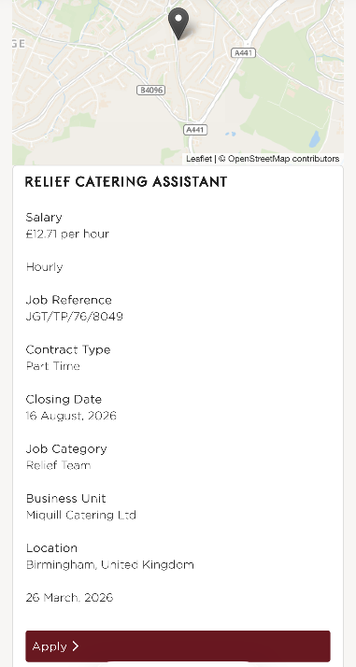
Job Adverts and Key Skills:
The chef role at Jubilee Talent involves preparing and cooking food for weddings and other special events. The advert explains that candidates should be able to work in a busy environment, stay calm under pressure and be flexible with their working hours. It also mentions that previous catering experience is preferred and that chefs need to work well with other members of the kitchen team to make sure food is prepared to a high standard.
The Relief Catering Assistant role at Miquill Catering is slightly different, as it focuses more on supporting the kitchen and serving customers. The main duties include helping prepare meals, serving food, keeping the kitchen clean and following food hygiene and health and safety rules. The advert also says that they are looking for someone who is reliable and friendly, who can work well with others. Although this role is less senior than the Event Chef position, it still requires a positive attitude and the ability to work efficiently during busy periods.
After comparing both adverts, I noticed several skills and areas of knowledge that appeared in both. One of the biggest similarities is teamwork. Both employers want staff who can work closely with colleagues to make sure everything runs smoothly. They also expect employees to be able to work in a fast paced environment, especially during busyl times or large events. Good communication skills are another important requirement because catering staff need to communicate clearly with both customers and their teammates. Also, both adverts highlight the importance of understanding food hygiene and health and safety procedures, as these help ensure that food is prepared safely and that the workplace remains clean and organised.
I think teamwork is one of the most important skills I will use in my future career. In catering, everyone has a different role, but they all need to work together to provide customers with a good experience. For example, during a wedding or large event, the chefs, servers and kitchen assistants all depend on each other to keep everything running on time. By communicating well, helping my colleagues when needed and staying organised, I can contribute at a good standard. Developing strong teamwork skills will also help me build confidence, improve my communication and become a dependable employee that employers can trust.

Self-Assessment and Readiness:
SWOT Analysis:
Strengths
One of my main strengths is my ability to communicate effectively and work well with others. Communication is an important skill in the catering industry because staff need to work closely together and understand customer needs to ensure events run smoothly. Through my experience helping with family catering events, I have developed confidence when interacting with guests and supporting others to provide a positive experience.
Another strength I have is my organisation and ability to manage my time effectively. Catering often involves completing multiple tasks within a short period of time, such as preparing food, setting up venues and serving customers. My experience supporting events has helped me understand the importance of being organised and staying calm in busy environments.
I am also hardworking, adaptable and willing to learn. I am open to developing my skills and gaining experience, which will help me continue improving professionally. I work well as part of a team and understand that cooperation is essential when delivering a successful catering service
Weaknesses
One area I would like to improve is gaining more professional experience within the catering industry. Although I have supported catering at family events, I have not yet worked in a large professional catering environment. Gaining more industry experience would help me develop a deeper understanding of areas such as professional kitchen operations, customer expectations and workplace procedures.
Another area for development is my confidence in leadership and decision making. In the future, I would like to improve my ability to take on more responsibility, lead a team and make decisions independently. I would also like to expand my knowledge in stock management and budgeting
Opportunities
One of the main opportunities is gaining more professional experience through part time catering roles, work placements or volunteering. This would allow me to build on the experience I have already gained from supporting family events and help me understand how professional catering businesses operate on a larger scale.
Another opportunity is to continue developing my knowledge and qualifications. Completing courses such as food hygiene and health and safety would improve my employability and show employers that I understand the importance of maintaining safe and quality catering standards.
My Business Management studies provide me with another opportunity to develop skills that are useful within catering. Understanding areas such as marketing, finance, customer service and business operations could help me not only work effectively as an employee but also potentially progress into a management position or start my own catering business in the future.
Threats
One potential threat within the catering industry is the high level of competition for employment opportunities. Many people apply for catering roles, so it is important that I continue improving my skills and gaining relevant experience to make myself stand out to employers. Building a stronger CV, gaining qualifications and developing my practical skills will help me overcome this challenge.
Another threat is that customer expectations within catering are constantly changing. Customers increasingly expect high quality service, a variety of food options with consideration of dietary requirements such as allergies and different preferences. To keep up with customers, I will need to continue learning and adapting to these changes, and by gaining experience, I can prepare myself for these challenges and continue developing towards my future career goals in catering.
Evidence of Readiness:
I believe I am developing the skills and experience needed to build a future career in the catering industry. Through helping with catering at different family events, including a reception, baby shower and birthday celebration, I have gained practical experience in preparing and presenting food, serving guests and helping events run smoothly. These experiences have shown me the importance of teamwork and organisation.
My studies in Business Management have also helped prepare me for employment by improving my understanding of how businesses operate, including customer needs, planning and organisation. These skills are useful in catering because businesses need to provide quality services while managing time and resources.
My peers would describe me as a professional, hardworking and reliable individual who is able to handle different situations calmly and efficiently. I take pride in completing my work to a high standard and always aim to be dependable when working with others. When completing tasks or working as part of a team, I am someone who can be trusted to take responsibility, stay organised and support others when needed. My ability to remain focused under pressure allows me to adapt to different situations and find solutions effectively.
Overall, my catering experience and education have helped me develop important skills such as communication, teamwork, reliability and problem-solving. I am hardworking, adaptable and willing to learn, and I aim to continue improving by gaining more professional experience, developing my food safety knowledge and taking on more responsibilities in the future.
Employment Goals and Development Plan:
Main Weaknesses:
Based on my SWOT analysis, one of my main weaknesses is that I have limited experience working in a professional catering environment. My short-term employment goal is to gain more practical experience by securing a part time catering role or work placement within the next 6 to12 months. This will allow me to develop my understanding of professional kitchen operations, customer service and workplace procedures. This goal is important to me because although I have gained experience through family catering events, I want to build my confidence and learn how catering businesses operate on a larger scale.
Another short-term goal is to improve my knowledge of food safety, hygiene and catering regulations by completing relevant training, such as a food hygiene certificate. This will help me become more prepared for employment and ensure I can meet industry standards.
My long-term employment goal is to progress into a leadership position within the catering industry, such as a catering supervisor or manager. I would like to develop my leadership, decision-making and organisational skills so that I can confidently manage teams and contribute to the success of a catering business. This aligns with my career aspirations because I am interested in both catering and business management, and I would like to combine these skills in the future.
Development Plan:
To achieve these goals, my personal development plan will focus on gaining experience and improving my qualifications and confidence. I will apply for catering roles, attend industry training and seek feedback to identify areas for improvement. I will use resources such as online courses, workplace training and advice from experienced catering professionals to develop my skills.
I will measure my progress by tracking the skills I gain, completing relevant qualifications and reviewing feedback from my workplace experiences. By consistently developing my abilities, I aim to overcome my weaknesses and become more prepared for future career opportunities within the catering industry.

