Summary Executive
This article will give a detailed assessment of cultural differences and the Kingdom of the Netherlands. So far, Hofstede's six cultural dimensions: power distance, individualism, masculinity, avoidance of uncertainty, time and indulgence. The impact on business culture has been profound. The Kingdom of Holland and The United Kingdom are both countries with a long history and a long culture. The business customs and traditions of the two countries differ to varying degrees. Therefore, this paper will focus on assessing the social structure, business culture and living customs of the UK. Then, some relevant suggestions are given through the comparison between the two countries. Firstly, it will evaluate the six cultural dimensions and business environment. Then, it will demonstrate the potential threats and challenges encountered in business talks and give some good suggestions. And will present a critical view of Hofstede's six cultural dimensions.

Introduction
This article analyzes the business culture in Britain and the Netherlands. First of all, the importance of cross-cultural communication is explained. Then, the six dimensions of Hofstede's Cultural Dimension are used to make a detailed analysis and comparison between Britain and the Netherlands. Potential threats to relevant values are presented. Give a brief overview of these challenges and propose solutions. In addition, the thesis critically demonstrates the six dimensions of Hofstede's cultural Dimension. Finally, the differences between British and Dutch business culture are analyzed and relevant suggestions are given.

main finding

Cross-cultural communication
Cross-cultural communication refers to the knowledge, information, The communication and understanding of emotions (Wiki,2021). The ways in which organizations have developed strategies to deal with The reality of globalization vary significantly (Adler, 1991). Since it involves a wide range of contents, including the beliefs, traditions, business customs, communication strategies, context environment, language differences, non-cultural communication and many other factors in different countries (Yunkim. Y,2012). Improving cross-cultural communication skills is particularly important for business negotiations. These skills can not only help enterprises avoid communication traps but also improve the success rate of negotiation (D. Amari,2020).

Hofstede's cultural dimension
Judge the Netherlands from Hofstede's cultural dimension. Hofstede obtained a cultural framework including six dimensions: power distance, individualism, masculinity and uncertainty avoidance through cultural measurement and value survey in 60 countries. Long term orientation, indulgence (Hofstede, g., Hofstede, G. J., minkov, M. 2010). Figure 1.0 analysis (Hofstede, 2021). Right distance expresses the unequal attitude of culture in society. Generally, the higher the power distance score, the higher the degree of restraint of employees in national enterprise institutions or organizations. Power is more concentrated, mostly manifested in bureaucracy. Countries with lower power distance usually have lower binding force at the lower level of enterprises or organizations. Easier bottom-up communication. People in countries with higher scores in the dimension of individualism are more inclined to the interests of themselves or their families. In countries with low scores, people are more inclined to collective interests in this society. At the gender level, male society is usually driven by competition and success. People will pursue success more and are more willing to sacrifice. In female society, the degree of competition is not so high, and people deal with things more rationally. More willing to spend time participating in it. In the dimension of avoiding uncertainty and time, different cultures deal with things in different ways, with advantages and disadvantages. In the dimension of indulgence, it is related to people's customs and cultural background.

The right distance of the Netherlands is 38 points, reflecting the relative dispersion of rights in the country. Convenient communication between superiors and subordinates and low degree of control. Employees have more freedom and less restraint. The score of individualism is 80, indicating that this is an individualistic society. More independent employees are more concerned about freedom, such as personal beliefs. However, they are less efficient in the workplace and more vulnerable to criticism (prosancons, 2021). Its masculinity score is 14, so it is a female society. In this society, people will pay more attention to equality. In general, long-term discussion and joint participation are the main ways to solve problems (Hofstede, 2021). The score for avoiding uncertainty is 53, indicating that people do not accept unconventional behaviors and ideas. Rules are more important to them. Excessive innovation may be resisted. The Netherlands has 67 points in time and pays more attention to long-term cooperation. As many as 68 people indulged themselves. This shows that people prefer to do what they want freely.
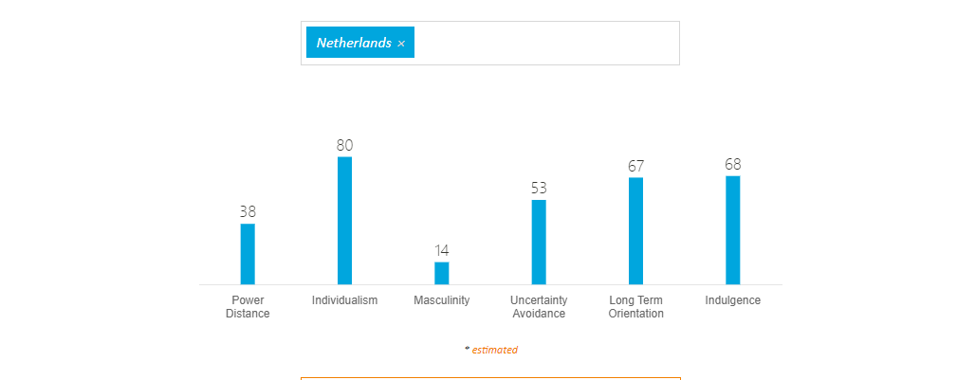Picture.1.0. The cultural dimension of Netherlands(Hofstede，2021)

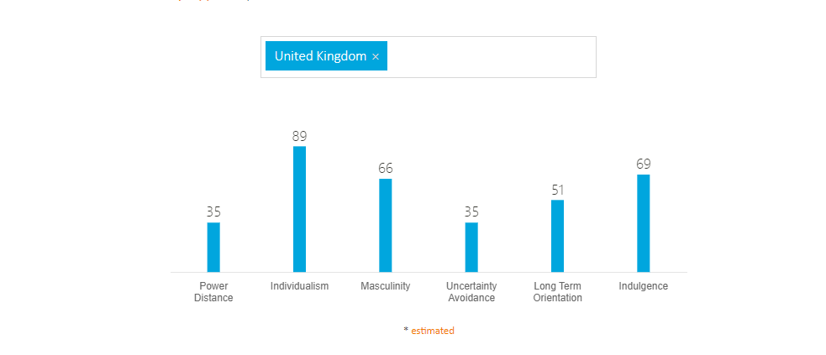
Picture.2.0. The cultural dimension of United Kingdom(Hofstede，2021)

Starting from Hofstede's cultural dimension, this paper evaluates the differences between Britain and the Netherlands. Figure 2.0 analysis (Hofstede, 2021): in terms of power distance, the UK scored 35. Therefore, the UK and the Netherlands have similar power frameworks in this regard. The power in enterprises is relatively decentralized, and employees can better communicate with leaders from bottom to top. There are fewer barriers and constraints on employees. In terms of individualism, the UK scored 89 points higher than the Netherlands. The UK is the first country in the world One of the countries with the highest humanism score. Therefore, the business etiquette and habits of British businessmen are also complex and changeable. Every businessman seems to have his own way of doing things. Masculinity scores 66. Unlike the Netherlands, Britain is a masculine society with a clear sense of purpose in all walks of life. Successful value orientation becomes the driving force. Therefore, after work, although most Britons finish their work, they still do some work-related things. The Dutch will not easily sacrifice their precious time. The lower score in avoiding uncertainty is 35. They are happy to "make up while doing" and change their plans when they receive information. Usually the British have few rules. But they are keen to line up. In terms of time, therefore, the middle score does not determine the main preference of the UK. In terms of indulgence, the score is close to the Netherlands. Usually on Friday nights and weekends, Britons organize all kinds of parties to reduce their stress.

Challenge

Language and communication barriers are not the only possible challenges in cross-cultural communication. 'Hall (1976) suggests that in order to understand communication in different cultures, we must look beyond words alone, To understand the meaning and Context of the interaction '(Dhara,S, Michelle,B. 2017). Therefore, cultural background and business etiquette may affect the negotiation process. In the context of German business negotiation etiquette, it is generally not acceptable to put your hands in your pockets. This is usually seen as rude by German businessmen. You need to be energetic when negotiating with Belgian businessmen, who usually like to mix business with pleasure. If you don't have an energetic spirit, you will be considered dull and lacking in energy. When doing business with Dutch businessmen, they usually care about rules. About their own unwillingness to accept too much advice or criticism (360Doc,2011). In addition to the challenges posed by business etiquette and traditional culture in different countries, context is also an important factor to consider.

Context environment is mainly divided into high context and low context. Hall (1976) focuses on the concept of high-context and low-context culture. He believes that high-context (HC) culture refers to a social hierarchical structure in which information is usually widely disseminated and has far-reaching significance. Low context (LC) refers to people's highly personalized social form (Hall, 1976, p. 39). Generally speaking, high-context culture can be understood as a complicated, indirect and far-reaching way of expression. Low context culture refers to the more direct and easy to understand the way of expression. Reference figure 3.0.(Globalequity,2021). Take China as a case: China is one of the high-context countries in the world. When negotiating with Chinese businessmen, there is usually some misunderstanding of context. "Keep your word when making friends." This is a quotation from the Warring States Period in China. The way friends communicate should be based on honesty. But it's also used in today's business negotiations. However, the significance of friendship is no longer as simple as the importance of good faith (Taoduyx, 2021). Context is also very important for business negotiation.
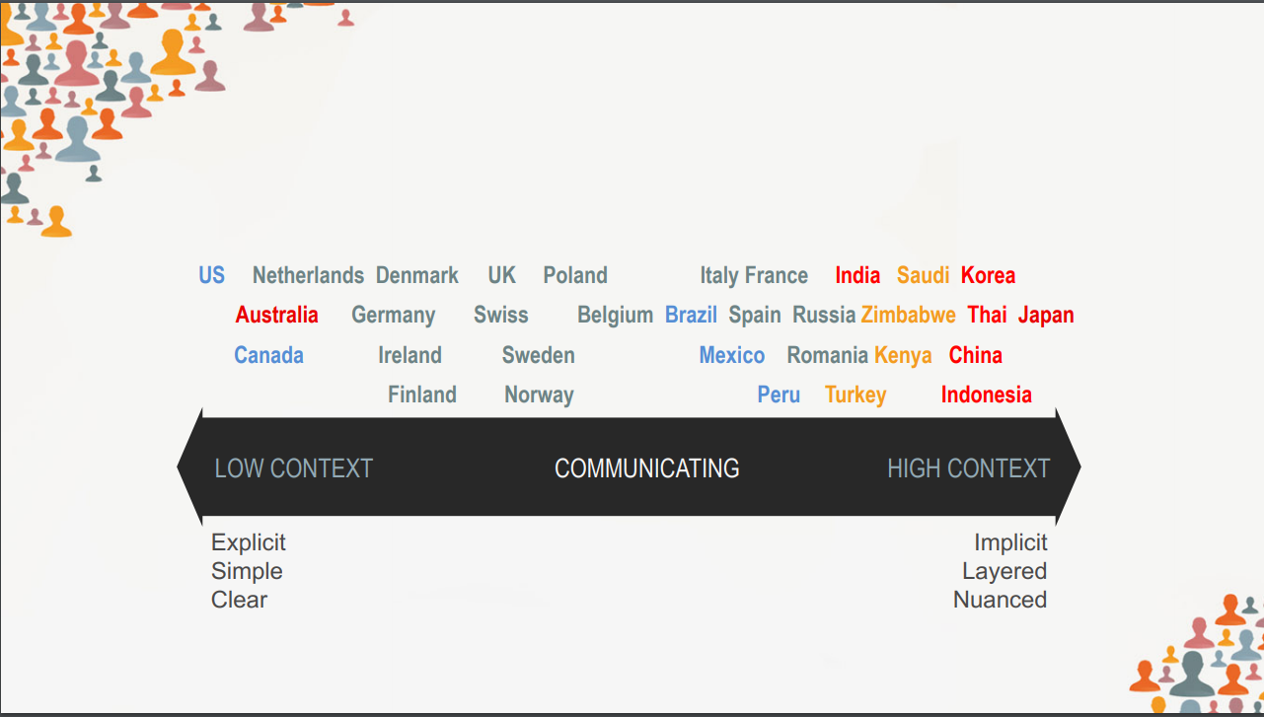
Picture.3.0.Contextual relationship degree of the world

Recognizing these challenges will help increase the success rate of negotiations and avoid failure. For these challenges, simply knowing the rules ahead of time can greatly avoid failure. But in addition to knowing the other person's background in advance. Cross-cultural communication skills are equally important. Cross cultural training enables individuals to learn knowledge and skills and promotes effective cross-cultural interaction by reducing misunderstandings and misconduct(Gupta, B, Singh, D, Jandhyala, K. 2013). Listening is the most commonly used and common skill. Effective listening can lead to effective communication and avoid misunderstandings. The second is nonverbal communication. Such as body language and non-body language, the deeper level includes facial expression, eye, gesture and posture communication. When it comes to some complicated words and sensitive topics, some simple expressions of body language and non-body language can subtly indirect this relationship (Passportcareer, 2019). In addition, mastering the mind is also a good way to solve these challenges. Having a good heart is essential. Misunderstandings happen from time to time in daily life. This becomes even trickier in cross-cultural Settings. A mistranslation of a word can take the topic off course. Therefore, keeping a generous mind is crucial. Secondly, don't trust your intuition too much and make sure you know what the other person means. The confusion needs to be clarified immediately. Speak slowly and repeatedly when the other person is confused. This will make communication more effective (Tim, S. 2019).

Critically analyze theories related to cultural differences

Hofstede's model appears to be unable to account for the complexity of culture, As Baskerville and McSweeney have Stressed (Signorini,P, Wiesemes, R. & Murphy, R. 2009). Power distance index refers to the degree of power difference. Taking India as an example, the caste system in India can be divided into four grades: Brahmin, Kshatriya, Veshas and Shudras (Baike, 2021). So India's hierarchy is rooted in its roots. But in a corporate system it's more complicated. In addition, communication for Indians is merely a means of maintaining relationships (Lewis, 1999; Van Marrewijk, 2010). In this country with a high power index, most enterprises adopt a family-style management style rather than bureaucracy. There is usually great rapport within the organization. Employees want more attention and recognition from their leaders. Therefore, cultural values are complex and changeable and not as monolithic as the theory suggests.

Differences between British and Dutch business cultures
Refer to Figure 1.0. The Netherlands is a women's society. Dutch workers typically leave work at 5pm and tend to allocate their time rather than work. So if you want to contact an employee from the Netherlands, you usually can't find him. In the Netherlands, work assignments are usually notified near the end of the schedule. A more important aspect of Dutch society is that most food markets close at 6 p.m. If they miss it, they lose the chance to buy dinner tonight (Neal R. Goodman.2012). The Kingdom of the Netherlands, like the UK, is a constitutional monarchy, but unlike the UK, the Dutch do not seem to like other people discussing their royal family and related matters. Even the projects signed by some countries are not mentioned. They seem to have a code of their own especially in business negotiations. In the UK, on the other hand, people are allowed to greet the royal family in the street. And everyone can discuss some news about the royal family. British people are more tolerant. Besides, the social structure of the two countries is different. Britain is a macho society in which success is the driving force for most people. Therefore, most British people are in the habit of working after hours. At the same time, Britain's infrastructure and food supply is relatively perfect. In this respect, Britain contrasts with the Netherlands.

Suggestions on cross-cultural communication
Advice from British and Dutch business culture. Work in the Netherlands usually ends at 5pm, except for those who work late when the deadline is approaching. Therefore, it is best to schedule meetings and work at noon. Second, refer to Figure 3.0. The context relationship in The UK is higher than that in the Netherlands. Therefore, the UK took the initiative when initiating business exchanges with the Netherlands. It's a little bit more passive for the Dutch. However, the contextual culture of the two countries is not very different. Secondly, Dutch people generally speak English and French. Dutch is their native language. Therefore, there are no more barriers in language communication. But the Dutch have their own set of rules just like the English merchants. There is a relatively high trend of individualism in these two countries. The Dutch people don't like to take too much advice and criticism. It's just for them to be themselves. The government and others will be conflicted about discussing the culture of their country. Therefore, it is necessary to know about Dutch cultural customs and traditional culture in advance. Use relevant skills flexibly in negotiation. When the other person's eyes and expressions show confusion. Speaking slowly and clarifying questions in a timely manner is all the more necessary. It is best to hire a translator who has lived in the area for many years before conducting business negotiations to avoid misunderstandings.

Conclusion
This paper first illustrates the importance of cross-cultural communication. Good cross-cultural communication skills can promote the success of negotiation and avoid failure. Then, the six dimensions of Hofstede's Cultural Dimension are used for a detailed analysis of Britain and the Netherlands. The two countries showed similar trends in terms of power, individualism, avoidance of uncertainty and indulgence. The two countries show opposite trends in terms of social structure and time. In terms of challenges, it is concluded that language communication, business etiquette, context environment and cultural differences will all bring challenges to cross-cultural communication. These challenges can be overcome from body language, non-body language, cross-cultural communication skills and mentality. In addition, the thesis critically demonstrates the six dimensions of Hofstede's cultural Dimension. Expressing the hierarchy of rights fails to express the complexity of its cultural structure. Finally, the differences between British and Dutch business cultures are analyzed. Summarize the characteristics of Dutch people who are more inclined to life. Then give some relevant suggestions.

Reference

Baike，2021. Caste system. ‘Indian caste system.’ {online}. Available at :https://baike.baidu.com/item/%E7%A7%8D%E5%A7%93%E5%88%B6%E5%BA%A6/424985{accessed at: 23 December 2021}.

Signorini, P,Wiesemes, R. & Murphy, R. (2009). Critically to Hofstede’s cultural dimension. ‘Developing alternative frameworks for exploring intercultural learning: a critique of Hofstede's cultural difference model.’ {e-book}. Vol.14 (3), p.253-264. Available at;https://web-s-ebscohost-com.ezproxy.uwtsd.ac.uk/ehost/detail/detail?vid=0&sid=ea4f0443-eebe-40ed-836d-88d8f492a18b%40redis&bdata=JnNpdGU9ZWhvc3QtbGl2ZQ%3d%3d#AN=40627267&db=eue{accessed at: 23 December 2021}

Tim，S.2019. Internation communication skills. ‘How to Improve Cross-Cultural Communication in the Workplace’
{online}. Available at: https://www.northeastern.edu/graduate/blog/cross-cultural-communication/{accessed at: 22 December 2021}.

Passportcareer，2019. International communication skills.‘8 SKILLS FOR EFFECTIVE INTERNATIONAL COMMUNICATION’{online}. Available at: https://www.passportcareer.com/8-skills-for-effective-international-communication/
{accessed at: 22 December 2021}.

Taoduyx，2021. The usage of Chinese Analects in business. ‘Sentences about business in the Analects of Confucius.’ {online}. Available at: https://www.taoduyx.com/etagid329311b0/{accessed at: 22 December 2021}.

Globalequity,2021. hierarchical map of cultural context in various countries. ‘The cultural map.’ {online}. Available at:
https://www.globalequity.org/geo/sites/default/files/KN3-The-Culture-Map-Breaking-Through-the-Invisible.pdf{accessed at:22 December 2021}.

Hall, E. T. (1976). Beyond culture. New York:Anchor Press-Doubleday.

360doc，2011. Negotiation style of major countries in the world. ‘Negotiation style of businessmen in various countries.’ {online}. Available at: http://www.360doc.com/content/11/1203/12/43724_169341395.shtml{accessed at: 22 December 2021}.

Gupta, B, Singh, D, Jandhyala, K. (2013) Self-monitoring, cultural training and prior international work experience as predictors of cultural intelligence – A study of Indian expatriates. Organizations and Markets in Emerging Economies 4(1): 56–71.

Dhara Shah, Michelle Barker.(2017). What challenges will business cross-cultural communication encounter. ‘Cracking the cultural code: Indian IT expatriates’ intercultural communication challenges in Australia.’ {e-book} Volume: 17 issue: 2, page(s): 215-236. Available at:https://journals-sagepub-com.ezproxy.uwtsd.ac.uk/doi/full/10.1177/1470595817706383{accessed at 23 December 2021}.

Neal R. Goodman.(2012). Improving Intercultural Interactions: Modules for Cross-Cultural Training Programs. {e-book}. SAGE Publications, Inc. Available at: https://sk-sagepub-com.ezproxy.uwtsd.ac.uk/books/improving-intercultural-interactions. {accessed at: 22 December 2021}

Adler, N. (1991). The international dimensions of organizational behavior (2nd ed.). Boston, MA: PWS-Kent Publishing..

YunKim.Y,(2012). Becoming Intercultural: An Integrative Theory of Communication and Cross-Cultural Adaptation. {e-book}. SAGE Publications, Inc. Available at: http://dx.doi.org.ezproxy.uwtsd.ac.uk/10.4135/9781452233253 {accessed at: 21 December 2021}.

Anamari,(2020). Evidence-based persuasion: A cross-cultural analysis of entrepreneurial pitch in English and Spanish. {e-book}. New York: Springer US. Available at: https://web-s-ebscohost-com.ezproxy.uwtsd.ac.uk/ehost/detail/detail?vid=0&sid=9f4abb7b-3210-4eb3-a50c-bf34e38c0bec%40redis&bdata=JnNpdGU9ZWhvc3QtbGl2ZQ%3d%3d#AN=147362117&db=bth {accessd at: 21 December 2021 }.

WiKI,2021. Communication Across Culture ‘What is communication Across Culture.’ {online}.Available at:
https://wiki.mbalib.com/wiki/%E8%B7%A8%E6%96%87%E5%8C%96%E6%B2%9F%E9%80%9A{Accssed at: 21 December 2021 }.

Hofstede，2021. The cultural dimension of United Kingdom. United Kingdom.{online}. Available at: https://www.hofstede-insights.com/country-comparison/the-uk/{accessed at 21 December 2021]

Prosancons，2021. Pros and cons of individualistic society. ‘Pros and Cons of Individualism’ {online}. Available at:
https://prosancons.com/politics/pros-and-cons-of-individualism/{accessed at: 21 December 2021 }

Hofstede，2021. The cultural dimension of Netherlands. ‘Netherlands’. {online}. Available at:
https://www.hofstede-insights.com/ {accessed at: 21 December 2021 }

Hofstede, G., Hofstede, G. J., Minkov, M. (2010). Cultures and organizations: Software of the mind (3rd. ed.). New York, NY: McGraw-Hill

