Health, Wellbeing and Sustainable Development

Component 1: Presentation

Student Name: Dorothy Tweneboah
Lecture Name: Junaid Shaikh
Moodle: BMHP6030

Table of Contents
Introduction 3
a) Definition and Discussion of Key Concepts 4
b) Incorporating Health and Wellbeing Approaches into the curriculum 5
c) Theoretical Perspectives 6
d) Policy and Governance 7
e) Service Delivery and Case Examples 8
f) Public Health initiatives 9
g) Equity and Access 10
Conclusion 11
Reference List 12

Introduction
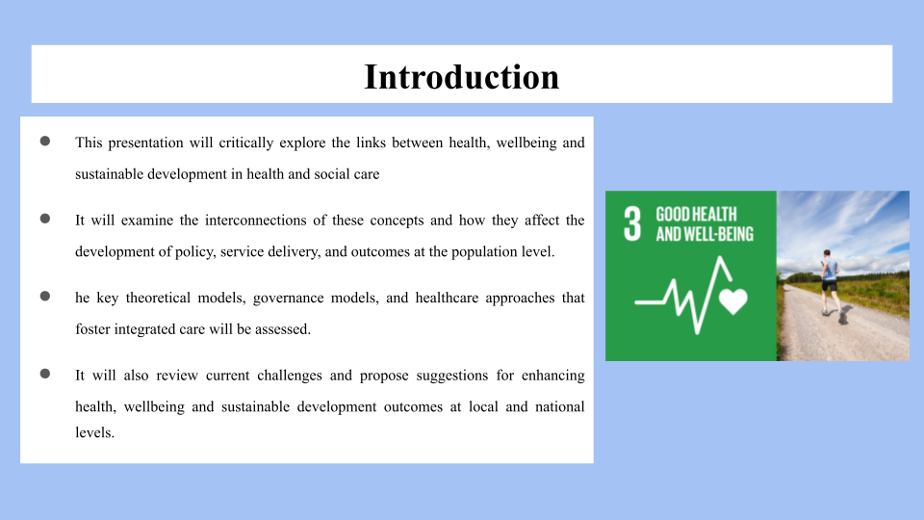
This presentation is going to critically examine the relationships between health, wellbeing and sustainable development in health and social care. It will explore the linkages of these concepts and their impact on the creation of policy, service provision and population results. The theoretical models, governance models and healthcare approaches that promote integrated care will be evaluated. It will also be reviewing existing challenges and recommendations for improving the health, wellbeing and sustainable development outcomes at local and national level.

a) Definition and Discussion of Key Concepts
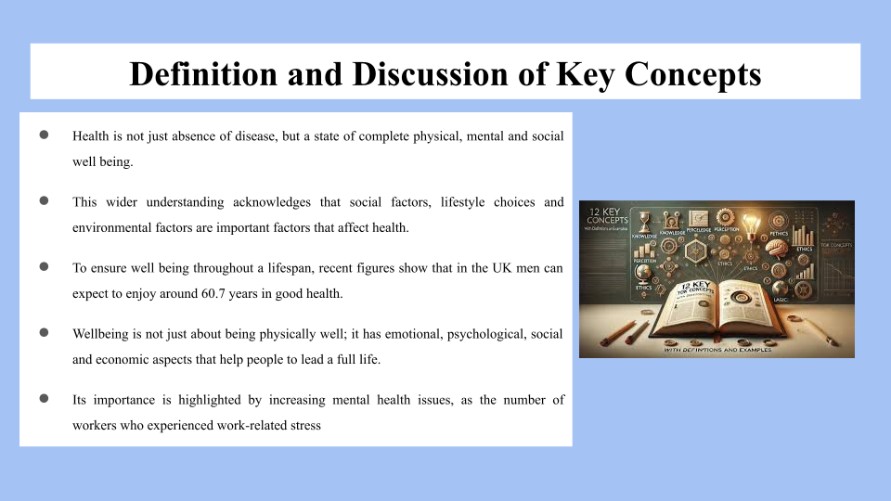
Health is not merely the absence of disease, it is a state of complete health – Physical, Mental and Social. This wider understanding acknowledges that social factors, lifestyle choices and environmental factors are important factors that affect health. To ensure wellbeing throughout a lifespan, recent figures show that in the UK men can expect to enjoy around 60.7 years in good health. Wellbeing goes beyond just the physical – there is a component of emotional, psychological, social and economic wellbeing that enables people to live their full lives. Its importance is highlighted by increasing mental health issues, as the number of workers who experienced work-related stress, depression and anxiety rose to around 875,000 in one of the last few years, resulting in important social and economic consequences (Guardian, 2026). Sustainable development is obtained by obtaining sustainable development to meet the needs of the present generation without compromising the ability of future generations to meet their needs. In healthcare, sustainable development for better health, maximum resource efficiency and minimum inequalities become the subject of sustainability. This is reflected in the importance of it in the global policy frameworks, specifically Sustainable Development Goal 3 which aims, among other goals, to ensure healthy lives and promote wellbeing for all ages.

b) Incorporating Health and Wellbeing Approaches into the curriculum
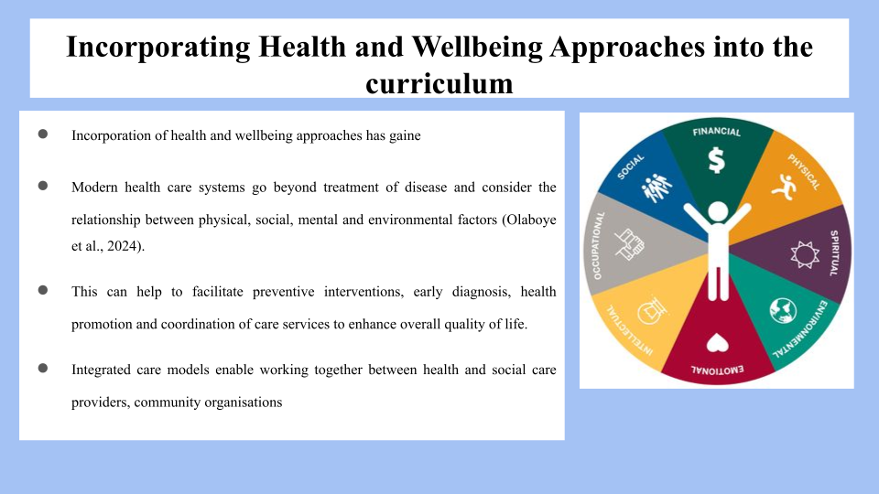
The significance of incorporating Health and Wellbeing approaches has increased in health care provision in a person centred and holistic way. Contemporary health care systems do not just focus on treating disease, but also on the interrelationships between physical, social, mental and environmental factors (Olaboye et al., 2024). This can aid in preventing interventions, early diagnosis, health promotion, and coordination of care which can improve the quality of life. Integrated care models enable working together between health and social care providers, community organisations and public health services with a focus on the wider determinants of health. This is especially vital in the context of the many mental health problems burdening England, estimated to cost the country around £300 billion a year due to health care costs, loss of productivity, and economic inactivity (‌Who, 2026). Sustainable development frameworks, such as the “Health in All Policies” approach, encourage the integration of health into decision-making processes in sectors that impact health, like housing, education, employment and transport. By addressing underlying drivers of poor health, integrated approaches are a means to help address inequalities and contribute to better population health, wellbeing and more sustainable health systems that can meet the needs of the future.

c) Theoretical Perspectives
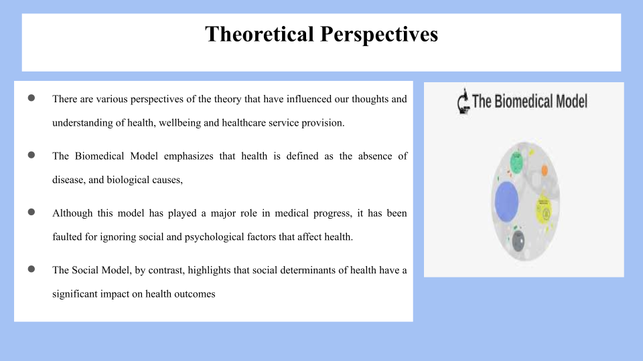
The theory has been discussed from several perspectives and has impacted our thinking and understanding of health, wellbeing and the provision of healthcare services. The Biomedical Model emphasizes that health is defined as the absence of disease, and biological causes, diagnosis and treatment are emphasised. This model has been widely influential in the advancement of medicine, but they have been criticized for neglecting the social and psychological aspects of health. On the other hand, the Social Model emphasizes the role of social determinants of health-on-health outcomes such as income, education, employment and housing and environmental factors (Mamun and Alam, 2025). This perspective gives a glimpse into the deep inequities in health outcomes between groups of individuals that may arise from inequalities. There is a lot of evidence available to indicate that there is a difference between socio-economic groups in terms of healthy life expectancy.
In addition, Biopsychosocial Model is a more comprehensive approach to health that addresses the biological, psychological and social aspects. It recognizes that health is dependent on the interrelationship of physical, mental health, behaviours and environmental factors (Green, 2023). The model is particularly relevant for the present day's health problems like mental health conditions. The prevalence of common mental health conditions is over a fifth of adults, highlighting the need for a health care system that takes into account more than just physical illness, but multiple aspects of wellbeing.

d) Policy and Governance
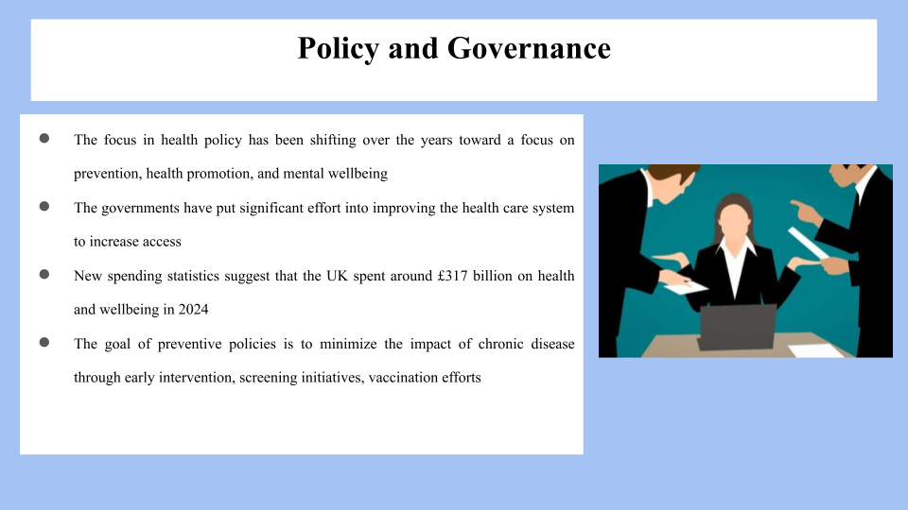
Over the years, more emphasis has been placed on prevention, health promotion and mental health than on health treatment services. Great efforts have been made by both governments to enhance the health care system with a view to increase access, decrease waiting lists, and to improve health outcomes for the population. Who (2026) estimates that the UK spent over £317 billion on health and wellbeing in 2024, which has since risen, and is now starting to be recognised as a key part of national policy agendas. Preventive policies aim to reduce the consequences of chronic disease by intervening at an early stage in life, implementing screening programs, promoting vaccinations and public health awareness campaigns. The rising population of patients suffering from mental illness and the need for mental health services have also increased the importance of mental health strategies (Amdam, 2024). Further investments have been made to the mental health system and building capacity. But there are still many issues to contend with. The funding constraints, staffing problems, regulatory hurdles, and increasing service needs continue to pose difficulties for healthcare systems.

e) Service Delivery and Case Examples
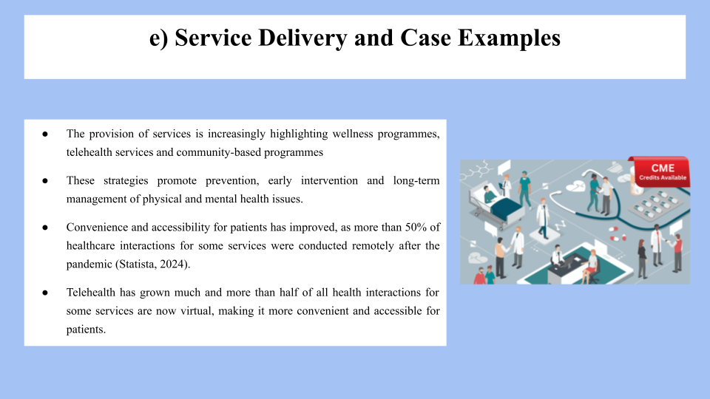
The provision of services is increasingly highlighting wellness programmes, telehealth services and community-based programmes as a way of delivering person-centred, holistic care. These strategies promote prevention, early intervention and long-term management of physical and mental health issues. Convenience and accessibility for patients have improved, as more than 50% of healthcare interactions for some services were conducted remotely after the pandemic (Statista, 2024). Telehealth has grown much and more than half of all health interactions for some services are now virtual, making it more convenient and accessible for patients. Community health programmes also contribute to wellbeing by addressing the local health needs and promote self-management. A holistic approach to care is found in the hospitals, incorporating medical, psychological and social care, understanding that health is a multi-faceted phenomenon (Himashree, 2025). Evidence suggests that using an integrated care model can decrease hospitalizations and increase patient satisfaction. These advances ensure better, more efficient health care and aid in sustaining the system through more efficient use of resources and health improvements for a variety of populations.

f) Public Health initiatives
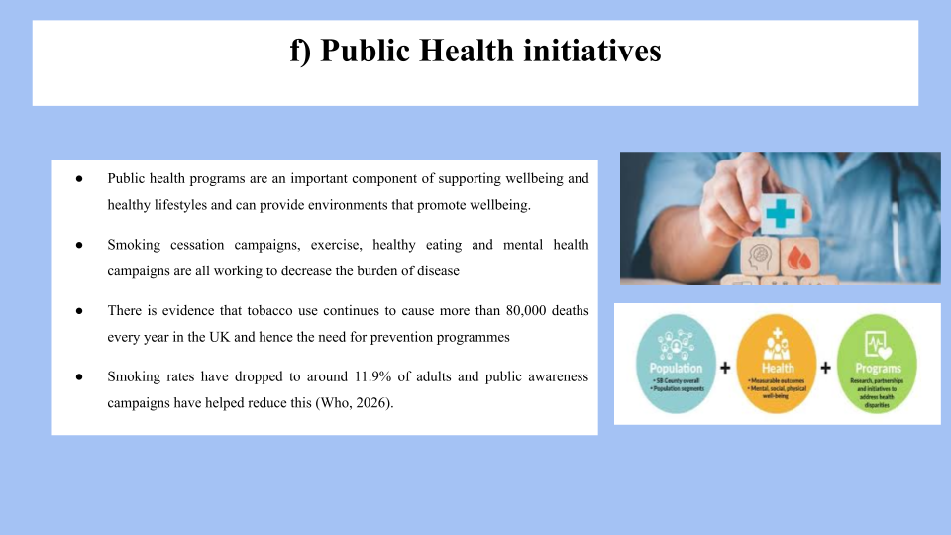
Public health programs play a key role in wellbeing, healthy lifestyles and can create environments that support wellbeing. Decreasing the burden of disease and improving the health of the population are all part of the smoking cessation campaigns, exercise, healthy eating and mental health campaigns. The use of tobacco is responsible for over 80,000 deaths in the UK every year and therefore there is need for prevention programmes. The prevalence of smoking among adults has decreased to approximately 11.9% and public awareness campaigns have contributed to this (Who, 2026). Besides that, there are programs available to encourage exercise and good nutritional regimen to help reduce the obesity issue facing about one in four adults. The interventions benefit society at large through their ability to save on health resources, value of production and quality of life. Public health tools can therefore help to deliver health outcomes but also sustainable development.

g) Equity and Access
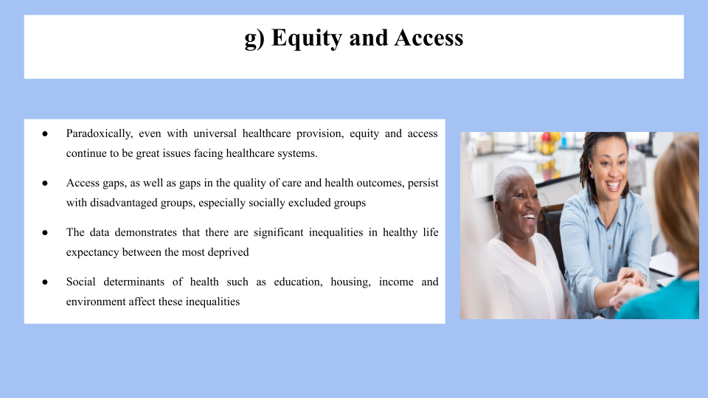
Ironically, equity and access remain major problems for healthcare systems notwithstanding universal healthcare. Disadvantaged populations continue to have gaps in access as well as in the quality of care and health outcomes, particularly those who are socially excluded, impoverished, or unemployed (Alitabar and Hadi, 2025). The data shows there can be substantial differences between the healthiest and least healthy life expectancies in different communities – 18 years or more in some. Social determinants of health such as education, housing, income and environment affect these inequalities. To meet these needs, governments and health care providers have implemented particular measures, including support for vulnerable groups, enhanced measures for preventive health care, and broader outreach efforts. Health equity improvement initiatives and policies that seek to minimize health inequities can enhance access and equitable distribution of health services to help achieve better population health and social justice.

Conclusion
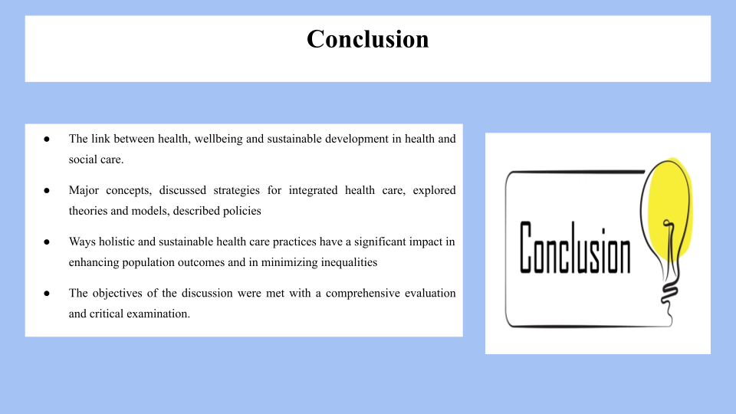
The relationship between health, wellbeing, and sustainable development in health and social care was critically examined. It covered key ideas, integrated health care methods, theories and models, policies, service delivery systems, public health policies, equity, and access challenges. This investigation showed that adopting a sustainable and holistic approach to health care practices can significantly improve population-level results and lessen inequality. Overall, the discussion's objectives were met, and a careful evaluation and criticism were carried out.

Reference List
Alitabar, S. and Hadi, S., (2025). The Biopsychosocial Model in Modern Healthcare: Overcoming Barriers to Holistic Patient Care. International Journal of Body, Mind & Culture (2345-5802), 12(2).
Amdam, R., (2024). New Perspectives in Health Promotion: Health in All Policies (HiAP). Routledge.
Green, S.E., (2023). Health impact assessment (HIA) as a tool to mobilise ‘health in all policies’.
Guardian. (2026). Health | The Guardian. [online] Available at: https://www.theguardian.com/society/health (Accessed 4 June 2026).
Himashree, G., (2025). The biopsychosocial-spiritual model: A holistic approach to health and well-being. Journal of Krishna Institute of Medical Sciences University, 14(1), pp.1-2. Himashree, G., 2025. The biopsychosocial-spiritual model: A holistic approach to health and well-being. Journal of Krishna Institute of Medical Sciences University, 14(1), pp.1-2.
Mamun, A.A. and Alam, M., (2025). Promoting equity in public health: Addressing inequality and social disparities. Health science reports, 8(5), p.e70821.
Olaboye, J.A., Maha, C.C., Kolawole, T.O. and Abdul, S., (2024). Promoting health and educational equity: Cross-disciplinary strategies for enhancing public health and educational outcomes. International Journal of Applied Research in Social Sciences, 6(6), pp.1178-1193.
‌Statista. (2024). Topic: Mental health in the UK. [online] Available at: https://www.statista.com/topics/8164/mental-health-in-the-uk/ (Accessed 4 June 2026).
‌Who. (2026). Health promotion. [online] Who.int. Available at: https://www.who.int/health-topics/health-promotion (Accessed 4 June 2026).
‌Who. (2026). World Health Statistics. [online] Available at: https://www.who.int/data/gho/data/themes/world-health-statistics (Accessed 4 June 2026).

