

Student Name:Nedelin Mihalev
Student ID number:2029603
Programme : BA Business Management
Module: Data Handling and Business Intelligence
Module code: LCBB5000
Lecturer:Khaza Ahmed
Assignment Title: Coursework(Written Report)

Introduction
Business intelligence refers to process where technologies are used to store and analyze data using different tools and techniques to acquire values from the data that can be implemented to gain business advantages. In these paper current trends in Business intelligence will be outlined. Different current trends such as using agile principles in BI program development, Fast analytics, and cloud based BI service and Security issues in BI will be outlined at the first of this discussion. At the second section, three process of BI will be outlined which are data mining, data warehousing and information system. At last a conclusion will be drawn on the basis of these discussions.

Current trends in Business intelligence
Using agile principles in BI system development
Lots of current trends have been found in Business intelligence which is being discussed here. Use of fist analytics in BI is one of the trends in BI. The main functionality of fast analytics is discovering data and data science uses fast analytics to discover data. Data acquisition is collecting or acquiring data (Ranjan, 2019). New technologies have been emerged where data can be acquired without the full understanding of the structure of the data. Hadoop is a file system developed by Google used in an open source platform open up opportunity to acquire data without modeling. Fast analytics can produce visual products such as scorecards dashboard or scorecard. Modeling is another phase of data science in producing BI products, here in this phase, data used in fast analytics is described and it includes descriptive, predictive and prescriptive analysis. Validation phase of fast analytics validate the analytical model to find out error and errors are tried to be minimized. Fast analytics and data science are inherently agile as each follows iterations, use small teams, and require collaboration between business subject matter experts and technical resources.

Source: Ranjan, 2019
Using agile principles in BI program development is another current trend in BI. Agile principles are used in Bi project to strengthen understanding between the end users and BI developer. In Modern time Data sources are identified in collaboration with the stakeholders and BI developer. After finding out data sources, BI developer start data profiling where values and structure of data are identified (Krawatzeck, Dinter and Thi, 2015). Data profiling provides statistical analysis such as frequency distribution, high and low value and so on. To produce Effective BI products Fast analytics and data science are used to review data demographics and identify relationship among the variables and to select parameter. Agile principles are used in architecture phase in BI product development.
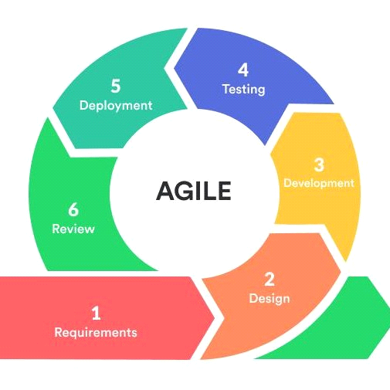
Source: Batra, 2017
Architecture of BI program starts with diagram that includes data models, data flows and infrastructure diagrams. Architecture for fast analytics refers to technical architecture and this type of architecture includes open source technical tools like R and Hadoop for develop analytical modeling (Batra, 2017). Agile principles are being used in designing BI products. There are two activities in modeling and mapping. Modeling with agile principles focuses on prioritized requirements, data demographics.
Cloud delivery and storage models
BI as a service model is a kind of BI service model where applications for developing BI products are offered by the public and private clouds. Different organizations have already started to reap the benefits of Cloud based B services. There are multiple benefits of adopting cloud based BI services. Cloud based BI services reduces the operating and infrastructural cost of an organization.
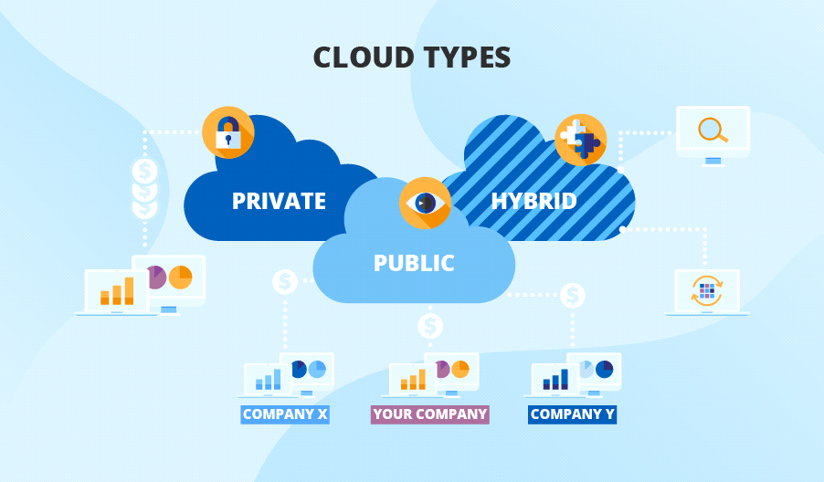
Source: Davenport, 2017
Another benefit of cloud based Bi is that it saves valuable time of an organization. Emerging service and analytics is another trending service in Bi which is a combination of software as a service and platform as a service (Davenport & Harris, 2017). Emerging service and analytics provides integrated services to the organization and this service includes data warehouse, machine learning, data visualization, big data and other technologies.
Security implications with big data
It has been found from the research that organizations use cloud Based Bi services face security and privacy issues. Cloud computing adaptation framework is being developed to ensure greater security to the organization using cloud Based services.
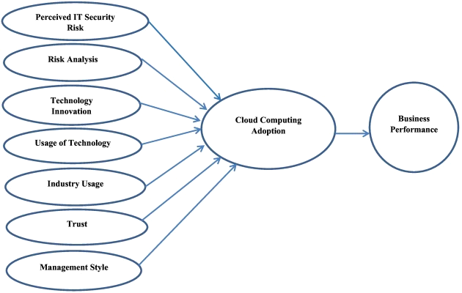
Source: Larson, 2019
It has been found from the research that CCAF can successfully block and kill more than 99% of viruses and Trojans injected on the cloud based platform (Hedgebeth, 2007). Big data poses a big security issues to the organization who are using big data for gaining actionable business information, it poses a security challenge because of its vast quantity, size and complexity.
Business Intelligence processes
Data mining
Data mining is the process of sorting through large scale of data to identify patterns and information and relationships between the data from a data set. Data analytics and data science knowledge is used to identify valuable information from vast scale of data to produce actionable information.
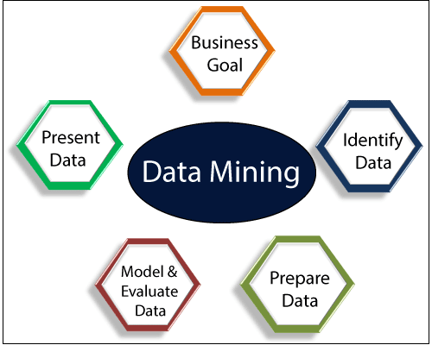
Data mining allows organization to run real time analytics on data and it open up opportunity to analysis big data (Marr, 2015). Organizations use data mining technology to extract data from data lake and data warehouse to produce valuable information for the business. Data mining helps organization to ensure competitive advantages as information advantage give an organization of competitive advantages.
Data warehousing
Data warehousing refers to a process through which organizations compile and organize data in a common database. In data warehousing, structured data is stored and there is a plan for processing and transforming data when it is sent to the warehouse (Hedgebeth, 2018). Data stored in warehouse can be used in tuning production strategies, doing customer analysis and conducting operational analysis.
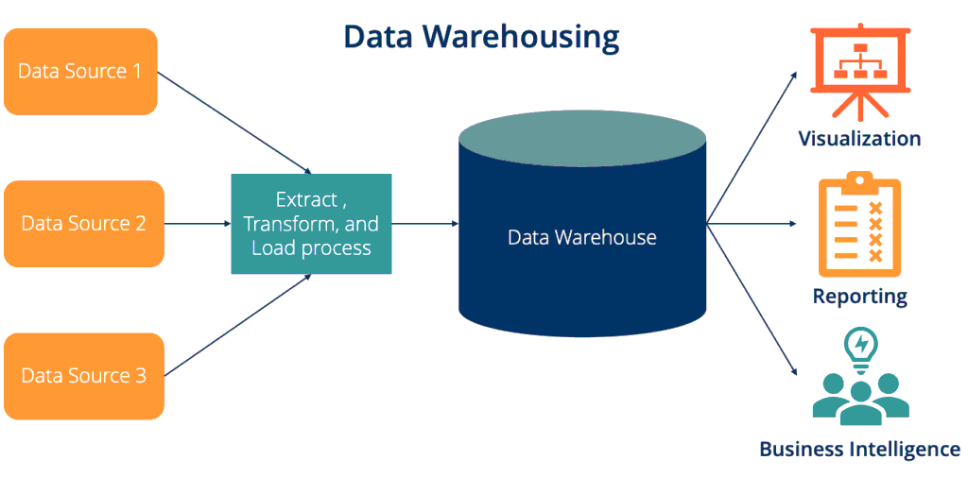
Source: Larson, 2019
Data warehousing process of BI saves time as data is stored in one platform and stored data can be analyzed anytime to produce actionable business decisions. In data warehousing, data loading resources are undermined.
Information system
Information system is an organizational system consist of technological tools such as software and hardware through which data and information is collected, analyzed, presented and distributed to different parts of the organization and helps organization to take appropriate decisions on the basis of data and information (Mayer and Cukier, 2013).
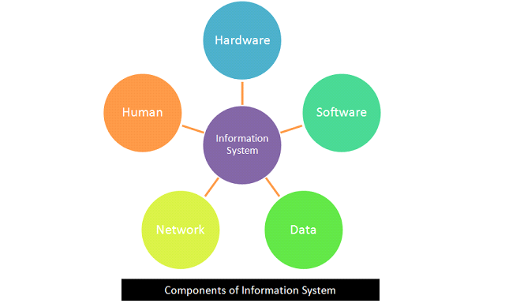
Source: Dyba, 2018
Information system is consisting of hardware, software, data, network and human intervention. Data flows through hardware, software and computer networks and helps business in decision making.

Conclusion
In summary of the above discussion, it can be concluded that Business intelligence is a system through which data is analyzed for gaining valuable information and BI is not a new term. There have been identified some current trends in BI which are useful for business organization to produce actionable business information. Agile software development methodologies are being used in developing BI system. Cloud based BI services are being offered by different organizations like Google, Amazon. Another trend in Business Intelligence is securing cloud based BI services using cloud computing adaptation framework through which potential threats to the system can be eliminated. Data mining and data warehousing are two important process of BI through which data are collected and analyzed in an effective and efficient way.

References
Ranjan, J., 2019. Business intelligence: Concepts, components, techniques and benefits. Journal of theoretical and applied information technology, 9(1), pp.60-70.
Batra, D., 2017. Adapting agile practices for data warehousing, business intelligence, and analytics. Journal of Database Management (JDM), 28(4), pp.1-23.
Larson, D. (2019). BI principles for agile development: keeping focused. BusinessIntelligence Journal, 14(4), 36–41. Retrieved from Business Source Completedatabase.
Davenport, T. H., & Harris, J. G. (2017). Competing on analytics: the new science ofwinning. Boston: Mass Harvard Business School Press
.Dyba, T., & Dingsøyr, T. (2018). Empirical studies of agile software development: asystematic review. Information and Software Technology, http://dx.doi.org/10.1016/j.infsof.2008.01.006
Hedgebeth, D. (2018). Data-driven decision making for the enterprise: an overviewof business intelligence applications. VINE, 37(4), 414–420. http://dx.doi.org/10.1108/03055720710838498
Mayer-Sch¨onberger, V., & Cukier, K. (2013). Big data: a revolution that will transformhow we live, work and think. John Murray: London
Marr, B. (2015). Big data: Using smart big data, analytics and metrics to makebetter decisions and improve performance.
Krawatzeck, R., Dinter, B. and Thi, D.A.P., 2015, January. How to make business intelligence agile: The Agile BI actions catalog. In 2015 48th Hawaii International Conference on System Sciences (pp. 4762-4771). IEEE.

