Student’s Name: Ileana Gabriela Juganaru
Student’s ID: 2106753
University Name: University of Wales Trinity Saint David
Lecturer: Chijoke Uba

Module Name: Problem Solving and Decision Making
Module Code: BMSW4004

Introduction
The concept of absenteeism is the voluntarily non attended at work without mentioning any valid reasons. The involuntary absences and occasional absences does not include an absenteeism because it has valid reason for the employees to take off. It might include sickness, accidents, or deaths of close family members (Aniyan, 2018). The concept of absenteeism closely related with the lack of productivity and lack of performance of organization. Even though employers out to set certain numbers of days and employ can take work leaves but excessive and un valid absences can result in less productivity which eventually impact on the financial department, internal creativity, and other important elements in terms of staying competitive in the relative industry. The main focus of this report is to examine the reason of absenteeism at Mid Cheshire Hospitals NHS Foundation Trust (MCHT). The report will typically examine the external factors which impact on the productivity of employees and lead them to take in-valid leaves from the organization. From the perspective of pestle analysis the external factors will be analyzed which plays a vital role in terms of influencing the internal environment of organizations.

Background of organization
Mid Cheshire Hospitals NHS Foundation Trust (MCHT) is the trust foundation providing its services in order to deliver quality off programs while providing effective health care to the people of Cheshire and beyond. The trust has employ almost 5000 health care workers having 540 hospital beds and including a range of services in order to facilitate different emergencies. the hospital is also responsible for the provision of range of community services for the people across Vale Royal and South Cheshire (Mcht.nhs.uk, 2022). Even in COVID-19 the dress was nationally as a secure and safe place with a fully equipped staff using PPE kits.
According to the current scenario the hospital has been facing a problem with staff absenteeism. Being a small medium sized foundation, the hospital seems to struggle with the financial crisis due to staff absence. According to the rolling average the rate of absenteeism steadily increased from 2007 to 2012. Due to frequent and invalid absence of the staff, the trust seems to combat again financial crisis. It cost them around £1 million each year. Moreover, frequent absence also led to poor quality of services which result in the use of temporary and agency staff who might not be as productive as the permanent staff. This report will typically cater the primary reason of absentees from the hospital whereas identifying the possible measures to reduce the absenteeism as well.

Discussion on the nature and impact of the complex problem on employees and their organisations
As mentioned in the presentation in task 1, it was evident that absenteeism plays a vital role in terms of impacting the overall productivity of organization. Staff taking frequent absences from work might lead to impact on the overall working of organization in such a way that it will eventually end in long delays. Organisations are then bound to hire people on the basis of contracts or short term in order to come back against this situation. But it might not be as effective solution because these staff members might not feel encouraged because they are not permanent. In this part of the report, nature and impact of absenteeism on employees and organisations will be analyzed:

Absenteeism leads to poor performance of organization
Absenteeism is also referred as bottom-line killer which is also costing the economy on annual basis. It is the unavailability of staff members where the profitability of organization is negatively influenced. Unavailable staff members resulted in incapable of reaching the organization objectives and goals in a given time frame. The unavailability of staff members also causes organization poor performance because of the constant work pressure on other people as they might not be able to handle the burden. It eventually impact on the way organization work and progress in a competitive field. In healthcare, it is very important that company must hire talented workforce who might handle their work tasks and complete it in given time frame. The organization must monitor, control, and reduce the absenteeism while using effective strategies. Organization must conduct a follow up for example a written note from doctor in order to track the cause of absence (Asfaw, Chang and Ray, 2013).

Reduce profit margin
Constant unavailability of staff members eventually impact on the way organization made profit out of it. It is evident that employees are the real assets of organization, if they stay unavailable or longer run then organization might not be able to generate revenues and complete their organization goals in a given time frame. Which eventually leads toward reduced profit margin.

Decrease employee’s revenues due to frequent absents
Revenue turnover is the percentage of an employer workforce which can be replaced by having voluntary and involuntary separation of employees from their employment or job. Decreased employee revenues might happen due to high degree of absenteeism. It costs money at impact on productivity where employees are often absent from their work due to invalid reasons. Most of the absences are paid leave which directly impacts on the production as the labor costs remains the same as compared to its outcome. This also impact on the loss of human resources which cannot be easily replicated or substituted.

Work burden increases to fill up the gap of absentees
And other evident impact of absenteeism is that other employees must fill the gap while doing more work apart from their own workers. Filling in for absentee might result in work burden (Geydar, 2020).

Analyses of macro-environmental factors through PESTLE
The backbone of strategy development tools is that they enable every organisation to take the lead by setting new policies and revising old ones. These instruments are versatile enough to allow the configuration to be changed in reaction to market conditions. Simply put, a strategy development tool is a method for managing and empowering a business by inquiring about, separating, and mapping an organization's capabilities to achieve a future envisioned state based on current reality and, on occasion, the organization's methodology, developments, business development, and individual capacities. A portion of the whole approach is the ability to connect voids that occur between the urgent, essential, and operational aspects of the affiliation.

One of the most essential things for every business to maintain is a strategy, which is the way to engage fight under the terms and conditions that are most acceptable to the firm. The goal of strategy is to achieve the greatest possible position among rivals while using measures that can help reduce cost, differentiation, or niche. PESTLE assessments are a method of defining business possibilities while assessing significant external variables that have a direct influence on the firm. PESTLE is a strategy for analysing an organization's external factors that is extensively used. PESTLE components stand for Political, Economic, Social, Technological, Environmental, and Legal issues. Every firm must have these components in order to grow and succeed (AIHR, 2022).

PESTEL
Political | One of the biggest current political change is the issue of Brexit where the United Kingdom decided to leave European Union which have its evident impact on society and public institutions like Mid Cheshire Hospitals NHS Foundation Trust (MCHT). The present political environment in the nation, the political parties in power, and government policies on corporate regulation and global trade agreements are all political issues. While negotiating a global trade agreement, political elements include an external review of the political state's attitude toward business laws and tax stability. The vote to leave the European Union has had a significant influence on the present political situation in the United Kingdom. Due to currency fluctuations and uncertainties in the realm of future trade restrictions in Europe, the subject of Brexit has had a significant influence on political issues.
Economic | Economic factors include economic downturn following the financial crisis at 2008 when you get seems to be having economic setbacks which also impact on Mid Cheshire Hospitals NHS Foundation Trust (MCHT). This might be a reason that organization is unable to fill the gap. Taxation obligations, economic obligations, economic growth, cost of living, inflation rate, consumer spending habits, economic growth decrease, and globalization are all economic factors. These aspects are crucial in altering business circumstances in accordance with the country's economic progress. With the current issue of Brexit, it is clear that the UK's economic situation has been severely harmed as a result of the country's economic separation from the European Union. Because Eurozone citizens are either hesitant to agree to a standard spending arrangement or because it is strategically impossible, the Eurozone's most vulnerable citizens have been forced to pay high loan fees, are vulnerable in security features, and are unable to protect themselves in the traditional way by debasing their money. Brexit hold the upper hand on the way people continue their employment. Moreover, UK seems to be unstable ever since the decision as healthcare have no policies to manage people
Social | Absenteeism largely impact on the way they treat their patients if the staff seems unavailable frequently then it will also impact on the expectations of the patients in order to treat them properly. The influence of consumer trends on the retail business is the focus of social factors in PESTLE analysis. Consumer buying habits, employment, consumer spending preferences, profession, lifestyle, work-life balance, demography, and population were all factors. These characteristics have a significant influence on how the retail business operates. Cultural variety so plays an important role in the country.
Technological | With the rising concern of improved health care system, it is very important to analyze and include the tools which can be a staple for the hospital and clinics. In this way it is very important to have a proper payroll and record keeping system which can help to analyze the current absenteeism in hospital (Hassink, 2018). Another major issue is the technology revolution, which may be used to assess current potential for retail development and income. Automation, disruptive technology, social media networks, artificial intelligence, security, and robots are all examples of technological factors in this way. In the current retail industry in the United Kingdom, it is critical to improve the operation of the firm through technological advancements. There is no evident HR policy toward managing the payroll and monitoring frequent absents of staff. It might be influencing factor to impact on the growing number of absents among hospital.
Legal 2 | Legislation towards poor performance must be included. Legal considerations include common law business rules, labor laws, and health and safety standards that apply to retail businesses. The retail industry is likewise concerned with how to do business in an ethical manner. Minimum wages and other options might be the influencing factor on frequent absenteeism. The present Brexit also impact on the way business used to eb done. In this way, hospital might not be able to provide best wages to their employees which might be an influencing factor to cause absenteeism
Environmental | A sustainable solution to reach the goals through improve employ performance. Environmental issues are one of the most popular topics these days, and they have an influence on how businesses operate and contribute to the economy. In this setting, it is critical to combine environmental principles with corporate activities in order to improve the situation. Furthermore, ethical considerations press for price increases. Hospital needs to develop policies to educate staff members about sustainability. Eventually it will boost up their morale to work and get them back to work.

Fish bone diagram
Fig 1 demonstrate fish bone diagram for Mid Cheshire Hospitals NHS Foundation Trust (MCHT). The image examine on the possible causes of absenteeism at hospital. With the help of fish bone diagram, the possible consequence can be seen clearly.
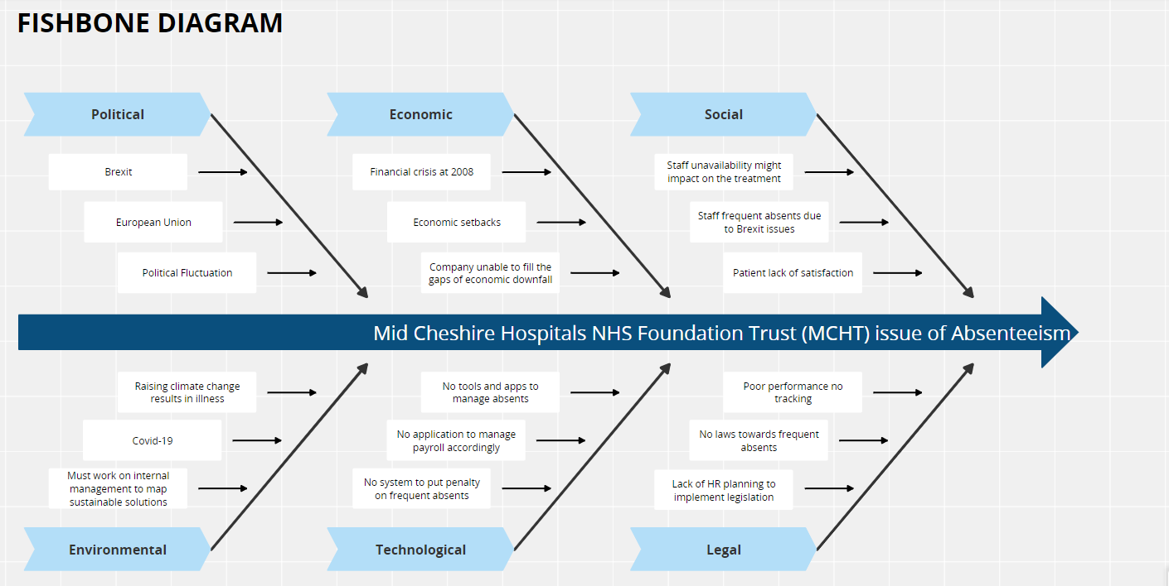
Figure 1 Fish bone Diagram

PMI analysis
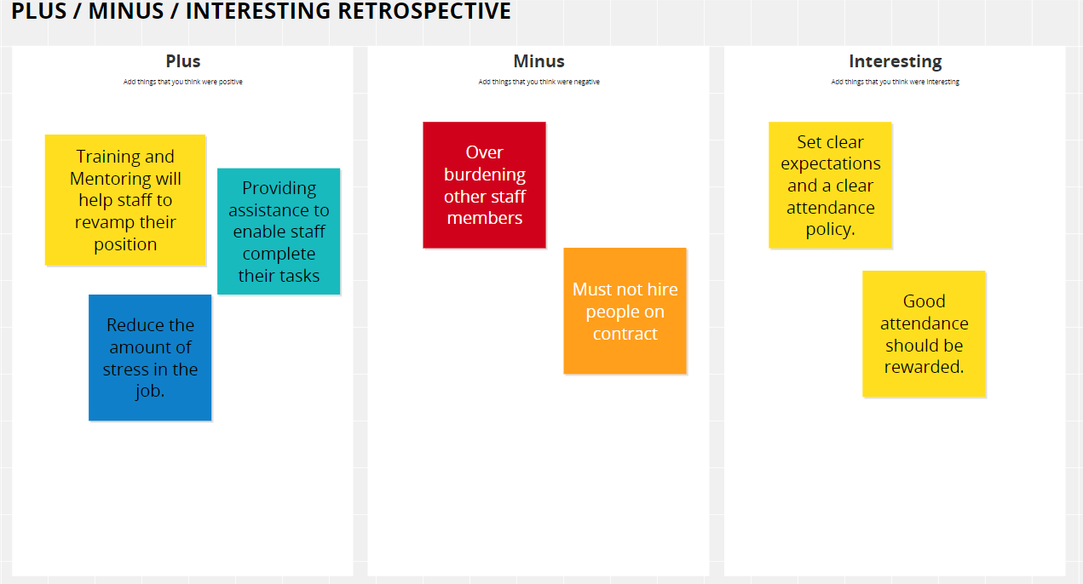
Figure 2 PMI Analysis

Cause-and-effect of Absenteeism
As shown in fig 1, it was evident that absenteeism must be managed with proper strategies to mitigate the risks Employee health and wellness are linked to higher performance, as seen in the diagram above. It is critical that the firm concentrate on these aspects in order to improve performance value by providing proper medical services and insurance policies. It is vital to focus on the employee mental and physical health as to ensure that employer concentrate on fostering positive environment inside the workplace (Villafuerte and David, 2020).
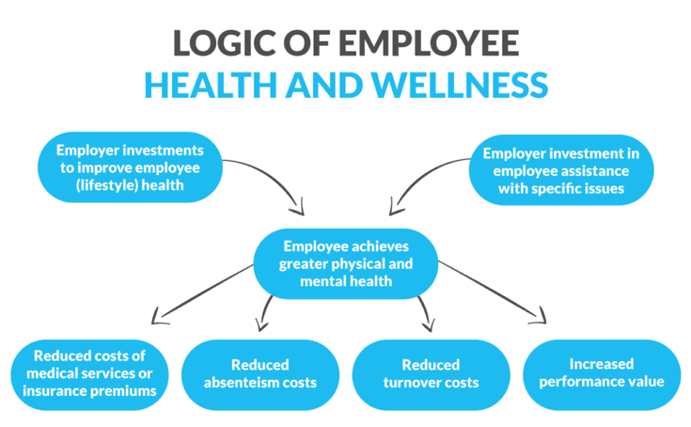
Figure 3 Mid Cheshire Hospitals NHS Foundation Trust (MCHT)

Implementing the decision to solve the complex problem
- One option is to set clear policy towards the attendance so that organization will have a clear goal to reduce absenteeism.
- Other option is to implement work life balance to reduce the amount of stress on worker.
- Meanwhile those who have good attendance must be given reward to appreciate them (Krpalek, Meredith and Ziviani, 2014).

Conclusion

The ideal solution would be for Mid Cheshire Hospitals NHS Foundation Trust (MCHT) to create clear expectations and a clear attendance policy in order to guarantee that every employee understands the policy and code of conduct in terms of taking time off from work. Employees will be able to keep mindful in terms of arranging their leaves and taking absents only in emergency situations if a clear policy of absence and penalties is established.

References
AIHR, 2022. Absenteeism in the Workplace: Impact, Causes, and Policies. [online] AIHR. Available at: <https://www.aihr.com/blog/absenteeism/#impact> [Accessed 18 March 2022].
Aniyan, A., 2018. Absenteeism and Factors Affecting Absenteeism. International Journal of Nursing & Midwifery Research, 05(01), pp.27-31.
Asfaw, A., Chang, C. and Ray, T., 2013. Workplace mistreatment and sickness absenteeism from work: Results from the 2010 National Health Interview survey. American Journal of Industrial Medicine, 57(2), pp.202-213.
Geydar, D., 2020. An Empirical Research on Factors Affecting Employee Absenteeism in an Airline Industry: A Relook on Job Stress, Work-Life Balance and Job Satisfaction as Predictors. International Journal of Psychosocial Rehabilitation, 24(02), pp.804-832.
Krpalek, D., Meredith, P. and Ziviani, J., 2014. Investigating Mediated Pathways Between Adult Attachment Patterns and Reported Rates of Absenteeism and Presenteeism. Journal of Workplace Behavioral Health, 29(4), pp.259-280.
Mcht.nhs.uk, 2022. About the Trust. [online] Mcht.nhs.uk. Available at: <https://www.mcht.nhs.uk/about-us/about-the-trust/> [Accessed 18 March 2022].
Villafuerte, A. and David, B., 2020. SOCIETAL AND ECONOMIC FACTORS AFFECTING PUPILS’ ABSENTEEISM AS A GAUGE OF ACADEMIC EFFICIENCY. International Journal of Research In Commerce and Management Studies, 02(02), pp.17-25.

