Name : | Martin Makuna
Student Number: | 1909478
Title of module: | Effective Team Working and Communication (BSMW4002)
Assignment: | Effective Team Working and Communication

Tables of Content:
1.0 Introduction pg3

1.1 teamwork pg3

1.2 Communication pg3

1.3 Types of communication pg3

1.4 Verbal communication pg3/4

1.5 Non-verbal communication pg4

2.0 Theories pg4

2.1 Shannon and weaver model of communication pg4/5

2.2 Berlo’s model of communication pg5/8

2.3 Schramm’s model of communication pg8

3.0 Importance of effective communication pg8

4.0 Conclusion pg8

5.0 References pg9

1.0 Introduction
In this assignment I will be talking about the different theories of communication as well as talking about a charity and how they important it is for them to be able to communicate and work as a team effectively.
Waltham Forest Community Hub (WFCHUB) is a company that has a very simple and strong aim in the borough of Waltham forest, it is a charity that concentrates on bringing the people in the Walthamstow community together and constantly developing its trust and stability. With a vital aim such as this it results in the company always having to work with its community obviously. Which means that Teamwork and communication skills are vital for the staff as well as the individuals that attend the youth centre. (WFCHUB.org)
1.1 Teamwork:
Teamwork is an essential skill for an individual to possess, this skill allows the individual to be able to comfortably sync with anyone that is put in their team and achieve the goal that is set. When teamwork is required to achieve a certain goal, it tends to mean that the goal cannot be achieved alone. Waltham forest community hub has huge aims and to be able to work effectively in a team is very important to them as there are always different people that volunteer for different events. (Chron.com)
1.2 Communication:
Communication is a process of which two or more individuals exchange information by using the signs, symbols, behaviour and most common speech. With communication being a huge part of our daily life, it is no surprise that it is seen as one of the most important skill that individuals possess, and some can use more effectively than others. For a charity like the Waltham forest hub communication its where the effectiveness of this skill can really be displayed as it is a constant skill being used with every action that occurs, this is due to the fact that communication is so vital as people have different levels of understanding certain things that are said, this could be due to the lack of English, the different level of speech and words used.(merriam-webster.com)
1.3 Types of communication:
There are different types of communication such as verbal and non-verbal, when it comes to non-verbal communication it can be done in various ways such as hand gestures, facial expressions and body language.
1.4Verbal communication
Verbal communication is an action that takes sound and words for an individual to express themselves during a conversation with another person. Due to the high number of people that attend the Waltham forest community hub with a huge variety of personalities and character the staff must be able to communicate with these individuals in different ways to get their point across as well as to answer questions they may have. This is conveyed in different ways at the hub as the level of English always varies, some individuals might not be able to comprehend some use of words. For example someone from another country might attend the community hub and wont really understand the aim so he or she would have to find out by asking a member of staff, this will lead to a communication that may or may not have a significant effect on the individual as the communication may decide whether they will attend further activities that the hub has to offer or avoid it. For this reason, the members of staff must be able to use verbal communication in a very effective way as it will determine them gaining members to join them or avoid them. (yourdictionary.com)
1.5 Non-verbal communication:
Non-verbal communication is a type of communication where facial expressions, hand gestures, body language and eye contact help to express feelings. For example, eye contact during communication is vital as it is known to show respect as well as interest in the other person. By an individual smiling during a conversation it shows that the individual is enjoying the conversation or when they frown, they might be showing anger and other emotions. (helpguide.org)
This type of communication is very important when it comes to welcoming new people anywhere in the world, with this skill being used with verbal communication it does show a lot of enthusiasm when welcoming people as well as interacting with them.
Waltham forest community hub adapts this type of communication especially when dealing with people that may have special needs and want to interact with their community but have difficulties doing so with verbal communication. In order to get through to these types of people non-verbal communication may be the most effective as an individual would be able to see the smiles on the staffs faces which will make them feel comfortable and welcome in such community.
2.0 Theories:
Since people see different types of communication it certainly made some individuals question how communication is achieved, therefor three individuals decided to study this and came up with three different modules of communication.
2.1 Shannon weaver model of communication:
This model was created in 1984 by a mathematician under the name of Elwood Weaver and a scientist by the name of Warren Weaver. These two individuals came together to create this model that in todays era is known as the ~mother of all models~ this is seen as the most technological than other models.
The concept of this model concentrates on the communication done with the use of modern technology the concept of this model is known to be simple and straight forward but not as easy for some people.
The model contains of 6 simple stages the first being the sender which is the source of the information being sent, this is the individual who chooses a message to be sent. This is followed by the Encoder this is known to be the machine used to send the message also it can be referred to the sender who uses a specific machine to convert the message into signals or data if need depending on machine used by an individual.
Channel is the third stage and is straight forward as it is the medium used to send the message through. This is followed by the Decoder which is the machine that is receiving the information being sent through the other device, at this stage the decoders job is to translate the signals or data to a message that can be understood by the other individual.
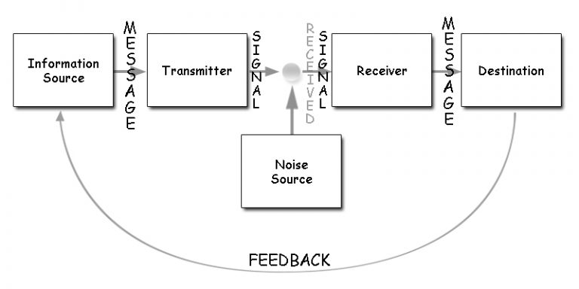
The 5th stage is the receiver and it is exactly as stated the individual that is receiving the message from the device that the message has been sent through, however, receiving message isn’t as easy as it may seem as Shannon and weaver included a stage that is known as the noise this is where the message can be interrupted due to noise around the individual that is saying the message or the individual receiving this message. Noise has a big part to play when it comes to communication through a device or telephone, the reason behind it is that the microphone can pick up a lot of noise around the individual which will block out some of the message sent. this doesn’t only include noises but can be interfered with the signal at the area the call is being made from and even be the providers fault.
Due to the high demand for mobile phones in the 21st century almost everyone uses it to pass on information, this is highly used in the Waltham forest community hub as sometimes information is need outside of working hours. This results in phone calls being made to be able to pass on information in the quickest way. Sometimes the information isn’t clear as the model shows due to outside noise interrupting the message. (businesstopia.net)
2.2 Berol’s model of communication:
Berlo’s model of communication is the easiest to understand out of all models, some people may argue that this model is not a good representation of communications as it is not specific to a certain way of communication instead it is very versatile as each stage has t different sub-sections to them.
The sub-sections refer to different communications styles, some of them may support more than one style as different people may argue that they are linked in their own specific way which widens an individual’s understandings of each communication style.
The first stage of the model is the source and it is known to be the place from which the communication or an idea originates from. Under this section there are 5 different factors that relate to an individual’s skills, personality, and interests these are known to be personality traits.

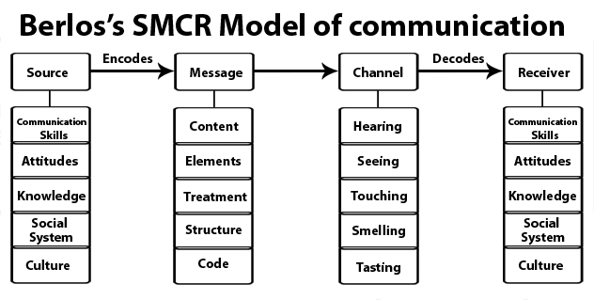

Source section:
Communications skills: this is a skill that one possesses in order to have a good and engaging conversation with another individual, this includes the ability to read, write, speak and listen.
Attitude: attitude is determined absolutely on the individual as everyone has different attitudes towards different topics as well as situations this may vary. One example can be that an individual may have a negative view on a topic and will always try to defend their point in a conversation or debate.
Knowledge: this is another factor that depends on the individual and what they know of a specific topic, usually people would not engage in a conversation that they have no knowledge off.
Social system & culture: these factors concentrates on the multicultural society that there is around the world and people will see a lot of things differently due to their culture and their understandings and beliefs.
Message section:
This section concentrates on the actual message that is relayed by the individual, this can either trigger the communication or extend it depending on how it is used by the individual.
Content: content of the message is very important as it must be well structed with the correct details otherwise it could be misunderstood.
Elements: these are extras that can be added to the message itself by the individual this can be done through body language, gestures as well as use of language.
Treatment: this factor refers to the was a message is delivered by the individual this can have a huge imp act on the conversation as it can be in different ways which results in the receiver to see it in a menacing way flipping the conversation around.
Structure: the structure of the message can always be different and will never be the same, this has a major effect on how the conversation will go.
Code: there are different cods and individual can portray during conversation but will always refer to the means through the different ways an individual communicates this could be through body language the use of different language and many more. The fact that some people tend to concentrate heavily on culture they may see that as a sort of code as well due to this people can engage into a conversation.
Channel: this refers to the 5 sense of the human body but can also refer to the different channels of a radio if a conversation takes place through that.
The 5 different senses are as followed:
- Hearing
- Seeing
- Touching
- Smelling
- Tasting
During a communication more than 2 of these channels tend to get used at the same time this allows the conversation to go more smoothly and even make it more effective as well as engaging.
Hearing: this channel is done using human ears they receive the message through sound that is given out by an individual’s mouth.
Seeing: seeing can sometimes be a major reason one can engage into a conversation as some individuals can not hear so communication is done through hand gestures that is taken into consideration with the eyes.
Touching: due to some individuals not being able to see they communicate just through sound itself but can be done through touch if one decided to use objects for that individual to have some imagination. Besides object communication can also be done through hugs, handshakes and many more.
Smelling: Smell for some individuals can be very delicate when it comes to the aroma an individual put out some may say if one smells good, they tend to represent themselves in a very positive way with wealth and self-consciousness.
Taste: some people tend to engage in a communication during a meal, this tends to bring about different topics to talk about and prolong the conversation and meeting.
Receiver: the receiver is the individual that is receiving the message being sent under this section the factors are the same as the source which refers to the sender of the message.
This model of communicate is the simplest one and is always used in the Waltham forest community hub, the reason is that there are constant communications on how to improve the centre as well as to help all individuals. (Communicationtheory.org)
2.3 Schram’s model of communication
The Schramm’s model of communication is known to be the circular model of communication as the diagram shows a constant loop during a conversation.
Encoder:
The conversation starts off by the encoder the individual who starts the conversation and encodes the message that they wish to send to the decoder.
Decoder:
The decoder is the individual that is receiving the message from the encoder and takes in the information sent to them.
This model does not always show that there is interruption in the communication, however, it can be shown in some of the diagrams. The way it can be shown is through the misunderstanding by the decoder and the way they take the message in. (communicationtheory.org)
3.0 Importance of effective communication.

Communication at any workplace is very important an any workplace, the fact that the Waltham forest community hub is so popular and very effective with their communication with different age groups is due to the sills level of the staff that work there.
Due to the different levels of communication skills the knowledge gets passed on to other employees which leads to even greater knowledge of the staff and centre as a whole.
4.0 Conclusion:
In conclusion the having good communication at a workplace is a huge factor as it does have a significant affect, the reason for this is because people have different levels of communication this always is a benefit for the company as they will be able to adapt to the workers and their communication. Due to the different levels of communication each employee can learn from each other which allows the company to evolve with customer service.
5.0 List of References:
Leonard, k. (2018) The definition of teamwork in a workplace, https://smallbusiness.chron.com/definition-teamwork-workplace-36105.html [accessed January 6, 2020]
(no date) Waltham forest community hub, https://www.wfchub.org/about [accessed January 6, 2020]
(no date) definition of communication https://www.merriam-webster.com/dictionary/communication [accessed January 6, 2020]
(no date) verbal communication https://www.yourdictionary.com/verbal-communication [accessed january6, 2020]

Jeanne Segal, PH.D., MS, LR and GB. (JUNE 2019) Nonverbal communication https://www.helpguide.org/articles/relationships-communication/nonverbal-communication.htm [accessed January 6. 2020]
Businesstopia in communication (2018) Shannon and weaver model of communication https://www.businesstopia.net/communication/shannon-and-weaver-model-communication [accessed January 6, 2020]
( no date) Berlo’s SMCR model of communication https://www.communicationtheory.org/berlos-smcr-model-of-communication/ [accessed January 6, 2020]
(no date)OSGOOS- Scgramm model of communication https://www.communicationtheory.org/osgood-schramm-model-of-communication/ [accessed January 6, 2020]

